- Launch one aws ec2 and install jenkins.
1. Objective
The objective of this task was to launch an Ubuntu EC2 instance on AWS and install Jenkins as a Continuous Integration and Continuous Delivery (CI/CD) automation server.
The implementation included launching the EC2 instance, connecting to it through SSH, installing Java and Jenkins, configuring Jenkins as a system service, verifying its status and port, and accessing the Jenkins web interface through a browser.

2. Prerequisites
AWS Requirements
- AWS account
- EC2 service access
- Ubuntu Server AMI
- Key pair for SSH authentication
- Security Group
- Internet connectivity
EC2 Configuration
- Ubuntu Server EC2 instance
- Minimum 2 GB RAM recommended for Jenkins
- Sufficient EBS storage
- Public IPv4 address
- SSH access through port 22
Software Requirements
- Java/JDK supported by the installed Jenkins version
- Jenkins
- systemd
- curl
Network Requirements
The EC2 Security Group was configured to allow:
Port | Protocol | Purpose
22 | TCP | SSH access
8080 | TCP | Jenkins web interface

3. Implementation
Step 1: Launched EC2 Instance
An Ubuntu Server EC2 instance was launched from the AWS EC2 console.
The instance was configured with:
- Ubuntu Server as the operating system
- Appropriate instance type
- EBS storage
- An existing or newly created key pair
- A Security Group allowing SSH access on port 22
- Port 8080 opened for Jenkins web access
After the instance was launched, its Public IPv4 address was noted for SSH and browser access.

Step 2: Connected to EC2 Instance
The Ubuntu EC2 instance was accessed through SSH using the downloaded private key:
ssh -i <key-file>.pem ubuntu@<EC2-Public-IP>
After successful authentication, the Ubuntu server terminal was available.

Step 3: Updated Ubuntu Packages
The package repository information was updated:
sudo apt update
The available packages were checked and updated as required.

Step 4: Installed Java
Java was installed as a prerequisite for Jenkins:
sudo apt install fontconfig openjdk-21-jre -y
The Java installation was verified:
java -version
The installed Java version was confirmed successfully.

Step 5: Installed Jenkins
The official Jenkins repository and signing key were configured, and the Jenkins package was installed.
The Jenkins service was then available through systemd.
The service status was checked using:
sudo systemctl status jenkins

Step 6: Enabled Jenkins Service
Jenkins was configured to start automatically when the EC2 instance boots:
sudo systemctl enable jenkins
The configuration was verified:
sudo systemctl is-enabled jenkins
Expected result:
enabled

Step 7: Verified Jenkins Service
The Jenkins service was checked using:
sudo systemctl is-active jenkins
Expected result:
active
The detailed status was also checked:
sudo systemctl status jenkins
The service status confirmed that Jenkins was running.

Step 8: Verified Jenkins Port
Jenkins uses port 8080 by default.
The listening port was verified using:
sudo ss -lntp | grep 8080
The output confirmed that Jenkins was listening on port 8080.

Step 9: Accessed Jenkins Web Interface
Jenkins was accessed from a web browser using:
http://<EC2-Public-IP>:8080
The Jenkins Welcome page/dashboard was displayed successfully.

Step 10: Checked Jenkins Logs
Jenkins service logs were checked using:
sudo journalctl -u jenkins -n 50 --no-pager
The logs were reviewed to verify successful Jenkins startup and identify any service-related errors.

4. Verification
The following checks were performed after installation:
java -version
sudo systemctl status jenkins
sudo systemctl is-active jenkins
sudo systemctl is-enabled jenkins
sudo ss -lntp | grep 8080
curl -I http://localhost:8080
Finally, the Jenkins web interface was accessed through:
http://<EC2-Public-IP>:8080

5. Conclusion
An Ubuntu AWS EC2 instance was successfully launched and configured with Jenkins.
Java was installed as the required runtime environment, Jenkins was installed and configured as a systemd service, and automatic startup was enabled. Jenkins was verified to be running and listening on port 8080.
The Jenkins web interface was successfully accessed using the EC2 instance's public IP address, completing the deployment of Jenkins on AWS EC2.
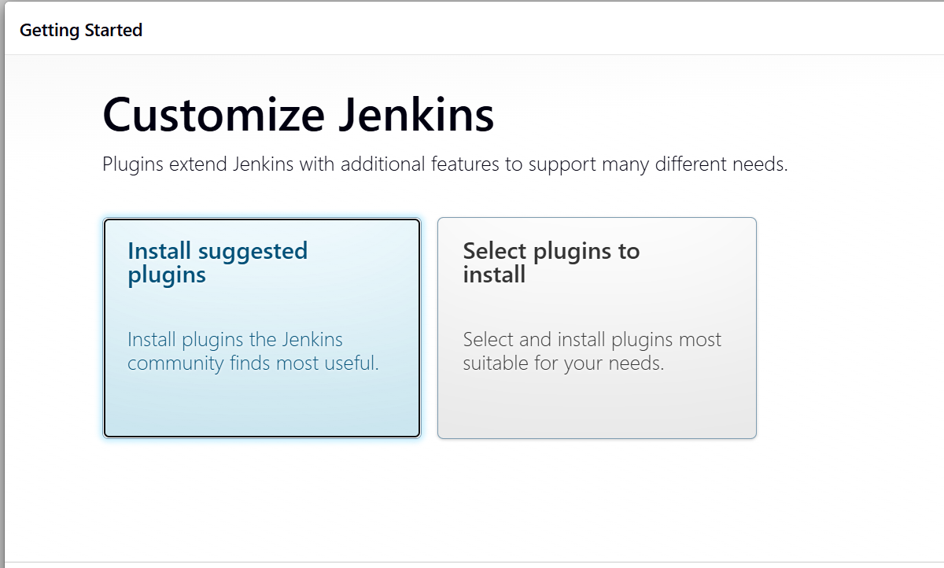
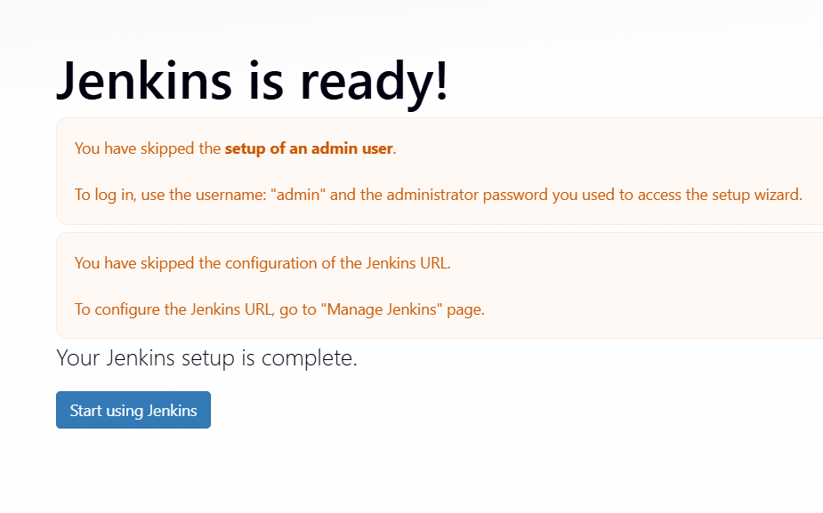

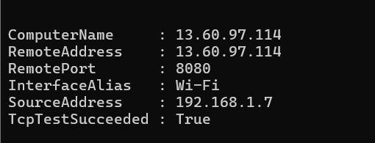

2.Setup Apache tomcat on ubuntu virtual machine
1. Objective
To install, configure, and run Apache Tomcat on an Ubuntu Virtual Machine as a web application server.
The task includes:
- Installing the required Java environment
- Downloading and configuring Apache Tomcat
- Creating a dedicated Tomcat user
- Configuring Tomcat as a systemd service
- Starting and enabling Tomcat
- Verifying that Tomcat is running on port 8080
- Accessing the Tomcat web server through a browser
- Checking Tomcat logs and service status

2. Prerequisites
Before starting, make sure the Ubuntu VM has:
Hardware/VM
- Ubuntu Virtual Machine
- Internet connectivity
- Minimum 2 GB RAM recommended
- At least 5 GB free disk space
- User with sudo privileges
Software
- OpenJDK 17
- Apache Tomcat 10.1.x
- wget
- tar
- systemd
Check the prerequisites:
1.Java version:
2. wget version
3.Tar version:
4.Available disk space:
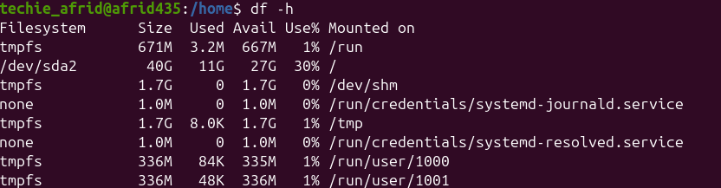

3. Implementation
Step 1: Updated Ubuntu Package Repository
The Ubuntu package repository information was updated before installing the required software.
Command
sudo apt update.

Step 2: Installed Java
OpenJDK 17 was installed as the Java runtime environment required by Apache Tomcat.
Command

sudo apt install openjdk-17-jdk -y

The installation completed successfully and the required Java packages were configured.
Java Verification
java -version
Output
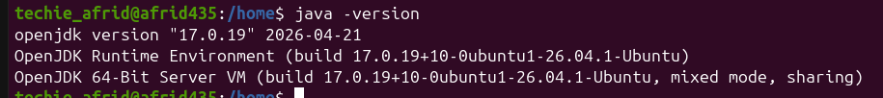
The Java installation path was identified using:
readlink -f $(which java)
Output
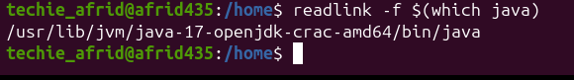
The identified Java installation directory was used as JAVA_HOME while configuring the Tomcat service.
Step 3: Verified Wget
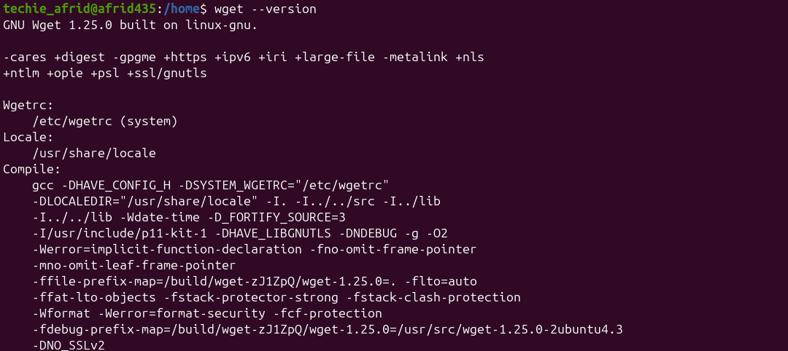
Step 4: Verified Tar
GNU Tar was already available on the Ubuntu Virtual Machine.
Command
tar –version
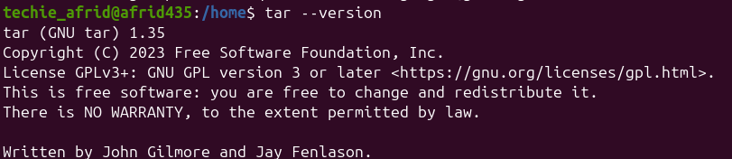
Tar was used to extract the Apache Tomcat compressed archive.

Step 5: Created a Dedicated Tomcat User
A dedicated tomcat user and group were created for running the Tomcat server.
Command
sudo useradd -m -U -d /opt/tomcat -s /bin/false tomcat
The user was verified using:
id tomcat

Step 6: Downloaded Apache Tomcat
Apache Tomcat 10.1.57 was downloaded using Wget:
cd /tmp
wget https://dlcdn.apache.org/tomcat/tomcat-10/v10.1.57/bin/apache-tomcat-10.1.57.tar.gz
The downloaded archive was verified using:
ls -lh apache-tomcat-10.1.57.tar.gz

Step 7: Extracted and Configured Tomcat
The Tomcat installation directory was created:
sudo mkdir -p /opt/tomcat
The archive was extracted into /opt/tomcat:
sudo tar -xzf apache-tomcat-10.1.57.tar.gz -C /opt/tomcat --strip-components=1
A symbolic link named latest was created for easier version management:
sudo ln -s /opt/tomcat/apache-tomcat-10.1.57 /opt/tomcat/latest
Tomcat ownership was assigned to the dedicated user:
sudo chown -R tomcat:tomcat /opt/tomcat
The Tomcat shell scripts were given execute permissions:
sudo find /opt/tomcat/latest/bin -type f -name "*.sh" -exec chmod +x {} \;
Important Tomcat directories included:
/opt/tomcat/latest/bin
/opt/tomcat/latest/conf
/opt/tomcat/latest/lib
/opt/tomcat/latest/logs
/opt/tomcat/latest/webapps
/opt/tomcat/latest/work

Step 8: Configured Tomcat as a systemd Service
A systemd service was configured at:
/etc/systemd/system/tomcat.service
The service configuration defined:
- Tomcat user and group
- Java environment
- Tomcat installation path
- Tomcat startup script
- Tomcat shutdown script
- Automatic restart on failure
The systemd configuration was reloaded using:
sudo systemctl daemon-reload

Step 9: Started and Enabled Tomcat
Tomcat was started using:
sudo systemctl start tomcat
The service status was verified using:
sudo systemctl status tomcat
The Tomcat service was enabled for automatic startup during system boot:
sudo systemctl enable tomcat
The enablement was verified using:
sudo systemctl is-enabled tomcat
Step 9: Verified Tomcat
Tomcat's default HTTP port, 8080, was verified using:
sudo ss -lntp | grep 8080
The server was tested using:
curl -I http://localhost:8080
The Tomcat web interface was accessed through:
http://localhost:8080
The Apache Tomcat welcome page was displayed successfully.
Tomcat logs were checked using:
sudo journalctl -u tomcat -n 50 --no-pager
Application logs were available under:
/opt/tomcat/latest/logs/
4. Conclusion
Apache Tomcat 10.1.57 was successfully installed and configured on the Ubuntu Virtual Machine.
OpenJDK 17 was configured as the Java runtime environment, and a dedicated tomcat user was created for running the server. Tomcat was installed under /opt/tomcat and configured as a systemd service.
The Tomcat service was successfully started and enabled for automatic startup. The server was verified on port 8080, and the Apache Tomcat welcome page was successfully accessed through the browser.
The setup demonstrated the basic administration of a Java-based application server on Linux, including installation, user management, permissions, service management, port verification, and log monitoring.

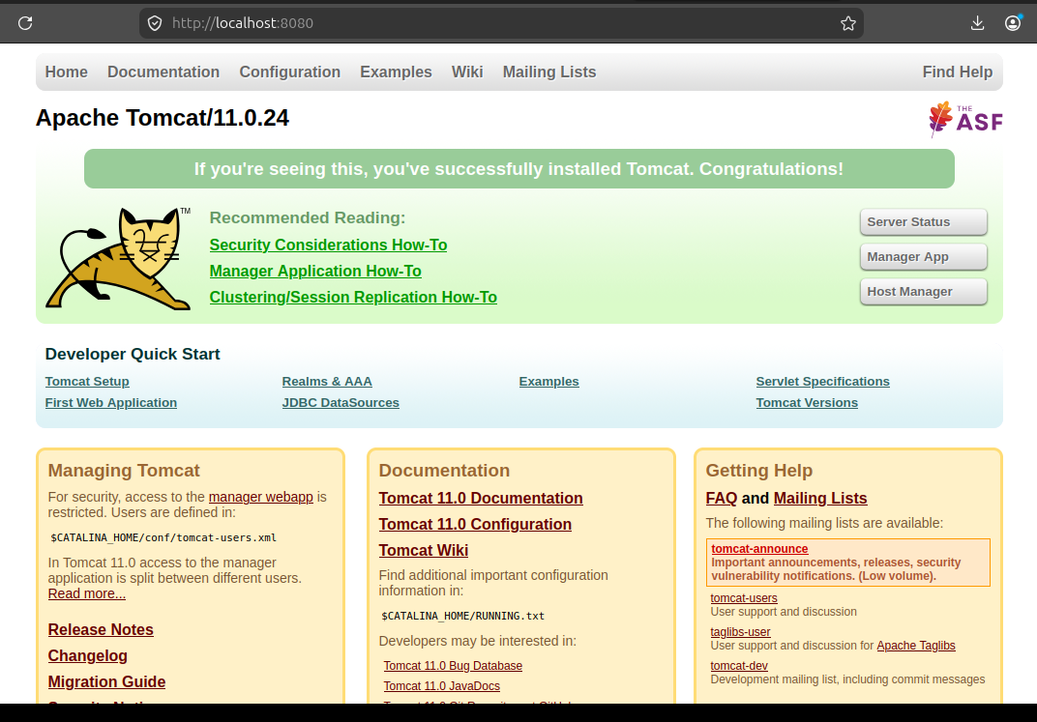

Setup Docker Desktop on Local Windows
1. Objective
To install and configure Docker Desktop on a Windows computer and verify that Docker is working correctly by running a sample Docker container.

2. Prerequisites
Before installing Docker Desktop, make sure you have:
- Windows 10/11 64-bit
- Administrator access to the computer
- Internet connection
- At least 4 GB RAM recommended
- WSL 2 enabled/recommended
- Virtualization enabled in BIOS/UEFI
- Enough free disk space for Docker Desktop and containers

3. Implementation
Step 1: Download Docker Desktop
- Open a web browser.
- Go to the official Docker website.
- Download Docker Desktop for Windows.
- Run the downloaded installer.

Step 2: Install Docker Desktop
During installation:
- Open the Docker Desktop installer.
- Keep the default options.
- Make sure the option to use WSL 2 instead of Hyper-V is selected if shown.
- Click OK/Install.
- Wait for the installation to complete.
- Restart the computer if Docker asks you to.

Step 3: Start Docker Desktop
- Open Docker Desktop from the Start Menu.
- Accept the required terms if prompted.
- Wait until Docker Desktop finishes starting.
You should see Docker Desktop running without an error.

Step 4: Verify Docker Installation
Open Command Prompt or PowerShell.
Run:
docker --version
Example output:
Docker version 28.x.x, build xxxxx
This confirms that Docker is installed.

Step 5: Check Docker Engine
Run:
docker info
This displays information about:
- Docker Server
- Containers
- Images
- Storage
- CPUs
- Memory
- Docker Engine
If Docker is working correctly, Docker information will be displayed.

Step 6: Run a Test Container
Run:
docker run hello-world
Docker will:
- Check whether the hello-world image exists locally.
- Download it from Docker Hub if necessary.
- Create a container.
- Run the container.
- Display a welcome message.
Example:
Hello from Docker!
This message shows that your installation appears to be working correctly.

Step 7: Check Containers
Run:
docker ps
This shows currently running containers.
To see all containers, including stopped ones:
docker ps -a
You should see the hello-world container listed.

Step 8: Check Docker Images
Run:
docker images
You should see the hello-world image.
Example:
REPOSITORY TAG IMAGE ID CREATED SIZE
hello-world latest xxxxxxxx ... ...

4. Verification
Use these commands to verify the installation:
docker --version
docker info
docker run hello-world
docker ps -a
docker images
If docker run hello-world displays "Hello from Docker!", Docker Desktop has been successfully installed and configured.

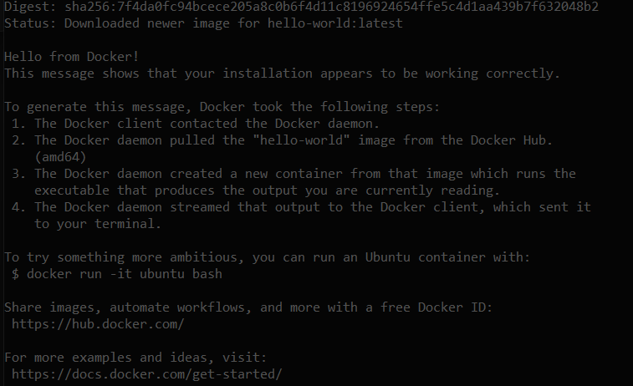

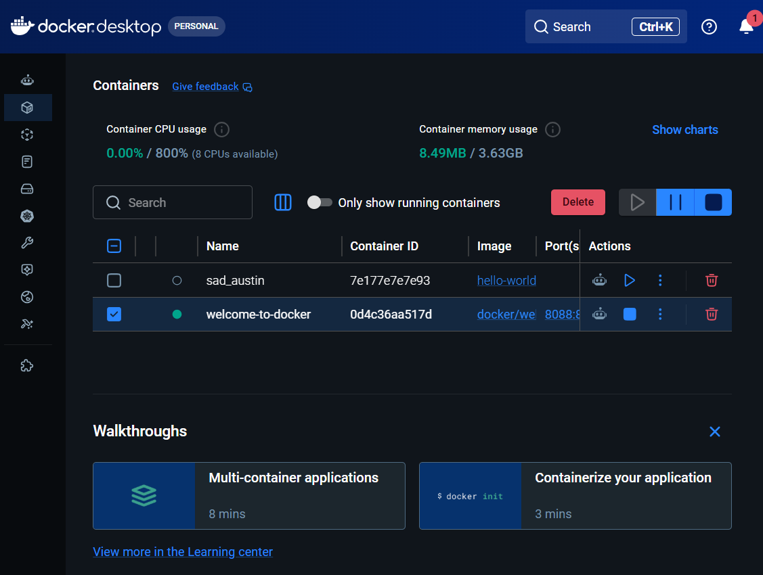
5. Conclusion
Docker Desktop was successfully installed and configured on the local Windows system. The Docker Engine was verified using Docker commands, and the hello-world container was successfully executed. This confirms that the Docker environment is ready to create and run containers.

