EC2 -DailyTasks

1. Launch one EC2 using Amazon Linux 2 image and add a script in user data to install Apache..

Objective
Launch an EC2 instance using the Amazon Linux 2 AMI and automatically install and configure the Apache HTTP Server (httpd) using an EC2 User Data script.
Implementation Steps
- Open the AWS Management Console and navigate to EC2.
- Click Launch instance.
- Enter an appropriate instance name.
- Select Amazon Linux 2 as the AMI.
- Select the required instance type, such as t3.micro.
- Select or create a Key Pair for SSH access.
- Configure the Security Group:
  - Allow SSH (Port 22) for instance access.
  - Allow HTTP (Port 80) to access the Apache web server.
- Open Advanced details.
- Scroll to the User Data section and add the following script:
#!/bin/bash
yum update -y
yum install -y httpd
systemctl start httpd
systemctl enable httpd
- Click Launch instance.
- Wait until the instance reaches the Running state.
- Copy the instance Public IPv4 address.
- Open the following in a web browser:
http://13.232.178.232
- Verify that the Apache HTTP Server page is displayed.
Verification
- EC2 instance is running.
- Apache (httpd) is automatically installed through User Data.
- Apache service is running.
- Port 80 is accessible through the Security Group.
- The web page is accessible using the EC2 instance's Public IPv4 address.

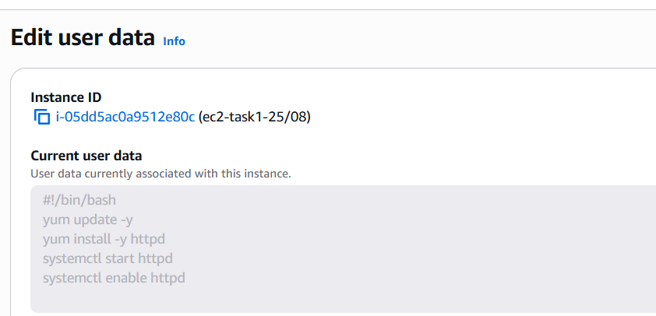
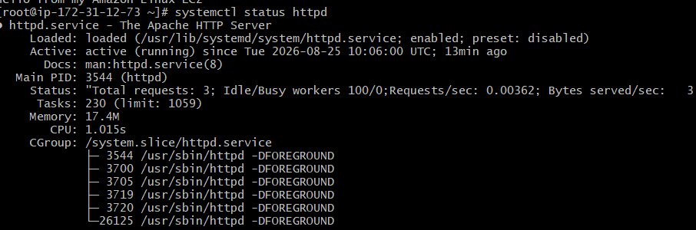
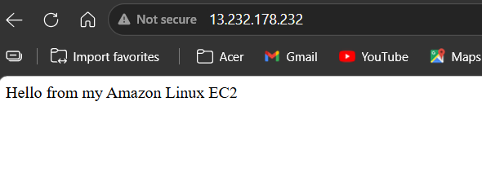
2. Launch one EC2 using Ubuntu image and add a script in user data to install Nginx..

Objective
Launch a new EC2 instance using an Ubuntu AMI and automatically install and configure Nginx using an EC2 User Data script.
Implementation Steps
- Open the AWS Management Console and navigate to EC2.
- Click Launch instance.
- Enter an appropriate instance name.
- Select an Ubuntu AMI.
- Select the required instance type, such as t3.micro.
- Select or create a Key Pair for SSH access.
- Configure the Security Group:
  - Allow SSH (Port 22) for remote access.
  - Allow HTTP (Port 80) to access the Nginx web server.
- Open Advanced details.
- Scroll to the User Data section and add the following script:
#!/bin/bash

apt update -y
apt install -y nginx
systemctl start nginx
systemctl enable nginx

echo "Hello, welcome to Afrid's Nginx webpage" > /var/www/html/index.html
- Click Launch instance.
- Wait until the instance reaches the Running state.
- Copy the instance Public IPv4 address.
- Open the following URL in a browser:
http:// 13.235.69.89
- Verify that the custom message is displayed.
Verification
The following flow confirms successful implementation:
Ubuntu EC2 launched → User Data executed → Nginx installed → Nginx started → Custom web page created → Public IP accessed → Message displayed
SSH Connection
For an Ubuntu EC2 instance, the default username is:
ubuntu
Example:
ssh -i servers-key.pem ubuntu@13.235.69.89
Important: Do not use ec2-user for an Ubuntu instance. ec2-user is typically the default user for Amazon Linux.

User data in instance:
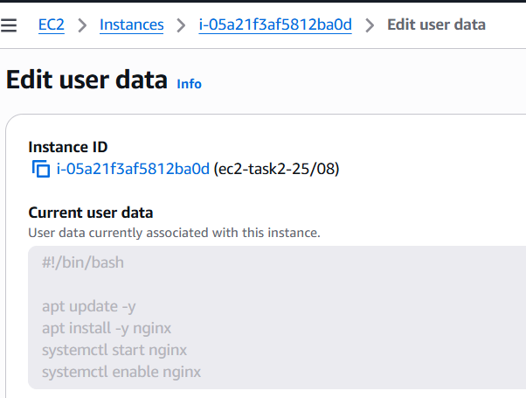
Ubuntu server evidence
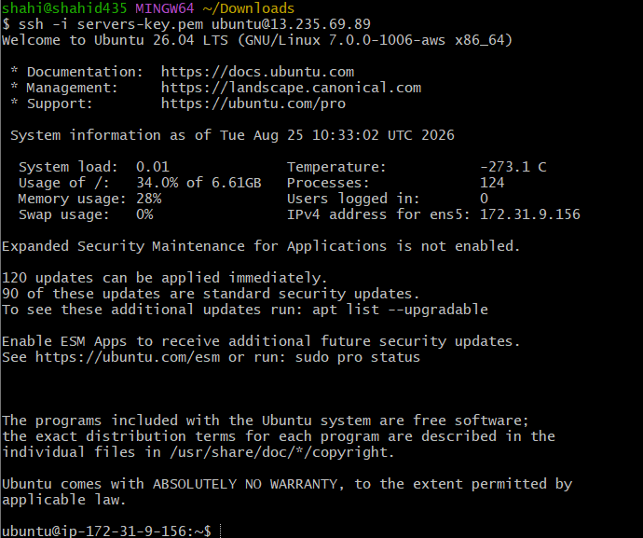

Status:
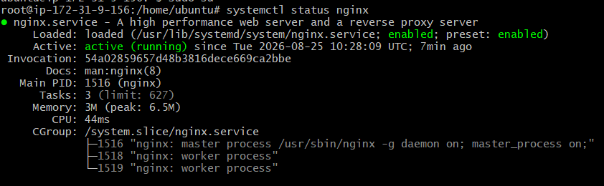

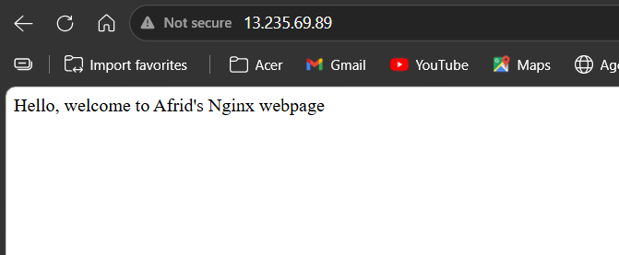
3. Launch one Windows server and install Tomcat on Windows..
Objective
Launch a Windows Server EC2 instance, connect to it using Remote Desktop Protocol (RDP), install Java JDK 17, and install and verify Apache Tomcat.
Implementation Steps
- Open the AWS Management Console and navigate to EC2.
- Click Launch instance.
- Enter an appropriate instance name.
- Select a Windows Server AMI.
- Select the required instance type.
- Select or create a Key Pair.
- Configure the Security Group:
  - Allow RDP (Port 3389) for remote access.
  - Allow Custom TCP Port 8080 if Tomcat needs to be accessed externally.
- Leave User Data empty.
- Launch the instance and wait until it reaches the Running state.
Connect to Windows EC2
- Select the Windows EC2 instance.
- Click Connect.
- Select RDP client.
- Download the Remote Desktop (.rdp) file.
- Click Get password.
- Upload the same .pem key pair used when launching the instance.
- Click Decrypt password.
- Connect using:
  - Username: Administrator
  - Password: Decrypted password
Install Java
Open PowerShell as Administrator.
Verify whether Java is installed:
java -version
Since Java was not installed, verify that winget is available:
winget --version
Install Java JDK 17:
winget install --id EclipseAdoptium.Temurin.17.JDK -e --source winget
Close and reopen PowerShell, then verify:
java -version

Install Apache Tomcat on Windows using PowerShell
- Open PowerShell as Administrator.
- Download the Tomcat Windows installer using Invoke-WebRequest:
Invoke-WebRequest -Uri "<Tomcat-Windows-Installer-URL>" -OutFile "C:\Tomcat.exe"
- Run the installer:
Start-Process "C:\Tomcat.exe"
- Complete the installation wizard.
- Open Windows Services:
services.msc
- Verify that the Apache Tomcat service is running.
- Verify Tomcat in the browser:
http://localhost:8080
For your notes, the key distinction is:
Java → installed using winget
Tomcat → downloaded using PowerShell and installed on Windows

Verify that the Apache Tomcat service is Running.
Verification
Open:
http://localhost:8080
The Apache Tomcat page confirms that Tomcat is running successfully.
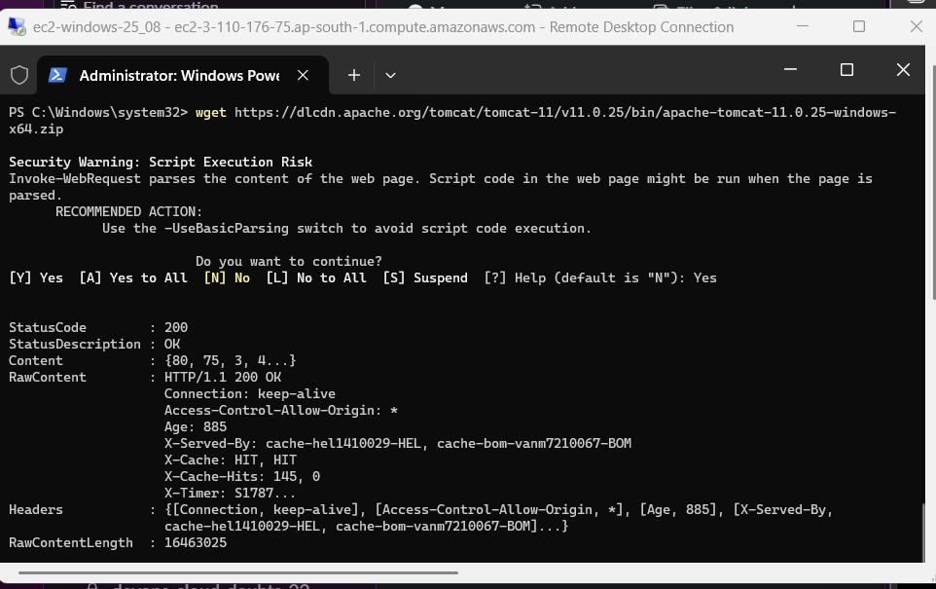

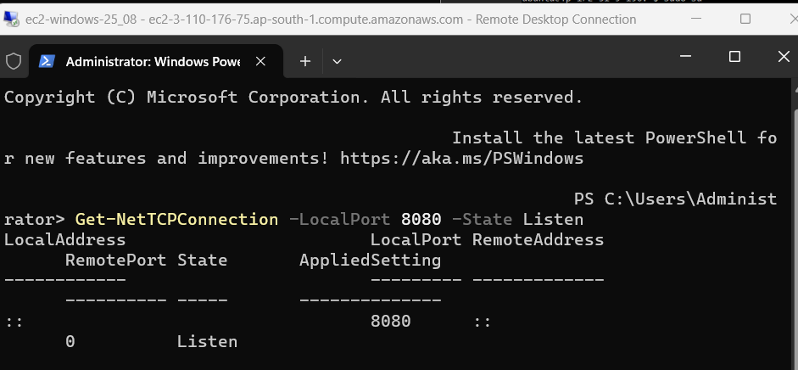
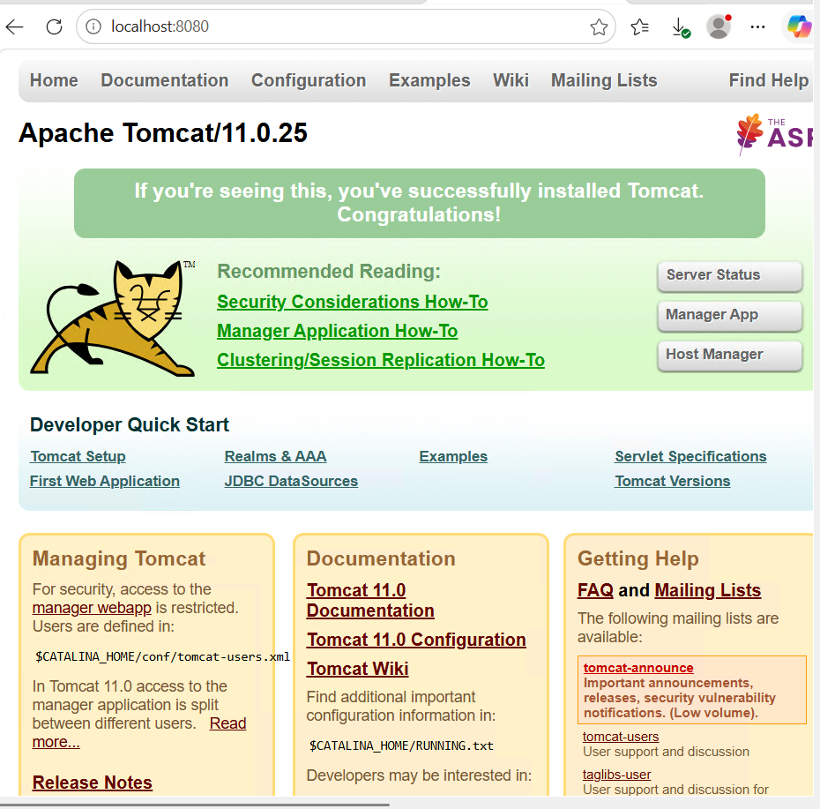

- Take a snapshot of the instance created in Task 1..

Objective
Create an EBS snapshot of the volume attached to the Amazon Linux 2 EC2 instance created in Task 1.
Implementation Steps
- Open the AWS Management Console and navigate to EC2.
- Go to Elastic Block Store → Volumes.
- Identify the volume attached to the Task 1 EC2 instance:
  - Check the Instance ID of the Task 1 instance.
  - Find the volume attached to the same Instance ID.
- Select the correct EBS volume.
- Click Actions → Create snapshot.
- Enter a description for the snapshot.
- Click Create snapshot.
- Go to Elastic Block Store → Snapshots.
- Wait until the snapshot status changes to Completed.
Verification
Confirm that the snapshot:
- Was created from the correct EBS volume.
- Shows the expected Volume ID.
- Has the status Completed.
Flow
Task 1 EC2 Instance → Attached EBS Volume → Snapshot

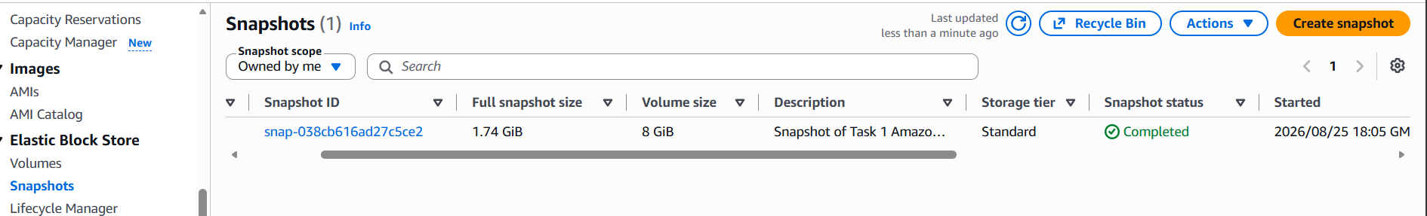

- Assign passwordless authentication for the EC2 created in Task 2..

Objective
Configure SSH key-based passwordless authentication for the Ubuntu EC2 instance created in Task 2 using a newly generated SSH key pair.
Implementation Steps
1. Generate an SSH key pair on the local machine
Open Git Bash and run:
ssh-keygen -t ed25519
Press Enter to use the default location. If no passphrase is required, press Enter when prompted.
This creates:
~/.ssh/id_ed25519 → Private key
~/.ssh/id_ed25519.pub → Public key
2. Display and copy the public key
cat ~/.ssh/id_ed25519.pub
Copy the complete public key.
3. Connect to the Task 2 Ubuntu EC2
Use the existing AWS .pem key:
ssh -i servers-key.pem ubuntu@<PUBLIC-IP>
4. Add the new public key to the Ubuntu server
Open the authorized_keys file:
nano ~/.ssh/authorized_keys
Paste the newly generated public key on a new line, then save and exit.
5. Set correct permissions
chmod 700 ~/.ssh
chmod 600 ~/.ssh/authorized_keys
6. Exit the EC2 instance
exit
7. Test passwordless authentication
From the local machine:
ssh ubuntu@<PUBLIC-IP>
If the login is successful without using:
-i servers-key.pem
then passwordless SSH authentication is successfully configured.
Flow
Local Machine
│
├── Private Key → ~/.ssh/id_ed25519
│
└── Public Key
│
▼
Ubuntu EC2 (Task 2)
│
▼
~/.ssh/authorized_keys
│
▼
Passwordless SSH Login
Important
Private key stays on the local machine.
Only the public key is copied to the EC2 instance.

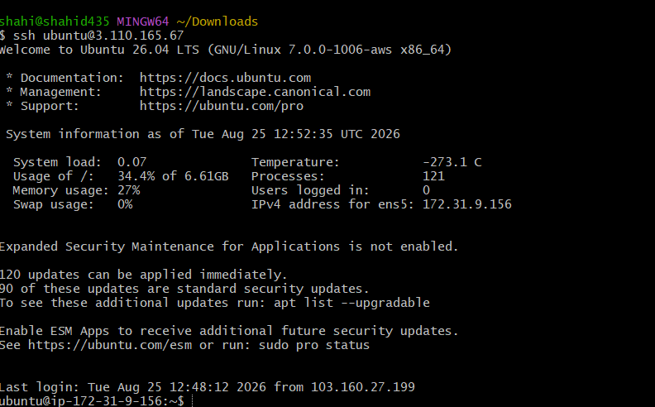

- Launch any EC2 using the spot purchasing option..

Objective
Launch an EC2 instance using the Spot purchasing option and verify that the instance lifecycle is Spot.
Implementation Steps
- Open the AWS Management Console and navigate to EC2.
- Click Launch instance.
- Enter an appropriate instance name.
- Select a suitable AMI.
- Choose the required Instance Type.
- Select an existing Key Pair.
- Configure the required Security Group.
- Open Advanced details.
- Scroll to the Purchasing option section.
- Select Request Spot Instances.
- Click Launch instance.
- Wait until the instance reaches the Running state.
Verification
- Select the launched EC2 instance.
- Open the Details tab.
- Check:
Lifecycle: Spot
Alternatively, enable the Lifecycle column in the Instances list and verify that it shows:
spot
Key Concept
A Spot Instance uses unused AWS EC2 capacity at a discounted price. However, AWS can interrupt or reclaim the instance when the capacity is required.
Evidence
- Screenshot showing the Spot Instance running.
- Screenshot showing Lifecycle: Spot.

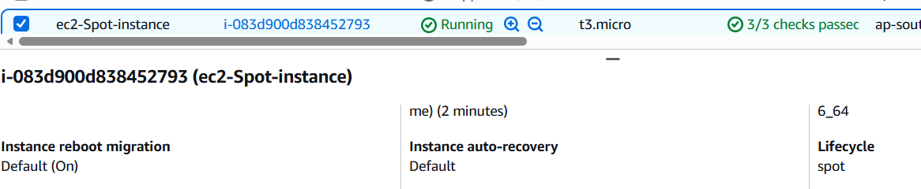

- Enable termination policy on the EC2 created in Task 2..

Objective
Enable Termination Protection for the Ubuntu EC2 instance created in Task 2 to prevent accidental termination.

Implementation Steps
- Open the AWS Management Console and navigate to EC2.
- Go to Instances.
- Select the Ubuntu EC2 instance created in Task 2.
- Click Actions.
- Select Instance settings.
- Click Change termination protection.
- Enable Termination protection.
- Click Save.
Verification
- Select the instance.
- Open the Details tab.
- Verify that:
Termination protection: Enabled
Key Concept
When Termination Protection is enabled, the EC2 instance cannot be accidentally terminated until termination protection is disabled.
Evidence
- Screenshot showing the Ubuntu EC2 instance selected.
- Screenshot showing Termination Protection: Enabled.

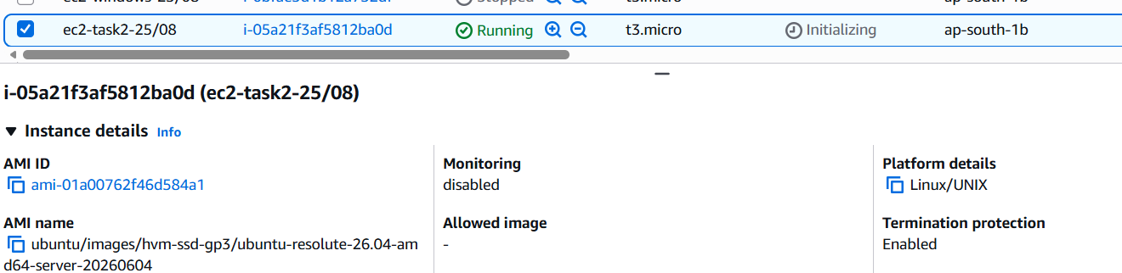
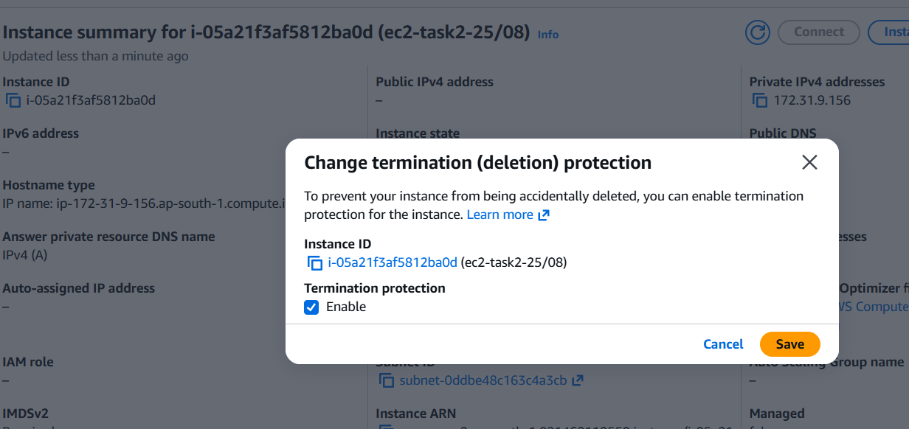

8. Launch one EC2 using AWS CLI..
Objective
Launch an EC2 instance using the AWS Command Line Interface (AWS CLI) instead of the AWS Management Console.
Implementation Steps
1. Install AWS CLI
Download and install AWS CLI v2 on the local Windows machine.
Verify the installation:
aws --version
2. Create an IAM User
- Open AWS Console → IAM.
- Go to Users → Create user.
- Create a user for AWS CLI access.
- Under permissions, attach:
AmazonEC2FullAccess
3. Create an Access Key
- Open the IAM user.
- Go to Security credentials.
- Under Access keys, click Create access key.
- Select Command Line Interface (CLI).
- Create the access key.
AWS provides:
- Access Key ID
- Secret Access Key
Keep these credentials private.
4. Configure AWS CLI
Run:
aws configure
Enter:
AWS Access Key ID
AWS Secret Access Key
Default region: ap-south-1
Default output format: json
5. Verify AWS CLI Authentication
aws sts get-caller-identity
Successful output displays details such as:
UserId
Account
Arn
6. Get the AMI ID
aws ec2 describe-images \
--owners amazon \
--filters "Name=name,Values=amzn2-ami-hvm-*" "Name=state,Values=available" \
--query "Images | sort_by(@, &CreationDate) | [-1].[ImageId,Name]" \
--output table
7. Get the Key Pair Name
aws ec2 describe-key-pairs \
--query "KeyPairs[*].KeyName" \
--output table
8. Get the Security Group ID
aws ec2 describe-security-groups \
--query "SecurityGroups[*].[GroupName,GroupId]" \
--output table
Choose the required Security Group ID.
9. Launch the EC2 Instance
aws ec2 run-instances \
--image-id <AMI-ID> \
--instance-type t3.micro \
--key-name <KEY-PAIR-NAME> \
--security-group-ids <SECURITY-GROUP-ID> \
--count 1
Replace:
- <AMI-ID>
- <KEY-PAIR-NAME>
- <SECURITY-GROUP-ID>
The command returns JSON containing the newly created Instance ID and its initial state, usually pending.
10. Verify the EC2 Instance
aws ec2 describe-instances \
--instance-ids <INSTANCE-ID> \
--query "Reservations[*].Instances[*].[InstanceId,State.Name,InstanceType,ImageId]" \
--output table

Verify that the instance state is:
running
Verification
AWS CLI configured → Authentication verified → AMI, Key Pair, and Security Group identified → run-instances command executed → Instance ID generated → Instance state verified as Running

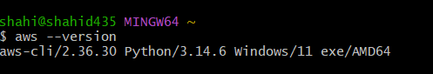
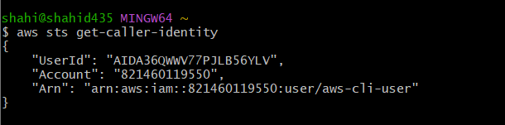
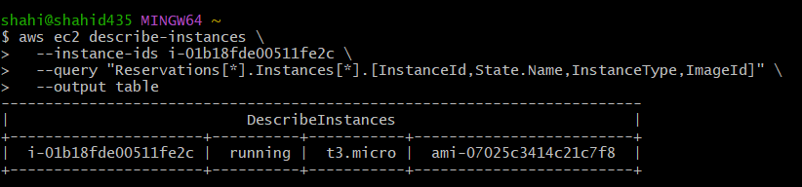
Change in AWS console:
