- Resolve Merge Conflicts
  - Create a merge conflict intentionally (two users editing the same line).
  - Resolve the conflict and push the changes.

Objective
To understand how Git handles merge conflicts by intentionally creating a conflict when two branches modify the same line of a file differently, and then resolving the conflict and completing the merge.
Steps to Implement
- Initialize a Git repository and create the initial commit.
- Create a file named app.txt with initial content:
echo "Application Version: 1.0" > app.txt
- Add and commit the file:
git add app.txt
git commit -m "Add application version file"
- Create and switch to a new branch named developer1:
git switch -c developer1
- Modify the same line in app.txt:
echo "Application Version: 2.0 - Developer1" > app.txt
- Add and commit the changes:
git add app.txt
git commit -m "Developer1 updates application version"
- Switch back to the main branch:
git switch main
- Modify the same line differently:
echo "Application Version: 3.0 - Main" > app.txt
- Add and commit the changes:
git add app.txt
git commit -m "Main updates application version"
- Merge the developer1 branch into main:
git merge developer1
- Git detects a merge conflict because both branches modified the same line.
- Check the conflicted file:
cat app.txt
- Resolve the conflict by editing the file and keeping the required final content:
echo "Application Version: 3.0 - Main and Developer1 changes merged" > app.txt
- Stage the resolved file:
git add app.txt
- Complete the merge by creating a commit:
git commit -m "Resolve merge conflict"
- Verify the commit history:
git log --oneline --graph --all
Result
The merge conflict was successfully created by modifying the same line differently in two branches. The conflict was manually resolved, staged, and committed successfully.

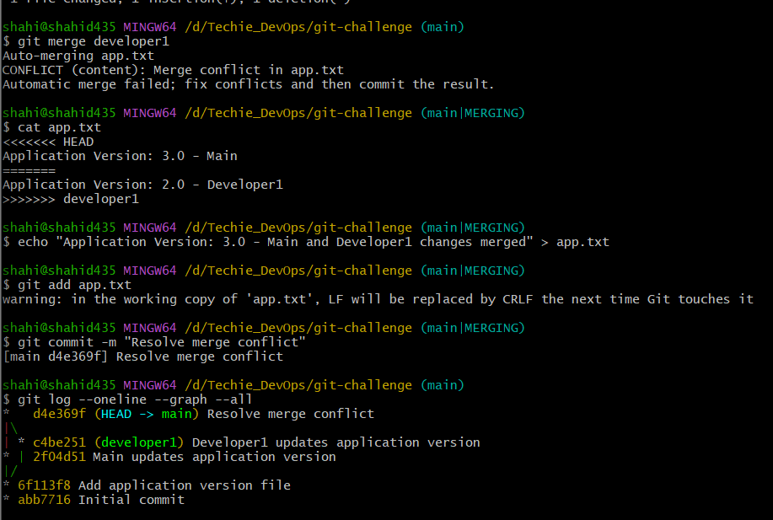

- Recover Deleted Branch
  - Delete a local branch and then recover it using the reflog.

Objective
To understand how to recover a deleted local branch using the Git reflog. The branch is deleted, but its commit reference can still be found in the reflog and used to recreate the branch.
Steps to Implement
- Create and switch to a new branch named recovery-test:
git switch -c recovery-test
- Create a file with some data:
echo "Important recovery data" > recovery.txt
- Add the file to the staging area:
git add recovery.txt
- Commit the changes:
git commit -m "Add recovery data"
- Switch back to the main branch:
git switch main
- Delete the local branch:
git branch -D recovery-test
- Verify that the branch has been deleted:
git branch
- View the Git reflog to find the commit associated with the deleted branch:
git reflog
- Identify the commit hash for the commit:
Add recovery data
Example:
abc1234 HEAD@{1}: commit: Add recovery data
- Recover the deleted branch using that commit hash:
git switch -c recovery-test abc1234
Replace abc1234 with your actual commit hash.
- Verify that the branch and commit have been recovered:
git branch
git log --oneline --all
Result
The recovery-test branch was successfully deleted and recovered using the commit reference available in git reflog.

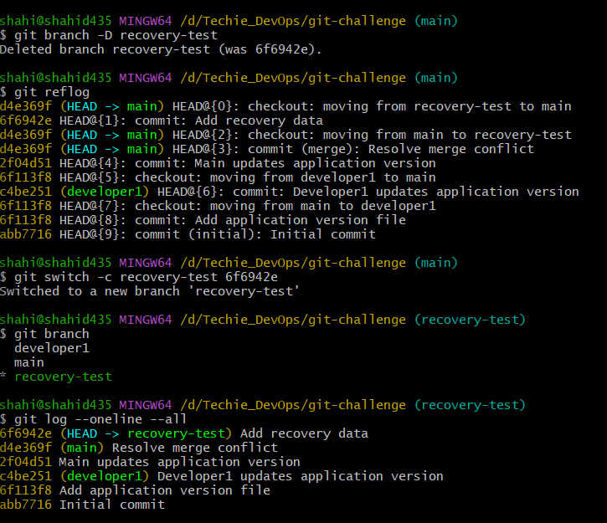

- Undo Wrong Push
  - Push a wrong commit to GitHub, then undo it without losing history.

Objective
To understand how to undo a wrong commit that has already been pushed to a remote repository without rewriting or deleting the existing Git history by using git revert.
Steps to Implement
Prerequisite: Create a GitHub repository named git-challenge and connect your local repository to it.
- Add the GitHub repository as the remote:
git remote add origin https://github.com/shahid8256/git-challenge.git
- Push the main branch to GitHub:
git push -u origin main
- Create a file containing incorrect data:
echo "This is wrong data" > wrong.txt
- Add the file to the staging area:
git add wrong.txt
- Commit the wrong changes:
git commit -m "Wrong commit"
- Push the wrong commit to GitHub:
git push origin main
- Undo the wrong commit without deleting Git history:
git revert HEAD
Git will create a new commit that reverses the changes made by the wrong commit.
- Push the revert commit to GitHub:
git push origin main
- Verify the commit history:
git log --oneline
You should see both commits:
<hash> Revert "Wrong commit"
<hash> Wrong commit
Result
The wrong commit was successfully pushed to GitHub and then undone using git revert. The original commit remained in the Git history, and a new revert commit was created to reverse its changes.

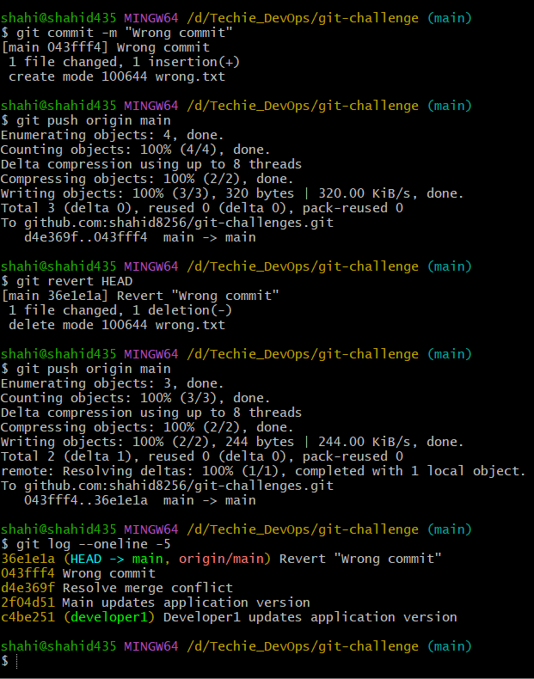

- Amend a Commit
  - Make a commit, then add a missing file to it usinggit commit --amend.

Objective
To understand how to modify the most recent commit by adding a missing file using git commit --amend.
Steps to Implement
- Make sure you are on the main branch:
git switch main
- Create a file:
echo "Main application file" > main.txt
- Add the file:
git add main.txt
- Create a commit:
git commit -m "Add application files"
- Assume that another required file was accidentally left out. Create the missing file:
echo "Configuration data" > config.txt
- Add the missing file to the staging area:
git add config.txt
- Amend the previous commit without changing its commit message:
git commit --amend --no-edit
- Verify that both files are included in the latest commit:
git show --stat
- Push the updated commit to GitHub:
git push origin main
Because git commit --amend changes the commit hash, Git may reject a normal push if the original commit was already pushed. In that case, use:
git push --force-with-lease origin main
Result
A missing file was successfully added to the most recent commit using git commit --amend. The original commit was replaced with an updated commit containing both files.

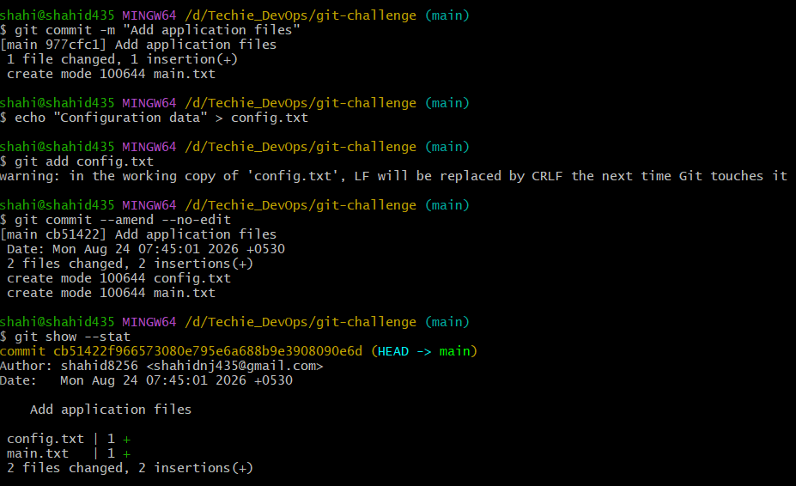

- Cherry-pick a Commit
  - Take a specific commit from one branch and apply it to another branch.

Objective
To understand how to take a specific commit from one branch and apply the same changes to another branch using git cherry-pick.
Steps to Implement
- Make sure you are on the main branch:
git switch main
- Create and switch to a new branch:
git switch -c feature-cherry
- Create a file:
echo "Cherry picked feature" > cherry.txt
- Add the file:
git add cherry.txt
- Commit the changes:
git commit -m "Add cherry pick feature"
- Get the commit hash:
git log --oneline -1
Example:
abc1234 Add cherry pick feature
- Switch back to the main branch:
git switch main
- Apply the specific commit from feature-cherry to main:
git cherry-pick abc1234
Replace abc1234 with your actual commit hash.
- Verify the commit history:
git log --oneline -5
- Verify that the file was added:
cat cherry.txt
- Push the changes to GitHub:
git push origin main
Result
A specific commit from the feature-cherry branch was successfully applied to the main branch using git cherry-pick. The changes from that commit were copied to main as a new commit with a different commit hash.

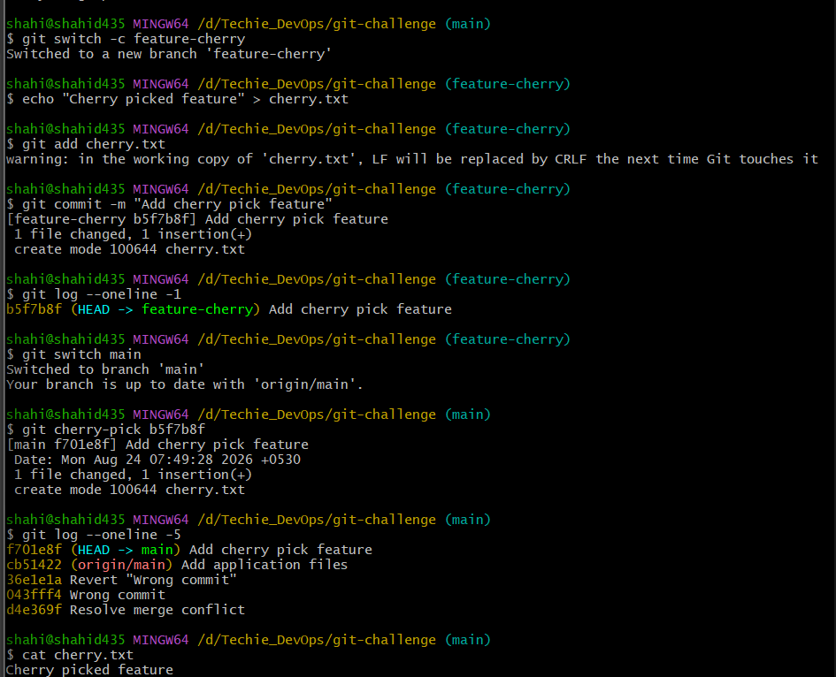
- Interactive Rebase
  - Reorder and squash multiple commits into a single clean commit.

Objective
To understand how to use interactive rebase to combine multiple commits into a single clean commit using git rebase -i.
Steps to Implement
- Make sure you are on the main branch:
git switch main
- Create and switch to a new branch:
git switch -c rebase-demo
- Create the first commit:
echo "First change" > rebase.txt
git add rebase.txt
git commit -m "First commit"
- Add the second change and create another commit:
echo "Second change" >> rebase.txt
git add rebase.txt
git commit -m "Second commit"
- Add the third change and create another commit:
echo "Third change" >> rebase.txt
git add rebase.txt
git commit -m "Third commit"
- Verify the three commits:
git log --oneline -3
- Start an interactive rebase for the last three commits:
git rebase -i HEAD~3
Git will open an editor showing something similar to:
pick <hash1> First commit
pick <hash2> Second commit
pick <hash3> Third commit
- Keep the first commit as pick and change the other two from pick to squash:
pick <hash1> First commit
squash <hash2> Second commit
squash <hash3> Third commit
This combines all three commits into one.
- Save and close the editor.
Git may open another editor for the final commit message. Replace the messages with:
Create rebase demo
Save and close the editor.
- Verify the result:
git log --oneline -3
You should now see only one new commit containing all three changes.
- Verify the file contents:
cat rebase.txt
- Push the branch to GitHub if required:
git push -u origin rebase-demo
Result
Three separate commits were successfully combined into a single clean commit using git rebase -i and the squash option.

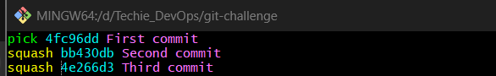

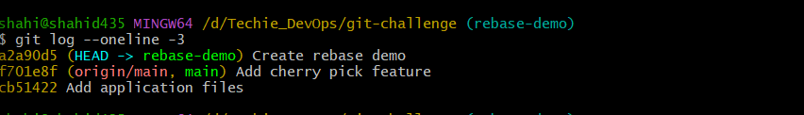
- Tagging & Release
  - Create a version tag (v1.0), push it to GitHub, then delete and restore it.

Objective
To understand how to create a version tag, push it to GitHub, delete the tag, and restore it using the commit reference.
Steps to Implement
- Switch to the main branch:
git switch main
- Check the latest commits and choose the commit you want to tag as version v1.0:
git log --oneline -5
For simplicity, tag the current HEAD commit.
- Create an annotated tag:
git tag -a v1.0 -m "Version 1.0 release"
- Verify the tag:
git tag
You should see:
v1.0
- Push the tag to GitHub:
git push origin v1.0
- Check which commit the tag points to:
git show v1.0
Note the commit hash shown in the output. You will use it to restore the tag.
- Delete the local tag:
git tag -d v1.0
- Delete the tag from GitHub:
git push origin --delete v1.0
- Restore the tag using the commit hash you noted earlier:
git tag -a v1.0 <commit-hash> -m "Version 1.0 release"
Example:
git tag -a v1.0 f701e8f -m "Version 1.0 release"
Use your actual commit hash.
- Push the restored tag to GitHub:
git push origin v1.0
- Verify:
git tag
git show v1.0
Result
The v1.0 version tag was successfully created, pushed to GitHub, deleted locally and remotely, and then restored by creating the tag again on the same commit.
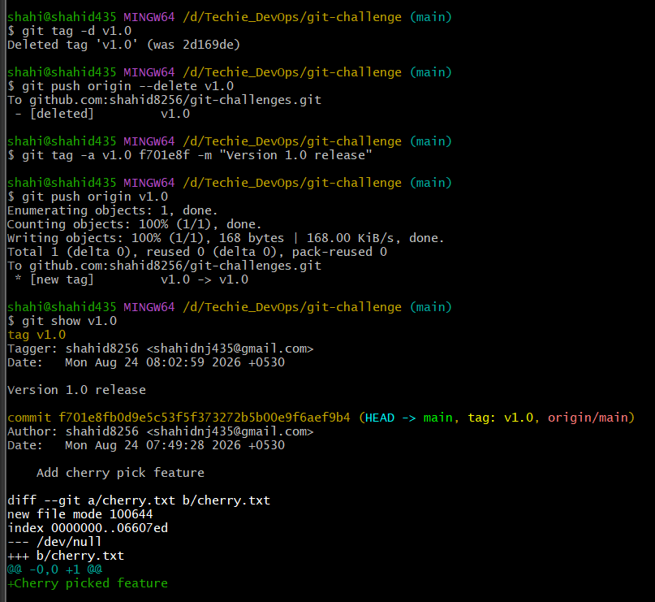

- Clone with Sparse Checkout
  - Clone only a subdirectory of a repo using sparse checkout.

Objective
To understand how to clone and work with only a specific subdirectory of a Git repository using Git Sparse Checkout, instead of checking out the entire repository.
Important
Your repository currently needs at least one subdirectory for this task. First create and push some directories from your existing repository.
Part 1: Create directories in the repository
Make sure you are on main:
git switch main
Create three directories:
mkdir backend frontend docs
Create files inside them:
echo "Backend code" > backend/app.txt
echo "Frontend code" > frontend/index.txt
echo "Documentation" > docs/readme.txt
Add and commit:
git add .
git commit -m "Add project directories"
git push origin main

Part 2: Perform Sparse Checkout
Go outside your current repository:
cd ..
Clone the repository without checking out all files:
git clone --no-checkout git@github.com:shahid8256/git-challenges.git sparse-repo
Enter the cloned repository:
cd sparse-repo
Initialize sparse checkout:
git sparse-checkout init --cone
Select only the backend directory:
git sparse-checkout set backend
Now check out the main branch:
git checkout main
Check the contents:
ls
You should see the backend directory and the root-level files needed by Git.
Check the backend directory:
ls backend
You should see:
app.txt
You should not have the contents of frontend and docs checked out.
Result
Only the backend subdirectory was checked out from the Git repository using Git Sparse Checkout, demonstrating how developers can work with a specific part of a large repository without checking out the complete project.

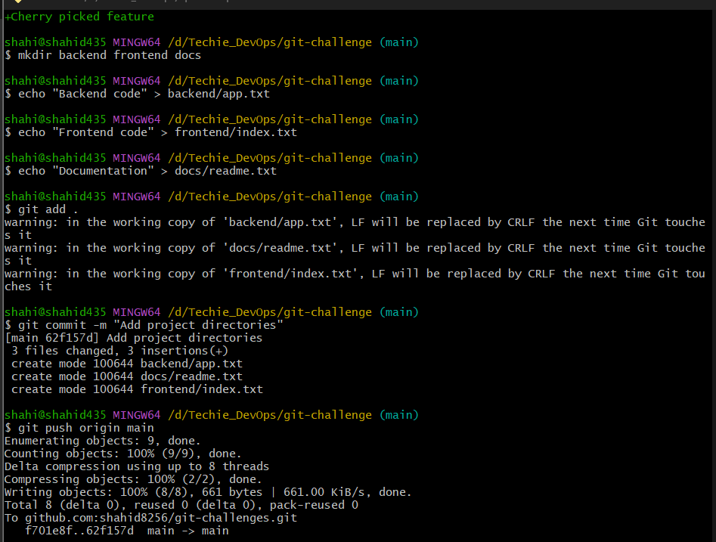

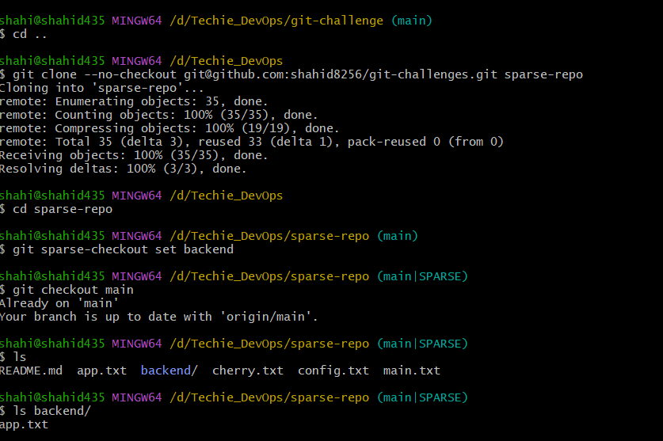

- Reset vs Revert Challenge
  - Demonstrate the difference betweengit reset --hardandgit revertin a repo.

Objective
To understand and demonstrate the difference between git reset --hard and git revert.
- git reset --hard moves the branch pointer backward and removes commits from the current branch history.
- git revert creates a new commit that reverses the changes of a previous commit while preserving history.
Steps to Implement
- Go to your original repository:
cd /d/Techie_DevOps/git-challenge
- Switch to main:
git switch main
- Create a separate branch:
git switch -c reset-revert-demo
- Create the first version:
echo "Version 1" > reset.txt
git add reset.txt
git commit -m "Version 1"
- Create the second version:
echo "Version 2" >> reset.txt
git add reset.txt
git commit -m "Version 2"
- Verify the commits:
git log --oneline -3
You should see:
<hash> Version 2
<hash> Version 1
Demonstrate git reset --hard
- Remove the latest commit from the current branch history:
git reset --hard HEAD~1
- Verify:
git log --oneline -3
The Version 2 commit will no longer appear in the current branch history.
- Recover the removed commit using reflog:
git reflog
Find the commit hash for Version 2, then restore it:
git reset --hard <Version-2-commit-hash>
Demonstrate git revert
- Revert the Version 2 commit:
git revert HEAD
- Verify the history:
git log --oneline -4
You should see:
<new-hash> Revert "Version 2"
<hash> Version 2
<hash> Version 1
- Check the file:
cat reset.txt
It should contain:
Version 1
Result
git reset --hard removed the latest commit from the current branch history by moving the branch pointer backward. The commit was recovered using git reflog. git revert then created a new commit that reversed the changes while preserving the original commit history.

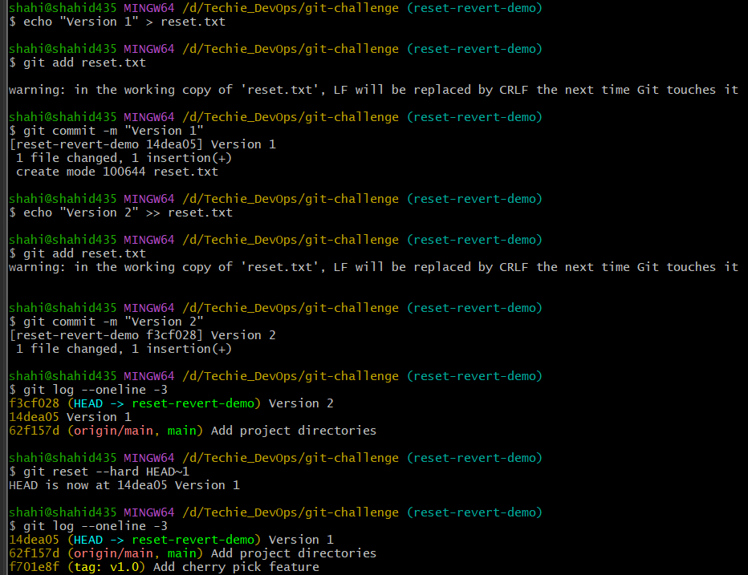

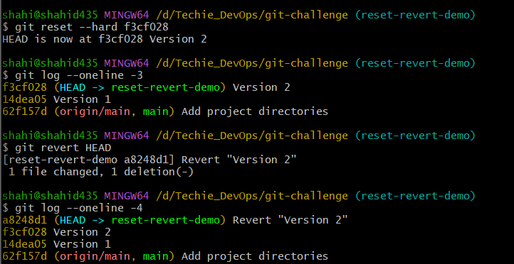

- Detached HEAD Challenge
  - Checkout a specific commit (detached HEAD state) and create a new branch from it.

Objective
To understand the detached HEAD state by checking out a specific commit and then creating a new branch from that commit.
Steps to Implement
- Go to your original repository if needed:
cd /d/Techie_DevOps/git-challenge
- View the commit history:
git log --oneline --all
- Choose an existing commit. For this task, use an older commit from main, for example:
f701e8f Add cherry pick feature
- Check out that specific commit:
git checkout f701e8f
Git should display a message saying that you are in detached HEAD state.
- Verify:
git status
You should see something similar to:
HEAD detached at f701e8f
At this point, HEAD points directly to a commit instead of a branch.
- Create a new branch from the detached HEAD commit:
git switch -c detached-feature
- Verify the new branch:
git branch
You should see:
* detached-feature
- Verify the branch history:
git log --oneline -5
Result
A specific commit was checked out, which placed Git in a detached HEAD state. A new branch named detached-feature was then created from that commit, preserving the ability to continue development from that point.

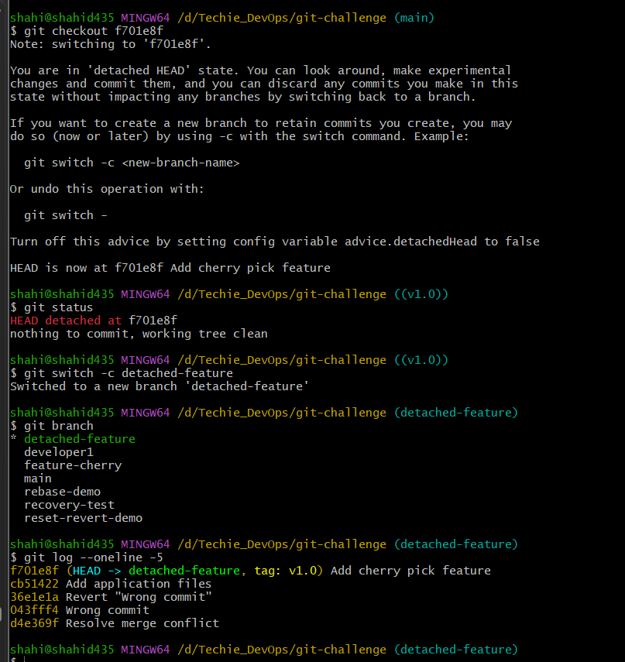

- Git Hooks Challenge
  - Configure apre-commithook to reject commits without a message format (e.g., must start withJIRA-XXX).

Objective
To understand how a Git hook can automatically validate commits before they are created by configuring a commit-msg hook that rejects commit messages unless they start with a required format such as JIRA-XXX.

Steps to Implement
1. Create the hook file
notepad .git/hooks/commit-msg
2. Add this script
#!/bin/sh

if ! grep -q "^JIRA-[0-9]" "$1"; then
echo "Error: Commit message must start with JIRA-XXX"
exit 1
fi
Save and close the file.
3. Make the hook executable
chmod +x .git/hooks/commit-msg
4. Create a test file
echo "Hook test" > hook-test.txt
git add hook-test.txt
5. Try an invalid commit message
git commit -m "Add hook test"
It should be rejected with:
Error: Commit message must start with JIRA-XXX
6. Commit with a valid message
git commit -m "JIRA-123 Add hook test"
This should succeed.
7. Verify
git log --oneline -3
Result
A commit-msg Git hook was configured to validate commit messages. Commits without the required JIRA-XXX prefix were rejected, while commits with a valid message were allowed.
Important distinction: pre-commit runs before a commit is created but doesn't receive the commit message as its intended input. For enforcing commit-message format, commit-msg is the appropriate hook.

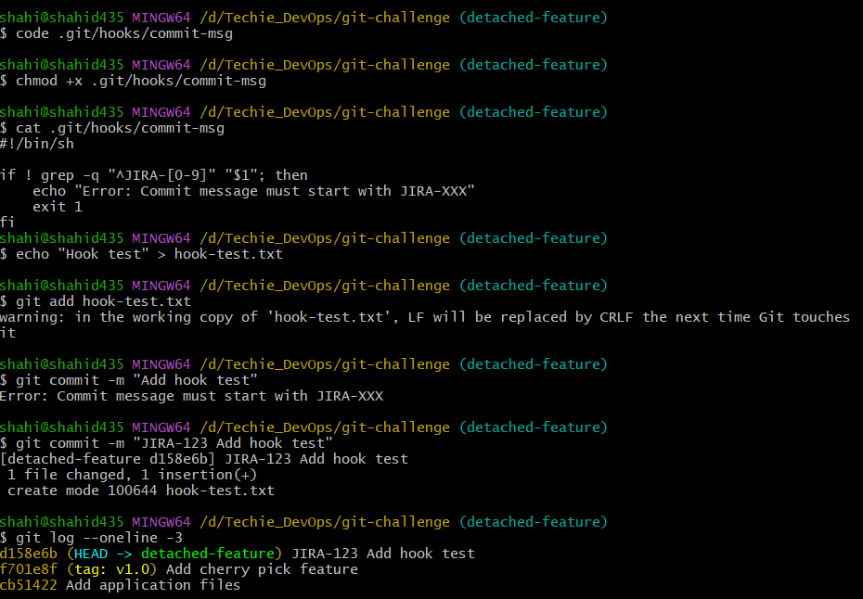
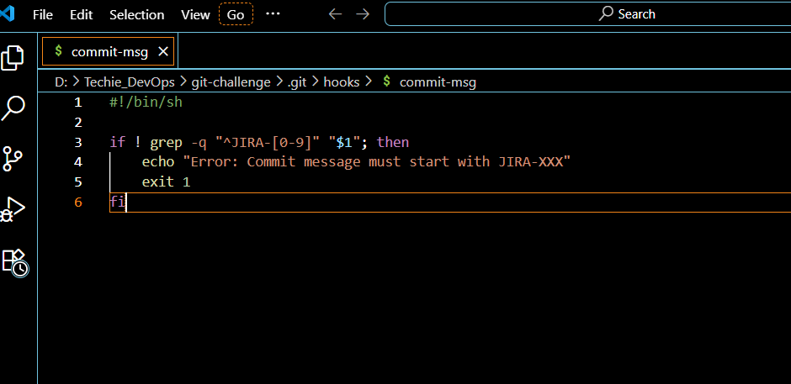
- Squash Merge vs Rebase Merge
  - Show the difference between squash merge and rebase merge with evidence.

Objective
To demonstrate the difference between:
- Squash merge → combines all feature-branch commits into one new commit on main.
- Rebase merge → reapplies feature commits onto the latest main, preserving the individual commits.
We'll use two separate demo branches so the evidence is clear.

Part A: Squash Merge
First switch to main:
git switch main
Create a feature branch:
git switch -c squash-feature
Create the first commit:
echo "Feature line 1" > squash.txt
git add squash.txt
git commit -m "Add squash feature line 1"
Create the second commit:
echo "Feature line 2" >> squash.txt
git add squash.txt
git commit -m "Add squash feature line 2"
Verify that the feature branch has two commits:
git log --oneline -3
Now switch back to main:
git switch main
Perform a squash merge:
git merge --squash squash-feature
Important: this prepares the combined changes but does not automatically create a commit.
Now commit:
git commit -m "Squash merge squash-feature"
Verify:
git log --oneline --graph -5
Evidence
The squash-feature branch has two commits, but main receives only one combined commit.

Part B: Rebase Merge
Create another feature branch from the current main:
git switch -c rebase-feature
Create the first commit:
echo "Rebase line 1" > rebase-merge.txt
git add rebase-merge.txt
git commit -m "Add rebase feature line 1"
Create the second commit:
echo "Rebase line 2" >> rebase-merge.txt
git add rebase-merge.txt
git commit -m "Add rebase feature line 2"
Now switch to main:
git switch main
To demonstrate a real rebase workflow, first update main with another commit:
echo "Main branch update" > main-update.txt
git add main-update.txt
git commit -m "Update main before rebase merge"
Switch back to the feature branch:
git switch rebase-feature
Rebase it onto the updated main:
git rebase main
Now merge it into main:
git switch main
git merge --ff-only rebase-feature
Verify:
git log --oneline --graph -10
Evidence
Unlike squash merge, both feature commits should remain visible:
Add rebase feature line 2
Add rebase feature line 1
Update main before rebase merge
Squash merge squash-feature
Result
Squash merge combined multiple feature commits into a single commit on main, creating a clean but condensed history. Rebase merge preserved the individual feature commits while moving them on top of the latest main, resulting in a linear commit history.

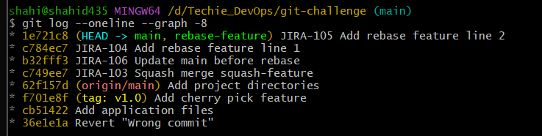
- Fork & Pull Request Workflow
  - Fork a repo, make a change, and submit a pull request to the original repo.

Objective
To understand the Fork and Pull Request workflow by creating a copy of an existing repository, making changes in the fork, and submitting those changes to the original repository through a Pull Request.
Steps to Implement
1. Fork the original repository
Open the original GitHub repository:
github/skills/introduction-to-github
Click Fork and create a copy under your GitHub account.
The forked repository:
shahid8256/introduction-to-github
2. Clone the forked repository
cd /d/Techie_DevOps
git clone git@github.com:shahid8256/introduction-to-github.git
cd introduction-to-github
3. Create a new branch
git switch -c update-readme
4. Make changes
Add a new line to the README file:
echo "Contribution from Shahid" >> README.md
5. Stage and commit the changes
git add README.md
git commit -m "Update README"
6. Push the branch to the forked repository
git push -u origin update-readme
7. Create a Pull Request
Open the forked repository on GitHub and click:
Compare & pull request
Enter:
Title:
Update README
Description:
Added a contribution line to the README file.
Then click Create pull request.
Result
The original repository was forked to my GitHub account. A new branch was created in the fork, changes were made to the README.md file, and the changes were committed and pushed. Finally, a Pull Request was created to propose the changes to the original repository.
Workflow
Original Repository
↓
Fork
↓
My GitHub Repository
↓
Create Branch
↓
Make Changes
↓
Commit & Push
↓
Pull Request
↓
Original Repository

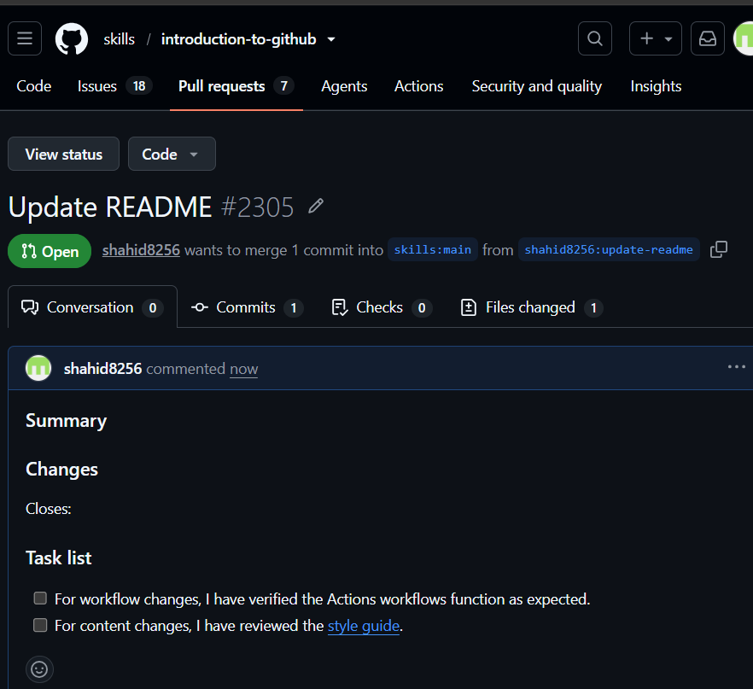

- Recover Lost Commit
  - Commit something, reset hard, and then recover it usinggit reflog.

Objective
To understand how to recover a commit that was removed using git reset --hard by locating it through git reflog.
Repository Path
/d/Techie_DevOps/git-challenge
Branch Used
lost-commit-demo
Steps to Implement
1. Switch to the main branch
git switch main
2. Create a new branch for the demonstration
git switch -c lost-commit-demo
3. Create a file
Create a file named:
lost.txt
Add the following content:
Important data
4. Stage and commit the file
git add lost.txt
git commit -m "Add important data"
5. Verify the commit
git log --oneline -3
The newly created commit should appear in the branch history.
6. Remove the latest commit
git reset --hard HEAD~1
This moves the branch pointer back by one commit. The latest commit is no longer visible in the normal commit history.
7. Check the reflog
git reflog -5
The reflog still contains a reference to the removed commit.
8. Recover the lost commit
Copy the commit hash from the reflog and run:
git reset --hard <commit-hash>
9. Verify the recovery
git log --oneline -3
Check the recovered file:
cat lost.txt
Expected content:
Important data
Result
A commit was intentionally removed using git reset --hard HEAD~1. Although the commit disappeared from the normal branch history, it was still available in the Git reflog. The commit was successfully recovered by resetting the branch back to the commit identified in the reflog.

