Git&Github :DailyTasks:20/08/2026

- Install git.
Objective
To install Git on the local system and verify that Git is installed successfully.
Steps to Implement
1.Download and install Git from the official Git website.
2.Open Git Bash after installation.
3.Verify the installed Git version using the following command:
git --version
Result
Git was successfully installed on the local system, and the installed Git version was verified using the git --version command.

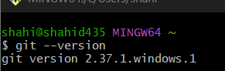
- Create a repo in github with README.md and .ignore file.
Objective
To create a new repository on GitHub containing a README.md file and a .gitignore file.
Steps to Implement
Log in to GitHub.
- Click New Repository.
- Enter the repository name.
- Select the required visibility.
- Select Add a README file.
- Create the repository.
- If a .gitignore template is not selected during repository creation, create it manually:
  - Click Add file → Create new file
  - Enter the filename:
.gitignore
7.Add content if required and click Commit changes.
Result
A new GitHub repository was successfully created with README.md and .gitignore files.

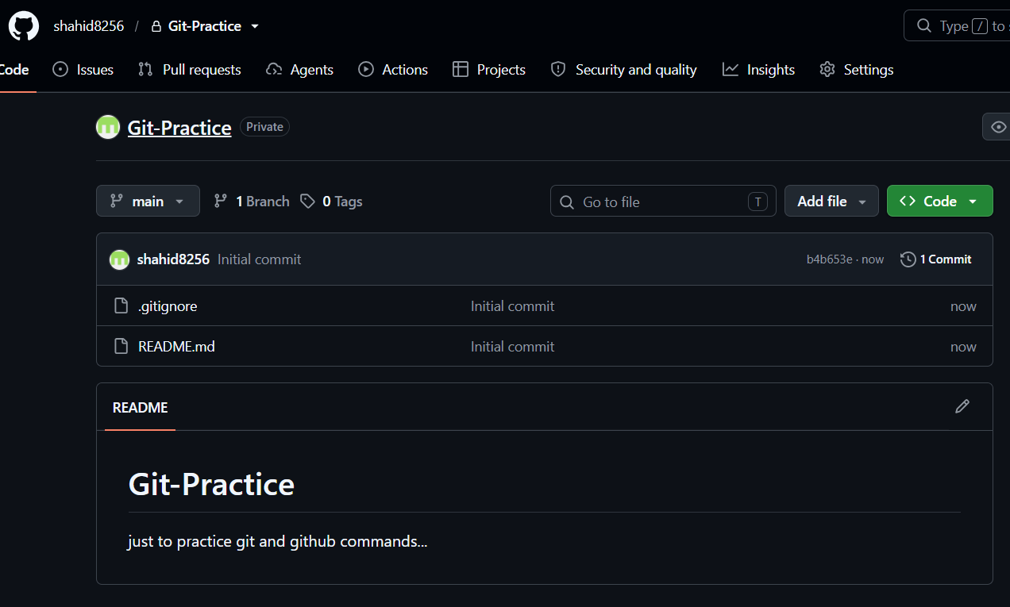
- Clone the created repo to local.
- Objective
  - To clone the GitHub repository from the remote server to the local system.
  - Steps to Implement
- Open Git Bash.
- Navigate to the location where the repository should be stored.
  - cd ~/Desktop
- Clone the GitHub repository using its repository URL:
  - git clone https://github.com/USERNAME/REPOSITORY.git
- Navigate into the cloned repository:
  - cd REPOSITORY
- Verify the files:
  - ls -la
  - Result
  - The GitHub repository was successfully cloned to the local system.

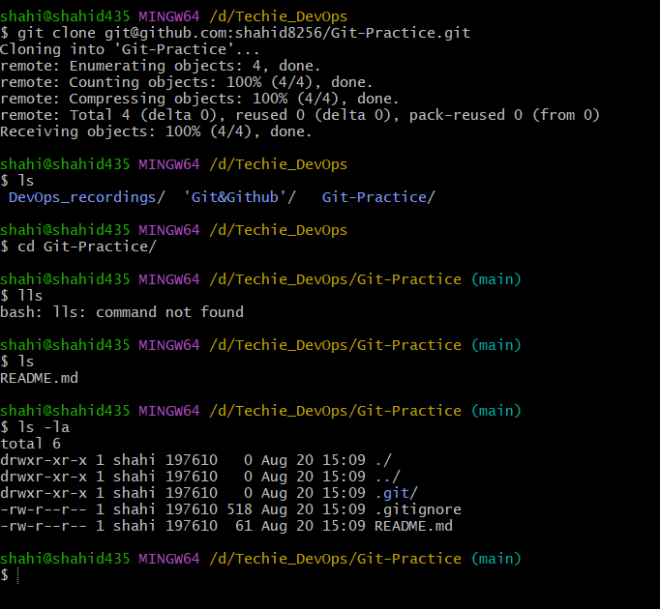

- Create two files in local repo.
Objective
To create two new files inside the local Git repository.
Steps to Implement
- Navigate to the cloned Git repository:
  - cd REPOSITORY
- Create two files:
  - touch file1.txt file2.txt
- Verify the created files:
  - ls
- Check the Git status:
  - git status
  - Result
  - Two files, file1.txt and file2.txt, were successfully created in the local repository. Git displayed them as untracked files.

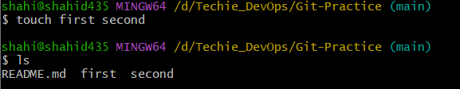
- Commit two files and push to central Repository.
Objective
To add two files to the staging area, commit them to the local repository, and push them to the remote GitHub repository.
Steps to Implement
- Check the status of the repository:
git status
- Add the files to the staging area:
git add .
- Verify the staged files:
git status
- Commit the files:
git commit -m "Added file1 and file2"
- Push the changes to the remote repository:
git push -u origin main
Result
The two files were successfully added to the staging area, committed to the local repository, and pushed to the central GitHub repository.
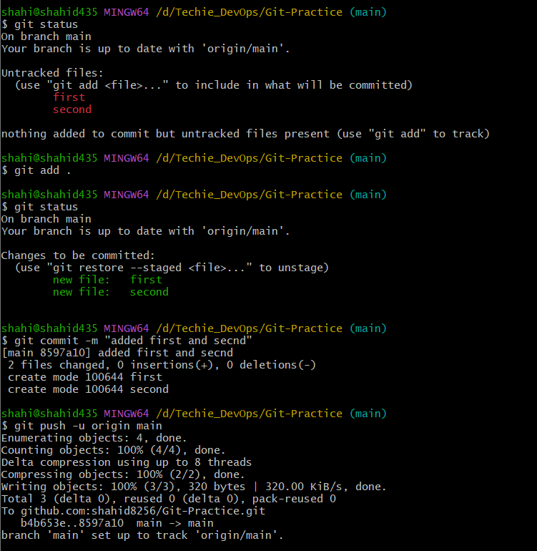
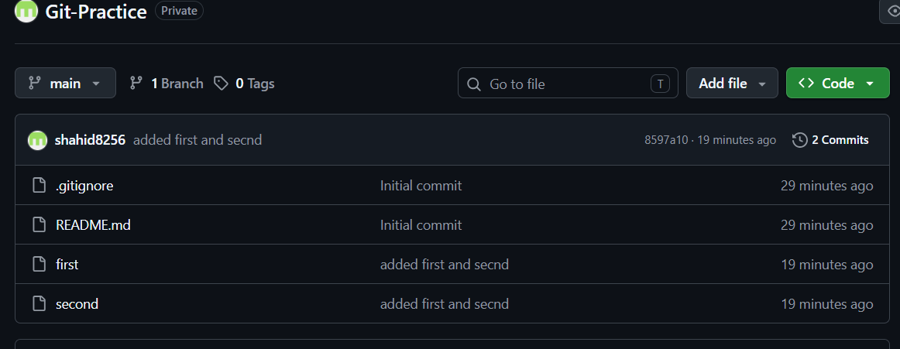

- Create a Branch in Local, Create a Sample File, and Push to Central Repository
Objective
To create a new branch in the local Git repository, create a sample file in that branch, commit the changes, and push the branch to the central GitHub repository.
Steps to Implement
- Check the current branch:
git branch
You should see:
* main
- Create a new branch and switch to it:
git switch -c feature-branch
This command does two things:
- Creates the branch feature-branch
- Switches from main to feature-branch
- Verify the current branch:
git branch
You should now see:
main
* feature-branch
- Create a sample file:
touch sample.txt
- Check the Git status:
git status
sample.txt should appear as an untracked file.
- Add the file to the staging area:
git add .
- Commit the file:
git commit -m "Added sample file in feature branch"
- Push the new branch to GitHub:
git push -u origin feature-branch
- Verify branches:
git branch -a
Result
A new branch named feature-branch was successfully created in the local repository. A sample file was created, committed, and the branch was successfully pushed to the central GitHub repository.
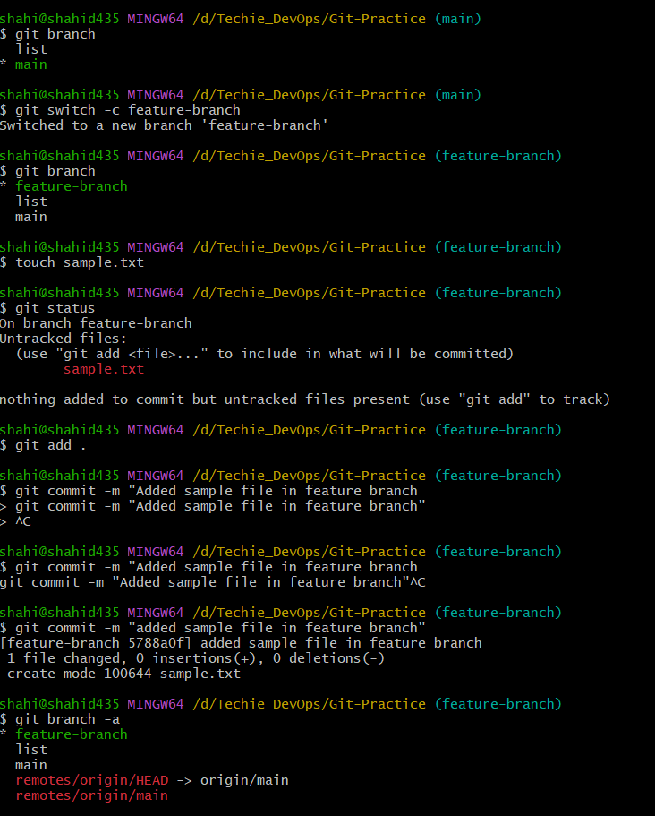
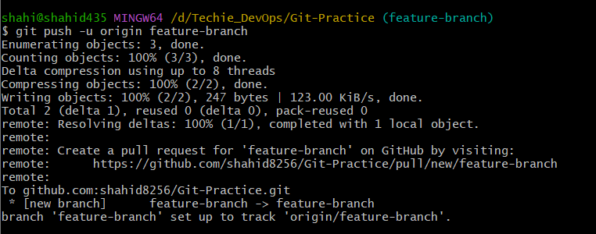

New branch and new sample file in repository
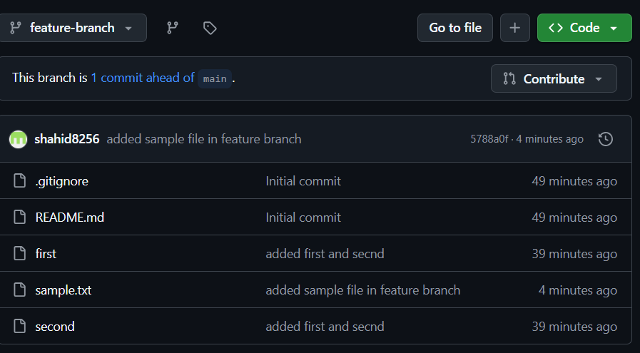

- Create a branch in github and clone that to local.
Objective
To create a new branch in the GitHub repository and create a corresponding local branch tracking it.
Steps to Implement
1. Create a branch on GitHub
Open your repository on GitHub.
- Click the branch dropdown, currently showing something like:
main
- Enter a new branch name, for example:
github-branch
- Click:
Create branch: github-branch from main

2. Fetch the new branch in Git Bash
You are currently inside your local repository. Run:
git fetch origin
Check all local and remote branches:
git branch -a
You should see something similar to:
* feature-branch
main
remotes/origin/feature-branch
remotes/origin/github-branch
remotes/origin/main

3. Create a local branch from the GitHub branch
Run:
git switch -c github-branch --track origin/github-branch
Now check:
git branch
Expected:
feature-branch
* github-branch
main
Result
A new branch named github-branch was successfully created on GitHub and brought into the local repository as a tracking branch.
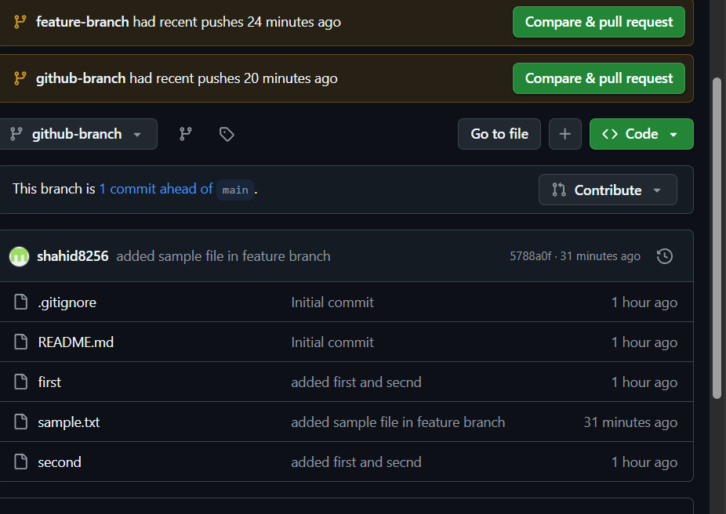
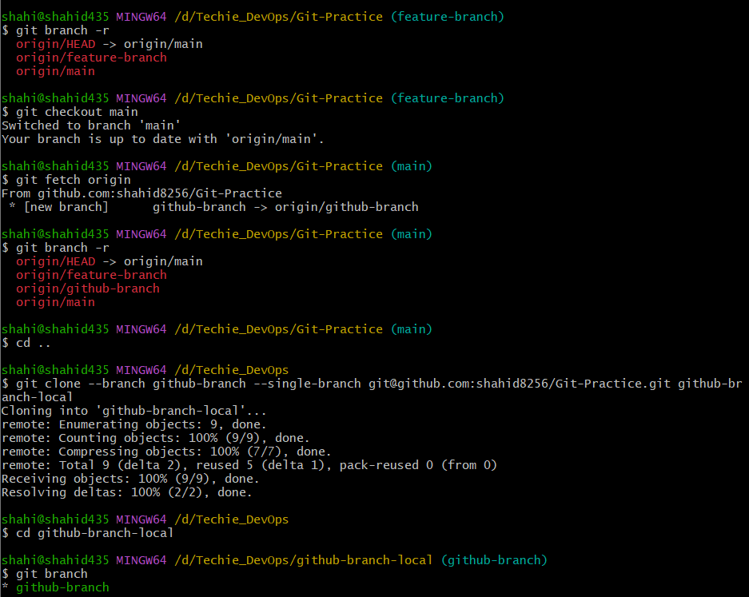

- Merge the created branch with master in git local.
Objective
To merge the changes from feature-branch into the main branch in the local Git repository.
Steps to Implement
cd /d/Techie_DevOps/Git-Practice
Check branches:
git branch
You should see something similar to:
* feature-branch
main
1. Switch to the main branch
git switch main
2. Merge feature-branch into main
git merge feature-branch
You may see a message like:
Fast-forward
sample.txt | 0
1 file changed, 0 insertions(+), 0 deletions(-)
3. Verify the merge
git log --oneline --graph --all
Also check that sample.txt exists:
ls
You should see:
README.md
first
second
sample.txt
Result
The feature-branch was successfully merged into the main branch in the local Git repository, and the changes from the branch, including sample.txt, are now available in main.
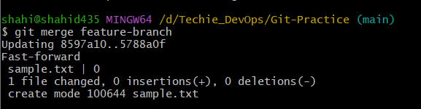
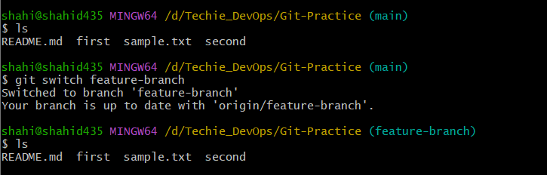

- Merge the created branch with master in github by sending a pull request.
Objective
To merge github-branch into the main branch on GitHub by creating and merging a Pull Request.
Steps to Implement
1. Go to your separate clone of github-branch
cd /d/Techie_DevOps/github-branch-local
Check:
git branch
It should show:
* github-branch
2. Create a new sample file
touch githubfile.txt
Add some content:
echo "This file was created in github branch" > githubfile.txt
3. Check status
git status
4. Add and commit the file
git add .
git commit -m "Added file in github branch"
5. Push to github-branch
git push
Because you cloned it with:
--branch github-branch --single-branch
the upstream is already configured.
If git push doesn't work, use:
git push origin github-branch

6. Create the Pull Request on GitHub
Go to your GitHub repository.
You should see an option like:
Compare & pull request
Click it.
Make sure:
base: main
compare: github-branch
Then:
- Click Create pull request
- Enter a title if required.
- Click Create pull request
- Click Merge pull request
- Click Confirm merge
Now github-branch is merged into main on GitHub.

7. Verify locally
In your original repository:
cd /d/Techie_DevOps/Git-Practice
git switch main
git pull origin main
Then:
ls
You should see:
README.md
first
second
sample.txt
githubfile.txt
Result
The changes from github-branch were successfully merged into the main branch on GitHub using a Pull Request.
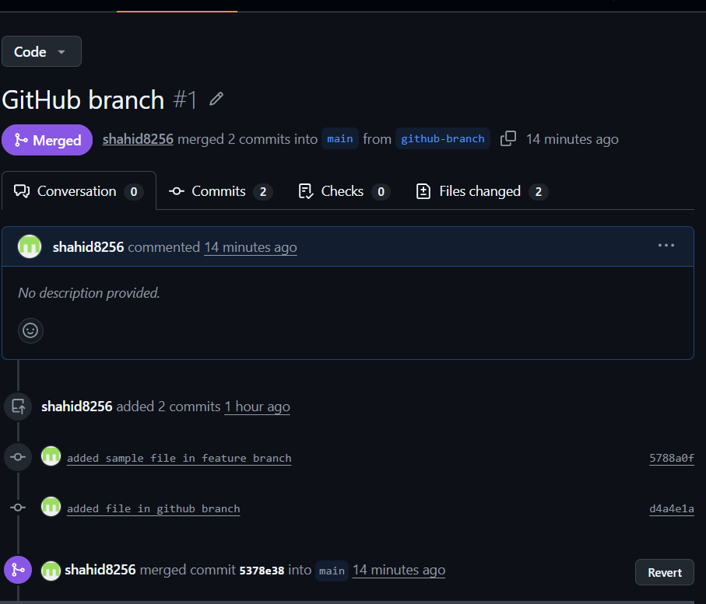
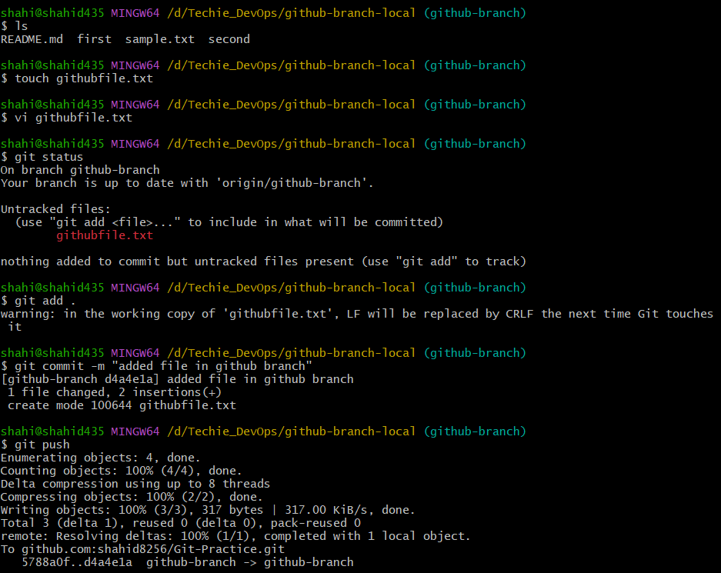
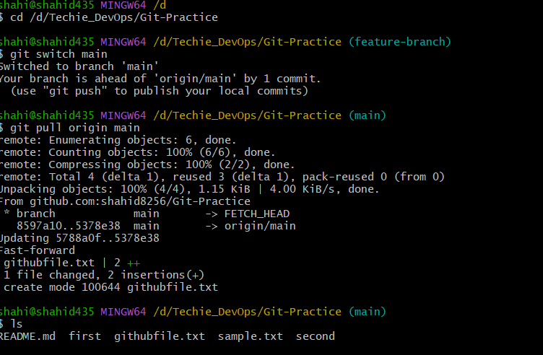

- Create a file in local and send that to branch in github.
Objective
To create a new file in the local repository, commit it, and push the changes to a specific branch in the remote GitHub repository.
Since you already have these branches, let's use:
feature-branch
Steps to Implement
1. Go to your original repository
cd /d/Techie_DevOps/Git-Practice
Check the branches:
git branch
2. Switch to feature-branch
git switch feature-branch
3. Create a new file
touch branchfile.txt
Add some content:
echo "This file is pushed to feature branch" > branchfile.txt
4. Check the status
git status
You should see:
Untracked files:
branchfile.txt
5. Add and commit the file
git add .
git commit -m "Added branchfile to feature branch"
6. Push the file's commit to feature-branch on GitHub
git push origin feature-branch
7. Verify on GitHub
Open your repository and switch the branch from main to:
feature-branch
You should see:
branchfile.txt
Result
A new file named branchfile.txt was created in the local repository, committed, and successfully pushed to the feature-branch branch in the GitHub repository.
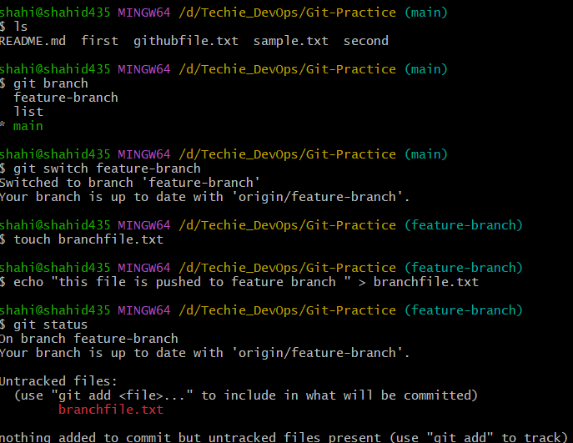
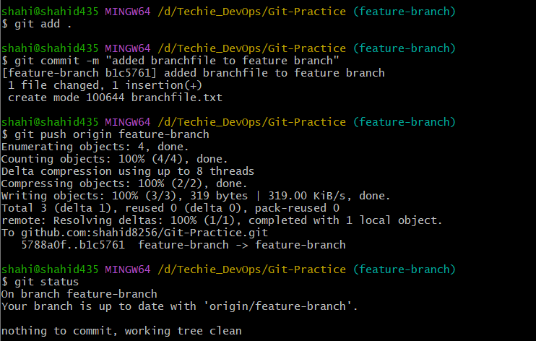

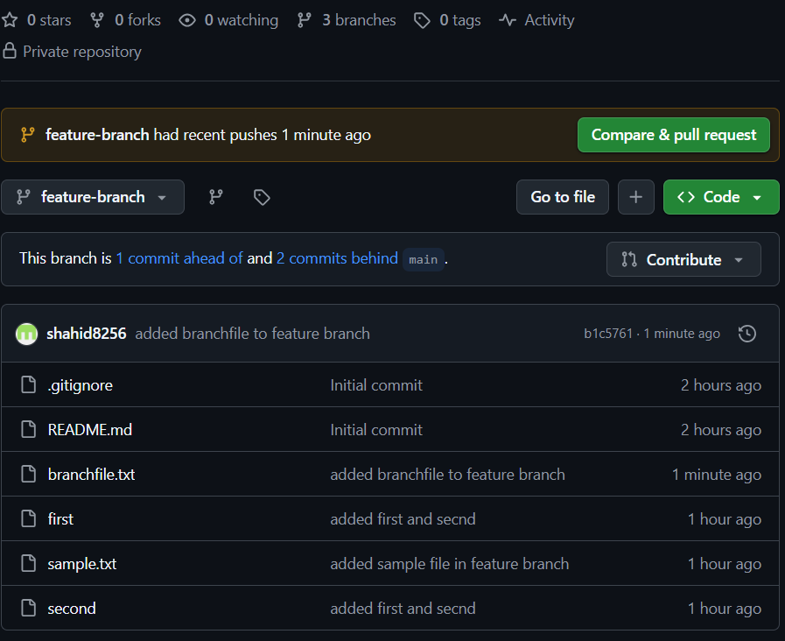

- Clone only a branch from github to local.
Objective
To clone only a specific branch from the GitHub repository to the local system.
For practice, let's clone:
feature-branch
Steps to Implement
1. Go outside your existing repositories
For example:
cd /d/Techie_DevOps
Check existing folders:
ls
2. Clone only feature-branch
Since you already have a Git-Practice folder, give this clone a different folder name:
git clone --branch feature-branch --single-branch git@github.com:shahid8256/Git-Practice.git feature-branch-clone
Here:
- --branch feature-branch → selects the branch to clone.
- --single-branch → clones only that branch's history instead of fetching other branches.
- feature-branch-clone → name of the new local folder.
3. Enter the cloned repository
cd feature-branch-clone
4. Verify the branch
git branch
Expected:
* feature-branch
You can also check:
git branch -a
Result
The feature-branch was successfully cloned from GitHub to the local system, and the cloned repository is currently on the feature-branch.
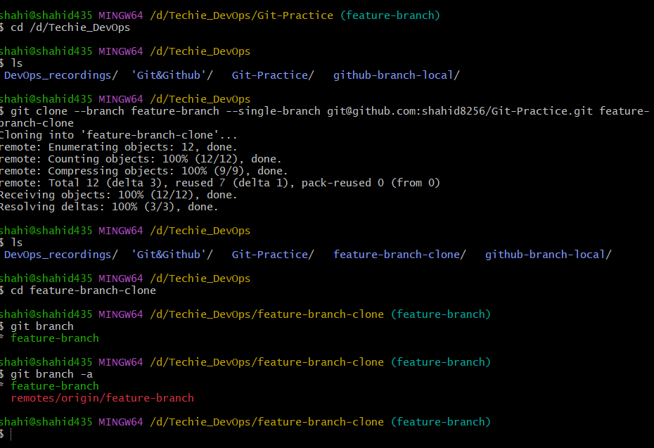
- Create a file with all passwords and make that untrackable with git.
Objective
Steps to Implement
1. Go to your original repository
Use your main working repository:
cd /d/Techie_DevOps/Git-Practice
2. Switch to main
git switch main
3. Create a password file
touch passwords.txt
Add fake credentials:
echo "username=testuser" > passwords.txt
echo "password=TestPassword123" >> passwords.txt
Check:
cat passwords.txt
4. Add the password file to .gitignore
echo "passwords.txt" >> .gitignore
Check .gitignore:
cat .gitignore
5. Check Git status
git status
You should see .gitignore modified, but passwords.txt should not appear as an untracked file.
6. Commit only the .gitignore change
git add .gitignore
git commit -m "Ignore passwords file"
Then push:
git push origin main
Result
A file named passwords.txt was created containing sample credentials. The file was added to .gitignore, preventing Git from tracking it, while the updated .gitignore file was committed and pushed to the GitHub repository.

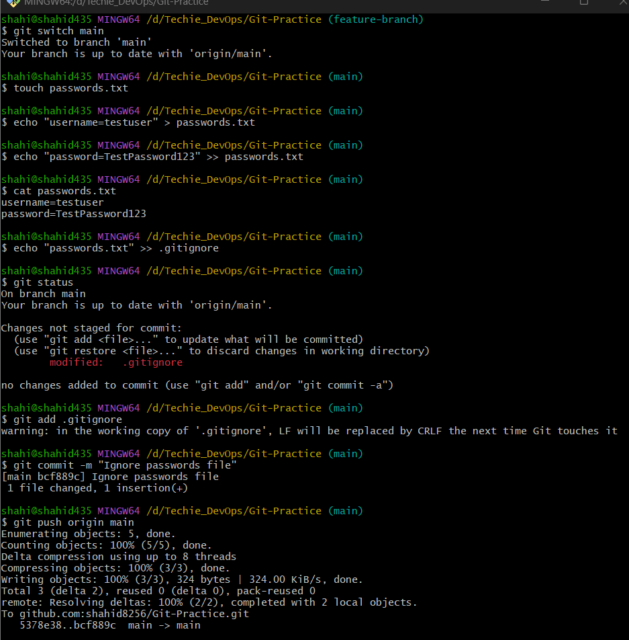
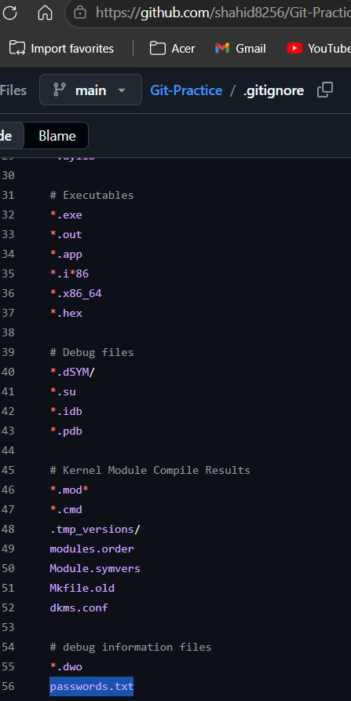

- Make a commit and make that commit reset without savings changes.
Objective
To create a commit and then undo that commit along with its changes using git reset.
Steps to Implement
1. Make sure you are in your original repository and on main
cd /d/Techie_DevOps/Git-Practice
git switch main
2. Create a file
touch resetfile.txt
Add some content:
echo "This file is created for reset practice" > resetfile.txt
3. Add and commit the file
git add resetfile.txt
git commit -m "Added reset practice file"
Check the commit:
git log --oneline -3
4. Reset the latest commit without saving the changes
Since the task says without saving changes, use:
git reset --hard HEAD~1
This does two things:
- Removes the latest commit.
- Deletes the changes introduced by that commit from your working directory.
5. Verify
git status
and:
ls
resetfile.txt should no longer exist.
Result
A new commit was created containing resetfile.txt. The latest commit was successfully removed using:
git reset --hard HEAD~1
The changes associated with the commit were also discarded, and the repository was restored to its previous state.
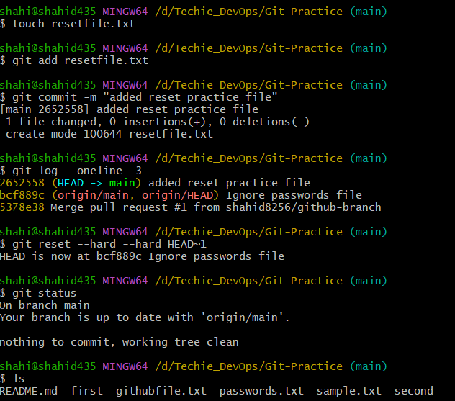

- Revert a commited commit to the older version.
Objective
To undo the changes introduced by a committed commit and restore the project to its previous state using git revert.
Important: git revert does not delete the old commit. It creates a new commit that reverses the changes.
Steps to Implement
1. Make sure you are on main
cd /d/Techie_DevOps/Git-Practice
git switch main
Check the status:
git status
It should preferably show:
nothing to commit, working tree clean
2. Create a file and commit it
touch revertfile.txt
Add some content:
echo "This is revert practice" > revertfile.txt
Stage and commit it:
git add revertfile.txt
git commit -m "Added revert practice file"
Check the commit history:
git log --oneline -3
You should see the latest commit similar to:
abc1234 Added revert practice file
3. Revert the latest commit
Since the commit you want to undo is the latest one:
git revert HEAD
Git may open an editor asking for the revert commit message. Save and close it.
Alternatively, to avoid the editor:
git revert --no-edit HEAD
4. Verify the result
git status
ls
revertfile.txt should no longer be present.
Check the history:
git log --oneline -4
You should see both:
Revert "Added revert practice file"
Added revert practice file
Result
The commit that added revertfile.txt was successfully reverted. Git created a new commit that reversed the changes, restoring the repository to its previous state.

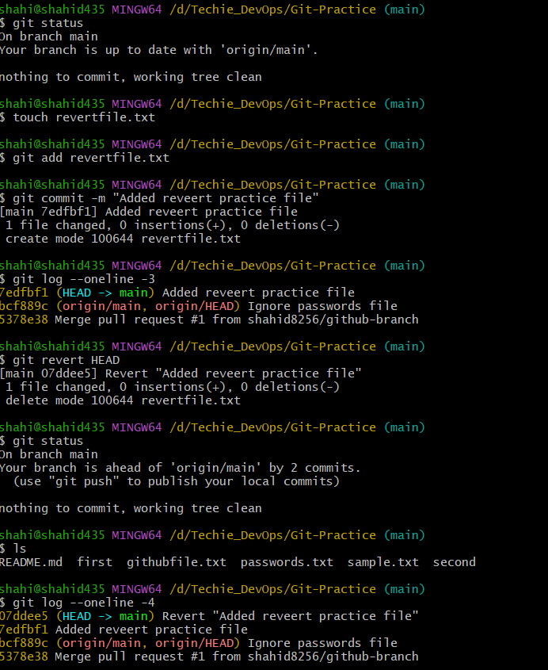
- Push a file to stash without savings the changes and work on another file.
Objective
To temporarily save uncommitted changes using git stash without committing them, and then work on another file.
Steps to Implement
1. Make sure the working tree is clean
git status
2. Create a file and add some work
touch stashfile.txt
echo "This is work in progress" > stashfile.txt
Check:
git status
You should see stashfile.txt as untracked.
Important
A normal:
git stash
does not include untracked files.
Since stashfile.txt is a new untracked file, use:
git stash -u
-u means include untracked files.
3. Verify the stash
git status
The working directory should be clean.
Check the saved stash:
git stash list
You should see something similar to:
stash@{0}: WIP on main: ...
4. Work on another file
Create another file:
touch anotherfile.txt
Add content:
echo "Working on another file" > anotherfile.txt
Check:
git status
Then you can stage and commit this file:
git add anotherfile.txt
git commit -m "Added another file while stash was saved"
Result
The unfinished work in stashfile.txt was temporarily stored using git stash -u without committing it. Another file was then created and worked on independently while the unfinished changes remained safely stored in the Git stash.
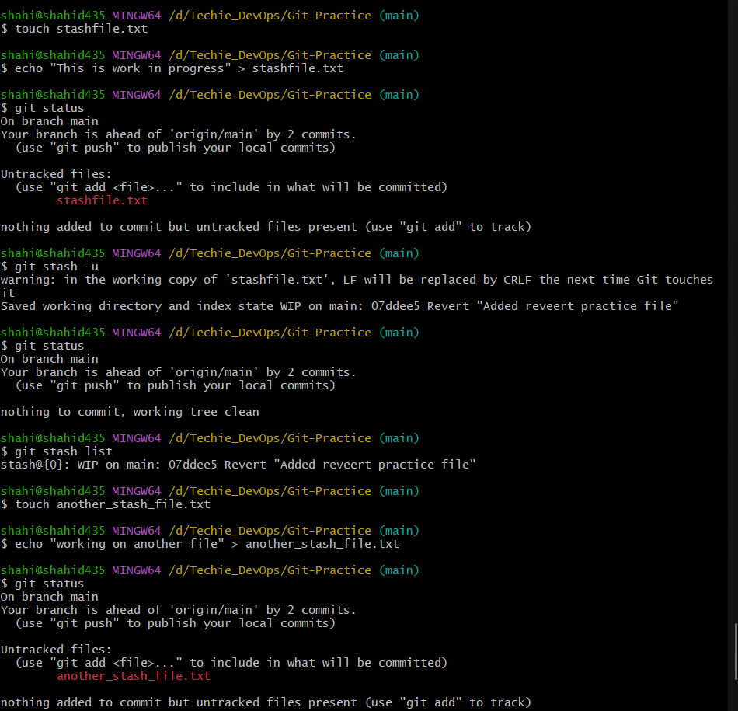

- Undo the stash file and start working on that again.
Objective
To restore the changes saved using git stash and continue working on them.
Your stash currently exists:
stash@{0}: WIP on main: 07ddee5 Revert "Added reveert practice file"
Step 1: First remove or handle the unrelated untracked file
You currently have:
another_stash_file.txt
If you don't need it:
rm another_stash_file.txt
Then check:
git status
Ideally, your working tree should be clean before restoring the stash.
Step 2: Restore the stashed changes
Use:
git stash pop
This will:
- Restore the stashed changes to your working directory.
- Remove that stash entry after successful restoration.
Step 3: Verify
git status
You should see your previous unfinished work again.
Also check:
ls
Your stashfile.txt should reappear.
Step 4: Confirm the stash was removed
git stash list
If git stash pop succeeded, stash@{0} should no longer appear.
Now you can continue working on the restored file:
echo "Continuing the work" >> stashfile.txt
Check:
cat stashfile.txt
git status
Result
The stashed changes were successfully restored using git stash pop, and work was continued on the restored file.
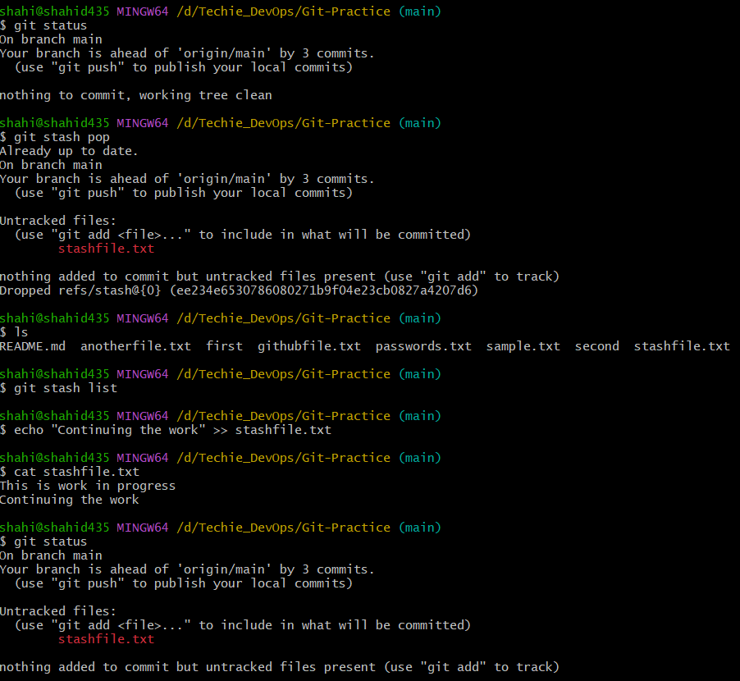

- Generate a ssh-keygen and configure into github.

Objective
To generate an SSH key pair, add the public key to GitHub, and verify SSH authentication between the local system and GitHub.
Steps to Implement
- Open Git Bash.
- Generate a new SSH key. Since an SSH key already existed, a new key was created with a different filename to avoid overwriting the existing key:
ssh-keygen -t ed25519 -C "shahidnj435.com" -f ~/.ssh/id_ed25519_gitpractice
- When prompted for a passphrase, press Enter to leave it empty.
- Verify that the new SSH key files were created:
ls ~/.ssh
The following files are created:
id_ed25519_gitpractice
id_ed25519_gitpractice.pub
- Display the public key:
cat ~/.ssh/id_ed25519_gitpractice.pub
- Copy the complete public key.
- Open GitHub and navigate to:
Profile → Settings → SSH and GPG keys → New SSH key
- Enter a title for the key, select Authentication Key, paste the public key, and click Add SSH key.
- Test the SSH connection:
ssh -T git@github.com
If asked to confirm the authenticity of GitHub, type:
yes
Result
A new SSH key pair was successfully generated without overwriting the existing SSH key. The public key was added to GitHub, and SSH authentication between the local system and GitHub was successfully configured and verified.

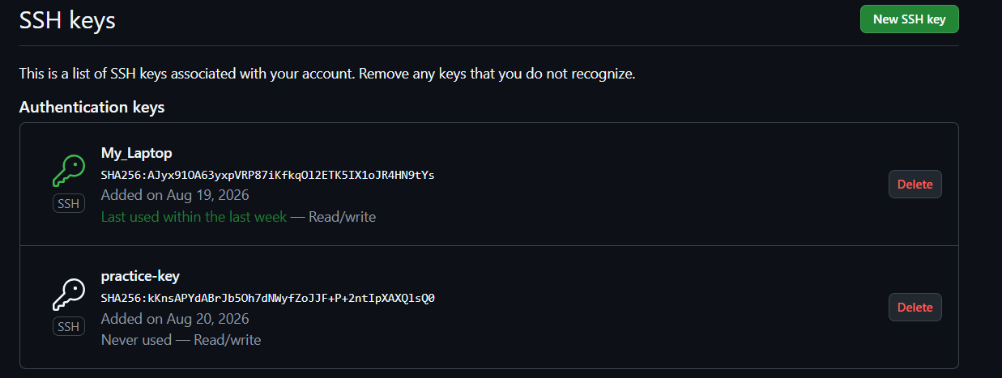
- Configure webhooks to github.
Objective
To configure a GitHub webhook and verify that a push event from the GitHub repository sends data to a webhook receiver.
Steps to Implement
- Opened Webhook.site and copied the unique webhook URL generated by the website.
- Opened the GitHub repository and navigated to:
Repository → Settings → Webhooks
- Clicked:
Add webhook
- Entered the Webhook.site URL in the Payload URL field.
- Selected the content type as:
application/json
- Selected the event:
Just the push event
- Kept the webhook Active and added the webhook.
- Created a test file locally and pushed the changes to the GitHub repository:
echo "Webhook test" > webhook-test.txt
git add webhook-test.txt
git commit -m "Test GitHub webhook"
git push origin main
- Opened Webhook.site and verified that the webhook request was received successfully.
The received request showed:
Method: POST
x-github-event: push
content-type: application/json
Result
A GitHub webhook was successfully configured using Webhook.site as the webhook receiver. When changes were pushed to the GitHub repository, GitHub triggered a push event and sent the event data as a POST request in JSON format. The request was successfully received and verified on Webhook.site.

- Basic understanding of .git file.
Objective
To understand the purpose and contents of the hidden .git directory in a Git repository.
Explanation
When you initialize a Git repository using:
git init
or clone an existing repository using:
git clone <repository-url>
Git creates a hidden directory called:
.git
This directory contains the internal data and configuration of the Git repository.
Without the .git directory, the folder is just a normal directory and Git cannot track its history.

Steps to Implement
1. Go to your Git repository
cd /d/Techie_DevOps/Git-Practice
2. Display hidden files and directories
In Git Bash:
ls -la
You should see:
.git
3. Check the contents of .git
ls .git
You may see directories and files such as:
HEAD
config
description
hooks
index
info
logs
objects
refs
Basic explanation of important contents
File/Directory | Purpose
HEAD | Points to the currently checked-out branch or commit
config | Contains repository-specific Git configuration
objects | Stores commits, files, trees, and other Git objects
refs | Stores references to branches and tags
index | Stores the staging area information
logs | Stores reference update history
hooks | Contains scripts that can run automatically during Git events
4. Check the current branch reference
cat .git/HEAD
Example:
ref: refs/heads/main
This means the currently checked-out branch is main.
5. View repository configuration
cat .git/config
This displays local repository settings, including information about the remote repository.
Result
The .git directory was examined and its basic structure was understood. It contains the internal metadata, commit history, branch references, configuration, staging information, and other data required for Git to manage the repository.
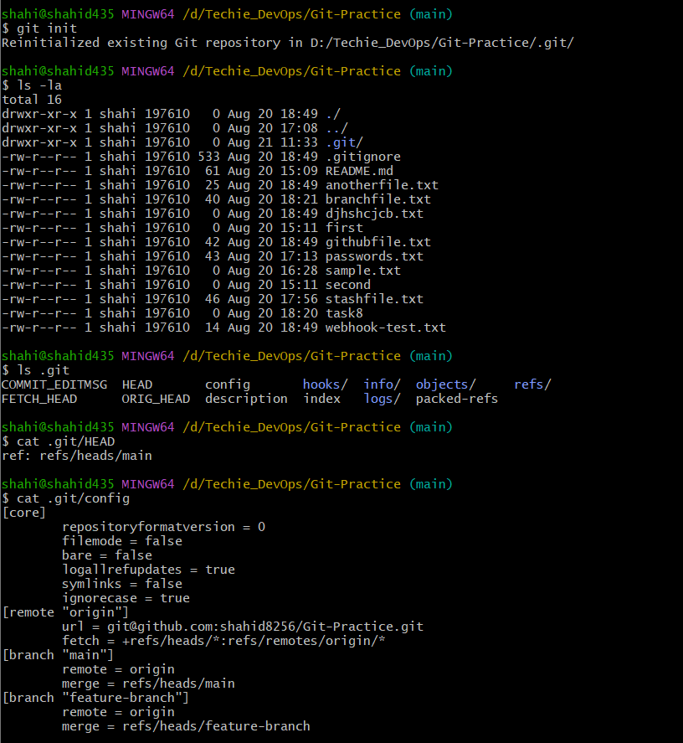
- Check all the logs of git.
Objective
To view and understand the commit history of a Git repository using different git log commands.
Steps to Implement
1. Go to your Git repository
cd /d/Techie_DevOps/Git-Practice
2. View the complete commit history
git log
This displays details such as:
- Commit ID
- Author
- Date
- Commit message
Press q to exit the log view.

3. View commit history in one-line format
git log --oneline
Example:
5267ca7 Added another file while stash was saved
07ddee5 Revert "Added revert practice file"
abc1234 Added revert practice file

4. View the last few commits
For the last 5 commits:
git log -5
Or in short format:
git log --oneline -5

5. View commit history as a graph
git log --oneline --graph --all
This is especially useful for viewing branch creation and merge history.
Example:
* 5267ca7 Added another file
* 07ddee5 Revert commit
| * d4a4e1a Added file in github branch
|/
* abc1234 Previous commit

6. View detailed changes for each commit
git log -p
This shows the commit history along with the changes made in each commit.
Result
The Git commit history was successfully viewed using different git log options, including complete logs, one-line logs, recent commits, graphical branch history, and commit changes.

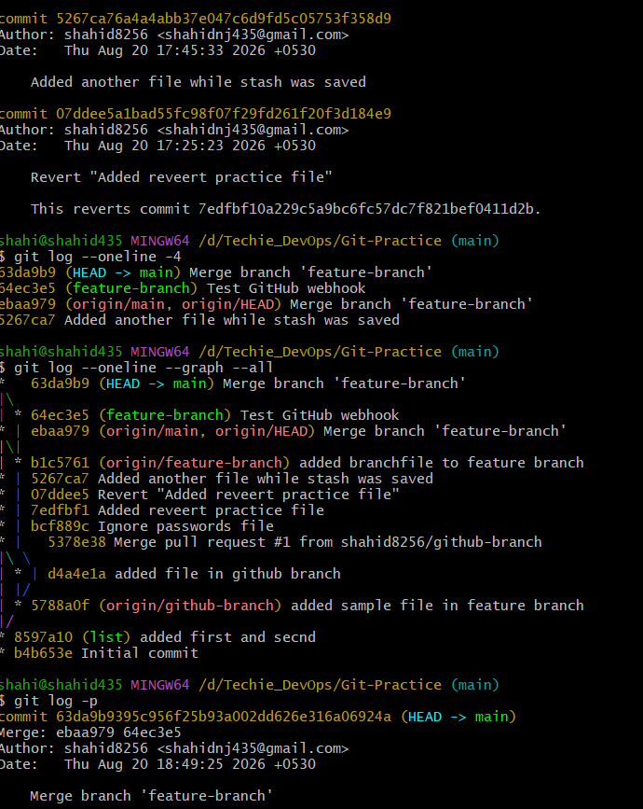

- Rename the commit message.
Objective
To change the message of an existing Git commit.
There are two common cases.

Case 1: Rename the Latest Commit Message
If you want to change the message of your most recent commit, use:
git commit --amend -m "New commit message"
Example
First check the latest commit:
git log --oneline -1
Suppose it shows:
5267ca7 Added another file while stash was saved
Rename it:
git commit --amend -m "Added another practice file"
Verify:
git log --oneline -1
You will see:
<new-commit-id> Added another practice file
Note: The commit ID changes because amending rewrites the commit.

Case 2: Rename an Older Commit Message
If the commit is not the latest, use interactive rebase:
git rebase -i HEAD~3
Git will show the last 3 commits. Change pick to reword for the commit whose message you want to change:
pick abc123 First commit
reword def456 Wrong commit message
pick ghi789 Another commit
Save and close the editor. Git will then allow you to change the selected commit message.

For Your Practice Task
The easiest demonstration is to rename the latest commit:
git log --oneline -1
git commit --amend -m "Updated commit message"
git log --oneline -1
Result
The commit message was successfully renamed using git commit --amend. The commit history was updated with the new commit message.

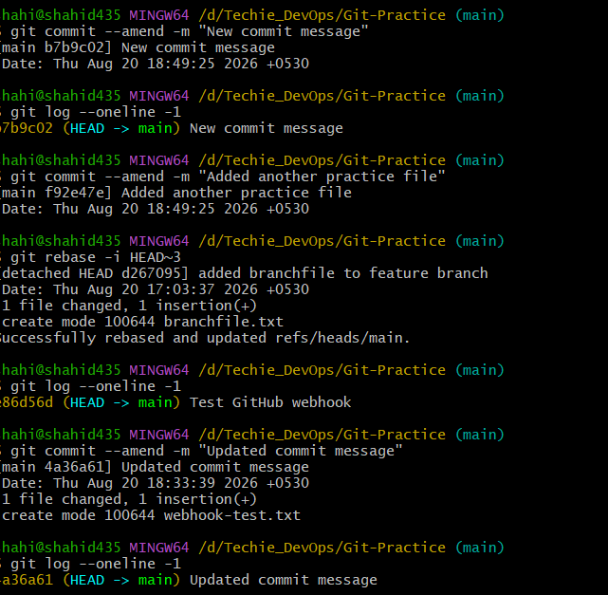

- Merge multiple commits into single commit.

Objective
To combine multiple commits into one single commit using Git interactive rebase.
Suppose your latest 3 commits are:
A - First change
B - Second change
C - Third change
You want to convert them into:
D - Combined changes

Steps to Implement
1. Check the recent commits
git log --oneline -3
For example:
a1b2c3 Third change
d4e5f6 Second change
g7h8i9 First change
2. Start interactive rebase
To combine the last 3 commits:
git rebase -i HEAD~3
An editor will open showing:
pick g7h8i9 First change
pick d4e5f6 Second change
pick a1b2c3 Third change
Keep the first commit as pick.
Change the remaining pick commands to squash or s:
pick g7h8i9 First change
squash d4e5f6 Second change
squash a1b2c3 Third change
Then save and close the editor.

3. Edit the combined commit message
Git will open another editor showing the commit messages.
You can replace them with one message:
Combined three commits into one
Save and close.

4. Verify
Run:
git log --oneline -5
Instead of three separate commits, you should now see one commit:
<new-commit-id> Combined three commits into one
Important
Interactive rebase rewrites commit history, so the commit IDs will change.
If these commits were already pushed to GitHub, you may need:
git push --force-with-lease origin main
For your practice assignment, it's better to create 3 fresh local commits and squash them before pushing.
Result
Multiple Git commits were successfully combined into a single commit using:
git rebase -i HEAD~3
The final commit contains all the changes from the selected commits.

