1. Basic Git Commands (For managing repositories)
git init: Initializes a new Git repository in the current
directory.
• git clone <repo_url>: Clones a repository from a remote
URL to your local machine.
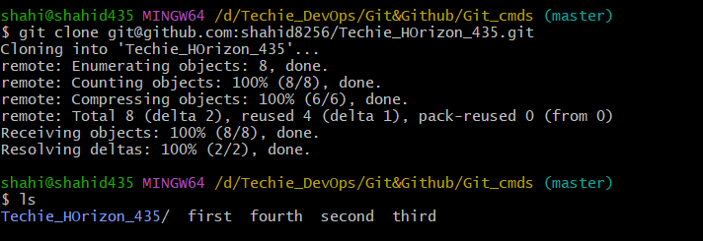
• git status: Shows the working directory status (which files are
modified, staged, etc.).
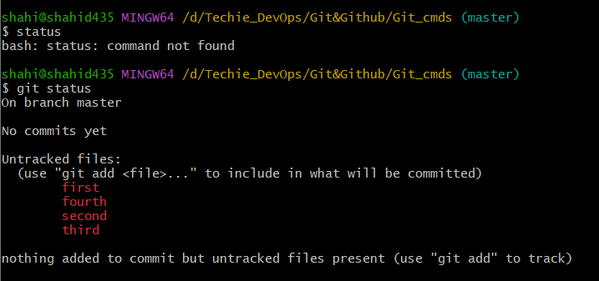
• git add : Stages a file or files to be committed.
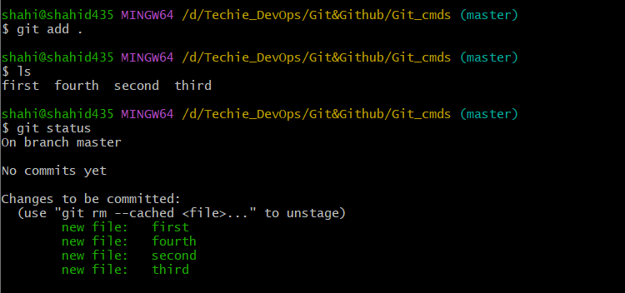
• git commit -m "message": Commits staged changes to the
local repository with a message.
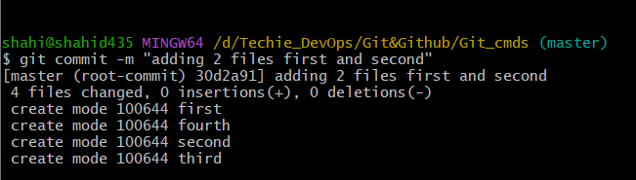
• git push: Pushes committed changes to the remote repository.
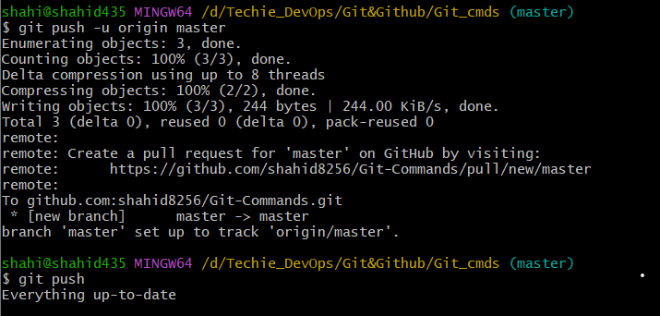
• git pull: Fetches and merges changes from the remote
repository to your local working directory.
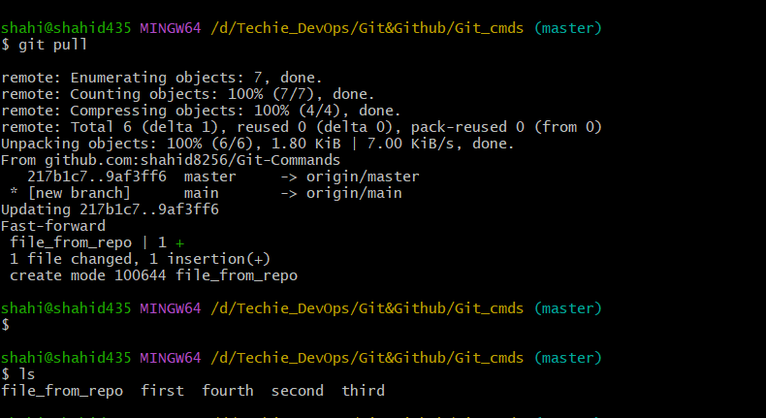

• git fetch: Downloads objects and refs from another repository
(without merging).
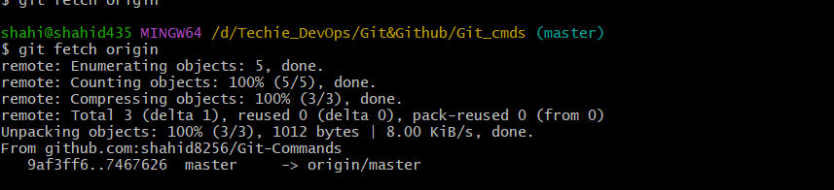

• git merge : Merges changes from the specified branch into the
current branch.
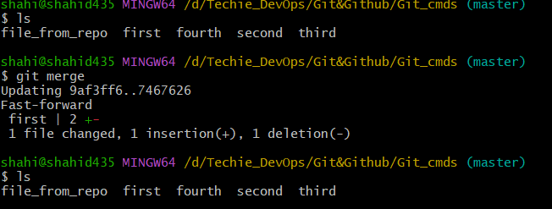
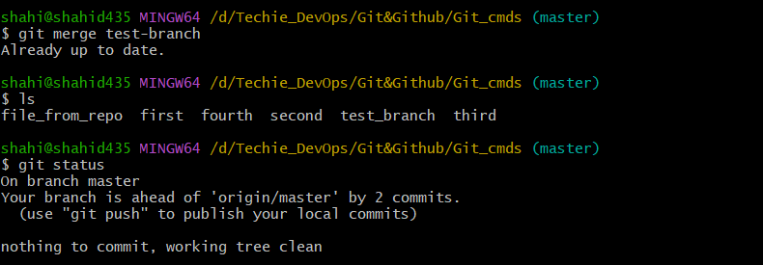

• git log: Shows the commit history of the repository.
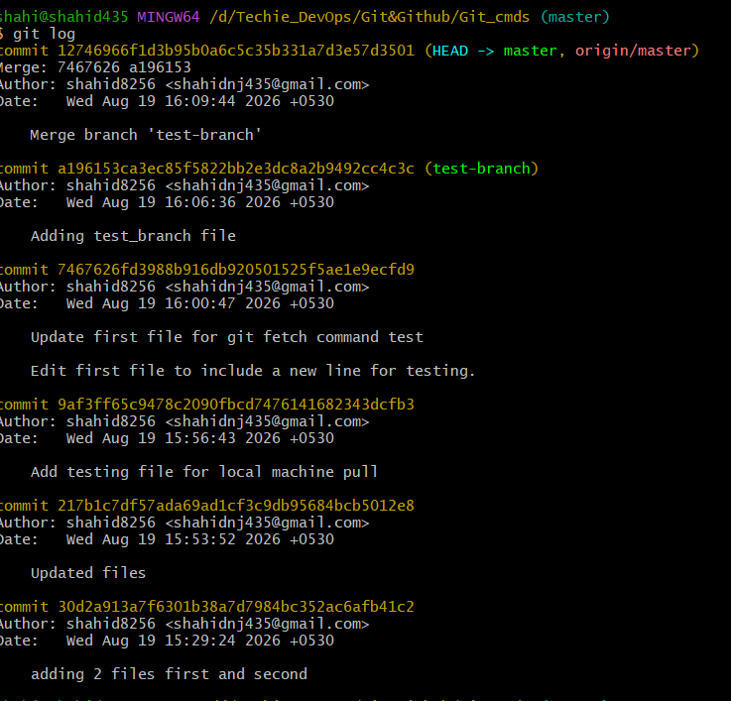
• git diff: Shows the differences between your working
directory and the index (staged changes)
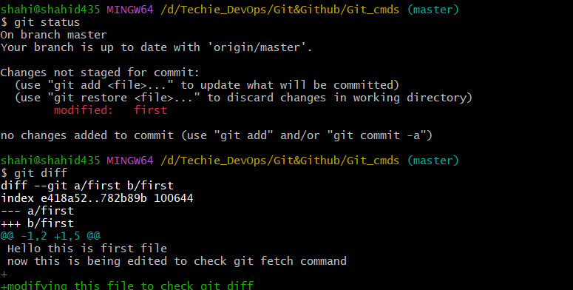
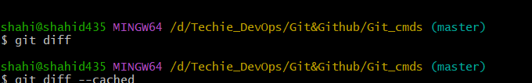
Now showing no diff because it in staging area now
If we want to check the modified …or diff in the staging area then
Git diff –cached
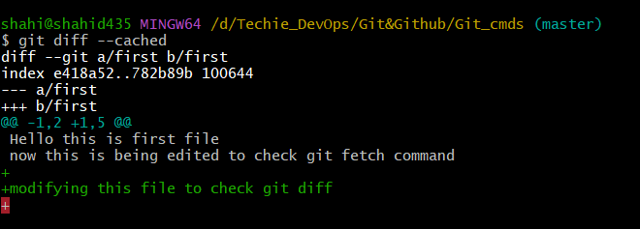

2. Branching Commands (Managing branches)
• git branch: Lists all branches in your repository.
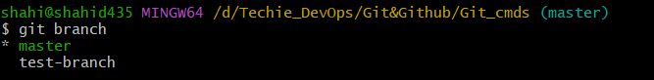

• git branch <branch_name>: Creates a new branch.
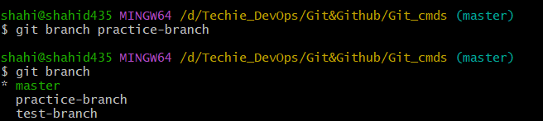

• git checkout <branch_name>: Switches to an existing
branch.
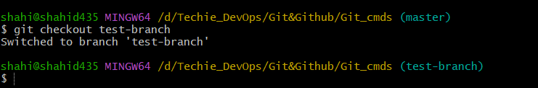

• git checkout -b <branch_name>: Creates and switches to a
new branch in one step.
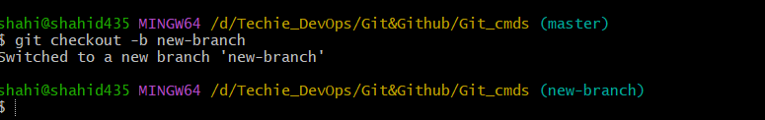

• git merge <branch_name>: Merges changes from the
specified branch into the current branch.
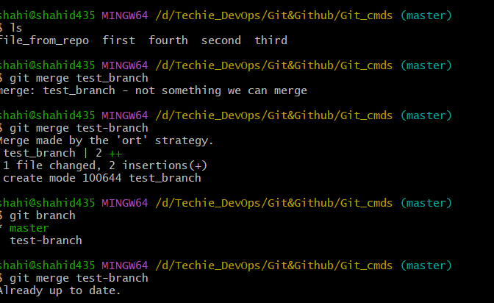
• git rebase <branch_name>: Applies changes from one
branch onto another branch (instead of merging).
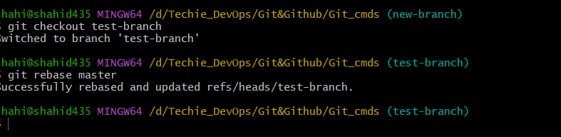
• git branch -d <branch_name>: Deletes the specified branch
(locally).
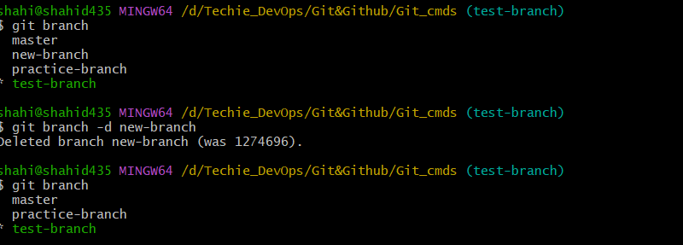
• git branch -D <branch_name>: Forcefully deletes a branch
(locally).
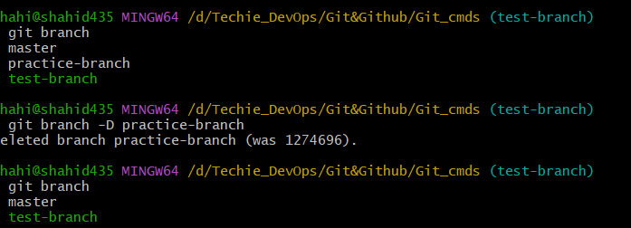
• git remote set-head origin <branch_name>: Sets the
default branch for the remote repository.

3. Remote Commands (Managing remotes and syncing with the cloud)
• git remote -v: Shows the remote repository URLs.
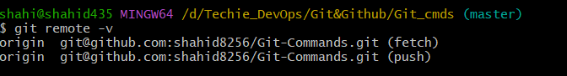
• git remote add : Adds a new remote repository.
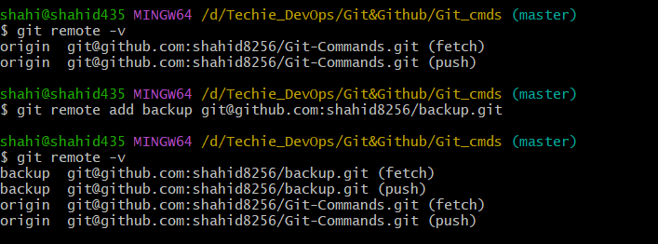
• git remote remove : Removes a remote repository.
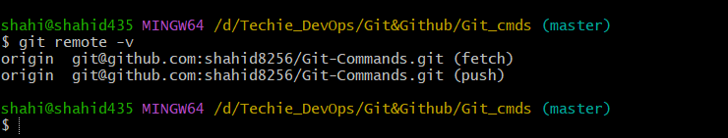
• git push origin <branch_name>: Pushes a branch to a
remote repository. 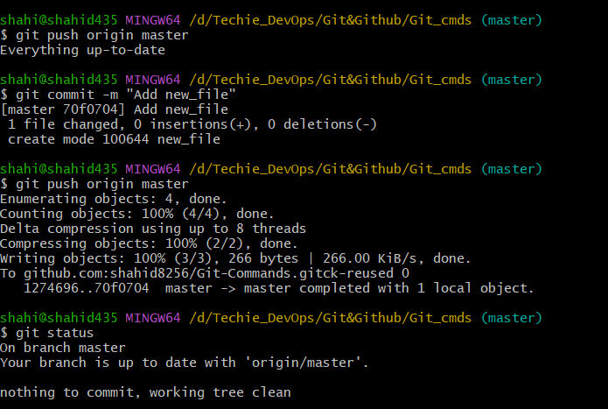

• git push -u origin <branch_name>: Pushes a branch to a
remote repository and sets the upstream for the branch.

• git pull origin <branch_name>: Fetches and merges a
branch from the remote repository.
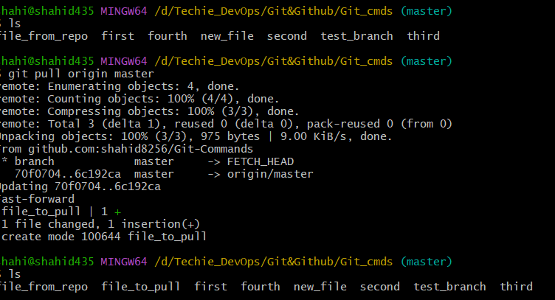
• git fetch origin: Downloads objects and refs from the
remote repository.

• git remote show origin: Displays detailed information
about a remote repository. 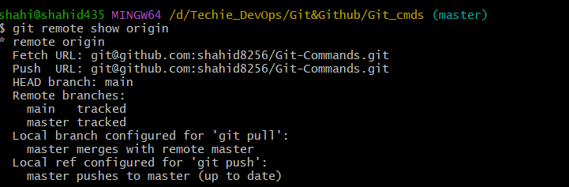

4. Staging and Committing (Managing changes)
• git add . : Stages all modified files in the working directory.
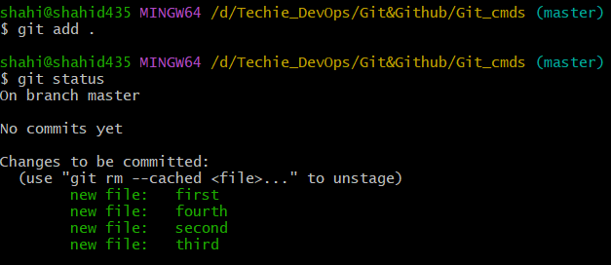
• git add -A: Stages all modified files (including file deletions).
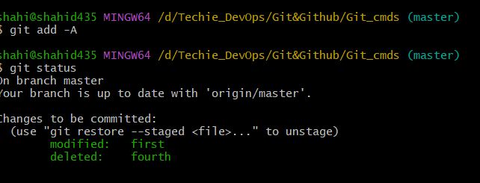
• git reset : Unstages a file (reverts it to the working directory).
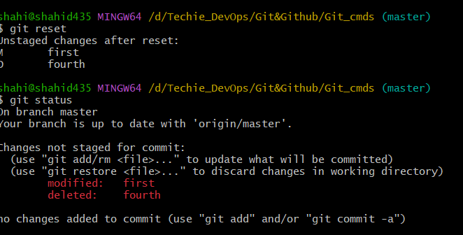
• git commit --amend: Modifies the last commit (can change
the commit message or add changes).
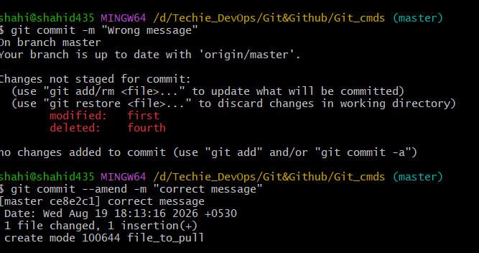

• git commit --all: Automatically stages tracked files and
commits them.
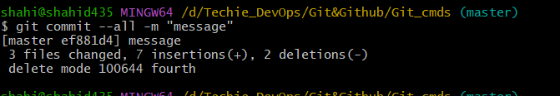

• git commit -a: Stages and commits all modified files.
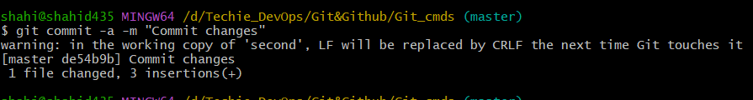
• git commit --no-verify: Skips pre-commit hooks while
committing.
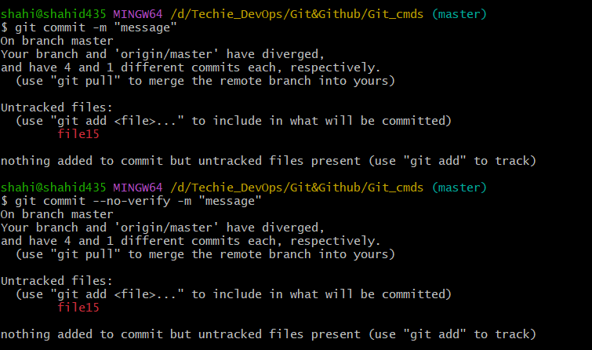
• git reset --soft HEAD~1: Moves the HEAD pointer back
one commit but leaves your changes staged.

• git reset --hard HEAD~1: Moves the HEAD pointer back
one commit and discards changes in the working directory

5. Viewing and Comparing Changes (Inspecting changes)
• git diff: Shows changes between your working directory and
the index (unstaged changes).

• git diff --staged: Shows changes between the index (staged
files) and the last commit.

• git diff <commit_id>: Shows the differences between your
working directory and a specific commit.
• git log: Displays the commit history.
• git log --oneline: Displays the commit history in a simplified
one-line format.
• git log --graph: Displays the commit history as a graph.
• git log --author="name": Filters commits by a specific
author.
• git log --since="2 weeks ago": Filters commits made
after a specific date.
• git blame : Shows line-by-line annotations for a file, telling who
last modified each line.
• git show <commit_id>: Shows details of a specific commit
(including diff and metadata).

