Jenkins Challenge 06/10/2026

Start working on Jenkins pipelines:
Use the below code and implement our CICD stages.
- Source Code: https://github.com/betawins/hiring-app.git
  - Repository contains the application code for the hiring app.

1.Create one Declarative pipeline job
2.Create one Scripted pipeline job
3.Create one multi stage pipeline job
4.Create one parallel stage pipeline job

Jenkins Official Documentation
Recommended
- Pipeline: https://www.jenkins.io/doc/book/pipeline/
- Environment Variables: https://www.jenkins.io/doc/book/pipeline/jenkinsfile/#using-environment-variables
- Parameters: https://www.jenkins.io/doc/book/pipeline/syntax/#parameters
- Handling credentials in Pipeline: https://www.jenkins.io/doc/book/pipeline/jenkinsfile/#handling-credentials

Pipeline
Jenkins – an open source automation server which enables developers around the world to reliably build, test, and deploy their softwarejenkins.io

Using a Jenkinsfile
Jenkins – an open source automation server which enables developers around the world to reliably build, test, and deploy their softwarejenkins.io

Pipeline Syntax
Jenkins – an open source automation server which enables developers around the world to reliably build, test, and deploy their softwarejenkins.io

Using a Jenkinsfile
Jenkins – an open source automation server which enables developers around the world to reliably build, test, and deploy their softwarejenkins.io

1.Create one Declarative pipeline job

Task 1 — Declarative CI/CD Pipeline
Job Name: jenk-chall-task-1
Pipeline Type: Declarative Pipeline
Source Code: https://github.com/betawins/hiring-app.git

1. Objective
Created a Declarative Jenkins CI/CD pipeline for the Hiring Application.
The pipeline performs:
Checkout → Compile → Test → Package → Verify Artifact → Archive → Deploy

2. Jenkins Agent
Used the existing Jenkins-Agent-01 instead of creating a new agent.
The agent label used in the pipeline is:
agent-1

Verified tools on the agent
java -version
git --version
mvn -version
Available:
- Java 17
- Git 2.50.1
- Maven 3.8.4

3. Manual Application Validation
Before running the Jenkins pipeline, the application was manually cloned and built on the agent:
cd /tmp
rm -rf hiring-app
git clone https://github.com/betawins/hiring-app.git
cd hiring-app
mvn -B clean package
The build completed successfully.
Generated WAR:
target/hiring.war
This confirmed that the application could be built successfully on the Jenkins agent before integrating it with Jenkins.

4. Deployment Directory
Created a deployment directory for the Jenkins user:
sudo mkdir -p /home/jenkins/hiring-deploy
sudo chown -R jenkins:jenkins /home/jenkins/hiring-deploy
Deployment location:
/home/jenkins/hiring-deploy

5. Declarative Pipeline Script
pipeline {
agent {
label 'agent-1'
}

environment {
REPO_URL = 'https://github.com/betawins/hiring-app.git'
BRANCH = 'main'
ARTIFACT = 'target/hiring.war'
DEPLOY_DIR = '/home/jenkins/hiring-deploy'
}

stages {

stage('Checkout') {
steps {
git branch: "${BRANCH}", url: "${REPO_URL}"
}
}

stage('Compile') {
steps {
sh 'mvn -B clean compile'
}
}

stage('Test') {
steps {
sh 'mvn -B test'
}
}

stage('Package') {
steps {
sh 'mvn -B package -DskipTests'
}
}

stage('Verify Artifact') {
steps {
sh '''
test -f "$ARTIFACT"
ls -lh "$ARTIFACT"
'''
}
}

stage('Archive') {
steps {
archiveArtifacts artifacts: 'target/hiring.war',
fingerprint: true
}
}

stage('Deploy') {
steps {
sh '''
mkdir -p "$DEPLOY_DIR"
cp "$ARTIFACT" "$DEPLOY_DIR/hiring-${BUILD_NUMBER}.war"
echo "Deployed build ${BUILD_NUMBER}"
ls -lh "$DEPLOY_DIR"
'''
}
}
}

post {
success {
echo 'CI/CD pipeline completed successfully.'
}

failure {
echo 'CI/CD pipeline failed. Check Console Output.'
}
}
}

6. Stage Explanation

1. Checkout
Clones the Hiring Application from GitHub.
git branch: "${BRANCH}", url: "${REPO_URL}"
The pipeline uses the main branch.

2. Compile
Runs:
mvn -B clean compile
This cleans the previous build and compiles the application.
Result:
BUILD SUCCESS

3. Test
Runs:
mvn -B test
The application currently has no tests, so Maven reported:
No tests to run.
BUILD SUCCESS

4. Package
Runs:
mvn -B package -DskipTests
This packages the web application as a WAR file.
Generated artifact:
target/hiring.war

5. Verify Artifact
Checks whether the WAR file exists:
test -f "$ARTIFACT"
Then displays the artifact:
ls -lh "$ARTIFACT"
If the WAR doesn't exist, this stage fails and the remaining stages are skipped.

6. Archive
Archives the WAR in Jenkins:
archiveArtifacts artifacts: 'target/hiring.war',
fingerprint: true
This keeps the generated WAR as a Jenkins build artifact.

7. Deploy
Copies the WAR to:
/home/jenkins/hiring-deploy
The file is renamed using the Jenkins build number:
hiring-${BUILD_NUMBER}.war
For example:
hiring-1.war
This is a file deployment/copy. It is not a Tomcat deployment.

7. Mistake Encountered
During the first pipeline execution, all stages up to Archive succeeded, but Deploy failed.
Error:
mkdir: cannot create directory '/home/ec2-user': Permission denied

Reason
The Jenkins pipeline runs as the jenkins Linux user.
The original deployment location was under:
/home/ec2-user/hiring-deploy
The jenkins user did not have permission to access that location.

Fix
Created a deployment directory owned by Jenkins:
sudo mkdir -p /home/jenkins/hiring-deploy
sudo chown -R jenkins:jenkins /home/jenkins/hiring-deploy
Then changed:
DEPLOY_DIR = '/home/jenkins/hiring-deploy'
After this change, the pipeline completed successfully.

8. Final CI/CD Flow
GitHub
↓
Checkout
↓
Compile
↓
Test
↓
Package
↓
target/hiring.war
↓
Verify Artifact
↓
Archive
↓
Deploy
↓
/home/jenkins/hiring-deploy

9. Final Result
Stage | Result
Checkout | ✅
Compile | ✅
Test | ✅
Package | ✅
Verify Artifact | ✅
Archive | ✅
Deploy | ✅

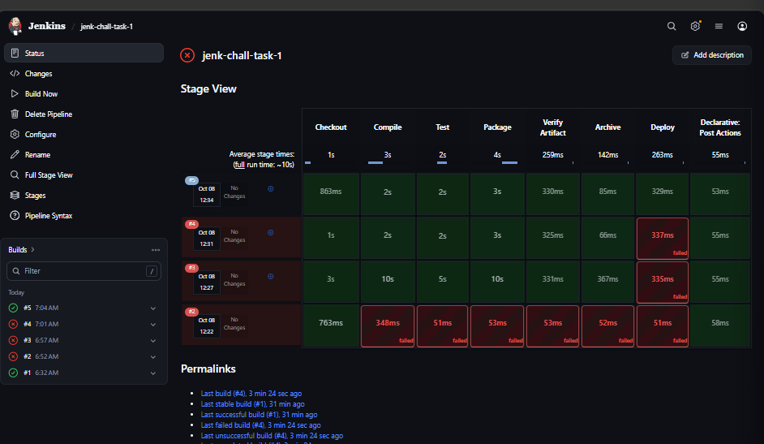

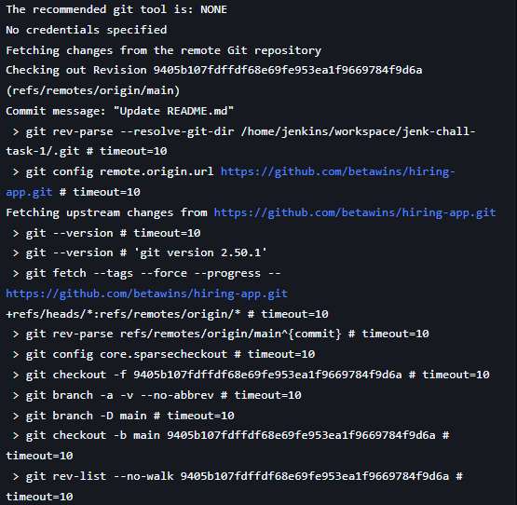
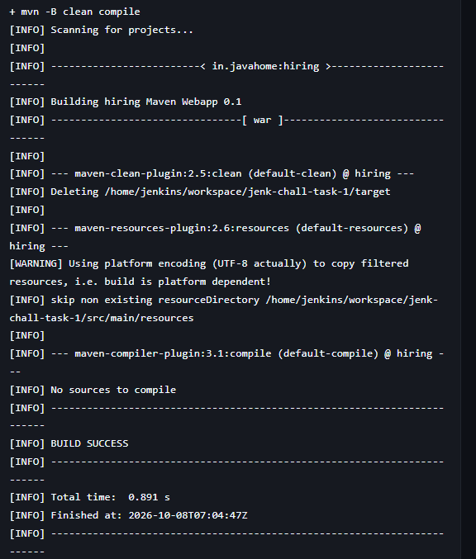

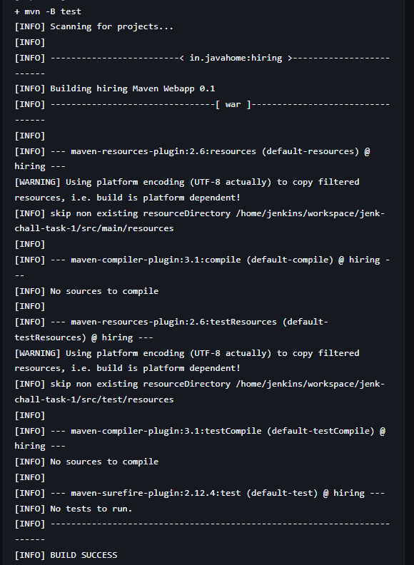
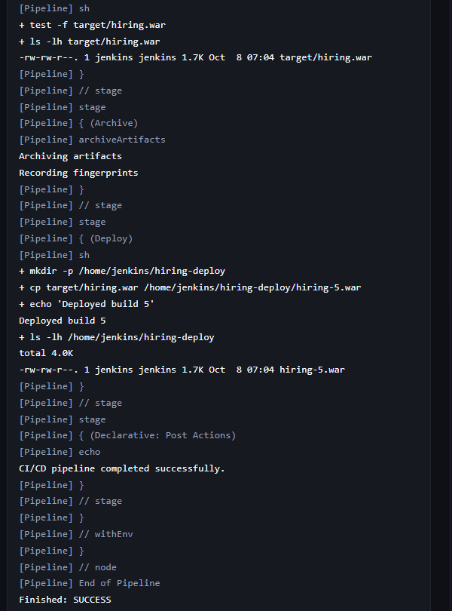

2.Create one Scripted pipeline job

Task 2 — Scripted CI/CD Pipeline

1. Task Details
Jenkins Job: jenk-chall-task-2
Pipeline Type: Scripted Pipeline
Source Repository:
https://github.com/betawins/hiring-app.git
Branch:
main
Jenkins Agent:
agent-1
The purpose of Task 2 was to implement the CI/CD process using Jenkins Scripted Pipeline syntax. The same practical CI/CD flow from Task 1 was used, with Nexus Repository added for artifact storage.

2. Existing Jenkins Agent Setup
We used the existing Jenkins agent instead of creating a new one.

Agent label
agent-1

Tools available on the agent
- Java
- Git
- Maven
Maven was installed on the agent because it was initially missing.
Maven version:
Apache Maven 3.8.4
Git version:
2.50.1
The application was manually tested before running the Jenkins pipeline to make sure Maven could build it successfully.

3. Application Build
The application source code was cloned from:
https://github.com/betawins/hiring-app.git
The Maven build generated:
target/hiring.war
This WAR file is the main artifact used throughout the pipeline.

4. Nexus Setup
Since Task 2 required Nexus, we used the extra EC2 instance:
sonar-server
Private IP:
10.0.1.200
Public IP:
15.206.91.177
Nexus was installed using Docker.

Docker
Docker was initially not installed, so we installed it:
sudo dnf install -y docker
Started Docker:
sudo systemctl start docker
Enabled Docker:
sudo systemctl enable docker
Docker version:
Docker 25.0.14
The ec2-user initially received a Docker socket permission error.
We fixed it with:
sudo usermod -aG docker ec2-user
Then:
newgrp docker
After that:
docker ps
worked successfully.

5. Nexus Docker Container
We pulled the Nexus image:
docker pull sonatype/nexus3
Image:
sonatype/nexus3:latest
Then started Nexus:
docker run -d \
--name nexus \
-p 8081:8081 \
-v nexus-data:/nexus-data \
sonatype/nexus3
Nexus was successfully running:
nexus
sonatype/nexus3
0.0.0.0:8081->8081/tcp
Nexus was accessed through:
http://15.206.91.177:8081
Nexus Repository version shown:
Nexus/3.96.4-01 (COMMUNITY)

6. Nexus Repository
A Maven hosted repository was created.

Repository name
hiring-app

Repository type
Maven 2 (hosted)

Version policy
Mixed

Deployment policy
Allow redeploy
Repository URL:
http://15.206.91.177:8081/repository/hiring-app/

7. Jenkins Nexus Credentials
A Jenkins credential was configured for Nexus.

Credential type
Username with password

Username
admin

Credential ID
nexus-credentials
The pipeline uses this credential instead of directly exposing the Nexus password.

8. Nexus Connectivity Test
From the Jenkins environment, we tested:
curl -I http://15.206.91.177:8081/repository/hiring-app/
The response was:
HTTP/1.1 401 Unauthorized
This confirmed that the Jenkins environment could reach Nexus successfully, while authentication was required for repository access.
The Jenkins credential was then used by the pipeline for the upload.

9. Task 2 Pipeline Flow
The final Scripted Pipeline flow was:
Checkout
↓
Compile
↓
Test
↓
Package
↓
Verify Artifact
↓
Upload to Nexus
↓
Archive
↓
Deploy

10. Scripted Pipeline
node('agent-1') {

def repoUrl = 'https://github.com/betawins/hiring-app.git'
def artifact = 'target/hiring.war'
def deployDir = '/home/jenkins/hiring-deploy'
def nexusUrl = 'http://15.206.91.177:8081/repository/hiring-app/'

try {

stage('Checkout') {
git branch: 'main', url: repoUrl
}

stage('Compile') {
sh 'mvn -B clean compile'
}

stage('Test') {
sh 'mvn -B test'
}

stage('Package') {
sh 'mvn -B package -DskipTests'
}

stage('Verify Artifact') {
sh """
test -f ${artifact}
ls -lh ${artifact}
"""
}

stage('Upload to Nexus') {
withCredentials([
usernamePassword(
credentialsId: 'nexus-credentials',
usernameVariable: 'NEXUS_USER',
passwordVariable: 'NEXUS_PASSWORD'
)
]) {
sh """
curl -u "\$NEXUS_USER:\$NEXUS_PASSWORD" \
--upload-file ${artifact} \
${nexusUrl}hiring-${BUILD_NUMBER}.war
"""
}
}

stage('Archive') {
archiveArtifacts artifacts: 'target/hiring.war',
fingerprint: true
}

stage('Deploy') {
sh """
mkdir -p ${deployDir}
cp ${artifact} ${deployDir}/hiring-${BUILD_NUMBER}.war
echo "Deployed build ${BUILD_NUMBER}"
ls -lh ${deployDir}
"""
}

echo 'CI/CD pipeline completed successfully.'

} catch (Exception e) {
echo 'CI/CD pipeline failed. Check Console Output.'
throw e
}
}

11. Stage Explanation

Stage 1 — Checkout
stage('Checkout') {
git branch: 'main', url: repoUrl
}
Jenkins clones the main branch from the GitHub repository.

Stage 2 — Compile
stage('Compile') {
sh 'mvn -B clean compile'
}
Maven cleans the previous build and compiles the application source code.

Stage 3 — Test
stage('Test') {
sh 'mvn -B test'
}
Maven executes the application's tests.
The project reported no tests to run, but the stage completed successfully.

Stage 4 — Package
stage('Package') {
sh 'mvn -B package -DskipTests'
}
Maven packages the application and generates:
target/hiring.war
-DskipTests prevents tests from running again because the separate Test stage already executed them.

Stage 5 — Verify Artifact
stage('Verify Artifact') {
sh """
test -f ${artifact}
ls -lh ${artifact}
"""
}
This verifies that:
target/hiring.war
actually exists before continuing.

Stage 6 — Upload to Nexus
The Nexus Jenkins credential is loaded using:
withCredentials()
The WAR is uploaded using:
curl
The artifact is uploaded to:
http://15.206.91.177:8081/repository/hiring-app/
The build number is used in the uploaded filename:
hiring-${BUILD_NUMBER}.war
For example:
hiring-2.war
This allows different Jenkins builds to be stored separately.

Stage 7 — Archive
archiveArtifacts artifacts: 'target/hiring.war',
fingerprint: true
Jenkins stores the generated WAR as a build artifact.
Fingerprinting is enabled to help track the artifact.

Stage 8 — Deploy
The WAR is copied to:
/home/jenkins/hiring-deploy
The deployed file uses the Jenkins build number:
hiring-${BUILD_NUMBER}.war
Example:
hiring-2.war

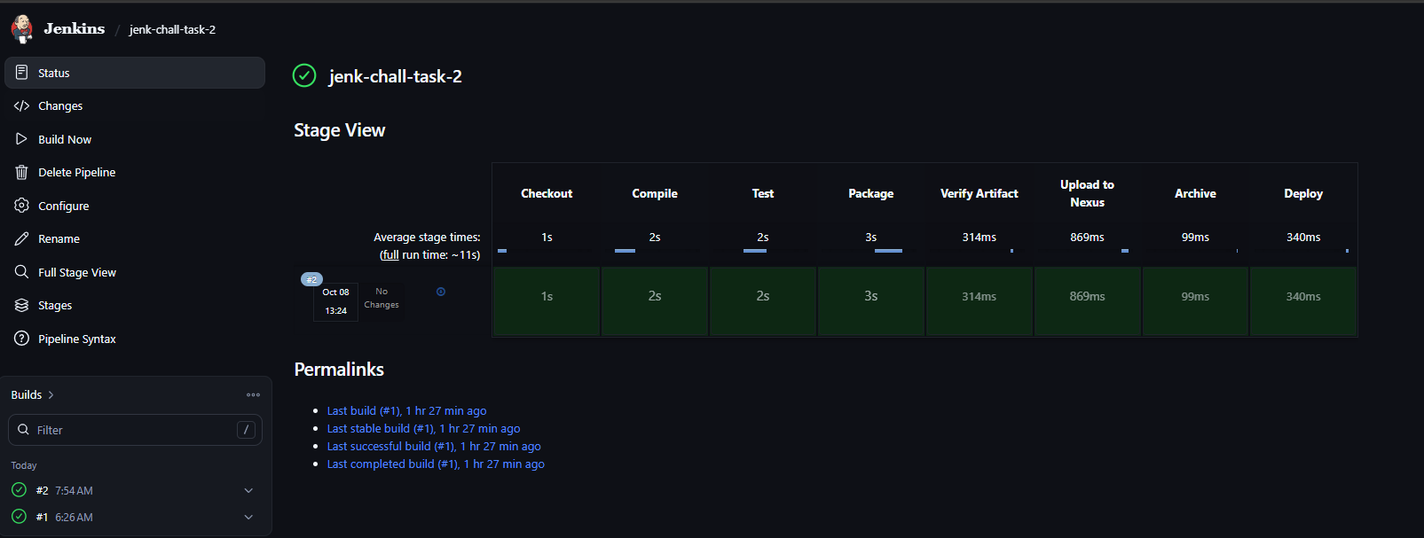

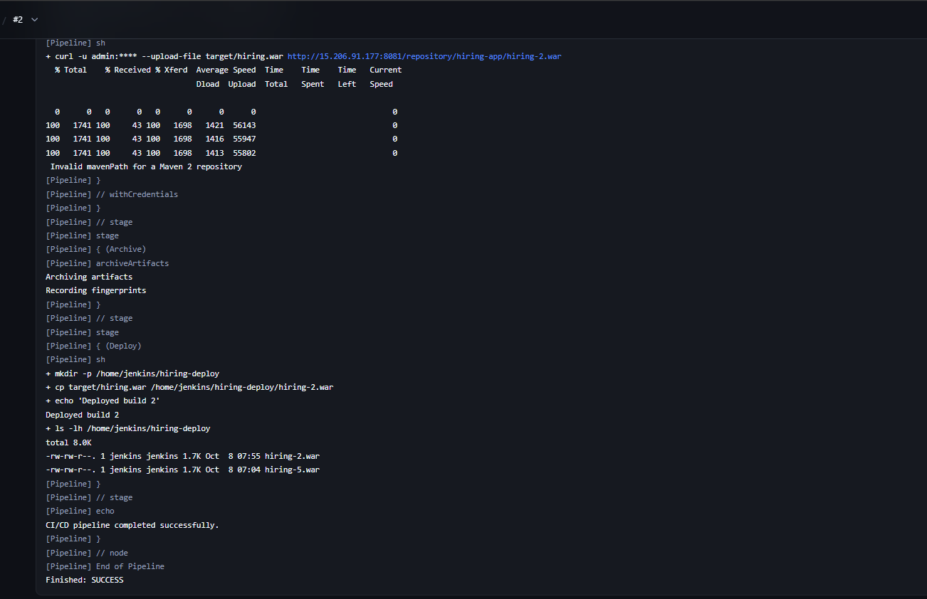

12. Task 2 Result
The pipeline was executed successfully.
The Jenkins stage view showed:
Stage | Result
Checkout | ✅ Success
Compile | ✅ Success
Test | ✅ Success
Package | ✅ Success
Verify Artifact | ✅ Success
Upload to Nexus | ✅ Success
Archive | ✅ Success
Deploy | ✅ Success
The successful build completed in approximately 11 seconds.
Most importantly, the Upload to Nexus stage completed successfully, proving that:
Jenkins → Nexus
integration is working.

13. Final Task 2 Architecture
GitHub
|
| Clone
↓
Jenkins Pipeline
|
↓
Jenkins Agent
|
┌──────────┴──────────┐
↓ ↓
Maven Build Testing
|
↓
hiring.war
|
├──────────────→ Jenkins Archive
|
↓
Nexus
|
↓
hiring-<build>.war
|
↓
Deploy

3.Create one multi stage pipeline job

Task 3 — Multi-Stage CI/CD Pipeline

1. Task Details
Jenkins Job: jenk-chall-task-3
Pipeline Type: Declarative Pipeline with multiple stages and conditional execution
Agent: agent-1
Repository: https://github.com/betawins/hiring-app.git
Branch: main
Task 3 builds on the CI/CD pipeline from the previous tasks by adding build parameters and conditional execution. The provided task document specifies the DEPLOY_ENV and RUN_TESTS parameters and conditional Unit Test stage. Pasted text

2. Task 3 Objective
The main purpose of Task 3 was to create a pipeline that can:
- Select the deployment environment.
- Control whether tests should run.
- Build the application.
- Verify the generated WAR file.
- Upload the WAR to Nexus.
- Archive the WAR in Jenkins.
- Deploy the WAR using the selected environment.

Final flow
Checkout
↓
Compile
↓
Test (Conditional)
↓
Package
↓
Verify Artifact
↓
Upload to Nexus
↓
Archive
↓
Deploy

3. Jenkins Parameters
The job was configured as This project is parameterized.

Parameter 1 — DEPLOY_ENV
Type: Choice Parameter
DEPLOY_ENV
Choices:
dev
test
prod
This parameter determines the deployment environment.
For the successful build, we selected:
DEPLOY_ENV = dev

Parameter 2 — RUN_TESTS
Type: Boolean Parameter
RUN_TESTS
Default:
true
This parameter controls whether the Test stage should execute.
If checked:
Compile → Test → Package
If unchecked:
Compile → Package
The parameter-based/conditional test behavior follows the Task 3 design in the provided document. Pasted text

4. Existing Agent Setup
We reused the existing Jenkins agent.

Agent label
agent-1
The pipeline therefore uses:
agent {
label 'agent-1'
}
No additional Jenkins agent was created.

5. Application
Source repository:
https://github.com/betawins/hiring-app.git
Branch:
main
The application is built using Maven.
Generated artifact:
target/hiring.war

6. Nexus Configuration
We reused the Nexus server configured during Task 2.

Nexus server
15.206.91.177:8081

Repository
hiring-app

Repository type
Maven 2 (hosted)

Repository URL
http://15.206.91.177:8081/repository/hiring-app/

Jenkins credential
nexus-credentials
The credential contains the Nexus username/password and is accessed through Jenkins withCredentials.

7. Deployment Directory
The application is deployed as a file to:
/home/jenkins/hiring-deploy
The environment is included in the deployed filename.
For example:
hiring-3-dev.war
This is file-based deployment, not Tomcat deployment.

8. Complete Task 3 Pipeline
pipeline {
agent {
label 'agent-1'
}

parameters {
choice(
name: 'DEPLOY_ENV',
choices: ['dev', 'test', 'prod'],
description: 'Select deployment environment'
)

booleanParam(
name: 'RUN_TESTS',
defaultValue: true,
description: 'Run unit tests'
)
}

environment {
REPO_URL = 'https://github.com/betawins/hiring-app.git'
BRANCH = 'main'
ARTIFACT = 'target/hiring.war'
NEXUS_URL = 'http://15.206.91.177:8081/repository/hiring-app/'
NEXUS_PATH = 'com/betawins/hiring-app/1.0/hiring-app-1.0.war'
DEPLOY_DIR = '/home/jenkins/hiring-deploy'
}

stages {

stage('Checkout') {
steps {
git branch: "${BRANCH}", url: "${REPO_URL}"
}
}

stage('Compile') {
steps {
sh 'mvn -B clean compile'
}
}

stage('Test') {
when {
expression {
params.RUN_TESTS
}
}

steps {
sh 'mvn -B test'
}
}

stage('Package') {
steps {
sh 'mvn -B package -DskipTests'
}
}

stage('Verify Artifact') {
steps {
sh '''
test -f "$ARTIFACT"
ls -lh "$ARTIFACT"
'''
}
}

stage('Upload to Nexus') {
steps {
withCredentials([
usernamePassword(
credentialsId: 'nexus-credentials',
usernameVariable: 'NEXUS_USER',
passwordVariable: 'NEXUS_PASSWORD'
)
]) {
sh '''
curl -f -u "$NEXUS_USER:$NEXUS_PASSWORD" \
--upload-file "$ARTIFACT" \
"${NEXUS_URL}${NEXUS_PATH}"
'''
}
}
}

stage('Archive') {
steps {
archiveArtifacts artifacts: 'target/hiring.war',
fingerprint: true
}
}

stage('Deploy') {
steps {
sh '''
mkdir -p "$DEPLOY_DIR"

cp "$ARTIFACT" \
"$DEPLOY_DIR/hiring-${BUILD_NUMBER}-${DEPLOY_ENV}.war"

echo "Deployed to environment: $DEPLOY_ENV"

ls -lh "$DEPLOY_DIR"
'''
}
}
}

post {
success {
echo "CI/CD pipeline completed successfully for ${DEPLOY_ENV}."
}

failure {
echo 'CI/CD pipeline failed. Check Console Output.'
}
}
}

9. Stage Explanation

Stage 1 — Checkout
stage('Checkout') {
steps {
git branch: "${BRANCH}", url: "${REPO_URL}"
}
}
Clones the main branch from GitHub.

Stage 2 — Compile
mvn -B clean compile
Cleans the previous build and compiles the application.

Stage 3 — Test
mvn -B test
Runs only when:
RUN_TESTS = true
During our successful run Maven reported:
No tests to run.
BUILD SUCCESS
So the Test stage completed successfully.

Stage 4 — Package
mvn -B package -DskipTests
Creates:
target/hiring.war
Tests are skipped here because the Test stage already handles testing.

Stage 5 — Verify Artifact
test -f "$ARTIFACT"
ls -lh "$ARTIFACT"
Checks that the WAR actually exists before uploading or deploying it.
The successful build showed:
target/hiring.war
1.7K

10. Nexus Upload
The Nexus upload uses Jenkins credentials:
withCredentials([
usernamePassword(
credentialsId: 'nexus-credentials',
usernameVariable: 'NEXUS_USER',
passwordVariable: 'NEXUS_PASSWORD'
)
])
The WAR is uploaded using curl.

Maven repository path
The important path is:
com/betawins/hiring-app/1.0/hiring-app-1.0.war
Therefore the complete upload URL is:
http://15.206.91.177:8081/repository/hiring-app/com/betawins/hiring-app/1.0/hiring-app-1.0.war
This is a valid Maven 2 repository path.

11. Archive
archiveArtifacts artifacts: 'target/hiring.war',
fingerprint: true
Jenkins archives the WAR as a build artifact and records its fingerprint.

12. Deploy
The WAR is copied to:
/home/jenkins/hiring-deploy
The filename contains:
- Jenkins build number
- Deployment environment
For the successful build:
hiring-3-dev.war
The console confirmed:
Deployed to environment: dev

13. Error Encountered — Invalid Maven Path
During the first Task 3 build, the Nexus stage showed:
Invalid mavenPath for a Maven 2 repository
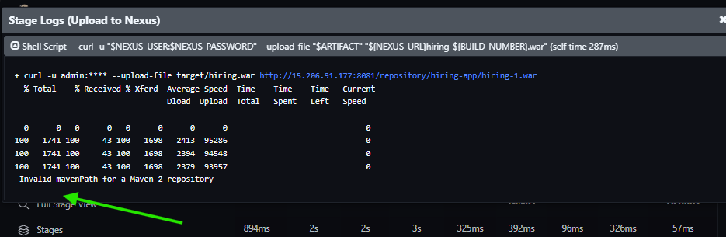
The original upload URL was effectively:
/repository/hiring-app/hiring-1.war

Reason
The Nexus repository is a Maven 2 hosted repository.
It expects a Maven-style artifact path rather than simply placing a WAR file directly at the repository root.

Resolution
We added:
NEXUS_PATH = 'com/betawins/hiring-app/1.0/hiring-app-1.0.war'
and changed the upload to:
"${NEXUS_URL}${NEXUS_PATH}"
We also added:
-f
to curl:
curl -f ...
This ensures curl returns a failure if the HTTP request itself fails.

14. Manual Curl Error
At one point, the Nexus upload command was manually executed directly on the EC2 shell:
curl -f -u "$NEXUS_USER:$NEXUS_PASSWORD" \
--upload-file "$ARTIFACT" \
"${NEXUS_URL}${NEXUS_PATH}"
It returned:
curl: option : blank argument where content is expected

Reason
Variables such as:
NEXUS_USER
NEXUS_PASSWORD
ARTIFACT
NEXUS_URL
NEXUS_PATH
are Jenkins pipeline variables/credentials. They were not defined in the normal EC2 shell.

Resolution
We did not run the command manually.
The command was executed inside the Jenkins pipeline's:
withCredentials
and environment context.

15. False SUCCESS Issue
The first Nexus upload returned:
Invalid mavenPath for a Maven 2 repository
but Jenkins still showed:
Finished: SUCCESS

Reason
The original curl command did not use:
-f
Therefore the HTTP error response did not cause the shell step to fail.

Resolution
We changed it to:
curl -f
Now an HTTP failure causes the Jenkins stage to fail.
This makes the pipeline more reliable because Jenkins will not report a successful build when the Nexus upload actually fails.

16. Successful Final Build
After correcting the Maven repository path, the final build successfully uploaded the WAR.
The console showed the corrected URL:
/repository/hiring-app/com/betawins/hiring-app/1.0/hiring-app-1.0.war
No:
Invalid mavenPath
error appeared.
The deployment created:
/home/jenkins/hiring-deploy/hiring-3-dev.war
Final result:
Finished: SUCCESS
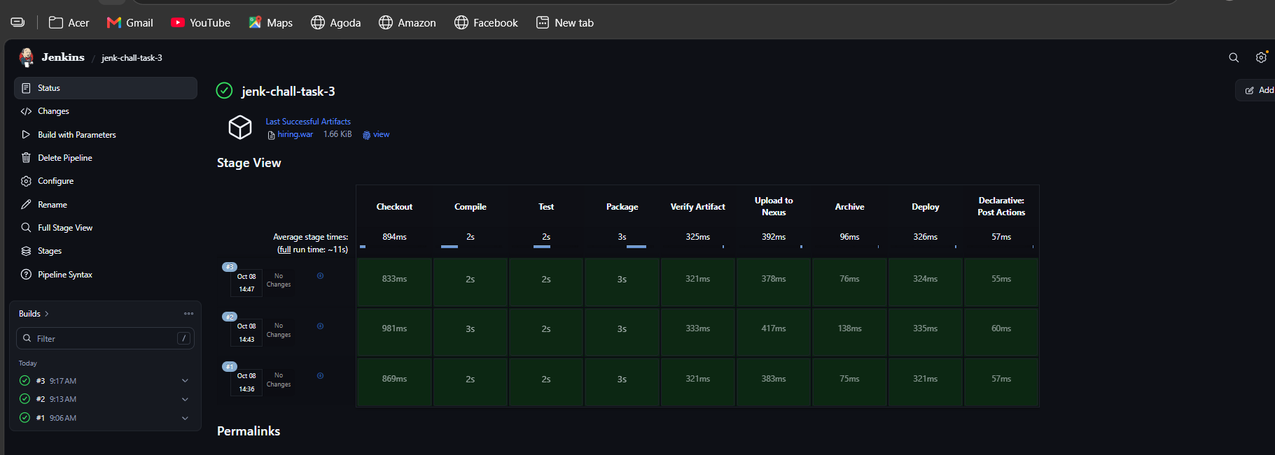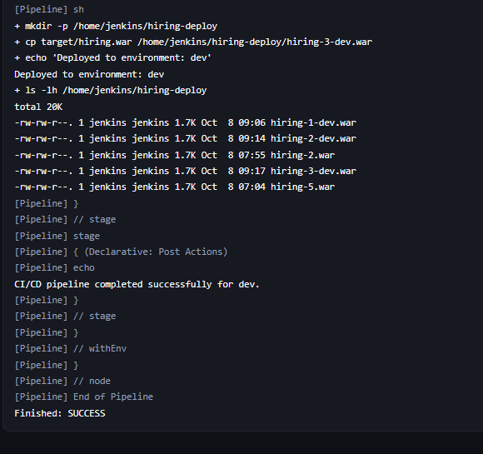

4.Create one parallel stage pipeline job

1. Objective
The objective of Task 4 was to create a Jenkins Declarative Pipeline with Parallel Stages for the hiring-app project.
Jenkins Job:
jenk-chall-task-4
GitHub Repository:
https://github.com/betawins/hiring-app.git
The pipeline performs the complete CI/CD flow:
Checkout
↓
Compile
↓
Test
↓
Package
↓
Parallel Verification
↓
Archive
↓
Upload to Nexus
↓
Deploy
The main concept of this task is that the verification stages execute in parallel.

2. Existing Configuration Used
We reused the existing Jenkins setup instead of creating unnecessary new resources.

Jenkins Agent
jenkins-agent-1

Jenkins Label
agent-1
Pipeline configuration:
agent {
label 'agent-1'
}

Existing Tools
The agent already had:
- Git
- Java
- Maven
Maven was used for compiling, testing and packaging the application.

Nexus
Existing Nexus server was used.
Nexus repository:
hiring-app
Nexus URL:
http://15.206.91.177:8081/repository/hiring-app/

Jenkins Credential
Existing Nexus credential:
nexus-credentials

Deployment Directory
/home/jenkins/hiring-deploy

3. Complete Pipeline
The final Task 4 pipeline is:
pipeline {
agent {
label 'agent-1'
}

environment {
REPO_URL = 'https://github.com/betawins/hiring-app.git'
BRANCH = 'main'
ARTIFACT = 'target/hiring.war'
NEXUS_URL = 'http://15.206.91.177:8081/repository/hiring-app/'
NEXUS_PATH = "com/betawins/hiring-app/2.0/hiring-app-2.0-${BUILD_NUMBER}.war"
DEPLOY_DIR = '/home/jenkins/hiring-deploy'
}

stages {

stage('Checkout') {
steps {
git branch: "${BRANCH}", url: "${REPO_URL}"
}
}

stage('Compile') {
steps {
sh 'mvn -B clean compile'
}
}

stage('Test') {
steps {
sh 'mvn -B test'
}
}

stage('Package') {
steps {
sh 'mvn -B package -DskipTests'
}
}

stage('Parallel Verification') {
parallel {

stage('Artifact Check') {
steps {
sh '''
test -f "$ARTIFACT"
ls -lh "$ARTIFACT"
'''
}
}

stage('Checksum') {
steps {
sh '''
sha256sum "$ARTIFACT"
'''
}
}

stage('Source Structure Check') {
steps {
sh '''
test -d src
test -d src/main
test -d src/main/webapp
echo "Source structure verified."
'''
}
}
}
}

stage('Archive') {
steps {
archiveArtifacts artifacts: 'target/hiring.war',
fingerprint: true
}
}

stage('Upload to Nexus') {
steps {
withCredentials([
usernamePassword(
credentialsId: 'nexus-credentials',
usernameVariable: 'NEXUS_USER',
passwordVariable: 'NEXUS_PASSWORD'
)
]) {
sh '''
curl -f -u "$NEXUS_USER:$NEXUS_PASSWORD" \
--upload-file "$ARTIFACT" \
"${NEXUS_URL}${NEXUS_PATH}"
'''
}
}
}

stage('Deploy') {
steps {
sh '''
mkdir -p "$DEPLOY_DIR"

cp "$ARTIFACT" \
"$DEPLOY_DIR/hiring-${BUILD_NUMBER}.war"

echo "Deployment completed."

ls -lh "$DEPLOY_DIR"
'''
}
}
}

post {
success {
echo 'Parallel CI/CD pipeline completed successfully.'
}

failure {
echo 'Parallel CI/CD pipeline failed. Check Console Output.'
}
}
}

4. Environment Variables
The pipeline defines the following environment variables:

Repository
REPO_URL = 'https://github.com/betawins/hiring-app.git'
GitHub repository containing the application.

Branch
BRANCH = 'main'
The pipeline checks out the main branch.

Artifact
ARTIFACT = 'target/hiring.war'
This is the WAR file generated by Maven.

Nexus URL
NEXUS_URL = 'http://15.206.91.177:8081/repository/hiring-app/'
Nexus Maven hosted repository.

Nexus Path
NEXUS_PATH = "com/betawins/hiring-app/2.0/hiring-app-2.0-${BUILD_NUMBER}.war"
A separate version/path is used for Task 4 to avoid conflicts with the artifact uploaded during Task 3.

Deployment Directory
DEPLOY_DIR = '/home/jenkins/hiring-deploy'
The final WAR is copied to this directory.

5. Stage 1 — Checkout
The pipeline clones the GitHub repository:
stage('Checkout') {
steps {
git branch: "${BRANCH}", url: "${REPO_URL}"
}
}
The pipeline successfully checked out the main branch.
Checked-out commit:
9405b107fdffdf68e69fe953ea1f9669784f9d6a
Commit message:
Update README.md
Result:
SUCCESS

6. Stage 2 — Compile
Maven compilation was performed using:
mvn -B clean compile
Maven successfully completed the compile phase.
Result:
BUILD SUCCESS
There were no Java source files to compile.

7. Stage 3 — Test
Tests were executed using:
mvn -B test
Maven reported:
No tests to run.
The build still completed successfully:
BUILD SUCCESS
This means the project currently does not contain test cases.

8. Stage 4 — Package
The application was packaged into a WAR file:
mvn -B package -DskipTests
Maven generated:
target/hiring.war
Artifact size:
1.7K
Result:
BUILD SUCCESS

9. Stage 5 — Parallel Verification
This is the main feature of Task 4.
The following three stages execute in parallel:
stage('Parallel Verification') {
parallel {

stage('Artifact Check') {
...
}

stage('Checksum') {
...
}

stage('Source Structure Check') {
...
}
}
}
Instead of executing these checks one after another, Jenkins starts them at the same time.

9.1 Artifact Check
The pipeline checks whether the WAR file exists:
test -f "$ARTIFACT"
ls -lh "$ARTIFACT"
Output:
-rw-rw-r--. 1 jenkins jenkins 1.7K target/hiring.war
Result:
SUCCESS

9.2 Checksum
The SHA-256 checksum of the WAR file was generated:
sha256sum "$ARTIFACT"
Output:
122534e0998f72990a57dc6e1993a262d6d55960b8d272ed1c4e110504b0e376 target/hiring.war
Result:
SUCCESS
The checksum can be used to verify the integrity of the artifact.

9.3 Source Structure Check
The pipeline verifies that the required project directories exist:
test -d src
test -d src/main
test -d src/main/webapp
Output:
Source structure verified.
Result:
SUCCESS

10. Parallel Execution Result
All three parallel branches completed successfully:
Artifact Check ✅
Checksum ✅
Source Structure Check ✅
This demonstrates the main requirement of Task 4 — parallel stage execution in Jenkins.

11. Stage 6 — Archive
After the parallel verification completed successfully, Jenkins archived the WAR:
archiveArtifacts artifacts: 'target/hiring.war',
fingerprint: true
Artifact:
target/hiring.war
Jenkins output:
Archiving artifacts
Recording fingerprints
Result:
SUCCESS

12. Stage 7 — Upload to Nexus
The WAR is uploaded to the Nexus repository using Jenkins credentials.
The pipeline uses:
withCredentials([
usernamePassword(
credentialsId: 'nexus-credentials',
usernameVariable: 'NEXUS_USER',
passwordVariable: 'NEXUS_PASSWORD'
)
])
The upload command is:
curl -f -u "$NEXUS_USER:$NEXUS_PASSWORD" \
--upload-file "$ARTIFACT" \
"${NEXUS_URL}${NEXUS_PATH}"
The -f option is important because it causes curl to return a failure when Nexus returns an HTTP error such as 400 or 409.
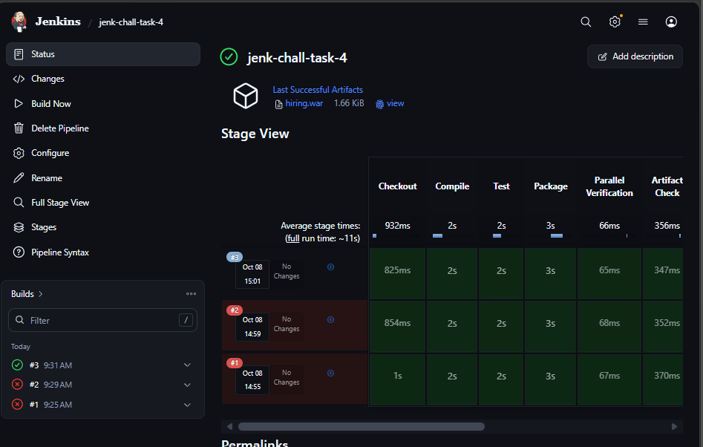

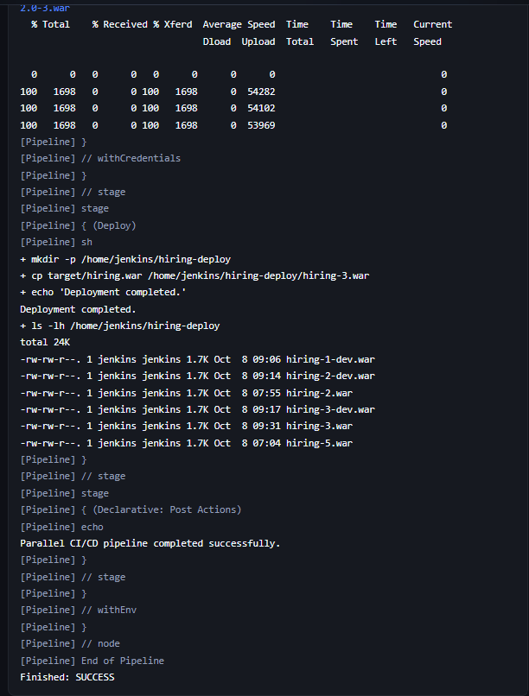

13. Error 1 — Nexus 409 Conflict
During the first Task 4 run, the Nexus upload failed with:
409 Conflict

Reason
Task 4 was initially using the same Nexus artifact path that had already been used by Task 3.
The artifact already existed at that location, so Nexus rejected the upload.

Resolution
A different Nexus artifact path was used for Task 4.

14. Error 2 — Nexus 400 Bad Request
After the first correction, the artifact path was changed to:
com/betawins/hiring-app/1.0/hiring-app-2.war
The upload then failed with:
curl: (22) The requested URL returned error: 400

Reason
The Nexus repository is a Maven 2 hosted repository.
Changing only the filename while keeping the Maven version/path as 1.0 did not provide the expected Maven repository structure.

Final Resolution
The Nexus path was changed to:
NEXUS_PATH = "com/betawins/hiring-app/2.0/hiring-app-2.0-${BUILD_NUMBER}.war"
This gives Task 4 a separate Maven version and a unique artifact filename based on the Jenkins build number.
For example:
com/betawins/hiring-app/2.0/hiring-app-2.0-2.war

15. Stage 8 — Deploy
After successful Nexus upload, the pipeline deploys the WAR by copying it to:
/home/jenkins/hiring-deploy
Command:
mkdir -p "$DEPLOY_DIR"

cp "$ARTIFACT" \
"$DEPLOY_DIR/hiring-${BUILD_NUMBER}.war"
For example:
/home/jenkins/hiring-deploy/hiring-2.war
The pipeline then lists the deployment directory:
ls -lh "$DEPLOY_DIR"

Important
This task performs file-based deployment.
Tomcat was not used in this pipeline.

16. Why Deploy Was Skipped During the Failed Run
When Nexus returned the error:
400
the Upload to Nexus stage failed.
Therefore Jenkins skipped:
Deploy
Console output showed:
Stage "Deploy" skipped due to earlier failure(s)
This is normal Jenkins Declarative Pipeline behavior when an earlier stage fails.

17. Post Actions
The pipeline has two post conditions.

On success
success {
echo 'Parallel CI/CD pipeline completed successfully.'
}

On failure
failure {
echo 'Parallel CI/CD pipeline failed. Check Console Output.'
}
This provides a simple final status message.

18. Final Task 4 Pipeline Flow
GitHub
↓
Checkout
↓
Compile
↓
Test
↓
Package
↓
┌──────────────────────────────────────┐
│ Parallel Verification │
│ │
│ Artifact Check │
│ Checksum │
│ Source Structure Check │
│ │
└──────────────────────────────────────┘
↓
Archive WAR
↓
Upload WAR to Nexus
↓
Deploy WAR
↓
Deployment Directory

19. Task 4 Key Concept
The main concept learned in Task 4 is Jenkins Parallel Stage execution.
Using:
parallel {
stage('Artifact Check') {
...
}

stage('Checksum') {
...
}

stage('Source Structure Check') {
...
}
}
Jenkins can execute independent tasks simultaneously.
This can reduce pipeline execution time when multiple tasks do not depend on each other.

20. Task 4 Errors and Resolutions Summary
Error | Reason | Resolution
409 Conflict | Nexus artifact path already existed | Used a different artifact path
400 Bad Request | Invalid Maven repository path structure | Changed to Maven 2.0 path with build number
Deploy skipped | Nexus upload failed | Deploy runs after successful upload

Difference Between Task 1, 2, 3 & 4
Task 1 – Declarative Pipeline
- Created a basic CI/CD pipeline using Declarative syntax.
- Stages execute sequentially: Checkout → Compile → Test → Package → Archive → Deploy.
- Focus: Understanding the standard Jenkins pipeline structure.
Task 2 – Scripted Pipeline
- Implemented the same CI/CD process using Scripted Pipeline syntax.
- Uses node {} and stage {} with Groovy-based scripting.
- Provides more flexibility and programmatic control.
- Focus: Understanding Scripted Pipeline and its difference from Declarative.
Task 3 – Multi-Stage Pipeline
- Extended the pipeline with parameters and conditional execution.
- Added DEPLOY_ENV and RUN_TESTS parameters.
- Used when to decide whether a stage should execute.
- Focus: Controlling pipeline behavior based on user input/conditions.
Task 4 – Parallel Stage Pipeline
- Added parallel execution for independent verification tasks.
- Artifact Check, Checksum, and Source Structure Check run simultaneously.
- Uses the parallel {} block.
- Focus: Running independent tasks at the same time to improve efficiency.
Easy way to remember
Task 1 → Structure
Task 2 → Flexibility
Task 3 → Control
Task 4 → Parallelism

How to identify each one
1. Declarative Pipeline
Look for:
pipeline {
agent {
}
stages {
}
}
👉 If you see pipeline {} at the top, it's Declarative.

2. Scripted Pipeline
Look for:
node('agent-1') {
stage('Checkout') {
...
}
}
👉 If it mainly starts with node {} instead of pipeline {}, it's Scripted.

3. Pipeline with Parameters / Conditions
Look for:
parameters {
choice(...)
booleanParam(...)
}
and/or:
when {
expression {
...
}
}
👉 parameters + when means the pipeline has user-controlled/conditional execution.

4. Parallel Pipeline
Look for:
parallel {
stage('A') {
...
}

stage('B') {
...
}
}
👉 If you see parallel {}, it's a Parallel Pipeline.

🔥 Quick identification
If you see | Identify as
pipeline {} | Declarative
node {} | Scripted
parameters {} / when {} | Parameterized/Conditional
parallel {} | Parallel

