Jenkins-4 (4/10/2026)

1.Setup Jenkins CICD pipeline using freestyle job using Docker containers using below code.
Source Code: https://github.com/betawins/hiring-app.git
Stages:
- Git Clone
- SonarQube Integration
- Maven Compilation
- Nexus Artifactory
- Slack Notification
- Deploy On tomcat

Task 1: Jenkins Freestyle CI/CD Pipeline Using Docker Containers

1. Objective
To automate the CI/CD process for a Java web application using a Jenkins Freestyle job, Docker, Maven, SonarQube, Nexus Repository Manager, Apache Tomcat, and Slack.

2. Tools and Technologies
Tool | Purpose
Jenkins | CI/CD automation
Git and GitHub | Source code management
Docker | Runs Maven in a container
Maven | Compiles, tests, and packages the application
SonarQube | Static code analysis
Nexus Repository Manager | Stores build artifacts
Apache Tomcat | Deploys the Java web application
Slack | Sends build notifications
Amazon EC2 | Hosts the services

3. Environment Details
Jenkins job: Hiring-App-Freestyle
GitHub repository: https://github.com/betawins/hiring-app.git
Branch: main
Application artifact: target/hiring.war
Service | Observed address
Jenkins | http://13.234.213.65:8081
SonarQube | http://13.234.213.65:9002
Nexus | http://13.234.213.65:8082
Tomcat | http://13.207.204.141:8080
IP address note: These are addresses observed during the practical. The latest Slack notifications linked to Jenkins at http://13.127.136.203:8081, so the public IP may have changed. Confirm the current EC2 public IP before reusing an address.

Docker containers
- SonarQube container: sonarqube
- SonarQube image: sonarqube:latest
- Nexus container: nexus
- Nexus image: sonatype/nexus3
- Maven image: maven:3.9-eclipse-temurin-17

Nexus repository
- Repository name: hiring-app
- Repository type: Maven2 (hosted)

Maven project details
- Group ID: in.javahome
- Artifact ID: hiring
- Version: 0.1
- Packaging: war
- Generated file: target/hiring.war

4. Create the Freestyle Job
- Open Jenkins.
- Click New Item.
- Enter Hiring-App-Freestyle.
- Select Freestyle project.
- Click OK.
Under Source Code Management, select Git and configure:
- Repository URL: https://github.com/betawins/hiring-app.git
- Branch specifier: */main
- Credentials: Not required for this public repository.
Jenkins checks out the source code into:
/var/lib/jenkins/workspace/Hiring-App-Freestyle

5. Git Clone
Jenkins retrieves the application source code from GitHub before executing the build steps.
The checked-out source code becomes available in the job workspace for Maven compilation, code analysis, and artifact packaging.

6. SonarQube Integration and Maven Build

Configuration
A SonarQube token was generated through My Account → Security and stored in Jenkins Credentials as Secret text.
The Freestyle job exposes it through this environment variable:
SONAR_TOKEN

Execute shell command
set -e

docker run --rm \
-e SONAR_TOKEN="$SONAR_TOKEN" \
-v "$WORKSPACE":/app \
-w /app \
maven:3.9-eclipse-temurin-17 \
mvn -B clean package \
org.sonarsource.scanner.maven:sonar-maven-plugin:5.3.0.6276:sonar \
-Dmaven.compiler.source=8 \
-Dmaven.compiler.target=8 \
-Dsonar.host.url=http://13.234.213.65:9002

Explanation
- docker run --rm runs a temporary Docker container and removes it after execution.
- -v "$WORKSPACE":/app mounts the Jenkins workspace into the container.
- -w /app sets the working directory.
- maven:3.9-eclipse-temurin-17 provides Maven and Java 17.
- mvn -B clean package cleans previous build output, compiles the application, executes the configured build lifecycle, and packages the application.
- The explicit sonar-maven-plugin coordinates invoke the SonarQube analysis goal.
- SONAR_TOKEN provides authentication.
- sonar.host.url specifies the SonarQube server.
The resulting application artifact is target/hiring.war.

7. Nexus Repository Integration

Purpose
Nexus stores the generated WAR file and POM so that build artifacts can be managed separately from source code.

Jenkins credentials
The existing Nexus credential was bound to these environment variables:
- Username: NEXUS_USER
- Password: NEXUS_PASSWORD

Execute shell command
set -e

curl --fail --show-error \
-u "$NEXUS_USER:$NEXUS_PASSWORD" \
--upload-file target/hiring.war \
http://13.234.213.65:8082/repository/hiring-app/in/javahome/hiring/0.1/hiring-0.1.war

curl --fail --show-error \
-u "$NEXUS_USER:$NEXUS_PASSWORD" \
--upload-file pom.xml \
http://13.234.213.65:8082/repository/hiring-app/in/javahome/hiring/0.1/hiring-0.1.pom

Explanation
- curl transfers files to Nexus.
- --fail makes unsuccessful HTTP responses return an error.
- --show-error displays transfer errors.
- -u supplies the Nexus credentials.
- --upload-file uploads the specified file.
- The URL follows the Maven repository layout using the group ID, artifact ID, and version.
The target repository is hiring-app, configured as a Maven2 hosted repository.

8. Tomcat Deployment

Purpose
Tomcat deploys and runs the Java web application packaged as a WAR file.
Tomcat was installed under /opt/tomcat on the EC2 host previously referenced by public IP 13.207.204.141.

Jenkins credentials
The Tomcat deployment credential was configured in Jenkins with:
- Username variable: TOMCAT_USER
- Password variable: TOMCAT_PASSWORD

Execute shell command
set -e

curl --fail --show-error \
-u "$TOMCAT_USER:$TOMCAT_PASSWORD" \
-T target/hiring.war \
"http://127.0.0.1:8080/manager/text/deploy?path=/hiring-app&update=true"

Explanation
- curl sends the deployment request.
- -T target/hiring.war uploads the WAR file.
- /manager/text/deploy invokes Tomcat's Manager deployment interface.
- path=/hiring-app specifies the application's context path.
- update=true requests an update if the application is already deployed.
- set -e stops the shell step if a command fails.
The intended application URL is:
http://13.207.204.141:8080/hiring-app/
Note: The deployment command uses 127.0.0.1, which works only if Tomcat is accessible locally from the Jenkins build executor. The intended application URL above uses the previously observed Tomcat public IP.

9. Slack Notification Integration

Purpose
Slack receives automatic notifications about Jenkins pipeline execution, including build start, success, and failure.

Configuration
- Configure the Jenkins Slack integration with the Slack workspace and channel.
- Open Hiring-App-Freestyle → Configure.
- Under Post-build Actions, configure Slack Notifications.
- Enable the required notification options.
- Save the job.

Verified Slack notifications
The Slack workspace received these messages:
- Build #3: Started, then reported Still Failing after 18 sec.
- Build #4: Started, then reported Success after 26 sec.
These messages demonstrate that Jenkins sent build-status notifications to Slack.

10. Error Encountered and Solution

Error
Maven reported:
No plugin found for prefix 'sonar' in the current project

Cause
Maven could not resolve the SonarQube plugin using the sonar:sonar prefix in the original build command.

Solution
The command was changed to use the explicit plugin coordinates:
org.sonarsource.scanner.maven:sonar-maven-plugin:5.3.0.6276:sonar
The SonarQube token was also stored in Jenkins Credentials and passed into the Maven Docker container using SONAR_TOKEN.
This addressed the missing-plugin error encountered in the earlier build.

11. Execute the Pipeline
- Open Hiring-App-Freestyle.
- Click Build Now.
- Open the latest build in Build History.
- Select Console Output.
- Review the execution logs and final build status.

Result observed
Build #4 — SUCCESS after 26 seconds
Slack also received the success notification for Build #4.

12. Screenshots for Documentation
Capture and insert these screenshots in the relevant sections:
- Jenkins job configuration showing the GitHub repository.
- Console Output showing Git checkout and Maven execution.
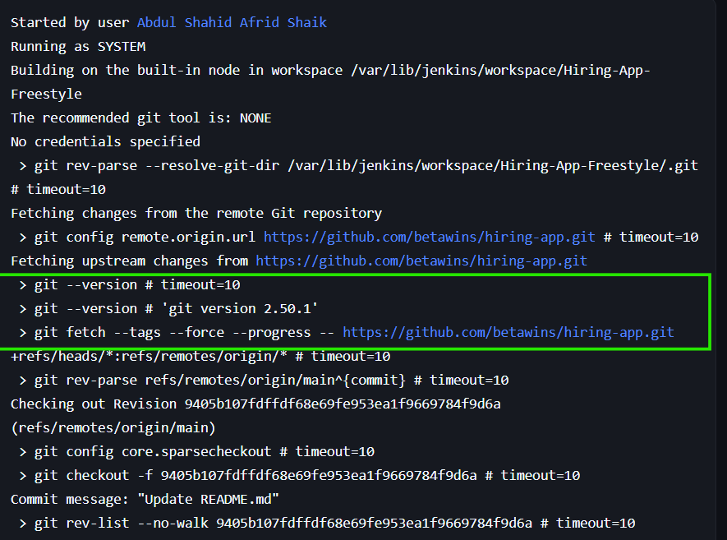
- SonarQube dashboard showing the project analysis.
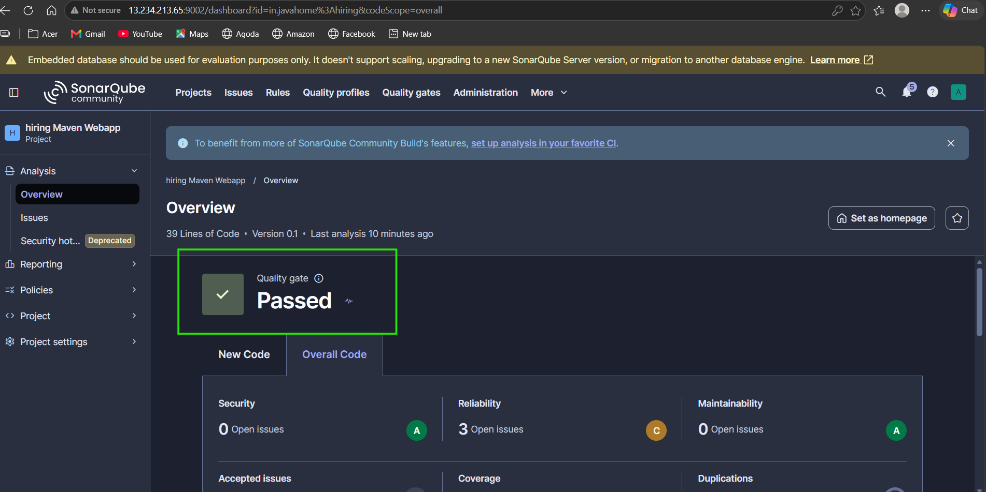
- Nexus Browse page showing the uploaded WAR artifact.
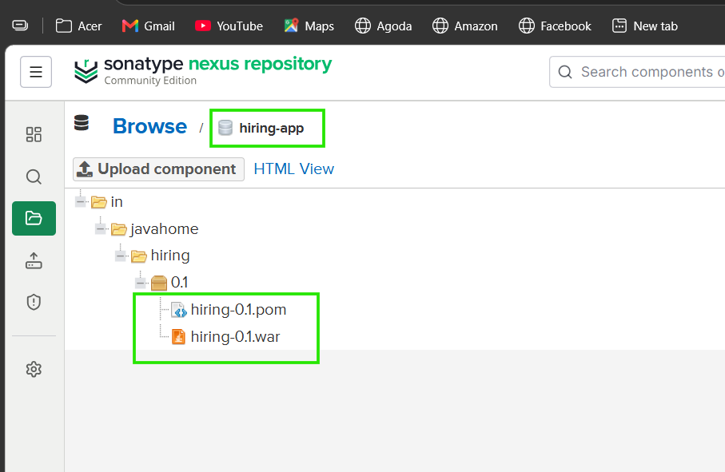
- Tomcat application page showing the deployed application.
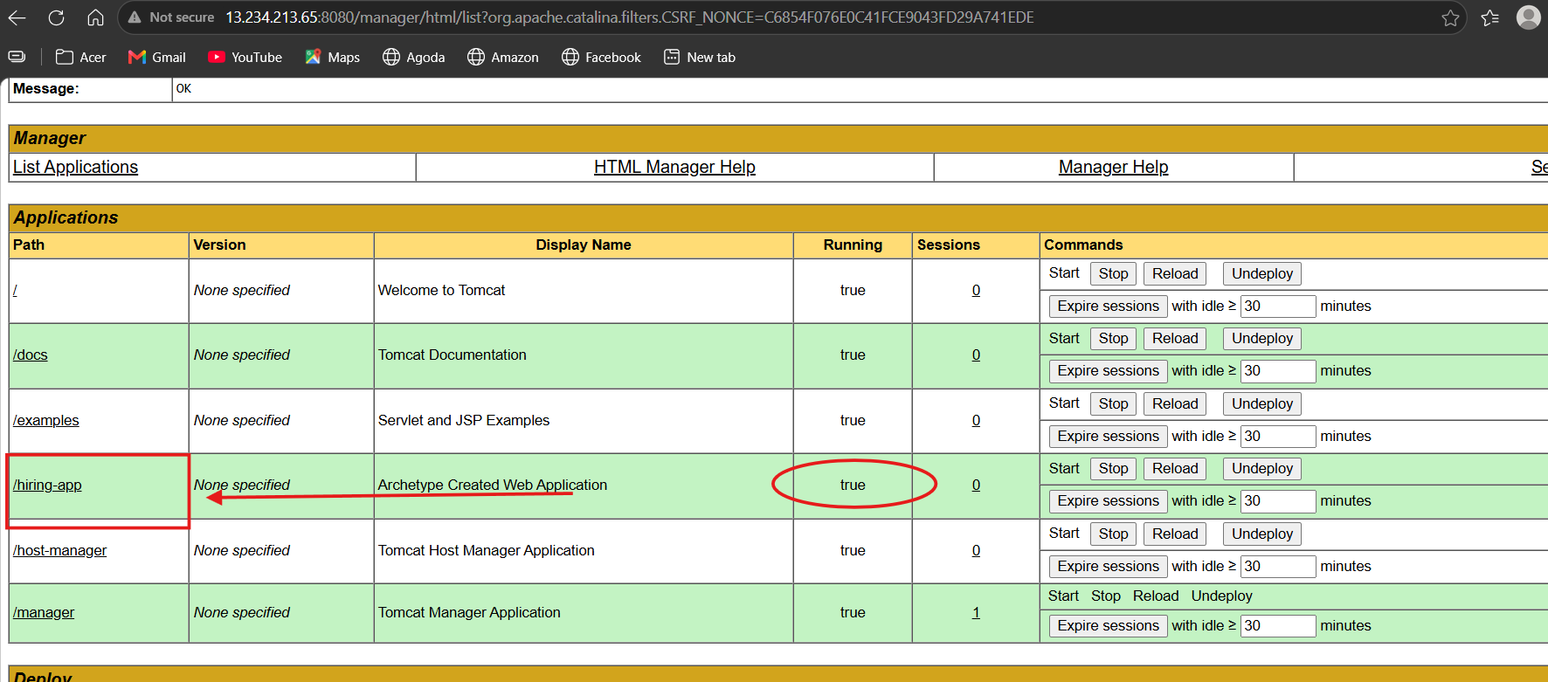
- Slack messages showing Build #3 failure and Build #4 success.

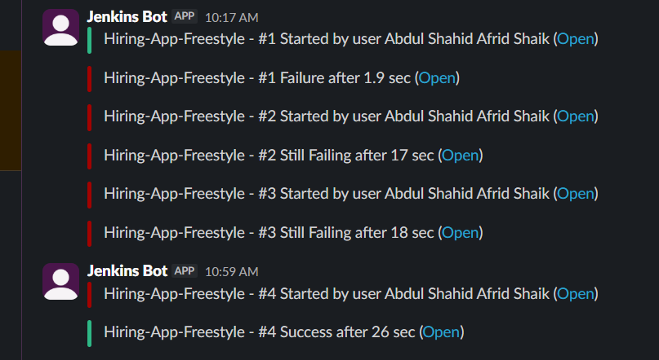
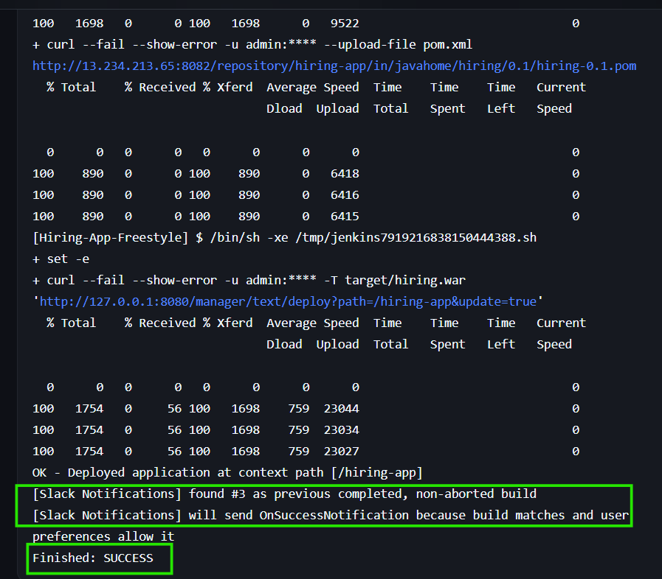
- Jenkins Build History showing the successful build.
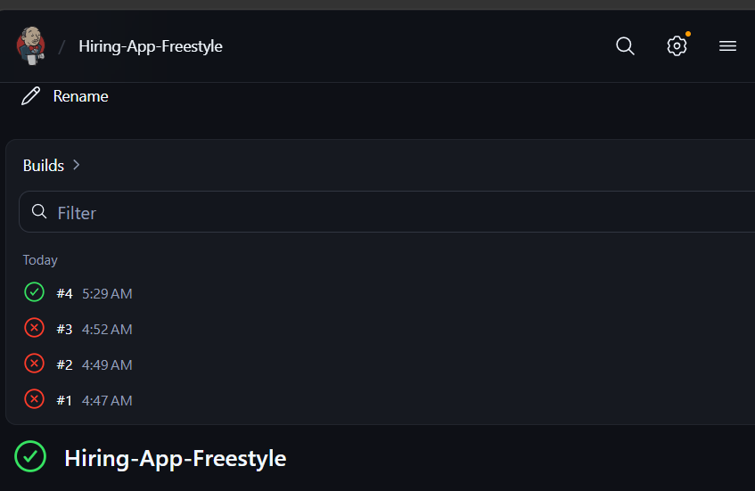

13. Result
A Jenkins Freestyle CI/CD job was configured for the hiring-app Java web application using GitHub, Docker, Maven, SonarQube, Nexus Repository Manager, Tomcat, and Slack.
The latest reported Jenkins build completed successfully, and Slack received the corresponding success notification.

14. Conclusion
This practical demonstrated how a Jenkins Freestyle job can automate source code checkout, Maven compilation and packaging, SonarQube analysis, artifact repository upload, Tomcat deployment, and Slack notifications. It also demonstrated the use of Docker for a consistent Maven build environment and Jenkins Credentials for managing service authentication.

2) Setup a Jenkins CICD pipeline using Declarative pipeline using feature-1.1 branch.
Source Code: https://github.com/betawins/sabear_simplecutomerapp/tree/feature-1.1
stages:
- Git Clone
- SonarQube Integration
- Maven Compilation
- Nexus Artifactory
- Slack Notification
- Deploy On tomcat

Task 2: Jenkins CI/CD Pipeline Using Declarative Pipeline
Jenkins Job: Hiring-App-Declarative

1. Objective
To automate the application CI/CD process using a Jenkins Declarative Pipeline, covering Git clone, SonarQube analysis, Maven packaging, Nexus artifact upload, Tomcat deployment, and Slack notifications.

2. Tools Used
- Jenkins – CI/CD automation
- GitHub – Source code management
- SonarQube – Code quality analysis
- Maven – Application build and packaging
- Nexus Repository – Artifact storage
- Apache Tomcat – Application deployment
- Slack – Build notifications

3. Correct Execution Flow
GitHub → Git Clone → SonarQube Analysis → Maven Package → Upload WAR to Nexus → Deploy WAR on Tomcat → Slack Notification

4. Jenkins Job Configuration
- Open Jenkins.
- Click New Item.
- Enter Hiring-App-Declarative.
- Select Pipeline and click OK.
- Under Pipeline, select Pipeline script.
- Paste the Jenkinsfile provided below.
- Click Save and then Build Now.

5. Complete Jenkinsfile
pipeline {
agent any

environment {
SONAR_URL = 'http://13.234.213.65:9002'
NEXUS_URL = 'http://13.234.213.65:8082'
NEXUS_REPO = 'hiring-app'
TOMCAT_URL = 'http://13.234.213.65:8080'
}

stages {
stage('Git Clone') {
steps {
git branch: 'feature-1.1',
url: 'https://github.com/betawins/sabear_simplecutomerapp.git'
}
}

stage('SonarQube Integration') {
steps {
withCredentials([
string(
credentialsId: 'jenkins-4-sonar',
variable: 'SONAR_TOKEN'
)
]) {
sh '''
mvn -B clean verify \
org.sonarsource.scanner.maven:sonar-maven-plugin:5.3.0.6276:sonar \
-Dmaven.compiler.source=8 \
-Dmaven.compiler.target=8 \
-Dsonar.host.url="$SONAR_URL" \
-Dsonar.token="$SONAR_TOKEN"
'''
}
}
}

stage('Maven Compilation') {
steps {
sh '''
mvn -B package -DskipTests \
-Dmaven.compiler.source=8 \
-Dmaven.compiler.target=8
'''
}
}

stage('Nexus Artifactory') {
steps {
withCredentials([
usernamePassword(
credentialsId: 'nexus-credentials',
usernameVariable: 'NEXUS_USER',
passwordVariable: 'NEXUS_PASSWORD'
)
]) {
sh '''
set -e

WAR_FILE=$(find target -maxdepth 1 \
-name '*.war' -type f | head -n 1)

test -n "$WAR_FILE"

curl --fail --show-error \
-u "$NEXUS_USER:$NEXUS_PASSWORD" \
--upload-file "$WAR_FILE" \
"$NEXUS_URL/repository/$NEXUS_REPO/in/javahome/simplecustomerapp/1.0/simplecustomerapp-1.0.war"
'''
}
}
}

stage('Deploy On Tomcat') {
steps {
withCredentials([
usernamePassword(
credentialsId: 'tomcat-credentials',
usernameVariable: 'TOMCAT_USER',
passwordVariable: 'TOMCAT_PASSWORD'
)
]) {
sh '''
set -e

WAR_FILE=$(find target -maxdepth 1 \
-name '*.war' -type f | head -n 1)

test -n "$WAR_FILE"

curl --fail --show-error \
-u "$TOMCAT_USER:$TOMCAT_PASSWORD" \
-T "$WAR_FILE" \
"$TOMCAT_URL/manager/text/deploy?path=/simplecustomerapp&update=true"
'''
}
}
}
}

post {
success {
slackSend(
color: 'good',
message: "SUCCESS: ${env.JOB_NAME} #${env.BUILD_NUMBER}"
)
}

failure {
slackSend(
color: 'danger',
message: "FAILED: ${env.JOB_NAME} #${env.BUILD_NUMBER}"
)
}
}
}
Important: Paste only the code inside the code block into Jenkins. Do not paste the opening or closing Markdown backticks.

6. Stage-by-Stage Implementation

Stage 1: Git Clone
The pipeline retrieves the source code from GitHub and checks out the feature-1.1 branch.
Repository: https://github.com/betawins/sabear_simplecutomerapp.git

Stage 2: SonarQube Integration
The pipeline runs Maven's SonarScanner plugin to submit the project for code analysis.
The SonarQube token is retrieved from Jenkins Credentials using withCredentials.
Successful console message:
ANALYSIS SUCCESSFUL

Stage 3: Maven Compilation / Packaging
Command:
mvn -B package -DskipTests
Maven packages the application as a WAR file.
Example artifact from the successful build:
target/SimpleCustomerApp-9-SNAPSHOT.war
The -DskipTests option skips test execution. This stage packages the application; the pipeline does not run unit tests.

Stage 4: Nexus Artifactory
The pipeline locates the generated WAR file and uploads it to the Nexus hiring-app repository using curl.
Artifact upload path:
/repository/hiring-app/in/javahome/simplecustomerapp/1.0/simplecustomerapp-1.0.war
Jenkins retrieves the Nexus username and password from the nexus-credentials entry.

Stage 5: Deploy on Tomcat
The pipeline uploads the WAR file through Tomcat Manager's Text API.
Deployment context path:
/simplecustomerapp
The update=true parameter allows the existing application at that context path to be updated.
Successful console message:
OK - Deployed application at context path [/simplecustomerapp]

Stage 6: Slack Notification
The post block executes after the pipeline stages finish.
- success: Sends a green Slack notification.
- failure: Sends a red Slack notification.
The final successful build log confirms that the slackSend step executed.

7. Errors Encountered and Solutions

Error 1: Groovy Compilation Error
Error message:
unexpected char: '\' @ line 1, column 1`
Cause: Markdown code-fence characters such as ```groovy were pasted into the Jenkins Pipeline script field.
Solution: Remove the opening and closing code fences and paste only the actual Jenkinsfile.

Error 2: Tomcat HTTP 403 Forbidden
Error message:
curl: (22) The requested URL returned error: 403
Cause: Tomcat Manager's RemoteCIDRValve restricted requests from IP addresses not included in its allowlist.
The configuration file was:
/opt/tomcat/webapps/manager/META-INF/context.xml
The existing configuration allowed localhost, the user's public IP 106.192.15.83, and the 10.0.0.0/8 private network.
The Tomcat access log showed Jenkins deployment requests arriving from 13.126.223.124 and returning HTTP 403.
Solution: Add the observed Jenkins source IP to the existing allowlist:
<Valve className="org.apache.catalina.valves.RemoteCIDRValve"
allow="127.0.0.0/8,::1/128,106.192.15.83/32,10.0.0.0/8,13.126.223.124/32" />
Save the file and restart the manually installed Tomcat server:
sudo /opt/tomcat/bin/shutdown.sh
sudo /opt/tomcat/bin/startup.sh
Then rerun the Jenkins pipeline.
Result: The deployment succeeded. The successful console output confirmed:
OK - Deployed application at context path [/simplecustomerapp]
Note: 13.126.223.124 was the source IP observed in the logs. If that address changes, the allowlist may need updating. Allow only trusted source addresses; do not remove the restriction entirely.

8. Jenkins Credentials
Credential ID | Purpose
jenkins-4-sonar | SonarQube token
nexus-credentials | Nexus authentication
tomcat-credentials | Tomcat Manager authentication
slack-token | Slack notifications
Credentials are stored in Jenkins rather than hardcoded into the pipeline.

9. Final Verification
The successful build console confirmed:
- Git Clone completed.
- SonarQube analysis succeeded.
- Maven generated the WAR file.
- Nexus accepted the artifact upload.
- Tomcat deployed the application.
- Slack notification step executed.
- Jenkins ended with Finished: SUCCESS.
Application URL:
http://13.234.213.65:8080/simplecustomerapp
Open this URL in a browser to verify the deployed application.

10. Conclusion
The Declarative Pipeline automates the process from source-code retrieval to application deployment and Slack notification. The HTTP 403 error was resolved by updating Tomcat Manager's IP allowlist to permit the Jenkins request source. The final pipeline execution completed successfully.
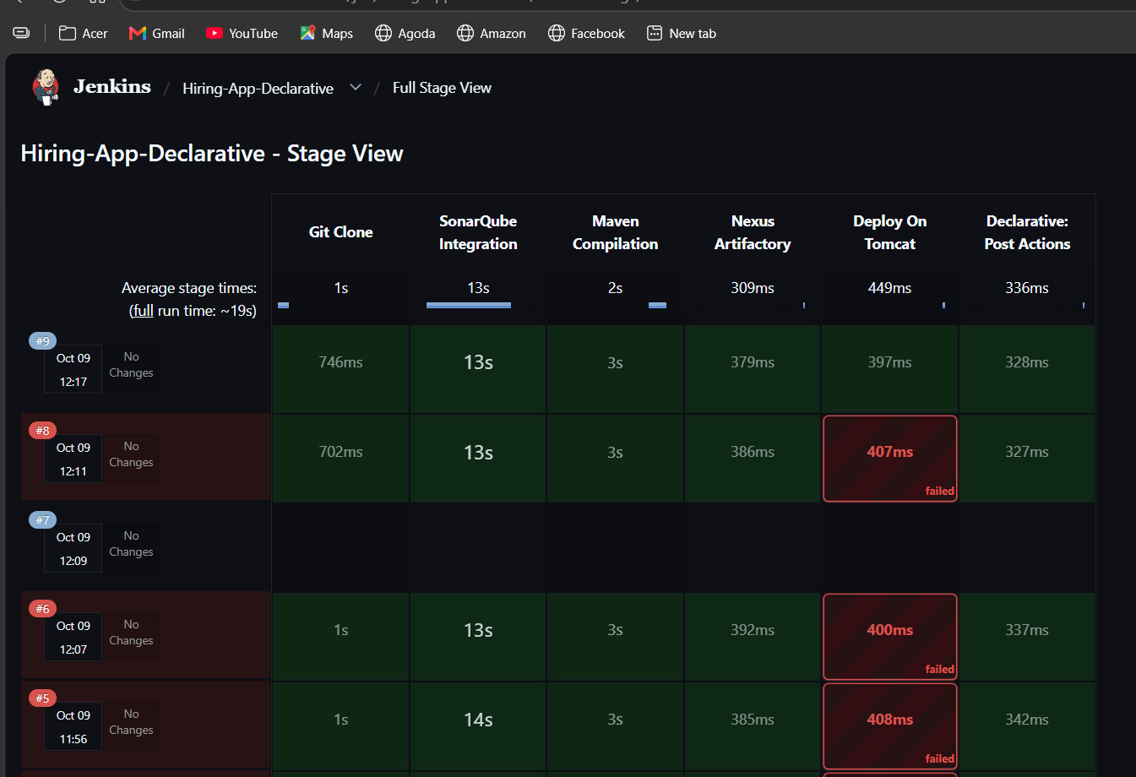
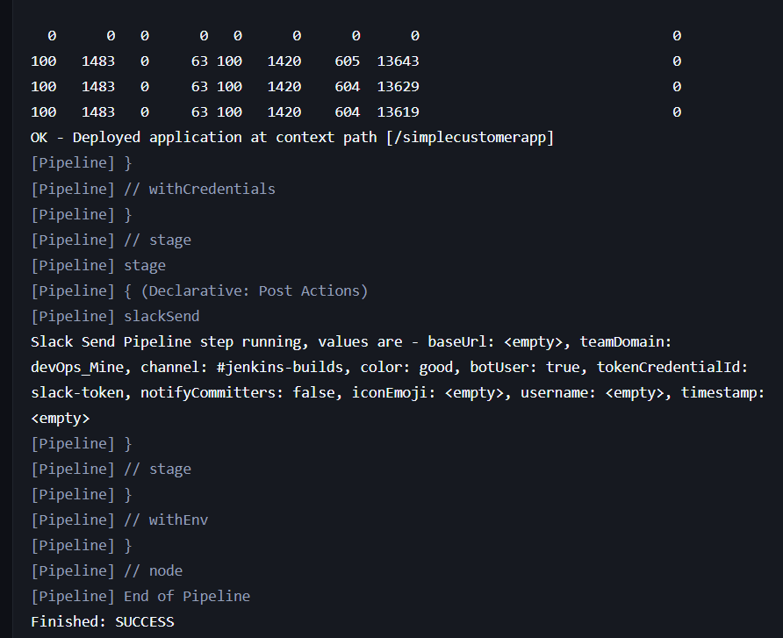

3) Setup a Jenkins CICD pipeline using Scripted pipeline using feature-1.1 branch.
Source Code: https://github.com/betawins/sabear_simplecutomerapp/tree/feature-1.1
stages:
- Git Clone
- SonarQube Integration
- Maven Compilation
- Nexus Artifactory
- Slack Notification
- Deploy On tomcat

Task 3: Jenkins CI/CD Pipeline Using Scripted Pipeline
Job Name: Hiring-App-Scripted

1. Objective
To automate the application CI/CD process using a Jenkins Scripted Pipeline on the feature-1.1 branch, including source code checkout, code analysis, build packaging, artifact upload, application deployment, and Slack notification.

2. Tools Used
- Jenkins — CI/CD automation
- GitHub — Source code management
- SonarQube — Code quality analysis
- Maven — Application build and packaging
- Nexus Repository — Artifact storage
- Apache Tomcat — Application deployment
- Slack — Build notifications

3. Pipeline Flow
1. Git Clone
2. SonarQube Integration
3. Maven Compilation
4. Nexus Artifactory
5. Deploy On Tomcat
6. Slack Notification

4. Jenkins Job Configuration
- Open Jenkins and click New Item.
- Enter Hiring-App-Scripted.
- Select Pipeline and click OK.
- Under Pipeline, select Pipeline script.
- Paste the Scripted Pipeline code.
- Click Save → Build Now.

5. Scripted Pipeline Code
The pipeline uses Groovy control flow with node, stage, try, and catch. This is the script structure used for Task 3, with the node selection set to jenkins-agent-1 because the built-in node did not have Maven available in its execution environment.

node('jenkins-agent-1') {
env.SONAR_URL = 'http://13.234.213.65:9002'
env.NEXUS_URL = 'http://13.234.213.65:8082'
env.NEXUS_REPO = 'hiring-app'
env.TOMCAT_URL = 'http://13.234.213.65:8080'

try {
stage('Git Clone') {
git branch: 'feature-1.1',
url: 'https://github.com/betawins/sabear_simplecutomerapp.git'
}

stage('SonarQube Integration') {
withCredentials([
string(
credentialsId: 'jenkins-4-sonar',
variable: 'SONAR_TOKEN'
)
]) {
sh '''
mvn -B clean verify \
org.sonarsource.scanner.maven:sonar-maven-plugin:5.3.0.6276:sonar \
-Dmaven.compiler.source=8 \
-Dmaven.compiler.target=8 \
-Dsonar.host.url="$SONAR_URL" \
-Dsonar.token="$SONAR_TOKEN"
'''
}
}

stage('Maven Compilation') {
sh '''
mvn -B package -DskipTests \
-Dmaven.compiler.source=8 \
-Dmaven.compiler.target=8
'''
}

stage('Nexus Artifactory') {
withCredentials([
usernamePassword(
credentialsId: 'nexus-credentials',
usernameVariable: 'NEXUS_USER',
passwordVariable: 'NEXUS_PASSWORD'
)
]) {
sh '''
set -e
WAR_FILE=$(find target -maxdepth 1 \
-name '*.war' -type f | head -n 1)
test -n "$WAR_FILE"

curl --fail --show-error \
-u "$NEXUS_USER:$NEXUS_PASSWORD" \
--upload-file "$WAR_FILE" \
"$NEXUS_URL/repository/$NEXUS_REPO/in/javahome/simplecustomerapp/1.0/simplecustomerapp-1.0.war"
'''
}
}

stage('Deploy On Tomcat') {
withCredentials([
usernamePassword(
credentialsId: 'tomcat-credentials',
usernameVariable: 'TOMCAT_USER',
passwordVariable: 'TOMCAT_PASSWORD'
)
]) {
sh '''
set -e
WAR_FILE=$(find target -maxdepth 1 \
-name '*.war' -type f | head -n 1)
test -n "$WAR_FILE"

curl --fail --show-error \
-u "$TOMCAT_USER:$TOMCAT_PASSWORD" \
-T "$WAR_FILE" \
"$TOMCAT_URL/manager/text/deploy?path=/simplecustomerapp&update=true"
'''
}
}

stage('Slack Notification') {
slackSend(
color: 'good',
message: "SUCCESS: ${env.JOB_NAME} #${env.BUILD_NUMBER}"
)
}

} catch (err) {
slackSend(
color: 'danger',
message: "FAILED: ${env.JOB_NAME} #${env.BUILD_NUMBER} - Check Jenkins console"
)
throw err
}
}

6. Stage Explanation
1. Git Clone
Clones the source code from the GitHub repository and checks out the feature-1.1 branch.
2. SonarQube Integration
Runs the SonarScanner Maven plugin to analyze the project and uploads the analysis report to SonarQube.
3. Maven Compilation
Runs mvn package -DskipTests to package the application into a WAR file. Unit tests are skipped in this command.
4. Nexus Artifactory
Uploads the generated WAR file to the Nexus hiring-app repository using curl and Jenkins credentials.
5. Deploy On Tomcat
Deploys the WAR file through the Tomcat Manager Text API at the /simplecustomerapp context path.
6. Slack Notification
Sends a green notification after success or a red notification when an earlier stage fails.

7. Error Encountered and Solution

Error: mvn: command not found
Cause: The Scripted Pipeline ran on the built-in Jenkins node:
/var/lib/jenkins/workspace/Hiring-App-Scripted
Maven was not available in that node's execution environment. The previous successful Declarative Pipeline ran on jenkins-agent-1, where Maven was available.
Solution: Change the node declaration from:
node {
to:
node('jenkins-agent-1') {
This directs the job to the node used by the previous successful build. The node label must match the actual configured label.

8. Jenkins Credentials
Credential ID | Purpose
jenkins-4-sonar | SonarQube token
nexus-credentials | Nexus authentication
tomcat-credentials | Tomcat Manager authentication
slack-token | Slack notification token

9. Final Result
The first build successfully cloned the GitHub repository and checked out feature-1.1. It then failed during SonarQube integration because the selected built-in node could not find Maven.
The node selection was changed to target jenkins-agent-1, where Maven had worked in the previous task. The final successful build for Task 3 has not yet been confirmed. After rerunning the pipeline, verify that all stages complete and Jenkins reports Finished: SUCCESS.
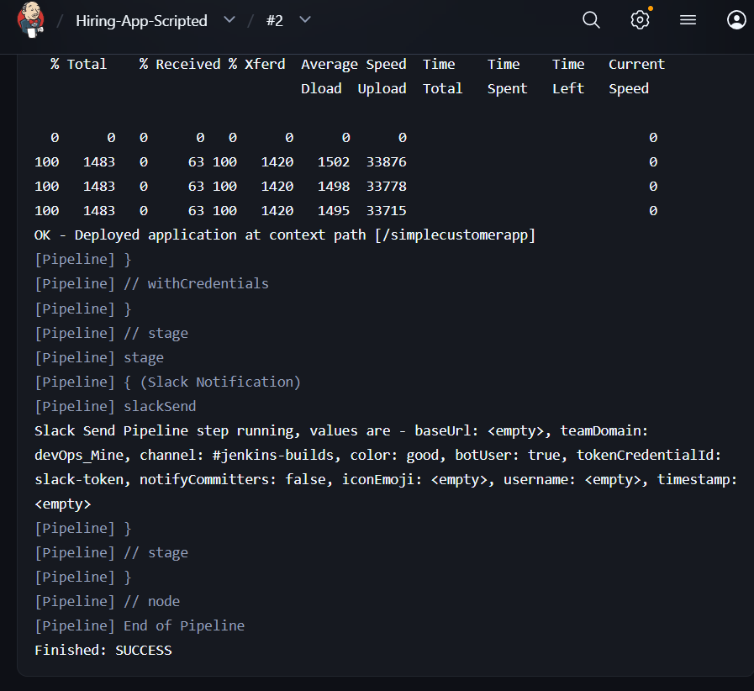
4) Write sample skeleton of pipelines.

Task 4: Write Sample Skeleton of Pipelines

Objective
To understand the basic structure of Jenkins Declarative and Scripted Pipelines.

1. Declarative Pipeline Skeleton
pipeline {
agent any

stages {
stage('Stage 1') {
steps {
echo 'Executing Stage 1'
}
}

stage('Stage 2') {
steps {
echo 'Executing Stage 2'
}
}
}

post {
success {
echo 'Pipeline completed successfully'
}

failure {
echo 'Pipeline failed'
}
}
}

2. Scripted Pipeline Skeleton
node {
try {
stage('Stage 1') {
echo 'Executing Stage 1'
}

stage('Stage 2') {
echo 'Executing Stage 2'
}

} catch (err) {
echo 'Pipeline failed'
throw err
}
}

3. Key Differences
Declarative Pipeline | Scripted Pipeline
Starts with pipeline {} | Starts with node {}
Uses stages and steps blocks | Uses Groovy scripting and stage blocks
Has a predefined, structured syntax | Offers greater programming flexibility
Supports a post block for build results | Commonly handles errors using try/catch
Result: Both skeletons define stages that Jenkins executes in sequence. These are basic templates; replace the sample stages with actual build, test, analysis, and deployment steps as required.
5) Create a parameterized job in Jenkins.
Source Code: https://github.com/betawins/spring3-mvc-maven-xml-hello-world-1.git

Task 5: Create a Parameterized Job in Jenkins

1. Objective
To create a parameterized Jenkins Freestyle job that accepts user-defined input values and executes the build based on the selected parameter.

2. Source Code
GitHub repository: https://github.com/betawins/spring3-mvc-maven-xml-hello-world-1.git

3. Job Configuration
- Job Name: Parameterized-Job
- Job Type: Freestyle project
- Parameter Type: Choice Parameter
- Parameter Name: ENVIRONMENT
- Choices: DEV, TEST, PROD

4. Practical Implementation

Step 1: Create a Jenkins Job
- Open Jenkins and click New Item.
- Enter Parameterized-Job.
- Select Freestyle project.
- Click OK.

Step 2: Configure the Parameter
- Open the job's Configure page.
- Select This project is parameterized.
- Click Add Parameter → Choice Parameter.
- Enter the following details:
  - Name: ENVIRONMENT
  - Choices:
  - DEV
  - TEST
PROD
- Save the configuration.

Step 3: Configure Source Code Management
- Under Source Code Management, select Git.
- Enter the repository URL:
https://github.com/betawins/spring3-mvc-maven-xml-hello-world-1.git
- Configure the correct branch under Branches to build.
- Save the configuration.

Step 4: Add a Build Step
Under Build Steps, select Execute shell and enter:
echo "Selected environment: $ENVIRONMENT"
echo "Building application from GitHub"
Save the configuration.

Step 5: Run the Parameterized Job
- Open Parameterized-Job.
- Click Build with Parameters.
- Select DEV, TEST, or PROD.
- Click Build.
- Open Console Output to verify the selected value.

5. Error Encountered and Solution

Error: Couldn't find any revision to build
Console error:
ERROR: Couldn't find any revision to build. Verify the repository and branch configuration for this job.
Cause: Jenkins attempted to build origin/main, but it could not find that branch in the configured repository.
Solution:
- Open the job's Configure page.
- Go to Source Code Management → Git → Branches to build.
- Check the repository's actual branch name.
- Enter the matching branch specifier, such as */master if master exists.
- Save and rebuild the job.
The correct branch must be verified from the repository; do not assume main or master exists.

6. Result
The job was configured with an ENVIRONMENT choice parameter containing DEV, TEST, and PROD. The first build cloned the repository but failed during branch checkout because Jenkins could not find origin/main.
After correcting the branch configuration, rerun the job and verify the selected environment in the console output.
Note: This exercise demonstrates parameterized execution. Selecting an environment does not automatically deploy the application to that environment.

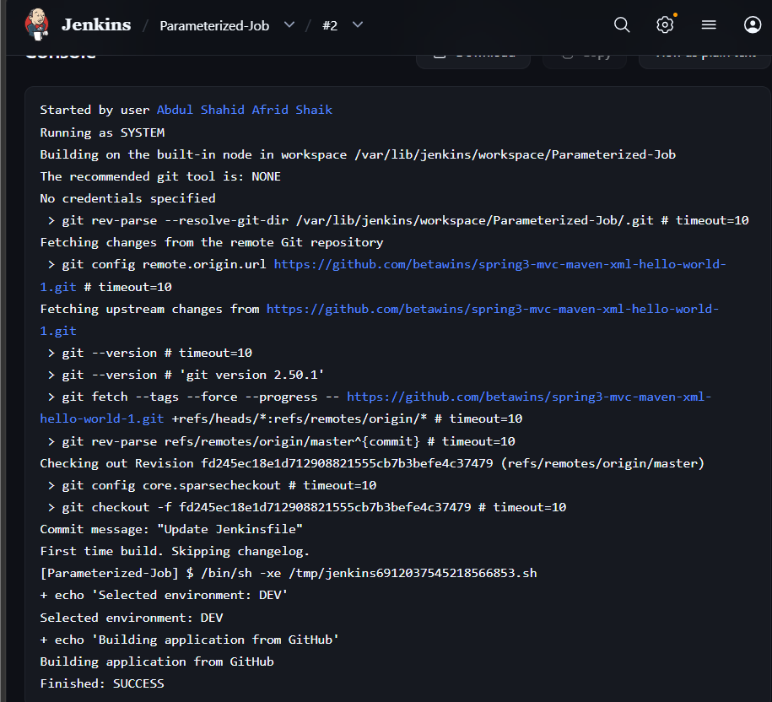
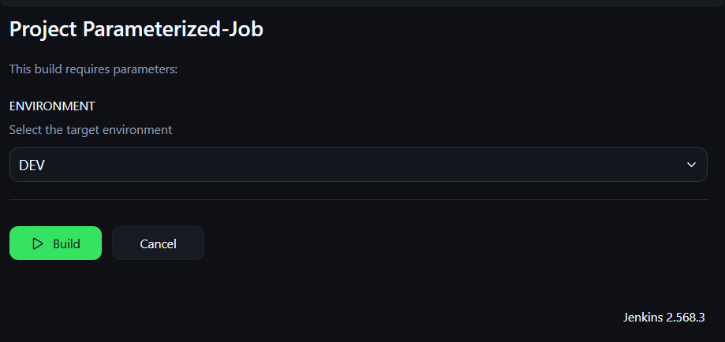

6) Setup one slave machine for Jenkins.

Task 6: Set Up One Slave Machine in Jenkins (Jenkins Agent)

1. Objective
To configure a separate machine as a Jenkins Agent and execute Jenkins Pipeline jobs on that machine instead of the Jenkins controller.

2. Practical Setup Details
- Jenkins Job Name: jenkins-4-task-6
- Agent Node Name: jenkins-agent-1
- Agent Label: agent-1
- Job Type: Pipeline
- Status: Successfully executed

3. Configuration Steps

Step 1: Verify the Jenkins Agent
- Open the Jenkins dashboard.
- Navigate to Manage Jenkins → Nodes.
- Select jenkins-agent-1.
- Verify that the agent status is Online.

Step 2: Create a Pipeline Job
- Click New Item.
- Enter the job name jenkins-4-task-6.
- Select Pipeline.
- Click OK.

Step 3: Configure the Pipeline
- Scroll to the Pipeline section.
- Set Definition to Pipeline script.
- Enter the following script.
pipeline {
agent { label 'agent-1' }

stages {
stage('Test Agent') {
steps {
sh '''
echo "Running on Jenkins Agent"
hostname
whoami
'''
}
}
}
}
- Click Save.

Step 4: Execute the Pipeline
- Open jenkins-4-task-6.
- Click Build Now.
- Open Console Output.
- Verify that the build completes successfully.

4. Pipeline Explanation
- pipeline: Defines a Declarative Pipeline.
- agent { label 'agent-1' }: Tells Jenkins to execute the Pipeline on a node matching the agent-1 label.
- stages: Groups the steps into stages.
- stage('Test Agent'): Defines a stage to test the agent.
- sh: Executes shell commands on the selected agent.
- hostname: Displays the hostname of the machine executing the commands.
- whoami: Displays the current execution user.

5. Verification
The Pipeline executed successfully using the existing Jenkins agent configuration.
- Agent node: jenkins-agent-1
- Label used: agent-1
- Build result: SUCCESS
The hostname and whoami commands help verify which machine and user executed the commands.

6. Controller vs Agent
Jenkins Controller | Jenkins Agent
Manages Jenkins jobs and scheduling. | Executes assigned build steps.
Coordinates the build process. | Provides resources for running jobs.
Assigns jobs to suitable nodes. | Runs commands based on the job's configuration and label.

7. Result
Successfully configured and tested a Jenkins Pipeline to execute on the existing Jenkins Agent using the agent-1 label.
Task 6 completed successfully.

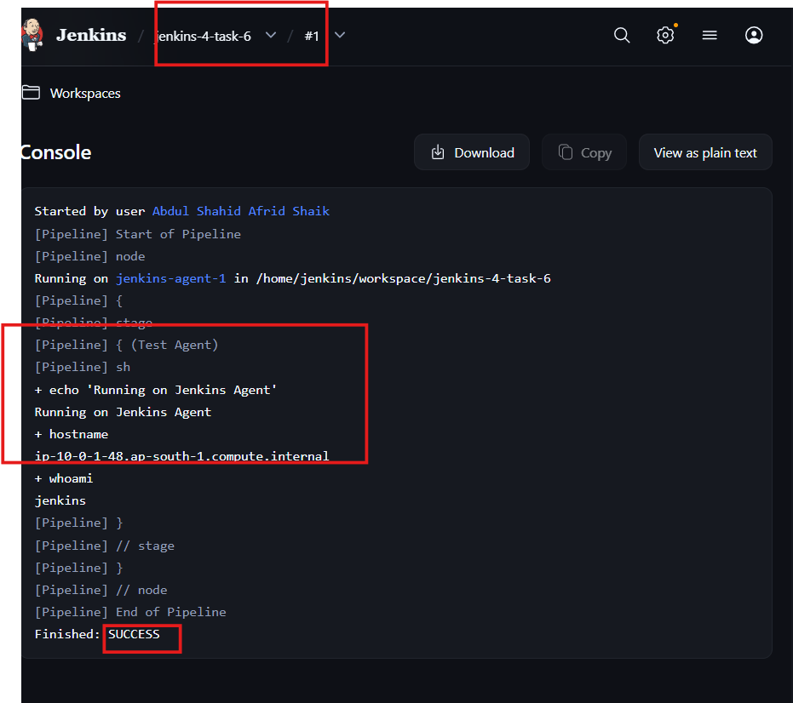
Jenkins Official Documentation
Recommended
- Pipeline: https://www.jenkins.io/doc/book/pipeline/
- Environment Variables: https://www.jenkins.io/doc/book/pipeline/jenkinsfile/#using-environment-variables
- Parameters: https://www.jenkins.io/doc/book/pipeline/syntax/#parameters
- Handling credentials in Pipeline: https://www.jenkins.io/doc/book/pipeline/jenkinsfile/#handling-credentials

Pipeline
Jenkins – an open source automation server which enables developers around the world to reliably build, test, and deploy their softwarejenkins.io

Using a Jenkinsfile
Jenkins – an open source automation server which enables developers around the world to reliably build, test, and deploy their softwarejenkins.io

