Jenkins-28-09-2026

- Install Jenkins and run Jenkins on port number 8081.

Objective
To install Jenkins on an Amazon Linux 2023 EC2 instance and configure Jenkins to run on port 8081.

Prerequisites
- AWS account
- Amazon Linux 2023 EC2 instance
- t3.micro instance
- Security Group with:
  - SSH — Port 22
  - Jenkins — Port 8081
- SSH key pair (jenkins-key.pem)
- Java 21

Steps of Implementation
- Launch an Amazon Linux 2023 EC2 instance.
- Connect to the instance using SSH:
ssh -i jenkins-key.pem ec2-user@<Public-IP>
- Update system packages:
sudo dnf update -y
- Install Java:
sudo dnf install java-21-amazon-corretto -y
- Add the Jenkins repository and import the Jenkins key.
- Install Jenkins:
sudo dnf install jenkins -y
- Configure Jenkins to run on port 8081.
- Reload systemd:
sudo systemctl daemon-reload
- Start Jenkins:
sudo systemctl start jenkins
- Enable Jenkins at boot:
sudo systemctl enable jenkins
- Verify Jenkins status:
sudo systemctl status jenkins
- Access Jenkins from the browser:
http://13.126.209.246/:8081

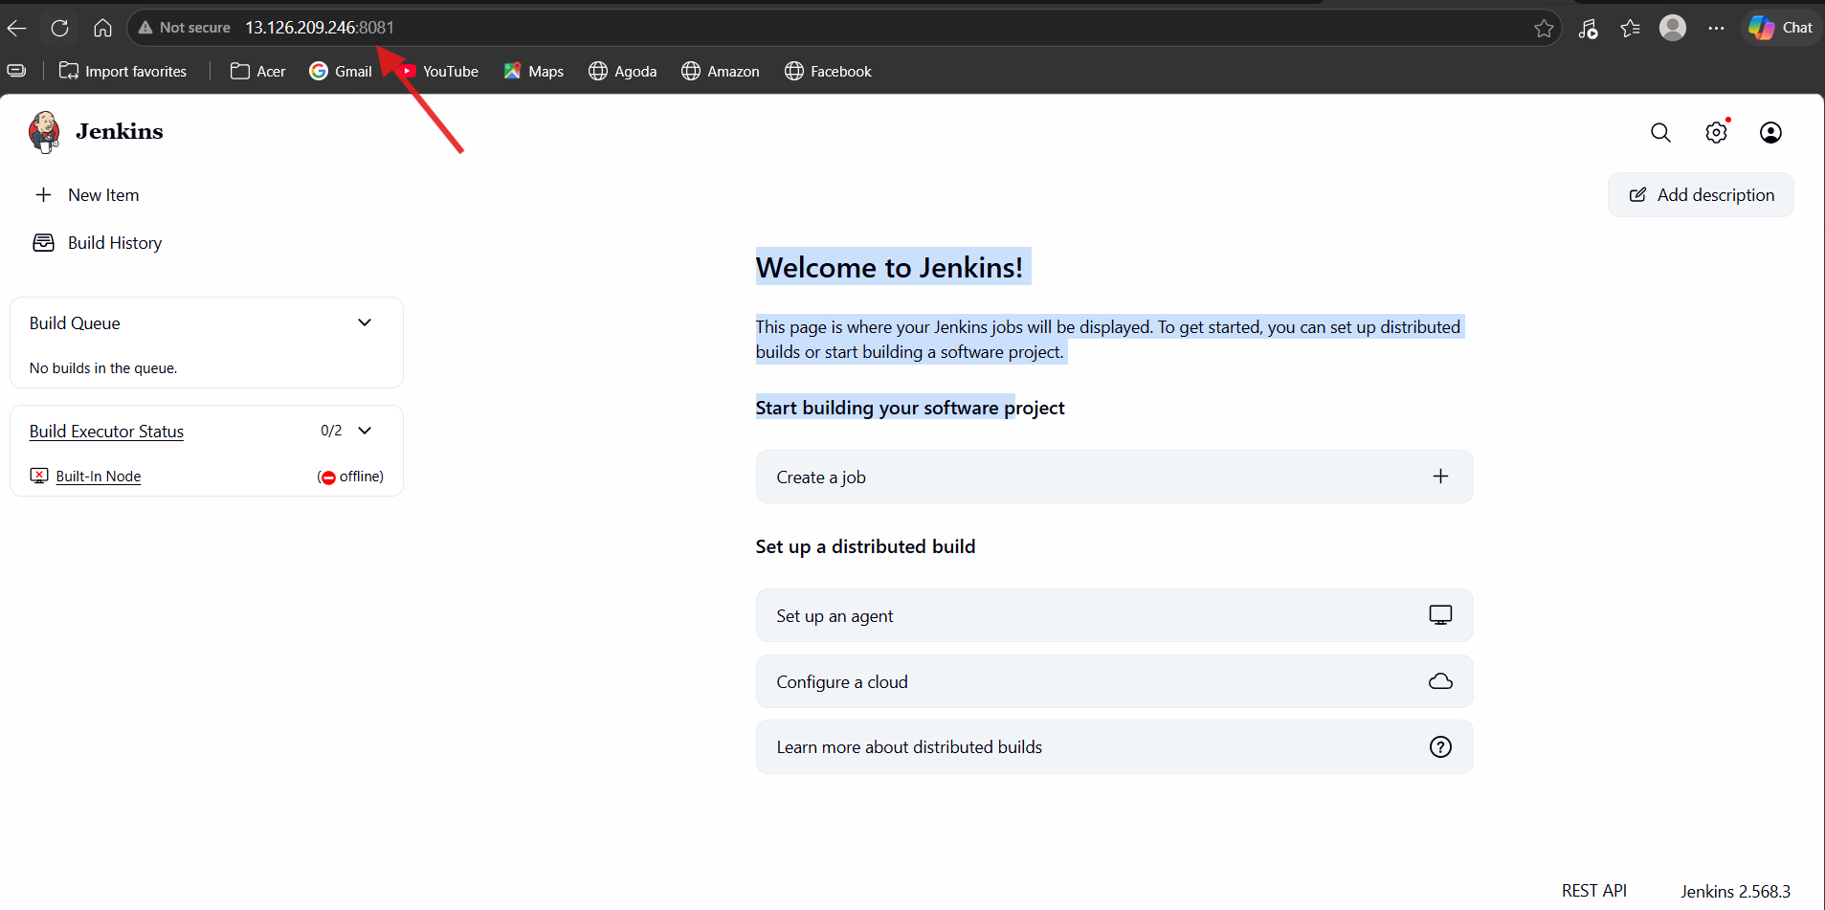

- Retrieve the initial administrator password:
sudo cat /var/lib/jenkins/secrets/initialAdminPassword
- Enter the password and complete the initial Jenkins setup.

Result
Jenkins was successfully installed and configured on Amazon Linux 2023, running on port 8081, and the Jenkins Dashboard was successfully accessed through the EC2 public IP.

- Secure Jenkins server

Objective
To secure Jenkins by configuring authentication and authorization so that only authorized users can access and manage Jenkins.

Prerequisites
- Jenkins installed and running
- Jenkins Dashboard accessible
- Administrator account created

Steps of Implementation
- Open:
Manage Jenkins → Security
- Keep Security Realm as:
Jenkins' own user database
- Keep Allow users to sign up unchecked.
- Under Authorization, select:
Matrix-based security
- Verify the administrator account has:
Overall → Administer
- Verify:
  - Anonymous → No permissions
  - Authenticated Users → No unnecessary permissions

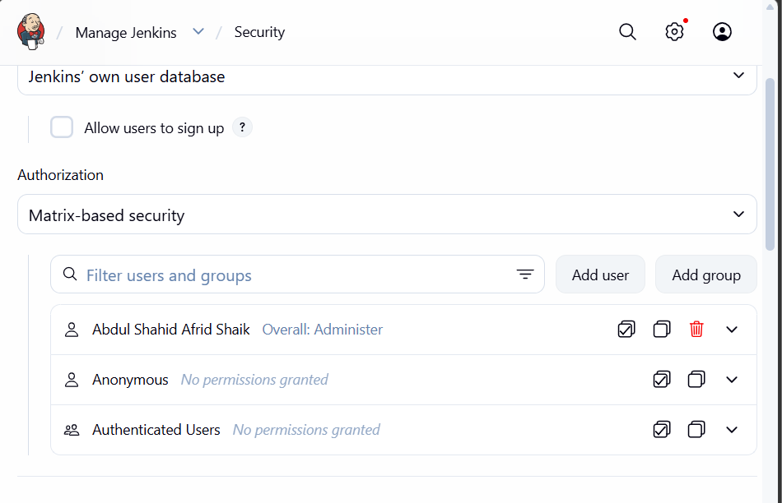

- Click Save.
- Log out and log back in to verify the security configuration.

Result
Jenkins was successfully secured using Matrix-based security. Anonymous access was disabled, user self-registration was disabled, and the administrator retained full administrative privileges.

- Create users called DevOps, Testing in Jenkins with Limited access.

Objective
To create separate DevOps and Testing users in Jenkins and provide them with limited permissions.

Prerequisites
- Jenkins installed and running
- Administrator account available
- Matrix-based security enabled

Steps of Implementation
- Go to Manage Jenkins → Users.
- Click Create User.
- Create the user:
Username: DevOps
- Create another user:
Username: Testing
- Go to:
Manage Jenkins → Security
- Under Matrix-based security, add:
  - DevOps
  - Testing
- Give both users:
  - Overall → Read
  - Job → Read
  - Job → Build
  - Job → Workspace
- Do not give them administrative permissions such as:
  - Overall → Administer
  - Job → Configure
  - Job → Delete
  - Credentials → Manage
- Click Save.
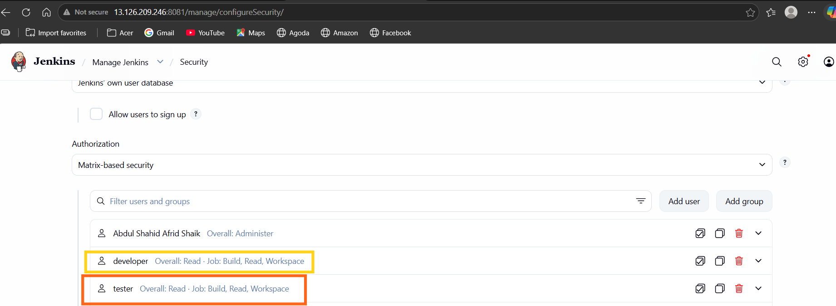

Result
The DevOps and Testing users were successfully created with limited Jenkins permissions, while administrative privileges remained restricted to the administrator account.
- Configure labels and restrict the jobs to execute based on label only.

Jenkins-01 — Task 4: Configure Labels and Restrict Jobs

Objective
To configure a Jenkins node label and restrict a Jenkins job so that it executes only on a node matching the specified label.

Prerequisites
- Jenkins installed and running
- Built-In Node available
- Administrator access
- Jenkins job created

Steps of Implementation
- Go to Manage Jenkins → Nodes.
- Open Built-In Node → Configure.
- Under Labels, enter:
Linux
- Save the node configuration.
- Create a Freestyle job named:
Label-Test
- Open the job configuration.
- Select Restrict where this project can be run.
- Enter the label:
Linux
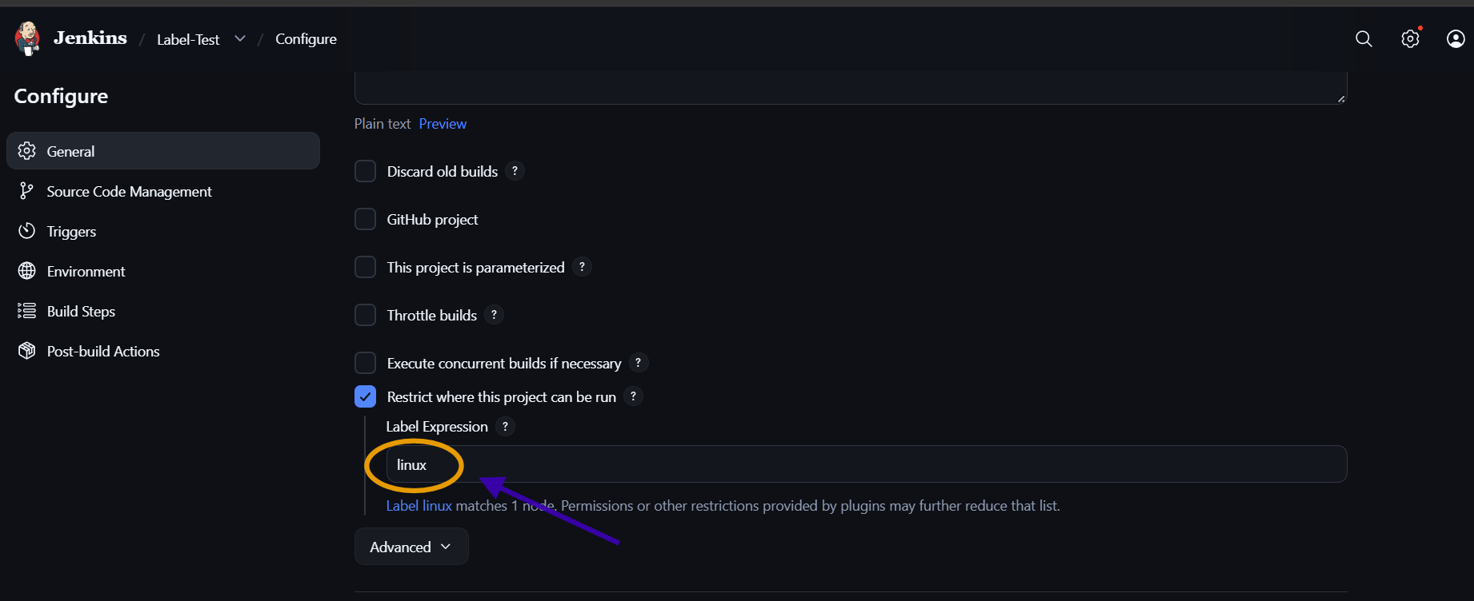

- Add an Execute shell build step:
- echo "Running on Linux node"
hostname
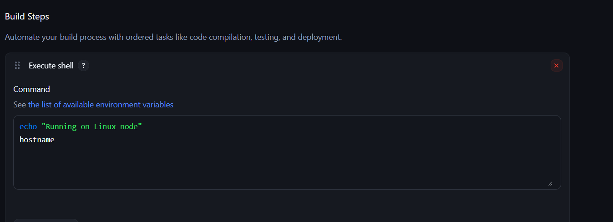
- Save and click Build Now.
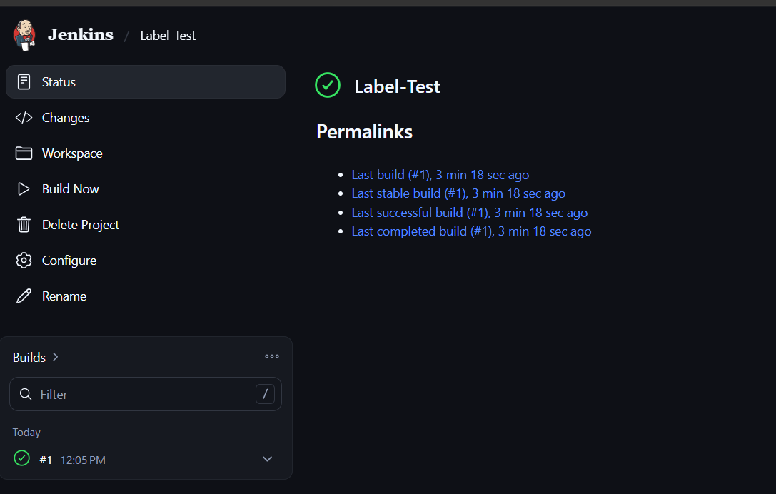
- Check Console Output and verify the build completed successfully.

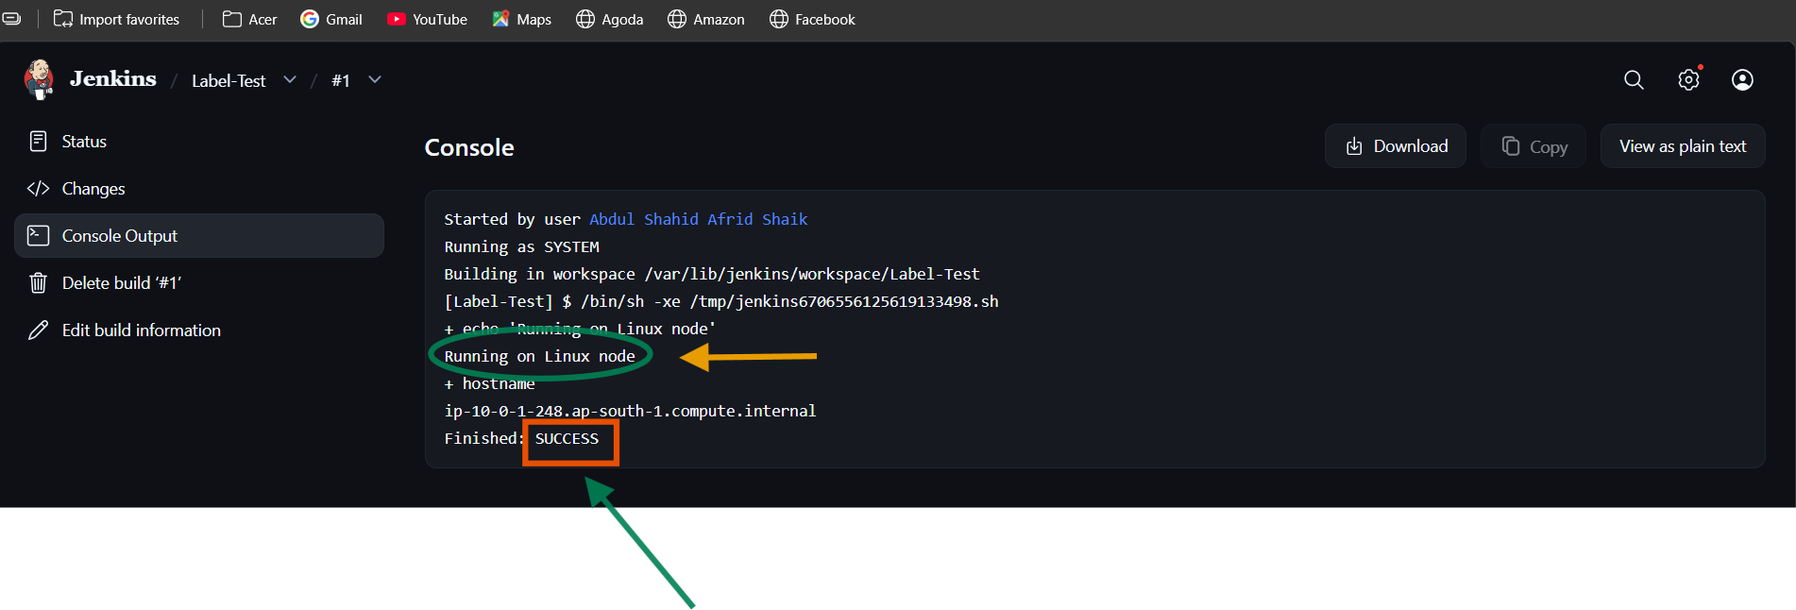

Result
The Built-In Node was successfully assigned the linux label, and the Label-Test job was restricted to that label. The job executed successfully on the matching node.

- Create Three sample jobs using the below URL.
  - Source Code: https://github.com/betawins/Techie_horizon_Login_app.git

Objective
To create and execute three sample Jenkins jobs using a GitHub repository and understand Git-based source code integration with Jenkins.
Source Repository:
https://github.com/betawins/Techie_horizon_Login_app.git

Prerequisites
- Jenkins installed and running
- Git installed on the Jenkins server
- Jenkins administrator access
- Public GitHub repository
- Jenkins node configured with linux label

Steps of Implementation

Job 1 — Git Checkout
Job: Jenkins-01-Git
- Create a Freestyle project.
- Select Git under Source Code Management.
- Configure:
- Repository URL:
- https://github.com/betawins/Techie_horizon_Login_app.git

- Credentials:
- none -
- Leave Branch Specifier blank.
- Add an Execute shell build step:
- echo "Repository cloned successfully"
ls -la
- Build the job and verify the Console Output.
Result: Repository successfully cloned into the Jenkins workspace.

Jenkins-01-git:
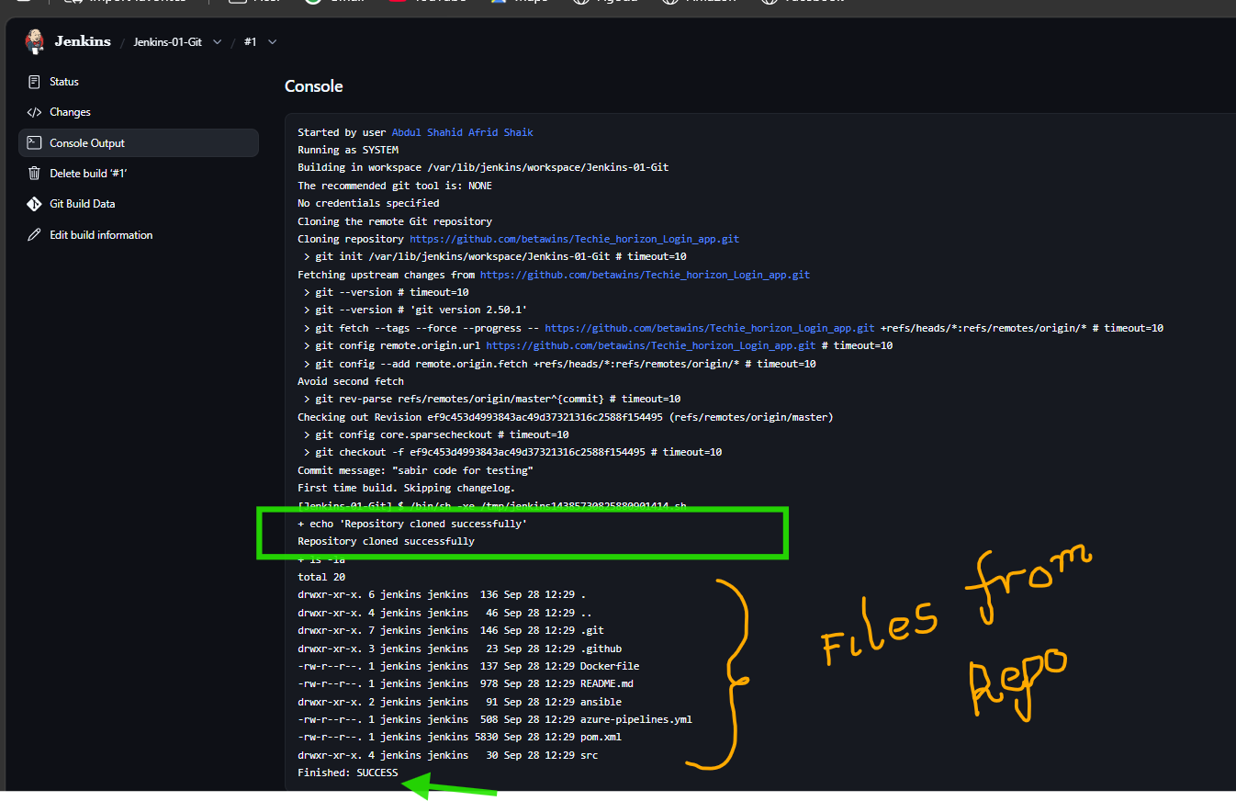

Job 2 — Workspace Verification
Job: Jenkins-01-Build
- Configure the same GitHub repository.
- Leave credentials and branch specifier blank.
- Add:
- echo "Checking project files"
find . -maxdepth 2 -type f
- Build the job.
- Verify the project files in Console Output.
Jenkins-01-build:
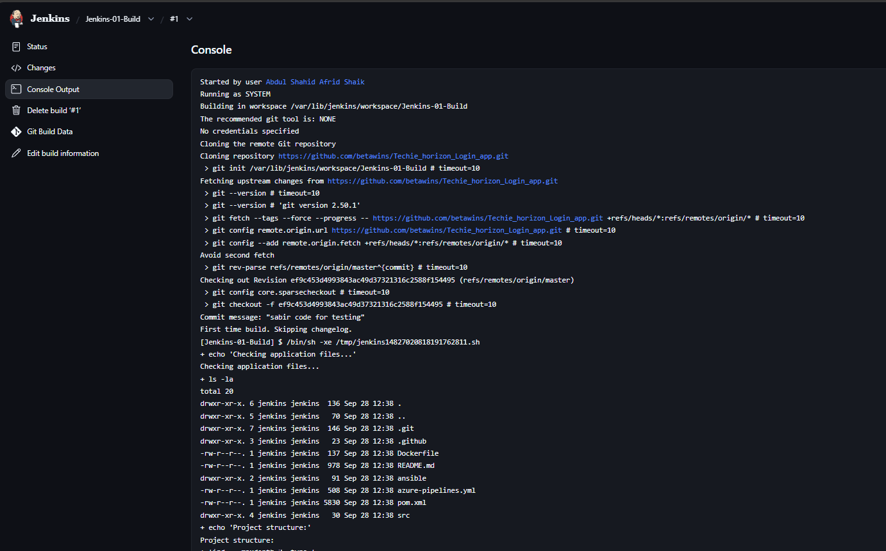
Result: Jenkins successfully checked out the repository and displayed the project structure.

Job 3 — Dockerfile Verification
Job: Jenkins-01-Dockerfile
- Configure the same GitHub repository.
- Leave credentials and branch specifier blank.
- Add:
- echo "Checking Dockerfile..."
- ls -l Dockerfile

- echo "Dockerfile contents:"
cat Dockerfile
- Build the job.
- Verify the Dockerfile and its contents in Console Output.
The Dockerfile was successfully found and displayed, and the build ended with:
Finished: SUCCESS

Jenkins-01-Dockerfile:
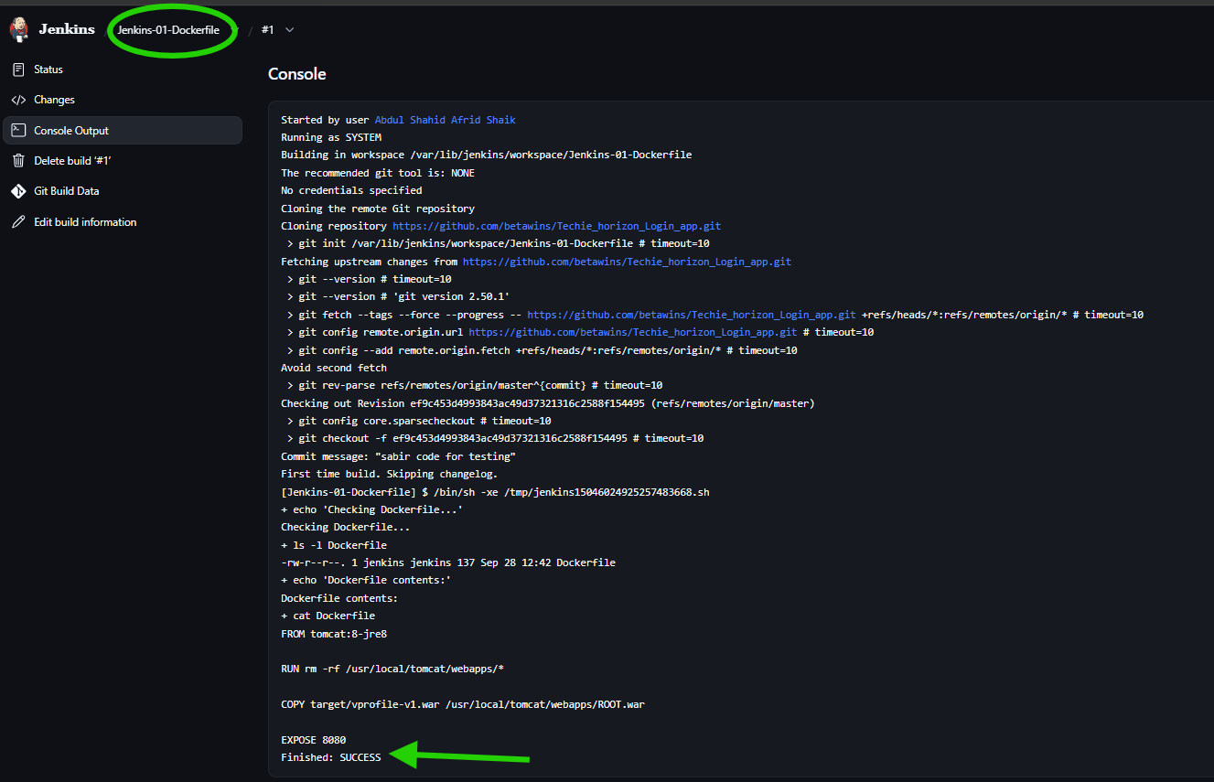

Result
Three sample Jenkins jobs were successfully created and executed using the GitHub repository.
GitHub Repository
↓
Jenkins
↓
┌─────┼─────────────┐
↓ ↓ ↓
Job 1 Job 2 Job 3
Git File Check Dockerfile Check
All three jobs completed successfully.

- Create one Jenkins job using GitHub Private repository.

Objective
To configure Jenkins to securely access and clone a private GitHub repository using Jenkins credentials.

Prerequisites
- Jenkins installed and running
- Git installed on the Jenkins server
- Private GitHub repository
- GitHub Personal Access Token (PAT)
- Jenkins administrator access

Steps of Implementation
- Create a private repository on GitHub:
jenkins-private-test
- Generate a GitHub Personal Access Token with access to the private repository.
- Add the GitHub credentials to Jenkins:
Manage Jenkins → Credentials → Add Credentials
- Kind: Username with password
- Username: GitHub username
- Password: GitHub PAT
ID: jenkins-private-test
- Create a Freestyle Jenkins job:
private-repo
- Under Source Code Management → Git, configure:
- Repository:
- https://github.com/shahid8256/jenkins-private-test.git

- Credentials:
jenkins-private-test
- Leave Branch Specifier blank.
- Add an Execute shell build step:
- echo "List of files in private repo"
ls -la
- Save and click Build Now. 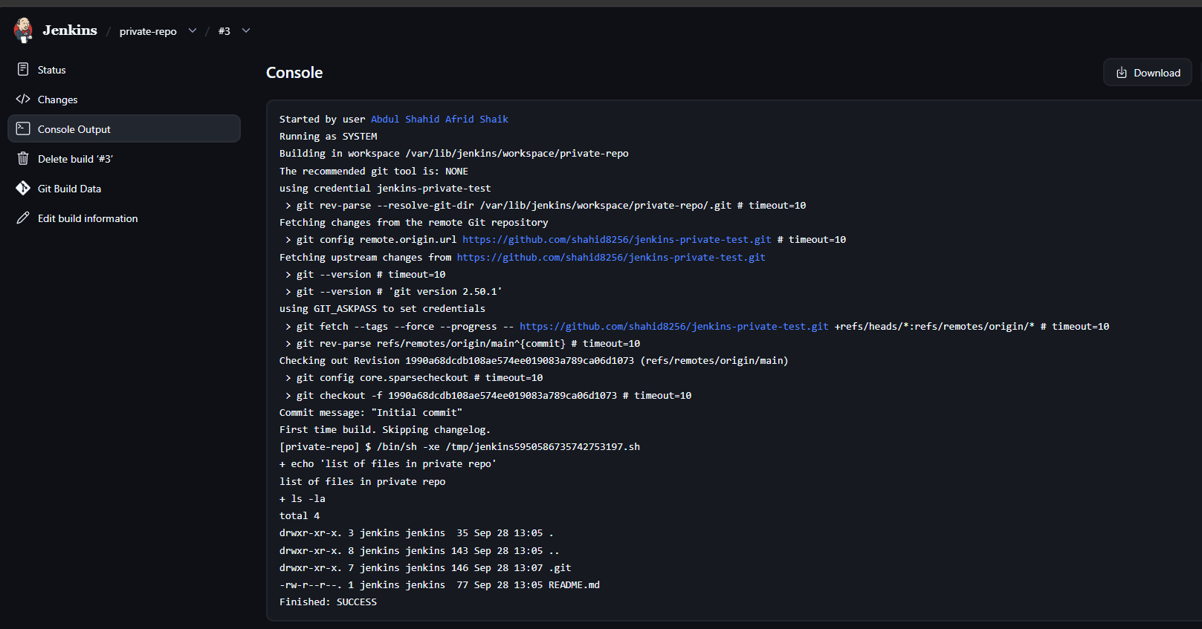
- Verify the Console Output for successful authentication, repository checkout, and file listing.

Result
Jenkins successfully authenticated with the private GitHub repository using stored credentials and checked out the repository.

