- Configure 2 slave machines in the Jenkins master.

1. Objective
Configure two separate Jenkins Agent machines and connect them to the Jenkins Controller using SSH.
The final setup contains:
- 1 Jenkins Controller
- 2 Jenkins Agents
- Dedicated jenkins user on all machines
- Java installed on both agents
- SSH key-based authentication
- Jenkins agents connected through SSH
- Both agents online in Jenkins

2. Jenkins Architecture
Jenkins Controller
10.0.1.248
|
+--------------+--------------+
| |
SSH : 22 SSH : 22
| |
v v
Jenkins Agent-1 Jenkins Agent-2
10.0.1.48 10.0.1.181
🟢 Online 🟢 Online

Machine Details
Machine | Name | Private IP | User | Role
Controller | ip-10-0-1-248 | 10.0.1.248 | jenkins | Jenkins Controller
Agent-1 | ip-10-0-1-48 | 10.0.1.48 | jenkins | Jenkins Agent
Agent-2 | ip-10-0-1-181 | 10.0.1.181 | jenkins | Jenkins Agent
Note: Jenkins communication between the Controller and Agents is configured using the private IP addresses because all machines are in the same VPC/network.

3. Controller Configuration
The existing EC2 instance was used as the Jenkins Controller.

Controller Details
Hostname:
ip-10-0-1-248

Private IP:
10.0.1.248

Jenkins User:
jenkins

Jenkins Home:
/var/lib/jenkins

Jenkins Port:
8081
Jenkins service was already installed and running under the dedicated jenkins user.

Verify Jenkins User
id jenkins
Expected:
uid=993(jenkins) gid=993(jenkins) groups=993(jenkins)

Verify Jenkins Process
ps -ef | grep '[j]enkins'
The Jenkins Java process should be owned by:
jenkins

Verify Jenkins Home
ls -ld /var/lib/jenkins
Expected ownership:
jenkins:jenkins

4. Jenkins SSH Key Configuration
A dedicated SSH key pair was created for the Jenkins user on the Controller.

Key Location
/var/lib/jenkins/.ssh/
Files:
id_ed25519
id_ed25519.pub

Private Key
/var/lib/jenkins/.ssh/id_ed25519
This key must remain on the Controller and must not be shared publicly.

Public Key
/var/lib/jenkins/.ssh/id_ed25519.pub
The public key was copied to both Agent-1 and Agent-2.

Display Public Key
sudo cat /var/lib/jenkins/.ssh/id_ed25519.pub
The complete public-key line was copied into each agent's:
/home/jenkins/.ssh/authorized_keys

5. Agent-1 Configuration

Agent-1 Details
Hostname:
ip-10-0-1-48

Private IP:
10.0.1.48

User:
jenkins

SSH Port:
22

Remote Root Directory:
/home/jenkins

Label:
agent-1

6. Create Jenkins User on Agent-1
On Agent-1:
sudo useradd -m -s /bin/bash jenkins
Verify:
id jenkins

7. Install Java on Agent-1
Java was required because Jenkins agents run the Jenkins agent process using Java.
Installation:
sudo dnf install java-21-amazon-corretto -y
Verify:
java -version

8. Configure SSH on Agent-1
Create the SSH directory:
sudo -u jenkins mkdir -p /home/jenkins/.ssh
Set permissions:
sudo chmod 700 /home/jenkins/.ssh
Create the authorized keys file:
sudo -u jenkins touch /home/jenkins/.ssh/authorized_keys
Set permissions:
sudo chmod 600 /home/jenkins/.ssh/authorized_keys
The Controller's public key was added to:
/home/jenkins/.ssh/authorized_keys
Set ownership:
sudo chown jenkins:jenkins /home/jenkins/.ssh
and:
sudo chown jenkins:jenkins /home/jenkins/.ssh/authorized_keys

9. Test SSH from Controller to Agent-1
From the Controller:
sudo -u jenkins ssh -i /var/lib/jenkins/.ssh/id_ed25519 jenkins@10.0.1.48
Successful connection:
[jenkins@ip-10-0-1-48 ~]$
This confirmed that:
- Network connectivity was working
- SSH port 22 was accessible
- Jenkins user existed
- Public/private key authentication worked

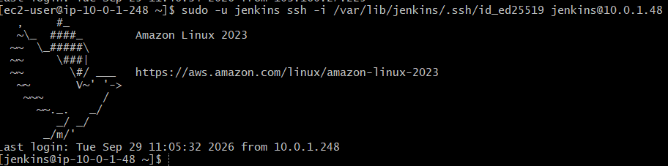

10. Create Agent-1 in Jenkins Console
Navigate to:
Manage Jenkins
↓
Nodes
↓
New Node

Node Name
jenkins-agent-1
Select:
Permanent Agent

11. Agent-1 Node Configuration

Number of Executors
1
An executor represents a slot where Jenkins can execute a build.

Remote Root Directory
/home/jenkins

Labels
agent-1
The label can later be used to tell Jenkins which agent should execute a particular job.

Usage
Use this node as much as possible

12. Agent-1 Launch Method
Select:
Launch agents via SSH
Configuration:
Host:
10.0.1.48

Port:
22

Credentials:
agent-1-ssh

Credentials
Credential type:
SSH Username with private key
Configuration:
Scope:
Global

Username:
jenkins

Treat username as secret:
Unchecked

Private Key:
Enter directly

Passphrase:
Empty
The private key used here was the Controller's:
/var/lib/jenkins/.ssh/id_ed25519

Host Key Verification
For this lab:
Non verifying Verification Strategy

Availability
Keep this agent online as much as possible

Node Properties
No additional properties were required initially.

13. Agent-1 Disk Space Issue
Initially Jenkins reported:
Disk space is below threshold of 1.00 GiB.
Only 456.43 MiB out of 456.59 MiB left on /tmp.
The issue was related to Jenkins' disk-space monitoring threshold, not SSH connectivity.
The threshold was lowered in the Jenkins node configuration to accommodate the small EC2 lab instance.
After changing the threshold, Agent-1 became online.
Final status:
jenkins-agent-1
🟢 Online

14. Agent-2 Configuration

Agent-2 Details
Hostname:
ip-10-0-1-181

Private IP:
10.0.1.181

User:
jenkins

SSH Port:
22

Remote Root Directory:
/home/jenkins

Label:
agent-2

15. Create Jenkins User on Agent-2
The first command attempted was incorrect:
sudo useradd -m -s jenkins
This generated:
useradd: invalid shell 'jenkins'
The correct command was:
sudo useradd -m -s /bin/bash jenkins
Verify:
id jenkins

16. Java on Agent-2
Java was already available on Agent-2.
Verify:
java -version
Java is required for Jenkins agent communication.

17. Configure SSH on Agent-2
Create the SSH directory:
sudo mkdir -p /home/jenkins/.ssh
Create the authorized keys file:
sudo touch /home/jenkins/.ssh/authorized_keys
Set ownership:
sudo chown -R jenkins:jenkins /home/jenkins/.ssh
Set directory permission:
sudo chmod 700 /home/jenkins/.ssh
Set authorized keys permission:
sudo chmod 600 /home/jenkins/.ssh/authorized_keys
The Controller's public key was copied into:
/home/jenkins/.ssh/authorized_keys

18. Test SSH from Controller to Agent-2
From the Controller:
sudo -u jenkins ssh -i /var/lib/jenkins/.ssh/id_ed25519 jenkins@10.0.1.181
The first connection displayed an SSH authenticity/fingerprint message.
The fingerprint confirmation was accepted with:
yes
After authentication, the Agent-2 shell was reached:
[jenkins@ip-10-0-1-181 ~]$
This confirmed that Controller → Agent-2 SSH connectivity was working.

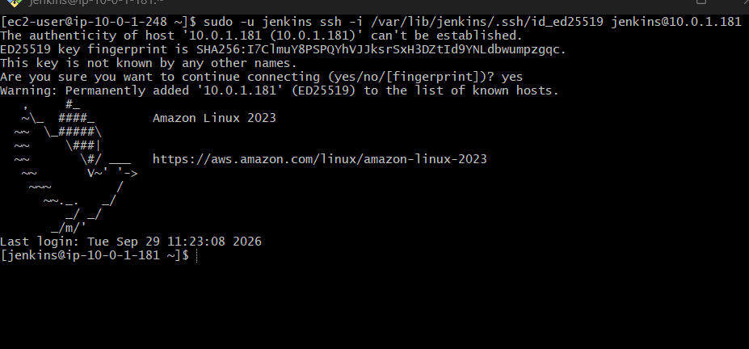

19. Create Agent-2 in Jenkins
Navigate to:
Manage Jenkins
↓
Nodes
↓
New Node
Node name:
jenkins-agent-2
Select:
Permanent Agent

20. Agent-2 Node Configuration

Executors
1

Remote Root Directory
/home/jenkins

Label
agent-2

Usage
Use this node as much as possible

21. Agent-2 SSH Launch Configuration
Select:
Launch agents via SSH
Use:
Host:
10.0.1.181

Port:
22

Credentials:
agent-1-ssh
The same credential was reused because both agents contain the Controller's public key in their authorized_keys.

Host Key Verification
Non verifying Verification Strategy

Availability
Keep this agent online as much as possible

22. Final Jenkins Node Status
After configuration, the Jenkins Nodes page showed:
Built-In Node → Online
jenkins-agent-1 → Online
jenkins-agent-2 → Online
Final status:
Node | Private IP | Status | Executors | Free Disk
Built-In Node | 10.0.1.248 | 🟢 Online | 1 | 17.43 GiB
jenkins-agent-1 | 10.0.1.48 | 🟢 Online | 1 | 5.98 GiB
jenkins-agent-2 | 10.0.1.181 | 🟢 Online | 1 | 5.98 GiB

23. Final Architecture
┌──────────────────────────┐
│ Jenkins Controller │
│ │
│ Host: ip-10-0-1-248 │
│ Private IP: 10.0.1.248 │
│ Jenkins User: jenkins │
│ Port: 8081 │
└────────────┬─────────────┘
│
SSH using Jenkins key
TCP Port 22
┌─────────────────┴─────────────────┐
│ │
▼ ▼
┌────────────────────────┐ ┌────────────────────────┐
│ Jenkins Agent-1 │ │ Jenkins Agent-2 │
│ │ │ │
│ 10.0.1.48 │ │ 10.0.1.181 │
│ User: jenkins │ │ User: jenkins │
│ Label: agent-1 │ │ Label: agent-2 │
│ Executor: 1 │ │ Executor: 1 │
│ 🟢 Online │ │ 🟢 Online │
└────────────────────────┘ └────────────────────────┘

24. Important Paths

Controller
Jenkins Home:
/var/lib/jenkins

SSH Directory:
/var/lib/jenkins/.ssh/

Private Key:
/var/lib/jenkins/.ssh/id_ed25519

Public Key:
/var/lib/jenkins/.ssh/id_ed25519.pub

Agent-1
Jenkins Home:
/home/jenkins

Authorized Keys:
/home/jenkins/.ssh/authorized_keys

Agent-2
Jenkins Home:
/home/jenkins

Authorized Keys:
/home/jenkins/.ssh/authorized_keys

25. Important Commands Used

Check Jenkins user
id jenkins

Check Java
java -version

Display Controller public key
sudo cat /var/lib/jenkins/.ssh/id_ed25519.pub

Test Agent-1 SSH
sudo -u jenkins ssh -i /var/lib/jenkins/.ssh/id_ed25519 jenkins@10.0.1.48

Test Agent-2 SSH
sudo -u jenkins ssh -i /var/lib/jenkins/.ssh/id_ed25519 jenkins@10.0.1.181

Check disk space
df -h

Check temporary directory
df -h /tmp

26. Key Concepts Learned

Controller
The Jenkins Controller manages Jenkins configuration, jobs, scheduling, credentials, and agent connections.

Agent
An Agent is a separate machine that Jenkins uses to execute builds and other tasks.

Executor
An Executor is a slot available on an agent for running a Jenkins build.
We configured:
Agent-1 → 1 executor
Agent-2 → 1 executor

Label
A label identifies an agent and allows jobs to be restricted to specific agents.
Examples:
agent-1
agent-2

Remote Root Directory
The directory on the agent where Jenkins stores its workspace and agent-related files.
We used:
/home/jenkins

SSH Launch
Jenkins connects to the agent through SSH and starts the Jenkins agent process remotely.

authorized_keys
The Agent stores the Controller's public SSH key in:
/home/jenkins/.ssh/authorized_keys
The Controller keeps the corresponding private key.

27. Task 1 Result
Task 1 – Configure 2 slave/agent machines in Jenkins: COMPLETED ✅
Final Jenkins environment:
Controller → 10.0.1.248 → 🟢 Online
Agent-1 → 10.0.1.48 → 🟢 Online
Agent-2 → 10.0.1.181 → 🟢 Online
Both agents are successfully connected to the Jenkins Controller through SSH and are ready to execute Jenkins jobs.
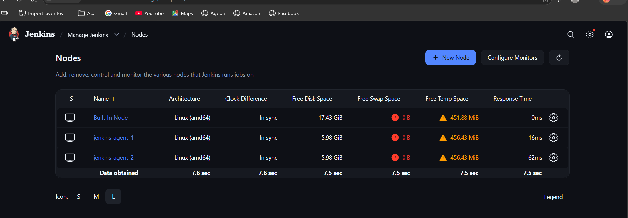

- Configure webhooks to the Jenkins job.

1. Objective
To configure a GitHub Webhook so that whenever code is pushed to the GitHub repository, GitHub automatically sends an event to Jenkins and Jenkins triggers the configured job.

Expected Flow
Developer
↓
git push
↓
GitHub Repository
↓
GitHub Webhook
↓
Jenkins Controller
↓
GitHub Webhook Endpoint
↓
Jenkins Job
↓
Build

2. Environment Details

Jenkins Controller
Item | Details
Hostname | ip-10-0-1-248
Private IP | 10.0.1.248
Public IP | 13.127.136.203
Jenkins Port | 8081
Jenkins URL | http://13.127.136.203:8081/
Jenkins Home | /var/lib/jenkins

GitHub Repository
https://github.com/shahid8256/Git-Commands.git

Jenkins Job
Git-Commands-Webhook
Job type:
Freestyle Project

3. Jenkins Job Configuration
Created a new Freestyle project:
Git-Commands-Webhook

Source Code Management
Selected:
Git
Repository URL:
https://github.com/shahid8256/Git-Commands.git
Initially, the repository was private.

Build Trigger
Selected:
GitHub hook trigger for GITScm polling
Important:
We did not enable Poll SCM because Poll SCM is part of Task 3.

Build Step
Selected:
Execute shell
Used:
echo "================================"
echo "GitHub Webhook Triggered Jenkins"
echo "Build Number: $BUILD_NUMBER"
echo "Node: $NODE_NAME"
echo "================================"

echo "Files in workspace:"
ls -la

4. Jenkins Webhook Endpoint
The Jenkins GitHub webhook endpoint is:
http://13.127.136.203:8081/github-webhook/
This URL was configured in GitHub.

5. GitHub Webhook Configuration
In GitHub:
Repository
→ Settings
→ Webhooks
→ Add webhook

Configuration
Payload URL:
http://13.127.136.203:8081/github-webhook/
Content type:
application/json
Secret:
Empty
Events:
Send me everything
Active:
Enabled

6. Initial Webhook Problem
Initially, GitHub could not deliver the webhook.
GitHub showed:
We couldn't deliver this payload:
failed to connect to host
The ping delivery appeared unsuccessful.

7. Troubleshooting

Check 1 – Jenkins Port
Verified that Jenkins was listening on port 8081.
Command:
sudo ss -lntp | grep 8081
Result:
LISTEN 0 50 *:8081 *:* users:(("java",pid=1732,fd=9))
This confirmed Jenkins was listening on all interfaces:
*:8081

Check 2 – Local Jenkins Webhook
Tested the webhook endpoint from the Jenkins server:
curl -i -X POST http://localhost:8081/github-webhook/
Response:
HTTP/1.1 400 Bad Request
Error 400 Hook should contain event type
This was not a Jenkins connectivity problem.
It meant Jenkins received the request but the manually generated request did not contain the GitHub event information that the webhook expects.

Check 3 – Public IP Test
Tested the public Jenkins IP:
curl -i -X POST http://13.127.136.203:8081/github-webhook/
Response:
HTTP/1.1 400 Bad Request
Error 400 Hook should contain event type
This confirmed that the Jenkins webhook endpoint was reachable through the public IP from the server itself.

8. AWS Security Group Check
The Jenkins Controller Security Group contained:
TCP 8081
Source: 0.0.0.0/0
Therefore, port 8081 was open for inbound traffic.
Other relevant rule:
TCP 22
was used for SSH access.

9. Network ACL Check
The Controller subnet was associated with:
NACL: acl-02e2386c9ed63e953
Inbound rule:
Rule 100
All traffic
Source: 0.0.0.0/0
Allow
Outbound rules also allowed traffic.
Therefore, the NACL was not blocking the webhook connection.

10. GitHub Webhook Redelivery
After correcting the connectivity issue, GitHub webhook redelivery worked.
GitHub showed successful ping/redelivery activity.
This confirmed:
GitHub
↓
Internet
↓
Jenkins Controller
↓
/github-webhook/
was working.

11. Testing the Actual Webhook
A local copy of the repository was cloned.
Then a test file/change was created and pushed:
echo "Webhook test" >> webhook-test.txt
Then:
git add .
git commit -m "Webhook test"
git push origin main
Expected flow:
git push
↓
GitHub
↓
Webhook
↓
Jenkins
↓
Git-Commands-Webhook

12. First Jenkins Build Error
The webhook successfully triggered Jenkins.
Jenkins created:
Build #1
However, Build #1 failed.
Console output showed:
Started by GitHub push by shahid8256
This proved the webhook trigger itself was working.
The failure happened during Git checkout.
Important messages:
No credentials specified
and:
remote: Invalid username or token.
Password authentication is not supported for Git operations.
and:
fatal: Authentication failed for
'https://github.com/shahid8256/Git-Commands.git/'

13. Cause of the Jenkins Build Failure
The GitHub repository was private at that time.
Jenkins was trying to clone:
https://github.com/shahid8256/Git-Commands.git
but the Jenkins job had:
Credentials: None
Therefore:
GitHub Webhook → Jenkins
was working.
But:
Jenkins → GitHub Repository
was failing because Jenkins did not have permission to clone the private repository.

Important Difference
Webhook authentication and repository authentication are separate things.
GitHub
│
│ Webhook
↓
Jenkins
│
│ Git clone
↓
Private GitHub Repository
The first connection was successful, while the second connection required GitHub credentials.

14. Resolution
Instead of configuring a GitHub Personal Access Token for Jenkins, the repository visibility was changed from:
Private
to:
Public
After making the repository public, Jenkins could clone the repository without credentials.
Therefore, the Jenkins configuration could remain:
Credentials: None

15. Final Working Configuration

GitHub
Repository:
Git-Commands

Visibility:
Public

Webhook:
Active

Webhook URL
http://13.127.136.203:8081/github-webhook/

Jenkins Job
Git-Commands-Webhook

Trigger
GitHub hook trigger for GITScm polling

Repository
https://github.com/shahid8256/Git-Commands.git

Credentials
None
because the repository is public.

16. Final Architecture
Developer
│
│ git push
↓
GitHub Repository
│
│ Webhook
↓
13.127.136.203:8081
│
↓
Jenkins Controller
10.0.1.248
│
↓
Git-Commands-Webhook Job
│
↓
Git Checkout
│
↓
Execute Shell
│
↓
Jenkins Build

17. Important Commands Used
Check Jenkins port:
sudo ss -lntp | grep 8081
Check current public IP:
curl -s http://checkip.amazonaws.com
Test Jenkins webhook locally:
curl -i -X POST http://localhost:8081/github-webhook/
Test using public IP:
curl -i -X POST http://13.127.136.203:8081/github-webhook/
Clone repository:
git clone https://github.com/shahid8256/Git-Commands.git
Test webhook:
echo "Webhook test" >> webhook-test.txt
git add .
git commit -m "Webhook test"
git push origin main

18. Errors and Solutions Summary
Error | Cause | Resolution
failed to connect to host | GitHub initially could not reach Jenkins webhook endpoint | Verified Jenkins port, SG, NACL, public IP and webhook endpoint; webhook redelivery subsequently worked
400 Hook should contain event type | Manual curl request did not contain GitHub event headers/payload | Expected response for manual test; actual GitHub webhook delivered correctly
No credentials specified | Jenkins job had no GitHub credentials | Repository was changed to public
Invalid username or token | Jenkins attempted to clone private repository without credentials | Changed repository visibility to public
Password authentication is not supported | GitHub does not accept normal account passwords for Git operations over HTTPS | Public repository avoided the need for Jenkins authentication

19. Result

Task 2 – Configure Webhook to Jenkins Job
STATUS: COMPLETED ✅
The final working flow is:
Git Push
↓
GitHub
↓
Webhook
↓
Jenkins
↓
Git-Commands-Webhook
↓
Build
The most important point learned from this task is:
A successful webhook only triggers Jenkins; Jenkins still needs permission to clone the repository.
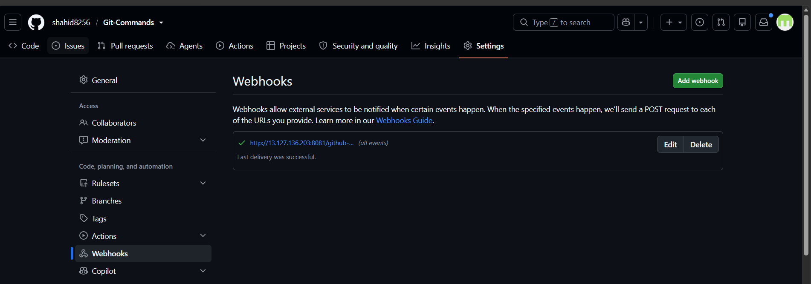

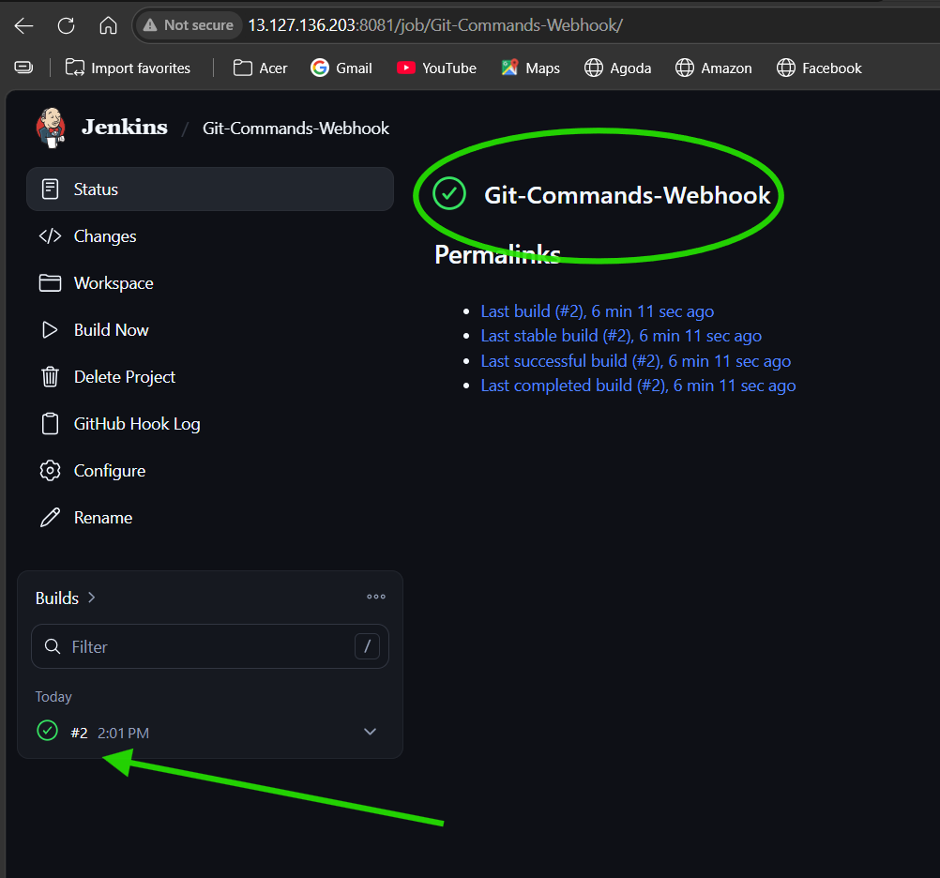
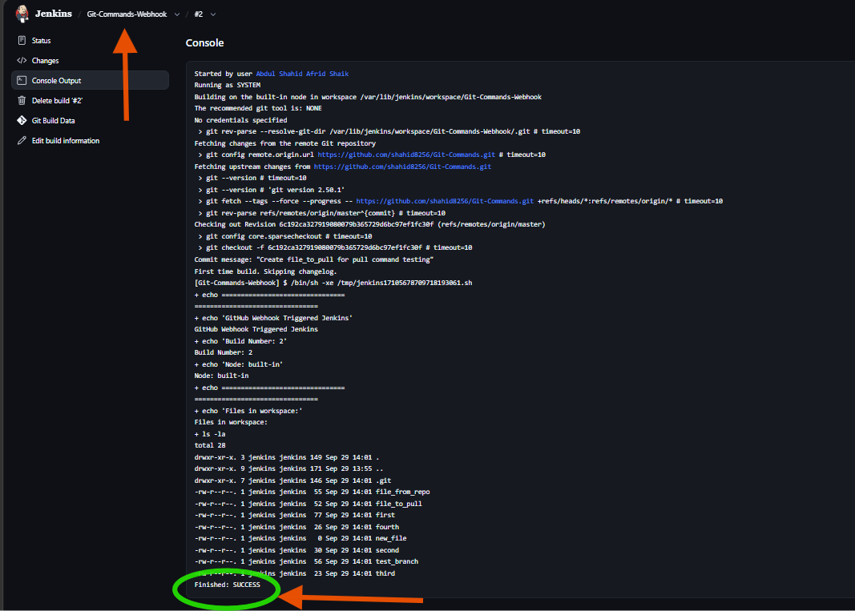

- Configure Poll SCM and Build Periodically options in the Jenkins job.

1. Objective
To configure Jenkins to automatically check the GitHub repository for changes using Poll SCM and to configure Jenkins to trigger builds at a scheduled time using Build Periodically.

Part A – Poll SCM

2. What is Poll SCM?
Poll SCM (Source Code Management) makes Jenkins periodically check the configured Git repository for new changes.
If Jenkins detects a new commit since the last build, it can trigger a new build.

Flow
GitHub Repository
↑
│ Check for changes
│
Jenkins
│
↓
New Changes?
↙ ↘
Yes No
↓ ↓
Build No Build

3. Jenkins Job Used
Job:
Git-Commands-Webhook
Job type:
Freestyle Project
Repository:
https://github.com/shahid8256/Git-Commands.git

4. Configure Poll SCM
Navigate to:
Jenkins
→ Git-Commands-Webhook
→ Configure
→ Build Triggers
Enabled:
☑ GitHub hook trigger for GITScm polling
☑ Poll SCM
For Poll SCM, the following schedule was configured:
H/2 * * * *

Meaning
H/2 * * * *
means Jenkins polls the repository approximately every 2 minutes.
H means Jenkins uses a hashed value to distribute the execution time instead of having every job run at exactly the same minute.

5. Testing Poll SCM
A change was made in the local Git repository.
Repository location:
Git-Commands
A test file/change was created and pushed to GitHub.
Commands used:
cd /d/newDirectory/Git-Commands
Then:
echo "Poll SCM test" >> poll-test.txt
Then:
git add .
git commit -m "Test Poll SCM"
git push origin main
The push completed successfully.
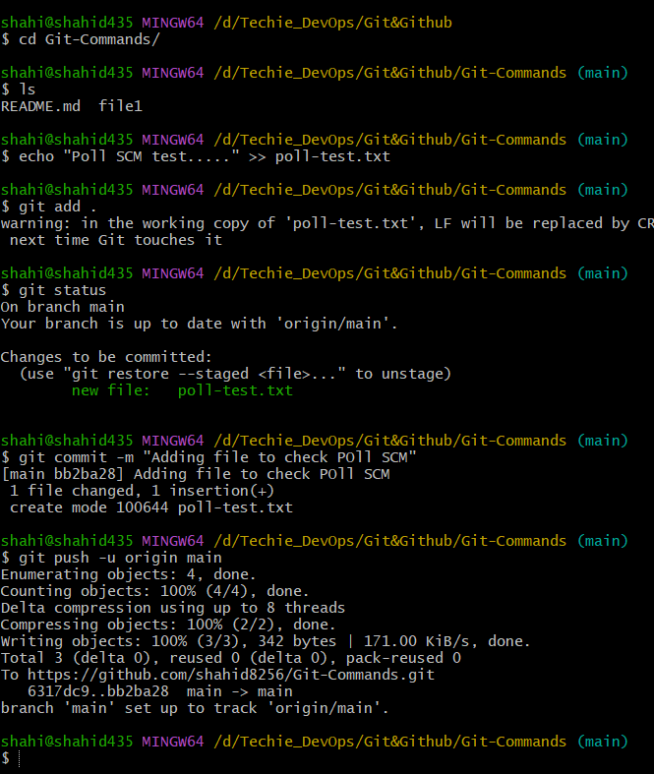

6. Verify Poll SCM
To verify that Jenkins was actually polling:
Jenkins
→ Git-Commands-Webhook
→ Git Polling Log
The polling log showed:
Started on Sep 29, 2026, 7:44:00 PM
Using strategy: Default [poll]
Jenkins then checked the Git repository using:
git ls-remote -h -- https://github.com/shahid8256/Git-Commands.git
The log showed:
Found 2 remote heads
Jenkins identified the latest remote revision:
6c192ca327919080079b365729d6bc97ef1fc30f
The log finally showed:
Latest remote head revision on refs/heads/master is:
6c192ca327919080079b365729d6bc97ef1fc30f

already built by 2

Done. Took 0.57 sec

No changes

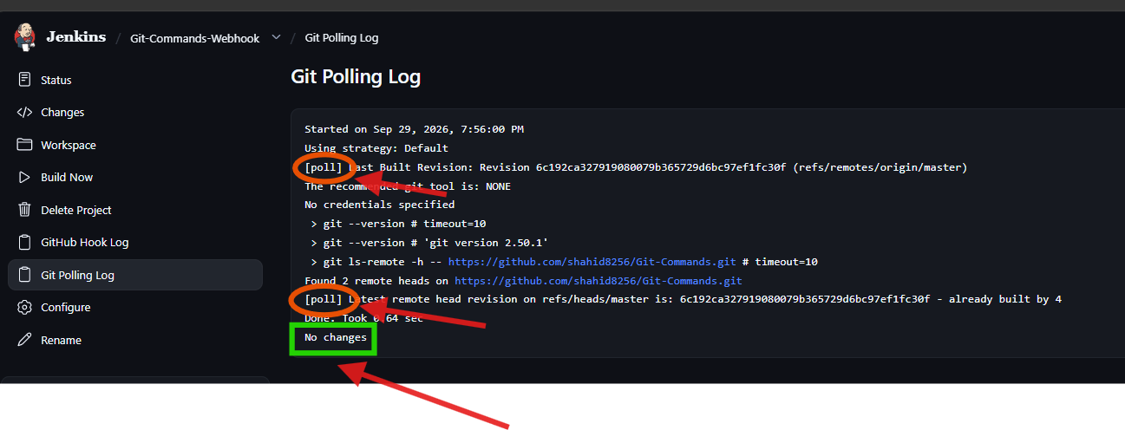

7. Understanding "No Changes"
The message:
No changes
does not mean Poll SCM is broken.
It means Jenkins successfully contacted GitHub and compared the latest remote commit with the revision already built.
Because the latest revision was already built:
already built by 2
Jenkins correctly decided:
No changes
Therefore, no new build was required.

8. Poll SCM Result

Status: COMPLETED ✅
Verified that:
- Poll SCM is enabled.
- Polling schedule is configured.
- Jenkins successfully connects to GitHub.
- Jenkins detects the remote branches.
- Jenkins checks the latest commit.
- Jenkins compares it with the previously built revision.
- Jenkins correctly reports No changes when nothing new needs to be built.

Part B – Build Periodically

9. What is Build Periodically?
Build Periodically runs a Jenkins job according to a fixed schedule, regardless of whether there are changes in the Git repository.

Important Difference
Poll SCM | Build Periodically
Checks Git for changes | Runs according to time
Build occurs when changes are detected | Build occurs at scheduled time
Depends on SCM changes | Does not require SCM changes
Used for change-based automation | Used for scheduled builds
Example:
Poll SCM
Every 2 minutes → Check GitHub → Build only if changes detected
Whereas:
Build Periodically
Every 5 minutes → Build
Every 5 minutes → Build
Every 5 minutes → Build
even if there are no Git changes.

10. Configure Build Periodically
Navigate to:
Jenkins
→ Git-Commands-Webhook
→ Configure
→ Build Triggers
Enable:
☑ Build periodically
For testing, a short schedule can be used:
H/5 * * * *
This means Jenkins will trigger the job approximately every 5 minutes.

Note
For a real production job, the schedule should be selected according to the actual requirement.

11. Expected Build Periodically Flow
Jenkins
│
↓
Scheduled Time Reached
│
↓
Start Jenkins Build
│
↓
Git Checkout / Build
│
↓
Build Result
Unlike Poll SCM, Jenkins does not need a new Git commit to trigger the scheduled build.
For every 5 mins new build :
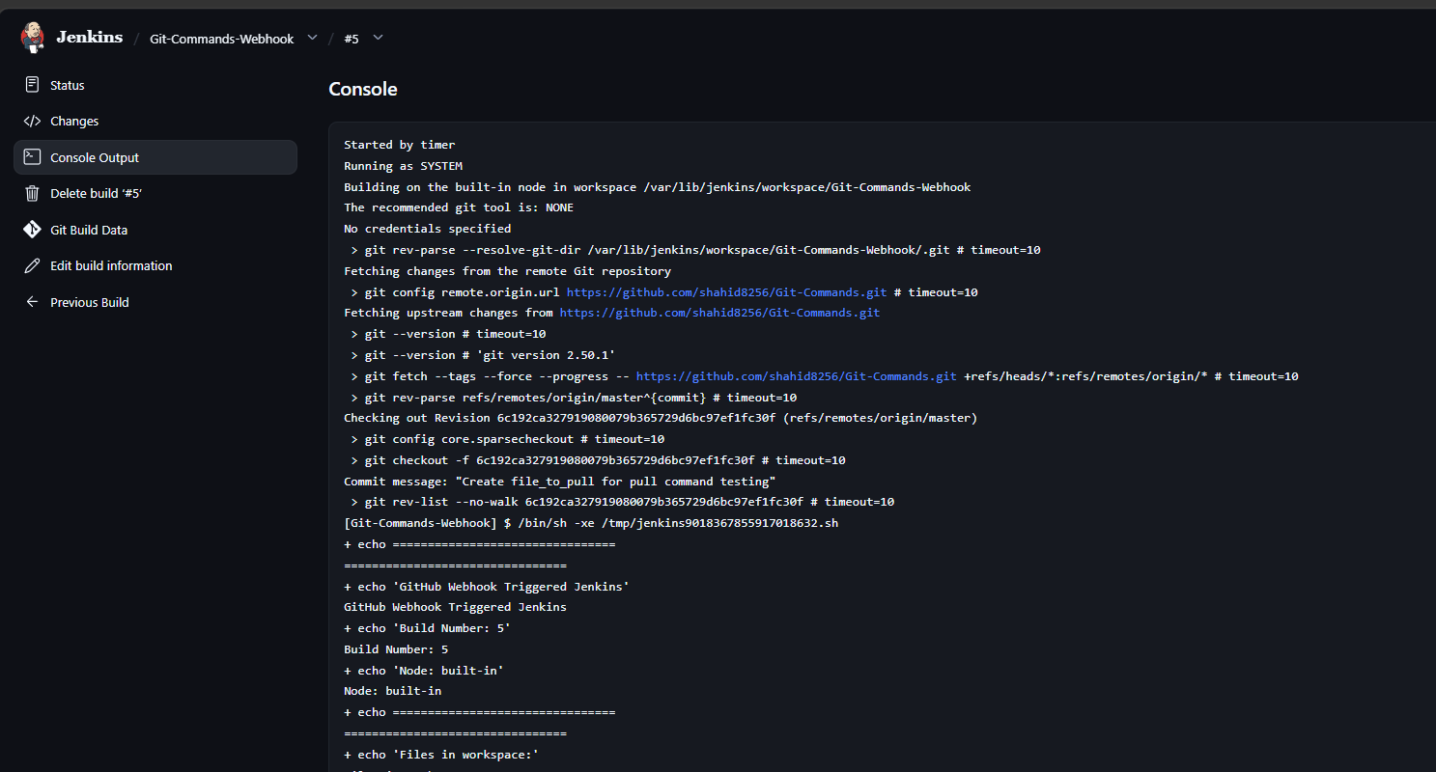

12. Final Task 3 Configuration
The Jenkins job can contain both triggers:
☑ GitHub hook trigger for GITScm polling

☑ Poll SCM
Schedule: H/2 * * * *

☑ Build periodically
Schedule: H/5 * * * *
This gives the job three possible ways to run:
GitHub Push
↓
GitHub Webhook
↓
Jenkins Build

Poll SCM
↓
Detect Git Change
↓
Jenkins Build

Build Periodically
↓
Scheduled Time
↓
Jenkins Build

13. Important Difference to Remember

Webhook
GitHub Push
↓
Webhook
↓
Jenkins
Near real-time notification from GitHub.

Poll SCM
Jenkins
↓
Check GitHub
↓
Changes?
↓
Yes → Build
No → Nothing

Build Periodically
Scheduled Time
↓
Jenkins Build
It does not depend on whether Git changed.

14. Result

Task 3 – Poll SCM and Build Periodically
STATUS: IN PROGRESS / POLL SCM COMPLETED

Poll SCM
COMPLETED ✅
Verified through the Jenkins Git Polling Log.

Build Periodically
To be configured/tested next.

- Take a backup of the Jenkins server using a bash-script.

1. Objective
To create a Bash script that backs up the Jenkins server's important Jenkins data, especially the Jenkins Home directory:
/var/lib/jenkins
The backup is stored as a compressed .tar.gz archive.

2. Jenkins Controller Details
Item | Details
Hostname | ip-10-0-1-248
Private IP | 10.0.1.248
Public IP | 13.127.136.203
Jenkins Port | 8081
Jenkins Home | /var/lib/jenkins
Backup Directory | /backup/jenkins

3. Initial SSH Issue
Before starting Task 4, SSH access to the Jenkins Controller timed out.
Command used:
ssh -i new.pem ec2-user@13.127.136.203
Error:
ssh: connect to host 13.127.136.203 port 22: Connection timed out
Verbose SSH output stopped at:
Connecting to 13.127.136.203 [13.127.136.203] port 22.
This indicated that the problem occurred before SSH authentication.

4. SSH Security Group Troubleshooting
The Controller Security Group contained:

Rule 1
SSH
TCP
22
Source: sg-07aa57580e435e27d

Rule 2
Custom TCP
TCP
8081
Source: 0.0.0.0/0

Rule 3
SSH
TCP
22
Source: 103.160.27.229/32
The third rule contained the previously allowed public IP.
The current public IP had changed, so SSH was being blocked by the Security Group.

Resolution
The SSH rule was changed to:
SSH
TCP
22
Source: My IP
AWS automatically added the current public IP as /32.
After saving the rule, SSH access worked again.
Command:
ssh -i new.pem ec2-user@13.127.136.203

5. Attempt to Switch to Jenkins User
After connecting to the Controller, the following command was used:
sudo su - jenkins
The shell prompt continued to display:
[ec2-user@ip-10-0-1-248 ~]$
and:
whoami
returned:
ec2-user
Therefore, the backup was performed using ec2-user with sudo.
This was appropriate because the Jenkins Home directory contains files requiring elevated permissions.

6. Create Backup Directory
Created a dedicated backup directory:
sudo mkdir -p /backup/jenkins
Backup location:
/backup/jenkins

7. Create Bash Backup Script
Created the script:
sudo vi /backup/jenkins/jenkins_backup.sh
Script:
#!/bin/bash

BACKUP_DIR="/backup/jenkins"
JENKINS_HOME="/var/lib/jenkins"
DATE=$(date +%Y-%m-%d_%H-%M-%S)
BACKUP_FILE="$BACKUP_DIR/jenkins_backup_$DATE.tar.gz"

echo "Starting Jenkins backup..."
echo "Source: $JENKINS_HOME"
echo "Backup: $BACKUP_FILE"

sudo tar -czf "$BACKUP_FILE" "$JENKINS_HOME"

if [ $? -eq 0 ]; then
echo "Jenkins backup completed successfully."
echo "Backup file: $BACKUP_FILE"
else
echo "Jenkins backup failed."
exit 1
fi

8. Make the Script Executable
Command:
sudo chmod +x /backup/jenkins/jenkins_backup.sh
Verified with:
ls -l /backup/jenkins/jenkins_backup.sh
Output:
-rwxr-xr-x. 1 root root 461 Sep 29 20:13 jenkins_backup.sh
The x permissions confirm that the script is executable.

9. Run the Backup Script
Executed:
sudo /backup/jenkins/jenkins_backup.sh
The script creates a compressed archive of:
/var/lib/jenkins
and stores it under:
/backup/jenkins

10. Backup Created Successfully
Verified using:
ls -lh /backup/jenkins/
Output showed:
total 149M

-rwxr-xr-x. 1 root root 461 Sep 29 20:13 jenkins_backup.sh

-rw-r--r--. 1 root root 149M Sep 29 20:14 \
jenkins_backup_2026-09-29_20-13-54.tar.gz

Backup file
jenkins_backup_2026-09-29_20-13-54.tar.gz

Backup size
149M

11. Backup File Naming
The script automatically generates the timestamp:
DATE=$(date +%Y-%m-%d_%H-%M-%S)
Therefore the backup filename follows:
jenkins_backup_DATE_TIME.tar.gz
Example:
jenkins_backup_2026-09-29_20-13-54.tar.gz
This allows multiple backups to be created without overwriting previous backups.

12. Backup Format
The backup uses:
tar -czf
Meaning:
Option | Meaning
tar | Archive files
-c | Create archive
-z | Compress using gzip
-f | Specify archive filename
Therefore:
tar -czf
creates a compressed .tar.gz archive.

13. Verify Backup Contents
To verify that the archive contains Jenkins data:
sudo tar -tzf /backup/jenkins/jenkins_backup_2026-09-29_20-13-54.tar.gz | head -20
Expected paths include:
var/lib/jenkins/
var/lib/jenkins/config.xml
var/lib/jenkins/jobs/
var/lib/jenkins/users/
This confirms that the Jenkins Home directory was included in the archive.

14. Why Jenkins Home Is Important
The Jenkins Home directory:
/var/lib/jenkins
contains important Jenkins configuration and data, including items such as:
config.xml
jobs/
users/
plugins/
secrets/
workspace/
credentials/
Backing up Jenkins Home therefore allows important Jenkins configuration and job data to be preserved.

15. Backup Architecture
Jenkins Controller
│
│
↓
/var/lib/jenkins
│
│ tar + gzip
↓
/backup/jenkins
│
↓
jenkins_backup_2026-09-29_20-13-54.tar.gz
│
↓
149 MB

16. Important Commands

Create backup directory
sudo mkdir -p /backup/jenkins

Create script
sudo vi /backup/jenkins/jenkins_backup.sh

Make executable
sudo chmod +x /backup/jenkins/jenkins_backup.sh

Run backup
sudo /backup/jenkins/jenkins_backup.sh

List backups
ls -lh /backup/jenkins/

Verify archive contents
sudo tar -tzf /backup/jenkins/jenkins_backup_2026-09-29_20-13-54.tar.gz | head -20

17. Evidence for Task 4
Recommended screenshots:

Evidence 1 – Backup Script
Show:
ls -l /backup/jenkins/jenkins_backup.sh
with executable permissions.
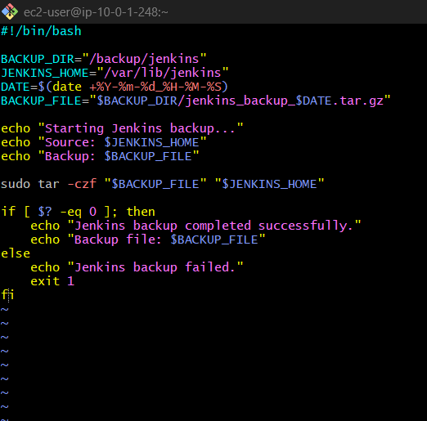

Evidence 2 – Backup File
Show:
ls -lh /backup/jenkins/
with:
jenkins_backup_2026-09-29_20-13-54.tar.gz
149M

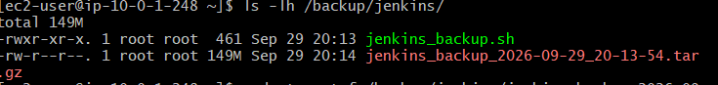

18. Error and Resolution Summary
Problem | Cause | Resolution
SSH connection timed out | SSH Security Group allowed an old public IP | Changed SSH source to My IP
sudo su - jenkins did not switch as expected | Shell remained under ec2-user | Used sudo for backup operations
Jenkins files require elevated permissions | Jenkins Home contains protected files | Executed backup script with sudo
Backup verification required | Need to confirm archive contains Jenkins data | Used tar -tzf to inspect archive

19. Final Result
Task 4 – Jenkins Server Backup Using Bash Script: COMPLETED ✅
Successfully created:
/backup/jenkins/jenkins_backup_2026-09-29_20-13-54.tar.gz
Size:
149 MB
Source backed up:
/var/lib/Jenkins

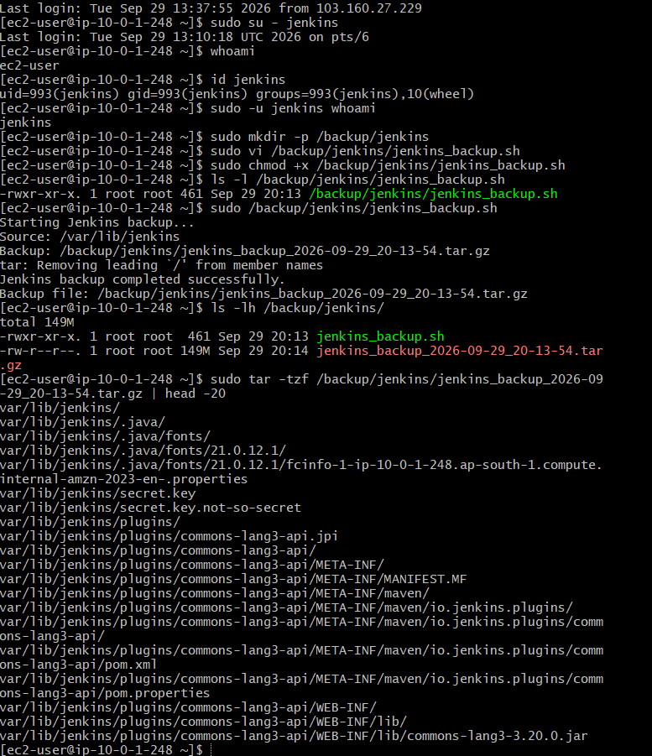

- Take a backup of Jenkins using the ThinBackup plugin.

1. Objective
To install and configure the ThinBackup plugin in Jenkins and create a backup of important Jenkins configuration and job data.
ThinBackup provides a convenient way to back up Jenkins configuration and related data without manually creating a complete archive of the Jenkins Home directory.

2. Jenkins Controller Details
Item | Details
Hostname | ip-10-0-1-248
Private IP | 10.0.1.248
Public IP | 13.127.136.203
Jenkins Port | 8081
Jenkins Home | /var/lib/jenkins
ThinBackup Directory | /backup/thinbackup

3. Install ThinBackup Plugin
Navigate to:
Jenkins
→ Manage Jenkins
→ Plugins
→ Available plugins
Search for:
ThinBackup
Install the plugin.
Installed version:
ThinBackup 2.1.5
The plugin appeared under:
Manage Jenkins
→ Plugins
→ Installed plugins
with the description:
Backups the most important global and job specific configuration files.

Jenkins Restart
Jenkins did not need to be restarted for this lab after installing the plugin because ThinBackup became available in Jenkins.

4. Open ThinBackup
After installation:
Manage Jenkins
→ ThinBackup
The ThinBackup page displayed:
ThinBackup

Settings are now integrated in global configuration.

Backup now
Restore
This indicated that the ThinBackup settings were available through the global Jenkins configuration.

5. ThinBackup Configuration
Navigate to:
Manage Jenkins
→ System
Find:
ThinBackup Configuration
Available configuration options included:
- Backup directory
- Backup schedule for full backups
- Backup schedule for differential backups
- Max number of backup sets
- Files excluded from backup
- Wait until Jenkins is idle
- Force Jenkins to quiet mode
- Backup build results
- Backup build archive
- Backup only builds marked to keep
- Backup userContent folder
- Backup next build number file
- Backup plugins archives
- Backup config-history folder
- Backup additional files
- Clean up differential backups
- Move old backups to ZIP files
- Stop backup on exception

6. Backup Directory
Configured:
/backup/thinbackup
Initially Jenkins displayed a message:
The directory does not exist, but will be created before the first run.
This is acceptable because ThinBackup can create the directory before its first backup.

7. Backup Schedule
Configured the full backup schedule as:
H 2 * * *

Meaning
H 2 * * *
means a full backup is scheduled approximately around 2:00 AM every day.
H represents Jenkins' hashed scheduling mechanism, which helps distribute scheduled tasks.
The differential backup schedule was left empty for this lab.

8. Manual Backup
Because the scheduled time had already passed, the scheduled backup was not used for the immediate test.
Instead:
Manage Jenkins
→ ThinBackup
→ Backup now
was used to manually start the backup.

9. Initial ThinBackup Problem
After clicking:
Backup now
no backup files appeared in:
/backup/thinbackup
We checked the directory permissions.
Command:
ls -ld /backup
Output:
drwxr-xr-x. 4 root root 39 Sep 29 20:29 /backup
Then:
ls -ld /backup/thinbackup
Output:
drwxr-xr-x. 2 root root 6 Sep 29 20:29 /backup/thinbackup

10. Cause of the Problem
ThinBackup runs under the Jenkins service account.
The backup directory was owned by:
root:root
and had:
drwxr-xr-x
The Jenkins user therefore did not have write permission to create the backup inside the directory.

Problem
/backup/thinbackup
↓
root:root
↓
Jenkins cannot write

11. Resolution
Changed the ownership of the ThinBackup directory:
sudo chown jenkins:jenkins /backup/thinbackup
Then verified:
ls -ld /backup/thinbackup
Output:
drwxr-xr-x. 2 jenkins jenkins 6 Sep 29 20:29 /backup/thinbackup
Now the Jenkins service account had ownership of the backup directory.

12. Run ThinBackup Again
After correcting the ownership:
Jenkins
→ Manage Jenkins
→ ThinBackup
→ Backup now
The backup completed successfully.

13. Verify ThinBackup Backup
Checked the directory:
ls -lah /backup/thinbackup
Output:
total 16K
drwxr-xr-x. 3 jenkins jenkins 35 Sep 29 20:36 .
drwxr-xr-x. 4 root root 39 Sep 29 20:29 ..
drwxr-xr-x. 7 jenkins jenkins 16K Sep 29 20:36 FULL-2026-09-29_20-36
This confirmed that ThinBackup successfully created a full backup.
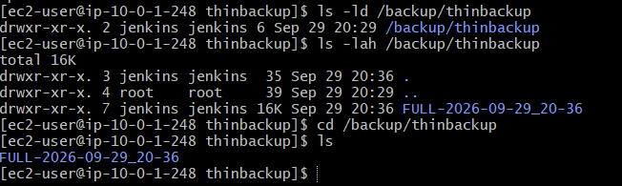

14. Backup Structure
The resulting directory was:
/backup/thinbackup/
└── FULL-2026-09-29_20-36/
The FULL-... directory represents a full ThinBackup backup set.

15. ThinBackup Architecture
Jenkins
│
↓
ThinBackup Plugin
│
↓
Backup Jenkins Data
│
↓
/backup/thinbackup
│
↓
FULL-2026-09-29_20-36

16. ThinBackup vs Bash Backup
Both Task 4 and Task 5 create backups, but their approaches are different.
Feature | Bash Backup | ThinBackup
Method | tar + gzip | Jenkins plugin
Backup location | /backup/jenkins | /backup/thinbackup
Backup format | .tar.gz | ThinBackup directory structure
Configuration | Shell script | Jenkins UI
Scheduling | Can use cron/script | Built into ThinBackup
Backup scope | Jenkins Home directory | Important Jenkins configuration/job data
Manual backup | Execute script | Backup now

Bash backup example
jenkins_backup_2026-09-29_20-13-54.tar.gz

ThinBackup example
FULL-2026-09-29_20-36

17. Important Commands

Check ThinBackup directory
ls -ld /backup/thinbackup

Change ownership
sudo chown jenkins:jenkins /backup/thinbackup

Verify ownership
ls -ld /backup/thinbackup

List ThinBackup files
ls -lah /backup/thinbackup

18. Evidence Screenshots
For Task 5, take these screenshots:

Evidence 1 – ThinBackup Plugin
Show:
ThinBackup Version 2.1.5
under:
Manage Jenkins → Plugins → Installed plugins

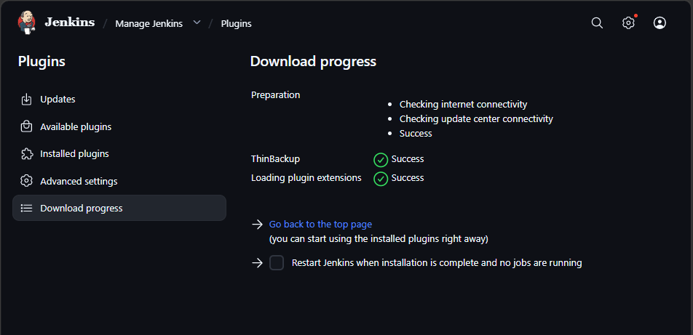

Evidence 2 – ThinBackup Configuration
Show:
/backup/thinbackup
and:
H 2 * * *
under:
Manage Jenkins → System → ThinBackup Configuration

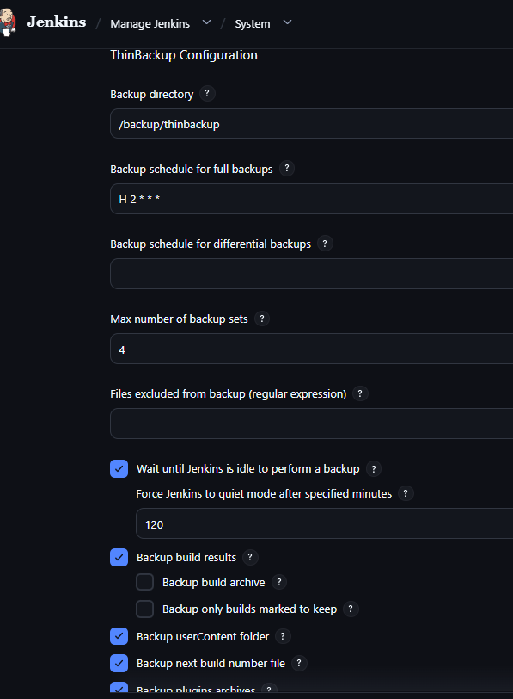

19. Error and Resolution Summary
Problem | Cause | Solution
Backup directory initially empty | Jenkins could not write to the directory | Checked directory permissions
Directory owned by root:root | Jenkins service user lacked ownership/write access | sudo chown jenkins:jenkins /backup/thinbackup
Scheduled 2 AM backup did not run during testing | Scheduled time had already passed | Used Backup now
No Jenkins restart after installation | ThinBackup became available without restart | Continued configuration normally

20. Final Result

Task 5 – ThinBackup Plugin Backup
STATUS: COMPLETED ✅
ThinBackup was successfully:
- Installed
- Verified as version 2.1.5
- Configured
- Given a backup directory
- Given a full-backup schedule
- Tested using Backup now
- Troubleshot for Linux permissions
- Successfully used to create:
FULL-2026-09-29_20-36
under:
/backup/thinbackup

Final ThinBackup Flow
Jenkins Controller
│
↓
ThinBackup Plugin
│
↓
Backup now / Scheduled Backup
│
↓
/backup/thinbackup
│
↓
FULL-2026-09-29_20-36

- Set up a new Jenkins server and restore the backup taken in task 4.

1. Objective
To create a new Jenkins server, install Jenkins on it, and restore the Jenkins backup created during Task 4 using the Bash backup script.
The purpose of this task is to verify that the Jenkins configuration and jobs can be recovered on a completely new Jenkins server using the backup.

2. Existing Jenkins Controller
The original Jenkins Controller was kept running and was not modified or terminated.
Item | Old Jenkins Controller
Hostname | ip-10-0-1-248
Private IP | 10.0.1.248
Public IP | 13.127.136.203
Jenkins Port | 8081
Jenkins Home | /var/lib/jenkins
The backup created in Task 4 was:
/backup/jenkins/jenkins_backup_2026-09-29_20-13-54.tar.gz
Backup size:
149 MB

3. New Jenkins Server
A new EC2 instance was launched specifically for the restore operation.

New Server Details
Item | Details
Hostname | ip-10-0-1-154
Public IP | 43.205.116.212
Jenkins Port | 8080
User | ec2-user
Jenkins Home | /var/lib/jenkins
Restore Directory | /restore
The new server uses port 8080, while the old Jenkins server uses 8081.
This does not cause any conflict because they are two different EC2 instances.

4. Create Jenkins User
Initially, the new server was accessed using:
ssh -i new.pem ec2-user@43.205.116.212
The Jenkins package had not yet been installed, so a dedicated Jenkins user was created:
sudo useradd -m -s /bin/bash jenkins
The user was verified:
id jenkins
Output:
uid=1001(jenkins) gid=1001(jenkins) groups=1001
This confirmed that the dedicated Jenkins service account existed.

5. Install Java
Jenkins requires Java.
Java 21 was installed using:
sudo dnf install java-21-amazon-corretto -y
Java was then verified using:
java -version
Java installation completed successfully.

6. Install Jenkins
The Jenkins repository was configured:
sudo wget -O /etc/yum.repos.d/jenkins.repo https://pkg.jenkins.io/redhat-stable/jenkins.repo
The Jenkins repository key was imported:
sudo rpm --import https://pkg.jenkins.io/redhat-stable/jenkins.io-2026.key
Jenkins was installed:
sudo dnf install jenkins -y

7. Jenkins Port
The old Jenkins server was using:
8081
The new Jenkins server was configured to use its default:
8080
There is no port conflict because the servers are separate EC2 instances.
The new Jenkins URL was:
http://43.205.116.212:8080

8. Security Group Configuration
The new Jenkins server required inbound access to Jenkins.
The Security Group was configured to allow:
TCP 8080
from the appropriate source.
SSH access was also allowed on:
TCP 22
This allowed administration of the new server and browser access to Jenkins.

9. Initial Jenkins Setup
The new Jenkins server was opened using:
http://43.205.116.212:8080
Jenkins displayed the initial administrator password requirement.
The password was retrieved using:
sudo cat /var/lib/jenkins/secrets/initialAdminPassword
The password was entered into the Jenkins unlock screen.

10. Plugin Selection
Instead of installing all suggested plugins, the option:
Select plugins to install
was selected.
A simple plugin such as Git was installed.

Reason
The purpose of the new server was to demonstrate the restore process.
The server was intentionally kept with minimal configuration so that the old Jenkins configuration could be restored from the backup.
No old jobs were manually created on the new server.

11. Create Restore Directory
A dedicated directory was created for the backup:
sudo mkdir -p /restore
The directory was given to the Jenkins user:
sudo chown jenkins:jenkins /restore
Verified using:
ls -ld /restore
Output showed:
jenkins jenkins

12. Backup Transfer Process
The backup was located on the old Jenkins Controller:
13.127.136.203
The backup file was:
jenkins_backup_2026-09-29_20-13-54.tar.gz
The private key was not copied to the new server.
Instead, the backup was transferred through the local Windows PC.

13. Copy Backup from Old Jenkins to Local PC
From Windows Git Bash:
scp -i new.pem ec2-user@13.127.136.203:/backup/jenkins/jenkins_backup_2026-09-29_20-13-54.tar.gz .
The backup was successfully downloaded to the local PC.
It was approximately:
149 MB

14. Copy Backup from Local PC to New Jenkins Server
The backup was then uploaded to the new Jenkins server:
scp -i new.pem jenkins_backup_2026-09-29_20-13-54.tar.gz ec2-user@43.205.116.212:/tmp/
After connecting to the new server, the backup was moved to:
/restore
Command:
sudo mv /tmp/jenkins_backup_2026-09-29_20-13-54.tar.gz /restore/
The backup was verified with:
ls -lh /restore/
The 149 MB backup was present.

15. Stop Jenkins Before Restore
Before replacing Jenkins Home, the new Jenkins service was stopped.
Command:
sudo systemctl stop jenkins
The service status was checked:
sudo systemctl status jenkins --no-pager
The result showed:
inactive (dead)
This was important because Jenkins should not be running while its Home directory is being replaced.

16. Preserve the New Jenkins Home
Before restoring the backup, the newly created Jenkins Home was renamed as a safety backup:
sudo mv /var/lib/jenkins /var/lib/jenkins-original
This preserved the initial configuration of the new Jenkins server.
The original directory could therefore be recovered if something went wrong during restoration.

17. Restore the Bash Backup
The Task 4 backup was a compressed .tar.gz archive containing:
/var/lib/jenkins
The backup was extracted from the root directory:
sudo tar -xzf /restore/jenkins_backup_2026-09-29_20-13-54.tar.gz -C /
This recreated:
/var/lib/jenkins
using the data from the old Jenkins server.

18. Verify Restored Jenkins Home
The restored Jenkins Home was checked:
sudo ls -ld /var/lib/jenkins
Output:
drwxr-xr-x. 17 jenkins jenkins 16384 Sep 29 20:10 /var/lib/jenkins
This confirmed:
Owner: jenkins
Group: jenkins

19. Verify Restored Configuration
The contents of Jenkins Home were checked:
sudo ls /var/lib/jenkins | head
The restored files included:
config.xml
credentials.xml
fingerprints
github-plugin-configuration.xml
hudson.model.UpdateCenter.xml
hudson.plugins.build_timeout.global.GlobalTimeOutConfiguration.xml
hudson.plugins.build_timeout.operations.BuildStepOperation.xml
hudson.plugins.emailext.ExtendedEmailPublisher.xml
hudson.plugins.git.GitSCM.xml
This confirmed that the old Jenkins configuration had been restored.

20. Start Restored Jenkins
After verifying the files, Jenkins was started:
sudo systemctl start jenkins
The Jenkins service became active.
The restored Jenkins was then accessed at:
http://43.205.116.212:8080

21. Final Verification
After opening the new Jenkins dashboard, the old job:
Git-Commands-Webhook
was visible.
This was the most important proof that the restoration worked.
The job had been created on the old Jenkins server, but after restoring the backup it appeared automatically on the new Jenkins server.
No manual recreation of the job was required.

22. Complete Restore Architecture
OLD JENKINS SERVER
13.127.136.203:8081
│
│
│ Task 4 Bash Backup
↓
/backup/jenkins/jenkins_backup_2026-09-29_20-13-54.tar.gz
│
│ 149 MB
↓
Local PC
│
│ SCP
↓
NEW JENKINS SERVER
43.205.116.212:8080
│
↓
/restore/
│
↓
Extract backup archive
│
↓
/var/lib/jenkins
│
↓
Start Jenkins
│
↓
Git-Commands-Webhook
RESTORED ✅

23. Important Commands Used

Create Jenkins user
sudo useradd -m -s /bin/bash jenkins

Verify Jenkins user
id jenkins

Install Java
sudo dnf install java-21-amazon-corretto -y

Install Jenkins
sudo dnf install jenkins -y

Get initial admin password
sudo cat /var/lib/jenkins/secrets/initialAdminPassword

Create restore directory
sudo mkdir -p /restore

Change ownership
sudo chown jenkins:jenkins /restore

Copy backup from old server to local PC
scp -i new.pem ec2-user@13.127.136.203:/backup/jenkins/jenkins_backup_2026-09-29_20-13-54.tar.gz .

Upload backup to new server
scp -i new.pem jenkins_backup_2026-09-29_20-13-54.tar.gz ec2-user@43.205.116.212:/tmp/

Move backup
sudo mv /tmp/jenkins_backup_2026-09-29_20-13-54.tar.gz /restore/

Stop Jenkins
sudo systemctl stop jenkins

Preserve original Jenkins Home
sudo mv /var/lib/jenkins /var/lib/jenkins-original

Extract backup
sudo tar -xzf /restore/jenkins_backup_2026-09-29_20-13-54.tar.gz -C /

Verify Jenkins Home
sudo ls -ld /var/lib/jenkins

Verify restored files
sudo ls /var/lib/jenkins | head

Start Jenkins
sudo systemctl start jenkins

Check Jenkins status
sudo systemctl status jenkins --no-pager

24. Why Jenkins Was Stopped Before Restoration
Jenkins was stopped before extracting the backup because Jenkins continuously reads and writes files inside:
/var/lib/jenkins
If Jenkins were running while the files were being replaced, it could:
- Modify files during restoration
- Keep old configuration in memory
- Cause inconsistent configuration
- Potentially overwrite restored files
Therefore:
Stop Jenkins
↓
Restore Jenkins Home
↓
Verify files
↓
Start Jenkins
is the safer restore sequence.

25. Why the Original New Jenkins Home Was Renamed
Instead of deleting:
/var/lib/jenkins
it was renamed:
/var/lib/jenkins-original
This provides a fallback.
If the restoration failed, the original directory could potentially be restored.
This is safer than immediately deleting the new Jenkins configuration.

26. Task 6 Evidence
Recommended screenshots:

Evidence 1 – New EC2 Server
Show:
Jenkins Restore Server
Public IP: 43.205.116.212

Evidence 2 – Backup File
Show:
ls -lh /restore/
with:
jenkins_backup_2026-09-29_20-13-54.tar.gz
approximately:
149M

Evidence 3 – Restored Jenkins Home
Show:
sudo ls -ld /var/lib/jenkins
and:
sudo ls /var/lib/jenkins | head
showing files such as:
config.xml
credentials.xml
github-plugin-configuration.xml

Evidence 4 – Restored Jenkins Job
Open:
http://43.205.116.212:8080
and show:
Git-Commands-Webhook
on the Jenkins dashboard.

Evidence 4 is the strongest proof of successful restoration.
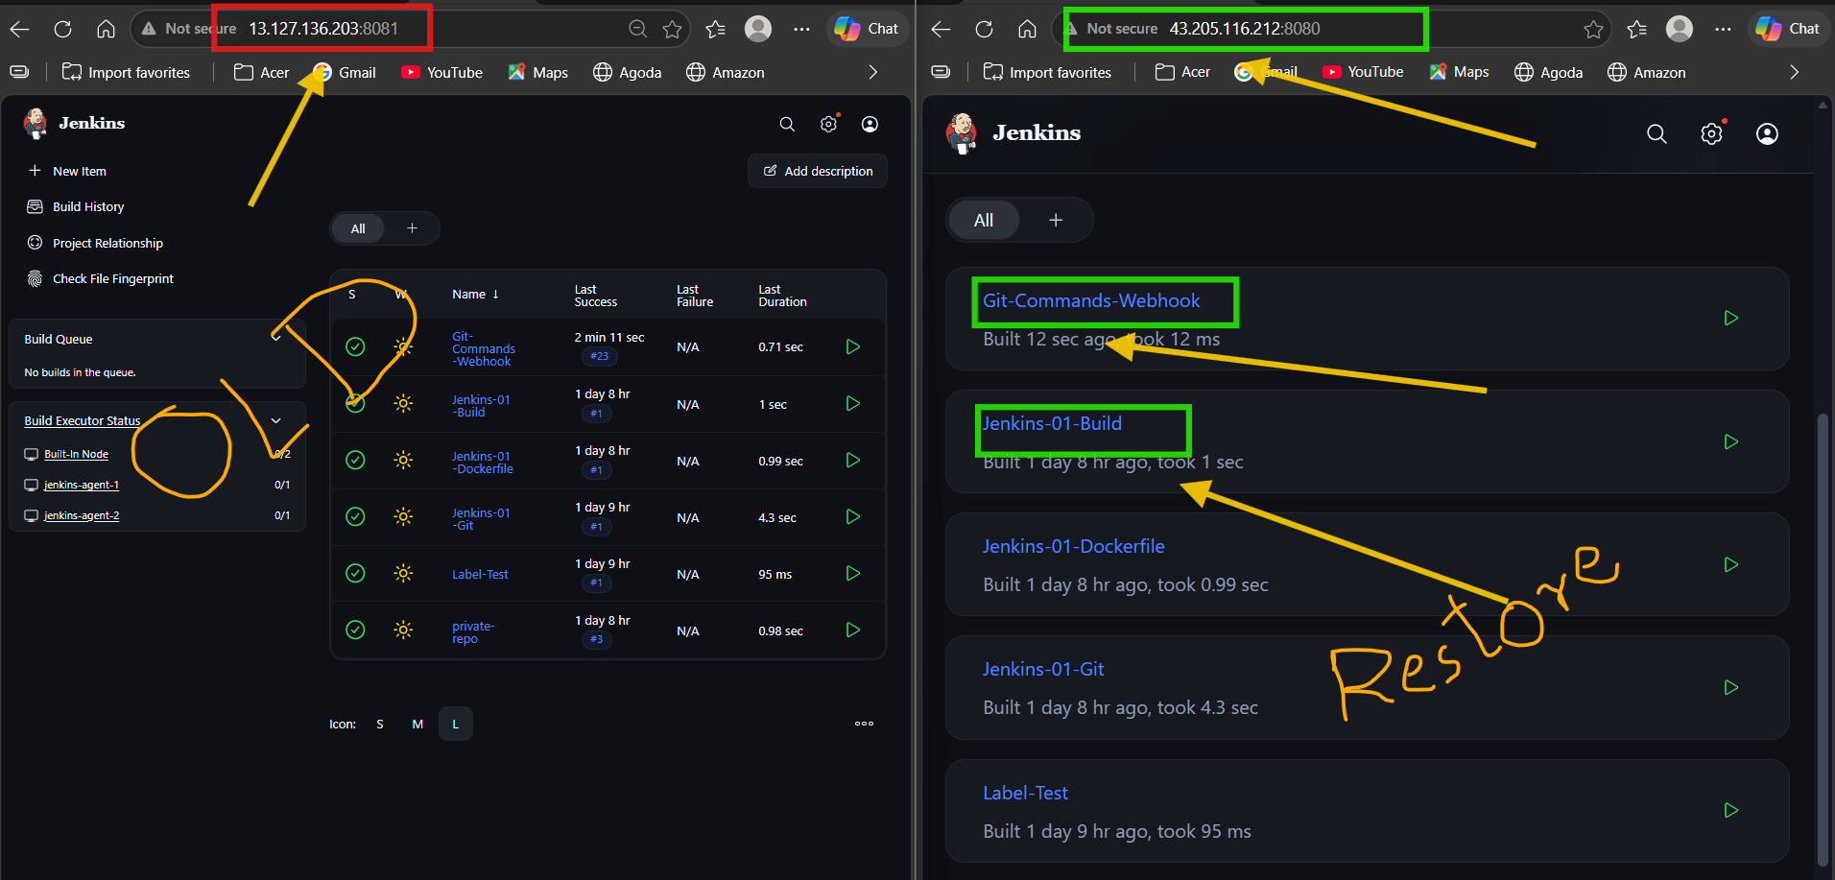

27. Important Difference Between Task 4 and Task 5 Backups
For Task 6, the Task 4 Bash backup was used.

Task 4
Backup:
/backup/jenkins/jenkins_backup_2026-09-29_20-13-54.tar.gz
Created using:
Bash + tar + gzip

Task 5
ThinBackup created:
/backup/thinbackup/FULL-2026-09-29_20-36
For this task, we intentionally demonstrated restoration using the Bash backup from Task 4.

28. Error Encountered During Transfer
When attempting to copy the backup from the new server, the command initially produced:
Warning: Identity file new.pem not accessible: No such file or directory.

Cause
The command was being run inside the new EC2 server, where the private key new.pem was not present.

Resolution
The private key was kept on the local PC.
The transfer was performed from Windows Git Bash, where new.pem was already available.
This avoided unnecessarily copying the private SSH key to the new server.

29. Final Result

Task 6 – New Jenkins Server + Restore
STATUS: COMPLETED ✅
Successfully demonstrated:
- ✅ New EC2 server created
- ✅ Dedicated Jenkins user verified
- ✅ Java installed
- ✅ Jenkins installed
- ✅ New Jenkins configured on port 8080
- ✅ Initial Jenkins setup completed
- ✅ Restore directory created
- ✅ Task 4 backup transferred
- ✅ Backup size verified at approximately 149 MB
- ✅ Jenkins stopped before restoration
- ✅ Original new-server Jenkins Home preserved
- ✅ Backup extracted into /var/lib/jenkins
- ✅ Jenkins ownership verified
- ✅ Restored configuration files verified
- ✅ Jenkins restarted successfully
- ✅ Git-Commands-Webhook appeared automatically on the new Jenkins server

Final Architecture
OLD JENKINS
13.127.136.203:8081
│
│ Bash Backup
↓
149 MB .tar.gz
│
│ Transfer
↓
NEW JENKINS
43.205.116.212:8080
│
│ Restore
↓
/var/lib/jenkins
│
↓
Git-Commands-Webhook
│
↓
RESTORED SUCCESSFULLY ✅

