1. AWS Lambda

1.1 What is AWS Lambda?
AWS Lambda is a serverless compute service that lets you run code without provisioning or managing servers.
You upload your code as a Lambda function, and AWS runs it when the function is invoked.

Simple idea
Event / Request
↓
Lambda
↓
Your Code
↓
Response
You focus on the application code while AWS manages the underlying infrastructure.

1.2 Why do we use Lambda?
Without Lambda, a simple application might require:
EC2
↓
Operating System
↓
Runtime
↓
Application
You have to manage:
- Server
- OS
- Patching
- Runtime
- Scaling
- Availability
- Infrastructure
With Lambda:
Event
↓
Lambda
↓
Code executes
↓
Response
AWS manages the infrastructure.

Main reasons to use Lambda
- No server management
- Automatic scaling
- Event-driven execution
- Pay for execution rather than maintaining an always-running server
- Integrates with many AWS services
- Suitable for short-running application logic
- Useful for automation and backend processing

2. Lambda Architecture
A basic Lambda architecture is:
Event Source
↓
Lambda Service
↓
Execution Environment
↓
Lambda Function
↓
Response

Example
An S3 file is uploaded:
S3
↓
Lambda
↓
Process uploaded file
Another example:
API Gateway
↓
Lambda
↓
Business Logic

3. Lambda Function
A Lambda function is the unit of code that AWS executes.
For example:
def lambda_handler(event, context):
return {
"statusCode": 200,
"body": "Hello World"
}
The function contains your application logic.

4. Lambda Handler
The handler tells Lambda which function it should execute.
For example:
def lambda_handler(event, context):
Here:
- lambda_handler → function name
- event → input data
- context → information about the Lambda execution
The handler is generally specified as:
filename.function_name
For example:
lambda_function.lambda_handler

5. Lambda Event
An event is the input passed to Lambda when it is invoked.
Example:
{
"name": "Afrid"
}
Your code can access it:
def lambda_handler(event, context):

name = event["name"]

return name
Different AWS services generate different event formats.
For example:
API Gateway → HTTP request event
S3 → Object event
SQS → Message event
EventBridge → Event information
This is why understanding the event object is important.

6. Lambda Context
context contains information about the current Lambda execution.
It can provide information such as:
- Function name
- Function version
- Request ID
- Remaining execution time
- Memory configuration
Example:
def lambda_handler(event, context):

print(context.function_name)
You won't normally need it for simple functions, but you should understand what it represents.

7. Lambda Runtime
The runtime provides the environment required to execute your code.
Examples include:
- Python
- Node.js
- Java
- Go
- .NET
For our hands-on implementation, we'll use Python.
Conceptually:
Lambda
↓
Python Runtime
↓
Your Python Code

8. Lambda Execution Role
Lambda often needs permission to access other AWS resources.
For example:
Lambda
↓
Read S3
or:
Lambda
↓
Use KMS
Lambda uses an IAM execution role to obtain the permissions required by its code.
Example:
Lambda Execution Role
│
├── CloudWatch Logs
├── S3
└── KMS

Important
The execution role is not the same thing as the permissions of the person creating the Lambda function.
There are two different concepts:
Your IAM permissions
↓
Can you create/configure Lambda?

Lambda execution role
↓
What can the running Lambda function access?
This distinction is very important for AWS interviews.

9. Lambda Invocation
Invocation means executing a Lambda function.
There are several ways Lambda can be invoked.

Synchronous
The caller waits for the response.
Client
↓
Lambda
↓
Response
Example:
API Gateway → Lambda

Asynchronous
The event is submitted and Lambda processes it without the caller waiting for the function's response.
Example:
Event
↓
Lambda

Event source / polling based
Some AWS services act as event sources that Lambda polls or consumes from, such as certain queue and stream services.
Example:
SQS
↓
Lambda

10. Lambda Scaling
Lambda can automatically create execution environments as demand increases, subject to AWS limits and concurrency controls.
For example:
1 request
↓
1 execution

100 requests
↓
Multiple executions
You don't manually launch 100 EC2 instances.
This is one of Lambda's major advantages.

11. Lambda Cold Start
When Lambda needs a new execution environment, there can be initialization overhead before your function begins processing.
This is commonly referred to as a cold start.
Conceptually:
Request
↓
Create/initialize environment
↓
Run function
If an execution environment is already available, Lambda may reuse it:
Request
↓
Existing environment
↓
Run function
This distinction matters when designing latency-sensitive applications.

12. Lambda Timeout
Every Lambda function has a maximum execution time configured by the function.
If your code doesn't finish within the configured timeout:
Lambda starts
↓
Code runs
↓
Timeout reached
↓
Execution stops
Therefore, Lambda is intended for workloads that fit within its execution limits.

13. Lambda Memory
Lambda allows you to configure memory for the function.
Increasing memory can also provide more CPU resources.
Therefore, memory configuration can affect:
- Execution performance
- Execution duration
- Cost
Don't think of Lambda memory as simply "RAM." It also affects the compute resources allocated to the function.

14. Lambda Environment Variables
Environment variables allow configuration values to be supplied to your Lambda function without hard-coding them into the application code.
Example:
DATABASE_NAME=InstituteDB
ENVIRONMENT=production
Code can read them.
import os

environment = os.environ["ENVIRONMENT"]
For sensitive values, don't treat ordinary environment variables as a substitute for proper secrets management. AWS services such as Secrets Manager or Parameter Store may be more appropriate depending on the use case.

15. Lambda Layers
A Lambda Layer is a mechanism for packaging reusable dependencies or supporting files separately from the main function code.
Conceptually:
Lambda Function
+
Lambda Layer
↓
Execution
Useful when multiple functions share common libraries or components.

16. Lambda Versions and Aliases
Lambda supports versions of functions.
You can have:
Version 1
Version 2
Version 3
An alias can point to a particular version.
Example:
production → Version 3
testing → Version 4
This helps with controlled deployments and release management.

17. Lambda Monitoring
Lambda integrates with Amazon CloudWatch.
CloudWatch can provide:
- Logs
- Metrics
- Monitoring
- Alarms
For example:
Lambda
↓
CloudWatch Logs
If your Lambda fails, one of the first places to investigate is its CloudWatch logs.

18. Lambda vs EC2
This is an important interview topic.
EC2 | Lambda
Virtual server | Serverless compute
You manage the OS | AWS manages infrastructure
Usually continuously running | Runs when invoked
You manage scaling configuration | Automatic scaling is built in, subject to limits
Suitable for long-running workloads | Suitable for event-driven/function-based workloads
More infrastructure control | Less infrastructure management
Pay for provisioned/used instance time | Pay based on Lambda usage

19.API GATEWAys

19.1 What is API Gateway?
Amazon API Gateway is a managed service for creating, publishing, monitoring, and securing APIs.
The simplest architecture:
Client
↓
API Gateway
↓
Backend
The backend could be:
Lambda
or other AWS/internet-accessible integrations depending on the API design.

20. Why do we use API Gateway?
Suppose you have Lambda:
Lambda
↓
Application logic
But your mobile application or website needs to call it over HTTP.
You can use:
Mobile/Web Client
↓
API Gateway
↓
Lambda
API Gateway provides the API-facing layer.

21. API Gateway Request Flow
For our implementation:
Client
│
│ HTTPS Request
↓
API Gateway
│
│ Route request
↓
Lambda
│
│ Execute code
↓
Lambda Response
│
↓
API Gateway
│
↓
Client
This request flow is something you should understand thoroughly.

22. API Route
An API route generally combines:
HTTP Method + Path
Example:
GET /users
POST /users
GET /users/10
DELETE /users/10
For our lab, we can use:
POST /hello

23. HTTP Methods
Common methods:

GET
Retrieve data.
GET /users

POST
Create/send data.
POST /users

PUT
Replace/update a resource.

PATCH
Partially update a resource.

DELETE
Delete a resource.

24. API Gateway Integration
An integration tells API Gateway what backend should handle the request.
Example:
POST /hello
↓
API Gateway
↓
Lambda
So:
Route = where the request goes
Integration = what backend handles it

25. HTTP API vs REST API
API Gateway provides different API types, including HTTP APIs and REST APIs.

HTTP API
Generally simpler and designed for common HTTP API use cases.

REST API
Provides additional API management features and capabilities.
For our basic Lambda lab, HTTP API is sufficient.
Don't memorize "REST is better." The correct choice depends on requirements.

26. API Gateway Stages
Stages represent deployment environments or versions of an API.
Common examples:
dev
test
prod
Conceptually:
API
├── dev
├── test
└── prod
This lets different environments expose different API configurations.

27. API Gateway Authentication & Authorization
API Gateway can integrate with mechanisms such as:
- IAM authorization
- Lambda authorizers
- Amazon Cognito
- API keys/usage plans for applicable API types and use cases
The important distinction:
Authentication
Who are you?
Authorization
What are you allowed to do?

28. API Gateway Throttling
Throttling controls request rates.
For example, if too many requests arrive:
10,000 requests
↓
API Gateway
↓
Rate limiting/throttling
This can help protect backend systems and manage traffic.

29. CORS
CORS = Cross-Origin Resource Sharing
It controls whether browsers are allowed to make requests to your API from another origin.
Example:
Website:
https://example.com

API:
https://api.example.com
The browser may enforce CORS rules when the website calls the API.

AMAZON KMS:
30. AWS KMS

30.1 What is AWS KMS?
AWS Key Management Service (KMS) is a managed service for creating and controlling cryptographic keys used to protect data.
The key idea is:
KMS is primarily about managing and controlling cryptographic keys.

31. Why do we need KMS?
Applications often need to protect sensitive data.
Without encryption:
Sensitive Data
↓
Stored as plaintext
With encryption:
Plaintext
↓
Encryption + Key
↓
Ciphertext
To recover the data:
Ciphertext
↓
Decryption + Key
↓
Plaintext
KMS helps manage the cryptographic keys involved in these operations and control who/what can use them.

32. KMS Key
A KMS key is a cryptographic key managed through KMS.
You might create:
alias/my-application-key
Then AWS services or applications can use that key where supported and authorized.

33. KMS Key Types
Two broad cryptographic categories you'll encounter are:

Symmetric
The same underlying key is used for encryption and decryption operations.
Encrypt
↓
Same key
↓
Decrypt
This is commonly used for data encryption.

Asymmetric
Uses a public/private key pair.
Public Key
+
Private Key
Used for scenarios such as certain encryption or signing operations.
For our lab:
Symmetric key → Encrypt and decrypt

34. AWS Managed Keys vs Customer Managed Keys

AWS managed key
AWS creates and manages the key for a particular AWS service/use case.

Customer managed key
You create and have greater control over the key configuration and policies.
For our hands-on:
Customer Managed KMS Key
This lets you understand the key configuration and permissions more directly.

35. KMS Key Policy
A key policy is a resource-based policy that controls access to a KMS key.
This is extremely important.
Think:
KMS Key
↓
Who can use this key?
Who can administer this key?
What actions can they perform?
KMS permissions can involve both:
- KMS key policies
- IAM policies
Understanding how these interact is important for troubleshooting access-denied errors.

36. Lambda + KMS Permissions
Suppose:
Lambda
↓
KMS
Lambda cannot simply use any KMS key.
Its execution role must have the required permissions, and the KMS key's access policy must permit the relevant principal where applicable.
Conceptually:
Lambda Execution Role
↓
IAM Permission
↓
KMS Key
↓
Encrypt / Decrypt
This is an important AWS security concept:
Having an AWS service doesn't automatically give it permission to access other AWS resources.

37. Envelope Encryption
This is an important KMS concept.
Instead of using a KMS key to directly encrypt large amounts of application data, AWS commonly uses envelope encryption.
Conceptually:
KMS Key
↓
Encrypts a Data Key
↓
Data Key encrypts actual data
So:
KMS
│
↓
Data Key
│
↓
Application Data
The KMS key protects the data key, while the data key is used for the actual data encryption.
You don't need to implement this manually for our basic lab, but understand the concept.

38. KMS Key Rotation
KMS supports key rotation capabilities depending on key type/configuration.
The purpose is to periodically rotate cryptographic key material while maintaining the ability to decrypt previously encrypted data where AWS's key management model supports it.
Don't confuse:
Rotating a key
with:
Creating a completely unrelated new key
They are not necessarily the same thing operationally.

39. KMS and AWS Services
Many AWS services integrate with KMS.
Examples include:
S3
RDS
EBS
Secrets Manager
Lambda
CloudWatch Logs
Conceptually:
KMS
│
┌──────┼────────┐
↓ ↓ ↓
S3 RDS EBS
This is why KMS is an important AWS security service.

40. The Complete Architecture
Now combine everything:
CLIENT
│
│ HTTPS
↓
┌─────────────────┐
│ API GATEWAY │
│ │
│ Route /hello │
└────────┬────────┘
│
│ Invoke
↓
┌─────────────────┐
│ LAMBDA │
│ │
│ Application │
│ Logic │
└────────┬────────┘
│
│ Encrypt /
│ Decrypt
↓
┌─────────────────┐
│ KMS │
│ │
│ Cryptographic │
│ Key │
└─────────────────┘

Remember these three lines
API Gateway
Receives and manages API requests.
Lambda
Executes application code without requiring you to manage servers.
KMS
Manages cryptographic keys and their use for protecting data.

41. End-to-End Request Flow
Suppose the client sends:
{
"name": "Afrid",
"secret": "AWS-Training"
}
The flow is:
1. Client sends HTTPS request
↓
2. API Gateway receives request
↓
3. API Gateway routes request
↓
4. Lambda is invoked
↓
5. Lambda executes application logic
↓
6. Lambda requests KMS encryption operation
↓
7. KMS performs the cryptographic operation
↓
8. Lambda prepares response
↓
9. API Gateway returns response
↓
10. Client receives response
That is the architecture we're going to actually build.

LAmbda tasks :

1. Task
Create and configure an AWS Lambda function using Python, invoke it using a test event, and verify that the function can receive and process input data through the event object.

Implementation Steps
- Create Lambda
  - Name: Lambda-baics-l1
  - Runtime: Python 3.14
  - Architecture: x86_64
  - Create execution role with basic Lambda permissions.
- Write Code
def lambda_handler(event, context):

name = event.get("name", "User")

return {
"statusCode": 200,
"body": f"Hello {name}, from Lambda!"
}
- Deploy the function.
- Create Test Event
{
"name": "Afrid"
}
- Test
  - Result: Succeeded
  - Response: Hello Afrid, from Lambda!
- Change Input
{
"name": "AWS"
}
- Response: Hello AWS, from Lambda!

Result
Successfully created and tested a Lambda function that processes dynamic input through the event object.

function:
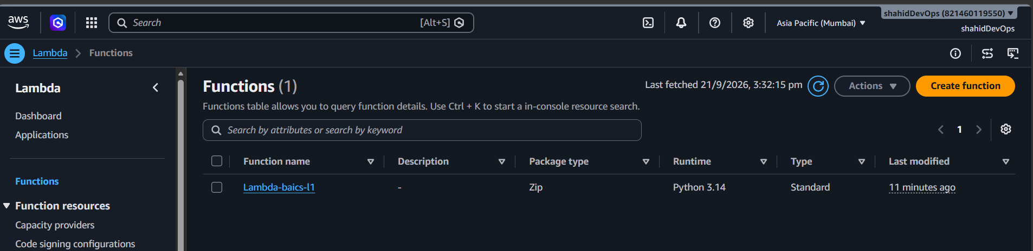

event name: name=”Afrid”
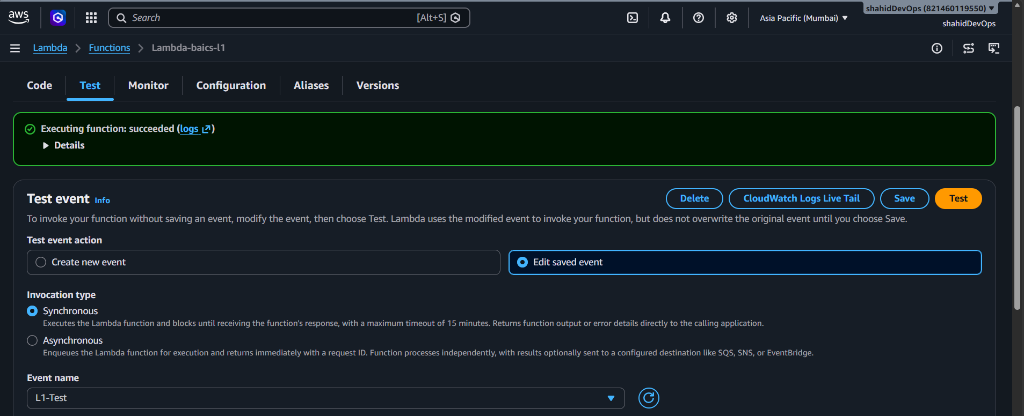
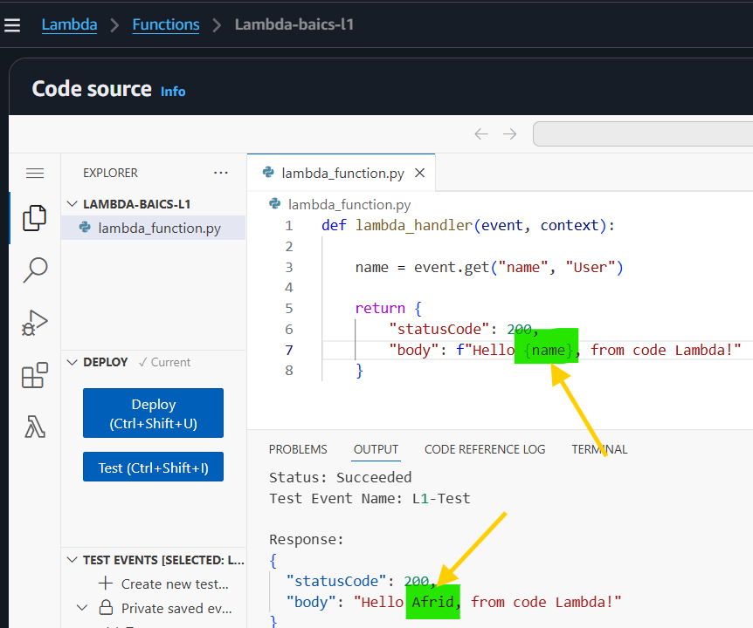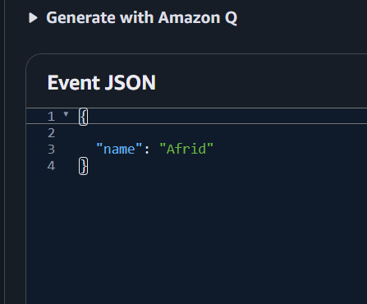

Event name : name=”AWS”
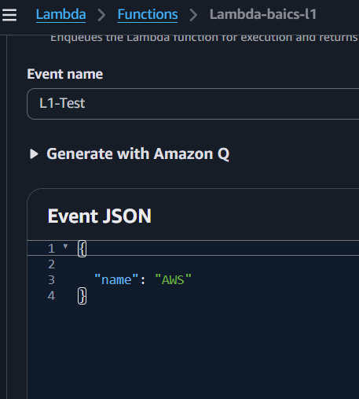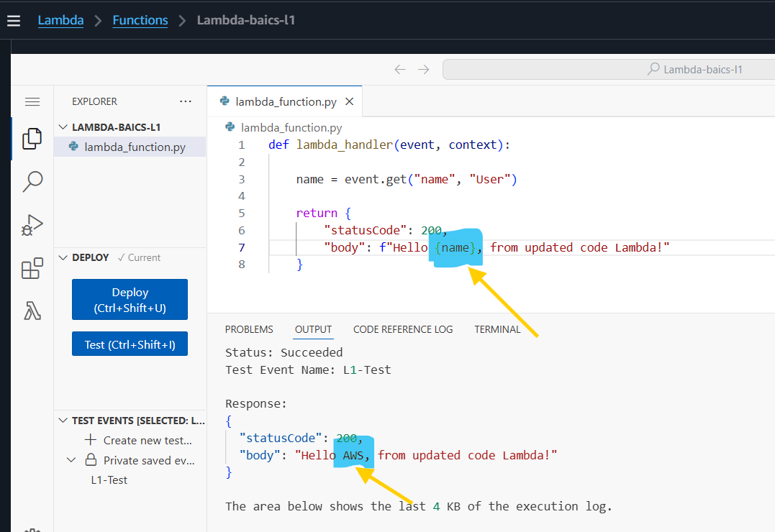

TASK L2 — Lambda + CloudWatch Logs
Task
Configure a Lambda function to generate execution logs and monitor those logs using Amazon CloudWatch.

Implementation Steps
- Modify Lambda code to use print() statements.
- Deploy the updated function.
- Invoke/Test Lambda with:
{
"name": "Afrid"
}
- Verify Status: Succeeded.
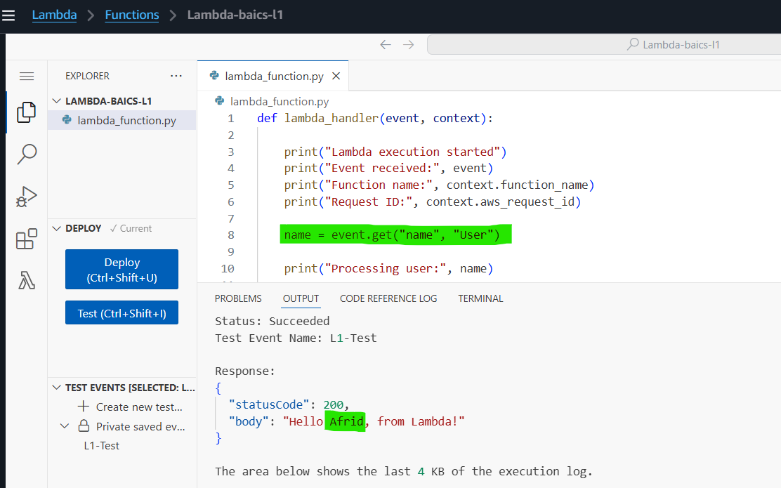
- Check the Log output in the Lambda test result.
- Go to Monitor → CloudWatch Logs.
- Open the Lambda Log Group:
/aws/lambda/Lambda-baics-l1
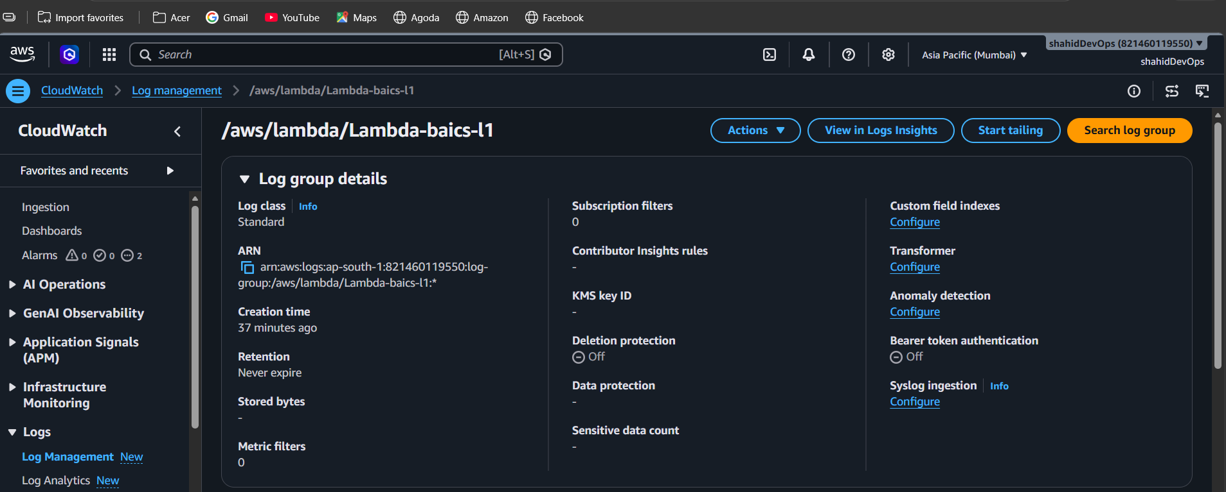
- Open the Log Stream and verify the execution logs.
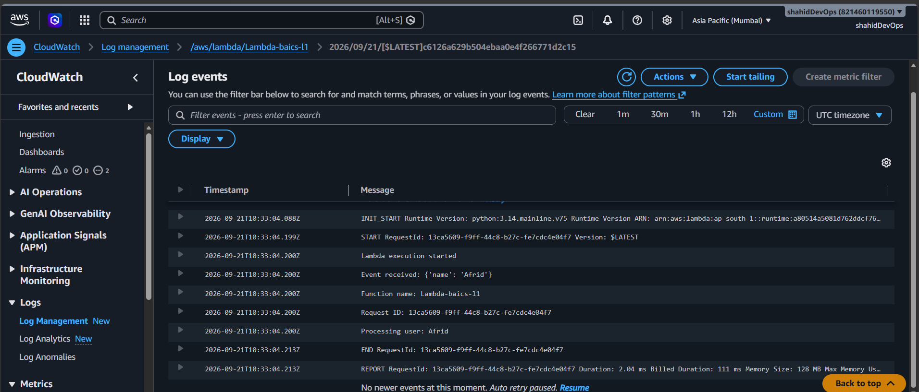

Important Concepts
- CloudWatch Logs: Stores Lambda execution logs.
- Log Group: Collection of logs for a Lambda function.
- Log Stream: Contains logs from Lambda execution environments.
- print() → generates application logs.
- Lambda automatically integrates with CloudWatch Logs when the execution role has the required logging permissions.

Architecture
Lambda
↓
Execution Logs
↓
CloudWatch
↓
Log Group
↓
Log Stream

Result
Successfully generated and viewed Lambda execution logs using Amazon CloudWatch.

L3 — Lambda + IAM + S3
Task: Configure Lambda to access an S3 object using IAM permissions.

Implementation Steps
- Created an S3 bucket:
lambda-l3-afrid-2026
- Uploaded text.txt to the bucket.
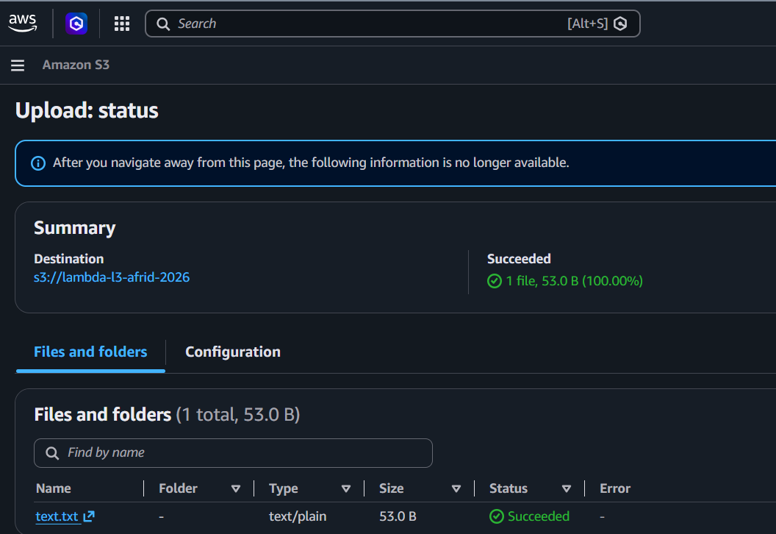

- Opened the Lambda function Lambda-baics-l1 and identified its IAM execution role.
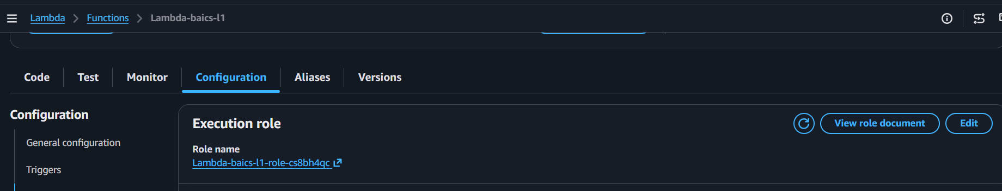
- Added an inline IAM policy to the execution role with:
  - Action: s3:GetObject
  - Resource: arn:aws:s3:::lambda-l3-afrid-2026/text.txt
- Created the policy:
LambdaL3S3GetObject
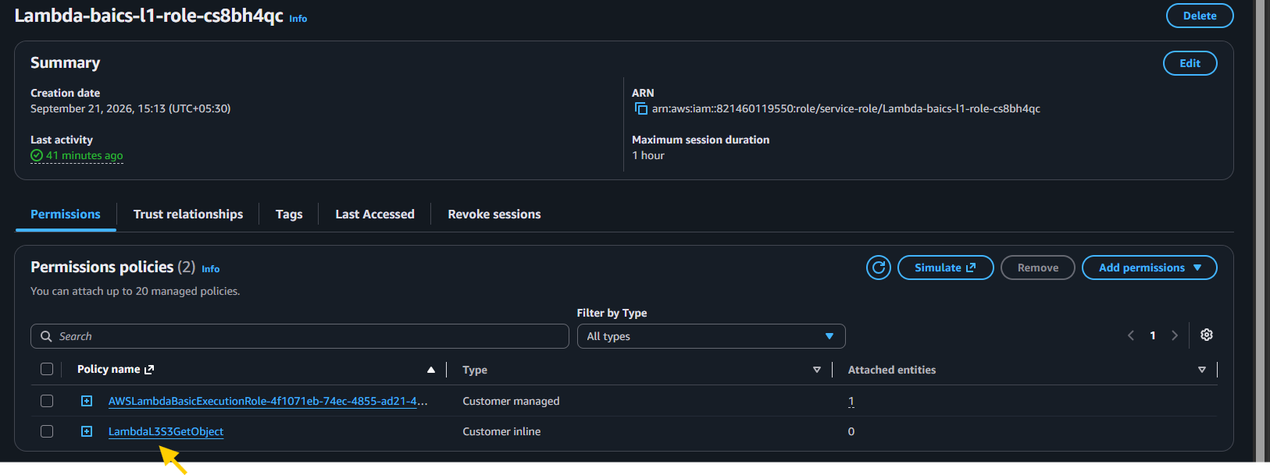
- Updated the Lambda function using boto3 to read text.txt from S3. 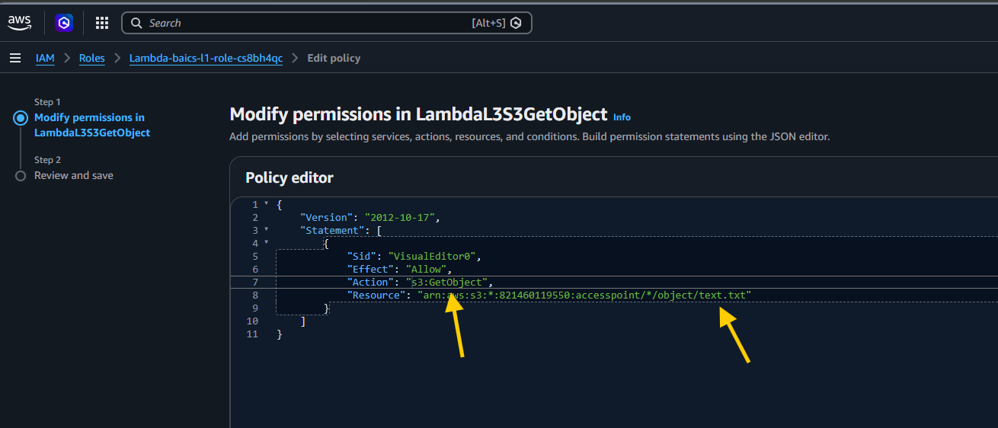
- Deployed the Lambda function and executed the test event.
- Lambda successfully retrieved the contents of text.txt.
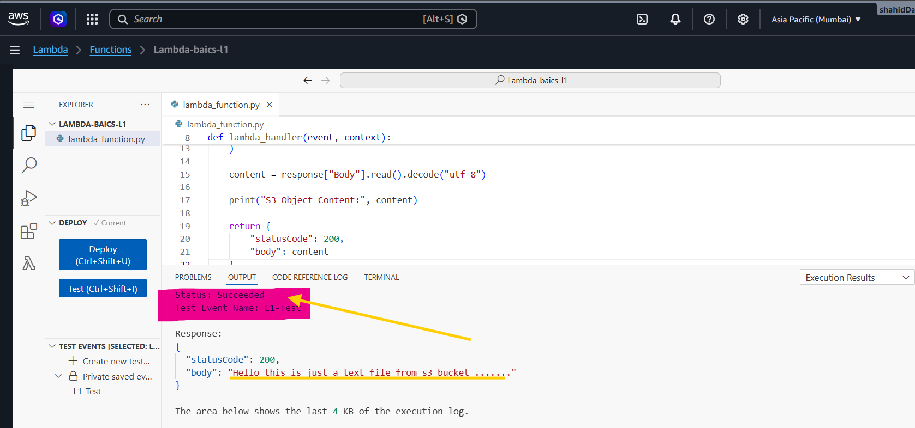

Result
Lambda → IAM Role → S3 integration successfully completed. ✅

TASKS ON API GATEWAY AND LAMBDA

API Gateway + Lambda
Task 1: Create an HTTP API and integrate it with the Lambda function.

Implementation Steps
- Created an HTTP API in API Gateway.
- API name:
Afrid-Lambda-API

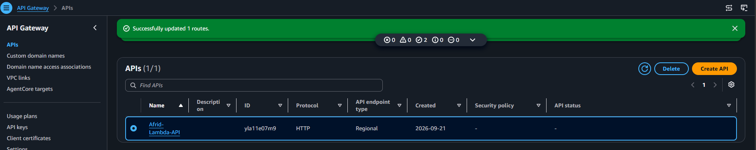
- Created the route:
GET /hello

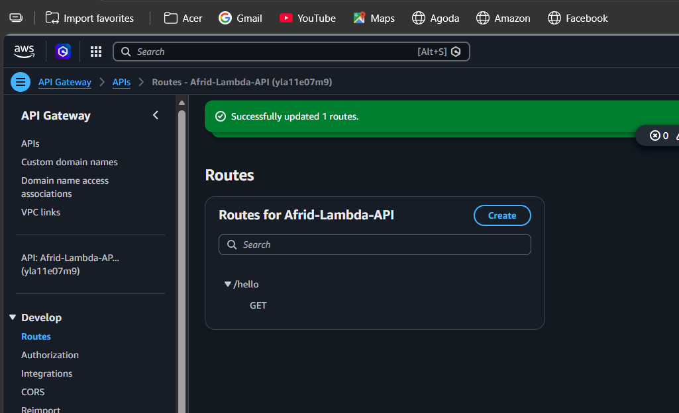
- Created a Lambda integration in ap-south-1.
- Selected Lambda function:
Lambda-baics-l1
- Enabled Grant API Gateway permission to invoke Lambda.
- Attached the Lambda integration to the GET /hello route.
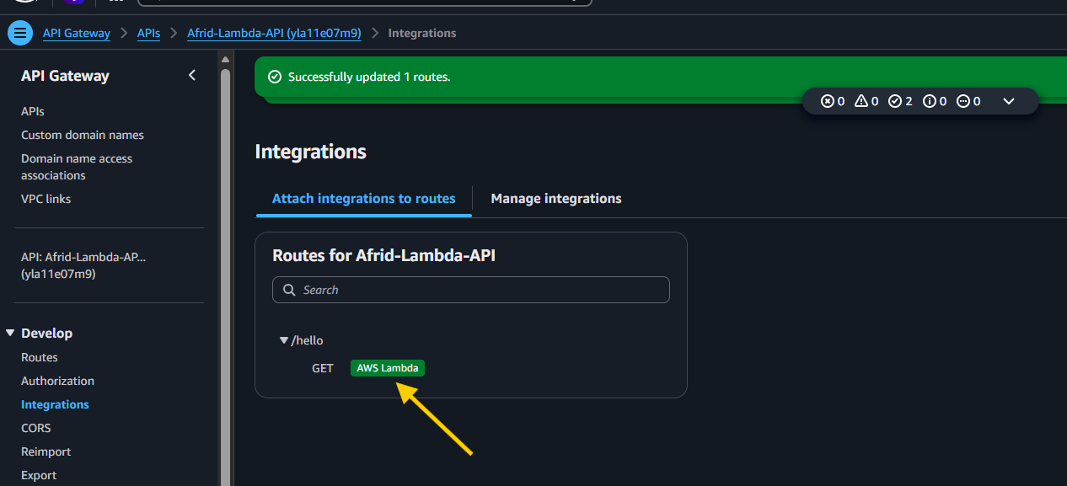
- Used the API Gateway Invoke URL to test the API.
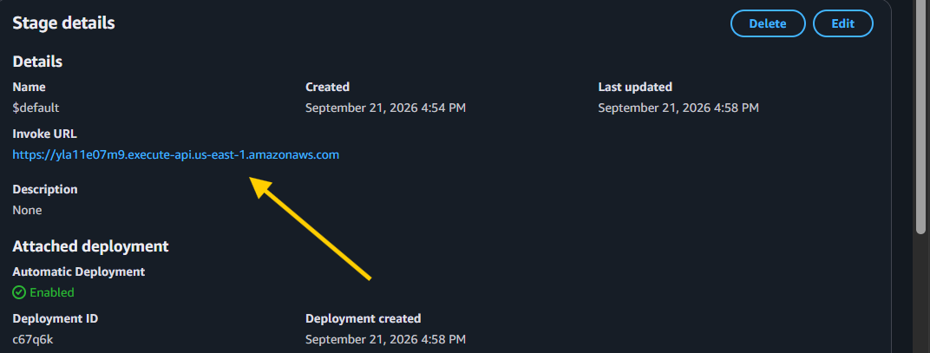
- Successfully received the contents of text.txt stored in S3.
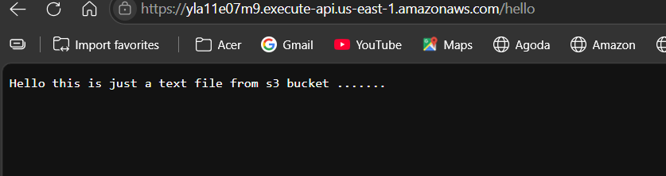

Architecture
Client
↓
API Gateway
↓
GET /hello
↓
Lambda
↓
IAM Role
↓
S3 → text.txt

Result
Successfully created and tested an API Gateway → Lambda → S3 integration. ✅

A3 — API Gateway Query Parameters
Task: Pass dynamic input from the API URL to Lambda using query parameters.

Implementation Steps
- Updated the Lambda function to read queryStringParameters.
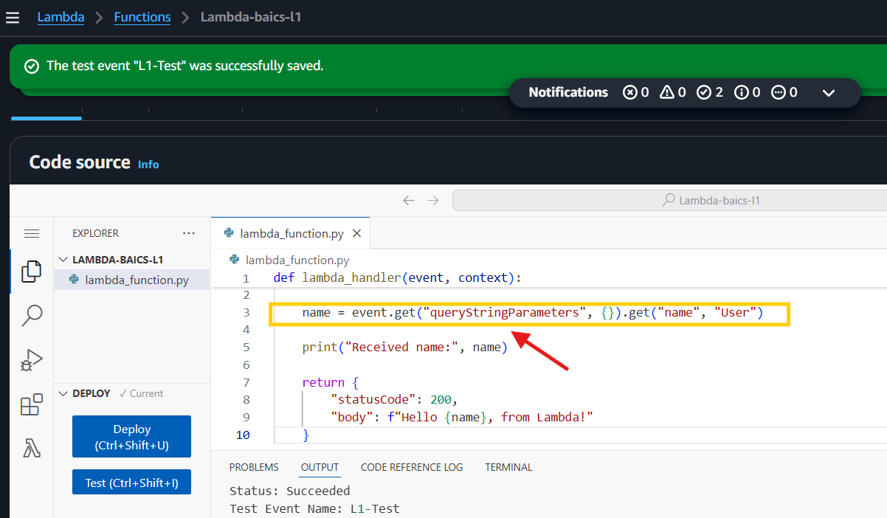
- Tested Lambda with:
{"queryStringParameters":{"name":"Afrid"}}
- Created API request:
GET /hello?name=Afrid

- Tested by changing the name directly in the URL:
/hello?name=Afrid

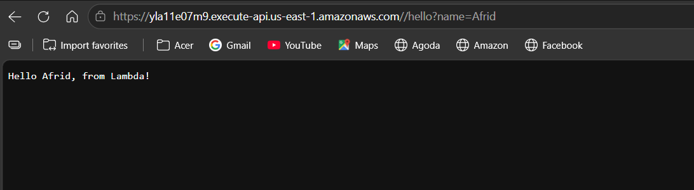

/hello?name=AWS

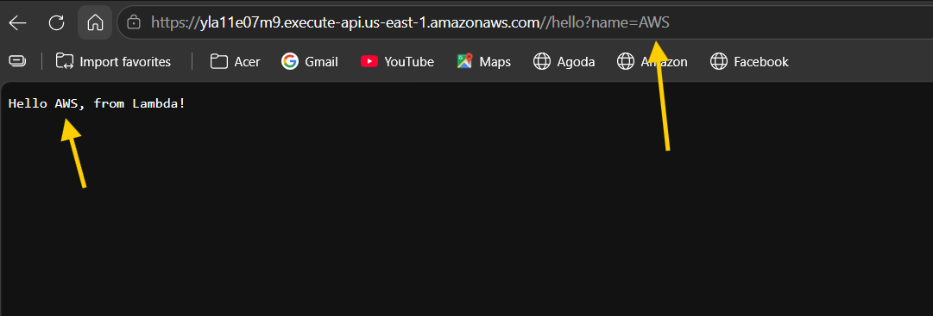

/hello?name=TECHIE

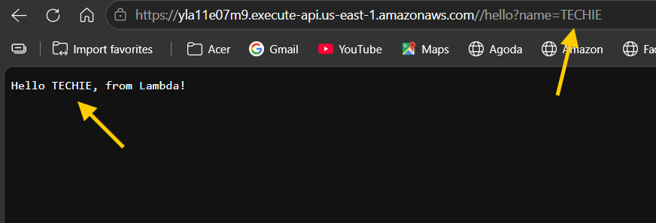
- Verified that Lambda returned the corresponding name dynamically.

Key Concept
/hello?name=Afrid
↓
API Gateway
↓
Lambda
↓
queryStringParameters → name

Result
Successfully passed dynamic query parameters from API Gateway → Lambda. ✅

A4 — API Gateway Troubleshooting
Task: Troubleshoot API Gateway → Lambda integration and permission issues.

Step 1 — Check Lambda Invoke Permission
- Opened Lambda → Lambda-baics-l1.
- Went to Configuration → Permissions.
- Checked Resource-based policy statements.
- Verified that API Gateway has permission to invoke the Lambda.
- Verified the policy contains:
  - Principal: apigateway.amazonaws.com
  - Action: lambda:InvokeFunction
  - Resource: Lambda-baics-l1
- Verified the SourceArn restricts access to our API's /hello route.

Key Concept
Execution role → controls what Lambda can access.
Resource-based policy → controls who/what can invoke Lambda.
API Gateway
↓
Lambda Resource Policy
↓
Lambda Function

Result
Verified that API Gateway has the required permission to invoke the Lambda function. ✅

A4 — API Gateway Troubleshooting: Invalid Route
Task: Test an incorrect API route and understand the response.
- Used the API Gateway Invoke URL.
- Changed the valid route /hello to an invalid route such as /hello123.
- Sent the request.
- API Gateway returned {"message":"Not Found"}. 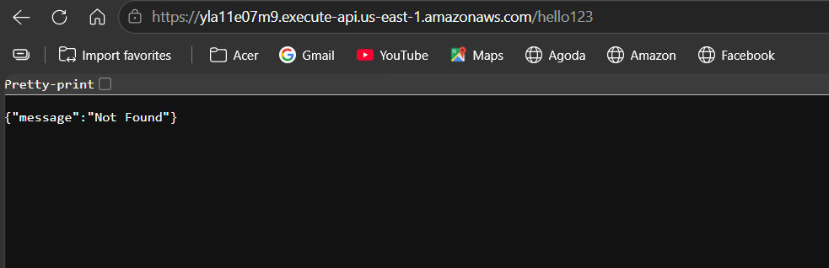
- Identified that the requested route does not exist in the API configuration.
Key Point:
Message: Not Found
usually means the HTTP method or resource path doesn't match a configured API Gateway route.

A4 — API Gateway Troubleshooting: Wrong HTTP Method
Task: Test an incorrect HTTP method for an existing API route.

Implementation Steps
- Existing route:
GET /hello
- Sent a POST request to the same URL using PowerShell:
Invoke-WebRequest -Uri "https://yla11e07m9.execute-api.us-east-1.amazonaws.com/hello" -Method POST

- API Gateway returned:
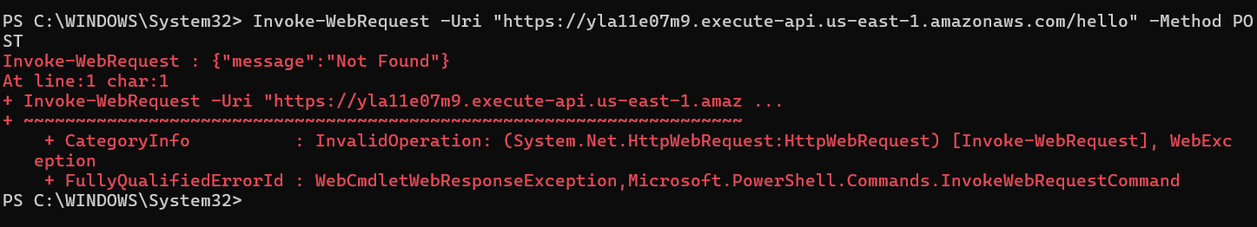
{"message":"Not Found"}
- Identified that POST /hello is not configured, while GET /hello is configured.

Key Point
API Gateway routes are defined by HTTP method + path.
GET /hello → ✅
POST /hello → ❌

Result
Successfully identified and troubleshot a route/method mismatch in API Gateway.

K1/K2 — AWS KMS + S3 Encryption
Task: Create a customer-managed KMS key and use it to encrypt S3 objects.

Implementation Steps
- Created a customer-managed KMS key in ap-south-1.
- Selected:
  - Key type: Symmetric
  - Key usage: Encrypt and decrypt
- Created key alias:
Afrid-KMS-Key
- Configured Admin as the key administrator and key user.
- Created the KMS key successfully.
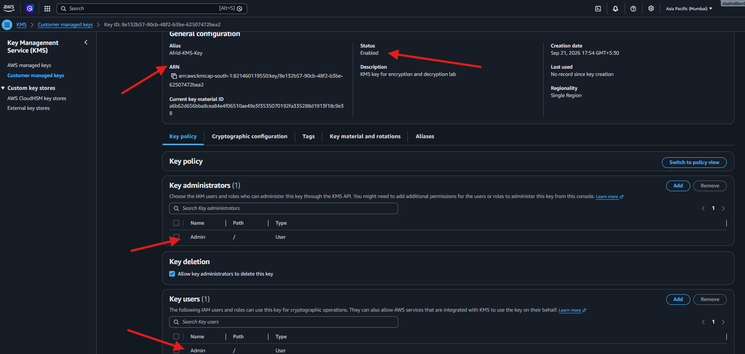
- Opened S3 bucket:
lambda-l3-afrid-2026
- Changed Default encryption from SSE-S3 to:
SSE-KMS

- Selected the customer-managed key:
Afrid-KMS-Key
- Kept S3 Bucket Key enabled.
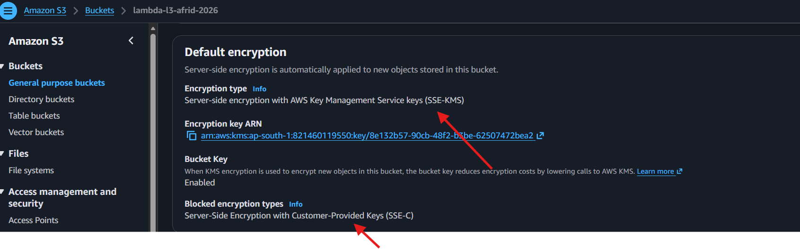
- Uploaded kms-test.txt.
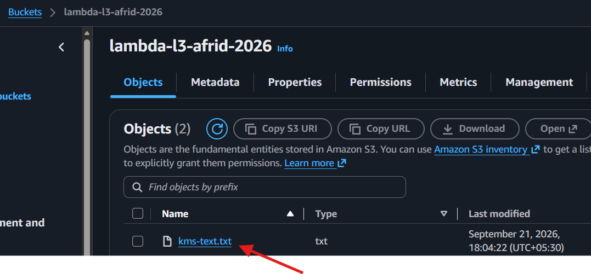
- Verified the object's encryption settings showed SSE-KMS and the ARN of Afrid-KMS-Key.
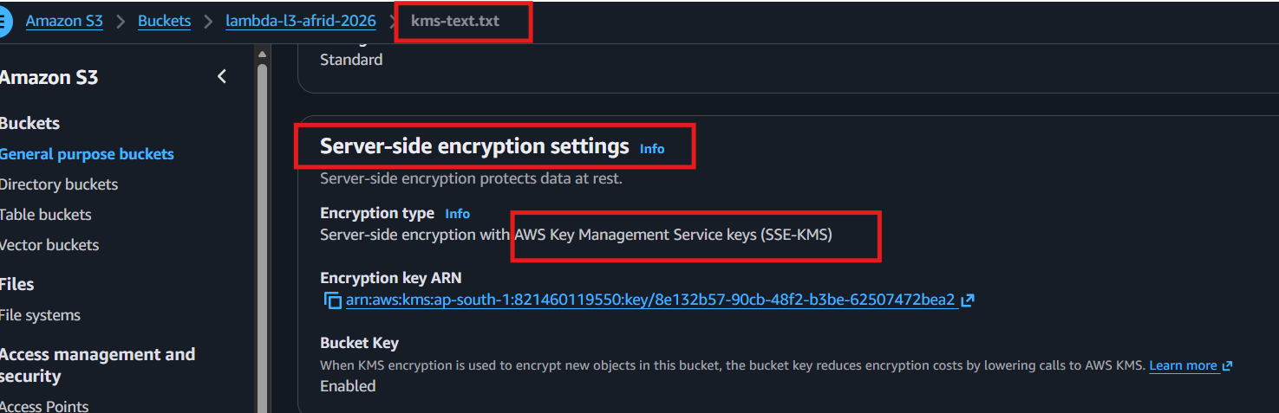

Result
Successfully configured S3 → KMS encryption and verified that the S3 object is protected using the customer-managed KMS key. 🔐

Current assignment status
Lambda
- Basic function ✅
- CloudWatch Logs ✅
- IAM + S3 ✅
API Gateway
- HTTP API ✅
- Lambda integration ✅
- Query parameters ✅
- Basic troubleshooting ✅
KMS
- Customer-managed key ✅
- S3 SSE-KMS encryption ✅
- KMS key verification ✅
At this point, the core hands-on requirements are covered.

AWS Lambda — Interview Questions

1. What is AWS Lambda?
AWS Lambda is a serverless compute service that runs code without requiring us to manage servers.

2. What triggers a Lambda function?
Lambda can be triggered by services such as API Gateway, S3, EventBridge, SNS, SQS, or direct invocation.

3. What is a Lambda execution role?
It is an IAM role assumed by Lambda that defines what AWS resources the function can access.

4. What is the difference between execution role and resource-based policy?
- Execution role: What Lambda can access.
- Resource-based policy: Who or what can invoke Lambda.

5. What are event and context in Lambda?
- Event: Input/request data passed to the function.
- Context: Runtime information such as function name and request ID.

6. What is a Lambda handler?
The handler is the function Lambda executes when invoked.
Example:
lambda_function.lambda_handler

7. What happens if Lambda doesn't have permission to access S3?
The function gets an AccessDenied error. We check the Lambda execution role and its IAM policies.

8. How did you allow Lambda to read an S3 object?
I attached an IAM policy to the Lambda execution role with:
s3:GetObject
and restricted the resource to the specific S3 object.

9. What is least privilege?
Giving only the minimum permissions required to perform a task.

10. How do you troubleshoot Lambda failures?
I check:
- Lambda execution logs in CloudWatch
- IAM permissions
- Function configuration
- Event/input
- Timeout and memory settings.

11. Where are Lambda logs stored?
By default, Lambda sends execution logs to CloudWatch Logs.

12. What is a cold start?
A cold start occurs when Lambda needs to initialize a new execution environment before processing a request.

API Gateway — Interview Questions

13. What is API Gateway?
API Gateway is a managed service used to create, expose, secure and manage APIs.

14. What is the difference between API Gateway and Lambda?
- API Gateway: Receives and manages API requests.
- Lambda: Executes the application code.

15. What is a route in API Gateway?
A route is a combination of an HTTP method and path.
Example:
GET /hello

16. What is an integration?
An integration defines the backend service that API Gateway invokes, such as Lambda.

17. How does API Gateway invoke Lambda?
API Gateway sends the request to the configured Lambda integration, and Lambda processes the request and returns a response.

18. What permission does API Gateway need to invoke Lambda?
Lambda needs a resource-based policy allowing:
lambda:InvokeFunction
for the API Gateway service.

19. What is a query parameter?
It is data passed through the URL.
Example:
/hello?name=Afrid
Lambda can access it through:
event["queryStringParameters"]["name"]

20. What happens if you request an unconfigured route?
API Gateway generally returns:
{"message":"Not Found"}

21. What happens if the HTTP method doesn't match?
For example, if only:
GET /hello
exists and we send:
POST /hello
the request fails because that route isn't configured.

22. What is a stage in API Gateway?
A stage represents an environment/version of an API, such as:
dev
test
prod
For our lab, we used the $default stage with auto-deploy.

23. How do you troubleshoot API Gateway issues?
I check:
- HTTP method and route
- Integration configuration
- Lambda permissions
- Lambda CloudWatch logs
- API Gateway logs/metrics
- Stage and deployment configuration.

24. Can API Gateway and Lambda be in different regions?
Yes. API Gateway can invoke a Lambda function in another AWS Region if the integration and permissions are configured correctly.

AWS KMS — Interview Questions

25. What is AWS KMS?
AWS KMS is a managed service used to create and control encryption keys.

26. What is a KMS key?
A KMS key is a cryptographic key managed by KMS and used by AWS services or applications for encryption-related operations.

27. What type of KMS key did you create?
I created a symmetric customer-managed KMS key for encryption and decryption.

28. What is SSE-KMS?
SSE-KMS is server-side encryption in S3 where AWS KMS manages the encryption key used to protect the object.

29. What is the difference between SSE-S3 and SSE-KMS?
- SSE-S3: S3 manages the encryption keys.
- SSE-KMS: AWS KMS manages the encryption keys and provides additional control over key permissions and auditing.

30. Can a user access an SSE-KMS encrypted S3 object without KMS permission?
Normally, no. The principal needs appropriate S3 permissions and permission to use the KMS key, such as kms:Decrypt.

31. What is kms:Encrypt?
It allows a principal to use the KMS key to encrypt data.

32. What is kms:Decrypt?
It allows a principal to use the KMS key to decrypt encrypted data.

33. What is a KMS key policy?
A key policy is a resource-based policy attached to a KMS key that controls who can administer or use the key.

34. What is a customer-managed key?
A KMS key that you create and manage in your AWS account, including its permissions, alias, rotation settings, and deletion schedule.

Scenario Questions ⭐

35. Lambda cannot access S3. What will you check?
I'd check the Lambda execution role, verify s3:GetObject, confirm the S3 object ARN, and check for explicit denies.

36. API Gateway returns Not Found. What will you check?
I'd verify the HTTP method + route path, for example whether GET /hello actually exists.

37. API Gateway can reach Lambda but Lambda fails. What will you check?
I'd check the Lambda CloudWatch Logs, Lambda code, input event, IAM permissions, timeout, and memory configuration.

38. S3 object is encrypted with KMS but Lambda gets AccessDenied. What do you check?
I'd check both:
s3:GetObject
kms:Decrypt
and verify that the correct KMS key is being used.

39. How would you explain your hands-on architecture?
"I created an HTTP API in API Gateway and integrated it with Lambda. Lambda processes the request and accesses an S3 object using its IAM execution role. I also configured SSE-KMS on S3 using a customer-managed KMS key. CloudWatch is used for Lambda execution logs."

