Docker-2 13/10/2026

- Create a tomcat container on 8080 and deploy sample application in tomcat.

Objective
Create a Tomcat Docker container, map port 8080 on the EC2 server to port 8080 inside the container, and deploy a sample HTML application.

Step 1: Pull the Tomcat image
sudo docker pull tomcat:latest
This downloads the official Tomcat image from Docker Hub.
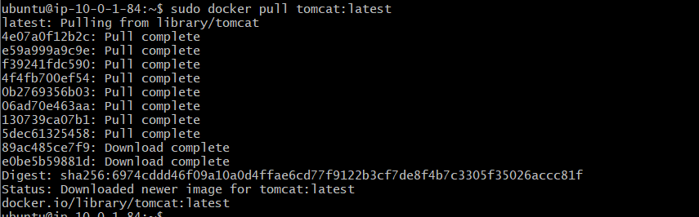

Step 2: Create and run the Tomcat container

sudo docker run -d --name tomcat-task1 -p 8080:8080 tomcat:latest

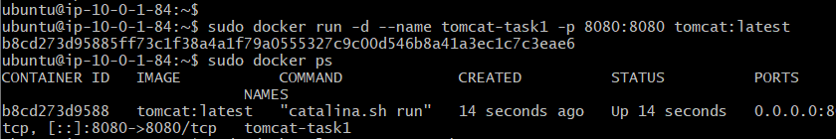
Command explanation:
- docker run — creates and starts a container.
- -d — runs the container in the background.
- --name tomcat-task1 — assigns a name to the container.
- -p 8080:8080 — maps EC2 host port 8080 to container port 8080.
- tomcat:latest — specifies the image used to create the container.

Step 3: Verify the container
sudo docker ps -a
The container was verified as running with the following configuration:
Property | Value
Container name | tomcat-task1
Image | tomcat:latest
Status | Up and running
Host port | 8080
Container port | 8080

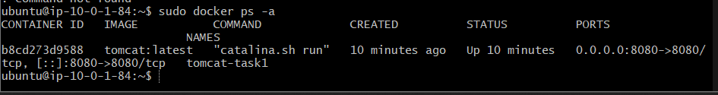

Step 4: Create a sample HTML application
Create a directory on the EC2 server:
mkdir -p ~/tomcat-app
Create the HTML file:
cat > ~/tomcat-app/index.html <<'EOF'
<!DOCTYPE html>
<html>
<head>
<title>Docker Tomcat Task 1</title>
</head>
<body>
<h1>Hello Afrid!</h1>
<p>My sample application is running on Tomcat in Docker.</p>
</body>
</html>
EOF
This creates an HTML page that will be served by Tomcat.
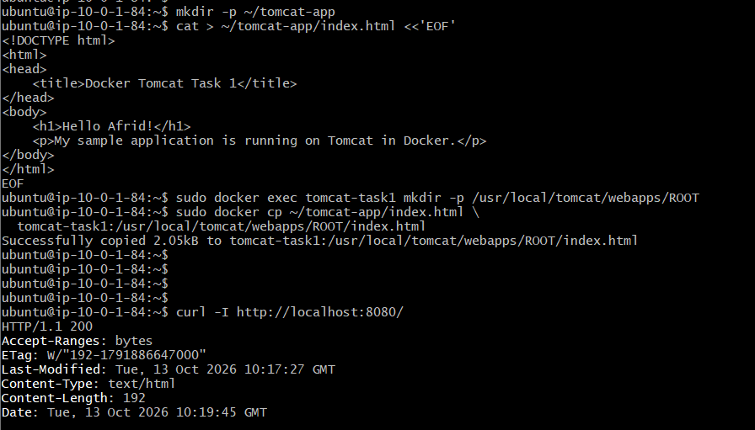

Step 5: Create the deployment directory
sudo docker exec tomcat-task1 \
mkdir -p /usr/local/tomcat/webapps/ROOT
Explanation:
- /usr/local/tomcat/ — Tomcat installation directory in the container.
- webapps/ — directory used to deploy web applications.
- ROOT/ — default web application context, accessible directly from /.

Step 6: Copy the HTML file into the container
sudo docker cp ~/tomcat-app/index.html \
tomcat-task1:/usr/local/tomcat/webapps/ROOT/index.html
The docker cp command copies the HTML file from the EC2 host into the Tomcat container.
The resulting path is:
/usr/local/tomcat/webapps/ROOT/index.html

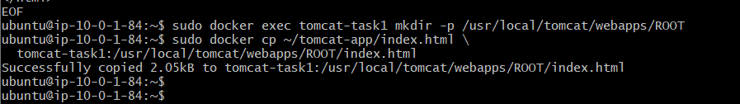

Step 7: Verify the application
Check the container logs:
sudo docker logs tomcat-task1
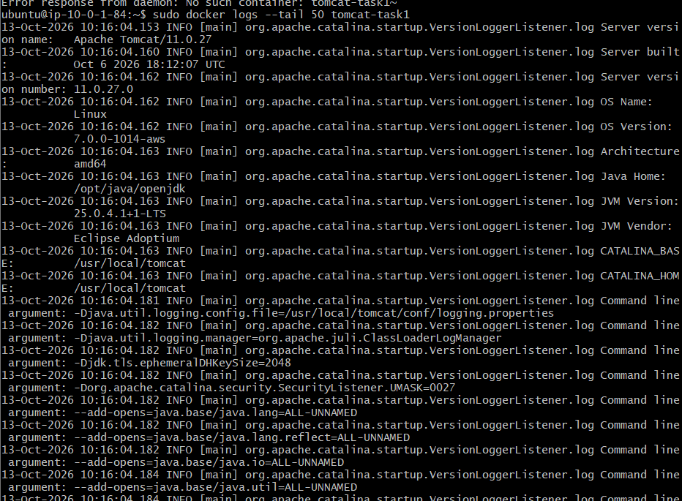
Test the application locally:
curl -I http://localhost:8080/
The response returned:
HTTP/1.1 200
Content-Type: text/html

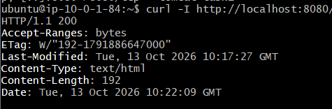
The sample application was also checked in the browser.

Step 8: Access the application externally
Open the following URL in your browser:
http://<EC2-PUBLIC-IP>:8080/
Replace <EC2-PUBLIC-IP> with the public IP address of your EC2 instance.
Ensure the EC2 security group permits inbound TCP traffic on port 8080. 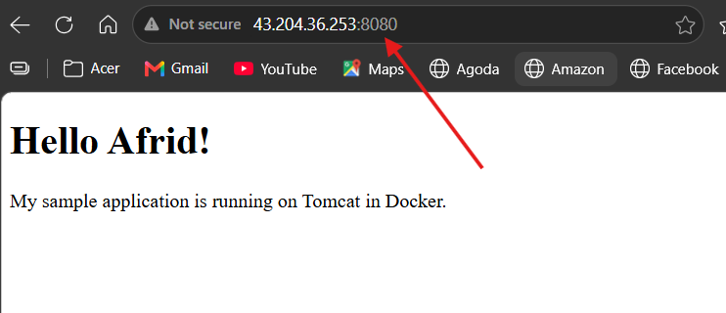

Task 1 — Key concepts learned
- Pulling a Docker image from Docker Hub.
- Creating and running a Tomcat container.
- Publishing container ports to the EC2 host.
- Creating an HTML sample application.
- Using docker exec to execute commands inside a running container.
- Using docker cp to copy files into a container.
- Deploying an application through Tomcat's webapps directory.
- Verifying container status, logs, and HTTP responses.
Task 1 is complete. The Tomcat container is running on port 8080, and the sample HTML application was deployed and tested successfully.

- Create volume and deploy tomcat container on port 8081.

Objective
Create a Docker volume, attach it to a Tomcat container, and deploy a sample application accessible through port 8081.

Step 1: Create a Docker volume
sudo docker volume create tomcat-volume
This creates a named volume called tomcat-volume.
Verify the volume:
sudo docker volume ls
Purpose: Docker volumes store data independently of a container's writable layer, allowing data to persist after the container is removed.
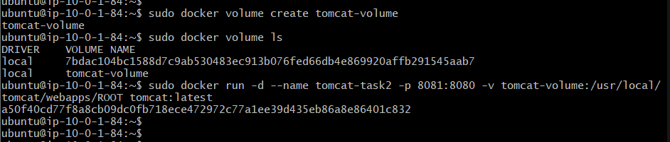

Step 2: Run the Tomcat container with the volume
sudo docker run -d \
--name tomcat-task2 \
-p 8081:8080 \
-v tomcat-volume:/usr/local/tomcat/webapps/ROOT \
tomcat:latest

Command explanation
Option | Description
-d | Runs the container in the background
--name tomcat-task2 | Assigns a name to the container
-p 8081:8080 | Maps host port 8081 to container port 8080
-v tomcat-volume:/usr/local/tomcat/webapps/ROOT | Mounts the volume at Tomcat's ROOT application directory
tomcat:latest | Uses the Tomcat image
Port mapping:
- Host port: 8081
- Container port: 8080
Task 1 continues using port 8080, while Task 2 uses port 8081.

Step 3: Copy the sample application
Copy the HTML file created during Task 1 into the volume-backed directory:
sudo docker cp ~/tomcat-app/index.html \
tomcat-task2:/usr/local/tomcat/webapps/ROOT/index.html
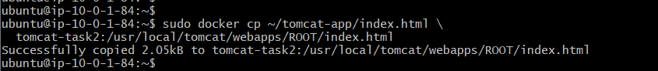
The application file is located at:
/usr/local/tomcat/webapps/ROOT/index.html
The ROOT directory is Tomcat's default application context, so the page is accessible directly at /.
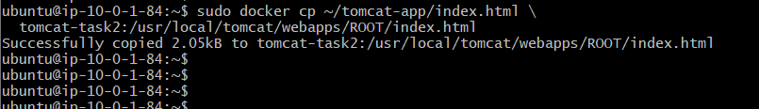

Step 4: Verify the container
sudo docker ps
Confirm that tomcat-task2 is running with the port mapping 8081:8080.
Inspect the volume mount:
sudo docker inspect tomcat-task2 \
--format '{{json .Mounts}}'
This displays the volume attached to the container.
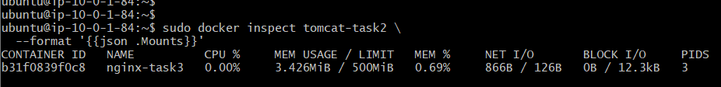

Step 5: Test the application
curl -I http://localhost:8081/
Expected response:
HTTP/1.1 200
Content-Type: text/html
To access the application externally, open:
http://<EC2-PUBLIC-IP>:8081/
Replace the placeholder with your EC2 instance's public IP address. Ensure inbound TCP port 8081 is allowed in the security group.
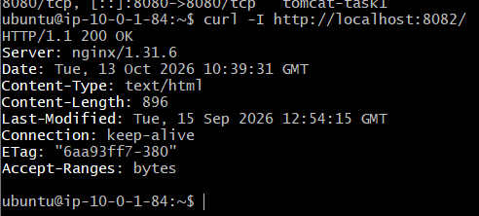

Step 6: Verify volume persistence
A Docker volume exists independently of its container.
Remove the Task 2 container:
sudo docker rm -f tomcat-task2
Recreate it using the same volume:
sudo docker run -d \
--name tomcat-task2 \
-p 8081:8080 \
-v tomcat-volume:/usr/local/tomcat/webapps/ROOT \
tomcat:latest

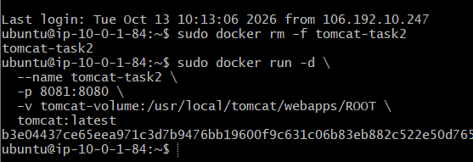
Test the application again:
curl http://localhost:8081/

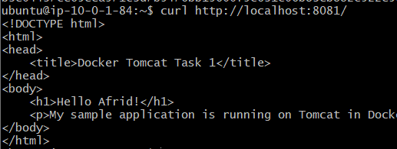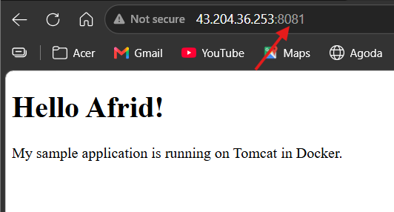
The HTML file should still exist because it was stored in tomcat-volume.

Key concepts learned
- Creating and listing Docker volumes.
- Attaching volumes using -v.
- Running Tomcat on host port 8081.
- Copying application files into a container.
- Verifying volume mounts with docker inspect.
- Understanding persistence when containers are removed and recreated.
Task 2 status: The configuration and verification steps are documented. Record the persistence test as completed only after you actually perform it.

- Limit the nginx container to 500 MB.

Objective
Create and run an Nginx container with a memory limit of 500 MB on the existing EC2 Docker server.

Step 1: Pull the Nginx image
sudo docker pull nginx:latest
This downloads the Nginx image from Docker Hub.
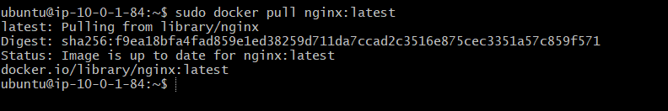

Step 2: Run the Nginx container with a memory limit
sudo docker run -d \
--name nginx-task3 \
-p 8082:80 \
--memory=500m \
nginx:latest

Command explanation
Option | Description
docker run | Creates and starts a container
-d | Runs the container in the background
--name nginx-task3 | Assigns a name to the container
-p 8082:80 | Maps host port 8082 to container port 80
--memory=500m | Limits container memory to 500 MiB
nginx:latest | Specifies the Nginx image
Port mapping:
- Host port: 8082
- Container port: 80
We use port 8082 because Task 1 and Task 2 use ports 8080 and 8081.

Step 3: Verify the memory limit
sudo docker inspect nginx-task3 \
--format '{{.HostConfig.Memory}}'
Expected output:
524288000

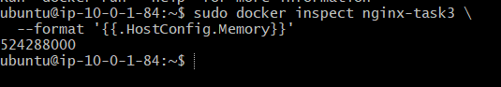
This value represents 500 MiB in bytes:
\[ 500 \times 1024 \times 1024 = 524288000 \]

Step 4: Monitor resource usage
sudo docker stats nginx-task3
Actual output from the lab:
CONTAINER ID NAME CPU % MEM USAGE / LIMIT MEM %
b31f0839f0c8 nginx-task3 0.00% 3.426MiB / 500MiB 0.69%
This shows that Nginx was using approximately 3.426 MiB of memory against its 500 MiB limit.
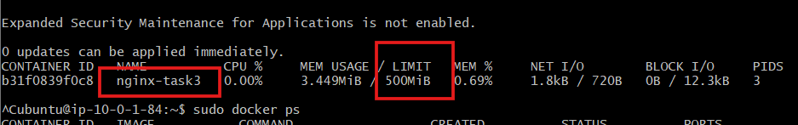

Press Ctrl+C to exit the live statistics display.

Step 5: Verify the container
sudo docker ps
The container was running with this port mapping:
0.0.0.0:8082->80/tcp
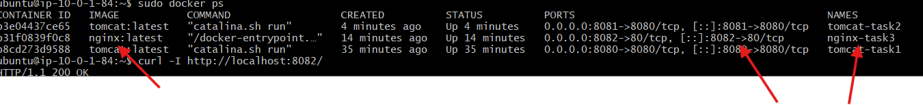

Step 6: Test the Nginx application
curl -I http://localhost:8082/
Actual response:
HTTP/1.1 200 OK
Server: nginx/1.31.6

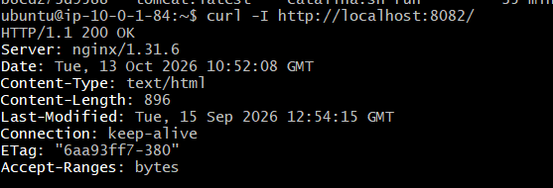
This confirms that Nginx was running and returning a successful HTTP response.
To access Nginx from your browser:
http://<EC2-PUBLIC-IP>:8082/
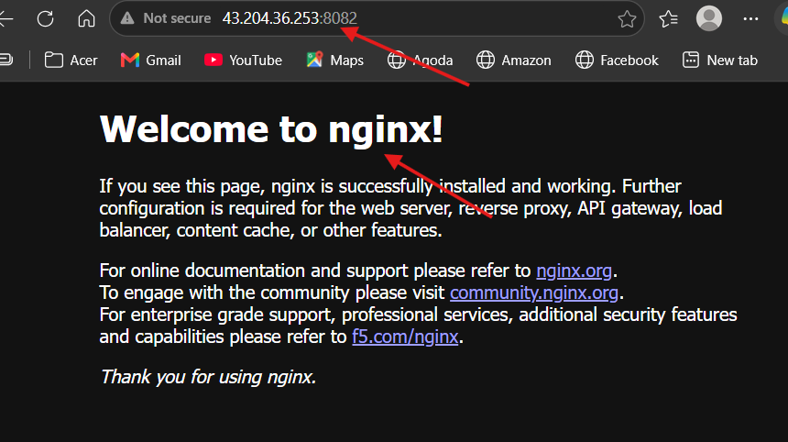

Replace <EC2-PUBLIC-IP> with your EC2 instance's public IP address. Ensure inbound TCP port 8082 is allowed in the EC2 security group.

Key concepts learned
- Pulling Docker images from Docker Hub.
- Creating and running an Nginx container.
- Applying memory limits with --memory.
- Mapping host ports to container ports using -p.
- Inspecting container configuration with docker inspect.
- Monitoring resource usage with docker stats.
- Testing HTTP connectivity with curl.
status: Completed. The Nginx container was running on port 8082, its memory limit was configured to 500 MiB, and the HTTP test returned 200 OK.

- Create a sample docker file using below instructions.
  - Base module as amazonlinux:latest

Objective
Use amazonlinux:latest as the base image for building a custom Docker image.

Step 1: Create the Project Directory
mkdir -p ~/nginx-amazonlinux
cd ~/nginx-amazonlinux
Explanation:
- mkdir -p creates the project directory if it does not already exist.
- cd moves into the project directory.
- This directory will contain the Dockerfile and application files.
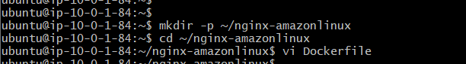

Step 2: Create the Dockerfile Using vi
vi Dockerfile
Press i to enter insert mode and add the following instruction:
FROM amazonlinux:latest
Save and exit:
- Press Esc.
- Type :wq.
- Press Enter.

Step 3: Verify the Dockerfile
cat Dockerfile
Output:
FROM amazonlinux:latest

Step 4: Pull the Amazon Linux Image
sudo docker pull amazonlinux:latest

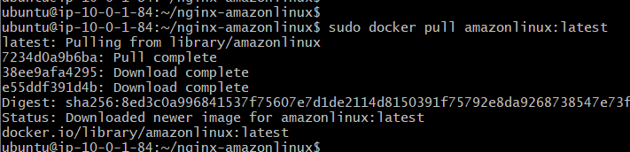
This downloads the Amazon Linux base image from Docker Hub.

Step 5: Verify the Downloaded Image
sudo docker images amazonlinux
Observed image details:
Property | Value
Repository | amazonlinux
Tag | latest
Image ID | 8ed3c0a99684
Disk usage | 227 MB
Content size | 59.3 MB
Docker reported that the image was downloaded successfully.
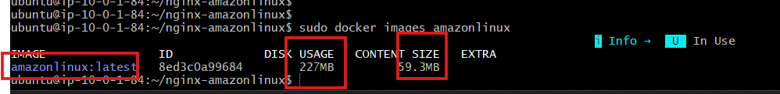

Understanding the FROM Instruction
FROM specifies the base image from which Docker builds a new image.
Syntax:
FROM <image>:<tag>
Example:
FROM amazonlinux:latest
- amazonlinux is the image name.
- latest is the image tag.
The base image provides the operating-system environment and tools needed for subsequent build instructions.

Key Concepts Learned
- Creating a project directory for a Docker build.
- Creating and editing a Dockerfile using vi.
- Understanding the FROM instruction.
- Pulling an image from Docker Hub.
- Verifying local images with docker images.

  - Maintainer you name

Objective
Add maintainer information to the Dockerfile using the Docker LABEL instruction.

Step 1: Navigate to the Working Directory
cd ~/nginx-amazonlinux

Step 2: Open the Dockerfile
vi Dockerfile
Press i to enter Insert mode and add the following line below the base image instruction:
LABEL maintainer="Afrid"

Step 3: Dockerfile Content
After adding the maintainer label, the Dockerfile contains:
FROM amazonlinux:latest

LABEL maintainer="Afrid"

Step 4: Save the File
- Press Esc to exit Insert mode.
- Type :wq.
- Press Enter to save and exit.

Step 5: Verify the Dockerfile
Run:
cat Dockerfile
Verified output:
FROM amazonlinux:latest

LABEL maintainer="Afrid"

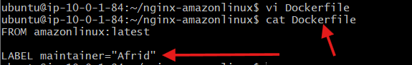

  - Install nginx

Objective
Install Nginx in the Amazon Linux-based Docker image using the Dockerfile RUN instruction.

Step 1: Open the Working Directory
cd ~/nginx-amazonlinux
Open the Dockerfile:
vi Dockerfile

Step 2: Add the Nginx Installation Instruction
The Dockerfile contains the following instructions:
FROM amazonlinux:latest

LABEL maintainer="Afrid"

RUN dnf install -y nginx

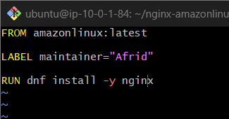

Step 3: Save the Dockerfile
- Press Esc to exit Insert mode.
- Type :wq.
- Press Enter to save and exit.

Step 4: Build the Docker Image
Run the following command:
sudo docker build -t afrid-nginx:1.0 .

Explanation of the Command
- docker build — builds a Docker image using the Dockerfile.
- -t afrid-nginx:1.0 — assigns the image name afrid-nginx and tag 1.0.
- . — specifies the current directory as the build context.

Step 5: Verify the Build
The build completed successfully. Docker displayed:
Successfully built 5f1822dba013
Successfully tagged afrid-nginx:1.0

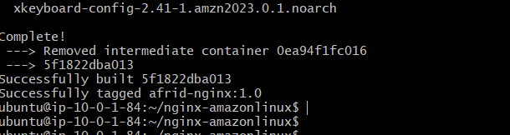
The image was verified using:
sudo docker images afrid-nginx
Observed image details:
- Repository: afrid-nginx
- Tag: 1.0
- Image ID: 5f1822dba013
- Disk usage: 688 MB
- Content size: 234 MB
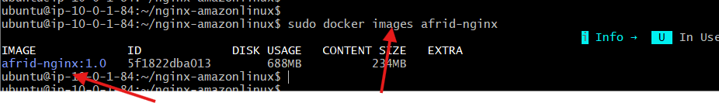

Theory

RUN
The RUN instruction executes commands during the image build process. The command's changes are saved in the resulting image layer.

dnf install -y nginx
- dnf is the package manager used by Amazon Linux 2023.
- install installs the specified package.
- -y automatically answers yes to installation prompts.
- nginx is the web server package being installed.

Status
Task 4.3 is complete. The intermediate Docker image built successfully with Nginx installed. The website-copy instruction, port exposure, and container startup command have not yet been completed.

  - COPY one index.html file to image

Objective
Create a sample HTML webpage and copy it into the Nginx web root inside the Docker image.

Step 1: Navigate to the Working Directory
cd ~/nginx-amazonlinux

Step 2: Create the HTML File
Open a new file using vi:
vi index.html
Press i and add the following HTML content:
<!DOCTYPE html>
<html>
<head>
<title>Afrid Docker Lab</title>
</head>
<body>
<h1>Hello Afrid!</h1>
<p>Nginx running on Amazon Linux Docker container.</p>
</body>
</html>
Save the file by pressing Esc, typing :wq, and pressing Enter.
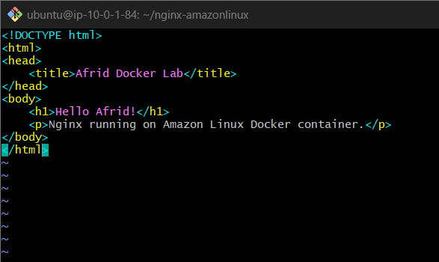

Step 3: Update the Dockerfile
Open the Dockerfile:
vi Dockerfile
Add the following instruction below the Nginx installation instruction:
COPY index.html /usr/share/nginx/html/index.html
The Dockerfile now contains:
FROM amazonlinux:latest

LABEL maintainer="Afrid"

RUN dnf install -y nginx

COPY index.html /usr/share/nginx/html/index.html

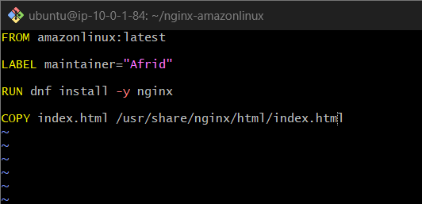
Save the file using Esc → :wq → Enter.

Step 4: Verify the Files
Run:
cat Dockerfile
cat index.html
Check that the Dockerfile contains the COPY instruction and that index.html contains the webpage content.

Theory

COPY Instruction
The Dockerfile COPY instruction copies files from the build context on the host into the Docker image.
Syntax:
COPY <source> <destination>
- Source: index.html — the HTML file in the current build directory.
- Destination: /usr/share/nginx/html/index.html — the location of the webpage in the Nginx web root.
This allows Nginx to serve the custom webpage instead of its default welcome page when the container runs.

Status
Task 4.4 is complete according to the steps performed. The HTML file and COPY instruction have been added. The updated image has not yet been rebuilt and tested with this webpage.
  - Expose on port 80
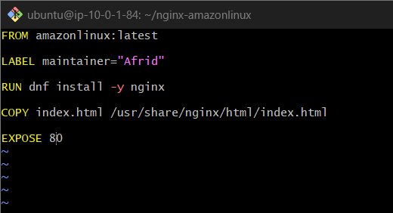
  - Command to start the nginx container

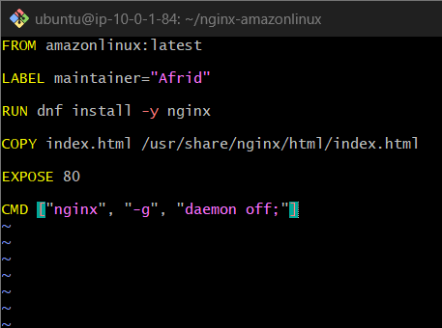
sudo docker build -t afrid-nginx:1.0 .

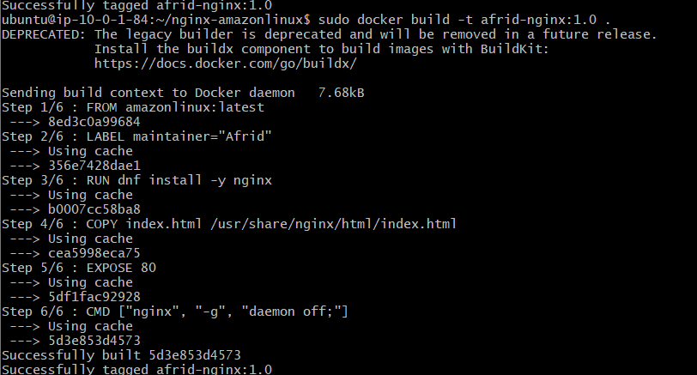

sudo docker image inspect afrid-nginx:1.0 --format 'Labels={{json .Config.Labels}} ExposedPorts={{json .Config.ExposedPorts}} Cmd={{json .Config.Cmd}}'

____________________________________________________________________

- Push image to Docker hub

Objective
Push a custom Docker image to Docker Hub so it can be stored in a remote registry and accessed from other machines.

Step 1: Verify the Local Image
The custom image was created in the previous task.
Image name: afrid-nginx:1.0
Command:
sudo docker images afrid-nginx
The image was used as the source for tagging and pushing to Docker Hub.
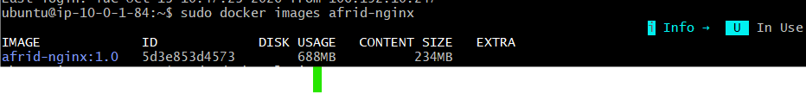

Step 2: Log in to Docker Hub
Run:
sudo docker login
Docker provided a one-time device confirmation code and an activation link.
The device authentication was completed in the browser. The terminal confirmed:
Login Succeeded
Note: Docker displayed a warning that credentials were stored unencrypted in /root/.docker/config.json.

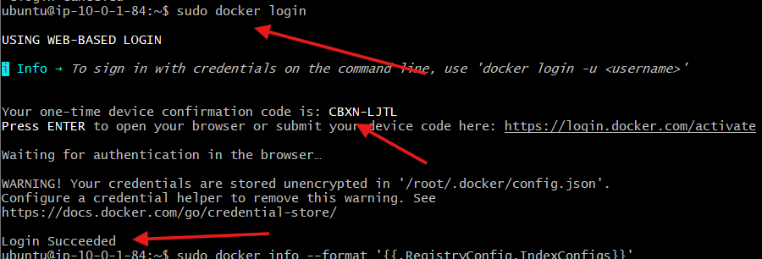

Step 3: Tag the Image
Docker Hub requires the image name to include the Docker Hub username and repository name.
Command:
sudo docker tag afrid-nginx:1.0 shahid8256/afrid-nginx:1.0

Explanation:
- afrid-nginx:1.0 — existing local image.
- shahid8256 — Docker Hub username.
- afrid-nginx — repository name.
- 1.0 — image tag.
Tagging creates another reference to the local image; it does not rebuild the image.

Step 4: Push the Image
Run:
sudo docker push shahid8256/afrid-nginx:1.0

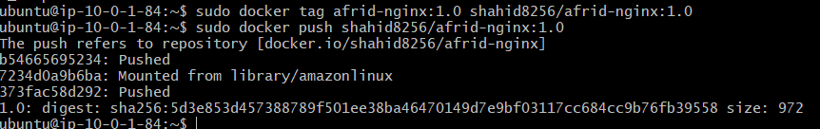
The push completed successfully. The terminal displayed:
The push refers to repository [docker.io/shahid8256/afrid-nginx]
b54665695234: Pushed

7234d0a9b6ba: Mounted from library/amazonlinux

373fac58d292: Pushed

1.0:digest:sha256:5d3e853d457388789f501ee38ba46470149d7e9bf03117cc684cc9b76fb39558 size: 972
Explanation:
- Pushed — the image layer was uploaded.
- Mounted from library/amazonlinux — Docker reused an existing compatible layer from the registry instead of uploading it again.
- digest — the content identifier returned for the pushed image.

Step 5: View the Image on Docker Hub
Repository URL:
https://hub.docker.com/r/shahid8256/afrid-nginx
Repository details:
- Registry: Docker Hub
- Username: shahid8256
- Repository: afrid-nginx
- Tag: 1.0
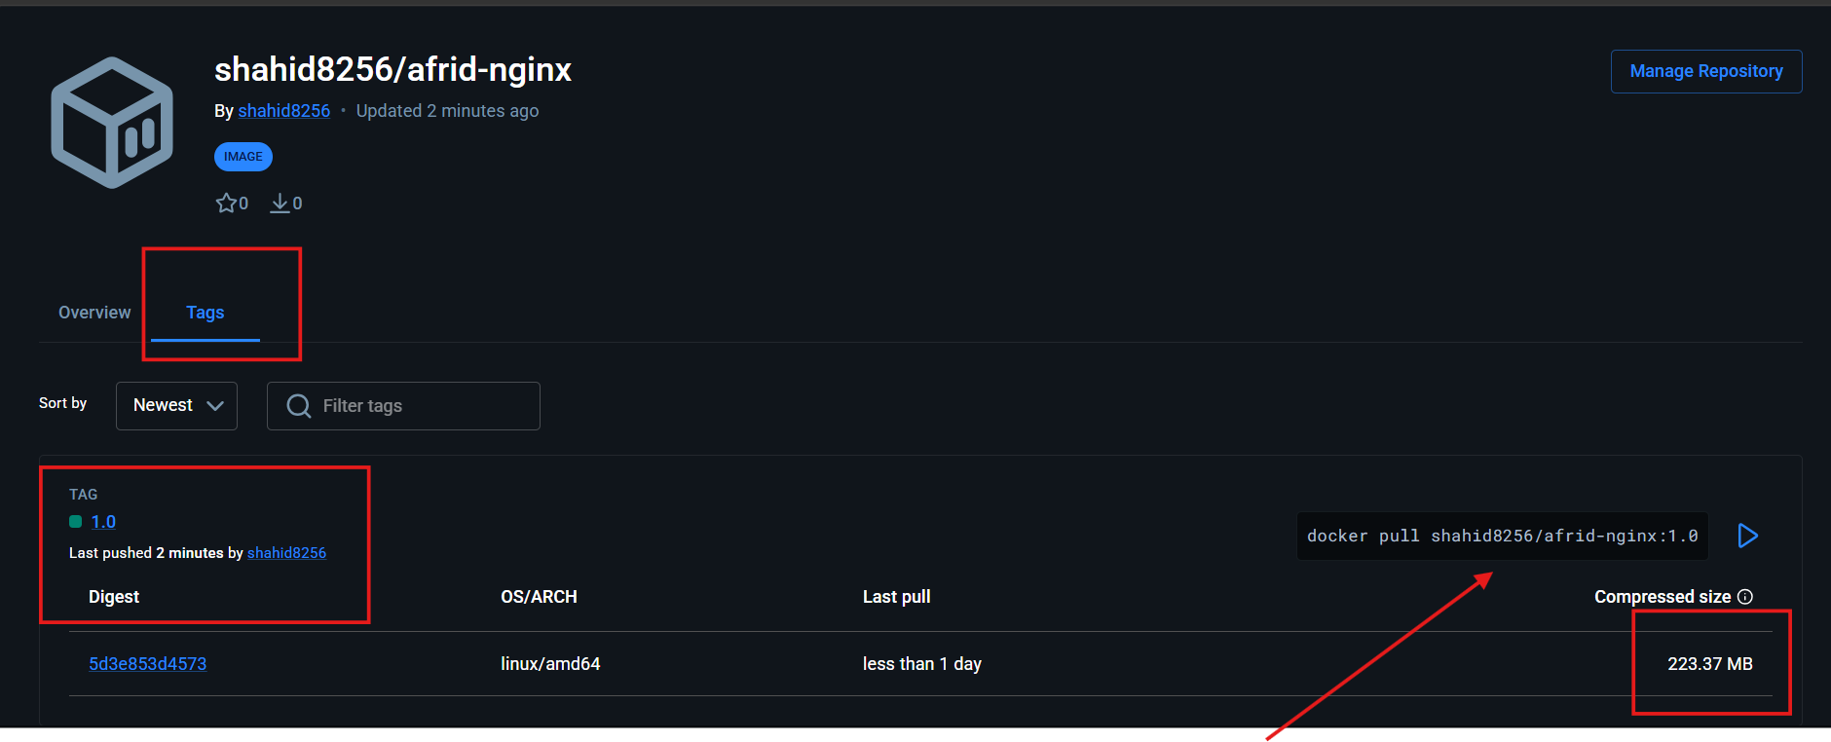The repository was opened in Docker Hub to view the uploaded image.

Step 6: Pull the Image from Docker Hub
To retrieve the image on another machine, use:
sudo docker pull shahid8256/afrid-nginx:1.0
This pull command is provided for future use; a separate pull verification was not recorded as completed.

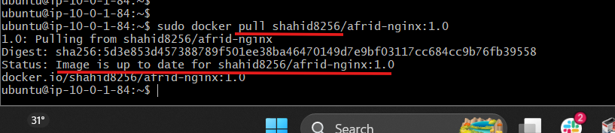

Important Docker Commands
Command | Purpose
sudo docker login | Authenticate with Docker Hub
sudo docker tag SOURCE TARGET | Assign a registry-compatible image tag
sudo docker push IMAGE | Upload an image to Docker Hub
sudo docker pull IMAGE | Download an image from a registry
sudo docker images | List local Docker images

Status
Task 5 is complete. The image shahid8256/afrid-nginx:1.0 was pushed successfully to Docker Hub, and the push digest was returned.

- push image to AWS ECR

Objective
Push the custom Docker image afrid-nginx:1.0 from an EC2 instance to Amazon Elastic Container Registry (ECR).
Amazon ECR is a managed container image registry used to store, manage, and deploy Docker images.

Prerequisites
- An AWS account.
- An EC2 instance with Docker installed.
- The custom image afrid-nginx:1.0.
- AWS CLI installed on the EC2 instance.
- An AWS identity with the required ECR permissions.

Step 1: Install AWS CLI
Check whether AWS CLI is installed:
aws --version
If the command is not found on Ubuntu, install it:
sudo apt update
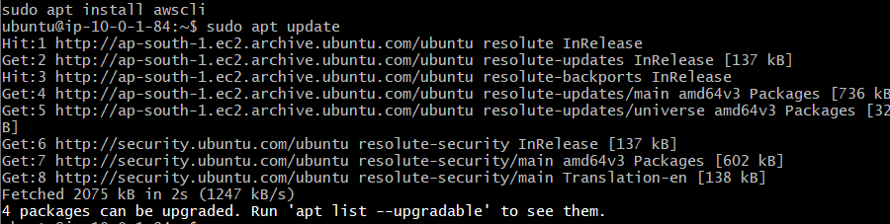

sudo apt install -y awscli

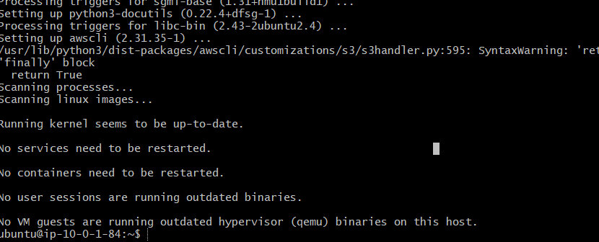
Verify the installation:
aws –version
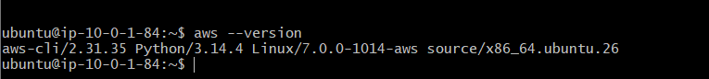

Step 2: Configure AWS Access Through an EC2 IAM Role
The initial identity check returned:
Unable to locate credentials.

An IAM role named EC2-ECR-Push-Role was configured and attached to the EC2 instance.

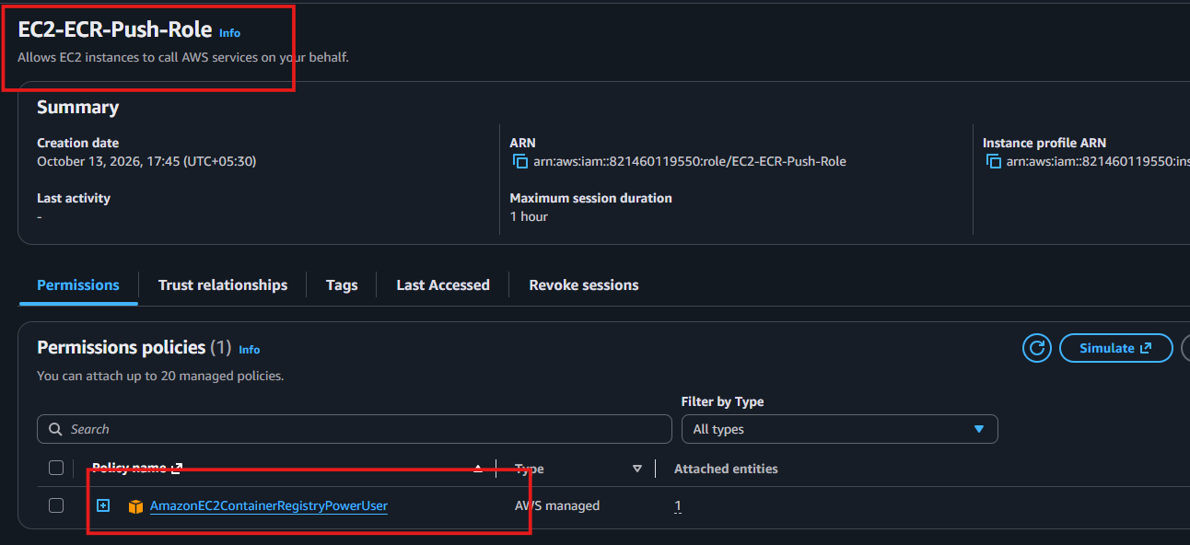
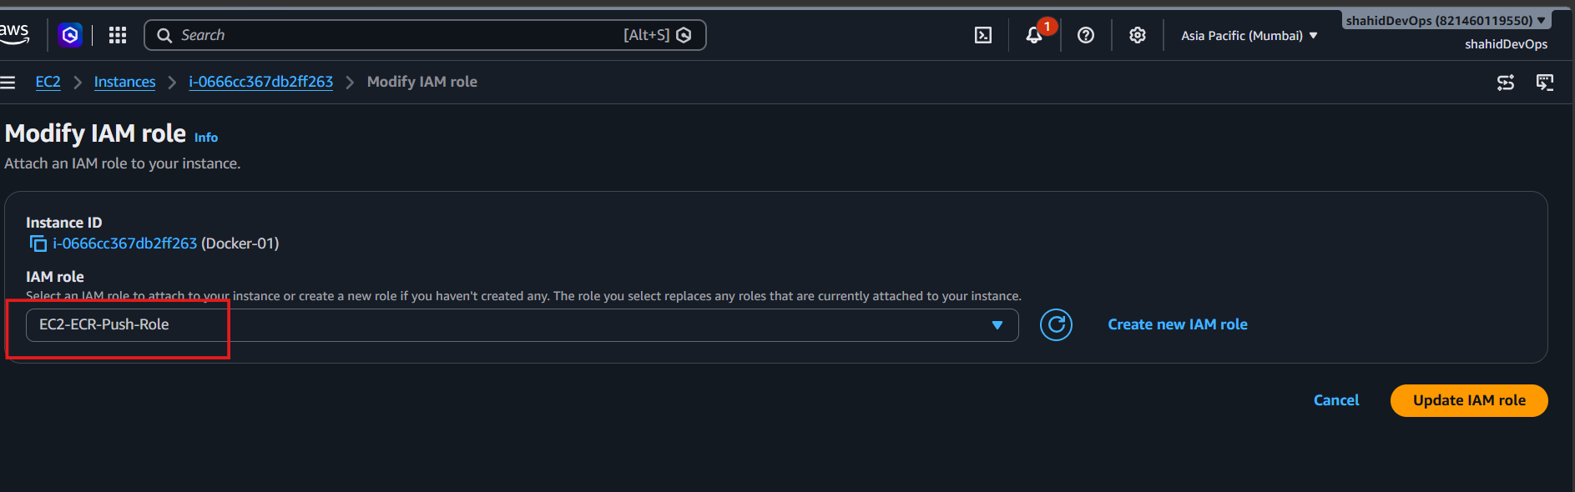
Verify the identity:
aws sts get-caller-identity

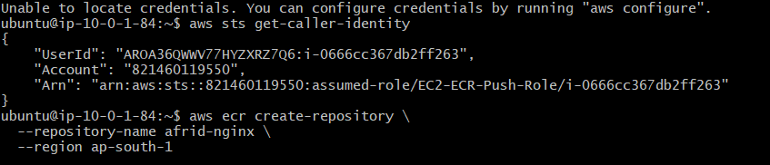
The command returned the following identity details:
- AWS Account ID: 821460119550
- IAM Role: EC2-ECR-Push-Role
- EC2 Instance ID: i-0666cc367db2ff263
The role was used to access AWS services without configuring long-term access keys on the EC2 instance.

Step 3: Create a Private ECR Repository Manually
The ECR repository was created through the AWS Management Console instead of the AWS CLI.

Procedure
- Sign in to the AWS Management Console.
- Open Amazon Elastic Container Registry (ECR).
- Select the Mumbai region, ap-south-1.
- Click Create repository.
- Choose Private repository visibility.
- Enter the repository name:
afrid-nginx
- Select Mutable image tag settings.
- Keep the default AES-256 encryption setting.
- Leave the remaining settings at their defaults for this lab.
- Click Create repository.
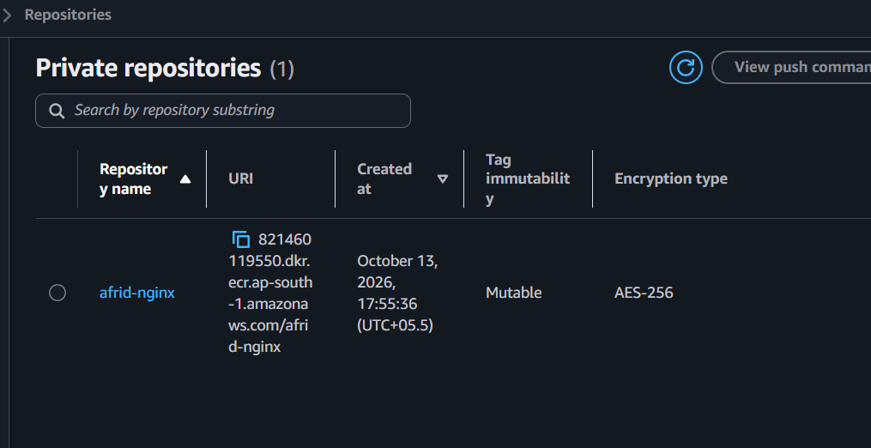

Repository URI
The repository URI follows this format:
821460119550.dkr.ecr.ap-south-1.amazonaws.com/afrid-nginx
This URI combines the AWS account ID, region, ECR registry domain, and repository name.

Step 4: Authenticate Docker to Amazon ECR
After creating the repository, Docker was authenticated to the ECR registry using the AWS CLI.
Command:
aws ecr get-login-password --region ap-south-1 \
| sudo docker login \
--username AWS \
--password-stdin 821460119550.dkr.ecr.ap-south-1.amazonaws.com
A successful authentication displays:
Login Succeeded

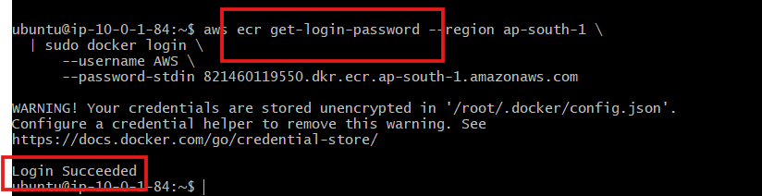
The get-login-password command retrieves a temporary authentication password for the registry. Docker uses this password to authenticate to ECR.

Step 5: Tag the Docker Image
The local image was tagged with its full ECR repository URI.
Command:
sudo docker tag afrid-nginx:1.0 \
821460119550.dkr.ecr.ap-south-1.amazonaws.com/afrid-nginx:1.0

Explanation
- afrid-nginx:1.0 — the local Docker image.
- 821460119550.dkr.ecr.ap-south-1.amazonaws.com/afrid-nginx — the destination ECR repository.
- 1.0 — the image tag.

Tagging creates another reference to the local image; it does not rebuild the image.

Step 6: Push the Image to ECR
The image was uploaded to the private ECR repository.
Command:
sudo docker push \
821460119550.dkr.ecr.ap-south-1.amazonaws.com/afrid-nginx:1.0
Docker uploads the required image layers to the ECR registry. Existing compatible layers may be reused when available.

Step 7: Verify the Image in ECR
The image can be verified in the AWS Management Console:
- Open Amazon ECR.
- Select the ap-south-1 region.
- Open the afrid-nginx repository.
- Select the Images tab.
- Check for the image tag 1.0.

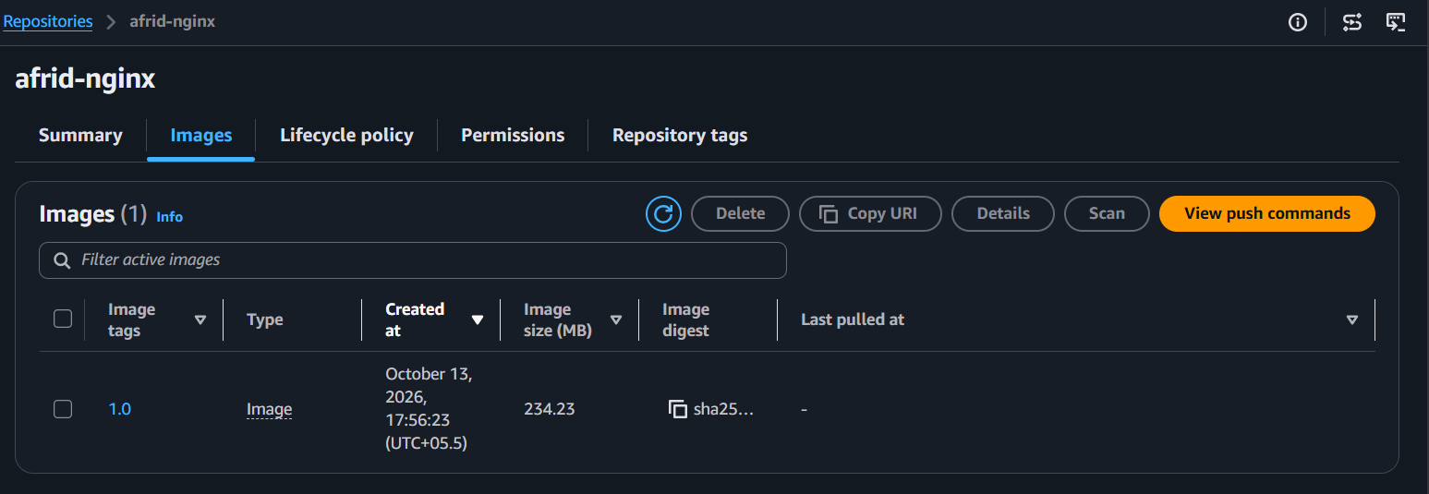
The AWS CLI can also be used for verification:
aws ecr describe-images \
--repository-name afrid-nginx \
--region ap-south-1

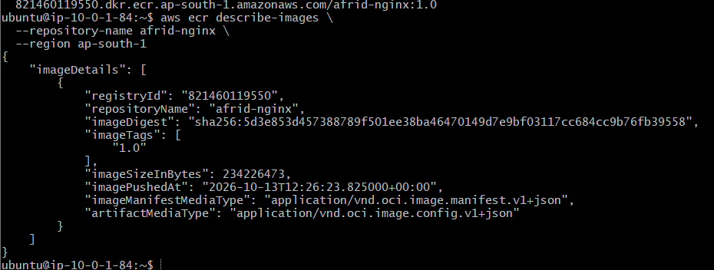
The command should return the image details, including its tag and digest, if the image exists and the IAM role has permission to describe it.

Important Docker and AWS Commands
Command | Purpose
aws --version | Verify AWS CLI installation
aws sts get-caller-identity | Check the active AWS identity
aws ecr get-login-password | Retrieve an ECR authentication password
docker login | Authenticate Docker to the ECR registry
docker tag | Assign the ECR destination tag
docker push | Upload the image to ECR
aws ecr describe-images | Retrieve ECR image details

Common Issues Encountered

1. AWS CLI Not Found
Cause: AWS CLI was not installed.
Resolution: Installed it using sudo apt update and sudo apt install -y awscli.

2. Unable to Locate Credentials
Cause: AWS CLI initially could not find credentials.
Resolution: Configured the EC2 IAM role EC2-ECR-Push-Role and verified access using aws sts get-caller-identity.

3. Access Denied During Repository Creation
Cause: The role initially lacked permission to perform ecr:CreateRepository.
Resolution: The repository was subsequently created manually in the AWS Management Console. The ECR repository creation command was not required for this workflow.

Status
The private ECR repository was created manually in the AWS Console, and the Docker image push workflow was completed using the EC2 terminal. The repository name is afrid-nginx, the region is ap-south-1, and the image tag is 1.0.

