AWS SELF-LEARNING AND HANDS-ON IMPLEMENTATION ON

AWS Web Application Firewall (WAF) & AWS Systems Manager Parameter Store

Topics
- AWS Web Application Firewall (WAF)
- AWS Systems Manager Parameter Store

1. Objective
The objective of this activity is to understand the concepts, use cases, architecture, and practical implementation of AWS Web Application Firewall (WAF) and AWS Systems Manager Parameter Store.
AWS WAF is used to protect web applications from common web-based attacks by inspecting incoming HTTP/HTTPS requests.
AWS Systems Manager Parameter Store is used to securely store and manage application configuration values and sensitive parameters.

2. AWS WEB APPLICATION FIREWALL (AWS WAF)

2.1 Introduction
AWS WAF stands for AWS Web Application Firewall.
AWS WAF is a security service provided by Amazon Web Services that helps protect web applications from common web attacks.
It allows us to create rules that inspect incoming web requests and either allow, block, or monitor those requests.
AWS WAF can be used with services such as:
- Application Load Balancer
- Amazon CloudFront
- Amazon API Gateway
- AWS AppSync
- Amazon Cognito user pools
For this hands-on implementation, AWS WAF is associated with an Application Load Balancer (ALB).

2.2 Why AWS WAF is Used
AWS WAF can help protect applications against:
- SQL Injection
- Cross-Site Scripting (XSS)
- Malicious requests
- Unwanted IP addresses
- Specific geographic locations
- Excessive requests
- Common web application attacks
It provides an additional security layer between users and the web application.

2.3 AWS WAF Architecture
The basic architecture used for this implementation is:
Internet
|
v
AWS WAF
|
v
Application Load Balancer
|
v
EC2 Instance
|
v
Web Application

Architecture Flow
User Request
|
v
+-------------+
| AWS WAF |
| Web ACL |
+-------------+
|
| Allowed Request
v
+---------------------+
| Application Load |
| Balancer (ALB) |
+---------------------+
|
v
+------------+
| EC2 Server |
+------------+
|
v
Web Application

2.4 AWS WAF Components

Web ACL
Web ACL stands for Web Access Control List.
A Web ACL contains the rules that determine how AWS WAF handles incoming requests.

Rules
Rules define conditions for inspecting web requests.
Examples include:
- IP address
- Request pattern
- SQL injection
- Cross-site scripting

Rule Groups
Rule groups contain multiple related rules.
AWS provides managed rule groups that can be used to protect applications against common threats.

Managed Rules
AWS Managed Rules are pre-configured rules maintained by AWS and can be added to a Web ACL.

2.5 AWS WAF Hands-On Implementation

Step 1: Open AWS WAF
- Open the AWS Management Console.
- Search for WAF & Shield.
- Select Protection packs (web ACLs) from the left navigation menu.
- Click Create protection pack (web ACL).

Step 2: Configure Application
Under App category:
Enterprise & business applications
Under App focus, select the option for an application primarily interacting with users through a website or mobile application.

Step 3: Select Resource Type
Select the resource type that includes Application Load Balancer.
This resource type allows AWS WAF to protect an Application Load Balancer and other supported AWS resources.

Step 4: Select Initial Protections
Select:
Recommended rules for you
AWS WAF provides recommended security rules to help protect the application from common web-based threats.

Step 5: Configure Protection Pack
Enter the following details:
Protection Pack Name:
web-WAF-LAB

Description:
WAF protection for DevOps Application Load Balancer
Select the recommended defaults for Count and Block actions.

Step 6: Configure Logging and Create
Select Amazon CloudWatch Logs as the logging destination.
Use the CloudWatch log group:
aws-waf-logs-devops
Review the configuration and click Create protection pack (web ACL).
The protection pack was successfully created with 18 rules.

Step 7: Verify Web ACL
Open the created protection pack:
web-WAF-LAB
Click Manage resources and verify whether the Application Load Balancer:
devops-application-lb
is associated with the protection pack.

Step 8: Monitor WAF
Open:
web-WAF-LAB
Select View dashboard, logs and sampled requests.
WAF monitoring can provide information about:
- Allowed requests
- Blocked requests
- Counted requests
- Rule activity

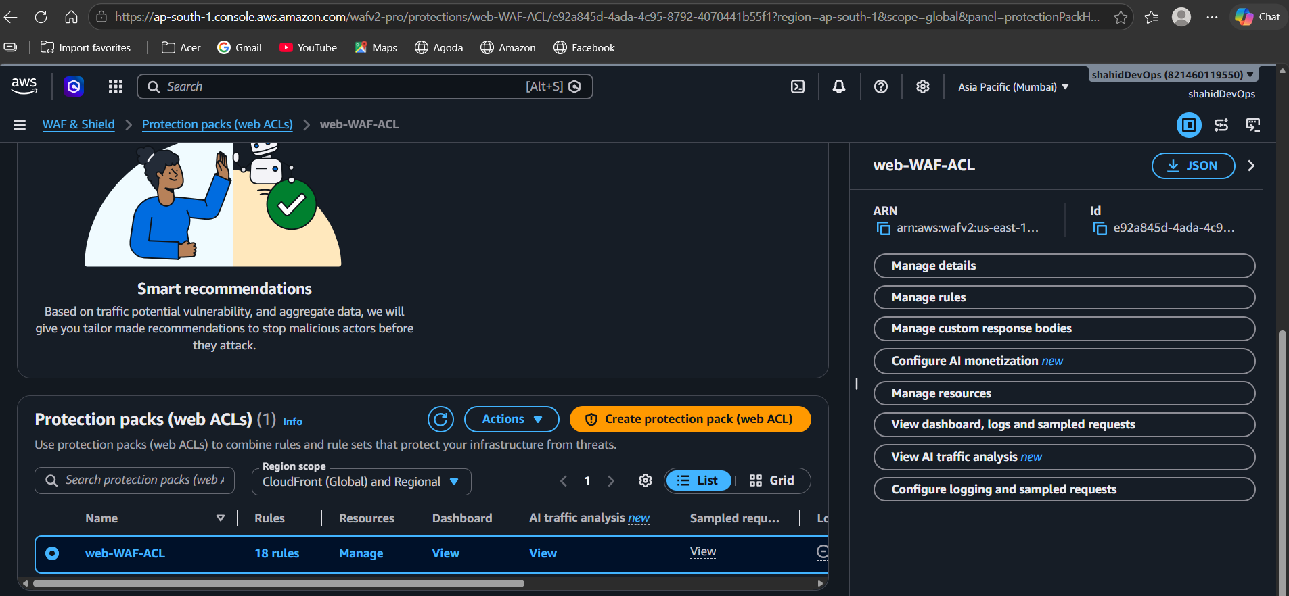

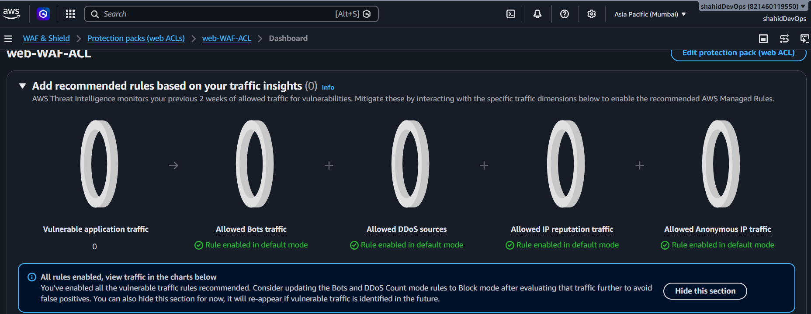

2.6 AWS WAF Observation
AWS WAF was successfully configured and associated with the Application Load Balancer.
AWS Managed Rules were added to inspect incoming web requests and provide protection against common web application attacks.
The implementation demonstrates how AWS WAF can be placed in front of an application to provide an additional security layer.

2.7 AWS WAF Use Cases
AWS WAF can be used for:
- Protecting websites from common web attacks.
- Blocking requests from unwanted IP addresses.
- Controlling access based on geographic locations.
- Protecting APIs.
- Protecting applications behind an Application Load Balancer.
- Protecting CloudFront-based applications.
- Controlling excessive web requests.

3. AWS SYSTEMS MANAGER PARAMETER STORE

3.1 Introduction
AWS Systems Manager Parameter Store is a capability of AWS Systems Manager used to securely store and manage configuration data and parameters.
Instead of directly storing configuration information inside application code, values can be stored in Parameter Store and retrieved when required.
For example, instead of storing database information directly inside an application:
DB_HOST=database.example.com
DB_USER=admin
DB_PASSWORD=password
the values can be stored in Parameter Store.
The application can retrieve these values when required.

3.2 Why Parameter Store is Used
Parameter Store can be used to store:
- Database host
- Database name
- Database username
- Database password
- Application configuration
- Environment values
- API configuration
- URLs
- Other configuration information
It helps reduce hardcoded configuration values in application code.

3.3 Parameter Store Parameter Types
There are three commonly used parameter types.

String
Used to store normal text values.
Example:
production

StringList
Used to store a list of values.
Example:
server1,server2,server3

SecureString
Used for sensitive information.
Example:
Database Password
SecureString parameters are encrypted using AWS Key Management Service (AWS KMS).

3.4 Parameter Store Architecture
The basic architecture is:
Application
|
v
EC2 Server
|
| IAM Permission
v
+----------------------+
| Parameter Store |
+----------------------+
| | |
v v v
DB Host DB User Password
The application running on EC2 can retrieve the required parameters from Parameter Store using appropriate IAM permissions.

3.5 Parameter Store Hands-On Implementation

Step 1: Open AWS Systems Manager
- Login to the AWS Management Console.
- Search for Systems Manager.
- Open AWS Systems Manager.
- From the left navigation menu, find Application Management.
- Select Parameter Store.

Step 2: Create a String Parameter
In Parameter Store, click Create parameter.
Enter the following details:
Name:
/devops/app/environment

Description:
Application environment configuration

Tier:
Standard

Type:
String

Value:
production
Click Create parameter.
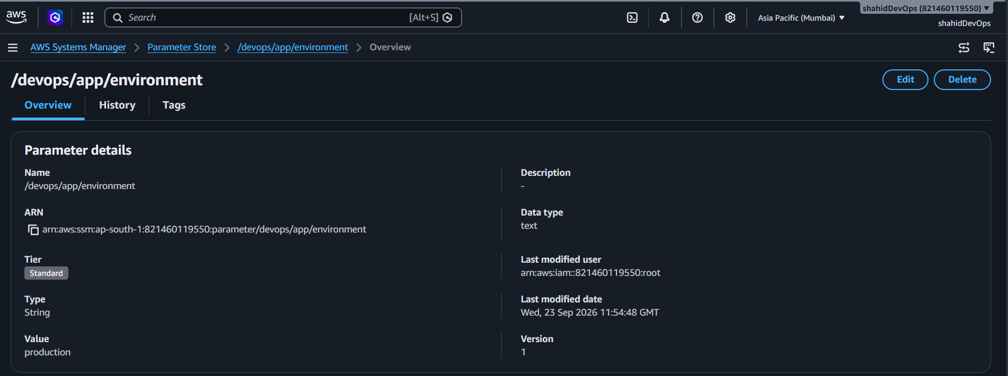
This parameter stores the application environment configuration without hardcoding it inside the application.

Step 3: Create Database Parameter
Create another parameter.
Enter:
Name:
/devops/app/database

Description:
Application database name

Tier:
Standard

Type:
String

Value:
companydb
Click Create parameter.

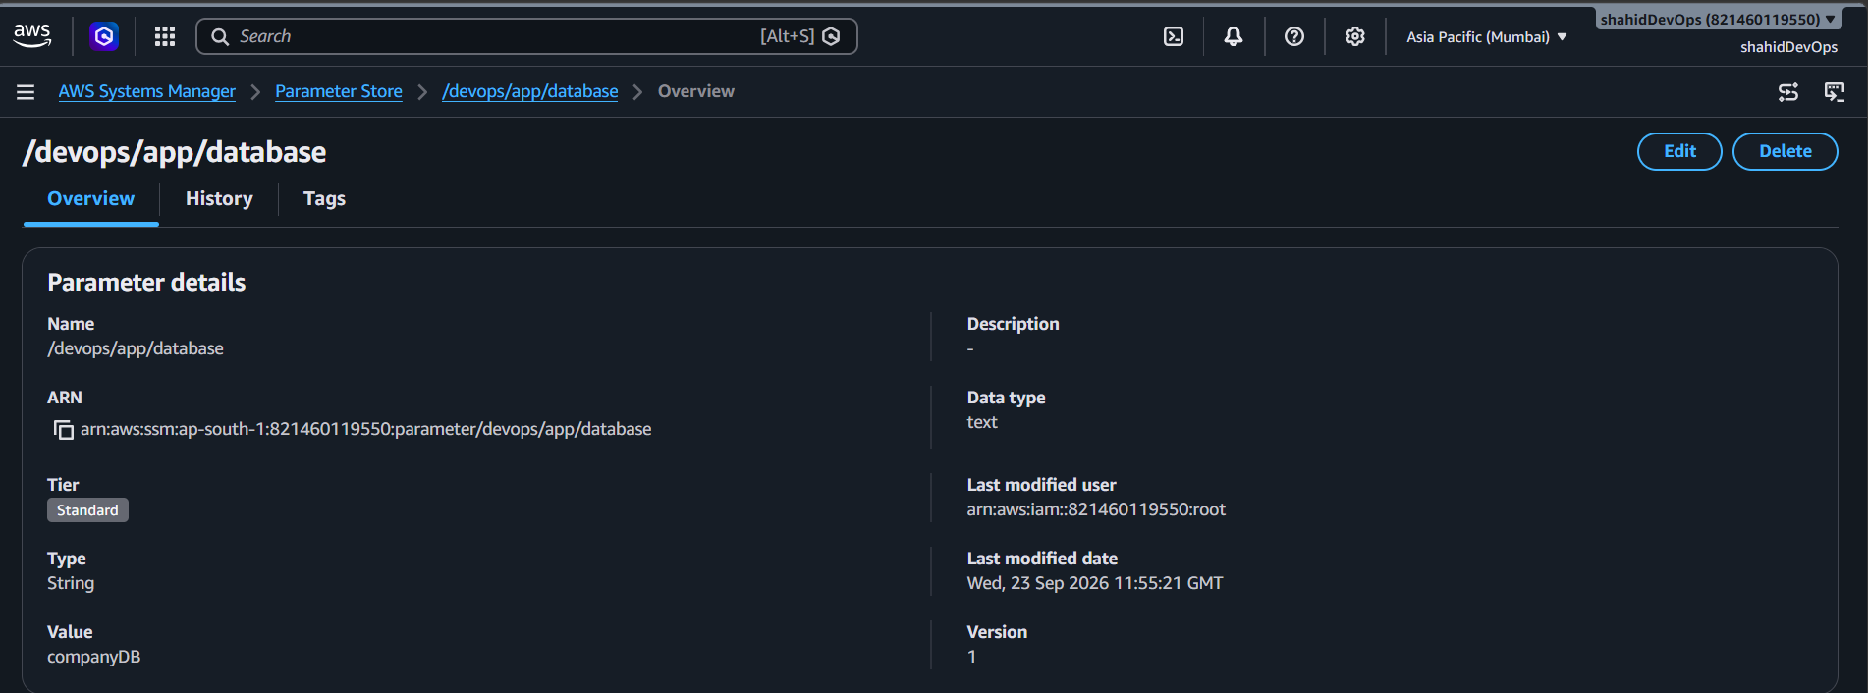

Step 4: Create Username Parameter
Create another parameter.
Enter:
Name:
/devops/app/username

Description:
Application database username

Tier:
Standard

Type:
String

Value:
admin
Click Create parameter.
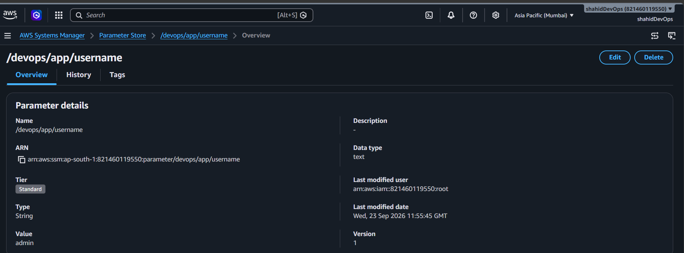

Step 5: Create SecureString Parameter
Create another parameter for sensitive information.
Enter:
Name:
/devops/app/password

Description:
Application database password

Tier:
Standard

Type:
SecureString
For the encryption key, use the available AWS managed key option if provided.
For the value, use a dummy password for the learning activity.
Click Create parameter.
SecureString encrypts the stored value using AWS Key Management Service (AWS KMS).
Important: Do not include a real password in documentation.

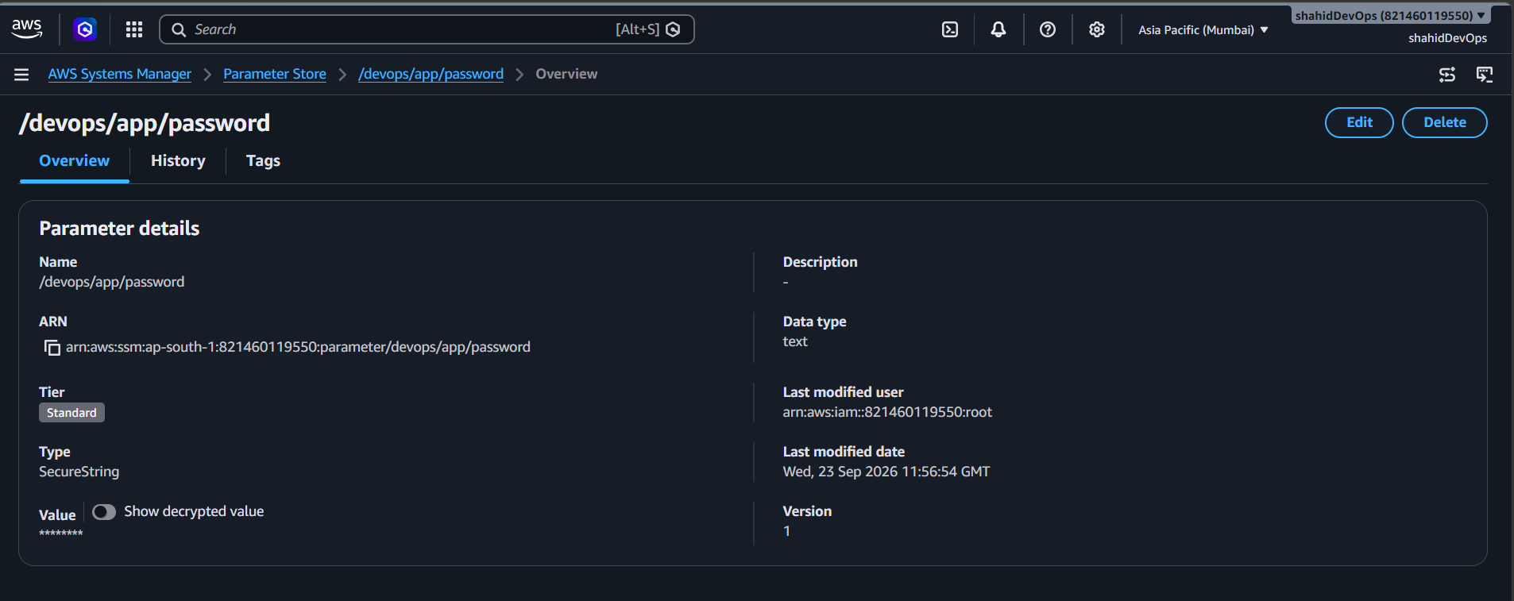

3.6 Verify Created Parameters
Go back to Parameter Store.
The following parameters should be available:
/devops/app/environment
/devops/app/database
/devops/app/username
/devops/app/password
Verify that all parameters were created successfully.

3.7 Open and Verify a Parameter
Click:
/devops/app/environment
Verify the parameter details.
Check:
- Parameter name
- Parameter type
- Parameter value
- Parameter tier
For the SecureString parameter, the value should remain protected and should not be exposed in documentation.

3.8 Retrieve Parameter Using AWS CLI
An EC2 instance with AWS CLI access can be used to retrieve the parameter.
The EC2 instance must have appropriate IAM permissions.
The basic command is:
aws ssm get-parameter --name "/devops/app/environment"
The command retrieves the stored parameter value.
To specify the Mumbai region explicitly:
aws ssm get-parameter \
--name "/devops/app/environment" \
--region ap-south-1
To retrieve only the parameter value:
aws ssm get-parameter \
--name "/devops/app/environment" \
--region ap-south-1 \
--query "Parameter.Value" \
--output text
Expected output:
Production

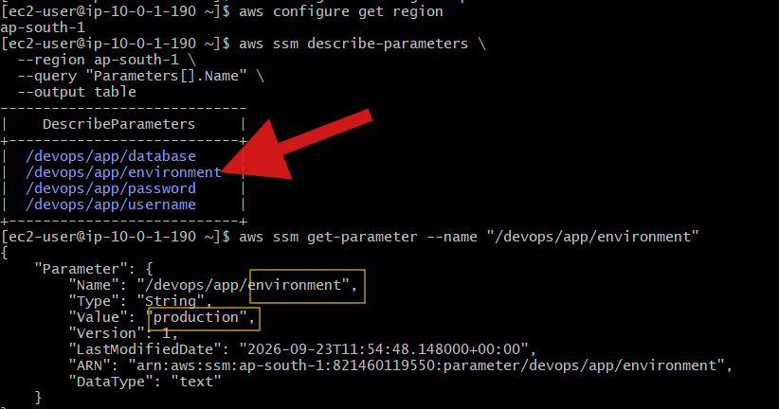

3.9 Retrieve SecureString Parameter
To retrieve the encrypted SecureString value with decryption, use:
aws ssm get-parameter \
--name "/devops/app/password" \
--with-decryption \
--region ap-south-1
The --with-decryption option requests AWS to decrypt the SecureString value.
Important: Do not expose the actual password in documentation.

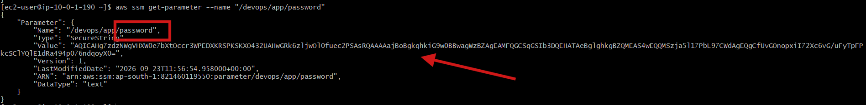

3.10 IAM Permission for Parameter Store
The EC2 instance or IAM user/role accessing Parameter Store requires permission to read parameters.
The required permission includes:
ssm:GetParameter
For listing or verifying parameters, the following permission can also be used:
ssm:DescribeParameters
For retrieving multiple parameters:
ssm:GetParameters
For SecureString parameters encrypted with a KMS key, appropriate KMS permissions may also be required.
For a practical environment, permissions should follow the principle of least privilege.

3.11 EC2 IAM Role Configuration
The EC2 instance used for the lab was already associated with:
EC2-CloudWatch-Monitoring-Role
The role already contained:
CloudWatchAgentServerPolicy
An additional inline policy was created:
SSMParameterReadAccess
The policy provides permission to retrieve Parameter Store values.
The required SSM actions include:
ssm:GetParameter
ssm:GetParameters
ssm:DescribeParameters
This allows the EC2 instance to access Parameter Store through the AWS CLI.

3.12 IAM Permission Troubleshooting
During implementation, an AccessDeniedException was initially received while running:
aws ssm get-parameter --name "/devops/app/environmet"
The error indicated that the EC2 role was not authorized to perform:
ssm:GetParameter
The EC2 instance was using:
EC2-CloudWatch-Monitoring-Role
The issue was resolved by providing the required SSM permissions through the SSMParameterReadAccess policy.
The CloudWatchAgentServerPolicy is used for CloudWatch Agent operations and does not automatically provide permission to retrieve SSM parameters.

3.13 Parameter Not Found Troubleshooting
After the IAM permission issue was resolved, the command returned:
ParameterNotFound
This indicated that the permission issue had been resolved, but AWS could not find the requested parameter with the specified name and region.
The AWS CLI region was checked using:
aws configure get region
The region was then configured as:
ap-south-1
using:
aws configure set region ap-south-1
The parameters were then verified using:
aws ssm describe-parameters \
--region ap-south-1 \
--query "Parameters[].Name" \
--output table
This helped verify the exact parameter names available in the Mumbai region.
The parameter was then successfully retrieved using the correct name and region.

3.14 Important Parameter Store CLI Commands

Check configured region
aws configure get region

Set Mumbai region
aws configure set region ap-south-1

List parameters
aws ssm describe-parameters \
--region ap-south-1 \
--query "Parameters[].Name" \
--output table

Get a parameter
aws ssm get-parameter \
--name "/devops/app/environment" \
--region ap-south-1

Get only the value
aws ssm get-parameter \
--name "/devops/app/environment" \
--region ap-south-1 \
--query "Parameter.Value" \
--output text

Get SecureString with decryption
aws ssm get-parameter \
--name "/devops/app/password" \
--with-decryption \
--region ap-south-1

3.15 Observation
The Parameter Store implementation was successfully configured to store application configuration data.
String parameters were used for normal configuration values, while SecureString was used for sensitive information such as passwords.
The stored parameters can be retrieved by authorized AWS resources or applications without hardcoding configuration values directly into application code.
The EC2 instance was successfully configured to access Parameter Store through an IAM role and AWS CLI.
The implementation also demonstrated troubleshooting of IAM AccessDeniedException and SSM ParameterNotFound errors.

3.16 Result
AWS Systems Manager Parameter Store was successfully implemented.
The following configuration parameters were created:
- Application environment
- Database name
- Database username
- Database password using SecureString
The parameters were verified through the AWS Management Console and retrieved using the AWS CLI by an authorized EC2 IAM role.
The implementation was performed in the Mumbai region:
ap-south-1

4. WAF vs Parameter Store
AWS WAF and Parameter Store serve different purposes.
AWS WAF | AWS Systems Manager Parameter Store
Web application security | Configuration management
Inspects incoming web requests | Stores application parameters
Protects against common web attacks | Reduces hardcoded configuration
Uses Web ACLs and rules | Uses String, StringList and SecureString
Works with ALB, CloudFront and API Gateway | Can be accessed by authorized AWS resources
Controls and filters requests | Retrieves configuration when required
Example:
AWS Application
|
+-------------------+
| |
v v
AWS WAF Parameter Store
| |
v v
Protects Web App Stores Configuration

5. Overall Implementation Architecture
Internet
|
v
+-------------+
| AWS WAF |
| Web ACL |
+-------------+
|
v
+---------------------+
| Application Load |
| Balancer |
+---------------------+
|
v
+-----------+
| EC2 |
| Web/App |
+-----------+
|
| IAM Role
v
+---------------------+
| Systems Manager |
| Parameter Store |
+---------------------+
| | |
v v v
DB Host DB User Password

6. Overall Observations
During this hands-on activity, AWS WAF and AWS Systems Manager Parameter Store were implemented successfully.
AWS WAF was used to protect an Application Load Balancer by inspecting incoming web requests using configured rules.
Systems Manager Parameter Store was used to store application configuration values and a SecureString parameter for sensitive information.
The activity provided practical understanding of:
- AWS security
- Web application protection
- Configuration management
- IAM permissions
- Parameter Store
- AWS CLI
- SecureString
- KMS integration
- AWS service integration
- Troubleshooting IAM and SSM errors

7. Conclusion
AWS WAF and AWS Systems Manager Parameter Store are useful AWS services for building secure and manageable applications.
AWS WAF provides an additional security layer for web applications by inspecting incoming requests and applying configured rules.
Parameter Store provides centralized storage and management of application configuration values and sensitive parameters.
Through this hands-on implementation, the basic concepts, architecture, configuration steps, IAM permissions, AWS CLI commands, and practical troubleshooting of AWS WAF and Systems Manager Parameter Store were understood and implemented successfully.

