- Configure VPC peering in cross regions..

Objective
Configure VPC peering between two VPCs in different AWS regions and test connectivity using private IP addresses.

Architecture
Resource | Mumbai | Virginia
Region | ap-south-1 | us-east-1
VPC | VPC-Mumbai | VPC-Virginia
VPC CIDR | 10.0.0.0/16 | 10.1.0.0/16
Subnet CIDR | 10.0.1.0/24 | 10.1.1.0/24
EC2 Private IP | 10.0.1.190 | 10.1.1.169

Steps Performed

1. Created two VPCs
- VPC-Mumbai: 10.0.0.0/16
- VPC-Virginia: 10.1.0.0/16
VPC CIDR ranges must not overlap.

2. Created subnets
- Mumbai: 10.0.1.0/24
- Virginia: 10.1.1.0/24

3. Created Cross-Region VPC Peering
- Requester: VPC-Mumbai
- Accepter: VPC-Virginia
- Accepted the peering request.
- Status: Active

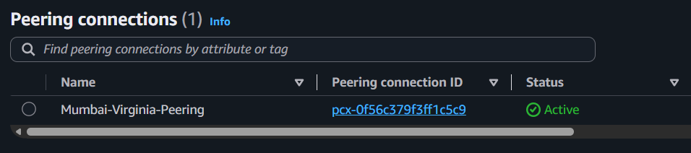

4. Configured Route Tables
Mumbai Route Table:
10.0.0.0/16 → local
10.1.0.0/16 → VPC Peering Connection
Virginia Route Table:
10.1.0.0/16 → local
10.0.0.0/16 → VPC Peering Connection

5. Launched EC2 Instances
Mumbai EC2: 10.0.1.190
Virginia EC2: 10.1.1.169

6. Configured Security Groups
Mumbai EC2:
All ICMP - IPv4
Source: 10.1.0.0/16
Virginia EC2:
All ICMP - IPv4
Source: 10.0.0.0/16

7. Tested Connectivity
From Mumbai:
ping 10.1.1.169
From Virginia:
ping 10.0.1.190
Both pings were successful.

Result
✅ Cross-region VPC peering successfully configured and tested.

Connectivity from Mumbai to North Virginia:

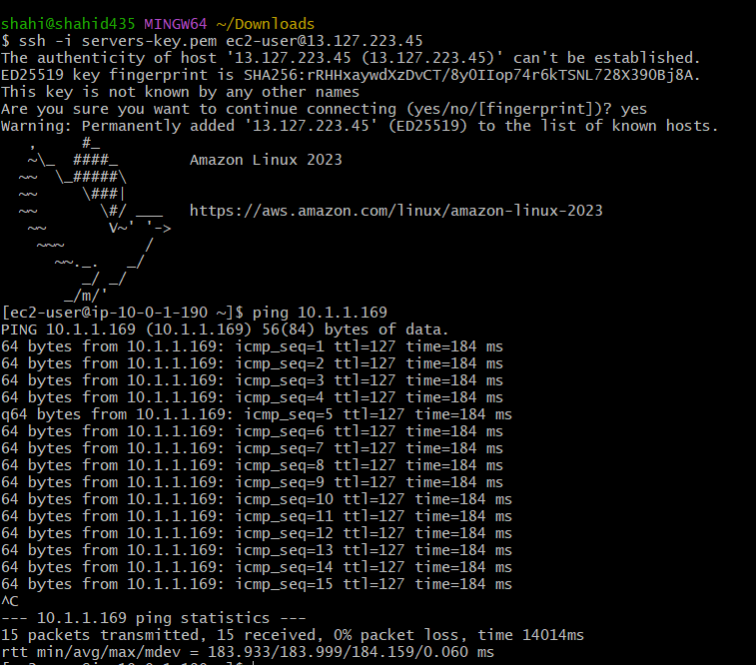

Connectivity from North virginia to Mumbai:
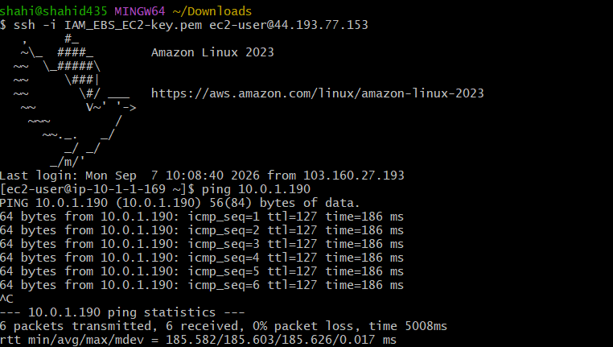

- Purchase one domain from GoDaddy..

Objective
Purchase a custom domain from GoDaddy to use for the static website.

Domain Purchased
shahid8256.online

Steps Performed
- Opened GoDaddy.
- Searched for an available domain.
- Selected:
shahid8256.online
- Selected 1-year registration.
- Removed unnecessary add-ons:
  - Domain Protection
  - Professional Email
- Completed the domain purchase.

Important Points
- The domain is purchased from GoDaddy, which acts as the domain registrar.
- We do not need to purchase separate web hosting from GoDaddy.
- The website will be hosted on AWS S3.
- Later, the domain will be connected as:
shahid8256.online
↓
Route 53
↓
CloudFront (CDN + SSL)
↓
S3 Static Website

Result
✅ Custom domain purchased successfully and ready for AWS configuration.

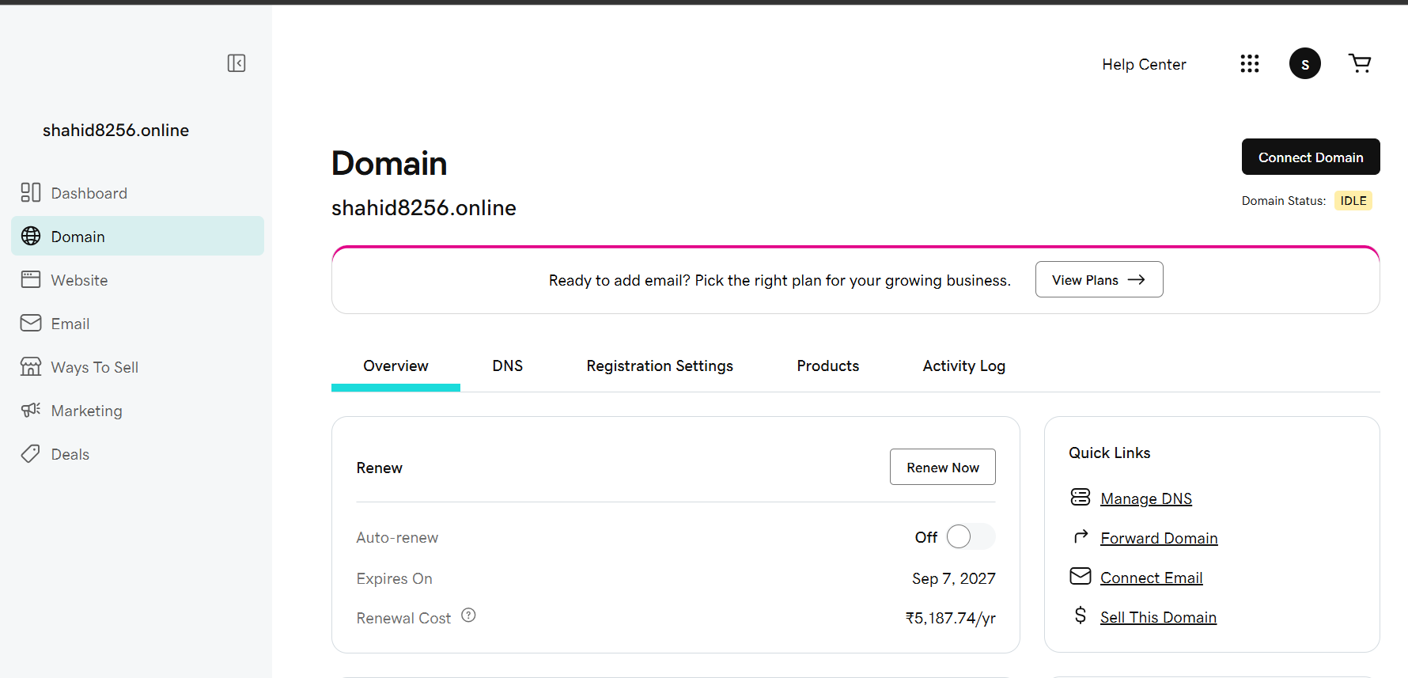

3. Deploy static website in S3..

Objective
Host a static website using an Amazon S3 bucket.

S3 Bucket
Bucket Name: shahid8256.online
Region: ap-south-1 (Mumbai)

Steps Performed

1. Created S3 Bucket
Created an S3 bucket named:
shahid8256.online

2. Enabled Static Website Hosting
Go to:
S3 → Bucket → Properties → Static website hosting → Edit
Configuration:
Static website hosting: Enable
Hosting type: Host a static website
Index document: index.html

3. Created and Uploaded Website
Created:
index.html
The webpage contains a professional website for:
SHAHID8256 PRIVATE LIMITED
It includes:
- Cloud Infrastructure
- DevOps Automation
- Security
- Monitoring
- CI/CD
- Infrastructure Architecture
- Animations and modern design
Uploaded index.html to the S3 bucket.

4. Fixed Access Denied
Initially, the S3 website showed:
Access Denied
To fix it:

Disabled Block Public Access
S3 → Bucket → Permissions → Block public access → Edit
Disabled public access blocking.

Added Bucket Policy
{
"Version": "2012-10-17",
"Statement": [
{
"Sid": "PublicReadForWebsite",
"Effect": "Allow",
"Principal": "*",
"Action": "s3:GetObject",
"Resource": "arn:aws:s3:::shahid8256.online/*"
}
]
}

5. Tested Website
Copied the Bucket website endpoint from:
S3 → Bucket → Properties → Static website hosting
Opened the endpoint in a browser and verified that the website was accessible.

Result
User
↓
S3 Static Website Endpoint
↓
S3 Bucket
↓
index.html
✅ Static website successfully deployed and accessible through the S3 website endpoint.

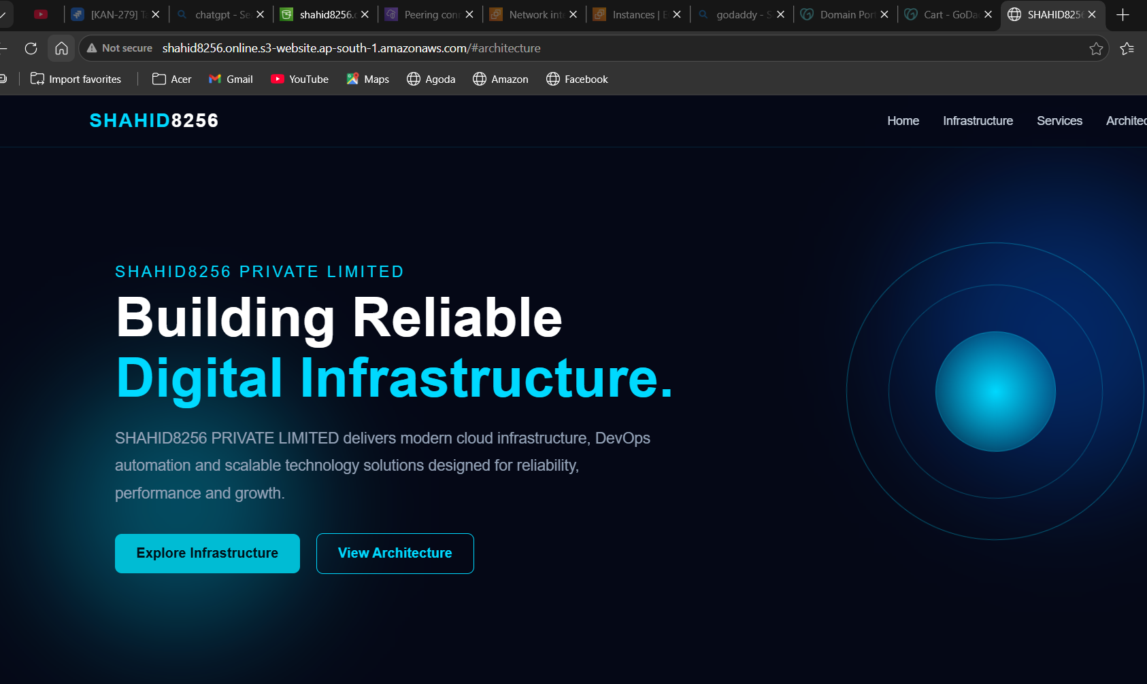
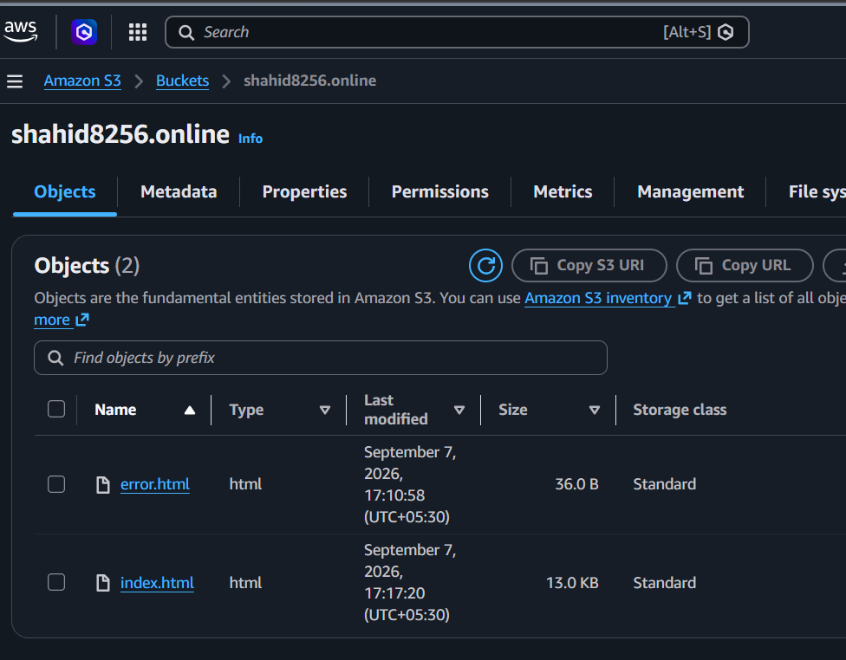
- Create a CDN and attach one SSL certificate..

5. Create a Route 53 hosted zone and map the domain with the CDN..
6. Update the index.html in the S3 bucket and ensure the updated file is accessible using the domain name..
7. Share the domain name in Slack to test the connectivity..

