Docker-1 12/10/2026

- Setup a virtual machine using Ubuntu image.

Docker-01 — Task 1: Setup Ubuntu Virtual Machine

Objective
Set up an Ubuntu virtual machine that will be used as the Docker host for the remaining lab tasks.

Implementation
- Opened AWS Management Console.
- Navigated to EC2 → Instances → Launch Instance.
- Created an EC2 instance with:
  - Name: Docker-01
  - AMI: Ubuntu Server 26.04 LTS
  - Instance Type: t3.small
  - Key Pair: Selected the required key pair
  - Storage: 20 GB
- Configured the Security Group:
  - SSH – Port 22 → My IP
  - TCP – Port 81 → My IP
  - TCP – Port 8080 → My IP
- Launched the EC2 instance.
- Waited until the instance reached Running state.

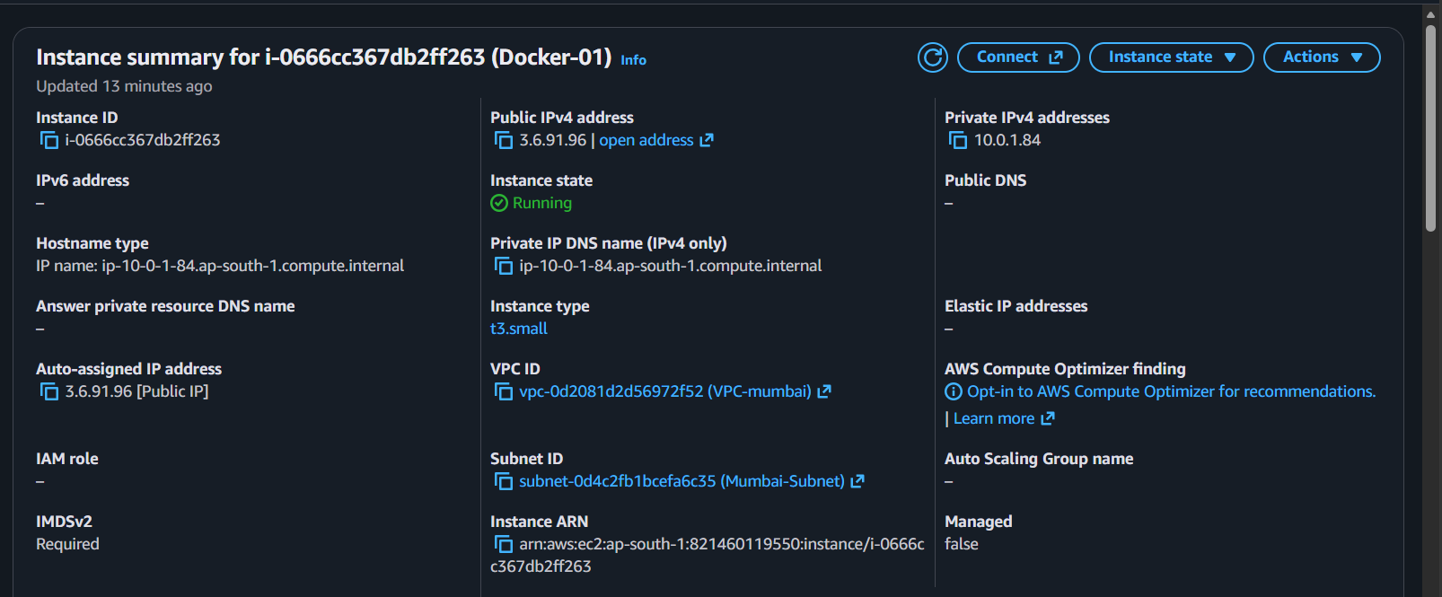

- Connected to the instance using SSH:
ssh -i Docker-key.pem ubuntu@<PUBLIC-IP>
- Verified the operating system:
cat /etc/os-release
- Verified the logged-in user:
whoami
Output:
Ubuntu

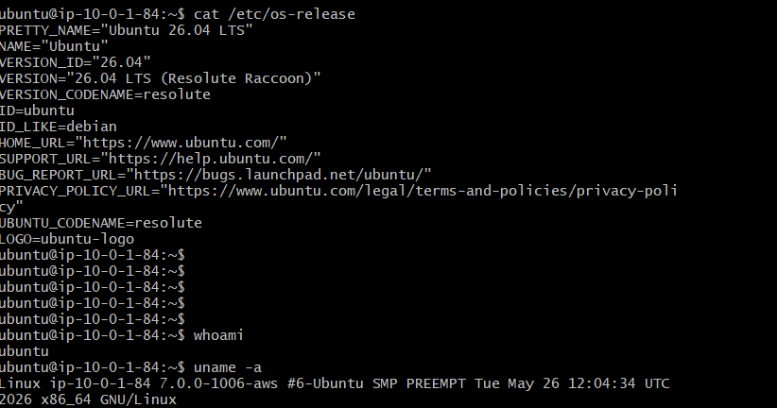

Important Note
For this lab, AWS EC2 is the virtual machine. No VMware, VirtualBox, or Docker Desktop was required.
The setup is:
AWS EC2
↓
Ubuntu 24.04
↓
Docker Engine
↓
Docker Containers
Task 1 completed: Ubuntu EC2 virtual machine is ready for Docker installation.

- Install docker on ec2.

Objective
Install Docker on the Ubuntu EC2 instance and verify that Docker is working correctly.

Implementation

1. Update package information
sudo apt update

2. Install Docker
sudo apt install docker.io -y

3. Start Docker service
sudo systemctl start docker

4. Verify Docker service
sudo systemctl status docker
Evidence:
Active: active (running)

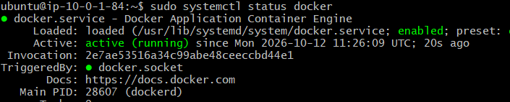This confirms that the Docker service is running successfully.

5. Verify Docker installation
sudo docker --version
Evidence:
Docker version <version>

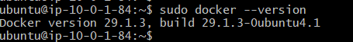This confirms that Docker was installed successfully.

6. Test Docker by running a container
sudo docker run hello-world
Evidence:
Hello from Docker!

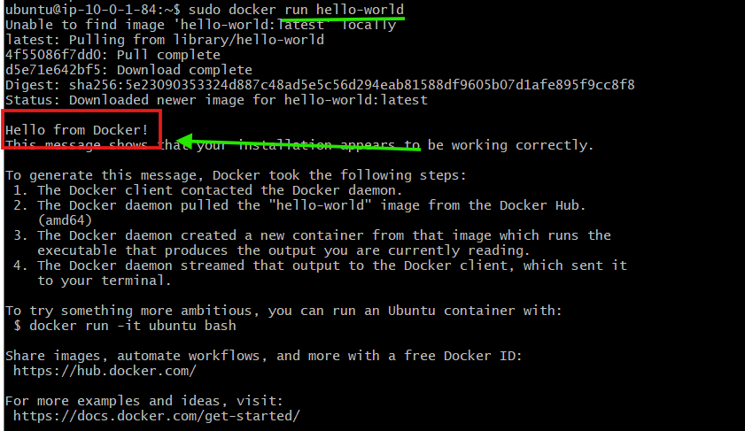
This confirms that Docker can successfully pull an image and create/run a container.

Task 2 Result
Docker was successfully installed and verified on the Ubuntu EC2 instance.

_______________________________________________________
- Pull 5 docker images. (nginx, Apache tomcat, ubuntu, Jenkins, SonarQube)

Objective
Pull the required Docker images from Docker Hub to the Ubuntu EC2 instance.

Implementation
Pulled the following five images:

1. Nginx
sudo docker pull nginx

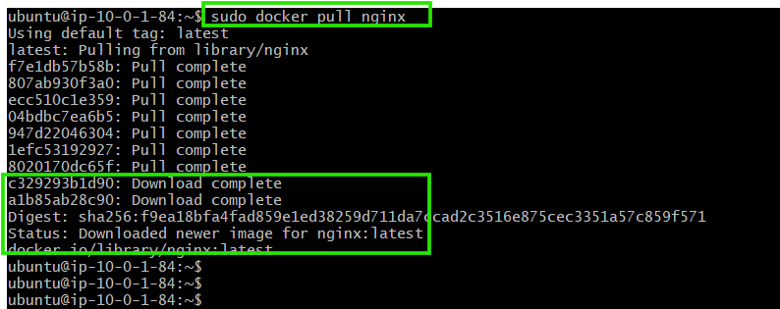

2. Apache Tomcat
sudo docker pull tomcat

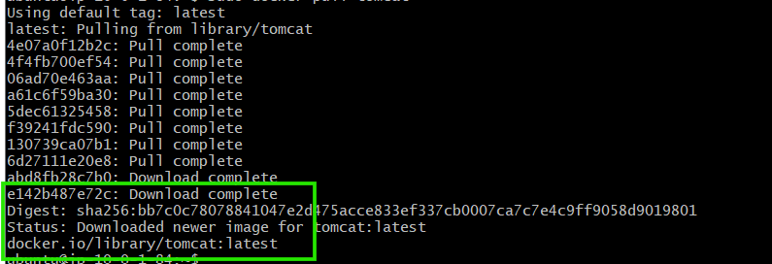

3. Ubuntu
sudo docker pull ubuntu

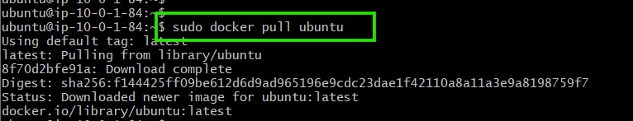

4. Jenkins
sudo docker pull jenkins/Jenkins

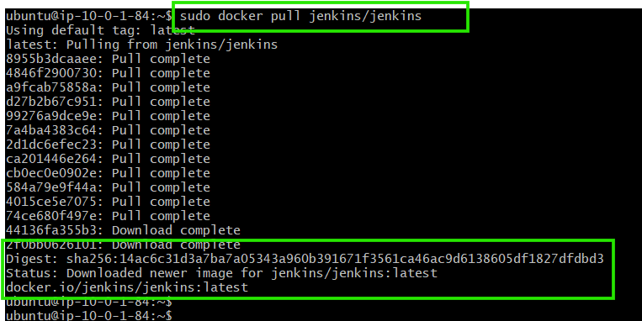

5. SonarQube
sudo docker pull sonarqube
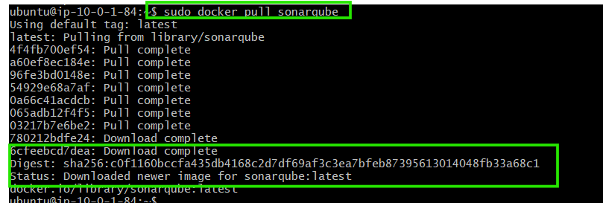

Verification
Checked the locally available Docker images:
sudo docker images

Evidence
The output displayed the following repositories:
nginx
tomcat
ubuntu
jenkins/jenkins
sonarqube
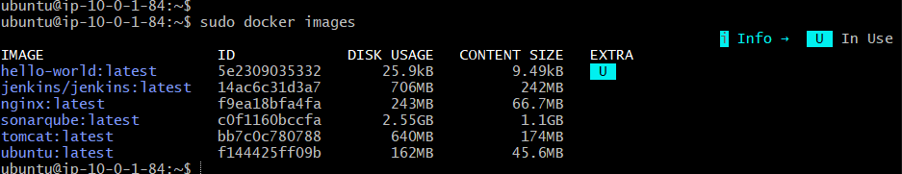

This confirms that all five required images were successfully pulled from Docker Hub and stored locally on the EC2 instance.

Result
5 required Docker images were successfully pulled and verified locally.

- Run nginx container and expose on port 81.

Objective
Run an Nginx container and expose the Nginx web server through port 81 of the EC2 instance.

Step 1: Run the Nginx Container
Used the Nginx image pulled in Task 3:
sudo docker run -d --name nginx-container -p 81:80 nginx
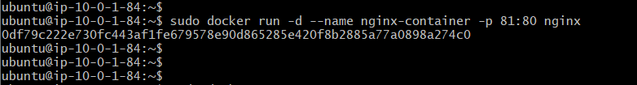

Explanation
- docker run → Creates and starts a container.
- -d → Runs the container in the background.
- --name nginx-container → Assigns a name to the container.
- -p 81:80 → Maps EC2 port 81 to container port 80.
- nginx → Uses the Nginx image.

Port Mapping
EC2 Host Port 81
↓
Container Port 80
↓
Nginx
Nginx listens on port 80 inside the container, while users access it through port 81 on the EC2 instance.

Step 2: Check the Running Container
sudo docker ps
This displays the currently running Docker containers.
The Nginx container should show a port mapping similar to:
0.0.0.0:81->80/tcp
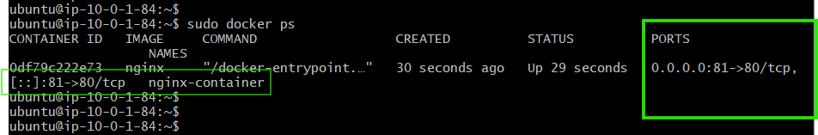
This confirms that port 81 on the EC2 host is mapped to port 80 inside the Nginx container.

Step 3: Access Nginx from the Browser
Opened:
http://<EC2-PUBLIC-IP>:81
The Nginx welcome page was displayed.
This confirms that the Nginx container is accessible from outside the EC2 instance.
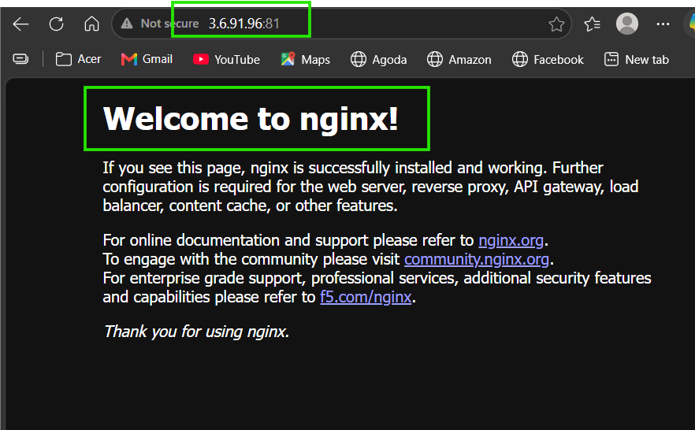

Optional: Change the Nginx Message
Changed the default Nginx page to a custom message.
Entered the running container:
sudo docker exec -it nginx-container bash
Changed the page:
echo "<h1>Docker-01 Nginx Server</h1>" > /usr/share/nginx/html/index.html4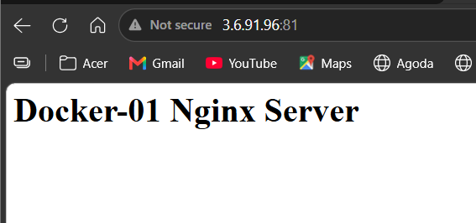
Exited:
exit
After refreshing the browser, the custom message was displayed.

Task 4 Result
Nginx was successfully run as a Docker container and exposed through EC2 port 81 using port mapping 81:80. The container was verified through the browser, and the Nginx page was optionally customized.

- Delete the Apache tomcat image from local.

Objective:
Delete the Apache Tomcat Docker image from the local Docker host.
Step 1 — Check available images
sudo docker images

The tomcat:latest image was present locally.
Step 2 — Remove the Tomcat image
sudo docker rmi tomcat

Docker successfully removed the Tomcat image.
Step 3 — Verify containers
sudo docker ps -a
The existing containers were:
nginx-container
amazing_booth
No Tomcat container was present.
Result:
The Apache Tomcat image was successfully deleted from the local Docker host.

- Inspect the Jenkins image, SonarQube image.

Docker-01 — Task 6: Inspect Jenkins and SonarQube Images

Objective
Inspect the Jenkins and SonarQube Docker images to view their configuration and metadata before running containers from them.
Both images were already pulled during Task 3.

Step 1: Inspect Jenkins Image
Executed:
sudo docker image inspect jenkins/jenkins
This displayed detailed information about the Jenkins image, including:
- Image ID
- Creation time
- Operating system
- Architecture
- Image size
- Environment variables
- Exposed ports
- Entrypoint
- Default command
- Volumes
- Image layers
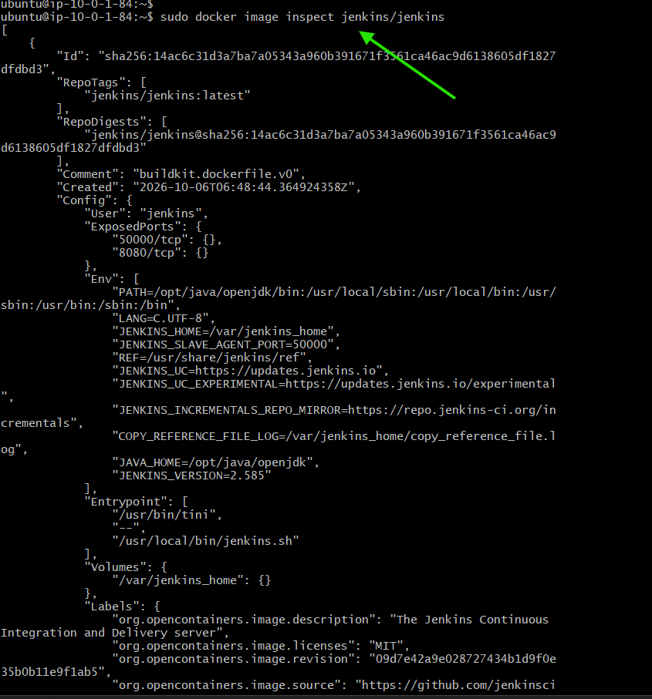

Step 2: Inspect SonarQube Image
Executed:
sudo docker image inspect sonarqube
This displayed the configuration and metadata of the SonarQube image, including:
- Image ID
- Creation time
- Operating system
- Architecture
- Image size
- Environment variables
- Exposed ports
- Entrypoint
- Volumes
- Image layers
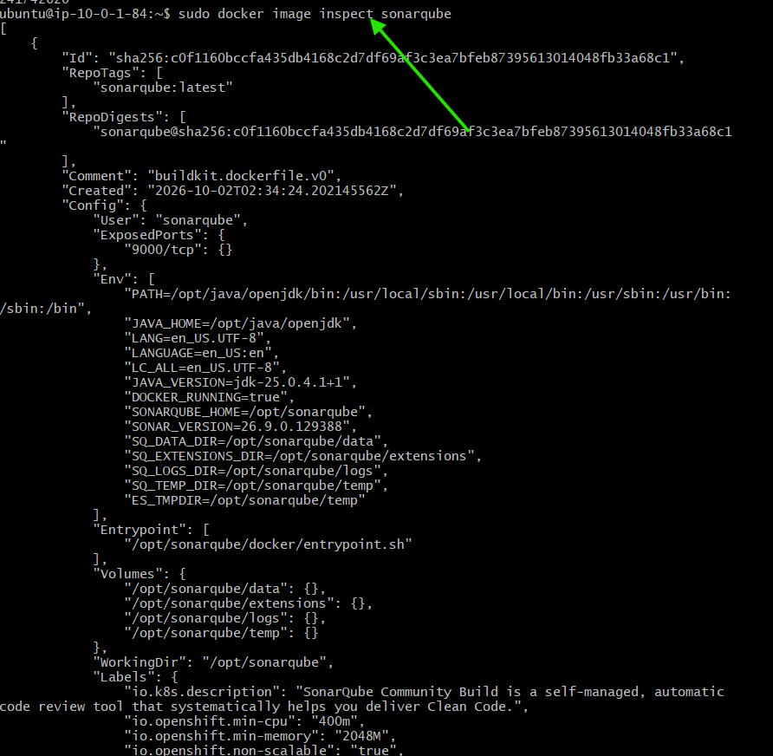

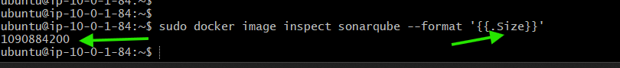

Purpose of Image Inspection
The docker image inspect command is used to view the detailed configuration and metadata of a Docker image.
It helps understand how an image is configured before creating a container from it.

Result
The Jenkins and SonarQube images were successfully inspected using docker image inspect.
__________________________________________________________________
- Run Jenkins container and run one sample job

Docker-01 — Task 7: Run Jenkins Container and Execute a Sample Job

Objective
Run Jenkins as a Docker container, access Jenkins through the browser, complete the initial Jenkins setup, install the suggested plugins, and execute one sample Jenkins job.

Step 1: Run Jenkins Container
Used the Jenkins image pulled in Task 3:
sudo docker run -d --name jenkins-container -p 8080:8080 jenkins/jenkins

Explanation
- -d → Runs the container in the background.
- --name jenkins-container → Assigns a name to the Jenkins container.
- -p 8080:8080 → Maps EC2 port 8080 to Jenkins container port 8080.
- jenkins/jenkins → Uses the Jenkins Docker image.

Step 2: Verify Jenkins Container
Checked the running containers:
sudo docker ps
The Jenkins container was running with the port mapping:
0.0.0.0:8080->8080/tcp
This confirms that Jenkins is running inside the Docker container and is accessible through EC2 port 8080.
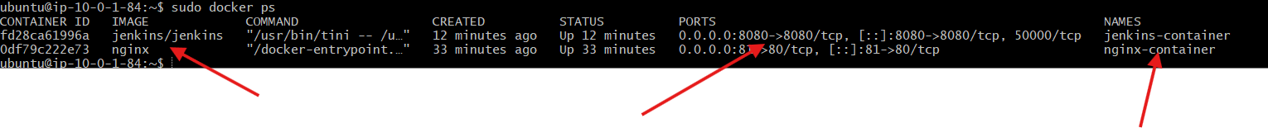

Step 3: Get the Initial Jenkins Password
Retrieved the initial administrator password from inside the Jenkins container:
sudo docker exec jenkins-container cat /var/jenkins_home/secrets/initialAdminPassword
Copied the generated password for the initial Jenkins setup.

Step 4: Access Jenkins
Opened Jenkins in the browser:
http://<EC2-PUBLIC-IP>:8080
The Unlock Jenkins page was displayed.
Entered the initial administrator password obtained from the container.
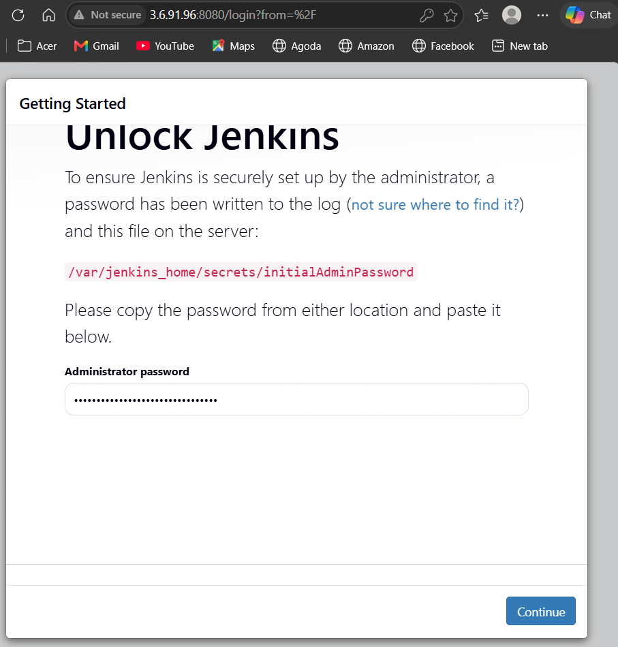

Step 5: Install Jenkins Plugins
Jenkins provided two plugin installation options.
Selected:
Install suggested plugins
Jenkins started installing the recommended plugins required for a basic Jenkins setup.
Waited for the plugin installation to complete.

Step 6: Create Jenkins Administrator
After plugin installation, created the Jenkins administrator account.
Provided:
- Username
- Password
- Full Name
Completed the initial Jenkins setup and reached the Jenkins dashboard.
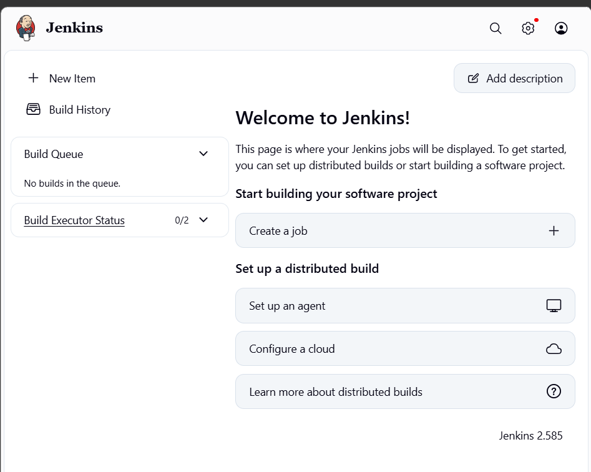

Step 7: Create a Sample Jenkins Job
From the Jenkins dashboard:
New Item → Docker-01-Sample-Job
Selected:
Freestyle project
Clicked OK.
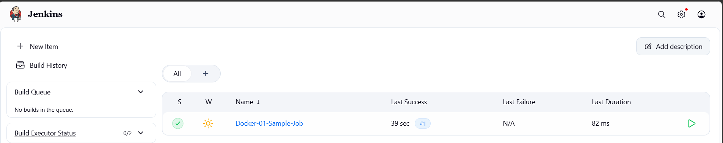

Step 8: Configure the Build Step
In the job configuration:
Build Steps → Add build step → Execute shell
Added:
echo "Hello from Jenkins Docker Container"
echo "Docker-01 Jenkins Sample Job"
echo “docker day 1 tasks completed…”
Saved the job configuration.

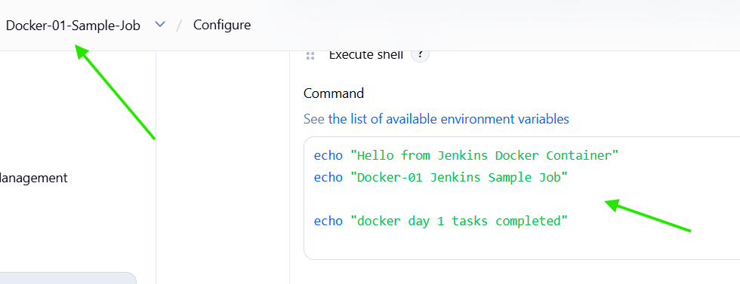

Step 9: Execute the Job
Clicked:
Build Now
Jenkins created the first build.
Opened the build number and selected:
Console Output
The console displayed:
Hello from Jenkins Docker Container
Docker-01 Jenkins Sample Job
Finished: SUCCESS

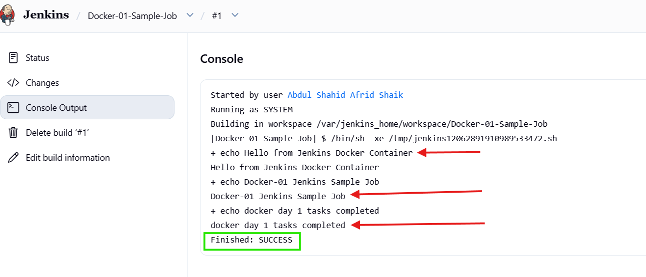

How the Setup Works
AWS EC2
│
▼
Ubuntu
│
▼
Docker Engine
│
▼
Jenkins Container
│
▼
Jenkins Web UI :8080
│
▼
Freestyle Job
│
▼
Execute Shell
│
▼
Build SUCCESS

Task 7 Result
Jenkins was successfully run as a Docker container, accessed through port 8080, initialized with the suggested plugins, and configured with a Freestyle sample job. The sample job executed successfully and returned Finished: SUCCESS.

