CloudTrail AND CloudWatch

- Enable CloudTrail monitoring and store the events in S3 and CloudWatch log events.

Objective
To enable AWS CloudTrail for monitoring AWS account activities and store the captured events in an Amazon S3 bucket and Amazon CloudWatch Logs.

Steps Performed
- Logged in to the AWS Management Console.
- Opened the AWS CloudTrail service.
- Navigated to Trails and created a new trail.
- Configured the trail name as:
cloudtrail-monitoring
- Enabled logging for the AWS account.
- Configured an Amazon S3 bucket for storing CloudTrail logs. AWS created the S3 bucket automatically.
- Verified that CloudTrail events were being captured in Event History.
- Verified that the CloudTrail log files were stored in the S3 bucket under the AWSLogs folder.
- Edited the CloudTrail configuration to enable CloudWatch Logs integration.
- Created a new CloudWatch Log Group:
/aws/cloudtrail/monitoring
- Created a new IAM Role:
CloudTrail-CloudWatchLogs-Role
- Saved the CloudTrail configuration.
- Opened Amazon CloudWatch → Logs → Log Management.
- Verified the CloudWatch Log Group:
/aws/cloudtrail/monitoring
- Verified that CloudTrail created the following log stream:
821460119550_CloudTrail_us-east-1

Result
CloudTrail monitoring was successfully configured. AWS account activity events are being captured and stored in:
- Amazon S3 for long-term log storage.
- Amazon CloudWatch Logs for monitoring and analysis.

Evidence / Screenshots Required
- CloudTrail trail configuration
- CloudTrail Event History showing events
- S3 bucket containing the AWSLogs folder
- CloudWatch Log Group /aws/cloudtrail/monitoring
- CloudWatch Log Stream 821460119550_CloudTrail_us-east-1

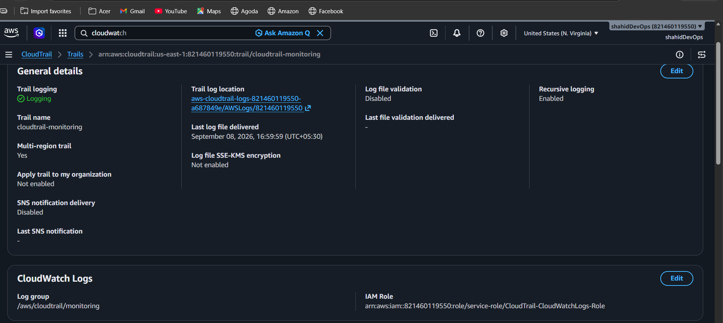

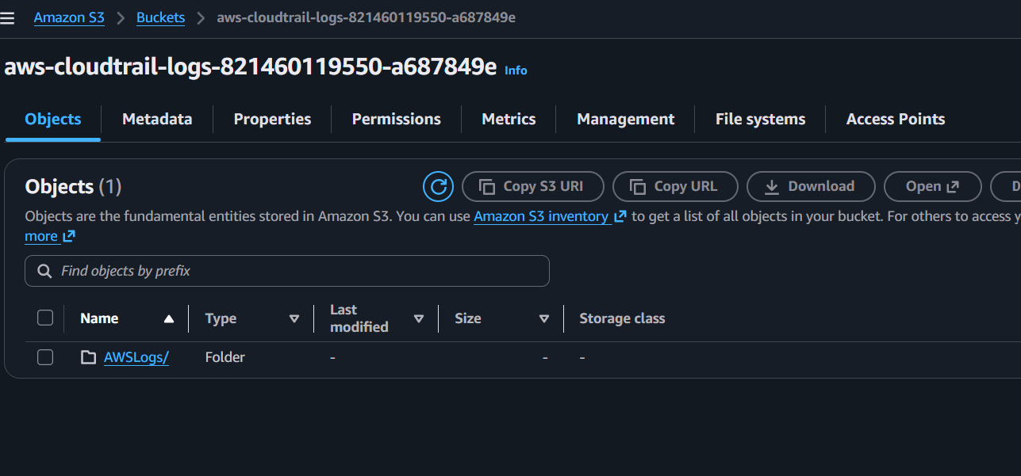

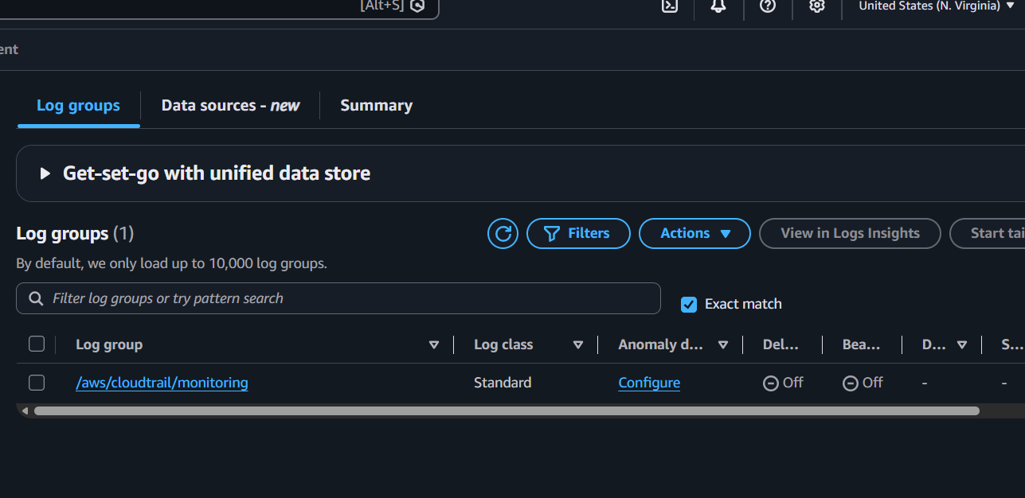

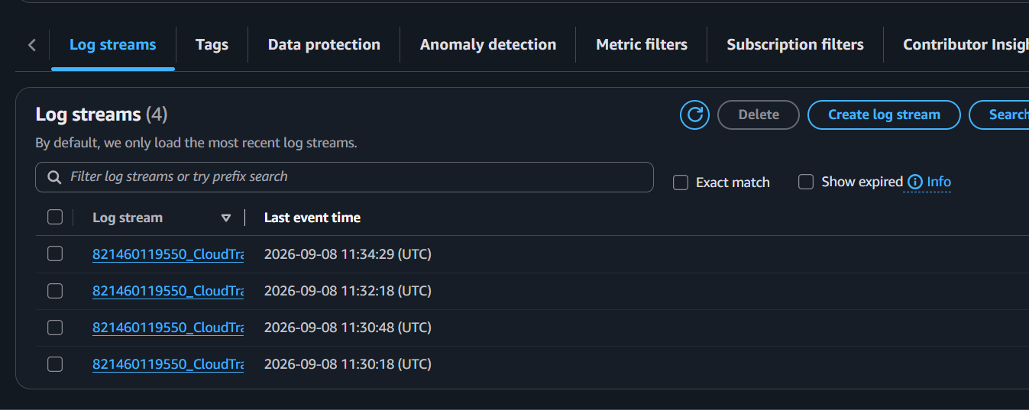

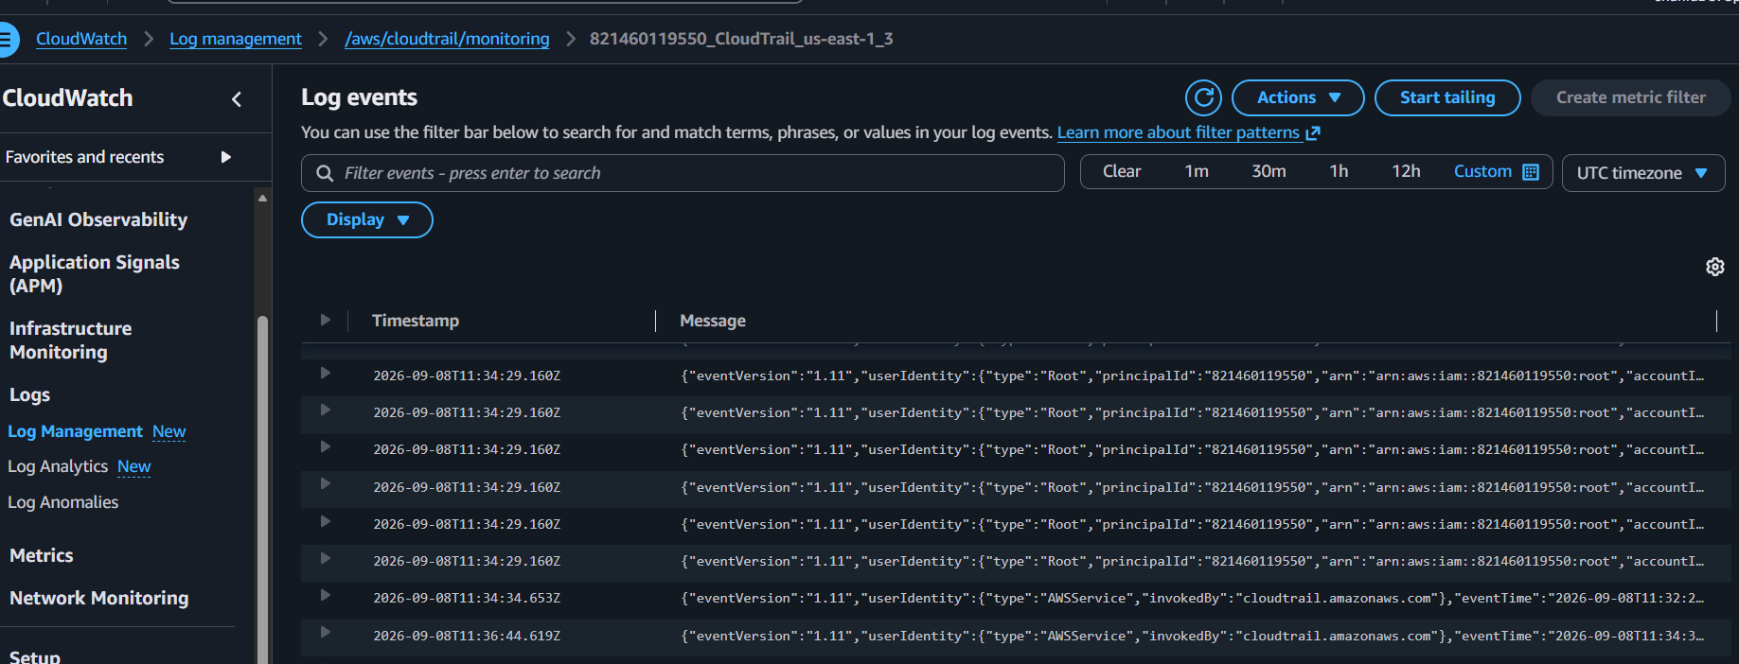

- Enable SNS for CloudTrail to send alerts via email.

Objective
Configure Amazon SNS to send email notifications for CloudTrail events.

Steps Performed
- Opened Amazon SNS in the AWS Management Console.
- Created an SNS Standard topic named:
cloudtrail-alert-topic
- Created an Email subscription for the SNS topic.
- Confirmed the email subscription.
- Opened Amazon CloudWatch → Log Management.
- Selected the CloudTrail log group:
/aws/cloudtrail/monitoring
- Created a metric filter with the following configuration:
  - Filter Name: ConsoleLoginFilter
  - Filter Pattern: { $.eventName = "ConsoleLogin" }
  - Metric Namespace: CloudTrailMonitoring
  - Metric Name: ConsoleLoginEvents
  - Metric Value: 1
- Created a CloudWatch Alarm using the custom metric.
- Configured the alarm condition:
  - Metric: ConsoleLoginEvents
  - Condition: Greater than or equal to 1
  - Period: 5 minutes
- Configured the alarm action to send a notification when the alarm enters the In Alarm state.
- Selected the existing SNS topic:
cloudtrail-alert-topic
- Created the alarm:
CloudTrail-ConsoleLogin-Alarm

Architecture Flow
CloudTrail Event
↓
CloudWatch Logs
↓
Metric Filter
↓
CloudWatch Custom Metric
↓
CloudWatch Alarm
↓
SNS Topic
↓
Email Alert

Evidence / Screenshots Required
- SNS Topic creation
- SNS Email Subscription showing Confirmed
- CloudTrail CloudWatch Log Group
- Metric Filter configuration
- Custom Metric: ConsoleLoginEvents
- CloudWatch Alarm: CloudTrail-ConsoleLogin-Alarm
- Alarm status showing Active

Result
Successfully configured Amazon SNS and CloudWatch Alarm integration to send email notifications based on CloudTrail events.

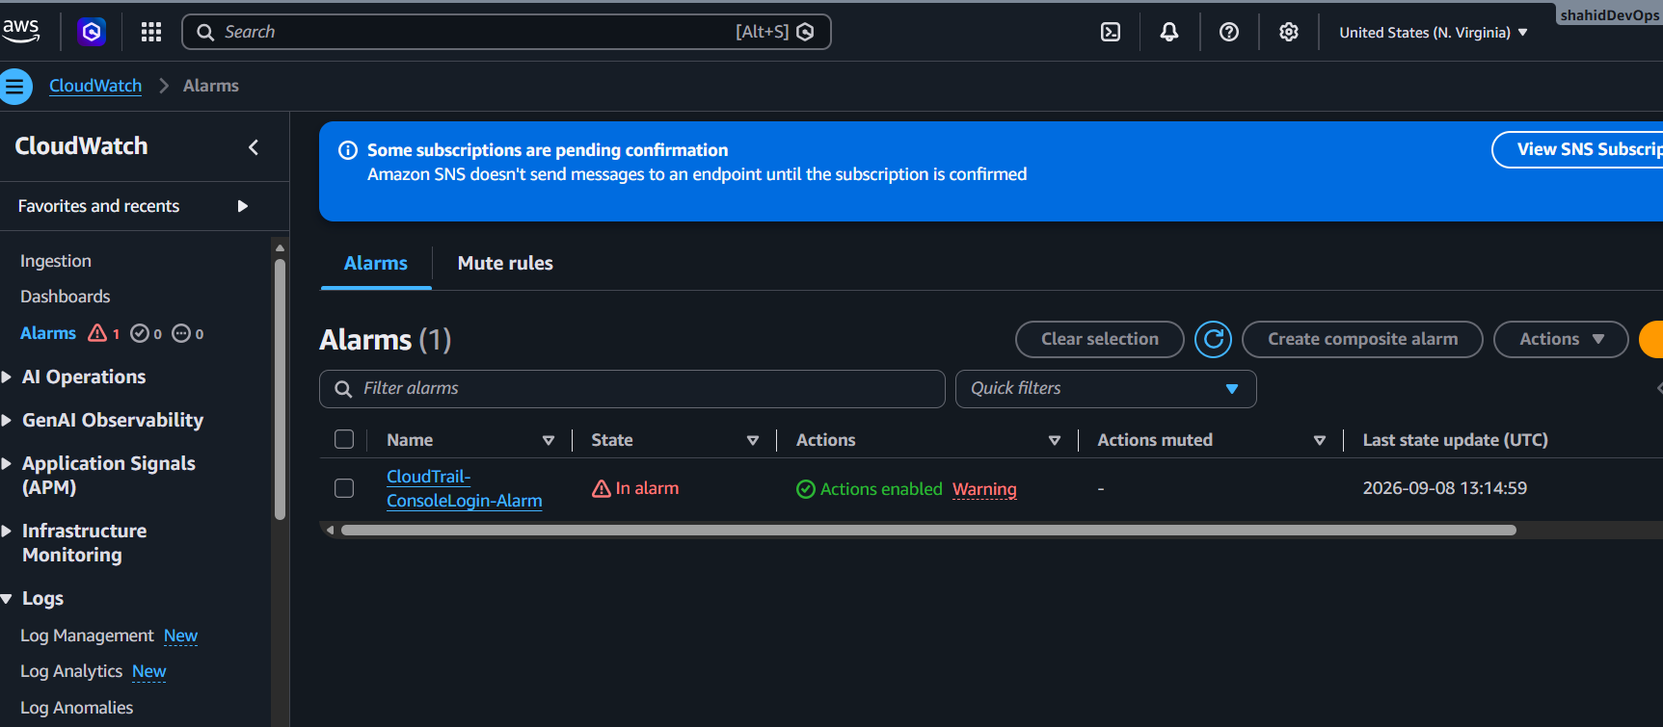
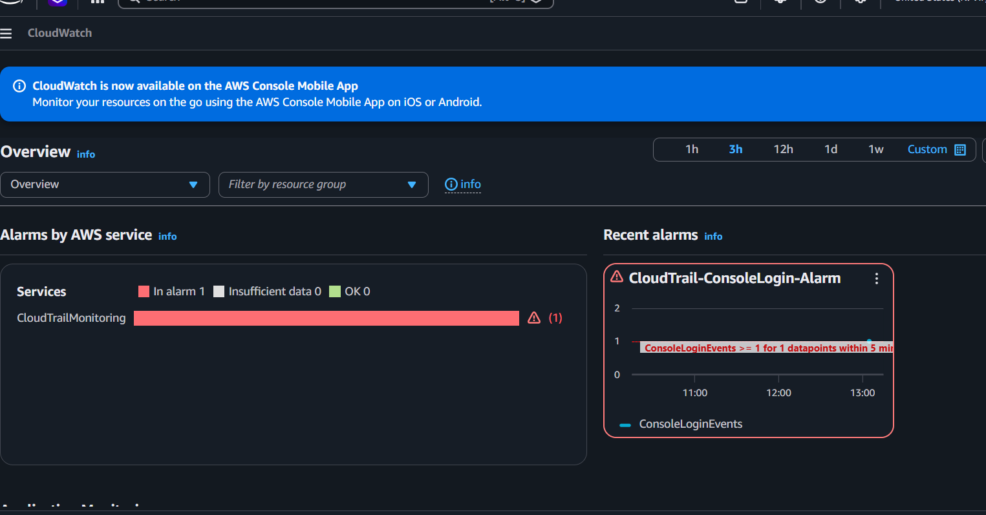
- Configure CloudWatch monitoring and record the CPU utilization and other metrics of EC2.

Objective
Configure and verify Amazon CloudWatch monitoring for an EC2 instance and record CPU utilization and other performance metrics.

EC2 Instance Details
- Instance ID: i-0a79d66900518a110
- Instance Name: Mumbai-EC2
- Region: ap-south-1 (Mumbai)

Steps Performed
- Logged in to the AWS Management Console.
- Opened the Amazon EC2 Console.
- Navigated to:
EC2 → Instances → i-0a79d66900518a110
- Opened the Monitoring tab.
- Verified that CloudWatch metrics were available for the EC2 instance.
- Monitored and recorded the following metrics:
  - CPU Utilization (%)
  - Network In (Bytes)
  - Network Out (Bytes)
  - Network Packets In (Count)
  - Network Packets Out (Count)
  - CPU Credit Usage
  - CPU Credit Balance
- Opened the detailed CPU Utilization metric graph.
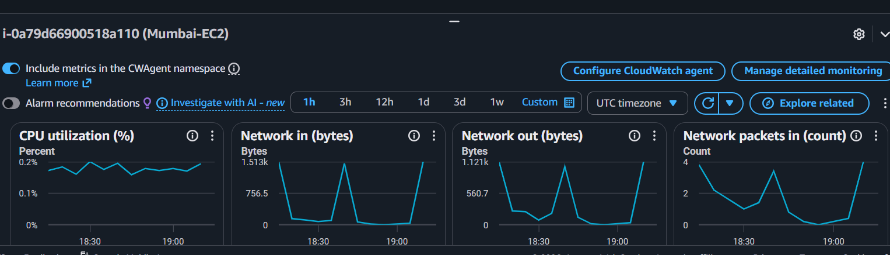

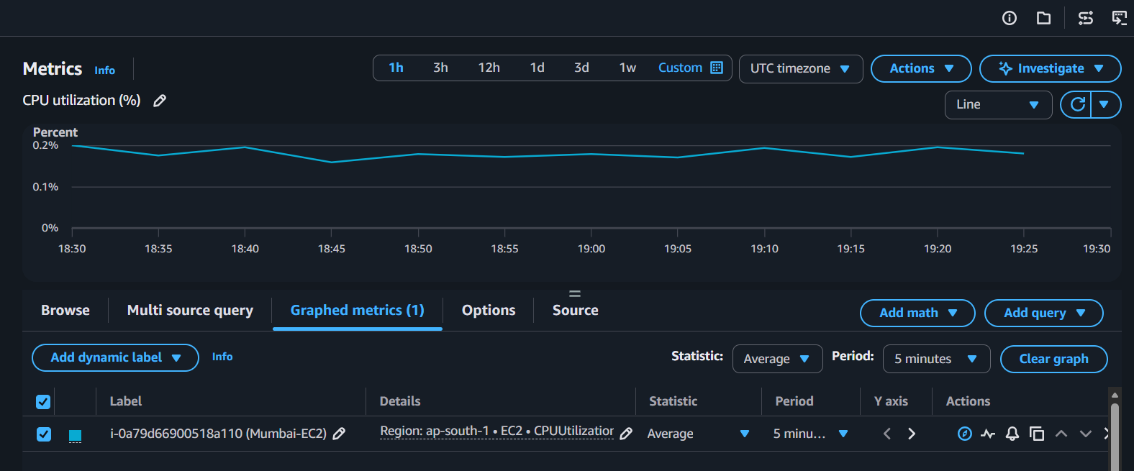
- Verified the metric configuration:
  - Statistic: Average
  - Period: 5 minutes
  - Unit: Percent
- Observed CPU utilization values approximately between 0.16% and 0.20%.
- Opened and verified the Network In metric.
- Recorded the Network In metric using:

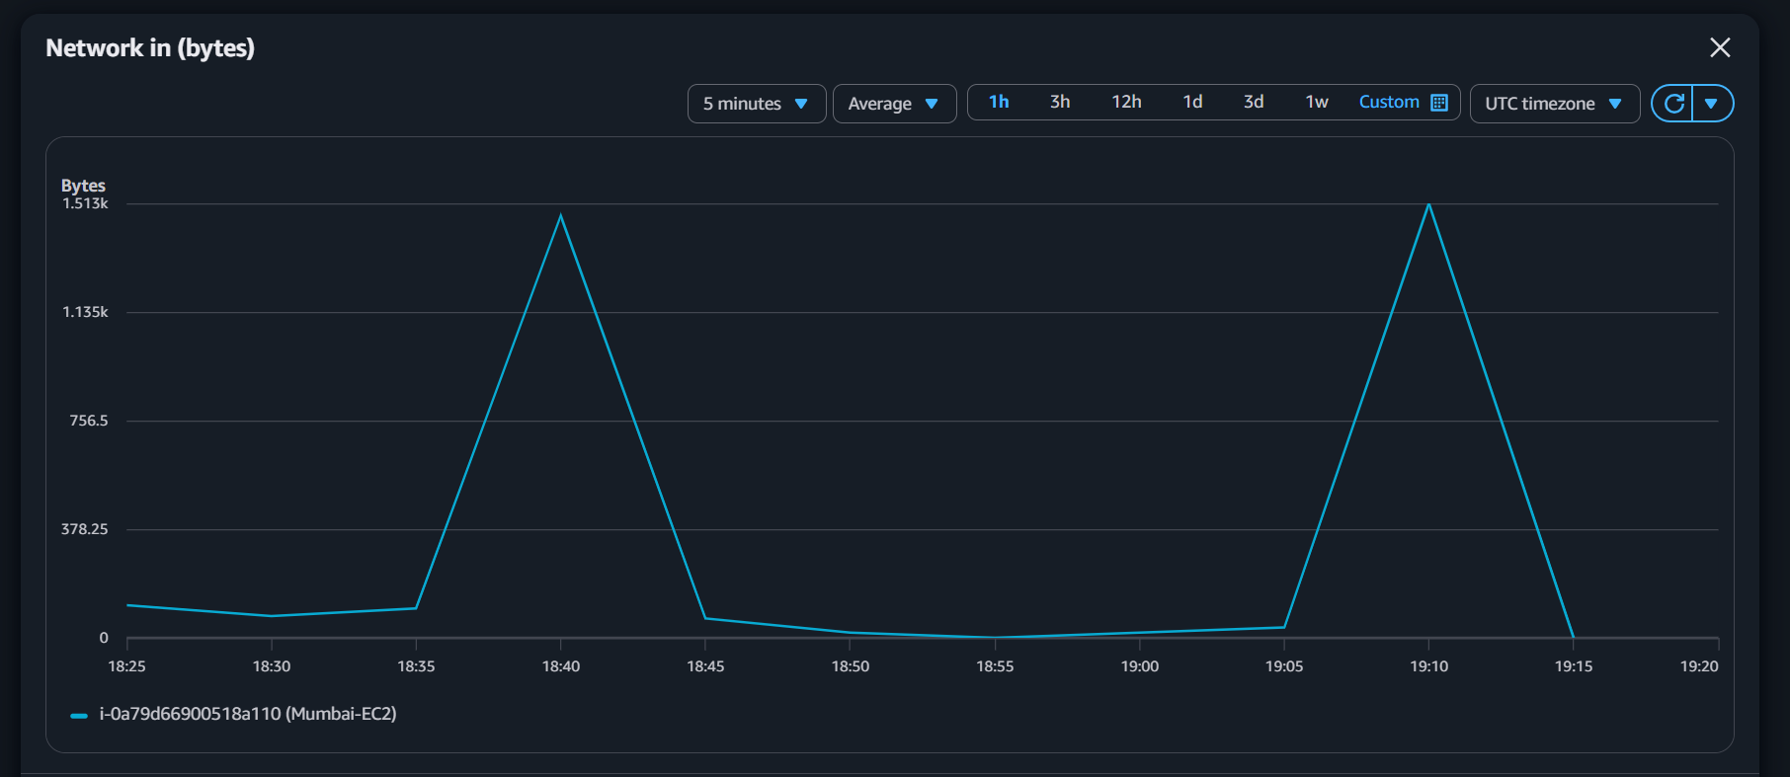
- Statistic: Average
- Period: 5 minutes
- Unit: Bytes

Result
Successfully verified Amazon CloudWatch monitoring for EC2 instance i-0a79d66900518a110. CPU Utilization and multiple network and CPU-related metrics were monitored and recorded.

- Create one alarm to send an alert to email if the CPU utilization is more than 70 percent.

Objective
Create an Amazon CloudWatch alarm to monitor EC2 CPU utilization and send an email notification when CPU utilization exceeds 70%.

EC2 Instance Details
- Instance ID: i-0a79d66900518a110
- Instance Name: Mumbai-EC2
- Region: ap-south-1 (Mumbai)

Steps Performed
- Opened the Amazon CloudWatch Console.
- Navigated to:
CloudWatch → Alarms → Create alarm
- Selected:
  - Data source: Metrics
  - Type: Classic
- Selected the EC2 metric:
  - Namespace: AWS/EC2
  - Metric name: CPUUtilization
  - Instance: Mumbai-EC2
- Configured:
  - Statistic: Average
  - Period: 5 minutes
- Set the alarm condition:
  - Threshold type: Static
  - Condition: Greater than (>)
  - Threshold: 70
- Configured the notification action:
  - Alarm state trigger: In alarm
  - SNS Topic: ec2-cpu-alert-topic
  - Email endpoint: shahidnj435@gmail.com
- Added alarm details:
  - Alarm name: EC2-CPU-Utilization-Above-70
  - Description: Sends an email alert when CPU utilization exceeds 70%.
- Created the CloudWatch alarm successfully.

Alarm Configuration
Setting | Value
Metric | CPUUtilization
Namespace | AWS/EC2
Instance | Mumbai-EC2
Statistic | Average
Period | 5 minutes
Condition | Greater than 70%
SNS Topic | ec2-cpu-alert-topic
Notification | Email
Alarm Name | EC2-CPU-Utilization-Above-70

Current Observation
- Current CPU Utilization: Approximately 0.16%
- Alarm Threshold: 70%
- Current State: Insufficient data (newly created alarm/evaluating metrics)

Result
Successfully created a CloudWatch alarm to monitor EC2 CPU utilization. The alarm is configured to send an email notification when the CPU utilization of Mumbai-EC2 exceeds 70%.

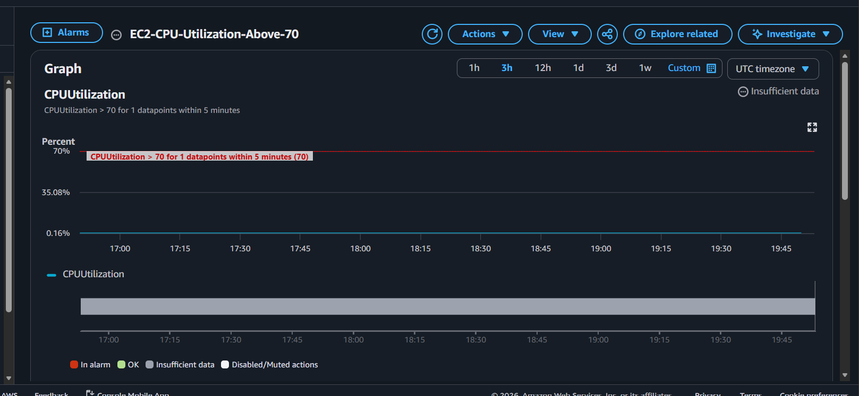

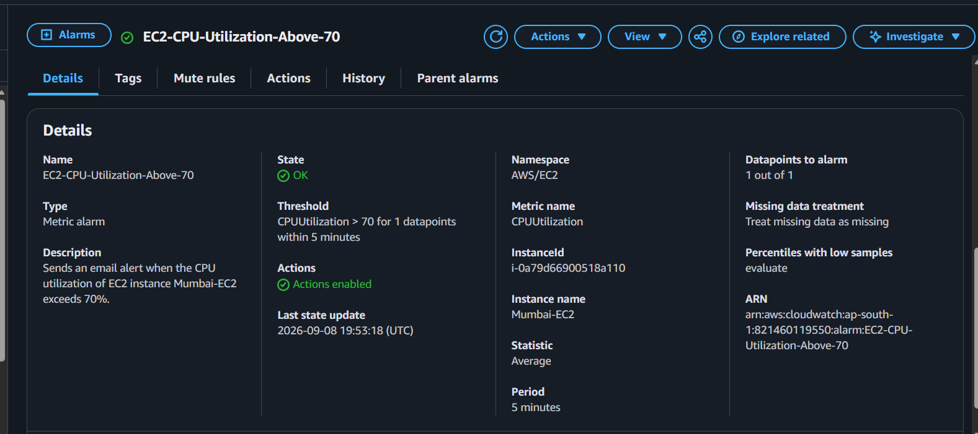

- Create a Dashboard and monitor the Tomcat service whether it is running or not and send the alert.

Objective
Monitor the Apache Tomcat service running on an EC2 instance and publish its status as a custom CloudWatch metric.

1. Tomcat Installation and Verification
Installed Apache Tomcat on the EC2 instance.
Verified Java:
java -version
Started Tomcat:
sudo /opt/tomcat/bin/startup.sh
Verified the Tomcat process:
ps -ef | grep -i tomcat
Tomcat was successfully running.
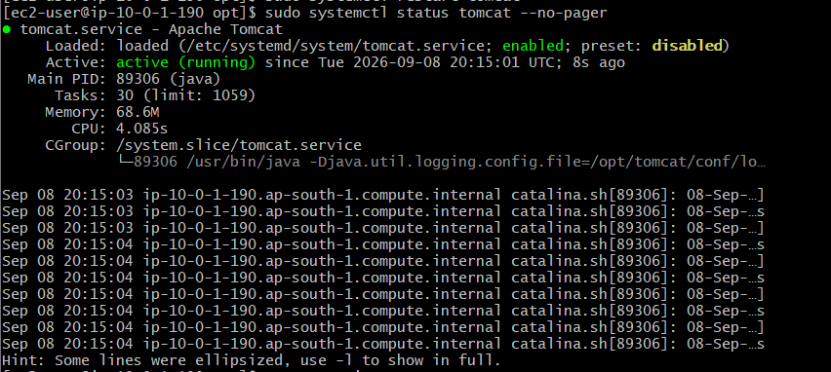

2. IAM Role for CloudWatch
Attached an IAM role to the EC2 instance:
EC2-CloudWatch-Monitoring-Role
Verified credentials using:
aws sts get-caller-identity
The output showed an assumed role, confirming the EC2 instance could use AWS permissions without access keys.
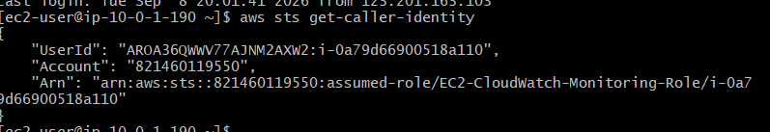

3. Custom CloudWatch Metric
Created a custom metric:
Namespace: ServiceMonitoring
Metric Name: TomcatStatus
The metric represents:
1 → Tomcat is running
0 → Tomcat is stopped
The metric was successfully published to CloudWatch.
Verified it under:
CloudWatch
→ Metrics
→ ServiceMonitoring
→ Metrics with no dimensions
→ TomcatStatus
CloudWatch showed:
TomcatStatus = 1
This confirms that Tomcat was running when the metric was published.
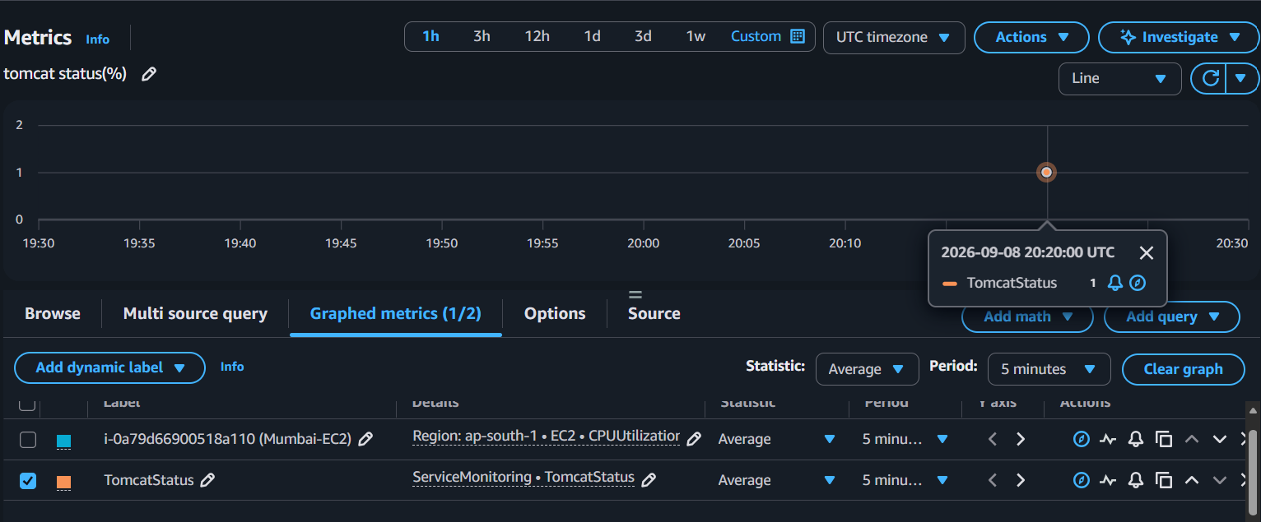

4. CloudWatch Dashboard
Created a dashboard:
EC2-Tomcat-Monitoring-Dashboard
Added the custom metric:
TomcatStatus
Initially, it appeared as a line graph.
Changed the widget visualization to:
Single Value
The dashboard now displays:

1

Result
TomcatStatus = 1
Meaning:
Tomcat service is RUNNING.

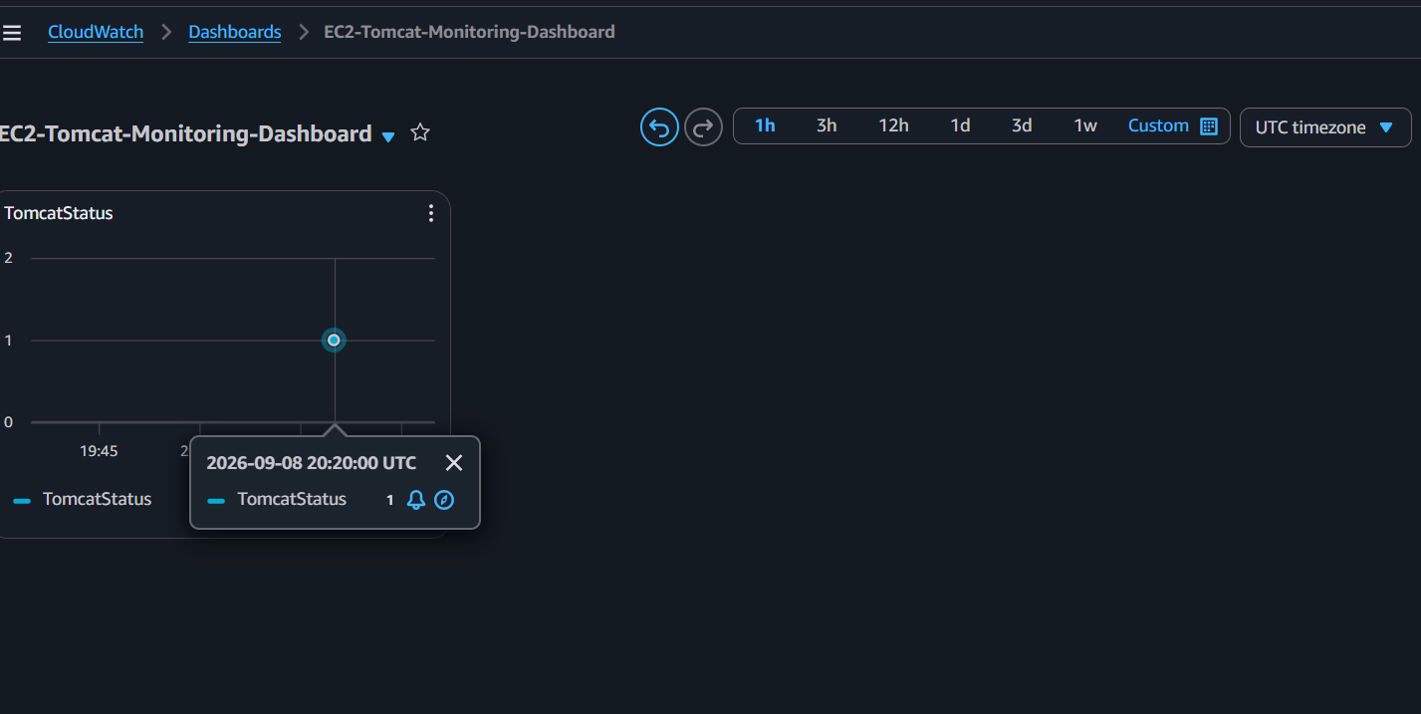

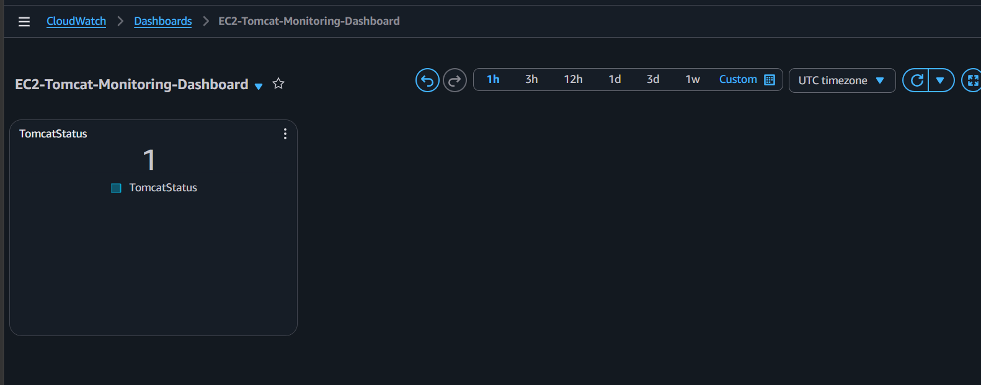

Final Outcome
Successfully implemented:
✅ Tomcat service monitoring
✅ Custom CloudWatch metric
✅ IAM role authentication
✅ TomcatStatus metric publishing
✅ CloudWatch metric verification
✅ CloudWatch Dashboard
✅ Single-value service status display

- Create a Dashboard and monitor the Nginx service to send the alert if Nginx is not running.

Objective
Monitor the Nginx service on EC2 using a custom CloudWatch metric and send an email alert if Nginx is not running.

Implementation Steps
1. Install and start Nginx
sudo dnf install nginx -y
sudo systemctl start nginx
sudo systemctl enable nginx
systemctl is-active nginx
2. Create the monitoring script
sudo nano /usr/local/bin/check-nginx.sh
#!/bin/bash

if systemctl is-active --quiet nginx; then
STATUS=1
else
STATUS=0
fi

aws cloudwatch put-metric-data \
--namespace ServiceMonitoring \
--metric-name NginxStatus \
--value $STATUS \
--region ap-south-1
3. Make the script executable and run it
sudo chmod +x /usr/local/bin/check-nginx.sh
sudo /usr/local/bin/check-nginx.sh
4. Verify in CloudWatch
CloudWatch → Metrics → ServiceMonitoring → NginxStatus
- 1 = Nginx running
- 0 = Nginx not running
5. Create Dashboard
Add NginxStatus to the CloudWatch Dashboard using a Number/Single Value widget.
6. Create Alarm
- Alarm name: EC2-Nginx-Not-Running-Alert
- Condition: NginxStatus <= 0
- Configure SNS email notification.

Result
Nginx monitoring was successfully configured, and the email alert was received. Task completed.

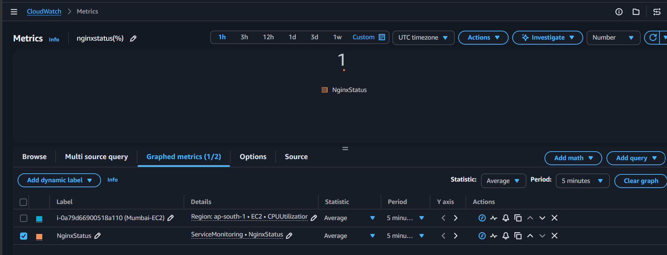

When running:

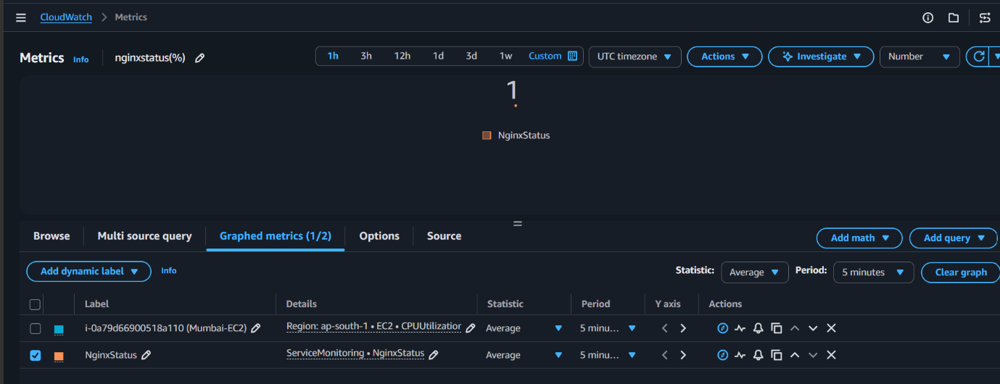

Stopped :
