Jenkins article tasks 3rd page

Tag: Jenkins Pipeline
>> Running Stages in Parallel With Jenkins Workflow / Pipeline

Task 21 — Running Stages in Parallel with Jenkins Pipeline

1. Objective
The objective of this task was to learn how to run multiple Jenkins Pipeline stages in parallel using the parallel directive.
Running independent stages in parallel can reduce the overall pipeline execution time.

2. Jenkins Job
Job Name:
jenkins-practice-21
Job Type:
Pipeline
We used Pipeline script directly in Jenkins. No GitHub repository was required for this practical.

3. Pipeline Used
pipeline {
agent any

stages {

stage('Build') {
steps {
echo 'Building the application'
}
}

stage('Test') {
parallel {

stage('Unit Tests') {
steps {
sleep 5
echo 'Running unit tests'
}
}

stage('Integration Tests') {
steps {
echo 'Running integration tests'
}
}
}
}

stage('Deploy') {
steps {
echo 'Deploying the application'
}
}
}
}

4. Pipeline Execution Flow
The pipeline executes in this order:
Build
|
v
Test
├── Unit Tests
│
└── Integration Tests
|
v
Deploy
The Build stage runs first.
After Build completes, the Test stage starts.
Inside Test, the following two stages run in parallel:
Unit Tests
Integration Tests
After both parallel stages complete, Jenkins proceeds to:
Deploy

5. Parallel Block
The main concept learned in this task is:
parallel {
stage('Unit Tests') {
steps {
...
}
}

stage('Integration Tests') {
steps {
...
}
}
}
The parallel directive tells Jenkins that the stages inside the block can execute simultaneously.
The stages don't have to finish in a particular order.
For example:
Unit Tests Integration Tests
| |
|---- running --------|
| |
↓ ↓
5 sec done
|
└────── Both complete ──────→ Deploy

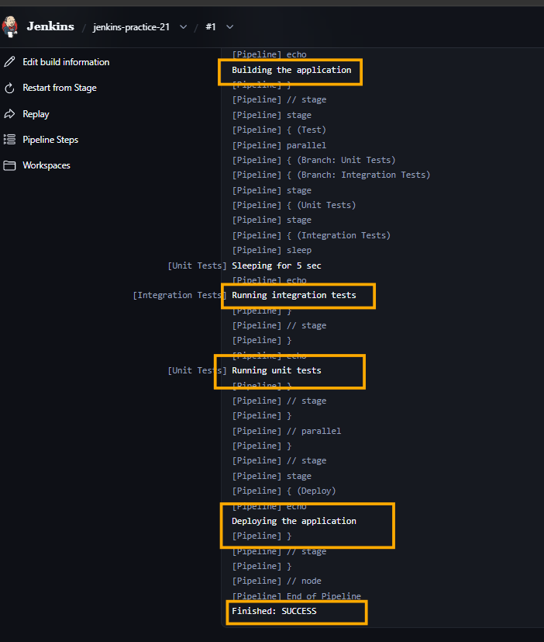

6. Why We Used sleep 5
In the Unit Tests stage, we used:
sleep 5
This was only to make the parallel execution clearly visible.
Without the delay, both stages would execute so quickly that it would be difficult to observe their parallel behavior.
It is not required in a real application pipeline.

7. Jenkins Stage View Result
Our Stage View showed:
Stage | Execution Time
Build | 161 ms
Test | 110 ms
Unit Tests | 5 sec
Integration Tests | 161 ms
Deploy | 71 ms
Total | ~8 sec
The important observation was that Unit Tests and Integration Tests appeared as separate stages under the Test stage and were executed in parallel.
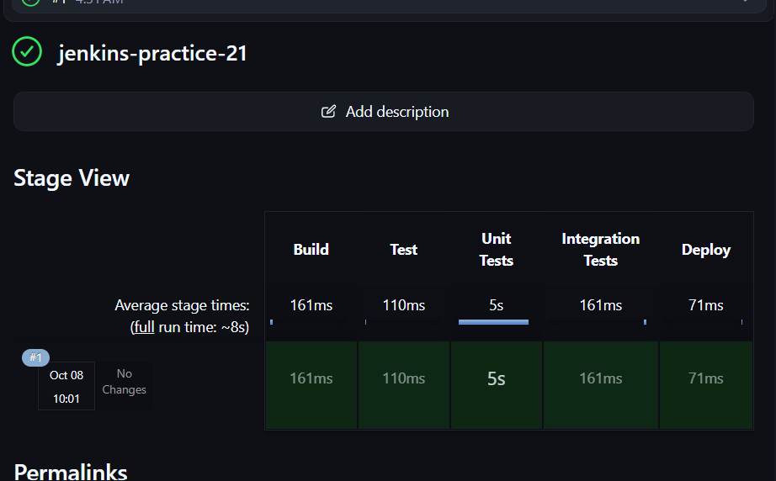

8. Sequential vs Parallel

Sequential
stage('Test') {
steps {
...
}
}

stage('Integration Test') {
steps {
...
}
}
They execute one after another:
Test
↓
Integration Test

Parallel
stage('Test') {
parallel {
stage('Unit Tests') {
...
}

stage('Integration Tests') {
...
}
}
}
They execute simultaneously:
┌─ Unit Tests ─┐
Test ──┤ ├── Deploy
└─ Integration ┘

9. When to Use Parallel Stages
Parallel execution is useful when stages are independent of each other.
For example:
┌── Unit Tests ──────┐
│ │
Build ───────┼── Integration Test ├── Deploy
│ │
└── Security Test ──┘
All three tests can potentially run at the same time.
But if one stage depends on the output of another, they should generally remain sequential.

10. Important Interview Point
Q: What is the purpose of parallel in Jenkins Pipeline?
Answer:
The parallel directive allows multiple independent stages to execute simultaneously instead of waiting for one stage to finish before starting another. This can reduce the overall pipeline execution time.
Q: When should we use parallel stages?
Answer:
We should use parallel stages when the tasks are independent and don't depend on each other's output.
Q: Does Deploy start immediately when one parallel stage finishes?
Answer:
No. Jenkins waits for all parallel branches to complete before proceeding to the next stage, unless the pipeline is specifically configured otherwise.

11. What We Actually Implemented
Jenkins Pipeline
↓
Build
↓
Test
┌───────────────┐
↓ ↓
Unit Tests Integration Tests
└───────┬───────┘
↓
Deploy

Final Result
Task 21 successfully completed.
The main practical concept to remember is:
parallel allows independent Jenkins Pipeline stages to execute simultaneously, reducing overall pipeline execution time.

__________________________________________________________________________
>> Get the Output of a Shell Command in a Jenkins Pipeline

Task 22 — Get the Output of a Shell Command in Jenkins Pipeline

1. Objective
To learn how to:
- Capture shell command output using returnStdout
- Store shell output in a variable
- Capture command exit status using returnStatus
- Remove unnecessary whitespace using trim()
- Use shell command substitution
- Use the captured values in Jenkins Pipeline logic

2. Jenkins Job
Job Name:
jenkins-practice-22
Job Type:
Pipeline
We used Pipeline script directly in Jenkins.

3. Check 1 — Capture pwd Output

Script used
pipeline {
agent any

stages {
stage('Capture Output') {
steps {
script {
def output = sh(
returnStdout: true,
script: 'pwd'
).trim()

echo "Current Directory: ${output}"
}
}
}
}
}

What we checked
pwd
The output of pwd was captured into the output variable.

Important point
returnStdout: true
allows Jenkins to return the shell command's standard output so that we can store it in a variable.
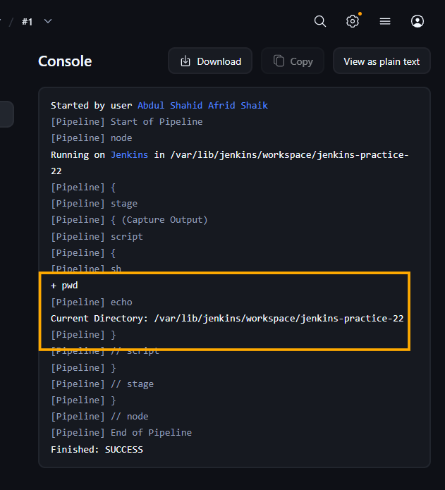

4. Check 2 — Capture ls Output

Script used
pipeline {
agent any

stages {
stage('Capture Shell Output') {
steps {
script {
def files = sh(
returnStdout: true,
script: 'ls'
).trim()

echo "Files in workspace:"
echo files
}
}
}
}
}

What we checked
ls
The output was stored in:
files
and then printed using:
echo files

Flow
ls
↓
returnStdout
↓
files variable
↓
Echo

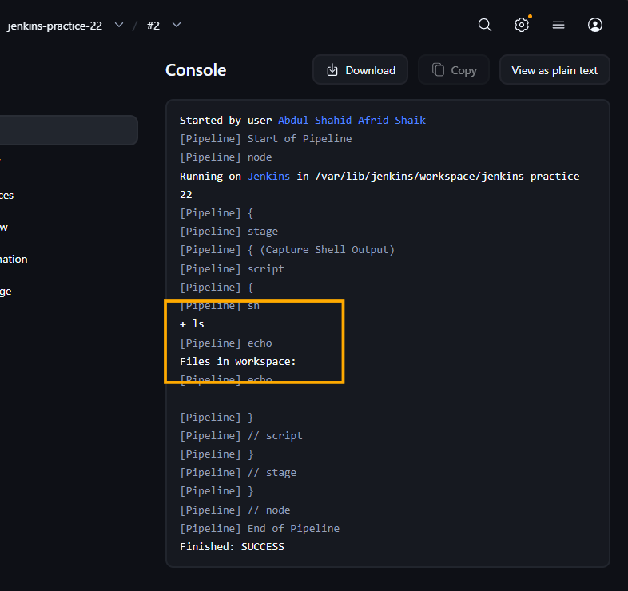

5. Check 3 — returnStatus

Script used
pipeline {
agent any

stages {
stage('Check Command Status') {
steps {
script {
def status = sh(
returnStatus: true,
script: 'ls /test'
)

if (status != 0) {
echo "Command failed with status: ${status}"
} else {
echo "Command executed successfully"
}
}
}
}
}
}

What we checked
ls /test
The /test directory doesn't exist, so the command returned a non-zero exit status.
We captured that status using:
returnStatus: true
Then checked it using:
if (status != 0)

Important point
0 → Success
Non-zero → Failure
returnStatus allows us to handle the command result ourselves instead of immediately failing the Pipeline.
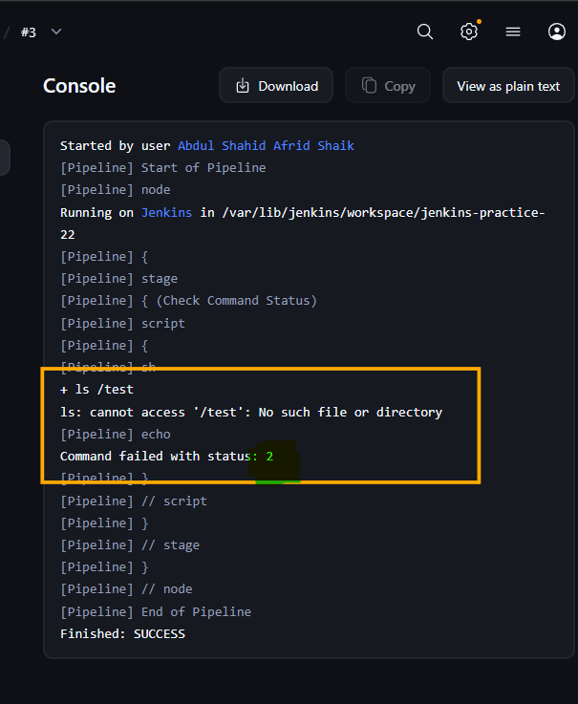

6. Check 4 — trim()

Script used
pipeline {
agent any

stages {
stage('Trim Output') {
steps {
script {
def output = sh(
returnStdout: true,
script: 'echo " hello "'
).trim()

echo "Output: '${output}'"
}
}
}
}
}

What we checked
The shell command produced whitespace around:
hello
Using:
.trim()
removed the leading and trailing whitespace/newline.
Expected output:
Output: 'hello'

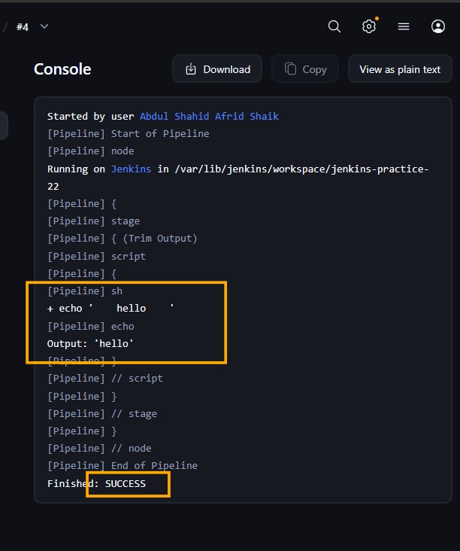

7. Check 5 — Command Substitution

Script used
pipeline {
agent any

stages {
stage('Command Substitution') {
steps {
script {
def output = sh(
script: 'echo $(ls)',
returnStdout: true
).trim()

echo "Output:"
echo output
}
}
}
}
}

What we checked
The shell uses:
$(ls)
This executes:
ls
and inserts its output into:
echo
The final result is captured by Jenkins using:
returnStdout: true

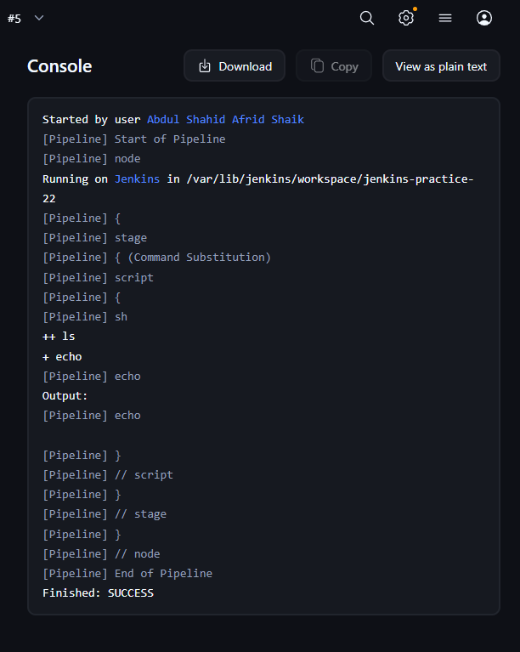

8. Final Combined Pipeline
After checking each concept individually, we tested the complete Pipeline.

Final script used
pipeline {
agent any

stages {

stage('Capture Output') {
steps {
script {
def output = sh(
returnStdout: true,
script: 'pwd'
).trim()

echo "Current Directory: ${output}"
}
}
}

stage('Capture Files') {
steps {
script {
def files = sh(
returnStdout: true,
script: 'ls'
).trim()

echo "Files:"
echo files
}
}
}

stage('Check Status') {
steps {
script {
def status = sh(
returnStatus: true,
script: 'ls /test'
)

if (status != 0) {
echo "Command failed with status: ${status}"
} else {
echo "Command executed successfully"
}
}
}
}

stage('Trim Output') {
steps {
script {
def output = sh(
returnStdout: true,
script: 'echo " hello "'
).trim()

echo "Output: '${output}'"
}
}
}
}
}

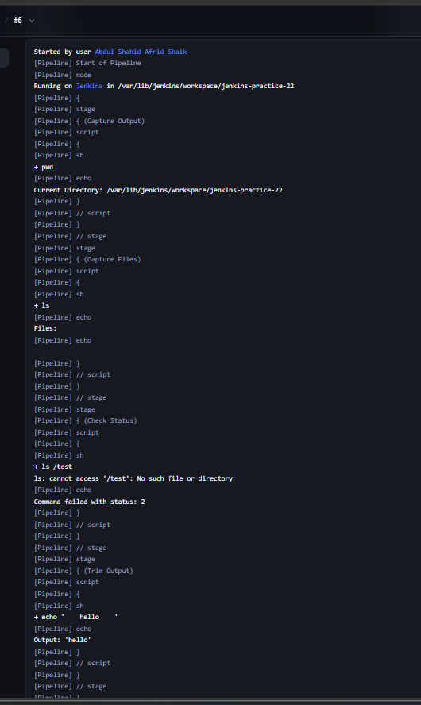

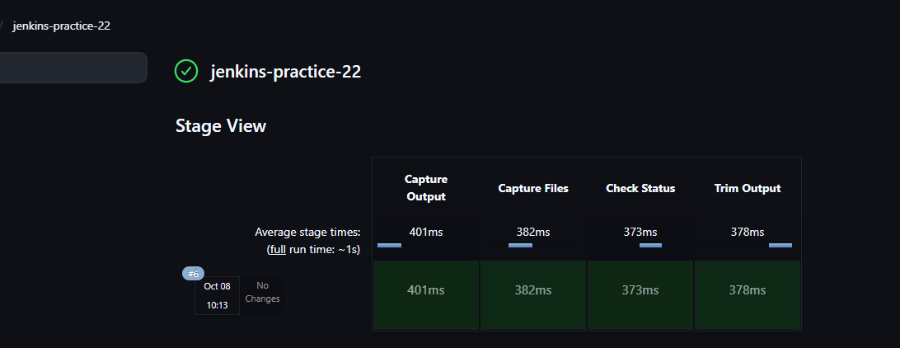

9. Important Jenkins Concepts

returnStdout
Captures the standard output of a shell command.
def output = sh(
returnStdout: true,
script: 'pwd'
).trim()

returnStatus
Captures the exit status of a shell command.
def status = sh(
returnStatus: true,
script: 'ls /test'
)

trim()
Removes leading/trailing whitespace and newline characters.
def output = sh(
returnStdout: true,
script: 'pwd'
).trim()

script
Allows us to use Groovy logic inside a Declarative Pipeline.
For example:
script {
def status = sh(...)

if (status != 0) {
echo "Command failed"
}
}

10. Interview Questions

What is returnStdout?
It captures the standard output of a shell command and returns it so the value can be stored in a Pipeline variable.

What is returnStatus?
It returns the exit status of the shell command instead of its output.

What does exit status 0 mean?
The command executed successfully.

What does a non-zero exit status mean?
The command failed or encountered an error.

Why use trim() with returnStdout?
Shell output often contains a trailing newline or unwanted whitespace. trim() removes it.

What is command substitution?
$(command) executes a shell command and substitutes its output into another command.

Which method is simpler for capturing output?
returnStdout: true is generally cleaner and easier to understand than command substitution.

11. Task 22 Summary
sh
│
├── returnStdout → Capture command output
│
├── returnStatus → Capture command exit status
│
└── trim() → Remove extra whitespace
We tested every concept individually and then tested the final combined Pipeline successfully.

________________________________________________________________
>> Jenkins Pipeline – Change to Another Folder

Task 23 — Jenkins Pipeline: Change to Another Folder

1. Objective
The objective of this task was to learn how to change the working directory in a Jenkins Pipeline.
We learned two methods:
- Jenkins dir step
- Shell cd command using the sh step
We also verified how the working directory behaves before, inside, and after a dir block.

2. Jenkins Job
Job Name:
jenkins-practice-23
Job Type:
Pipeline
We used Pipeline script directly in Jenkins.

3. Part 1 — Create scripts Directory
Before testing directory changes, we created a scripts directory inside the Jenkins workspace.

Script used
pipeline {
agent any

stages {
stage('Create Directory') {
steps {
sh 'mkdir -p scripts'
echo 'scripts directory created'
}
}
}
}
The command:
mkdir -p scripts
creates the scripts directory inside the current Jenkins workspace.
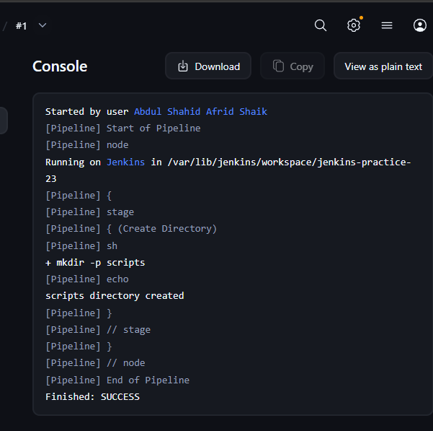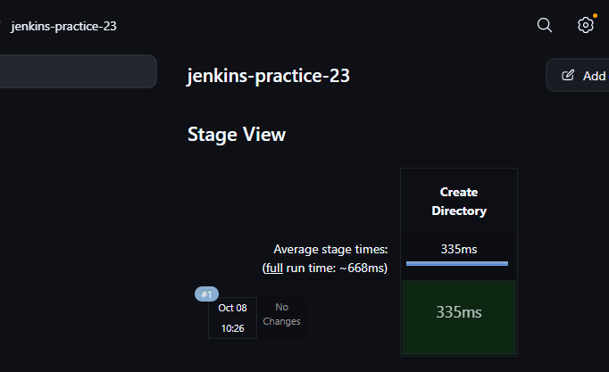

4. Part 2 — Using the dir Step
The Jenkins dir step changes the working directory for the commands inside its block.

Script used
pipeline {
agent any

stages {
stage('Change Directory') {
steps {
dir('scripts') {
sh 'pwd'
}
}
}
}
}

Important syntax
dir('scripts') {
// commands
}
The commands inside the block execute from the scripts directory.
For example:
Jenkins workspace
↓
scripts/
↓
pwd / ls / commands
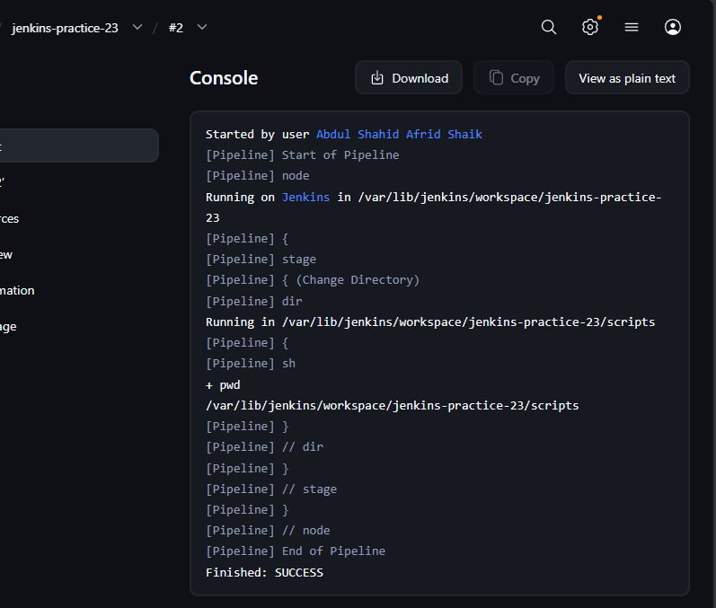

5. Part 3 — Verify Directory Before, Inside and After dir
The article explains that once the dir block ends, Jenkins returns to the previous working directory.
We verified this practically.

Script used
pipeline {
agent any

stages {
stage('Directory Test') {
steps {

echo 'Before dir:'
sh 'pwd'

dir('scripts') {
echo 'Inside dir:'
sh 'pwd'
}

echo 'After dir:'
sh 'pwd'
}
}
}
}

Expected behavior
Before dir:
.../jenkins-practice-23

Inside dir:
.../jenkins-practice-23/scripts

After dir:
.../jenkins-practice-23

Conclusion
dir() changes the working directory only for the duration of its block.
After the block finishes, Jenkins returns to the previous directory.

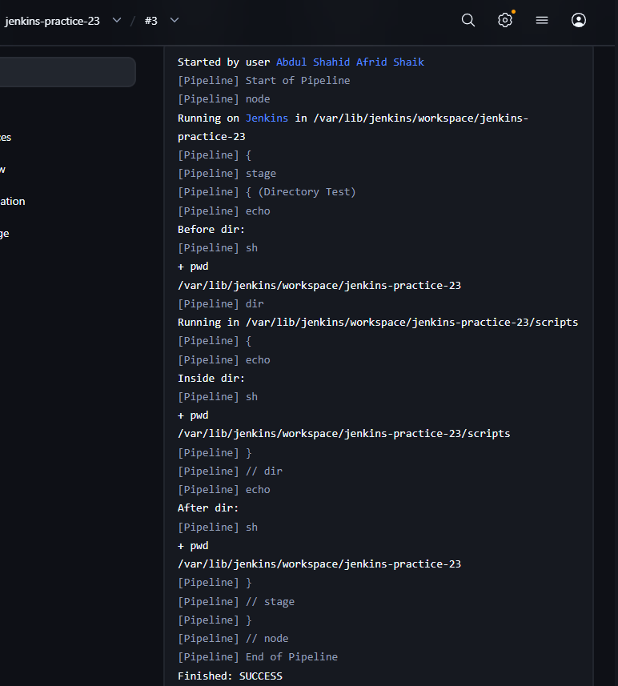

6. Part 4 — Run Multiple Commands Inside dir
We also verified that multiple commands can be executed inside the same dir block.

Script used
pipeline {
agent any

stages {
stage('Run Commands in Directory') {
steps {
dir('scripts') {
sh 'pwd'
sh 'touch test.txt'
sh 'ls'
}
}
}
}
}

Commands executed
pwd
touch test.txt
ls
The test.txt file was created inside the scripts directory.
This demonstrates that all commands inside the dir block operate from that directory.
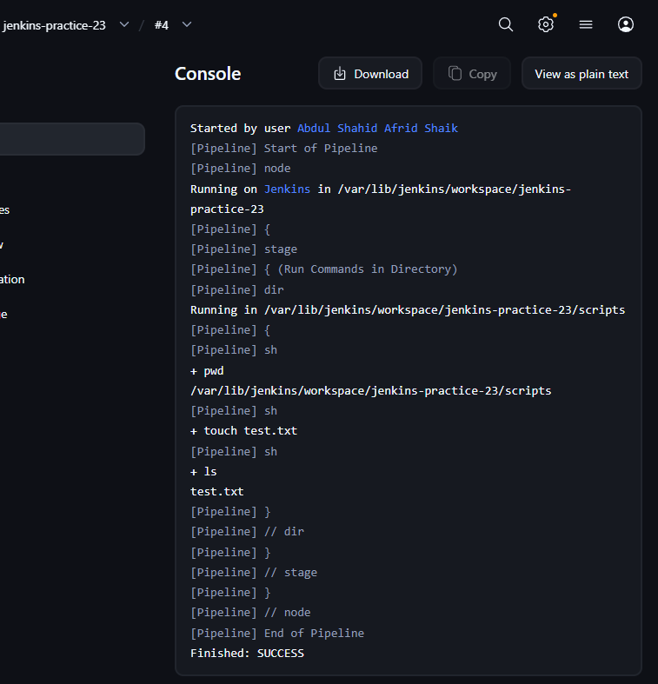

7. Part 5 — Using an Absolute Path
The article also explains that dir() can use an absolute path.
We first checked the Jenkins workspace path.

Script used
pipeline {
agent any

stages {
stage('Find Workspace') {
steps {
sh 'pwd'
}
}
}
}
Our Jenkins workspace path was:
/var/lib/jenkins/workspace/jenkins-practice-23
Important: Your actual path may differ on another Jenkins installation.

Absolute path test
Because our absolute workspace path ends at:
/var/lib/jenkins/workspace/jenkins-practice-23
we used that path directly.

Script used
pipeline {
agent any

stages {
stage('Absolute Path') {
steps {
dir('/var/lib/jenkins/workspace/jenkins-practice-23') {
sh 'pwd'
sh 'ls'
}
}
}
}
}
The pwd output confirmed that Jenkins changed to the specified absolute directory.

Important
The article gives an example such as:
/var/jenkins_home/workspace/SamplePipeline/scripts
but we did not blindly use that path because it does not match our Jenkins environment.
Our actual absolute path was:
/var/lib/jenkins/workspace/jenkins-practice-23
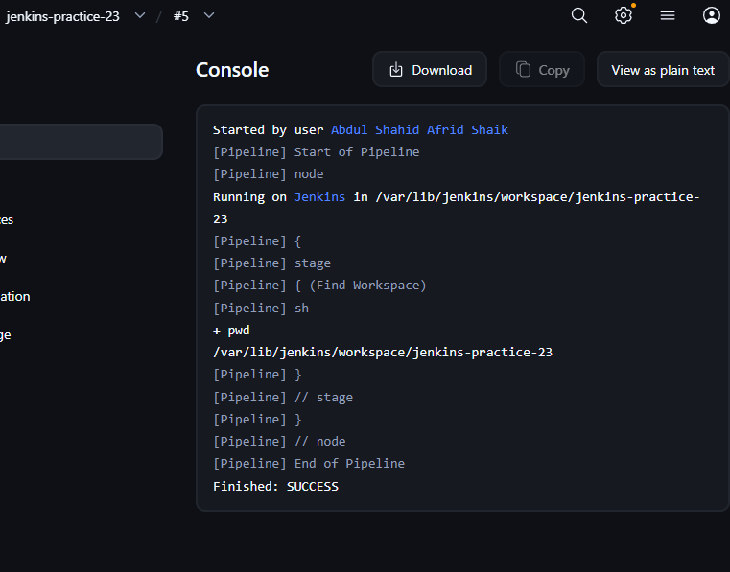

8. Part 6 — Using sh with cd
The second method from the article is using the Linux cd command inside an sh step.

Script used
pipeline {
agent any

stages {
stage('Change Directory Using CD') {
steps {
sh '''
cd scripts

echo "Current directory:"
pwd

echo "Files:"
ls
'''
}
}
}
}
Here:
cd scripts
changes the directory for the commands running in that shell.
The following commands:
pwd
ls
therefore execute inside scripts.

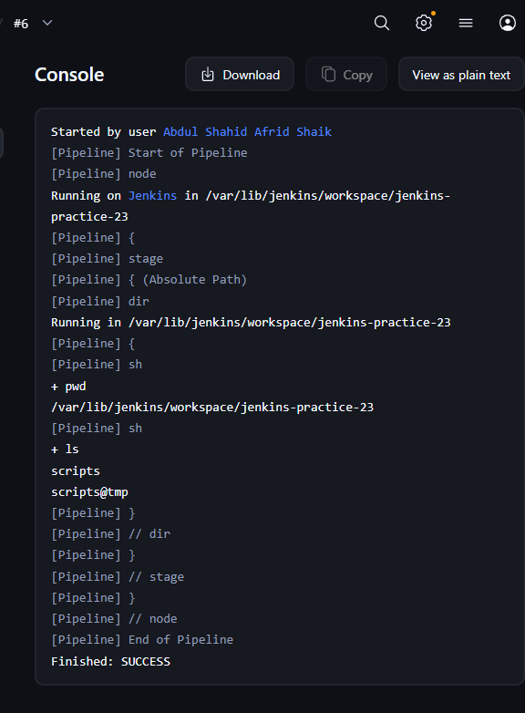

9. Part 7 — Verify cd Scope
We tested an important difference between cd and dir.

Script used
pipeline {
agent any

stages {
stage('Test CD Scope') {
steps {
sh 'cd scripts && pwd'

echo 'After the first sh step:'

sh 'pwd'
}
}
}
}

Result
The first sh command showed:
.../jenkins-practice-23/scripts

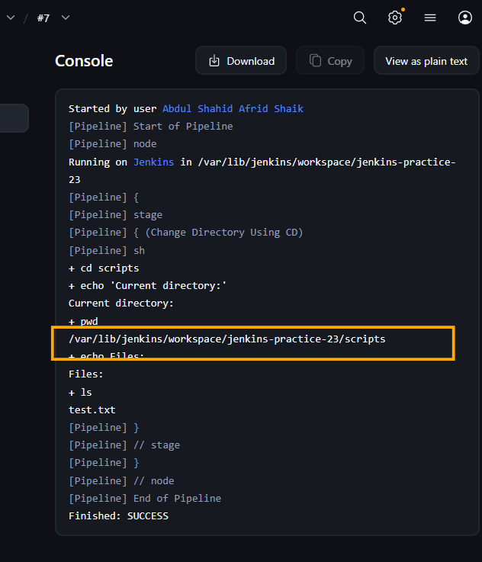
But the second sh command returned to:
.../jenkins-practice-23

Why?
Each sh step runs in its own shell process.
Therefore:
sh 'cd scripts'
does not permanently change the working directory for subsequent sh steps.

10. dir vs cd

Using dir
dir('scripts') {
sh 'pwd'
sh 'ls'
}
dir changes the Jenkins working directory for the entire block.

Using cd
sh '''
cd scripts
pwd
ls
'''
cd changes the directory only within that shell execution.

Main Difference
dir()
│
├── Command 1
├── Command 2
└── Command 3
│
└── Returns to previous directory
Whereas:
sh
│
├── cd scripts
├── Command 1
└── Command 2

Next sh → starts from original workspace
For Jenkins Pipeline code, dir() is generally the cleaner Jenkins-specific approach when multiple Pipeline steps need to run in another directory.

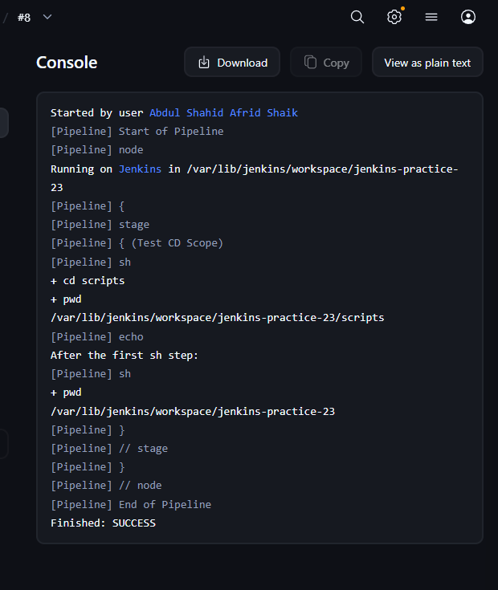

11. Part 8 — Final Combined Pipeline
After testing all the concepts individually, we ran the final combined Pipeline.

Final script used
pipeline {
agent any

stages {

stage('Create Directory') {
steps {
sh 'mkdir -p scripts'
}
}

stage('Using dir Step') {
steps {
echo 'Before dir:'
sh 'pwd'

dir('scripts') {
echo 'Inside dir:'
sh 'pwd'

sh 'touch test.txt'

echo 'Files inside scripts:'
sh 'ls'
}

echo 'After dir:'
sh 'pwd'
}
}

stage('Using cd') {
steps {
sh '''
cd scripts

echo "Inside scripts using cd:"
pwd

echo "Files:"
ls
'''
}
}
}
}

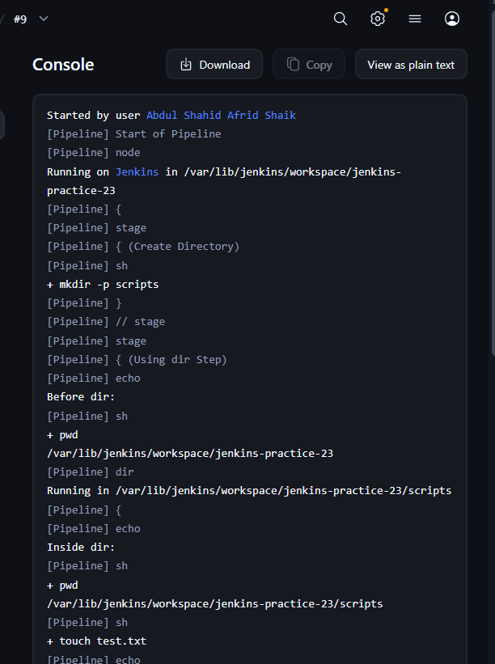
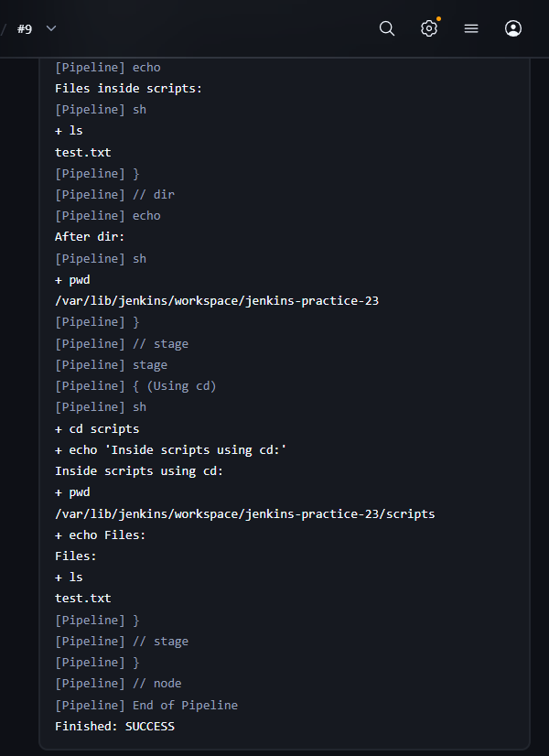

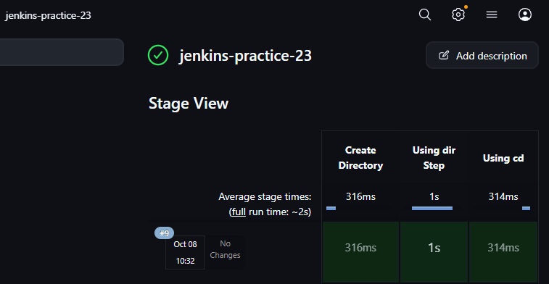

12. Execution Flow
Create Directory
↓
Original Workspace
↓
dir('scripts')
↓
scripts directory
↓
Create / view test.txt
↓
Return to original workspace
↓
sh + cd scripts
↓
scripts directory

13. Important Interview Questions

What is the dir step in Jenkins?
dir is a Jenkins Pipeline step used to change the working directory for the duration of a block.

What happens after a dir block finishes?
Jenkins returns to the previous working directory.

Can dir use an absolute path?
Yes. dir() can use either a relative path or an absolute path.
Example:
dir('/var/lib/jenkins/workspace/jenkins-practice-23') {
sh 'pwd'
}

Can we use Linux cd in Jenkins Pipeline?
Yes. We can use cd inside an sh step.
sh '''
cd scripts
pwd
'''

Does cd persist between separate sh steps?
No. Each sh step runs in its own shell environment.

Which approach is cleaner for Jenkins Pipeline?
dir() is generally cleaner when multiple Jenkins Pipeline steps need to execute in another directory.

14. Key Takeaways
dir('folder') { ... }
→ Changes Jenkins working directory for the block.
cd folder
→ Changes directory within that shell execution.
pwd
→ Shows the current working directory.
ls
→ Lists files/directories.
mkdir -p scripts
→ Creates the directory used in our practical.

Most important concept
dir() provides scoped directory changes in Jenkins Pipeline, while cd only applies to the shell session in which it is executed.

__________________________________________________________________
>> Fixing the “No Such DSL method” Error in Jenkins Pipeline

Task 24 — Fixing the “No Such DSL Method” Error in Jenkins Pipeline

1. Objective
The objective of this task was to understand the Jenkins Pipeline error:
No such DSL method
We learned how to identify an unrecognized Pipeline method, reproduce the error, correct it, and understand the common reasons behind it.

2. Jenkins Job
Job Name:
jenkins-practice-24
Job Type:
Pipeline
We used Pipeline script directly in Jenkins.

3. Check 1 — Reproduce the Error
The article demonstrates the error using an incorrect Maven Pipeline step:
mvn 'clean instal'
We tested the concept using the same approach.

Script used
pipeline {
agent any

stages {
stage('Build') {
steps {
mvn 'clean instal'
}
}
}
}

Result
Jenkins produced a No Such DSL method error because mvn was not recognized as a valid Pipeline step in our Jenkins setup.
Example:
No such DSL method 'mvn'

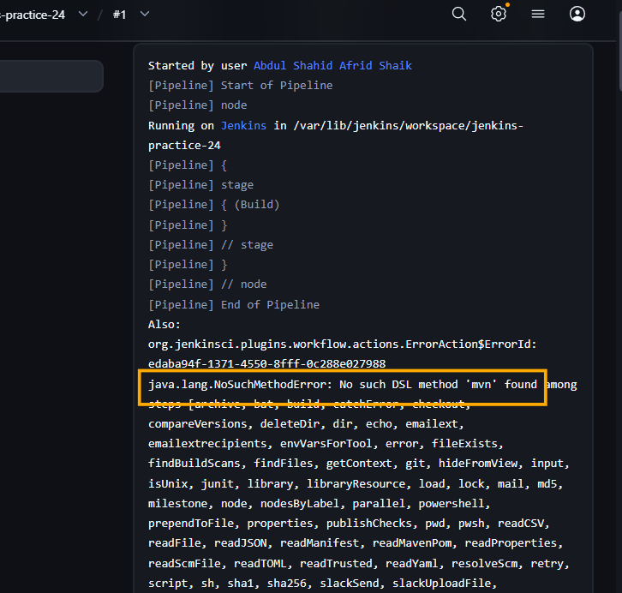

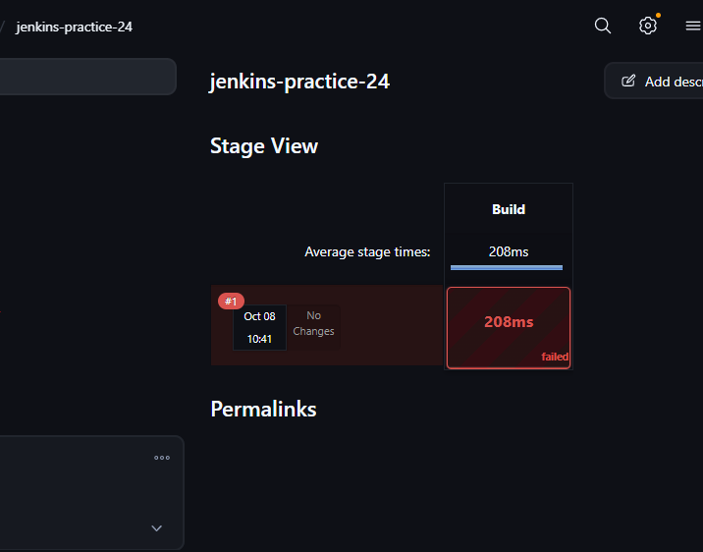

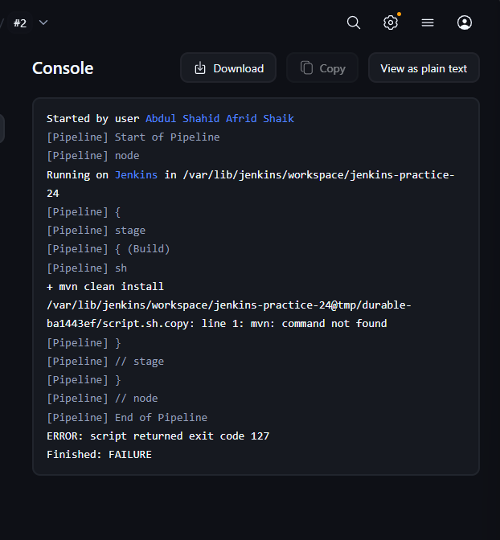

Important observation
There are actually two things in the article's example:
mvn
clean instal
instal is a typo for:
install
But mvn itself is also not a standard Pipeline step in our setup.
Therefore, we did not blindly treat the article's example as a perfect copy-paste solution.

4. Check 2 — Correct Maven Approach
We tested the normal shell-based approach for running Maven.

Script used
pipeline {
agent any

stages {
stage('Build') {
steps {
sh 'mvn clean install'
}
}
}
}
Here Maven is executed as a Linux shell command through Jenkins' sh step.
The important difference is:
mvn 'clean install'
versus:
sh 'mvn clean install'
The second one executes Maven through the shell.

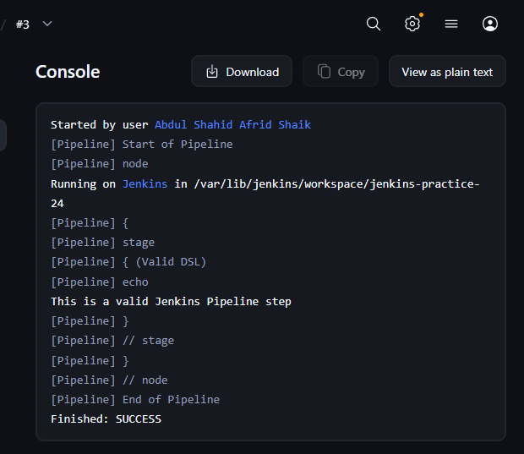

5. Check 3 — Valid Jenkins DSL Method
To clearly understand the error, we tested a valid built-in Pipeline step.

Script used
pipeline {
agent any

stages {
stage('Valid DSL') {
steps {
echo 'This is a valid Jenkins Pipeline step'
}
}
}
}

Result
The Pipeline executed successfully.
Console output:
This is a valid Jenkins Pipeline step
This confirmed that echo is recognized by Jenkins.

6. Check 4 — Intentionally Invalid DSL Method
We then created a deliberately invalid Pipeline method.

Script used
pipeline {
agent any

stages {
stage('Invalid DSL') {
steps {
myInvalidStep 'hello'
}
}
}
}

Result
Jenkins reported an error similar to:
No such DSL method 'myInvalidStep'
This directly demonstrated the error discussed in the article.

Why did it happen?
Because:
myInvalidStep
is not a recognized Jenkins Pipeline DSL step.
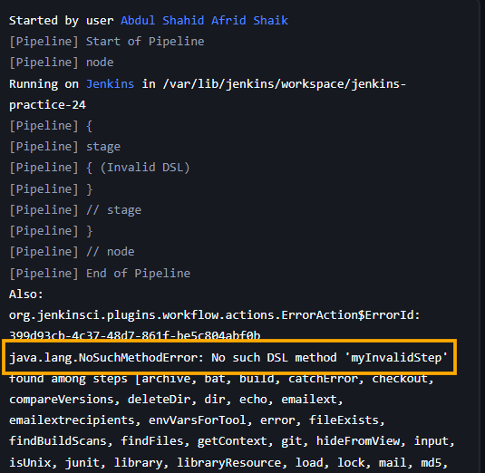

7. Check 5 — Fix the Invalid DSL
We replaced the invalid method with the valid echo step.

Script used
pipeline {
agent any

stages {
stage('Fixed DSL') {
steps {
echo 'DSL method fixed successfully'
}
}
}
}

Result
The Pipeline executed successfully:
DSL method fixed successfully
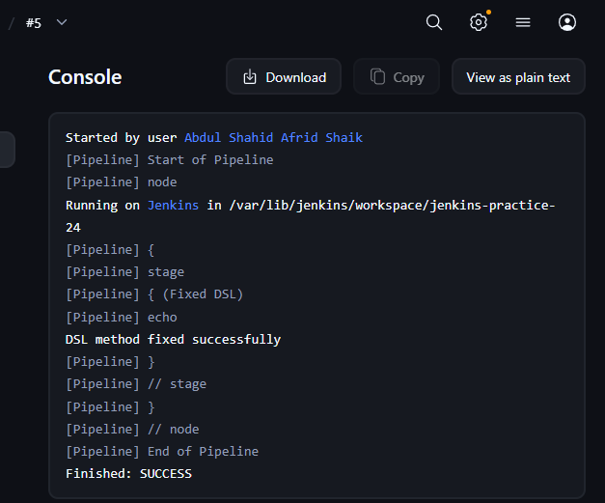

This demonstrated the basic troubleshooting process:
Invalid DSL method
↓
No such DSL method
↓
Check method name
↓
Replace with valid DSL
↓
Pipeline succeeds

8. Check 6 — Plugin/Dependency Reason
The article explains that some Jenkins Pipeline methods are provided by plugins.
If Jenkins doesn't recognize a method, one possible reason is that the required plugin is missing.
Examples of Pipeline-related plugins include:
Pipeline
Pipeline: Basic Steps
Pipeline: Groovy
Pipeline: Stage Step
We did not uninstall or install plugins for this task because there was no need to modify our working Jenkins installation.
The important concept is:
If a Pipeline step comes from a plugin and that plugin isn't available, Jenkins may report a No such DSL method error.

9. Check 7 — Check Spelling and Syntax
Another important cause is a typo.
For example, this is incorrect:
ech 'hello'
The correct syntax is:
echo 'hello'
Similarly, an unknown method such as:
myInvalidStep 'hello'
will result in:
No such DSL method
Therefore, the first thing to check is the method name and syntax.

10. Final Pipeline
After testing the individual cases, we ran the final Pipeline.

Final script used
pipeline {
agent any

stages {

stage('Valid DSL') {
steps {
echo 'Pipeline DSL is working'
}
}

stage('Build') {
steps {
sh 'echo "Build stage executed successfully"'
}
}

stage('Check') {
steps {
sh 'echo "Checking Pipeline syntax and commands"'
}
}
}
}

Result
All stages completed successfully.
Valid DSL
↓
Build
↓
Check
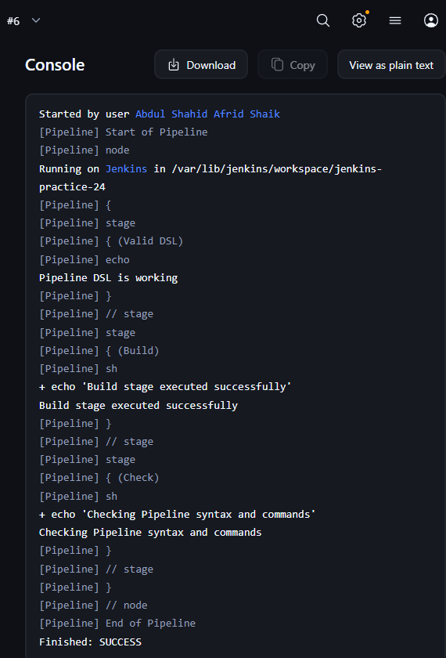

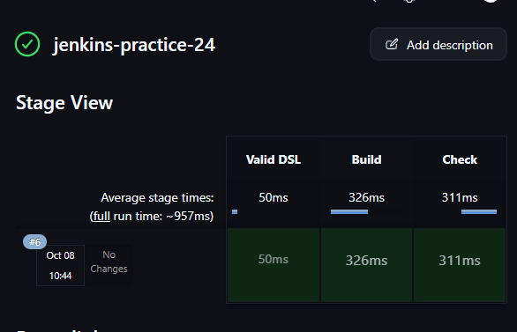

11. Common Causes of No Such DSL Method
The article identifies several possible causes.

1. Typo
Example:
ech 'hello'
instead of:
echo 'hello'

2. Invalid/Unknown Pipeline Step
Example:
myInvalidStep 'hello'
Jenkins doesn't know this method.

3. Missing Plugin
Some Pipeline steps depend on Jenkins plugins.
If the required plugin isn't installed or available, the step may not be recognized.

4. Outdated Jenkins Version
Older Jenkins versions may not support newer Pipeline functionality.
Updating Jenkins can provide newer Pipeline features and fixes.

5. Outdated Pipeline Syntax
An older Jenkinsfile may contain syntax that is no longer supported or recommended.
The Pipeline should be updated to the currently supported syntax.

12. Important Troubleshooting Process
When you see:
No such DSL method 'methodName'
check in this order:
1. Check spelling
↓
2. Check Pipeline syntax
↓
3. Confirm it is a valid Pipeline step
↓
4. Check whether a plugin is required
↓
5. Check whether the plugin is installed
↓
6. Check Jenkins/Pipeline version
↓
7. Check for outdated syntax

13. Important Difference — DSL Error vs Shell Error
This is important for Jenkins troubleshooting.

DSL error
myInvalidStep 'hello'
Jenkins doesn't recognize the Pipeline method.
Result:
No such DSL method

Shell command error
sh 'mvn clean install'
If Maven isn't installed, you could get:
mvn: command not found
That is not a DSL error.
The sh step itself is valid; the command executed inside the shell failed.

14. Interview Questions

What does "No such DSL method" mean?
It means Jenkins does not recognize the Pipeline method or syntax used in the Jenkinsfile.

What are the common causes?
Typos, invalid Pipeline syntax, missing plugins/dependencies, outdated Jenkins versions, or outdated Pipeline syntax.

How do you troubleshoot it?
First check spelling and syntax, then verify that the method is a valid Pipeline step and check whether the required plugin is installed.

Is mvn a standard Pipeline step?
Not in our setup. Maven can be executed through the shell using:
sh 'mvn clean install'
or through Jenkins' configured Maven tool mechanisms.

What is the difference between a DSL error and a shell error?
A DSL error occurs when Jenkins cannot recognize a Pipeline step. A shell error occurs when a valid sh step executes a command that fails.

15. Key Takeaway
The main lesson from Task 24 is:
No Such DSL Method
↓
Jenkins doesn't recognize the Pipeline step
↓
Check spelling + syntax
↓
Check valid DSL/plugin
↓
Correct the Jenkinsfile
The practical example we verified was:
myInvalidStep 'hello'
❌ Invalid
and:
echo 'DSL method fixed successfully'
✅ Valid

_________________________________________________________________
>> Trigger Another Job from a Jenkins Pipeline

Task 25 — Trigger Another Job from a Jenkins Pipeline

Objective
To trigger one Jenkins job from another Jenkins Pipeline job using the Jenkins build step.

Jobs Created
- Child Job: jenkins-practice-25-child
- Parent Job: jenkins-practice-25

1. Create the Child Job
Created a Freestyle project:
jenkins-practice-25-child

Build Step
Selected:
Build Steps → Execute shell
Used:
echo "Child job executed successfully"

Purpose
This job represents the child job that will be triggered by the Pipeline.

2. Create the Parent Pipeline Job
Created a Pipeline job:
jenkins-practice-25
Initially verified that the Pipeline job itself executes correctly.

Basic Pipeline
pipeline {
agent any

stages {
stage('Build') {
steps {
echo 'Parent job executed'
}
}
}
}
This confirmed that the parent Pipeline was working before adding the child-job trigger.
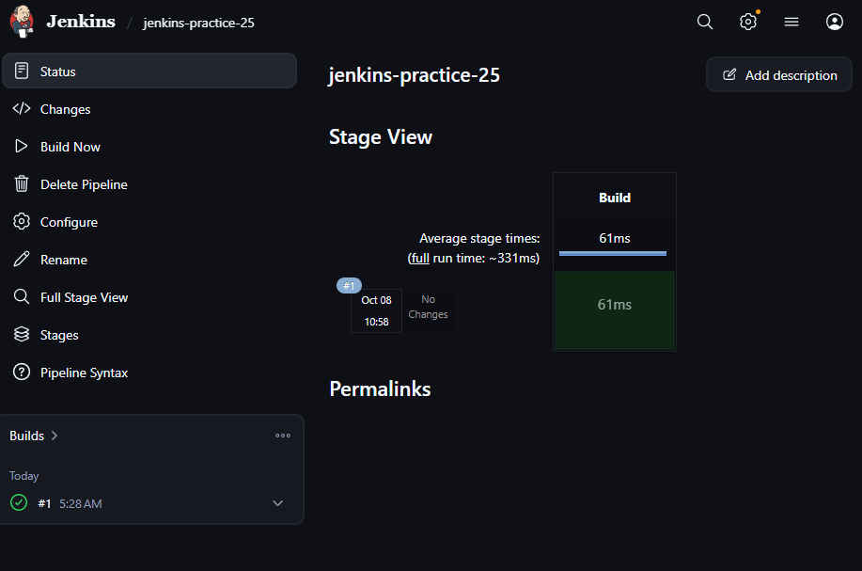

3. Trigger the Child Job
Added a second stage to the parent Pipeline.

Pipeline Used
pipeline {
agent any

stages {

stage('Build') {
steps {
echo 'Parent job executed'
}
}

stage('Trigger Child Job') {
steps {
build job: 'jenkins-practice-25-child', wait: true
}
}
}
}

Important Line
build job: 'jenkins-practice-25-child', wait: true
This triggers the Jenkins job:
jenkins-practice-25-child
from the parent Pipeline.
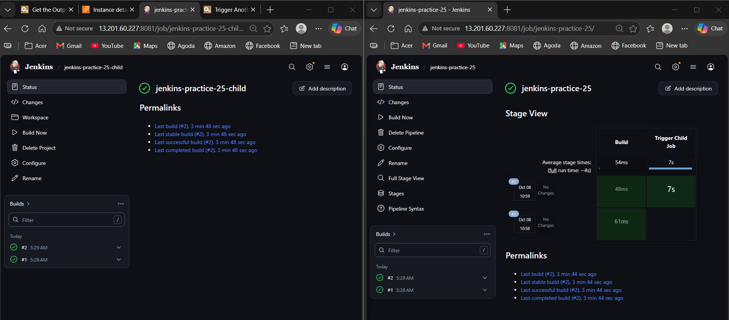

4. Verify wait: true
To verify that the parent waits for the child job to finish, the child job was temporarily changed to:
echo "Child job started"
sleep 5
echo "Child job completed"
The parent Pipeline was changed to:
pipeline {
agent any

stages {

stage('Build') {
steps {
echo 'Parent job started'
}
}

stage('Trigger Child Job') {
steps {
echo 'Triggering child job...'

build job: 'jenkins-practice-25-child', wait: true

echo 'Child job completed'
}
}

stage('After Child') {
steps {
echo 'Parent continues after child job'
}
}
}
}

Result
The execution order was:
Parent job started
↓
Triggering child job
↓
Child job started
↓
5-second wait
↓
Child job completed
↓
Parent continues after child job
This verified that wait: true makes the parent Pipeline wait until the child job completes.
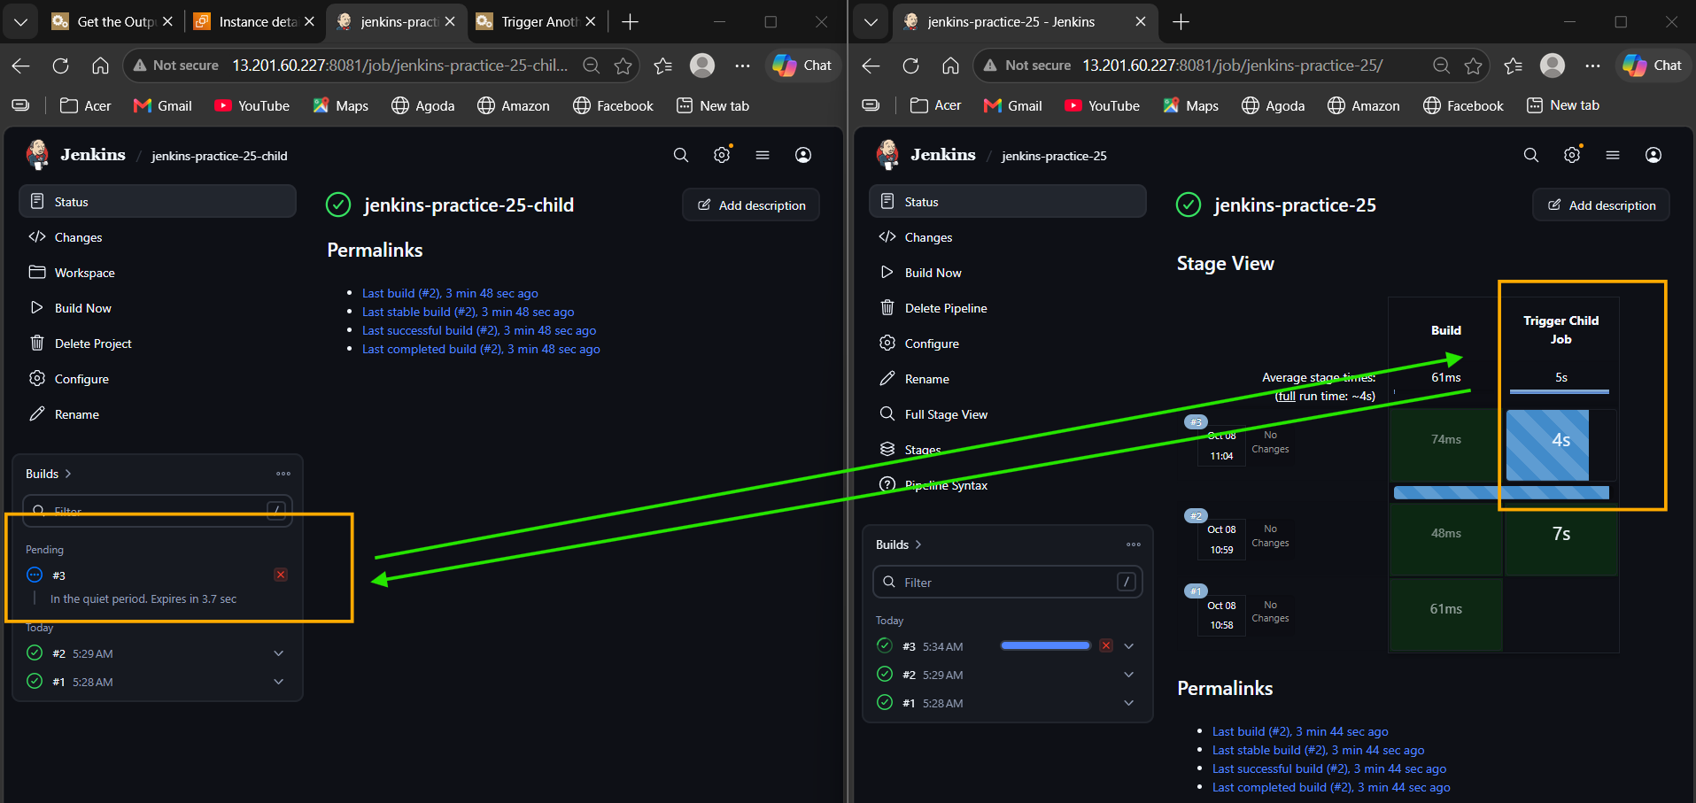

Key Concepts

build Step
The Jenkins Pipeline build step is used to trigger another Jenkins job.
build job: 'jenkins-practice-25-child'

wait: true
build job: 'jenkins-practice-25-child', wait: true
The parent Pipeline waits for the child job to finish before continuing.

wait: false
build job: 'jenkins-practice-25-child', wait: false
The parent triggers the child job but does not wait for it to finish.
We only understood this behavior; no separate practical implementation was required.

Final Takeaway
A Jenkins Pipeline can trigger another Jenkins job using the build step.
build job: 'jenkins-practice-25-child', wait: true
With wait: true, the parent Pipeline waits for the child job to complete before moving to the next stage.

_________________________________________________________________________________
>> How to Inject Git Secrets in Jenkins

Task 26 — Jenkins Credentials / Secret Injection

Objective
To understand how Jenkins securely stores sensitive information in Jenkins Credentials and injects it into a Pipeline without exposing the actual secret in the build console.

1. Create Pipeline Job
Created a Pipeline job:
jenkins-practice-26
Path:
Jenkins Dashboard → New Item → Pipeline → OK

2. Create Secret Text Credential
Navigated to:
Manage Jenkins → Credentials → System → Global credentials → Add Credentials
Configured:
Kind: Secret text
Secret: MySecret123
ID: git-secret
Description: Git Secret
The important part is the credential ID:
git-secret
The actual secret is stored securely inside Jenkins rather than directly inside the Pipeline script.

3. Inject Credential into Pipeline
Used the Jenkins credentials() function:
pipeline {
agent any

environment {
MY_SECRET = credentials('git-secret')
}

stages {
stage('Use Secret') {
steps {
echo 'Secret credential is available to the Pipeline'
}
}
}
}

Explanation
MY_SECRET = credentials('git-secret')
Jenkins retrieves the credential with ID:
git-secret
and makes it available to the Pipeline as:
MY_SECRET

4. Verify the Secret Is Available
We did not print the actual secret because credentials should not be exposed in Jenkins console logs.
Used this verification:
pipeline {
agent any

environment {
MY_SECRET = credentials('git-secret')
}

stages {
stage('Check Secret') {
steps {
sh 'if [ -n "$MY_SECRET" ]; then echo "Secret is available"; else echo "Secret is missing"; fi'
}
}
}
}

Expected Output
Secret is available
This confirms that Jenkins successfully injected the credential into the Pipeline.

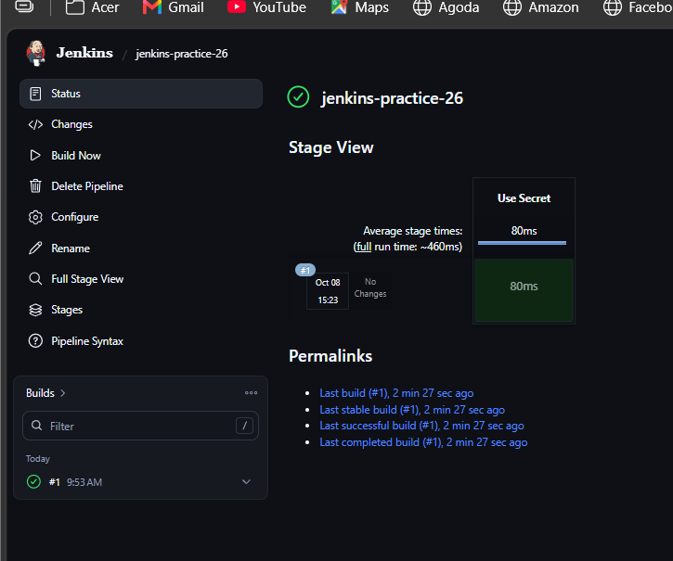
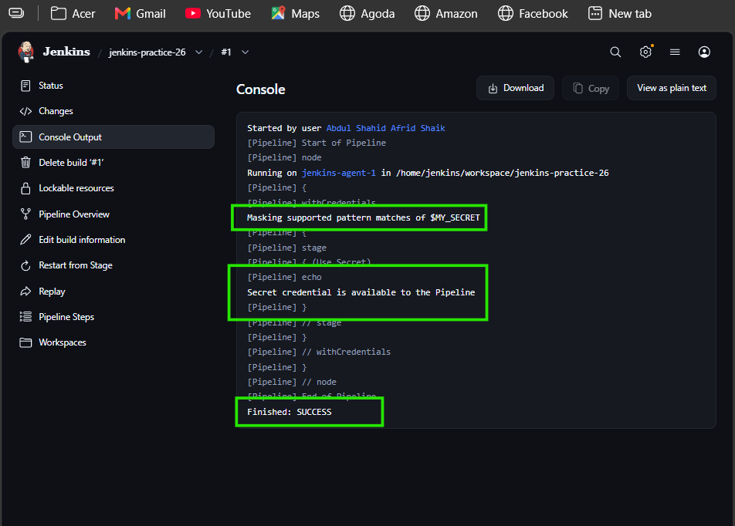

Why We Don't Print the Credential
We should not do:
echo "${MY_SECRET}"
because it would attempt to expose the secret in the Jenkins build log.
The correct approach is to use the credential internally without revealing its value.

Key Concepts

Jenkins Credentials
Jenkins Credentials provides a secure place to store sensitive information such as:
- Passwords
- API tokens
- Secret text
- SSH keys
- Certificates
- Secret files

credentials()
Used in a Declarative Pipeline to access a Jenkins credential:
environment {
MY_SECRET = credentials('git-secret')
}

Main Benefit
Instead of writing:
MY_SECRET = "MySecret123"
inside the Pipeline, we store the secret in Jenkins and reference it using its credential ID.

Final Takeaway
Secret
↓
Jenkins Credentials
↓
Credential ID: git-secret
↓
credentials('git-secret')
↓
Pipeline Environment Variable
↓
Use Secret Securely
Task 26 completed.

_____________________________________________________________________
>> Scripted vs Declarative Pipelines in Jenkins

Task 27 — Scripted vs Declarative Pipelines

Objective
To understand the difference between Declarative and Scripted Jenkins Pipelines and learn how scripted logic can be used inside a Declarative Pipeline.

1. Jenkins Job
Created:
jenkins-practice-27
Job type:
Pipeline

2. Declarative Pipeline
Used the following Pipeline:
pipeline {
agent any

stages {
stage('Hello World') {
steps {
sh 'echo Hello World'
}
}
}
}

Result
Build completed successfully.

Structure
pipeline
├── agent
└── stages
└── stage
└── steps
Declarative Pipeline follows a predefined and structured syntax.

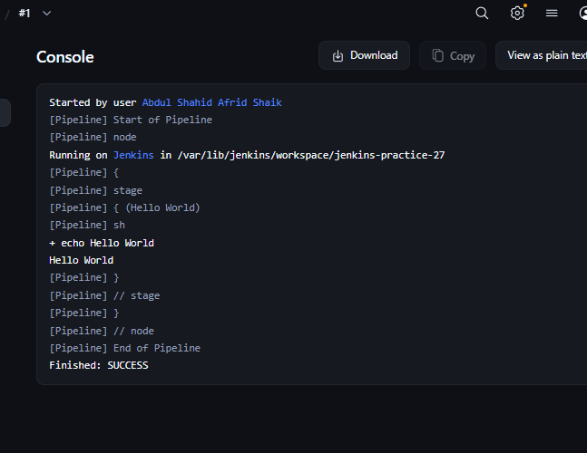

3. Scripted Pipeline
Replaced the Pipeline with:
node {
stage('Hello World') {
sh 'echo Hello World'
}
}

Result
Build completed successfully.

Structure
node
└── stage
└── steps
Scripted Pipeline provides more flexibility and is based heavily on Groovy.

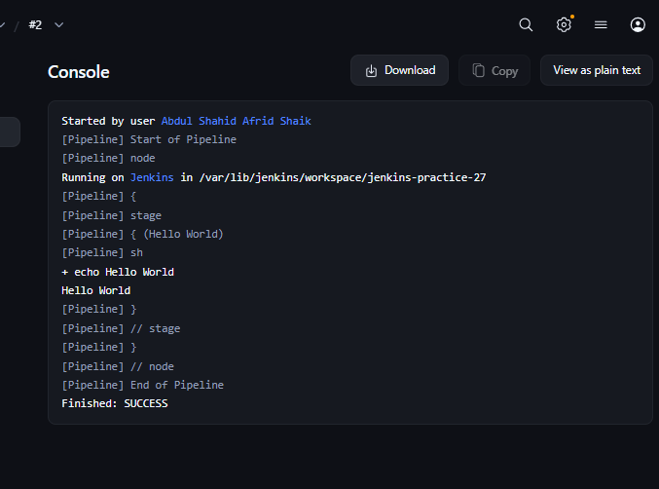

4. Declarative vs Scripted
Declarative Pipeline | Scripted Pipeline
Uses pipeline | Uses node
Uses agent | node handles execution
Uses stages | Uses stage directly
More structured | More flexible
Easier to read | Requires more Groovy knowledge
Preferred for most normal pipelines | Useful for complex logic

Main Difference
The main difference is syntax and flexibility.
Declarative Pipeline provides a structured format, while Scripted Pipeline gives more freedom for implementing complex Groovy logic.

5. Using script Inside Declarative Pipeline
Tested scripted logic inside a Declarative Pipeline:
pipeline {
agent any

stages {
stage('Script Block') {
steps {
script {
def message = 'Hello from scripted logic'
echo message
}
}
}
}
}

Result
Build completed successfully.
The script block allows us to use scripted/Groovy logic inside a Declarative Pipeline.
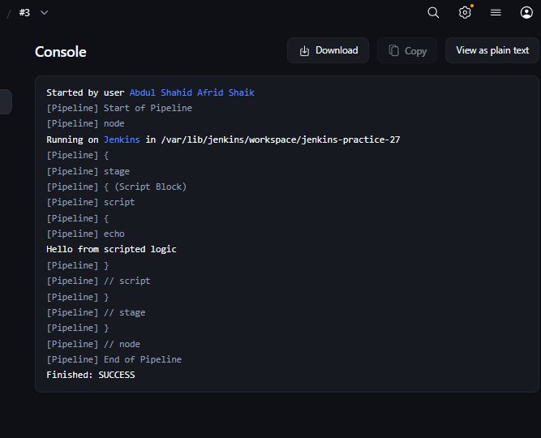

Key Interview Points

Declarative Pipeline
A structured Jenkins Pipeline syntax using blocks such as:
pipeline
agent
stages
steps
It is easier to read and is generally preferred for normal Jenkins CI/CD pipelines.

Scripted Pipeline
A Groovy-based Jenkins Pipeline using constructs such as:
node
stage
It provides greater flexibility for complex logic.

script Block
The script block allows scripted Groovy logic to be used inside a Declarative Pipeline.
steps {
script {
// Groovy logic
}
}

Final Takeaway
Both approaches perform the same basic Jenkins Pipeline work.
Declarative → Structured + easier
Scripted → Flexible + more Groovy control
For your regular Jenkins work, Declarative Pipeline should be your default, while Scripted Pipeline is important to understand for interviews and more complex logic.
______________________________________________________________________

>> Intro to Jenkins 2 and the Power of Pipelines

Task 28 — Intro to Jenkins 2 and the Power of Pipelines
Jenkins Job: jenkins-practice-28
Job Type: Pipeline
Repository: https://github.com/Baeldung/ops-tutorials.git
Branch: main
Project Directory: jenkins-modules/spring-jenkins-pipeline

1. Git Clone

Initial attempt — Error
Initially, the branch was not specified:
pipeline {
agent any

stages {
stage('Clone') {
steps {
git 'https://github.com/Baeldung/ops-tutorials.git'
}
}
}
}

Error
ERROR: Couldn't find any revision to build.
Verify the repository and branch configuration for this job.
Jenkins was trying to use the default master branch, while the repository uses main.
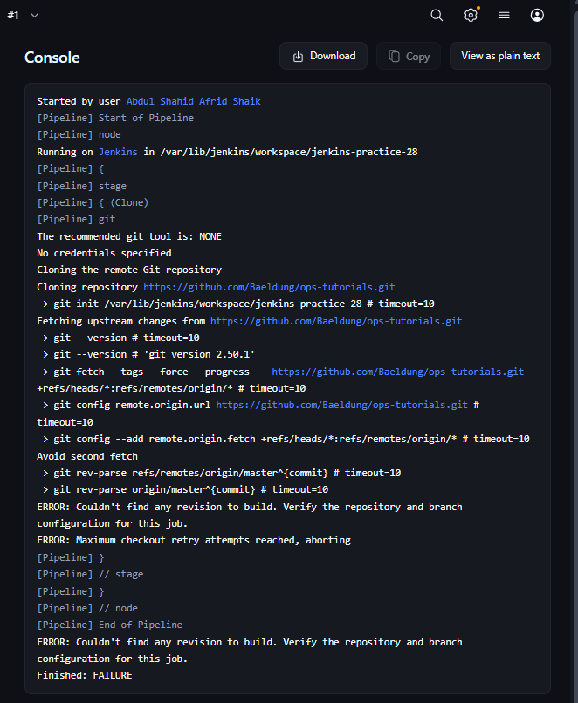

Correct implementation
pipeline {
agent any

stages {
stage('Clone') {
steps {
git branch: 'main',
url: 'https://github.com/Baeldung/ops-tutorials.git'
}
}
}
}

Result
Git clone completed successfully and Jenkins checked out:
refs/remotes/origin/main

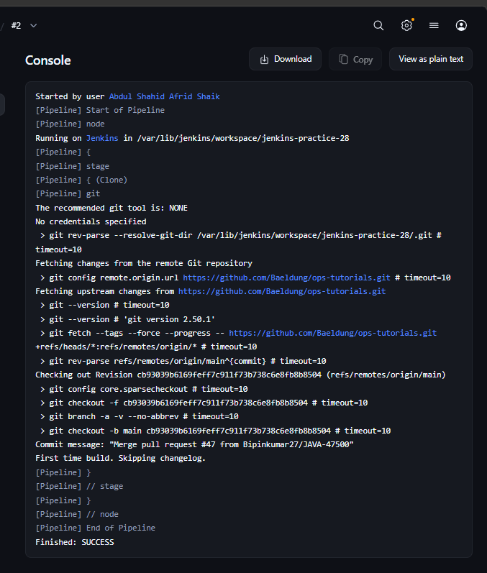

2. Using dir() to Enter the Project Directory
After cloning the repository, we entered the Spring Jenkins Pipeline project directory.
pipeline {
agent any

stages {
stage('Clone') {
steps {
git branch: 'main',
url: 'https://github.com/Baeldung/ops-tutorials.git'
}
}

stage('Enter Project Directory') {
steps {
dir('jenkins-modules/spring-jenkins-pipeline') {
sh 'pwd'
sh 'ls'
}
}
}
}
}

Purpose
dir() changes the working directory for the Pipeline steps inside its block.
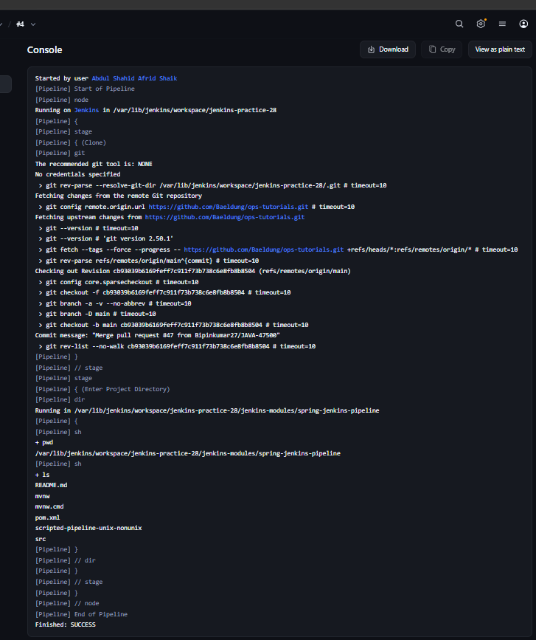

3. Compilation and Static Analysis in Parallel
The article demonstrates running Compilation and Static Analysis simultaneously.

First implementation — Error
We initially tried the Maven wrapper:
pipeline {
agent any

stages {

stage('Clone') {
steps {
git branch: 'main',
url: 'https://github.com/Baeldung/ops-tutorials.git'
}
}

stage('Compilation and Analysis') {
parallel {

stage('Compilation') {
steps {
dir('jenkins-modules/spring-jenkins-pipeline') {
sh './mvnw clean install -DskipTests'
}
}
}

stage('Static Analysis') {
steps {
dir('jenkins-modules/spring-jenkins-pipeline') {
sh './mvnw checkstyle:checkstyle'
}
}
}
}
}
}
}

Error
./mvnw: Permission denied
The Maven wrapper did not have execute permission.
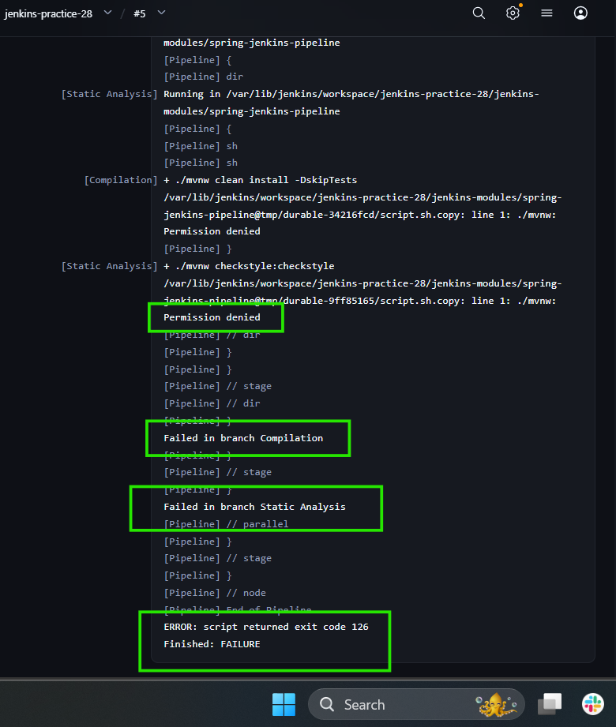

4. Fixing Maven Wrapper Permission
Instead of executing mvnw directly, we ran it through Bash:
pipeline {
agent any

stages {

stage('Clone') {
steps {
git branch: 'main',
url: 'https://github.com/Baeldung/ops-tutorials.git'
}
}

stage('Compilation and Analysis') {
parallel {

stage('Compilation') {
steps {
dir('jenkins-modules/spring-jenkins-pipeline') {
sh 'bash mvnw clean install -DskipTests'
}
}
}

stage('Static Analysis') {
steps {
dir('jenkins-modules/spring-jenkins-pipeline') {
sh 'bash mvnw checkstyle:checkstyle'
}
}
}
}
}
}
}

Next error
The Maven wrapper started successfully, but the old sample application's pom.xml failed:
'dependencies.dependency.version' for
de.flapdoodle.embed:de.flapdoodle.embed.mongo:jar is missing.
The problem was with the old sample application's Maven configuration, not the Jenkins Pipeline concept.
Therefore, we did not modify the application's pom.xml. Instead, we simplified the commands to verify Jenkins' parallel execution.
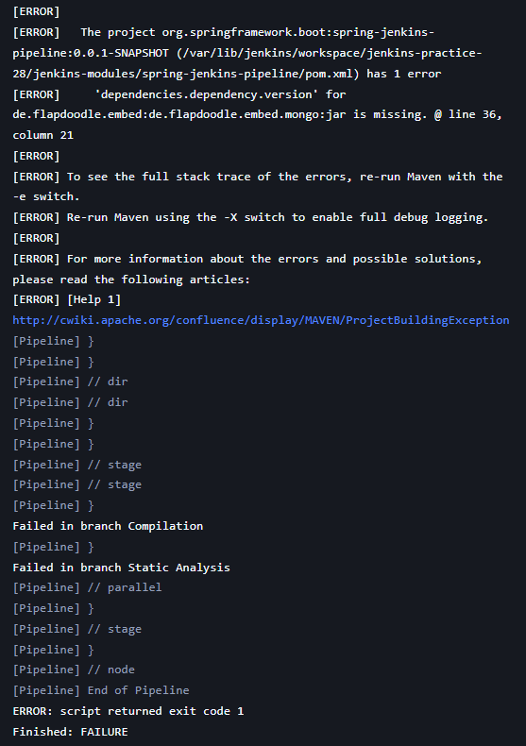

5. Compilation + Static Analysis — Successful Version
pipeline {
agent any

stages {

stage('Clone') {
steps {
git branch: 'main',
url: 'https://github.com/Baeldung/ops-tutorials.git'
}
}

stage('Compilation and Analysis') {
parallel {

stage('Compilation') {
steps {
dir('jenkins-modules/spring-jenkins-pipeline') {
sh 'echo "Compilation stage executed"'
}
}
}

stage('Static Analysis') {
steps {
dir('jenkins-modules/spring-jenkins-pipeline') {
sh 'echo "Static Analysis stage executed"'
}
}
}
}
}
}
}

Result
Both branches executed successfully:
Compilation stage executed
Static Analysis stage executed
Build result:
Finished: SUCCESS
This verified Jenkins' parallel functionality.

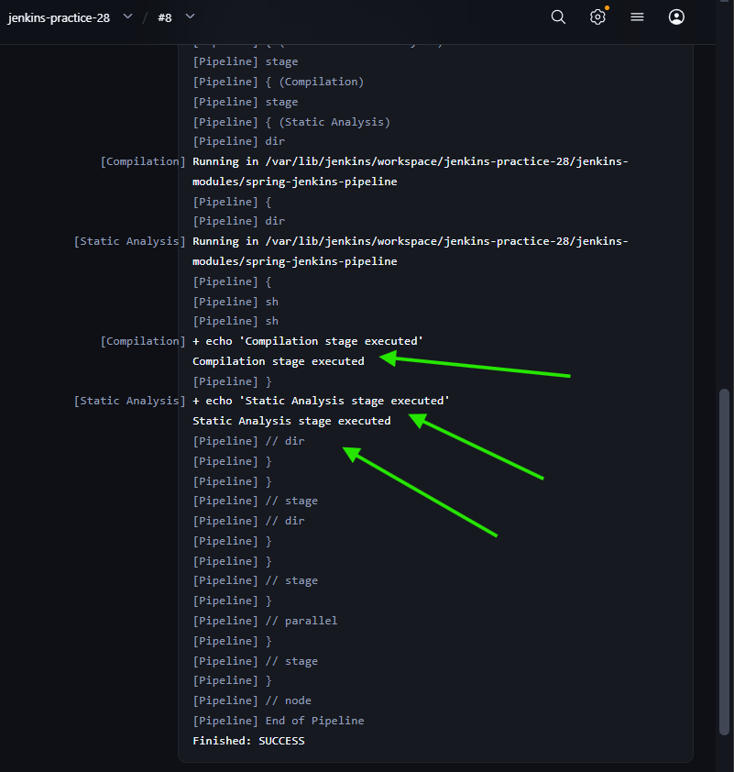

6. Unit Tests + Integration Tests in Parallel
The article also demonstrates running Unit Tests and Integration Tests in parallel.
pipeline {
agent any

stages {

stage('Clone') {
steps {
git branch: 'main',
url: 'https://github.com/Baeldung/ops-tutorials.git'
}
}

stage('Tests') {
parallel {

stage('Unit Tests') {
steps {
dir('jenkins-modules/spring-jenkins-pipeline') {
sh 'echo "Unit Tests stage executed"'
}
}
}

stage('Integration Tests') {
steps {
dir('jenkins-modules/spring-jenkins-pipeline') {
sh 'echo "Integration Tests stage executed"'
}
}
}
}
}
}
}

Concept
The two test branches can execute simultaneously:
Tests
├── Unit Tests
└── Integration Tests

7. Deployment Stage
After both test branches finish, the deployment stage executes.
stage('Deploy') {
steps {
echo 'Deploying application...'
}
}

Complete implementation used for the test + deployment flow
pipeline {
agent any

stages {

stage('Clone') {
steps {
git branch: 'main',
url: 'https://github.com/Baeldung/ops-tutorials.git'
}
}

stage('Tests') {
parallel {

stage('Unit Tests') {
steps {
dir('jenkins-modules/spring-jenkins-pipeline') {
sh 'echo "Unit Tests stage executed"'
}
}
}

stage('Integration Tests') {
steps {
dir('jenkins-modules/spring-jenkins-pipeline') {
sh 'echo "Integration Tests stage executed"'
}
}
}
}
}

stage('Deploy') {
steps {
echo 'Deploying application...'
}
}
}
}

Execution flow
Clone
↓
Tests
├── Unit Tests
└── Integration Tests
↓
Deploy
Deploy runs only after both parallel test branches finish.

Important Jenkins Concepts Learned

git
Used to clone a specific Git branch:
git branch: 'main',
url: 'https://github.com/Baeldung/ops-tutorials.git'

dir()
Changes the working directory for Pipeline steps:
dir('jenkins-modules/spring-jenkins-pipeline') {
sh 'pwd'
}

parallel
Runs independent stages simultaneously:
parallel {

stage('Unit Tests') {
steps {
echo 'Unit Tests'
}
}

stage('Integration Tests') {
steps {
echo 'Integration Tests'
}
}
}

Pipeline flow
The article's overall CI/CD concept is:
Compilation
+
Static Analysis
↓
Unit Tests
+
Integration Tests
↓
Deployment
The key Jenkins concept is that independent stages can run in parallel to reduce Pipeline execution time.

>> Simple Jenkins Pipeline with Marathon and Mesos

ask 29 — Basic Theory

Marathon
Marathon is a framework used to deploy and manage applications on top of an Apache Mesos cluster.
It provides features such as:
- Application deployment
- Health checking
- Auto-scaling
- Failover
- Monitoring

Mesos
Apache Mesos is a distributed cluster management system. It provides the infrastructure where applications and containers can run across a cluster.
Simple way to remember:
Mesos = Cluster/resource manager
Marathon = Application deployment/scheduling framework

Jenkins + Marathon + Mesos
The article's CI/CD flow is:
Developer
↓
Git
↓
Jenkins
↓
Build & Test
↓
Docker Image
↓
Marathon
↓
Mesos Cluster
↓
Application Running

Docker's role
The application is packaged into a Docker image because Marathon manages containerized applications.

marathon.json
marathon.json contains the application definition that tells Marathon things such as:
- Application ID
- Docker image
- Container type
- Container port
- Port mapping

Overall idea
Jenkins builds the application → creates/publishes the Docker image → Marathon deploys the image → Mesos provides the cluster resources to run it.
That's all you need to know for Task 29 since your instructor asked you to skip the practical.

