Tag: Jenkins Pipeline
How to Prevent Two Pipeline Jenkins Jobs of the Same Type to Run in Parallel on the Same Node?

Objective
To prevent multiple builds of the same Jenkins Freestyle job from running simultaneously.

Job Name
jenkins-practice-1

Configuration
Navigate to:
Jenkins
→ jenkins-practice-1
→ Configure
→ General
The following option is available:
Execute concurrent builds if necessary
Keep this option unchecked.

Build Step
Navigate to:
Build Steps
→ Add build step
→ Execute shell
Add:
echo "Build started"
sleep 30
echo "Build completed"

Execution
- Click Save.
- Click Build Now.
- While the first build is running, click Build Now again.
- The second build will remain in the queue.
- After the first build completes, the second build starts.

Result
Build #1 → Running
Build #2 → Waiting
↓
Build #1 → Completed
↓
Build #2 → Running

Throttle:

Step 1 — Create Throttle Category
Navigate to:
Jenkins
→ Manage Jenkins
→ Configure System
→ Throttle Concurrent Builds
→ Categories
→ Add Category
Create:
Category Name:
jenkins-practice-category
Configure:
Maximum Total Concurrent Builds:
Leave empty

Maximum Concurrent Builds Per Node:
1
Save the configuration.
This limits the category to one concurrent build on each node. Pasted text

Step 2 — Assign the Job to the Category
Navigate to:
jenkins-practice-1
→ Configure
→ General
→ Throttle Concurrent Builds
Select:
Throttle this project as part of one or more categories
Select:
jenkins-practice-category
Configure:
Maximum Total Concurrent Builds:
Leave empty

Maximum Concurrent Builds Per Node:
1
Leave:
Prevent multiple jobs with identical parameters
unchecked.
Save the configuration.

Step 3 — Build Configuration
Use the following Execute shell build step:
echo "Build started"
sleep 30
echo "Build completed"

Step 4 — Execution
Start two builds immediately.
The first build runs:
Build #2 → Running
The next build remains pending because the configured node limit has already been reached:
Build #3 → Pending
After the running build completes, the pending build starts.

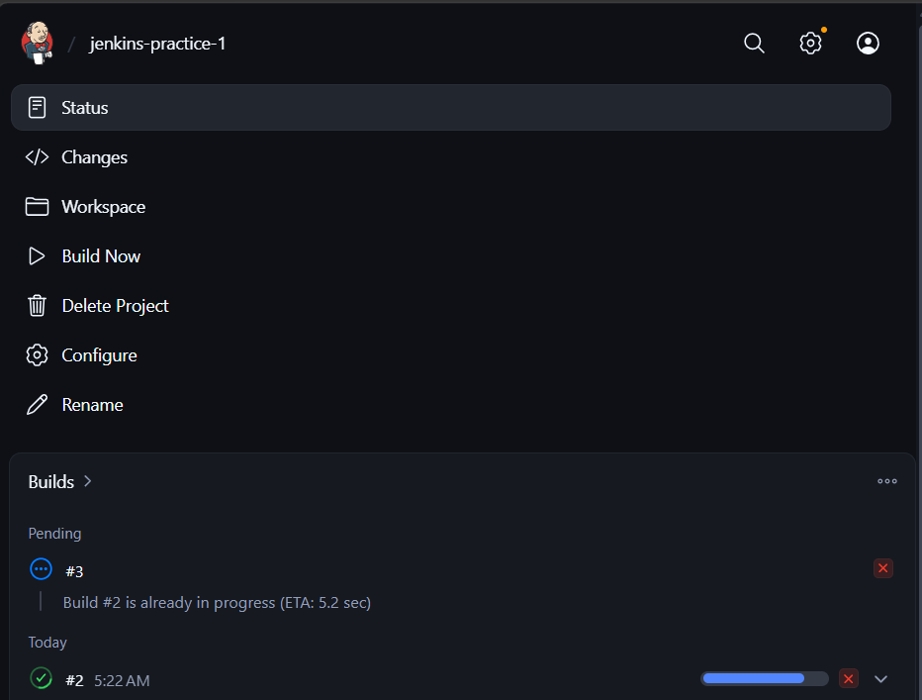

Lockable Resources

Objective
To prevent multiple Jenkins builds from using the same shared resource simultaneously.

Plugin
Lockable Resources Plugin

Configuration
- Install Lockable Resources Plugin.
- Go to Manage Jenkins → Lockable Resources.
- Create a resource:
jenkins-practice-resource

Pipeline Configuration
lock(resource: 'jenkins-practice-resource') {
echo 'Lock acquired'
echo 'Running one build using the locked resource'
sleep 60
echo 'Build completed'
}

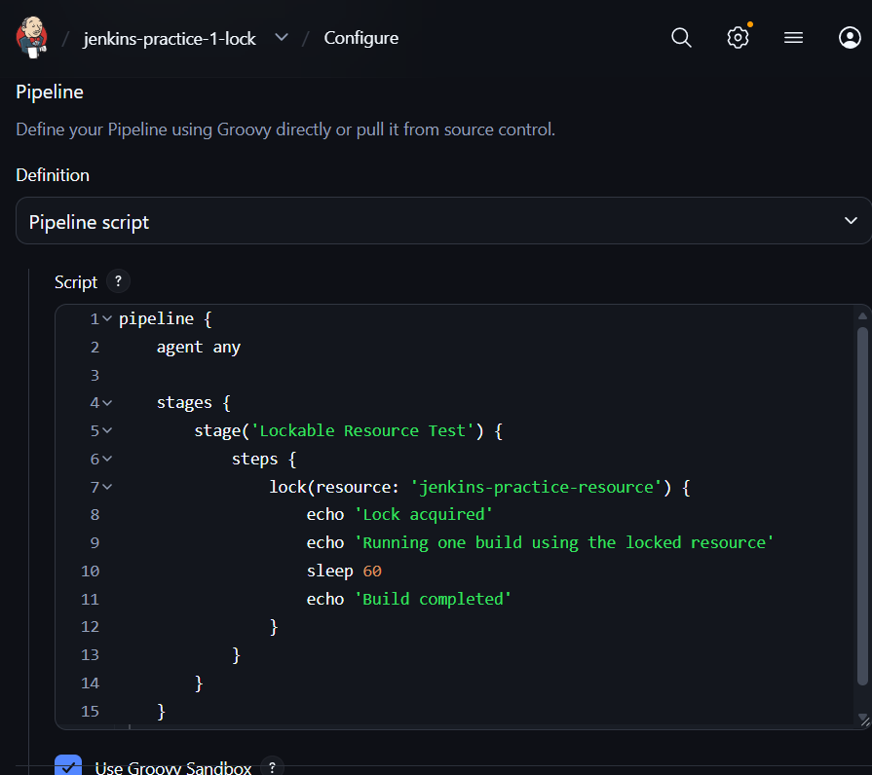

How it works
- A build requests the jenkins-practice-resource.
- If the resource is available, Jenkins acquires the lock and the build continues.
- If another build requests the same resource while it is locked, that build waits in the queue until the resource is released.
- After the first build finishes the locked section, Jenkins releases the resource.
- The waiting build can then acquire the resource and continue. Pasted text

Important Console Messages
Resource acquired:
Lock acquired on [Resource: jenkins-practice-resource]
Resource unavailable:
The resource [jenkins-practice-resource] is not free, waiting for execution ...
Resource released:
Lock released on resource [Resource: jenkins-practice-resource]
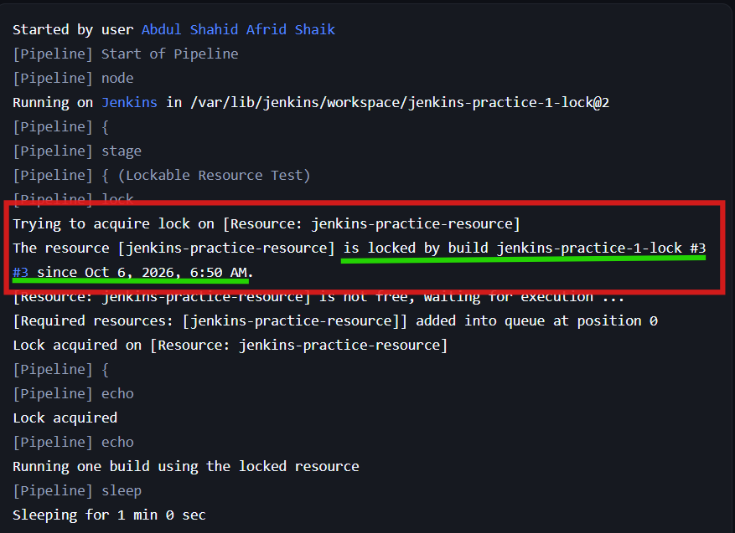

>> Check if a File Exists in a Jenkins Pipeline
Freestyle/plugin:

Objective
To check whether a file exists in the Jenkins workspace before and after creating it.

Job Name
jenkins-practice-2

Plugin Used
File Operations Plugin
The plugin was installed from:
Jenkins
→ Manage Jenkins
→ Plugins
→ Available plugins
→ File Operations

Build Steps
Three Execute Shell build steps were configured.

Step 1 — Check File
if [ -f test.txt ]; then
echo "FILE EXISTS"
else
echo "FILE DOES NOT EXIST"
fi
Since test.txt does not initially exist, the output is:
FILE DOES NOT EXIST

Step 2 — Create File
echo "Jenkins file check test" > test.txt
This creates test.txt in the Jenkins workspace.

Step 3 — Check File Again
if [ -f test.txt ]; then
echo "FILE EXISTS"
else
echo "FILE DOES NOT EXIST"
fi
The output is:
FILE EXISTS

Execution Flow
Check test.txt
↓
Does not exist
↓
Create test.txt
↓
Check test.txt again
↓
File exists

Result
The build successfully verified the file's existence before and after creating test.txt.

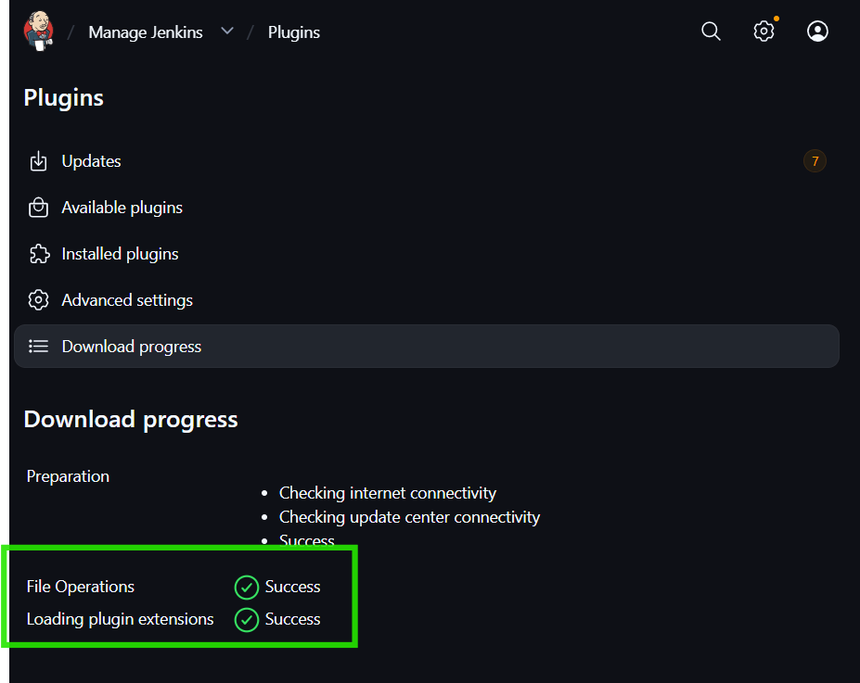
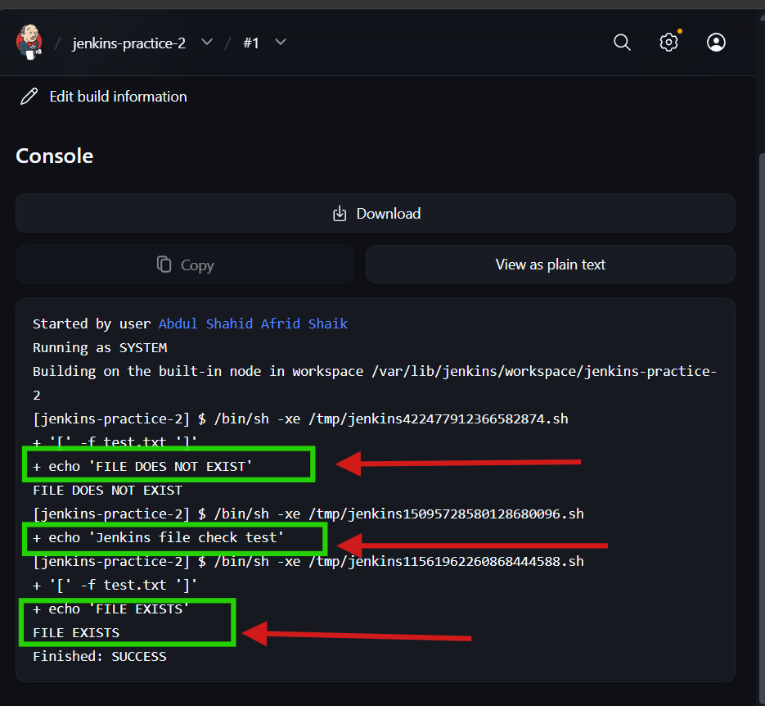
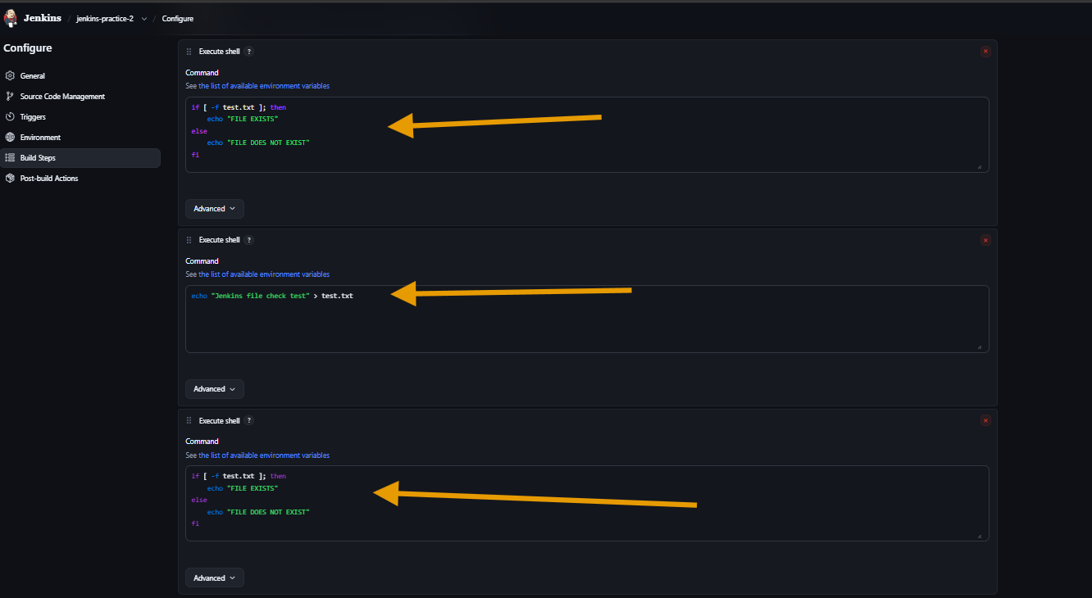
Pipeline:
1.Using Jenkins Pipeline Steps

Objective
To check whether a particular file exists in the Jenkins workspace before proceeding with further steps.

Job
jenkins-practice-2-pipeline

Pipeline Type
Declarative Pipeline

Pipeline Script
pipeline {
agent any

stages {
stage('Check File') {
steps {
script {
if (fileExists('myfile.txt')) {
echo 'File found.'
} else {
echo 'File not found.'
}
}
}
}
}
}

How it works
- fileExists('myfile.txt') checks whether myfile.txt is present in the current Jenkins workspace.
- It returns a boolean value:
  - true → file exists
  - false → file does not exist.
- if/else is used to perform different actions based on the result.
- echo displays the result in the Jenkins Console Output. Pasted text

Result
Since myfile.txt was not created in the workspace:
File not found.

Key Point
fileExists() is a built-in Jenkins Pipeline step used to verify whether a file exists in the workspace.
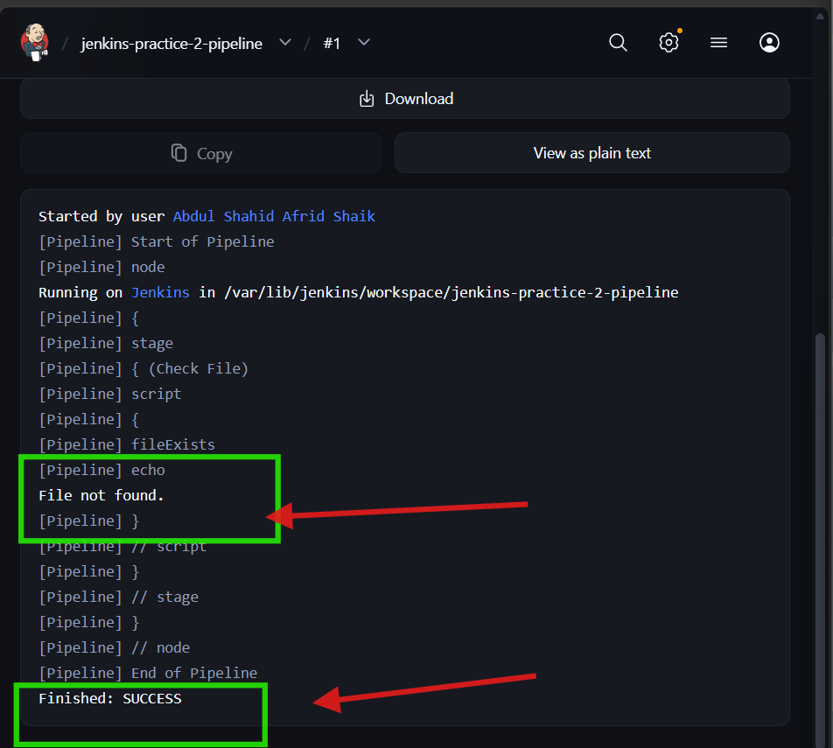

Checking Files with Shell Commands

Objective
To check whether a file exists using a Linux shell command inside a Jenkins Pipeline.

Job
jenkins-practice-2-pipeline

Pipeline Script
pipeline {
agent any

stages {
stage('Shell File Check') {
steps {
script {
def result = sh(
script: '[ -f myfile.txt ] && echo "YES" || echo "NO"',
returnStdout: true
)

if (result.trim() == "YES") {
echo "myfile.txt exists."
} else {
echo "myfile.txt missing."
}
}
}
}
}
}

How it works
- sh executes a Linux shell command.
- [ -f myfile.txt ] checks whether myfile.txt is a regular file.
- If the file exists, YES is returned.
- If the file does not exist, NO is returned.
- returnStdout: true captures the command output in the result variable.
- result.trim() removes extra whitespace before comparing the result. Pasted text

Result
Since myfile.txt was not present:
myfile.txt missing.
Build completed successfully:
Finished: SUCCESS

Key Point
The sh step can execute Linux commands and capture their output, allowing the Pipeline to make decisions based on the command result.

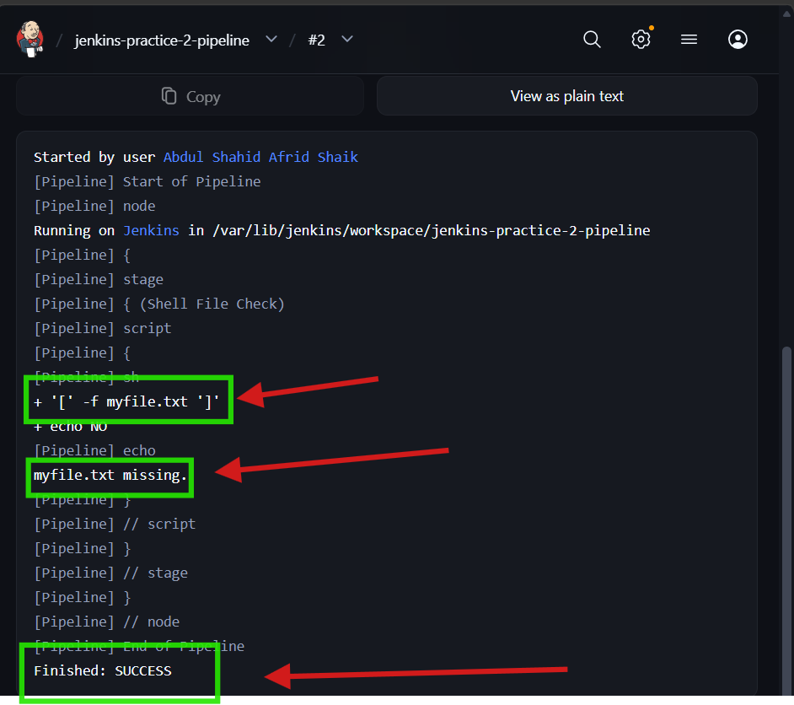

Checking a File in Declarative Pipelines

Objective
To check whether a file exists using the fileExists() step inside a Declarative Jenkins Pipeline.

Job
jenkins-practice-2-pipeline

Pipeline Script
pipeline {
agent any

stages {
stage('Check File Declarative') {
steps {
script {
if (fileExists('myfile.txt')) {
echo 'Found myfile.txt!'
} else {
echo 'Did not find myfile.txt.'
}
}
}
}
}
}

How it works
- pipeline {} defines the Declarative Pipeline.
- agent any allows Jenkins to run the Pipeline on any available agent.
- fileExists('myfile.txt') checks whether the file exists in the workspace.
- The script block allows the if/else logic to be used.
- If the file exists, Jenkins prints Found myfile.txt!.
- If the file does not exist, Jenkins prints Did not find myfile.txt. Pasted text

Result
Since myfile.txt was not present:
Did not find myfile.txt.

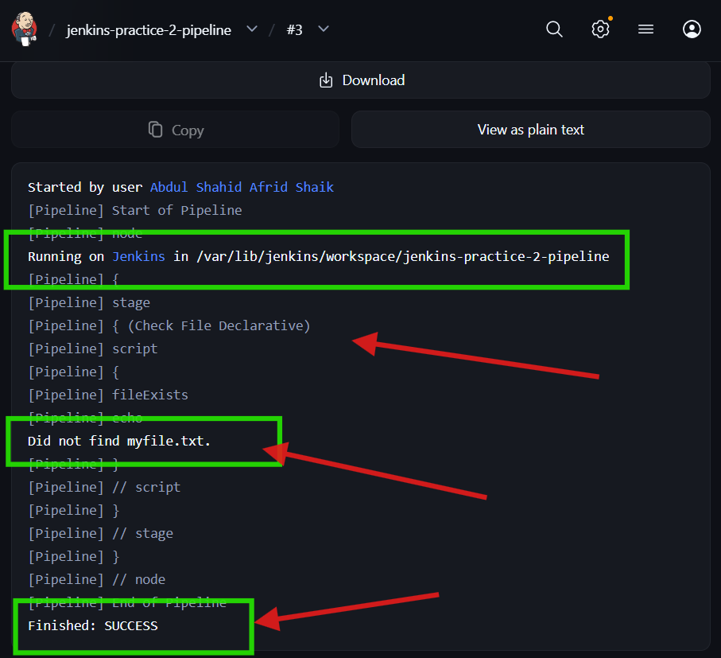

Skipping a Stage

Objective
To prevent a deployment stage from running when a required file is missing.

Job
jenkins-practice-2-pipeline

Pipeline Script
pipeline {
agent any

stages {
stage('Build') {
steps {
echo 'Building application...'
}
}

stage('Check for Package') {
steps {
script {
if (!fileExists('deploy-package.zip')) {
error 'Package not found. Aborting deployment.'
}
}
}
}

stage('Deploy') {
steps {
echo 'Deploying application...'
}
}
}
}

How it works
- The Build stage executes first.
- The Check for Package stage checks whether deploy-package.zip exists.
- !fileExists() means the file is not present.
- If the file is missing, error stops the Pipeline.
- Because the Pipeline stops, the Deploy stage does not execute. Pasted text

Flow
Build
↓
Check for Package
↓
deploy-package.zip missing
↓
ERROR
↓
Deploy stage skipped

Result
Expected Console Output:
Package not found. Aborting deployment.
Build Status: FAILURE

Key Point
This approach can prevent deployment when a required package or file is not available. Pasted text

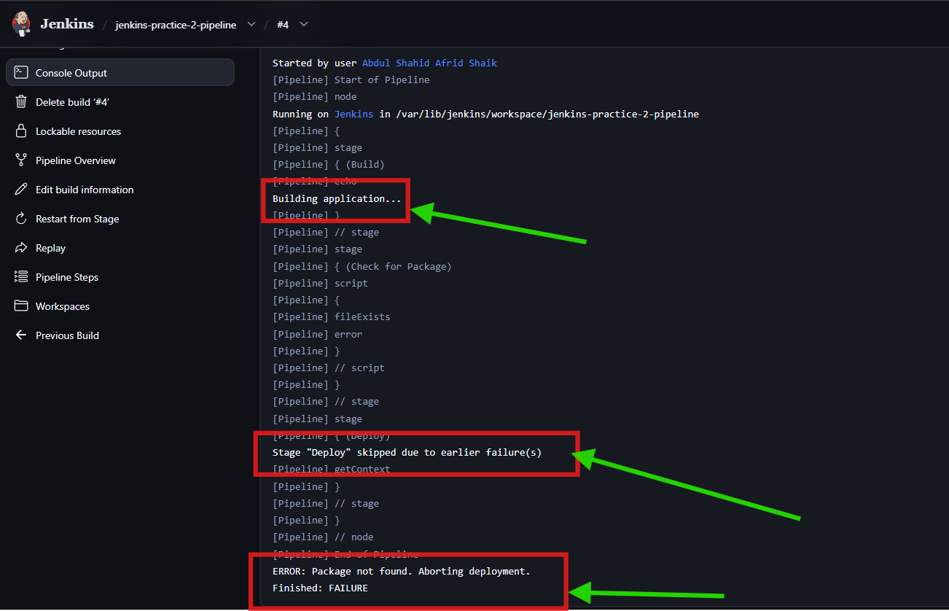

Setting Build Status

Objective
To mark a Jenkins build as UNSTABLE when an optional file is missing, while allowing the Pipeline to continue.

Job
jenkins-practice-2-pipeline

Pipeline Script
pipeline {
agent any

stages {
stage('Check File') {
steps {
script {
if (!fileExists('optional-report.txt')) {
currentBuild.result = 'UNSTABLE'
echo 'optional-report.txt is missing, marking build unstable.'
}
}
}
}

stage('Continue') {
steps {
echo 'Pipeline continues after marking build unstable.'
}
}
}
}

How it works
- fileExists('optional-report.txt') checks whether the file is present.
- !fileExists() means the file is missing.
- currentBuild.result = 'UNSTABLE' changes the build status to UNSTABLE.
- The Pipeline does not stop after setting the status.
- The Continue stage executes normally. Pasted text

Flow
Check File
↓
File missing
↓
Set status → UNSTABLE
↓
Pipeline continues
↓
Continue stage executes

Result
Console:
optional-report.txt is missing, marking build unstable.
Pipeline continues after marking build unstable.
Final Build Status: UNSTABLE

Key Point
Unlike the previous 5.1 approach, which uses error and stops the Pipeline, currentBuild.result = 'UNSTABLE' allows the Pipeline to continue even though the build is marked unstable.

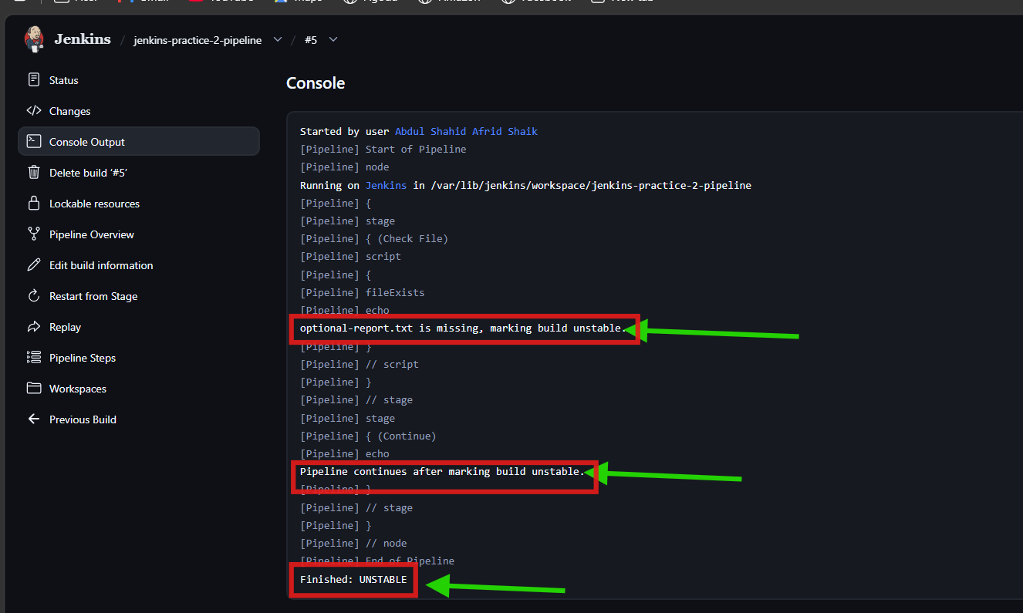

Working With Shared Libraries

Objective
To practice creating a reusable file-checking function that can be called from a Jenkins Pipeline.

Job
jenkins-practice-2-pipeline

Pipeline Script
def checkFileExists(String filePath) {
return fileExists(filePath)
}

pipeline {
agent any

stages {
stage('Check File') {
steps {
script {
if (checkFileExists('myfile.txt')) {
echo 'myfile.txt found.'
} else {
echo 'myfile.txt missing.'
}
}
}
}
}
}

How it works
- checkFileExists() is a reusable Groovy function.
- It accepts the file path as an argument.
- The function calls Jenkins' fileExists() step.
- The returned value is used in the if/else condition.
- In our test, myfile.txt was not present, so Jenkins displayed:
myfile.txt missing.
- The build completed successfully. Pasted text

Key Point
The article's Shared Library approach uses a reusable checkFileExists function so the same file-checking logic can be reused across Pipelines. Pasted text
Note: We practiced the concept directly inside the Pipeline rather than creating an external vars/checkFileExists.groovy Shared Library.

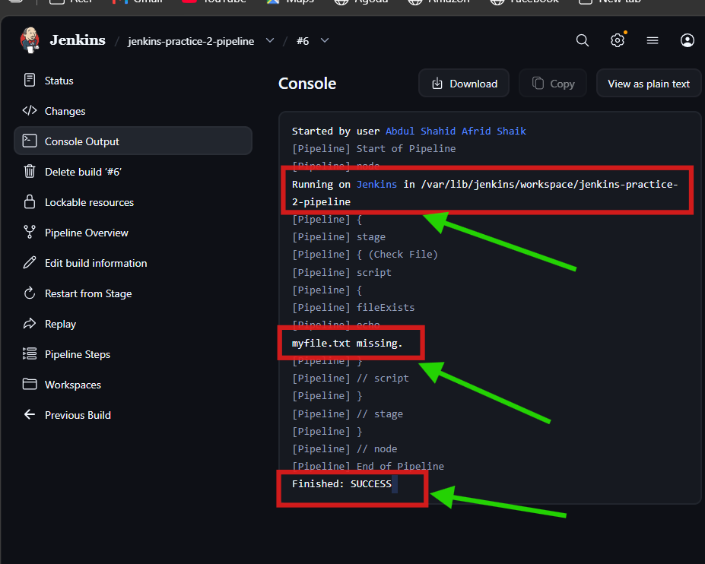

>> Set Stage Status in Jenkins Pipelines

Jenkins Practice 3 — Set Build Status

freestyle

Objective
To manually set the Jenkins build result to UNSTABLE using a Jenkins plugin in a Freestyle project.

Job Name
jenkins-practice-3

Plugin Used
Fail The Build Plugin
Installed from:
Jenkins
→ Manage Jenkins
→ Plugins
→ Available plugins
→ Fail The Build

Build Step 1 — Execute Shell
Navigate to:
Configure
→ Build Steps
→ Add build step
→ Execute shell
Command:
echo "Build execution completed"

Build Step 2 — Set Build Result
Add another build step:
Add build step
→ Set the build result
Configure:
Result: UNSTABLE

Build Configuration
The build steps are executed in this order:
Execute shell
↓
Build execution completed
↓
Set the build result
↓
UNSTABLE

Execution
Click:
Save
→ Build Now
→ Build #1
→ Console Output
The shell command executes successfully, and the plugin changes the final build result to:
UNSTABLE
Jenkins displays the build as unstable (yellow).

Result
The build completed successfully from the shell-command perspective, but the Fail The Build Plugin changed the final Jenkins build status to UNSTABLE.

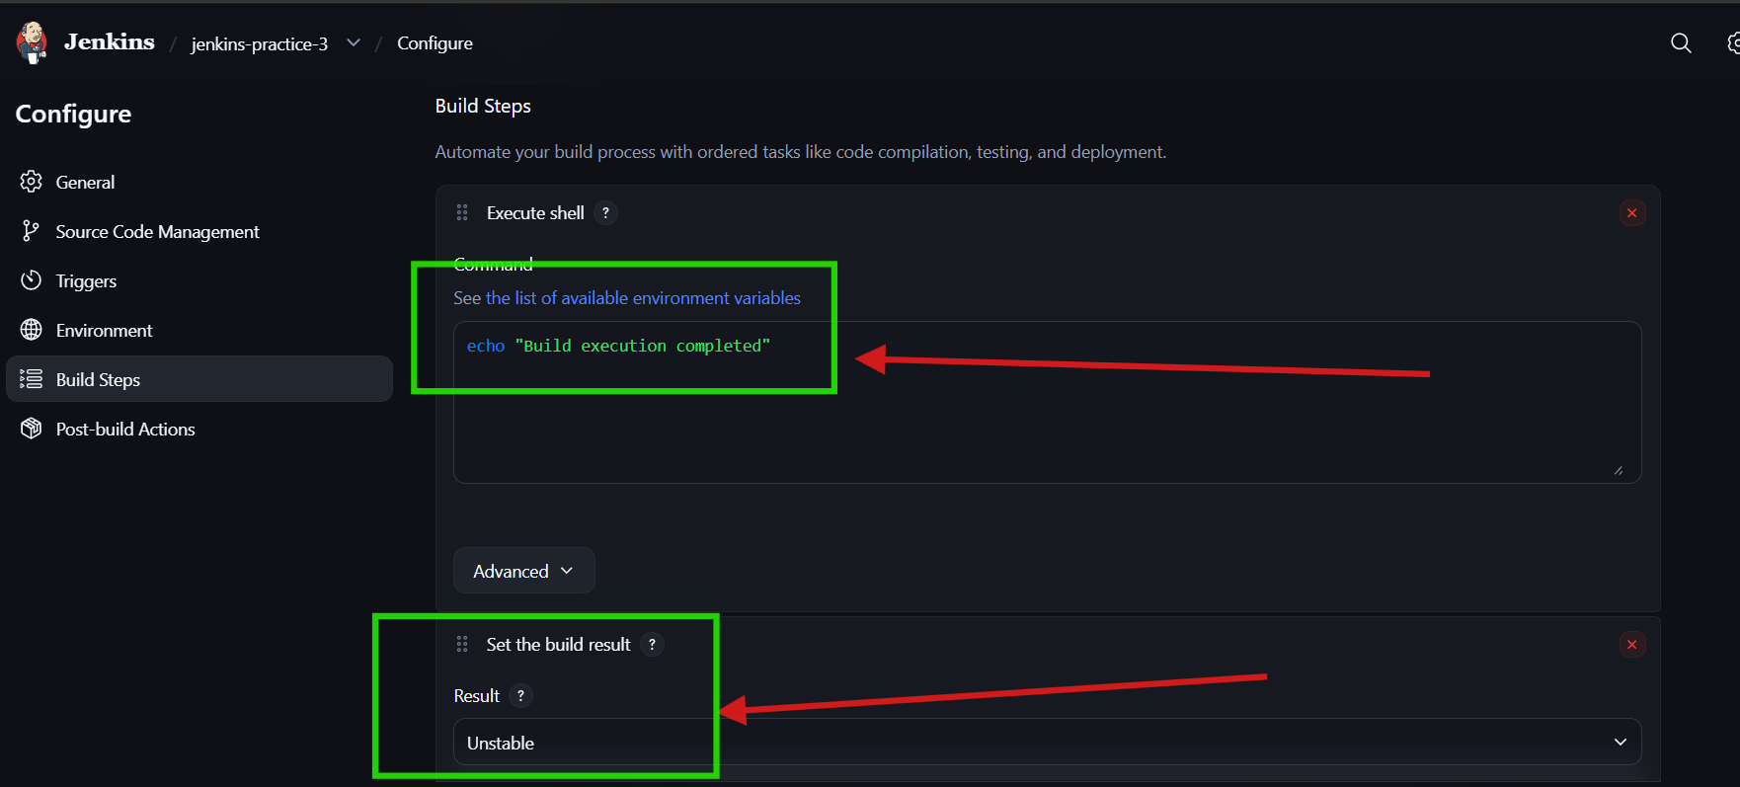
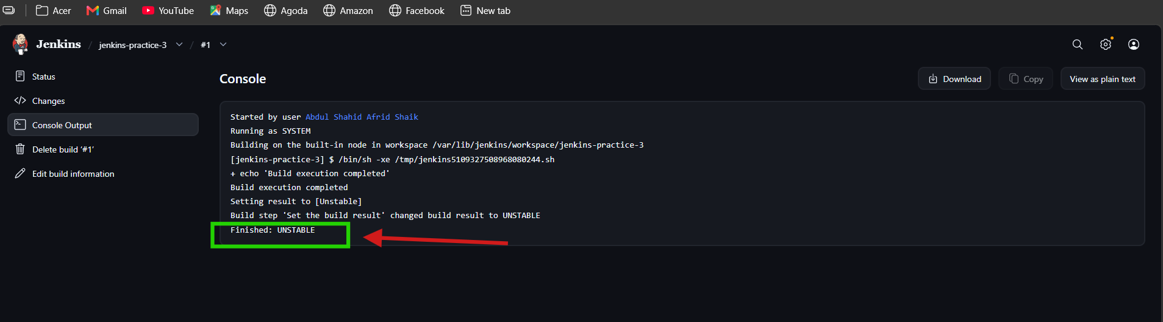
Pipeline:

Task 3 — Set Build Status in Jenkins Pipeline

3.1 SUCCESS

Objective
To understand the SUCCESS status of a Jenkins Pipeline stage.

Job
jenkins-practice-3-pipeline

Pipeline Script
pipeline {
agent any

stages {
stage('Success') {
steps {
sh 'exit 0'
sh 'ls -l'
}
}
}
}

How it works
- The Success stage contains two shell commands.
- exit 0 indicates successful execution.
- ls -l also executes successfully.
- Since all steps inside the stage execute successfully, the stage is marked SUCCESS.
- After a successful stage, Pipeline execution can continue to the next stage.

Result
Stage: Success
Status: SUCCESS
The stage is displayed as green in Jenkins.

Key Point
A stage receives SUCCESS when all the steps inside that stage execute successfully.

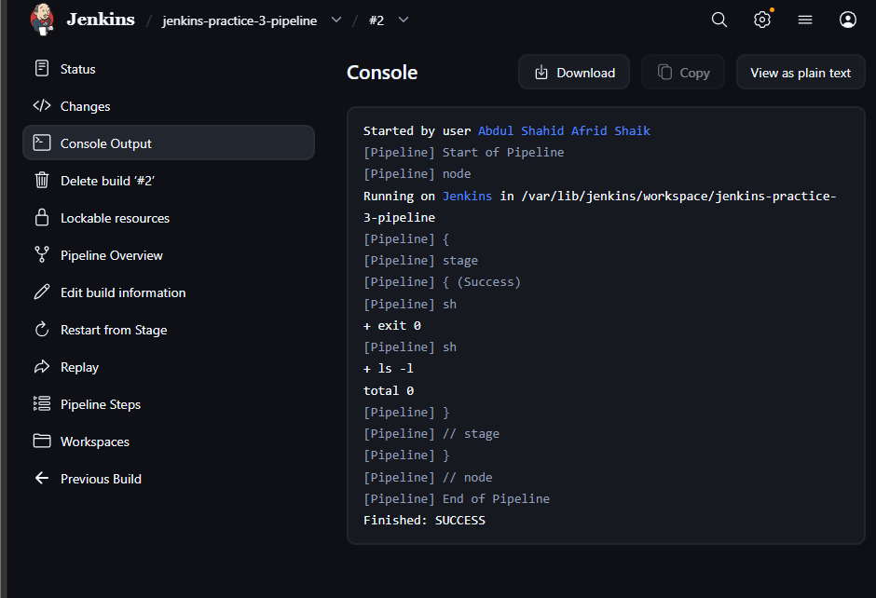

3.2 unstable :

Objective
To change the Jenkins build status to UNSTABLE while allowing the Pipeline to continue.

Job
jenkins-practice-3-pipeline

Pipeline Script
pipeline {
agent any

stages {
stage('Build') {
steps {
echo 'Build completed'
}
}

stage('Set Status') {
steps {
script {
currentBuild.result = 'UNSTABLE'
echo 'Build marked as UNSTABLE'
}
}
}
}
}

How it works
- currentBuild.result is used to set the current Jenkins build result.
- Setting it to 'UNSTABLE' marks the build as UNSTABLE.
- The Pipeline continues executing after the status is changed. Pasted text

Result
Build completed
↓
Set build status → UNSTABLE
↓
Pipeline continues
↓
Final Status: UNSTABLE

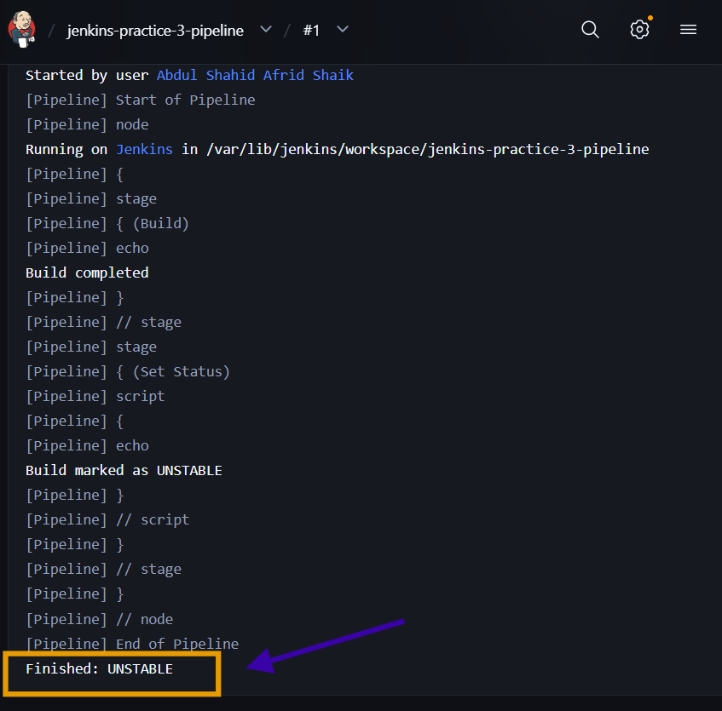

3.3 FAILED:

Objective
To understand the FAILED status of a Jenkins Pipeline stage.

Job
jenkins-practice-3-pipeline

Pipeline Script
pipeline {
agent any

stages {
stage('Success') {
steps {
sh 'exit 0'
sh 'ls -l'
}
}

stage('Fail') {
steps {
sh 'ls -l'
sh 'exit 1'
}
}
}
}

How it works
- The Success stage executes successfully.
- The Fail stage executes ls -l successfully.
- exit 1 returns a non-zero exit code, indicating failure.
- Because one step in the stage fails, the Fail stage is marked FAILED.
- Pipeline execution does not continue to the next stage.

Result
Success → SUCCESS
Fail → FAILED
The Fail stage is displayed in red in Jenkins.

Key Point
A stage is FAILED when any step inside that stage does not execute successfully. A failed stage stops the Pipeline from progressing to the next stage.

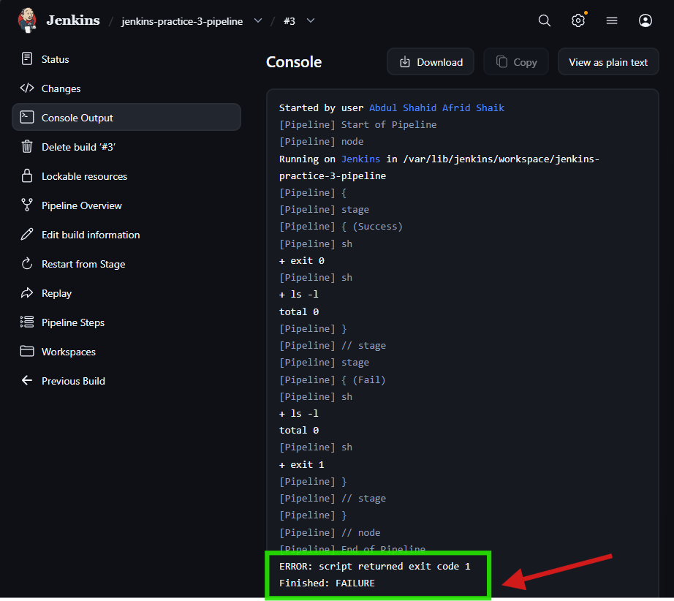

Task 4 — Return Stdout, Stderr, and Status From Jenkins sh Script

1. Overview
Jenkins Pipeline provides a flexible structure for integrating with different tools and platforms. A common requirement is to execute native operating system commands from a Pipeline.
On Linux, Jenkins provides the sh step to execute shell commands. The output and execution status of these commands can be displayed in the Jenkins console or returned to Pipeline variables for further processing.
In this task, we practice stdout, stderr, status codes, and returning these values from the Jenkins sh step.

2. What Are Stdout, Stderr, and Status Codes?
Linux commands use standard streams to communicate with their environment.
The three important concepts are:
- stdout — Standard Output
- stderr — Standard Error
- status code / exit code — Indicates whether the command succeeded or failed

2.1 Standard Output — stdout
Standard output (stdout) captures the normal output produced by a command.
For example:
echo "this is coming from stdout"
Output:
this is coming from stdout
The message generated by echo is sent through stdout.

Key Point
stdout is used for normal/successful command output.

2.2 Standard Error — stderr
Standard error (stderr) captures error messages produced by a command.
For example:
ls noSuchFile
Output:
ls: cannot access 'noSuchFile': No such file or directory
Because noSuchFile doesn't exist, the error message is sent through stderr.

Key Point
stderr is used for error output generated by commands.

2.3 Status Code
A status code, also called an exit code, is a numerical value returned after a command finishes.
The important values are:
0 → Success
Non-zero → Failure
The status code can be checked using:
$?

Successful command
echo "this is a successful command"
echo $?
Output:
this is a successful command
0

Failed command
ls unsuccessful
echo $?
Output:
ls: cannot access 'unsuccessful': No such file or directory
2

Key Point
A status code of 0 means success, while a non-zero status code indicates failure.

3. Using the Jenkins sh Step
Jenkins uses the sh step to execute Linux commands on the agent where the Pipeline is running.

Pipeline
pipeline {
agent any

stages {
stage("use Linux commands") {
steps {
script {
sh "echo successful command"
sh "ls noSuchFile"
}
}
}
}
}

What happens?
The first command:
echo successful command
runs successfully.
The second command:
ls noSuchFile
fails because the file doesn't exist.
The Jenkins console therefore displays:
- Normal command output → stdout
- Error message → stderr
- Command exit status → status code

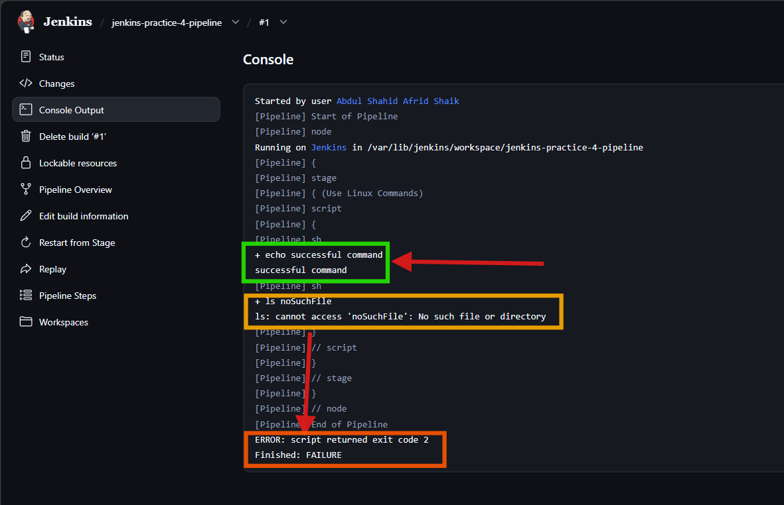 Key Point
The sh step allows Jenkins Pipeline to execute Linux commands and display their output and status in the console.

4. Returning Stdout, Stderr, and Status From sh Script
Instead of only displaying command output in the Jenkins console, we can return the values from the sh step and store them in Pipeline variables.
This allows the Pipeline to use the returned values for further processing or decisions.

4.1 Return the Stdout
The sh step provides:
returnStdout: true
to return the standard output of a command.

Pipeline
pipeline {
agent any

stages {
stage("use Linux commands") {
steps {
script {
def stdout = sh(
script: "echo returned output",
returnStdout: true
)

print "The stdout is:\n ${stdout}"
}
}
}
}
}

How it works
sh command
↓
echo returned output
↓
stdout
↓
returnStdout: true
↓
stdout variable
↓
print output
The output is stored in:
stdout

Expected output
The stdout is:
returned output

Key Point
returnStdout: true returns the command's stdout to the Pipeline instead of only displaying it directly.

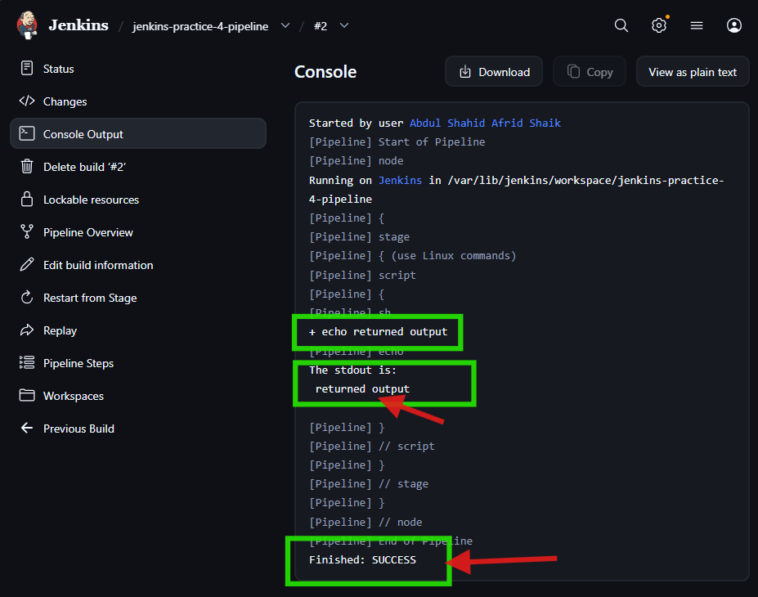

4.2 Return the Status Code
The sh step also provides:
returnStatus: true
to return the command's exit/status code.

Pipeline
pipeline {
agent any

stages {
stage("use Linux commands") {
steps {
script {
def status = sh(
script: "echo returned output",
returnStatus: true
)

print "The status code is:\n ${status}"

status = sh(
script: "ls noSuchFile",
returnStatus: true
)

print "The status code is:\n ${status}"
}
}
}
}
}

First command
echo returned output
Successful command:
Status code: 0

Second command
ls noSuchFile
Failed command:
Status code: 2

Expected result:
The status code is: 0

The status code is: 2
- 0 → command executed successfully.
- 2 → ls noSuchFile failed because the file does not exist.
- returnStatus: true returns the command's status code instead of failing the Pipeline.

Key Point
returnStatus: true allows the Pipeline to capture the command's exit status in a variable.
Unlike a normal failing sh step, the returned status can be inspected by the Pipeline.

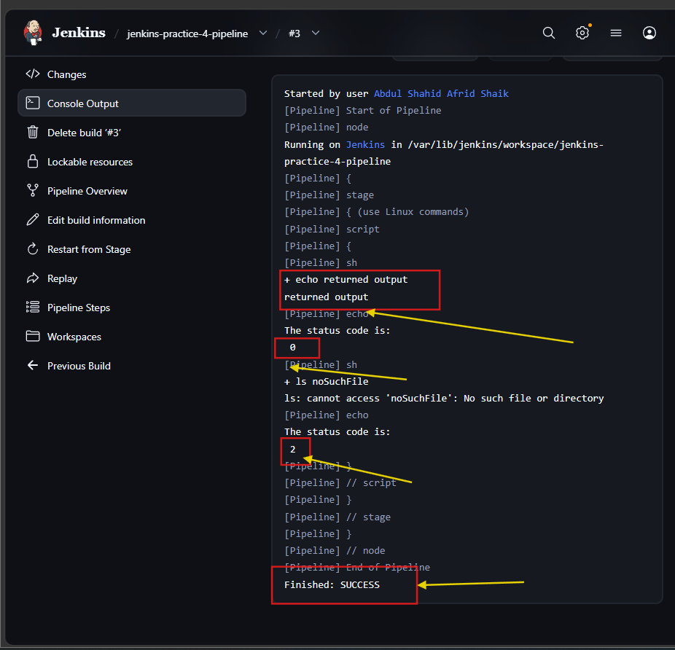

4.3 Return the Stderr
There is no direct returnStderr flag in the Jenkins sh step.
Instead, the article demonstrates redirecting stderr to stdout using Linux file descriptors.
The file descriptors are:
1 → stdout
2 → stderr
We can redirect stderr to stdout using:
2>&1

Pipeline
pipeline {
agent any

stages {
stage("use Linux commands") {
steps {
script {
def stderr = sh(
script: "ls noSuchFile 2>&1 || true",
returnStdout: true
)

print "The stderr is:\n ${stderr}"
}
}
}
}
}

How it works
The command:
ls noSuchFile
generates an error.
Then:
2>&1
redirects stderr (2) to stdout (1).
The:
|| true
forces the overall shell command to finish successfully so that the Pipeline does not abort because of the failed ls command.
Finally:
returnStdout: true
captures the redirected error message.

Expected output
The stderr is:
ls: cannot access 'noSuchFile': No such file or directory

Key Point
Because sh doesn't provide a direct stderr-return option, stderr can be redirected to stdout and then captured using returnStdout: true.

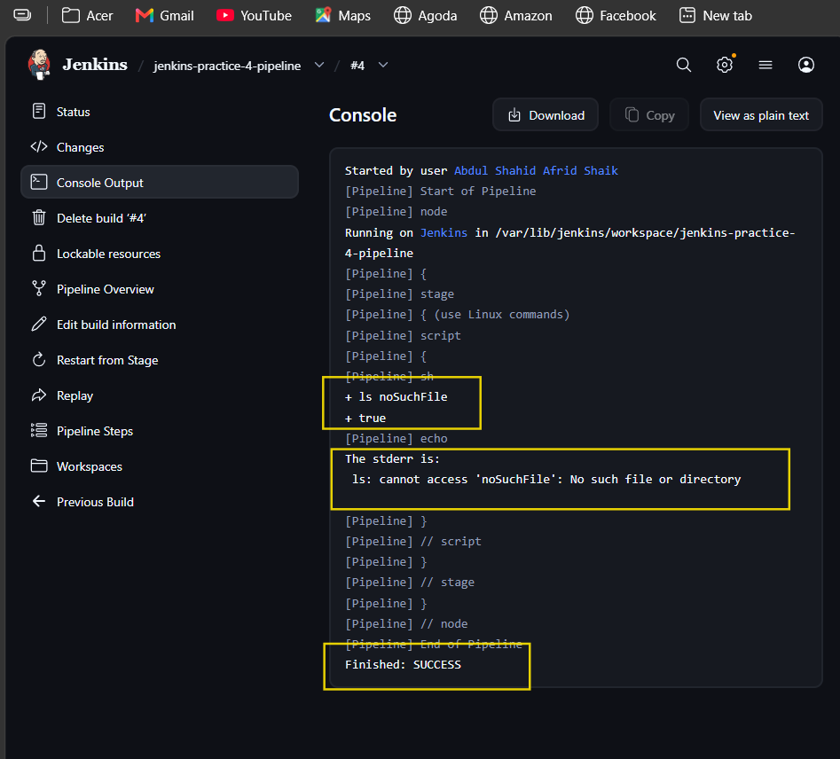
What is happening?
- ls noSuchFile generates an error.
- 2>&1 redirects stderr to stdout.
- returnStdout: true captures that output into the stderr variable.
- || true prevents the Jenkins step from failing.

4.4 Return Both in a Single Step
The article also demonstrates returning the output and status code together.

4.4.1 Return stdout + status

Pipeline
pipeline {
agent any

stages {
stage("use Linux commands") {
steps {
script {
def stdout_status = sh(
script: 'echo "this is stdout" && echo "$?"',
returnStdout: true
)

print "The stdout and status is:\n ${stdout_status}"
}
}
}
}
}

How it works
The first command:
echo "this is stdout"
produces stdout.
Then:
echo "$?"
prints the status code of the previous command.
Both outputs are returned through stdout.

Expected result
The variable contains:
this is stdout
0

Key Point
The && operator allows both command outputs to be included in the returned stdout.

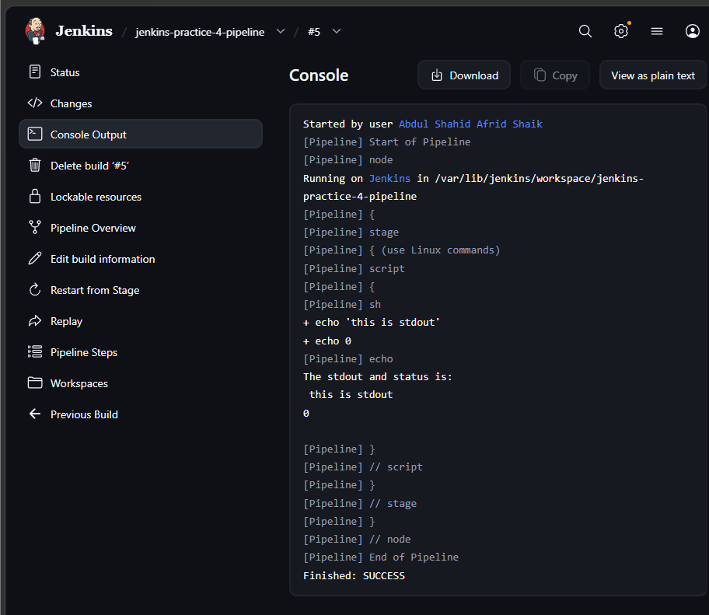

4.4.2 Return stderr + status
The article also demonstrates the same concept with stderr.

Pipeline
pipeline {
agent any

stages {
stage("use Linux commands") {
steps {
script {
def stderr_status = sh(
script: 'ls noSuchFile 2>&1 || true && echo "$?"',
returnStdout: true
)

print "The stderr and status is:\n ${stderr_status}"
}
}
}
}
}

How it works
ls noSuchFile
↓
Error generated
↓
2>&1
↓
stderr redirected to stdout
↓
echo "$?"
↓
status code included
↓
returnStdout: true
The returned variable contains the error message and status information.

Key Point
The article uses stderr redirection + returnStdout to capture both the error output and status information in a single Pipeline variable.
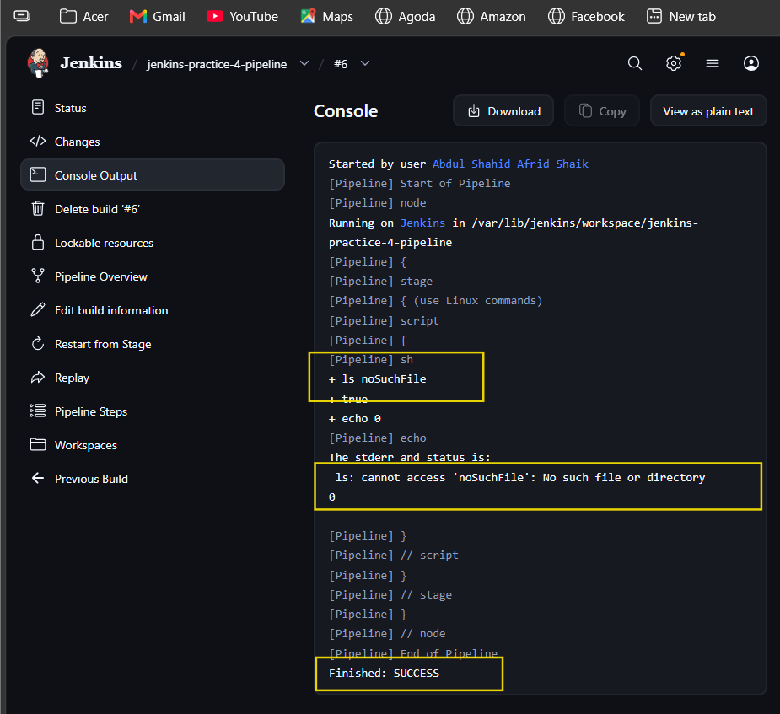

5. Complete Task Flow
Linux Commands
↓
sh
↓
┌────┼──────────────┐
↓ ↓ ↓
stdout stderr status code
↓ ↓ ↓
Normal Error 0 / non-zero
output output status
↓
returnStdout / returnStatus
↓
Pipeline variables
↓
Further processing

Important Jenkins Options
Option | Purpose
sh "command" | Executes a Linux shell command
returnStdout: true | Returns command stdout
returnStatus: true | Returns command exit status
$? | Gets the status code of the previous shell command
2>&1 | Redirects stderr to stdout
`

Task 4 — Key Points
- stdout contains normal command output.
- stderr contains error output.
- Status code indicates command success or failure.
- 0 means success.
- Non-zero means failure.
- Jenkins uses the sh step to execute Linux commands.
- returnStdout: true captures stdout.
- returnStatus: true captures the exit status.
- There is no direct returnStderr option in sh.
- stderr can be redirected to stdout using 2>&1.
- || true can prevent a failing shell command from aborting the Pipeline.
- stdout/stderr and status information can also be combined into a single returned value.
These notes follow the article's sections and examples for Task 4.

Task 5 — Updating Jenkins Plugins from Command Line

1. Overview
Jenkins has a powerful plugin management system. Plugins can normally be updated from the Jenkins Dashboard, but updating plugins from the command line is useful for administrators who want to automate plugin-management tasks.
This article covers two methods:
- Using the Jenkins CLI install-plugin command.
- Using the Jenkins CLI groovy command.
The article uses Jenkins CLI to perform plugin updates.

2. The Jenkins CLI
Jenkins provides a command-line interface called the Jenkins CLI.
It allows Jenkins to be accessed from a script or command line and is useful for automating routine tasks.
The main file used is:
jenkins-cli.jar
We downloaded the JAR from:
Jenkins → Manage Jenkins → CLI
The Jenkins CLI provides several commands.
For this task, the article uses:
list-plugins
install-plugin
groovy

list-plugins
Lists the installed Jenkins plugins.

install-plugin
Installs or updates plugins.

groovy
Executes a Groovy script through Jenkins CLI.

3. Using the install-plugin Command
This is the first method in the article.
The process is:
List installed plugins
↓
Find plugins needing updates
↓
Store plugin names in update_list
↓
Update plugins
↓
Restart Jenkins
↓
Verify

3.1 Getting the List of Plugins
After downloading jenkins-cli.jar, we used the Jenkins CLI to list installed plugins.
Our Jenkins is running on port 8081, so we adapted the article's command to our environment.
java -jar jenkins-cli.jar -s http://localhost:8081/ -http -auth 'USERNAME:API_TOKEN' list-plugins

Explanation
java -jar jenkins-cli.jar
Runs the Jenkins CLI.
-s http://localhost:8081/
Specifies the Jenkins server URL.
-http
Uses the HTTP CLI connection.
-auth 'USERNAME:API_TOKEN'
Authenticates with Jenkins.
list-plugins
Lists the installed plugins.

Plugin output
The output contains:
- Plugin short name
- Plugin name
- Installed version
- Newer version, if available
For example:
woodstox-core-api ... 7.2.2-10.vcb_629759b_2c2 (7.3.0-16.v017f30ed004c)
Here:
7.2.2-10.vcb_629759b_2c2
is the currently installed version.
And:
7.3.0-16.v017f30ed004c
inside parentheses is the newer available version.
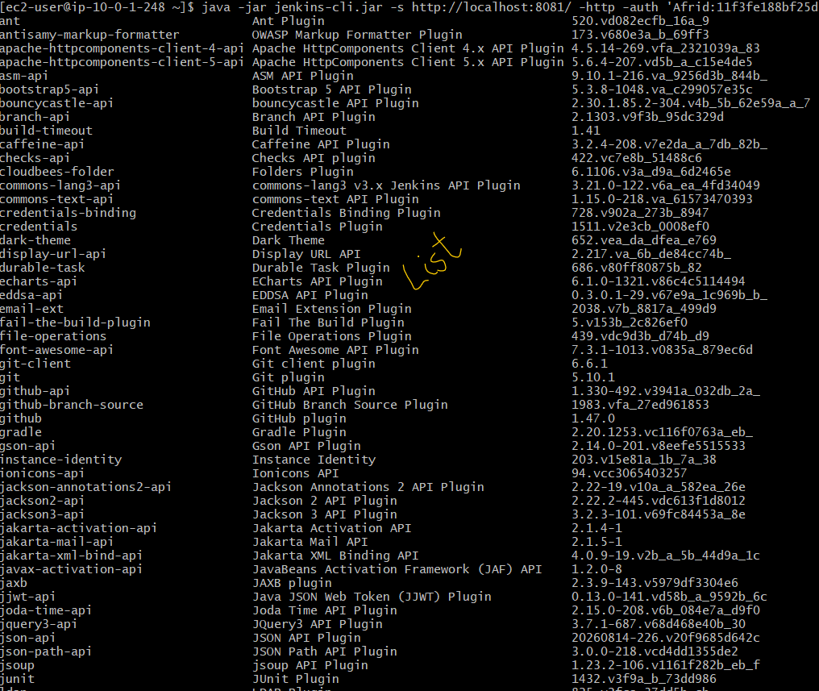

Finding Plugins That Need Updates
The article filters the list-plugins output to identify plugins that have newer versions.
We used:
update_list=$(java -jar jenkins-cli.jar -s http://localhost:8081/ -http -auth 'USERNAME:API_TOKEN' list-plugins | grep ")$" | awk '{print $1}')
Then:
echo $update_list
Our output contained:
apache-httpcomponents-client-5-api
commons-lang3-api
joda-time-api
junit
pipeline-graph-view
snakeyaml-engine-api
woodstox-core-api

How the command works
grep ")$"
Selects lines ending with ).
According to the article, those lines indicate plugins with newer versions available.
awk '{print $1}'
Gets the first column, which is the plugin's short name.
update_list=$(...)
Stores the plugin names in the update_list variable.

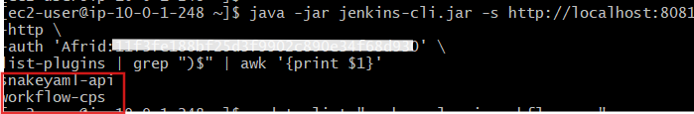

3.2 Updating the Plugins
The article uses the install-plugin command to install the plugins stored in update_list.
We used:
java -jar jenkins-cli.jar -s http://localhost:8081/ -http -auth 'USERNAME:API_TOKEN' install-plugin $update_list -restart

Explanation
install-plugin
Installs/updates the specified plugins.
$update_list
Contains the plugin names that need updates.
-restart
Restarts Jenkins after the plugins are installed.

Our output
Installing apache-httpcomponents-client-5-api from update center
Installing commons-lang3-api from update center
Installing joda-time-api from update center
Installing junit from update center
Installing pipeline-graph-view from update center
Installing snakeyaml-engine-api from update center
Installing woodstox-core-api from update center

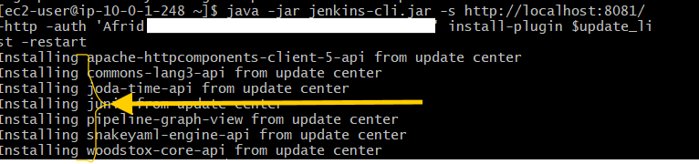

Verify the Plugins
After Jenkins restarted, we ran the article's verification command:
java -jar jenkins-cli.jar -s http://localhost:8081/ -http -auth 'USERNAME:API_TOKEN' list-plugins | grep ")$" | awk '{print $1}'
Initially, two plugins were still reported:
snakeyaml-api
workflow-cps
These were updated as well.
After Jenkins restarted again, we ran the verification command once more.

Final result
There was no output.
This means there were no plugins currently reported as having newer versions available.

No pending updates

4. Using the groovy Command
⏳ This is the remaining practical section of Task 5.
The article provides another method for updating plugins using the Jenkins CLI.
The Jenkins CLI's:
groovy
command can execute a Groovy script.
The article creates:
update_plugins.groovy
The script finds plugins with available updates, installs them, and safely restarts Jenkins.

update_plugins.groovy
The article uses:
import jenkins.model.*

def plugins = Jenkins.instance.pluginManager.plugins.findAll {
it -> it.hasUpdate()
}.collect {
it -> it.getShortName()
}

Jenkins.instance.pluginManager.install(plugins, false).each{ it -> it.get() }

Jenkins.instance.safeRestart()

Script explanation

1. Import Jenkins model
import jenkins.model.*
Imports the Jenkins model package.

2. Find plugins with updates
def plugins = Jenkins.instance.pluginManager.plugins.findAll {
it -> it.hasUpdate()
}.collect {
it -> it.getShortName()
}
The script:
- Gets the installed plugins.
- Finds plugins for which an update is available using hasUpdate().
- Gets their short names.
- Stores them in the plugins variable.

3. Install the plugins
Jenkins.instance.pluginManager.install(plugins, false).each{ it -> it.get() }
Installs/updates the plugins stored in plugins.

4. Restart Jenkins
Jenkins.instance.safeRestart()
Safely restarts Jenkins.

Running the Groovy Script
The article runs the script using:
java -jar jenkins-cli.jar -s http://localhost:8080 -auth admin:admin_secret_password groovy = < update_plugins.groovy
For our Jenkins environment, the URL/connection details need to match our working CLI setup:
java -jar jenkins-cli.jar -s http://localhost:8081/ -http -auth 'USERNAME:API_TOKEN' groovy = < update_plugins.groovy
The important part is:
groovy = < update_plugins.groovy
The groovy command executes the Groovy script, while:
< update_plugins.groovy
feeds the script contents to Jenkins CLI through standard input.
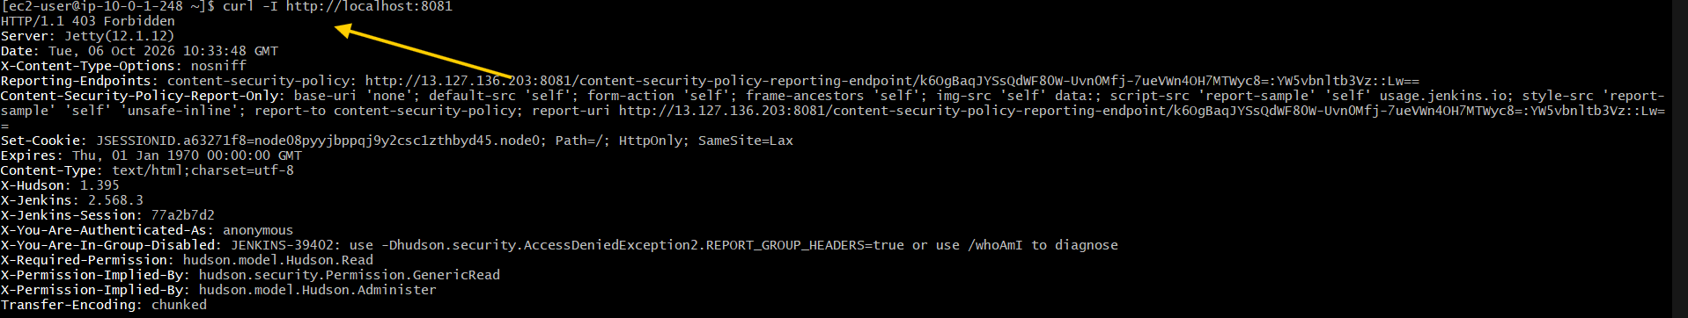

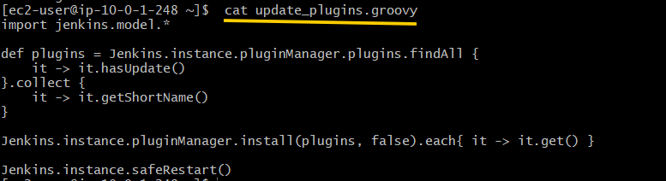

Verify Again
The article verifies the plugin updates by running:
java -jar jenkins-cli.jar -s http://localhost:8080 -auth admin:admin_secret_password list-plugins | grep ")$" | awk '{print $1}'
For our Jenkins:
java -jar jenkins-cli.jar -s http://localhost:8081/ -http -auth 'USERNAME:API_TOKEN' list-plugins | grep ")$" | awk '{print $1}'
If there is no output, there are no plugins requiring an update.

5. Conclusion
The article explains two ways to update Jenkins plugins from the command line.

Method 1 — install-plugin
list-plugins
↓
Filter plugins needing updates
↓
update_list
↓
install-plugin
↓
-restart
↓
Verify

Task 6 — Cleaning Jenkins Workspace

1. Overview
A Jenkins workspace is a storage location where a build stores files related to the job.
The workspace is reused by successive builds of the same job, so it may need to be cleaned to avoid conflicts with existing files or output artifacts.
In this task, we cover three ways to clean the Jenkins workspace:
- deleteDir() step
- cleanWs() step
- Linux rm command

2. What is a Jenkins Workspace?
A Jenkins workspace is a directory created on the node where a job is executing.
It stores files required by the build, such as:
- Source code
- Output artifacts
- Dockerfiles
- Other files generated during the build
Each Jenkins job has its own workspace on the node.
For example:
/var/lib/jenkins/workspace/test-folder/test-job
Here:
/var/lib/jenkins
is the Jenkins root directory.
The workspace structure follows the job/folder name.

Checking the workspace
pwd
ls
Example:
/var/lib/jenkins/workspace
If the job is inside a folder:
/var/lib/jenkins/workspace/test-folder/test-job

3. Creating a File in the Workspace
We can create a file in the workspace using a Jenkins Pipeline.
pipeline {
agent any

stages {
stage("create file") {
steps {
script {
sh "touch myfile.txt"
}
}
}
}
}
The touch command creates:
myfile.txt
inside the current Jenkins workspace.
We can verify it using:
sh "ls"
Example output:
+ touch myfile.txt
+ ls
myfile.txt

Key point
The workspace allows the build to create and work with files during execution.

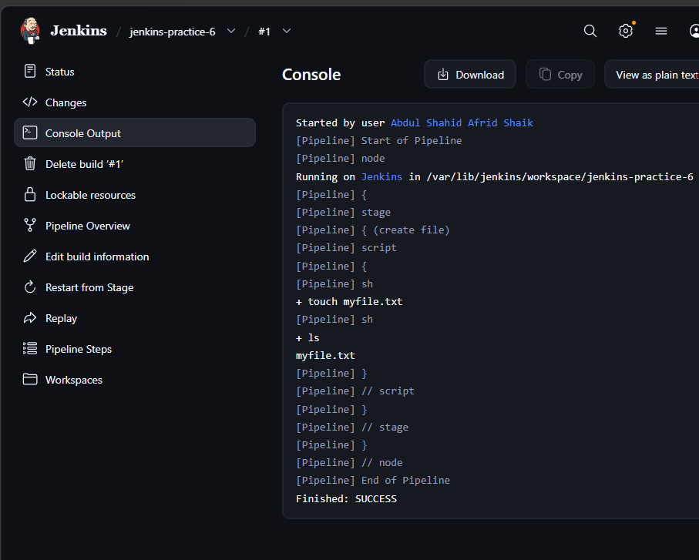

4. Cleaning the Workspace Using deleteDir()
deleteDir() is a Jenkins Pipeline step used to remove files from the current directory.
It is part of the Workflow Basic Steps plugin, which is normally available by default.
Example:
pipeline {
agent any

stages {
stage("create file") {
steps {
script {
sh "touch myfile.txt"
}
}
}

stage("clean workspace") {
steps {
script {
sh "ls"
deleteDir()
sh "ls"
}
}
}
}
}

How it works
First:
sh "ls"
shows:
myfile.txt
Then:
deleteDir()
removes the contents of the current workspace directory.
The second:
sh "ls"
shows no files.

Expected console output
+ touch myfile.txt

+ ls
myfile.txt

[Pipeline] deleteDir

+ ls

Key point
deleteDir() removes the contents of the current workspace directory.

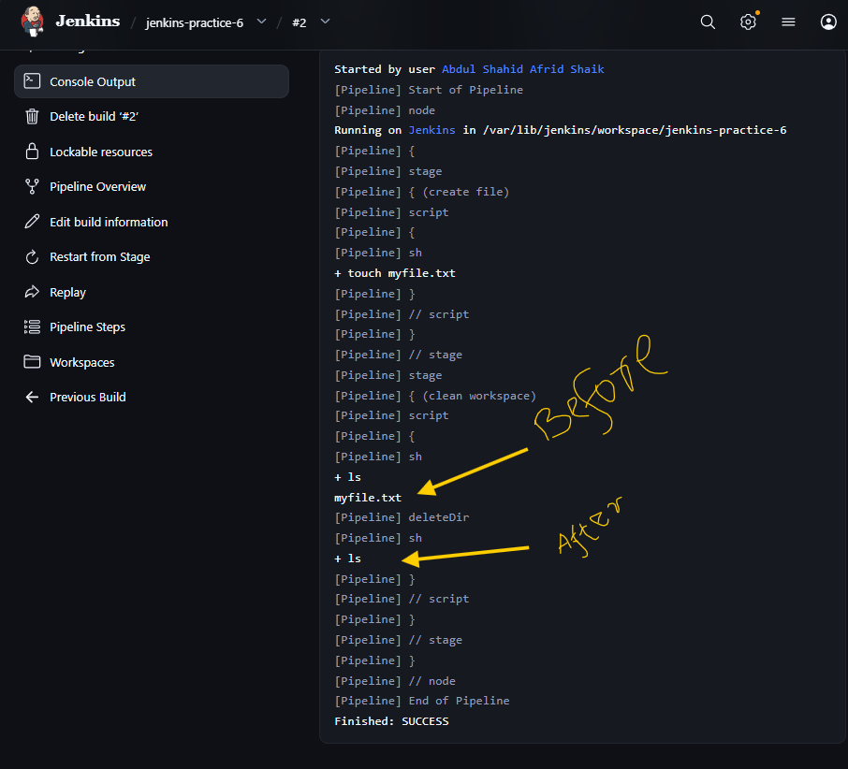

5. Cleaning the Workspace Using cleanWs()
Another way to clean the Jenkins workspace is using:
cleanWs()
cleanWs() is provided by the Workspace Cleanup Plugin.
Therefore, the Workspace Cleanup Plugin must be installed before using this step.

Plugin
Workspace Cleanup Plugin
After installing the plugin, we can use:
pipeline {
agent any

stages {
stage("create file") {
steps {
script {
sh "touch myfile.txt"
}
}
}

stage("clean workspace") {
steps {
script {
sh "ls"
cleanWs()
sh "ls"
}
}
}
}
}

How it works
Before cleanup:
+ ls
myfile.txt
Then:
cleanWs()
cleans the workspace.
The final:
sh "ls"
shows no content.

Key point
cleanWs() cleans the Jenkins workspace and is provided by the Workspace Cleanup Plugin.

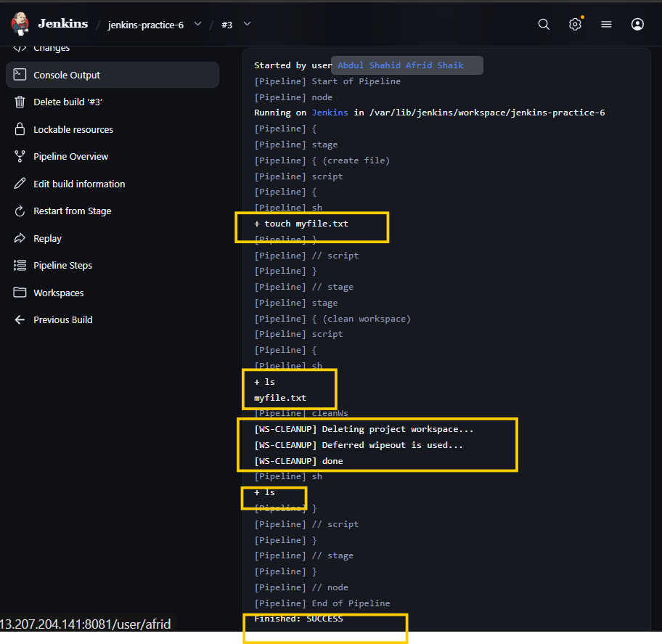

6. Cleaning the Workspace Using rm Command
Jenkins allows us to use the native commands of the operating system on the node where the job executes.
For a Linux node, we can use Linux shell commands.
For example:
pipeline {
agent any

stages {
stage("create file") {
steps {
script {
sh "touch myfile.txt"
}
}
}

stage("clean workspace") {
steps {
script {
sh "ls"
sh "rm *"
sh "ls"
}
}
}
}
}

How it works
First:
sh "ls"
shows:
myfile.txt
Then:
sh "rm *"
removes the files matching *.
Finally:
sh "ls"
shows no content.

Expected output
+ ls
myfile.txt

+ rm myfile.txt

+ ls

Key point
rm * uses the native Linux command to remove files from the workspace instead of using a Jenkins cleanup step/plugin.
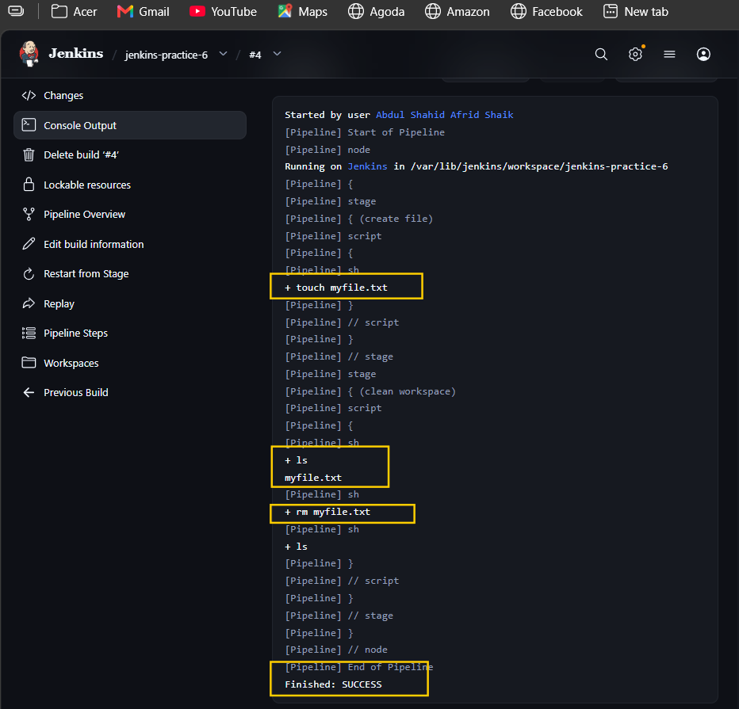

7. Comparison of Workspace Cleanup Methods
Method | Requirement | Purpose
deleteDir() | Workflow Basic Steps | Removes contents of the current directory
cleanWs() | Workspace Cleanup Plugin | Cleans the Jenkins workspace
rm * | Linux node | Uses native Linux command to remove files

8. Conclusion
A Jenkins workspace is a directory on the node where a job stores files related to its build.
Because the workspace is reused by successive builds, old files can cause conflicts.
The article covers three methods to clean the workspace:

deleteDir()
Removes the contents of the current directory.

cleanWs()
Cleans the workspace using the Workspace Cleanup Plugin.

rm *
Uses the native Linux rm command to remove files from the workspace.

Task 7 — Serializing Groovy Objects to JSON in Jenkins Pipeline

1. Overview
Serialization is the process of converting an object into a standard format that can be stored or transferred.
In this task, we implemented how to serialize Groovy objects into JSON strings inside a Jenkins Pipeline.
We used two methods from the article:
- Groovy JsonOutput class
- Jenkins writeJSON step

2. Creating Groovy Object in Jenkins
Jenkins allows us to use Groovy scripts inside a Pipeline through the script block.
We created a Groovy variable called student:
def student = [
"name": "John",
"age": 20,
"subjects": ["English", "Math", "Physics"]
]
The complete Pipeline we implemented:
pipeline {
agent any

stages {
stage("create groovy variable") {
steps {
script {
def student = [
"name": "John",
"age": 20,
"subjects": ["English", "Math", "Physics"]
]

echo "The variable type is ${student.getClass()}"
echo "The student name is ${student.name}"
echo "The student age is ${student.age}"
echo "The first subject is ${student.subjects[0]}"
}
}
}
}
}

Output
The variable type is class java.util.LinkedHashMap
The student name is John
The student age is 20
The first subject is English
The student variable is a Map, whose implementation is LinkedHashMap.

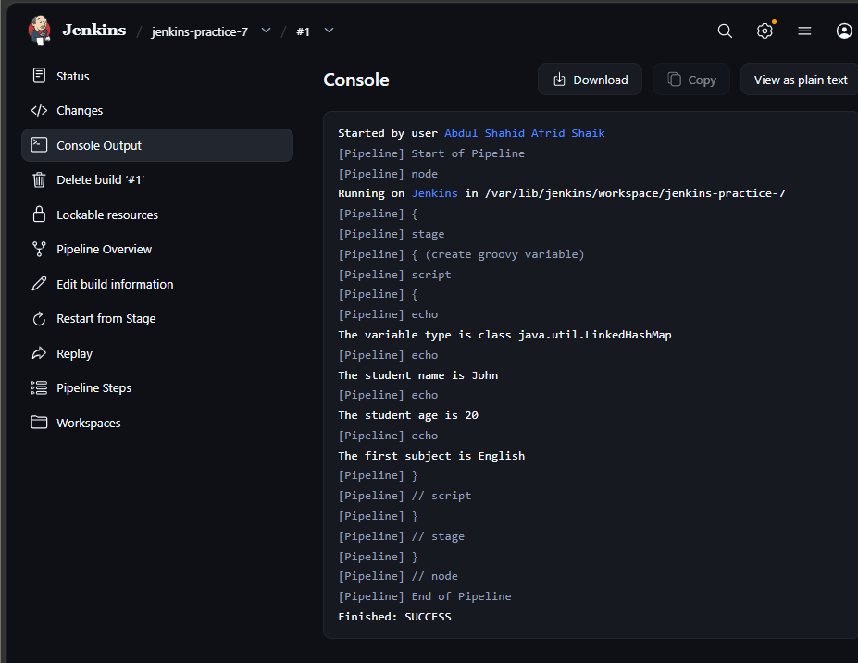

3. Creating JSON Using JsonOutput
The article uses the Groovy JsonOutput class to serialize the Groovy object into a JSON string.
We imported:
import groovy.json.JsonOutput

Pipeline implemented
import groovy.json.JsonOutput

pipeline {
agent any

stages {
stage("serialize groovy variable") {
steps {
script {
def student = [
"name": "John",
"age": 20,
"subjects": ["English", "Math", "Physics"]
]

def json_string = JsonOutput.toJson(student)
def json_pretty = JsonOutput.prettyPrint(json_string)

echo "${json_pretty}"
}
}
}
}
}

Important methods
JsonOutput.toJson(student)
Converts the Groovy object into a JSON string.
JsonOutput.prettyPrint(json_string)
Formats the JSON output to make it easier to read.

Output
{
"name": "John",
"age": 20,
"subjects": [
"English",
"Math",
"Physics"
]
}

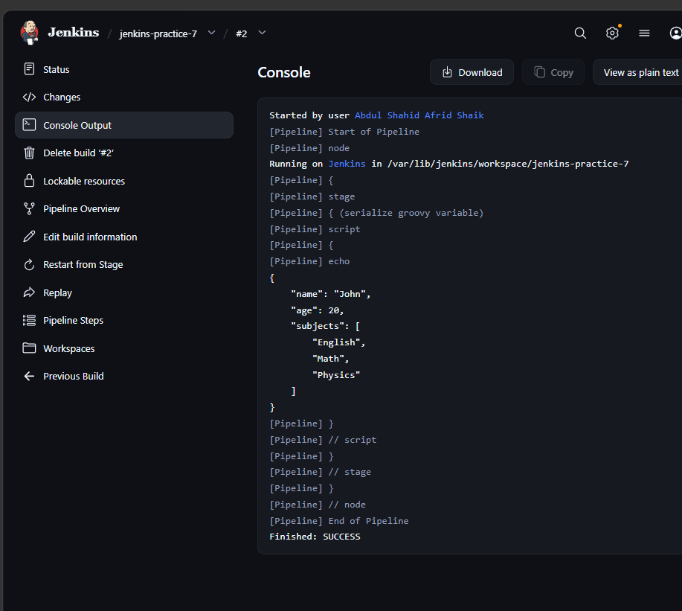

Key point
JsonOutput is a Groovy class used to serialize Groovy objects into JSON strings.

4. Creating JSON Using writeJSON
The second method in the article is the Jenkins writeJSON step.
writeJSON is part of the:
Pipeline Utility Steps Plugin
So we installed the Pipeline Utility Steps Plugin before using it.

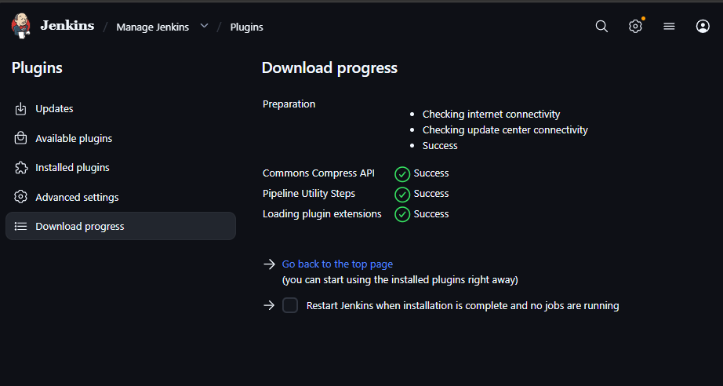 Pipeline implemented
pipeline {
agent any

stages {
stage("serialize groovy variable") {
steps {
script {
def student = [
"name": "John",
"age": 20,
"subjects": ["English", "Math", "Physics"]
]

def json_pretty = writeJSON(
json: student,
returnText: true,
pretty: 4
)

echo "${json_pretty}"
}
}
}
}
}

Parameters used

json
json: student
Specifies the Groovy object that needs to be converted into JSON.

returnText
returnText: true
Returns the JSON string as the output of the step instead of writing it to a file.

pretty
pretty: 4
Formats the JSON output using indentation.

Output
{
"name": "John",
"age": 20,
"subjects": [
"English",
"Math",
"Physics"
]
}

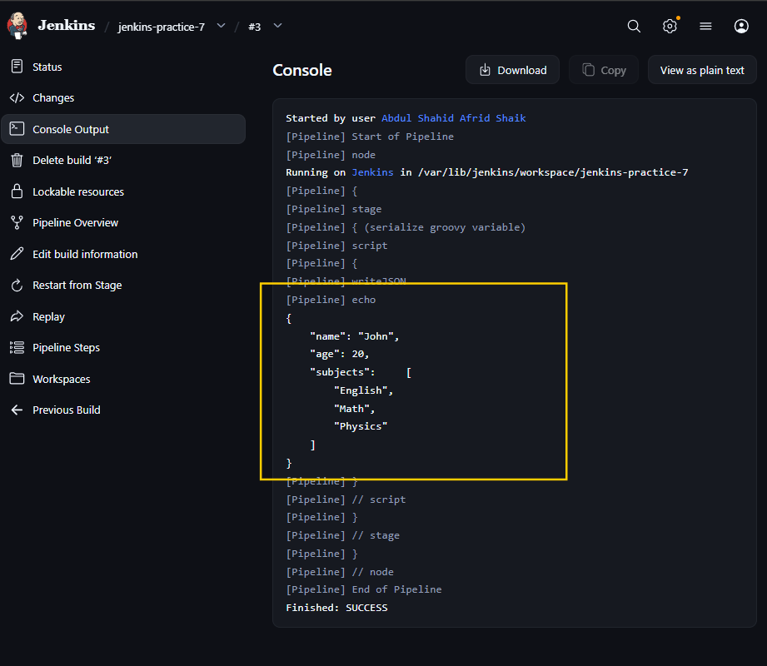

5. Methods Implemented

Method 1 — JsonOutput
Groovy Object
↓
JsonOutput.toJson()
↓
JSON String
Uses the Groovy groovy.json.JsonOutput class.

Method 2 — writeJSON
Groovy Object
↓
writeJSON()
↓
JSON String
Uses the Jenkins writeJSON step from the Pipeline Utility Steps Plugin.

6. Difference Between the Two Methods
JsonOutput | writeJSON
Groovy class | Jenkins Pipeline step
From groovy.json | From Pipeline Utility Steps Plugin
Uses toJson() | Uses writeJSON()
Used to serialize Groovy objects | Used to serialize Groovy objects
Both methods produced similar JSON output because we converted the same student object.

7. Conclusion
In this task, we learned how to create Groovy objects inside a Jenkins Pipeline and serialize them into JSON strings.
We implemented both methods covered in the article:
- JsonOutput.toJson()
- writeJSON()
The Pipeline Utility Steps Plugin was installed for the writeJSON implementation.

Task 8 — Jenkins Pipeline sh “Bad Substitution” Error

1. Introduction
Jenkins is widely used for CI/CD automation. One common issue in Jenkins Pipelines is the Pipeline sh bad substitution error.
This error generally occurs when there is a mismatch between Groovy variable syntax and shell variable syntax inside a Jenkins sh step. Pasted text

2. Understanding the Bad Substitution Error
The error commonly occurs when Jenkins executes shell commands containing variables such as:
${env.BUILD_NUMBER}
inside an sh step.
For example:
sh 'echo ${env.BUILD_NUMBER}'
This can result in:
Bad substitution
The article identifies three common causes:
- Incorrect quotation marks
- Shell discrepancies
- Incorrect variable scope/syntax Pasted text

3. Diagnosing the Issue
The article recommends simplifying the Pipeline to reproduce and isolate the problem.
We used:
pipeline {
agent any

stages {
stage('Test') {
steps {
sh 'echo ${env.BUILD_NUMBER}'
}
}
}
}
This produced the:
Bad substitution
error.
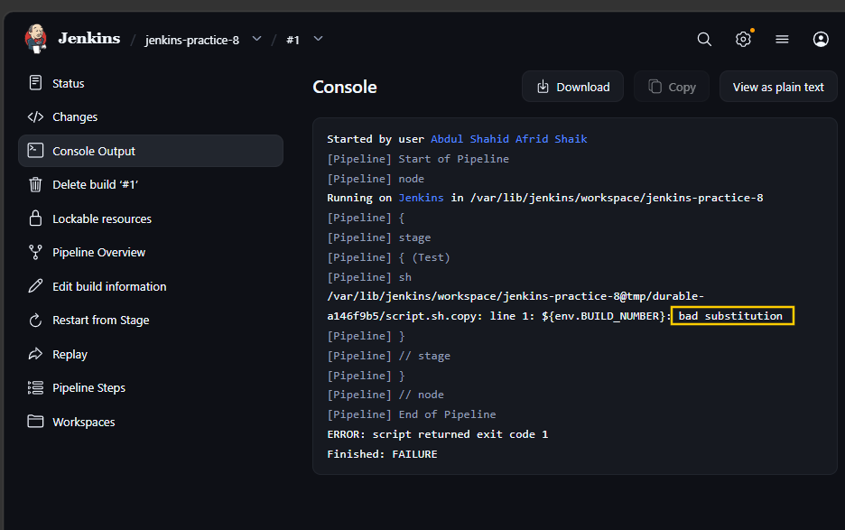

Key point
The problem occurs because ${env.BUILD_NUMBER} is Jenkins/Groovy-style variable syntax, while the sh step is executed by a shell.

4. Fix Using Double Quotes
The first solution from the article is to use double quotes.
We changed:
sh 'echo ${env.BUILD_NUMBER}'
to:
sh "echo ${env.BUILD_NUMBER}"

Complete Pipeline
pipeline {
agent any

stages {
stage('Test') {
steps {
sh "echo ${env.BUILD_NUMBER}"
}
}
}
}
The build successfully printed the Jenkins build number.
Example:
+ echo 2

2

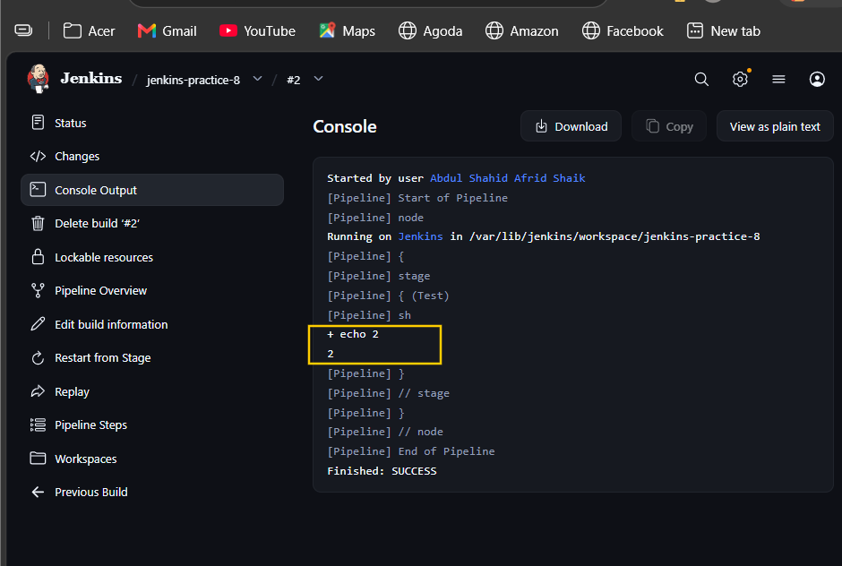

Key point
Double quotes allow Groovy to interpolate ${env.BUILD_NUMBER} before the command is passed to the shell. Pasted text

5. Fix Using Triple Double Quotes
The article also describes using triple double quotes for Groovy string interpolation.
We implemented:
pipeline {
agent any

stages {
stage('Test') {
steps {
sh """echo ${env.BUILD_NUMBER}"""
}
}
}
}
The build successfully displayed the build number.
Example:
+ echo 3
3

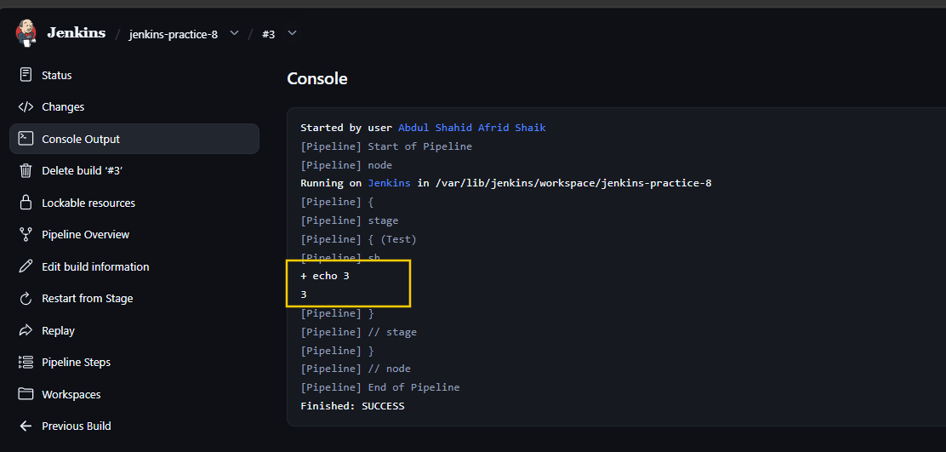 Key point
Triple double quotes are useful for longer or more complex shell commands because they make handling quotes easier and reduce escaping. Pasted text

6. Ensuring Correct Shell Usage — Bash
The article explains that Jenkins normally uses the sh shell, and some syntax may require Bash.
We implemented the Bash approach:
pipeline {
agent any

stages {
stage('Test') {
steps {
sh '''#!/bin/bash -xe
echo ${BUILD_NUMBER}
'''
}
}
}
}
The build successfully displayed the build number.
Example:
+ echo 4
4

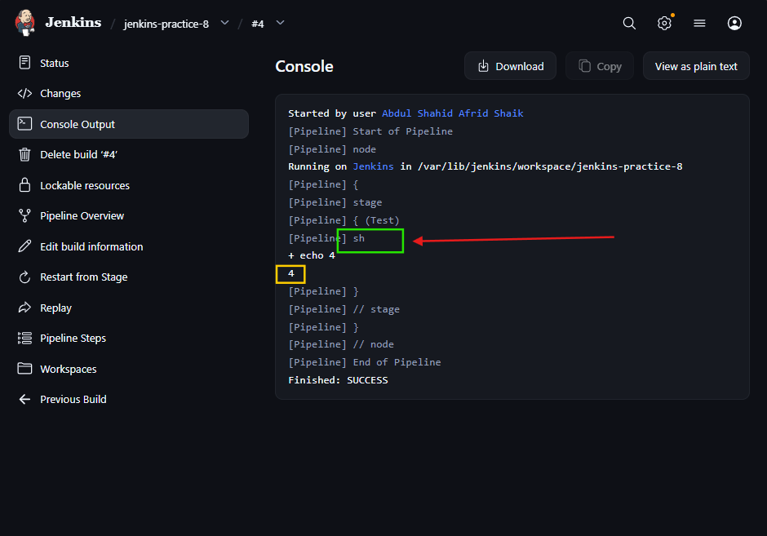

Key point
#!/bin/bash -xe
explicitly tells Jenkins to use Bash for the shell script. The -x option provides command tracing and -e causes the shell to stop when a command fails. Pasted text

7. Using withEnv for Environment Variables
The article also provides withEnv as a way to explicitly define environment variables for the shell.
We implemented:
pipeline {
agent any

stages {
stage('Test') {
steps {
withEnv(["BUILD_NUMBER=${env.BUILD_NUMBER}"]) {
sh '''#!/bin/bash -xe
echo ${BUILD_NUMBER}
'''
}
}
}
}
}
The build successfully displayed the build number.
Example:
+ echo 5
5

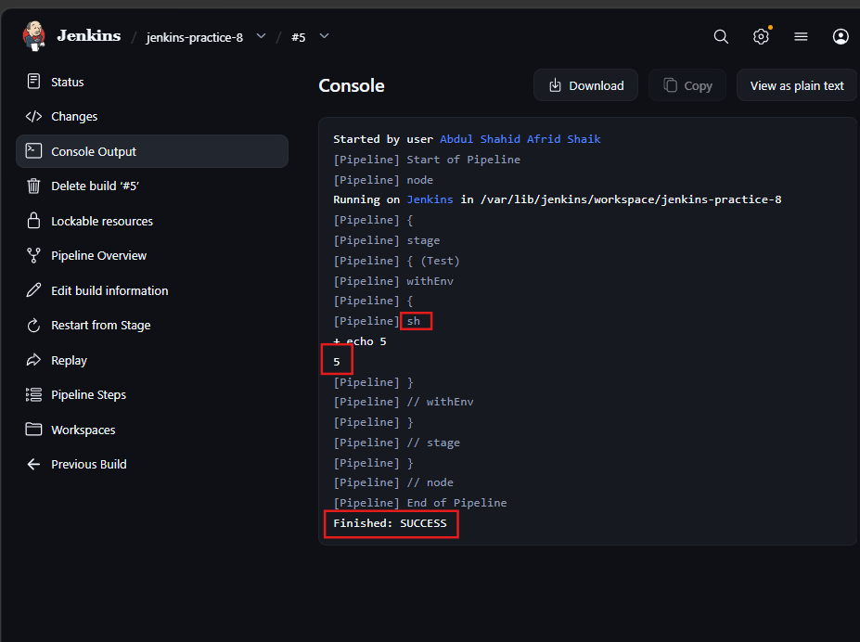

How it works
This:
withEnv(["BUILD_NUMBER=${env.BUILD_NUMBER}"])
makes BUILD_NUMBER available as an environment variable inside the shell.
The shell then uses:
${BUILD_NUMBER}
The article explains that withEnv provides explicit control over environment variables available to the shell. Pasted text

8. Implementations Completed
Method | Implementation | Result
Reproduce error | sh 'echo ${env.BUILD_NUMBER}' | Bad substitution ❌
Double quotes | sh "echo ${env.BUILD_NUMBER}" | Successful ✅
Triple quotes | sh """echo ${env.BUILD_NUMBER}""" | Successful ✅
Bash | #!/bin/bash -xe | Successful ✅
withEnv | withEnv(["BUILD_NUMBER=..."]) | Successful ✅

9. Important Difference

Problem
sh 'echo ${env.BUILD_NUMBER}'
The shell receives the ${env.BUILD_NUMBER} syntax and reports:
Bad substitution

Double quotes
sh "echo ${env.BUILD_NUMBER}"
Groovy handles the variable interpolation before the command reaches the shell.

withEnv
withEnv(["BUILD_NUMBER=${env.BUILD_NUMBER}"]) {
sh 'echo ${BUILD_NUMBER}'
}
The Jenkins environment variable is explicitly made available to the shell.

10. Conclusion

The article explains that Bad substitution can occur because of incorrect quoting, shell differences, or incorrect environment-variable syntax.
We implemented the following solutions from the article:
- Double quotes
- Triple double quotes
- Explicit Bash shell
- withEnv
We also reproduced the error first using a simplified Pipeline so that the problem could be clearly identified.

Task 9 — Jenkins Pipeline Global Variables

1. What are Global Variables?
Global variables are predefined Jenkins objects or values that can be accessed throughout a Jenkins Pipeline.
They provide information about:
- Build environment
- Job
- Build
- Build parameters
- Jenkins system information Pasted text

2. env Variables
The env object provides information about the current build environment.

Important variables
env.JOB_NAME
env.BUILD_NUMBER
env.WORKSPACE
- env.JOB_NAME → Current job name
- env.BUILD_NUMBER → Current build number
- env.WORKSPACE → Current workspace path Pasted text

Example
pipeline {
agent any

stages {
stage('Environment Info') {
steps {
echo "Building ${env.JOB_NAME} #${env.BUILD_NUMBER}"
echo "Workspace: ${env.WORKSPACE}"
}
}
}
}

Output
Building jenkins-practice-9 #1
Workspace: /var/lib/jenkins/workspace/jenkins-practice-9

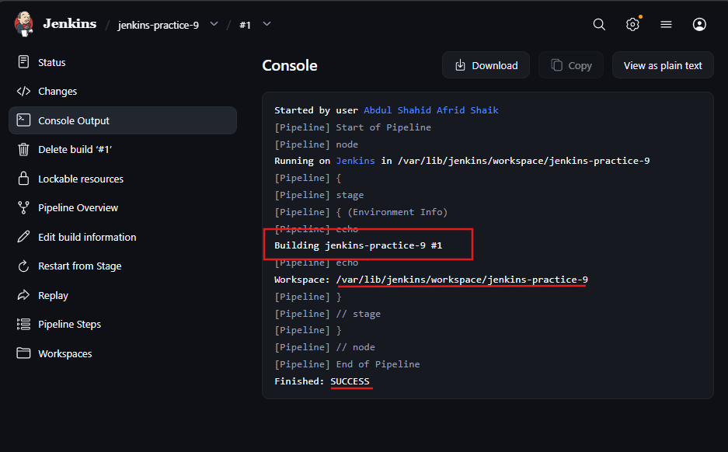

3. currentBuild Variables
The currentBuild object provides information about the current build.

Important variables
currentBuild.result
currentBuild.duration
currentBuild.previousBuild
- currentBuild.result → Build result such as SUCCESS, FAILURE, UNSTABLE
- currentBuild.duration → Build duration in milliseconds
- currentBuild.previousBuild → Information about the previous build Pasted text

Example
post {
always {
echo "Build result: ${currentBuild.result}"
echo "Build duration: ${currentBuild.duration}ms"
}
}

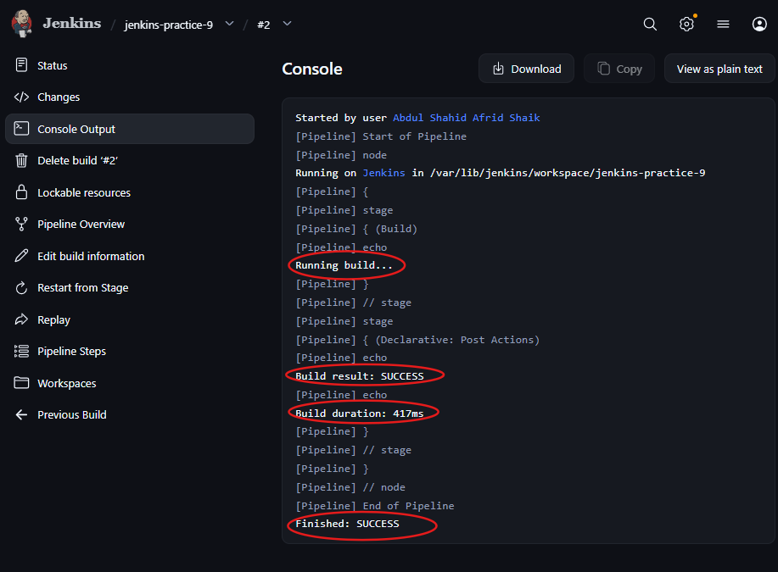

4. params Variables
The params object is used to access build parameters defined in the Jenkins job.
For example, we created:
parameters {
choice(
name: 'DEPLOY_ENV',
choices: ['dev', 'staging', 'prod'],
description: 'Deployment environment'
)
}
When we click Build with Parameters, Jenkins allows us to select the environment.
We access the selected value using:
params.DEPLOY_ENV
Example:
echo "Deploying to ${params.DEPLOY_ENV} environment"
If we select dev:
Deploying to dev environment
Pasted text
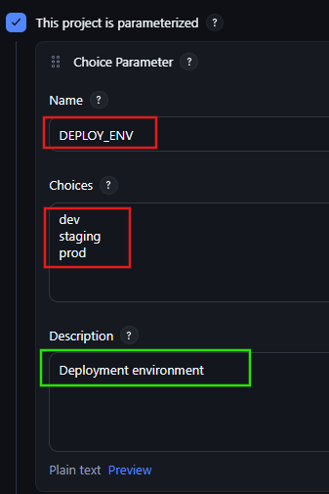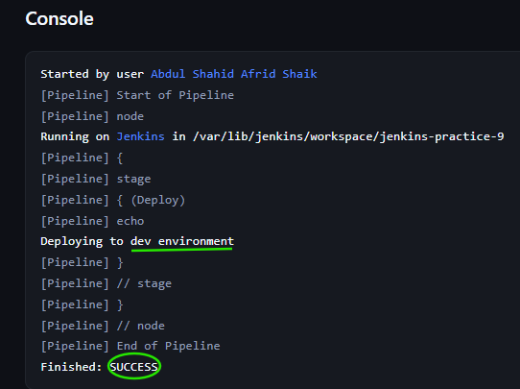

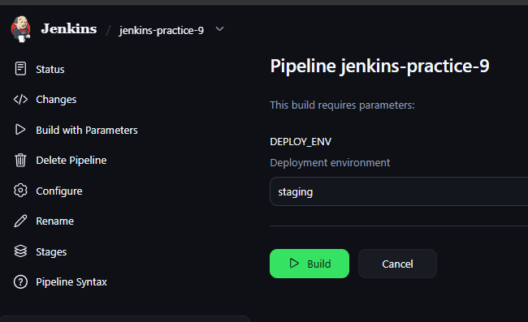
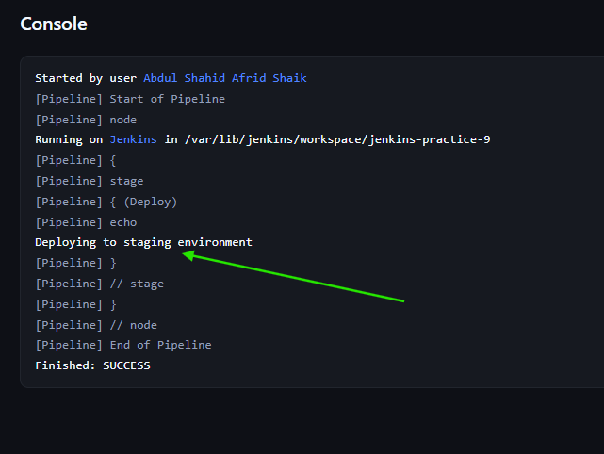
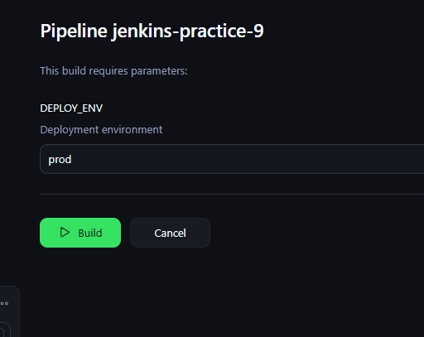
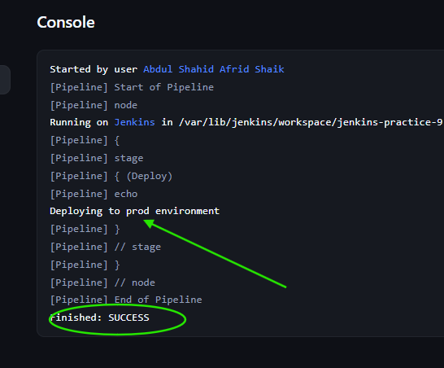

5. Accessing Global Variables
Global variables can be accessed using different syntax.

Using env
env.JOB_NAME
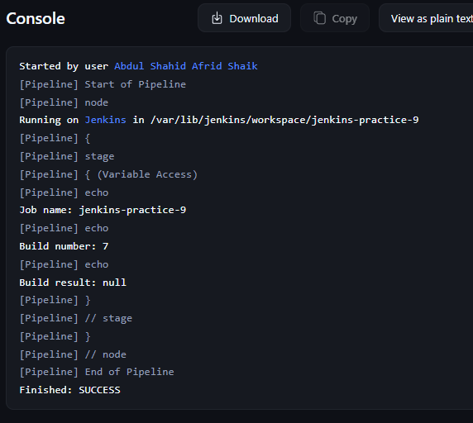

Directly accessing environment variable
BUILD_NUMBER

Using currentBuild
currentBuild.result
Example:
pipeline {
agent any

stages {
stage('Variable Access') {
steps {
echo "Job name: ${env.JOB_NAME}"
echo "Build number: ${BUILD_NUMBER}"
echo "Build result: ${currentBuild.result}"
}
}
}
}
Pasted text

6. Using Build Parameters — VERSION
The article also demonstrates a VERSION build parameter.
parameters {
string(
name: 'VERSION',
defaultValue: '1.0.0',
description: 'Version to deploy'
)
}
Then access it using:
params.VERSION
Example:
echo "Deploying version ${params.VERSION}"
This allows different versions to be specified when triggering the build. Pasted text
Note: The article uses a string parameter for VERSION. A dropdown would require a choice parameter, which is different from the article's example.
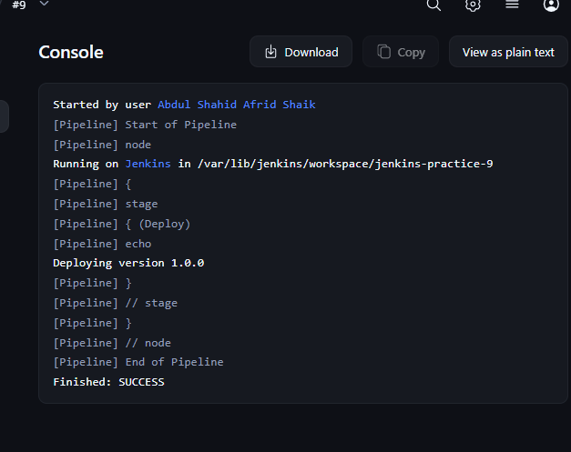

7. Important Difference
Global variable | Used for
env | Environment/job information
currentBuild | Current build information
params | Build parameters

Easy way to remember
env → Environment
currentBuild → Current build
params → Parameters

8. Custom Global Variables
The article also explains that Jenkins can have custom global variables configured through:
Dashboard → Manage Jenkins → Configure System → Environment variables
For example:
Name: COMPANY_NAME
Value: TechCorp
Then a Pipeline can access it using:
echo "Welcome to ${env.COMPANY_NAME}'s Jenkins Pipeline!"
Pasted text
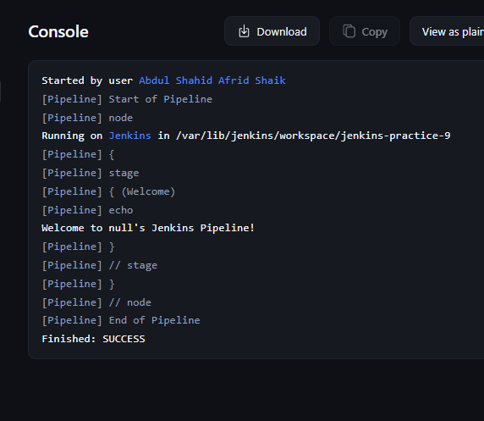

9. Key Points for Interview/Teammate Explanation
What are Jenkins global variables?
Predefined Jenkins objects/values that provide information about the environment, job, build, and parameters.
What is env?
Used to access environment information such as job name, build number and workspace.
What is currentBuild?
Used to access information about the current build, such as result and duration.
What is params?
Used to access values provided through Build with Parameters.
Example:
env.JOB_NAME → Job information
env.BUILD_NUMBER → Build information
currentBuild.result → Build status
params.VERSION → Parameter value

Task 10 — Get Last Successful Build Status Using Jenkins APIs

Objective
To retrieve Jenkins build information using the Jenkins API through curl and Jenkins Pipeline.

Step 1 — Using curl
We used the existing job:
jenkins-practice-9
Command:
curl --user 'USERNAME:API_TOKEN' \
http://localhost:8081/job/jenkins-practice-9/lastSuccessfulBuild/buildNumber
The command returns the build number of the last successful build.
Example:
10

Other API endpoints from the article
Last build:
curl --user 'USERNAME:API_TOKEN' \
http://localhost:8081/job/jenkins-practice-9/lastBuild/buildNumber
Last failed build:
curl --user 'USERNAME:API_TOKEN' \
http://localhost:8081/job/jenkins-practice-9/lastFailedBuild/buildNumber

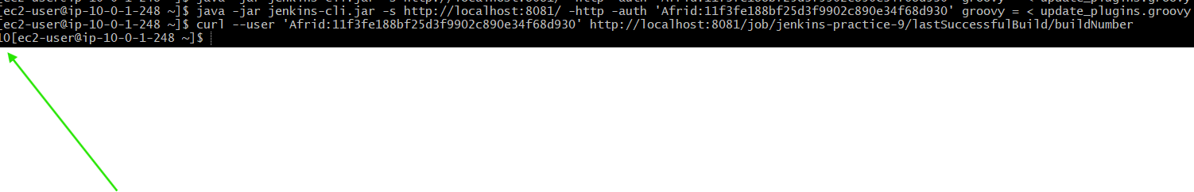

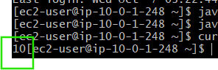

Step 2 — Jenkins Pipeline
Created:
jenkins-practice-10
The article's Pipeline approach uses Jenkins APIs to access:
getLastSuccessfulBuild()
getLastFailedBuild()
getLastBuild()
The Pipeline initially required Jenkins Script Approval because these Jenkins internal API methods are restricted by the Pipeline sandbox.
We approved the required signatures while testing the article's example.
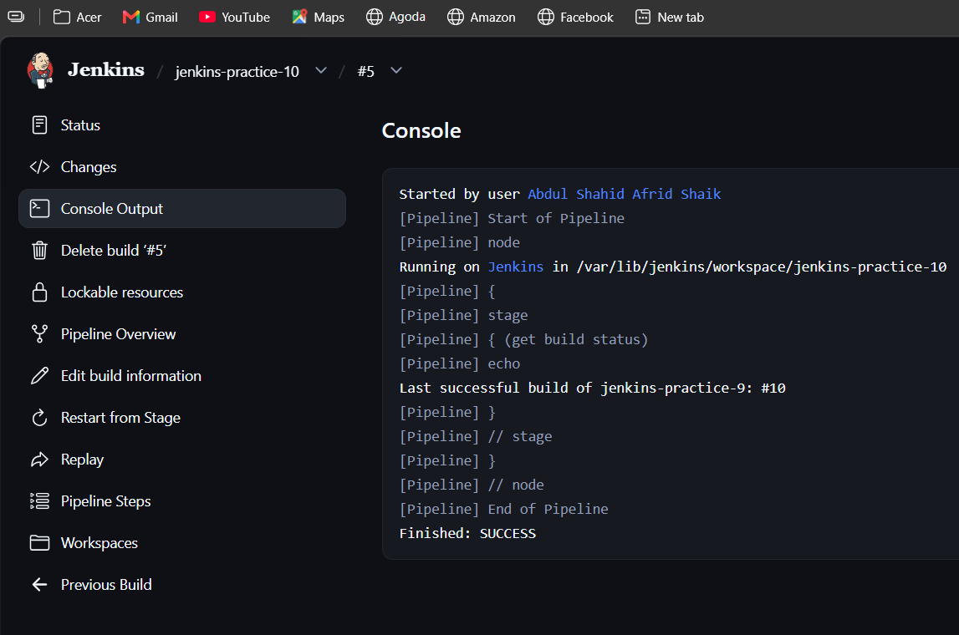

Result
- Successfully accessed Jenkins build information using the Jenkins API.
- curl was used to retrieve the last successful build number.
- The Pipeline approach demonstrated accessing the last successful, failed, and last build through Jenkins APIs.
- Jenkins Script Security may require administrator approval for internal Jenkins API methods.

Key Point
Jenkins APIs allow us to programmatically retrieve build information such as the last successful, last failed, and last build.

