Step 1: Create a Public GitHub Repository Using Jenkins Pipeline

Objective
Create a public GitHub repository through Jenkins and add eight JSON configuration files.

1. Verify Jenkins–GitHub Connection
Existing Jenkins credential used: github-pat
Created a temporary Pipeline job named github-connection-check to verify GitHub authentication and repository API access.
Verification:
- GitHub authentication returned HTTP 200.
- Repository listing API returned HTTP 200.
- Jenkins build status: SUCCESS.

2. Create the Jenkins Pipeline Job
Created a Jenkins Pipeline job named config-automation.
The Pipeline was configured to:
- Authenticate with GitHub using the github-pat credential.
- Check whether the repository exists.
- Create a public repository if it does not exist.
- Clone the repository.
- Create the required folders and JSON files.
- Validate the JSON files.
- Commit and push the files to the main branch.

3. Repository Details
- Repository name: jenkins-config-automation
- Visibility: Public
- GitHub account: shahid8256
- Repository URL: https://github.com/shahid8256/jenkins-config-automation

4. Repository Structure
jenkins-config-automation/
├── Environment/
│ ├── dev.json
│ ├── stage.json
│ ├── uat.json
│ └── prod.json
└── nodes/
├── dev.json
├── stage.json
├── uat.json
└── prod.json

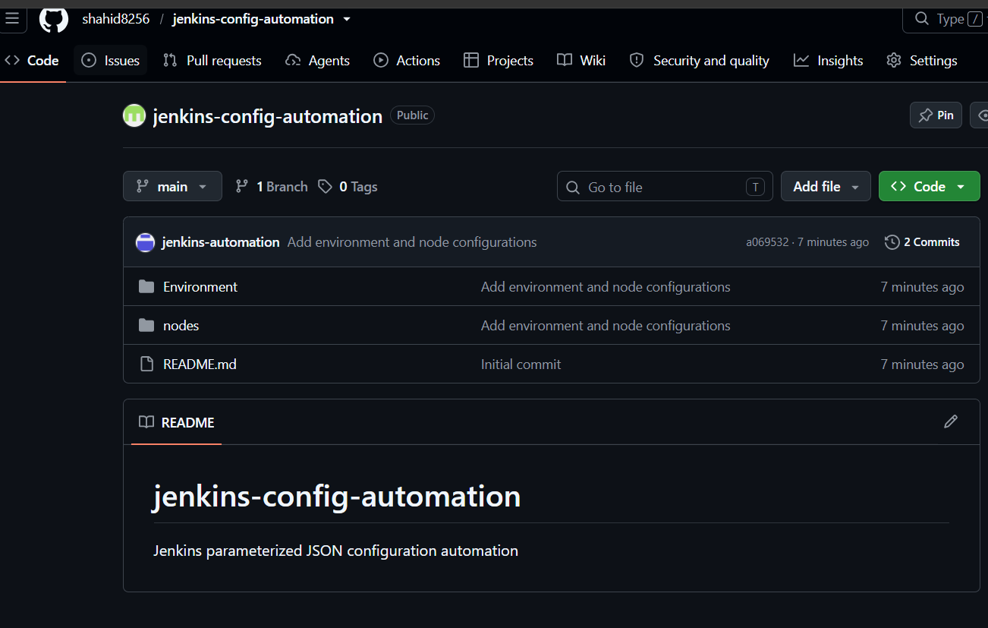

5. JSON Configuration Parameters
Environment JSON files
- environment
- region
- replicas
- debug

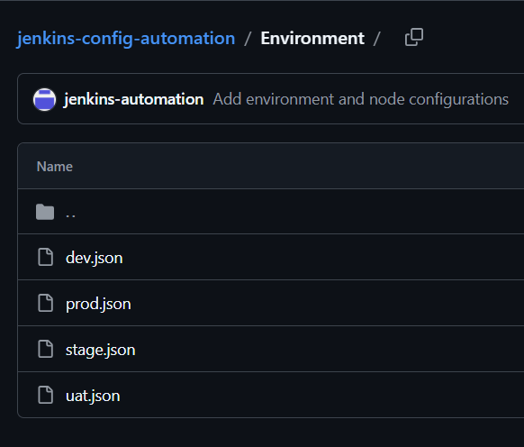
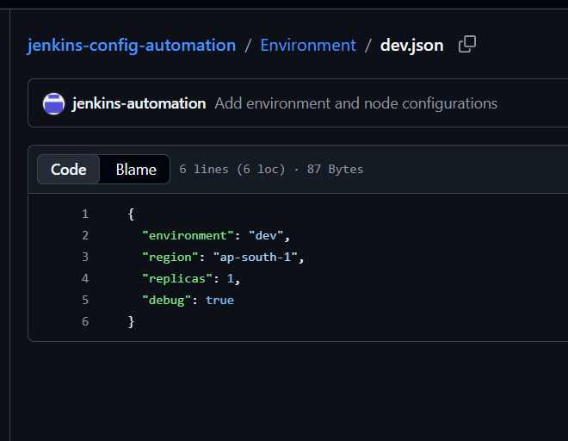
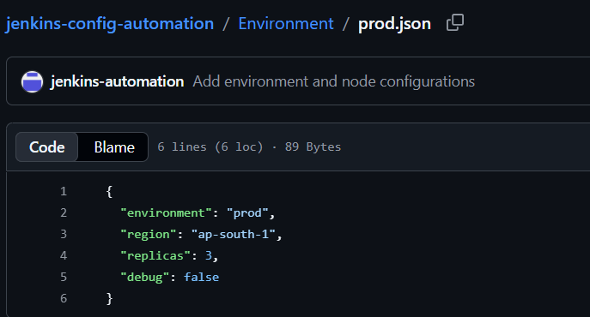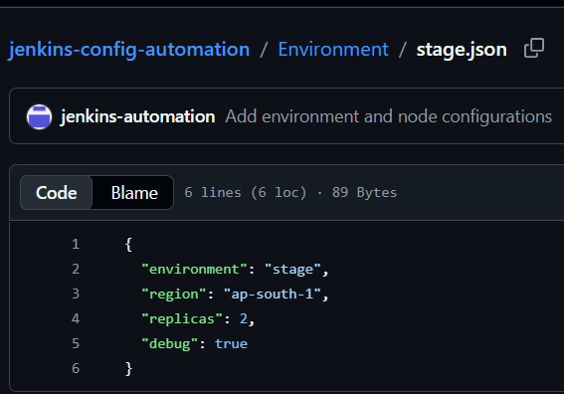

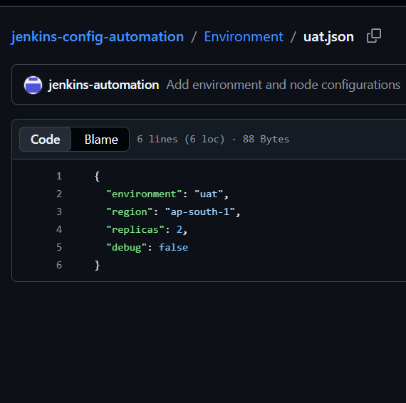

Nodes JSON files
- environment
- node_type
- min_nodes
- max_nodes
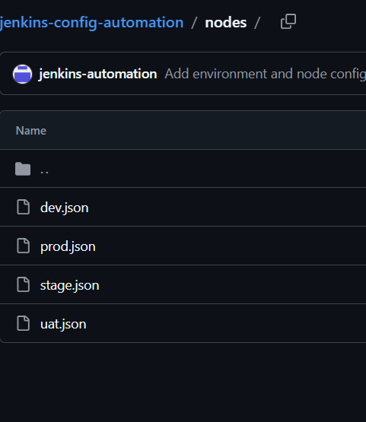

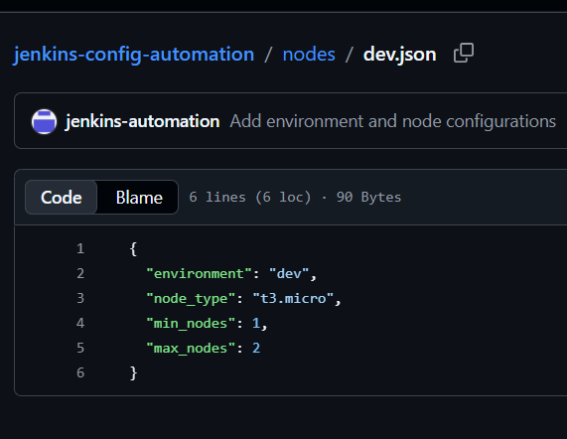
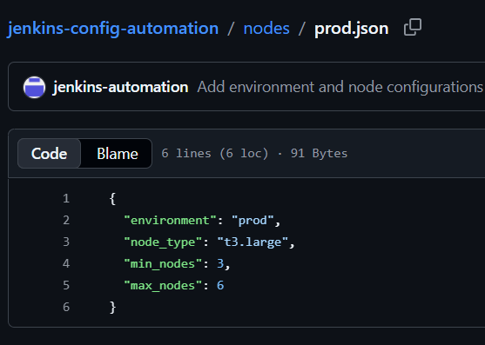
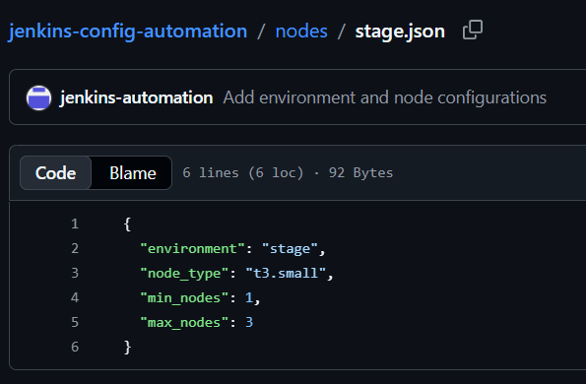
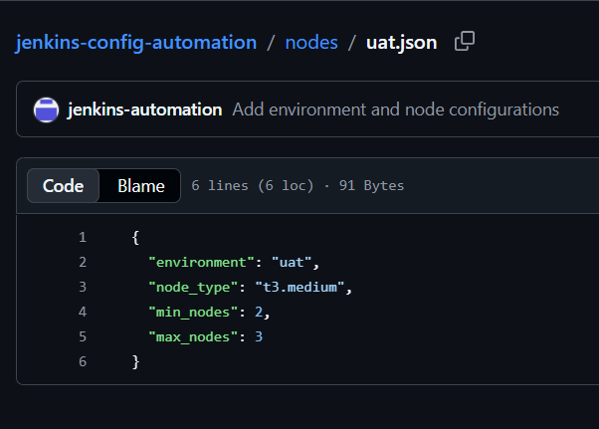
Each JSON file contains configuration values appropriate to its environment.

Step 2: Environment Pipeline Using Jenkins

Objective
Create a parameterized Jenkins Pipeline that updates environment-specific JSON configuration files and pushes the changes to a GitHub feature branch.

1. Create the Jenkins Job
- Job name: environment-pipeline
- Job type: Pipeline
- Definition: Pipeline script

2. Configure Build with Parameters
The following parameters were configured in the pipeline:
Parameter | Type | Purpose
ENVIRONMENT | Choice | Select dev, stage, uat, or prod
DEPLOYMENT_VERSION | String | Specify application version
INSTANCE_TYPE | Choice | Select instance type
DATABASE_ENABLED | Boolean | Enable or disable database
MONITORING_ENABLED | Boolean | Enable or disable monitoring
BACKUP_ENABLED | Boolean | Enable or disable backups
LOG_LEVEL | Choice | Select application logging level
These parameters allow the user to customize the configuration during each build.

3. Pipeline Execution Stages

Stage 1: Checkout Repository
- Used the existing Jenkins credential github-pat.
- Cloned the public GitHub repository into the Jenkins workspace.
- Repository: jenkins-config-automation.

Stage 2: Update Environment JSON
- Read the selected JSON file using readJSON.
- Updated the configuration using the selected build parameters.
- Wrote the modified configuration using writeJSON.
Example: Selecting dev updates Environment/dev.json.
Additional parameters added:
- instance_type
- database_enabled
- monitoring_enabled
- backup_enabled
- deployment_version
- log_level

Stage 3: Validate JSON
- Used the command python3 -m json.tool to validate the selected JSON file.
- Confirmed that the updated file contains valid JSON syntax.

Stage 4: Push Feature Branch
- Configured Git username and email.
- Created or checked out the environment-specific feature branch.
- Staged and committed the modified JSON file.
- Pushed the branch to GitHub using the existing Jenkins credential.

4. Git Branch and Commit Details
Feature branch: feature/environment-dev
Commit ID: ec20244
Commit message: Update dev environment configuration
The changes were pushed successfully to the remote GitHub repository.

5. Error Encountered and Resolution
Issue: The Build with Parameters button was initially unavailable.
Resolution: Saved and ran the Declarative Pipeline so Jenkins could register the parameters. Afterward, the Build with Parameters option became available.
Another issue occurred during JSON validation because the environment parameter was not passed correctly to the shell command. This was fixed by explicitly referencing params.ENVIRONMENT in the validation stage.

6. Screenshots to Attach
- Jenkins environment-pipeline job configuration.
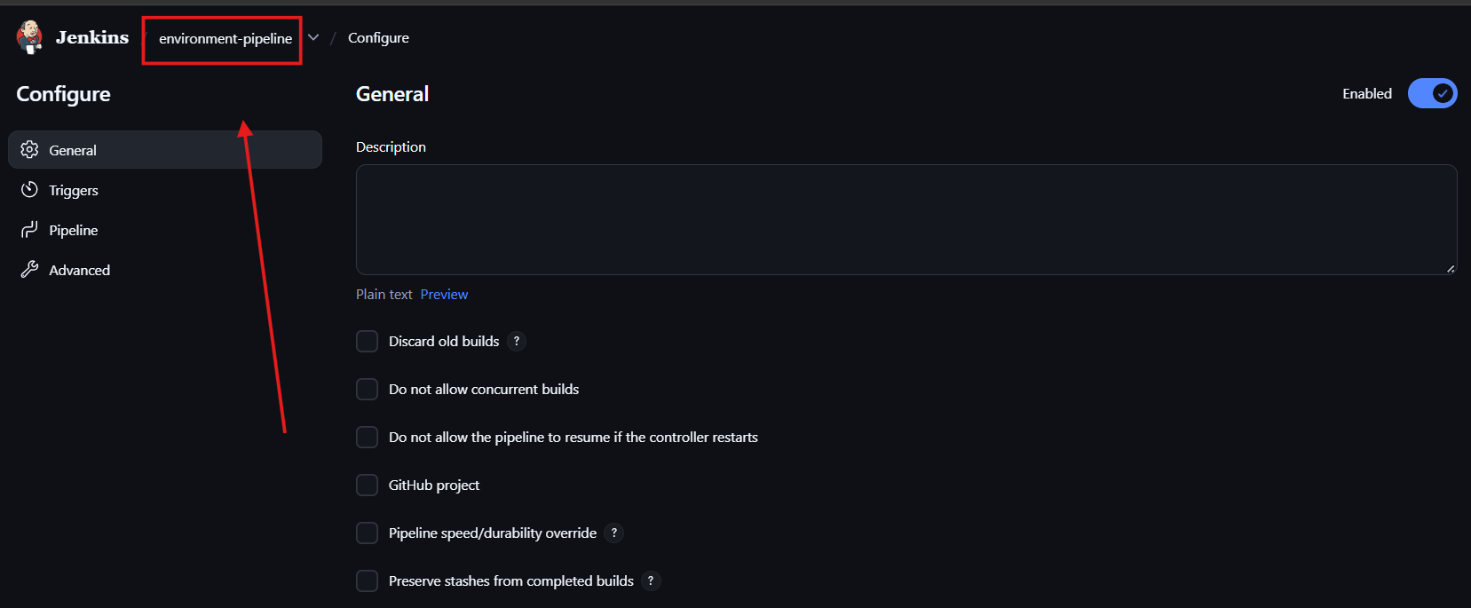
- Build with Parameters page.
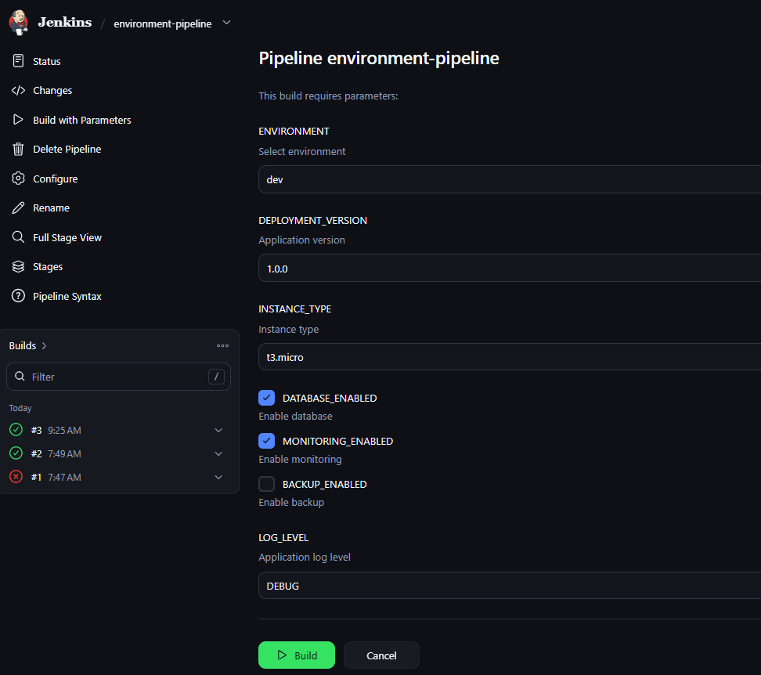
- Console Output showing successful JSON update and validation.
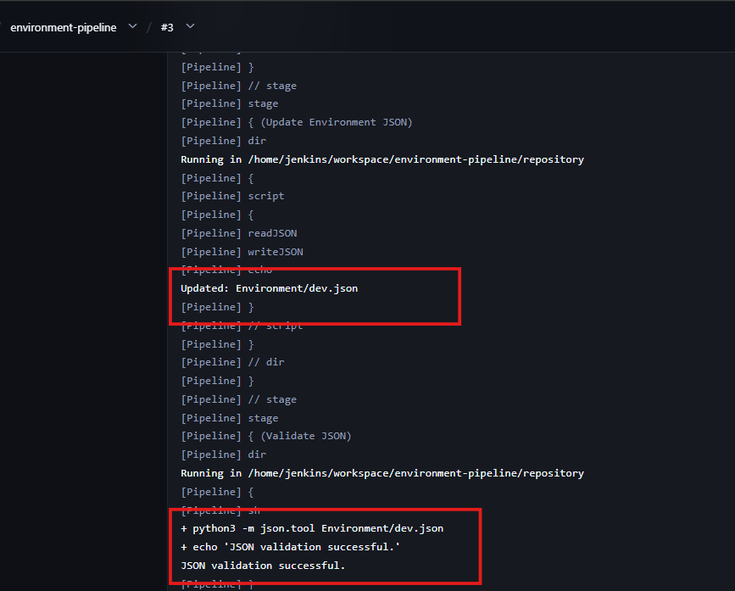
- Console Output showing feature branch push.
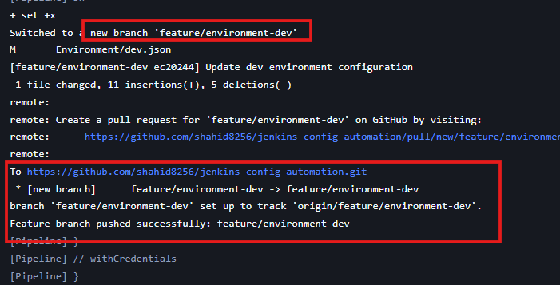
- GitHub repository displaying feature/environment-dev.
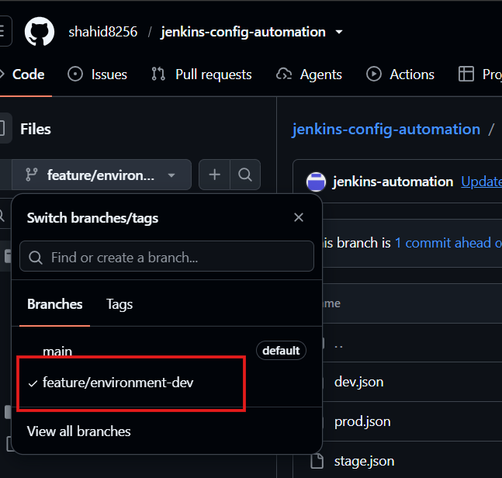
- Updated Environment/dev.json on the feature branch.
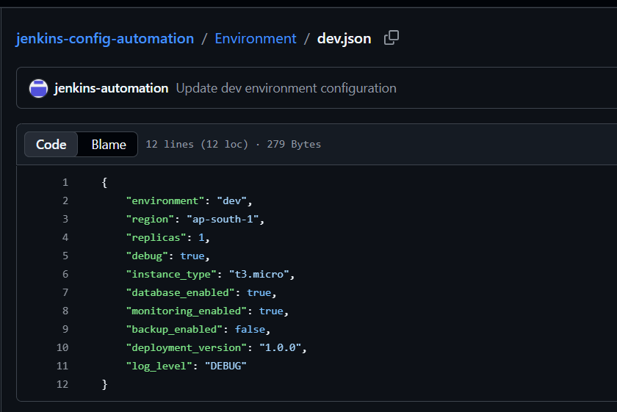

Step 3: Configure Jenkins Tools and Credentials
Configured Jenkins with the tools and credentials required by the pipeline.
Tools
- JDK: JDK21
- Maven: Default Maven
- Git: Installed on the Jenkins agent.
Credentials
- github-pat – Used for GitHub checkout and pushing changes.
- SonarQube token credential – Used for SonarQube analysis.
- nexus-credentials – Configured for Nexus authentication.

Step 4: Create the Jenkins Pipeline Job
Created a Jenkins Pipeline job named:
environment-pipeline
The job uses parameters to select the target environment and configuration values.
Parameters configured:
Parameter | Options / Default
ENVIRONMENT | dev, stage, uat, prod
DEPLOYMENT_VERSION | 1.0.0
INSTANCE_TYPE | t3.micro, t3.small, t3.medium, t3.large
DATABASE_ENABLED | true
MONITORING_ENABLED | true
BACKUP_ENABLED | false
LOG_LEVEL | DEBUG, INFO, WARN, ERROR
These parameters are used by the pipeline to update the selected environment's JSON file.

Step 5: Configure Pipeline from SCM
Initially, the pipeline was configured using a script in Jenkins. We then added the pipeline file to the GitHub repository and changed the Jenkins job to retrieve it from source control.
Jenkins configuration:
- Definition: Pipeline script from SCM
- SCM: Git
- Repository URL: https://github.com/shahid8256/jenkins-config-automation.git
- Credentials: github-pat
- Branch: */main
- Script Path: jenkinsfile
The filename is lowercase jenkinsfile.
We committed the file to the feature branch, created Pull Request #3, and merged it into main. The merge commit was 4cf1407.

Step 6: Validate Inputs
The pipeline starts with a Validate Inputs stage.
It processes the supplied build parameters before performing the configuration and build operations.

Step 7: Checkout Repository
The pipeline checks out the GitHub repository into:
/home/jenkins/workspace/environment-pipeline/repository
The configured Git username and email are:
- Username: Jenkins
- Email: jenkins@example.com
The pipeline prepares a feature branch based on the selected environment.
Example:
feature/environment-dev
The current checkout logic uses git checkout -B, which resets the local feature branch to the checked-out main commit. This became important when troubleshooting the automatic PR stage.

Step 8: Create Java Application
The pipeline creates the Java application directory:
java-app/src/main/java
It writes the following files:
- java-app/src/main/java/App.java
- java-app/pom.xml
The Maven configuration includes the Java compiler, JAR packaging, and SonarQube Maven plugin configuration.
The project uses Java release 17 and runs using the configured JDK 21 tool.

Step 9: Update Environment JSON
The pipeline reads the JSON file for the selected environment and updates it using the build parameters.
For example, when ENVIRONMENT=dev, it processes:
Environment/dev.json
The updated configuration includes:
- Deployment version
- Instance type
- Database enabled setting
- Monitoring enabled setting
- Backup enabled setting
- Log level
The pipeline uses Jenkins' readJSON and writeJSON steps to read and write the configuration.

Step 10: Validate JSON
After updating the selected file, the pipeline validates its JSON syntax using Python.
Example command from the build log:
python3 -m json.tool Environment/dev.json
The validation stage completed successfully in the recorded builds.

Step 11: Maven Build
The Java application is built from the java-app directory using:
mvn -B clean verify
Maven performs the configured compilation and verification steps and packages the application as a JAR.
Generated artifact:
java-app/target/jenkins-java-app-1.0.0.jar
The build log confirmed:
BUILD SUCCESS
Jenkins also archived the generated JAR as a build artifact.
The log reported that there were no test sources to compile or tests to run.

Step 12: SonarQube Analysis
Configured the pipeline to analyze the Java application using SonarQube.
Configuration:
- SonarQube installation name in Jenkins: SonarQube
- SonarQube URL: http://13.234.213.65:9002
- Project key: jenkins-java-app
- Project name: jenkins-java-app
The pipeline runs the Maven SonarQube analysis goal:
mvn -B sonar:sonar
The analysis completed successfully. The console log displayed:
ANALYSIS SUCCESSFUL
The results are available on the SonarQube project dashboard.

Step 13: Push Feature Branch
The pipeline stages the following tracked files:
- Environment/dev.json or the selected environment's JSON file
- java-app/src/main/java/App.java
- java-app/pom.xml
It attempts to commit the changes with a message similar to:
Update dev configuration and Java app
The branch is pushed to GitHub using the GitHub PAT.
We encountered two Git behaviours during troubleshooting:
- Nothing to commit: The tracked files had no new changes.
- Non-fast-forward rejection: Git rejected a push when the remote feature branch contained commits not present in the local branch.
We removed --force-with-lease from the push command to avoid force-overwriting the remote feature branch. However, removing the force option alone does not fix the branch history or PR creation logic.

Step 14: Create and Merge Pull Request
The pipeline uses the GitHub API to create or locate a pull request.
Source branch example:
feature/environment-dev
Target branch:
main
The intended process is to create a pull request and request an automatic merge through GitHub's API.
We successfully created and manually merged Pull Request #3 to add the pipeline file to main.
However, the pipeline's own automatic PR stage has not yet completed successfully in the latest recorded build.
The latest console output reported:
No commits between main and feature/environment-dev
The reason is that the checkout stage resets the local feature branch to the current main commit, and the push stage can push that same commit to the remote feature branch. When no additional tracked changes create a separate commit, GitHub has nothing new to include in the pull request.
This branch-handling logic still needs to be corrected for reliable automatic PR creation and merging.

Step 15: Upload Artifact to Nexus
The pipeline contains an Upload to Nexus stage intended to upload the generated JAR.
Configuration:
- Nexus URL: http://13.234.213.65:8082
- Repository: jenkins-automation
- Artifact: jenkins-java-app-1.0.0.jar
The intended repository path is:
com/example/jenkins-java-app/1.0.0/jenkins-java-app-1.0.0.jar
The stage runs only after the preceding stages succeed.
In the latest recorded build, the PR stage failed, so the Nexus upload stage was skipped. Therefore, a successful upload has not been established by that build log.

Step 16: Verify the Pipeline
We verify the components separately:
- Jenkins: Check the build status and Console Output.
- GitHub: Check the selected JSON file, feature branch, and pull-request status.
- SonarQube: Confirm that the latest analysis appears on the project dashboard.
- Nexus: Verify that the JAR exists in the hosted repository after a successful upload.
A successful Maven build or SonarQube analysis does not by itself mean that the GitHub merge and Nexus upload have succeeded.

Conclusion
The project uses Jenkins parameters to update environment-specific JSON configuration, validates the JSON, creates a Java application, builds it with Maven, and performs SonarQube analysis.
The pipeline also contains GitHub feature-branch and pull-request automation, followed by a Nexus artifact-upload stage. The build and analysis stages have been verified successfully, while the automatic PR branch-handling logic remains to be fixed and the Nexus upload must be verified after the pipeline completes successfully.

