1. **Introduction**
   1. **Purpose**

* Brainbuddy helps rewire your brain back to how it was before you got hooked on porn. From day one, your tailored rebooting program isolates and destroys addiction signals in the brain, while creating healthy new pathways that restore your brain - and improve your life.
* Users daily check-up measures the improvements that eliminating porn has on your life. In combination with daily exercises, users report radical changes to many aspects of their life, from feeling stronger to unshakeable self-confidence.
  1. **Scope**
* Users only use application free for 7 days trial after purchase the application using In-App purchase.
* Users must complete the morning routines.
  1. **Definition, Acronyms, and Abbreviations**
     1. **Definition**

BB application which help people to quit porn addiction. We create application to help people to quitting on porn and masturbation addiction. Brainbuddy helps rewire your brain back to how it was before you got hooked on porn. From day one, your tailored rebooting program isolates and destroys addiction signals in the brain, while creating healthy new pathways that restore your brain - and improve your life.

SQL-

MB-

* + 1. **Acronyms**

**Min**: - Minimum

* + 1. **Abbreviations**

**BB**: - BrainBuddy

**SQL**: - Structure Query Language

**MB**: - Mega Bytes

* 1. **Technologies to be used**
     1. **Development Hardware Configuration**

|  |  |
| --- | --- |
| **Min.Hard Disk** | 20GB |
| **Min.RAM** | Minimum 8 GB |
| **Min.Processor** | Intel i5 processor |

* + 1. **Development Software Configuration**

|  |  |
| --- | --- |
| **Operating System** | Windows,Mac, Android,iOS |
| **Back-end** | MySQL |
| **Development Tool** | WebStorm, X-Code |
| **Analysis Tool** | Fabric |
| **Server** | Phpmyadmin |
| **Technologies** | React Native, Objective-c, PHP Laravel |

1. **System Analysis**
   1. **Identification of Need**

Currently, there is number of people who are addicted to using internet porn, they are habited to use porn. For quitting porn people have to join some NGO or make effort by themselves. People have to manage the porn free days or porn days manually. People cannot talk with other people freely about their addiction. There is no restriction on using internet porn, but using BrainBuddy app they are restricted to use internet porn using content blocker.

* 1. **Functionalities**
     1. **Usual Functionalities**
* User Management: Registration, Login with BrainBuddy account and Forgot Password, logout from BrainBuddy.
* User Profile: Edit Profile**,** change first name, age, gender or also change avatar image.
* Morning Routine: User have daily different exercise and that improve users.
* Optional Activities: User have different optional activities according to their mood.
* Priority Popup: There are priority popup, if one popup has highest priority than other than its show first to user.
* Daily Check-up: User have to do daily check-up if they missed their check-up than next day they have to complete yesterday check-up.
* Shared Advice: User can shared advice with other user.
* In app purchase and subscription: User have free trial of 7 days. To use app user must subscribe first. There is monthly subscription.
* Manage Data: User can manage their app data.
* PIN & Device Id: If user device support touch id or face id then they can use it in app for security.
  + 1. **Distinct Functionality**
* Internet Filter –Users can do block porn related sites and keywords.
* Activity Life tree- Show activity life tree According to daily activity.
* Team Chat: Users can do team chat with other user.
  1. **User Characteristics**
     1. **Users**

### User Management

### User Profile

### Morning Routine

### Optional Activities

### Priority Popup

### Daily Checkup

### Team Chat

### Shared Advice

### In App Purchase and Subscription

### Manage Data

### PIN & Device Id

### Internet Filter

### Activity Life Tree

* 1. **Software development process**
* The Project Management System follows the Spiral Model

In our project, we have used Spiral model. This model is used when requirements no index entries found. Well defined and reasonably stable, and in our project the BrainBuddy application all the requirement are well defined.

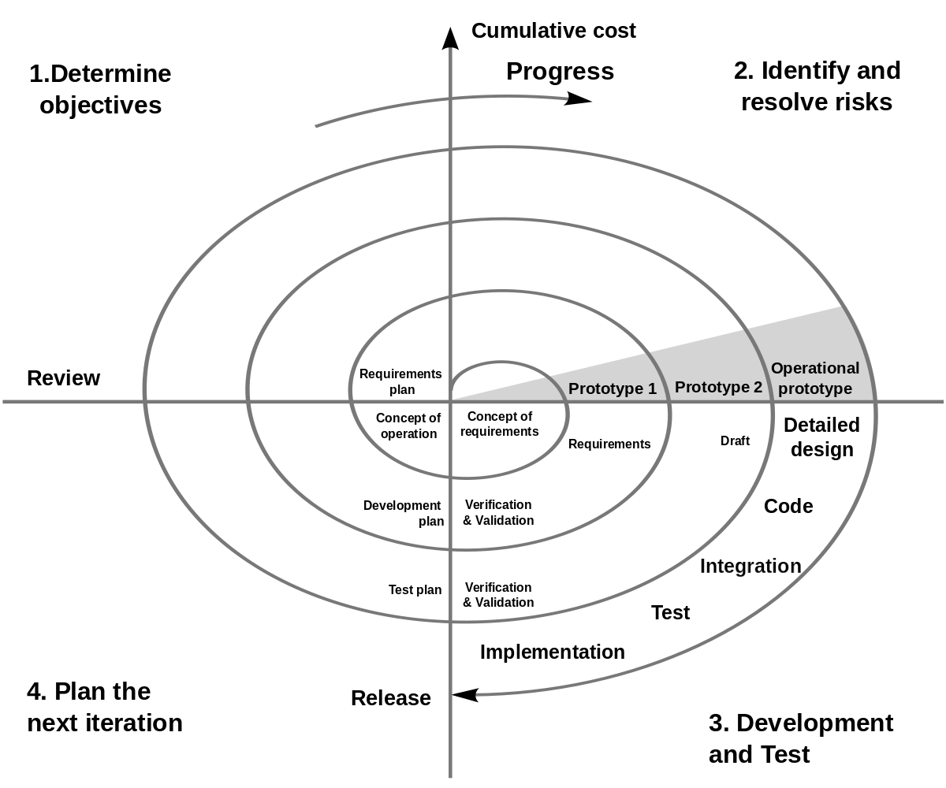

**[Figure 2.4.1 Spiral Model Design]**

The spiral model is similar to the incremental model, with more emphasis placed on risk analysis. The spiral model has four phases: Planning, Risk Analysis, Engineering and Evaluation. A software project repeatedly passes through these phases in iterations (called Spirals in this model). The baseline spiral, starting in the planning phase, requirements are gathered and risk is assessed. Each subsequent spirals builds on the baseline spiral. It’s one of the software development model Waterfall, Agile, V-Model.

* Requirement Analysis: In the requirement phase while using waterfall model we gather all requirement for campus recruitment system to develop a website and then do analysis on that requirements according to the website flow.
* Planning Phase: Requirements are gathered during the planning phase. Requirements like ‘BRS’ that is ‘Business Requirement Specifications’ and ‘SRS’ that is ‘System Requirement specifications’.
* Risk Analysis: In the risk analysis phase, a process is undertaken to identify risk and alternate solutions. A prototype is produced at the end of the risk analysis phase. If any risk is found during the risk analysis then alternate solutions are suggested and implemented.
* Engineering Phase: In this phase software is developed, along with testing at the end of the phase. Hence in this phase the development and testing is done.
* Evaluation phase: This phase allows the customer to evaluate the output of the project to date before the project continues to the next spiral.

1. **Conceptual Diagram**
   1. **Use case diagram**
      1. **User use case diagram**

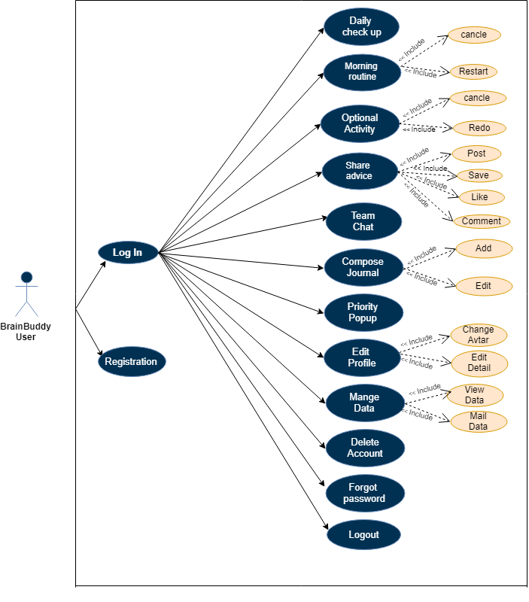

**[Figure 3.1.1-User use case Diagram]**

**3.2 Activity diagram**

**3.2.1 User Activity**

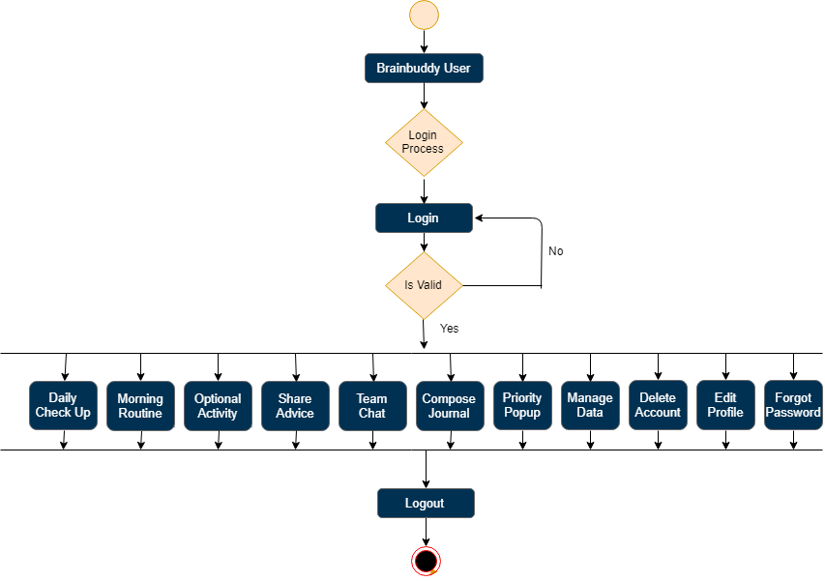

[Figure 3.2.1 Use case Diagram for User]

**3.2.2 Login Activity**

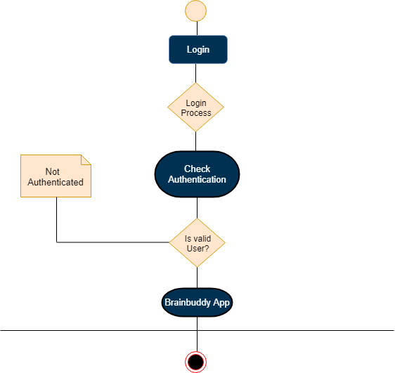

**[Figure 3.2.2 Activity Diagram for Login]**

**3.2.3 Priority Popup Activity**

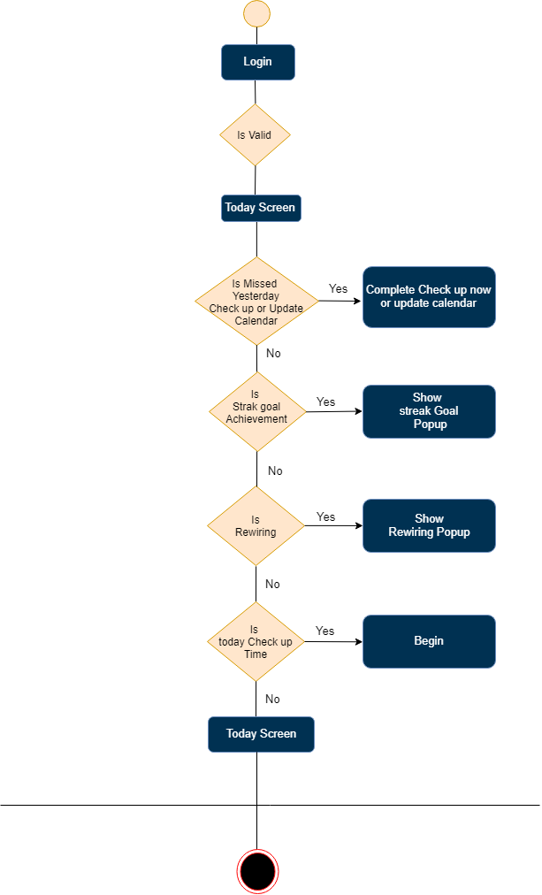

**[Figure 3.2.3 Activity Diagram for Priority Popup]**

**3.2.4 In App purchase Activity**

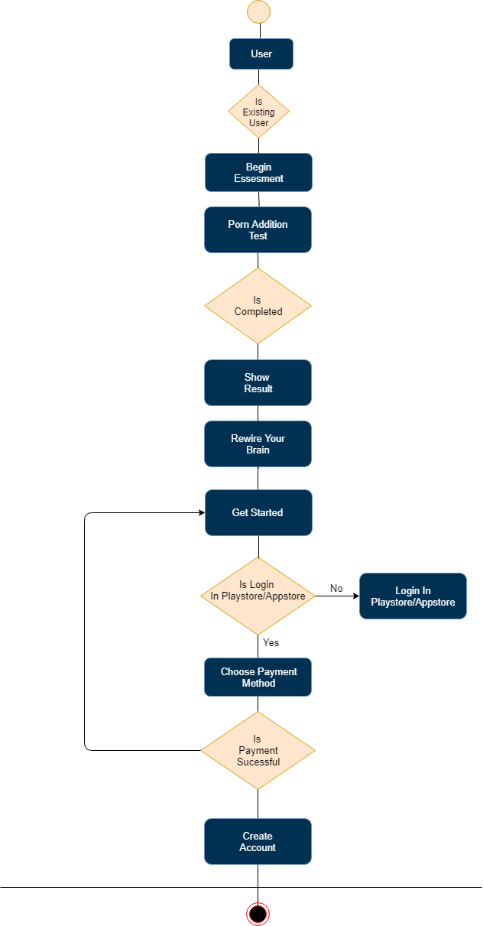

**[Figure 3.2.4 Activity Diagram for In app purchase]**

1. **System Design**
   1. **User Interface Design**

**4.1.1. Main Screen & create account**

|  |  |
| --- | --- |
|  |  |

**[Figure 4.1.1- Main Screen & create account]**

**4.1.2. Login Screen & Login flow**

|  |  |
| --- | --- |
|  |  |

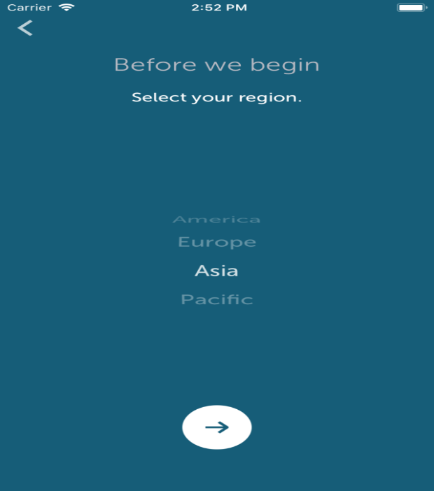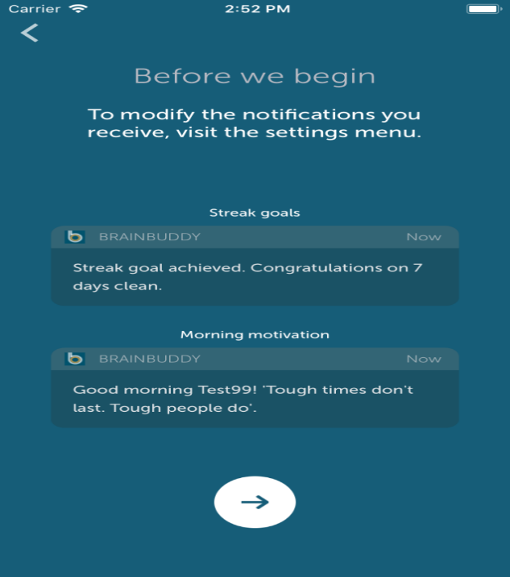

**[Figure 4.1.2 Login Screen & Login flow]**

**4.2.3. Finish Check-up**

|  |  |
| --- | --- |
|  |  |

**[Figure 4.1.3 Finish Check-up]**

**4.1.4. Today Screen**

|  |  |
| --- | --- |
|  |  |

**[Figure 4.1.4 Finish Check-up]**