Lab 4.2
- Add a screenshot of the completed 28 Lessons of the Basic HTML and HTML5 Course from freecodecamp
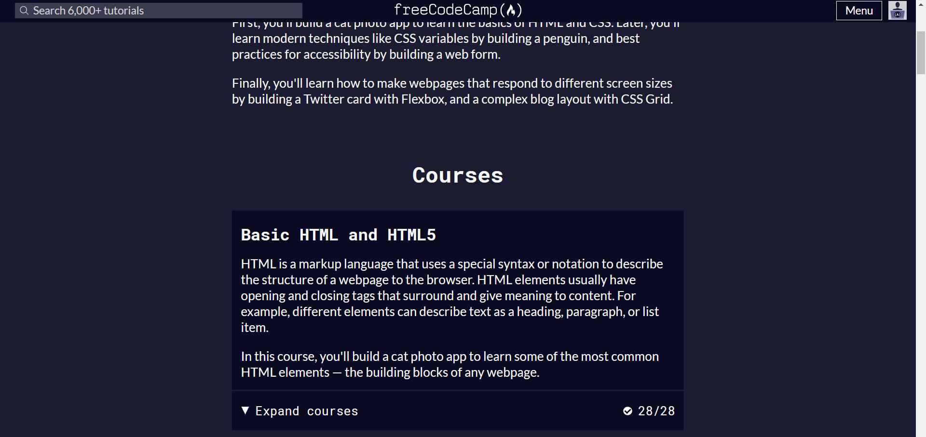

- Add a screenshot of the cat photo app created in the Basic HTML and HTML5 Course from freecodecamp
