Low-Group-Delay Morphology-Preserving Digital Filtering: Constrained FIR versus Phase-Equalized IIR
V N Shahid Ibrahim (ED24B064)
Nida Paravath (ED24B062)
Madhav Tripathi (ED24B059)
Deepak Meena (ED24B045)
ED5017 - Digital Signal Processing (research-oriented course project)
Department of Engineering Design, IIT Madras
Code repository: https://github.com/shahidibrahimvn015/low-delay-morphology-filtering

Abstract
Real-time biomedical front ends must remove out-of-band noise while staying within a strict latency budget and without distorting diagnostically relevant waveform morphology. We ask which filter architecture best preserves morphology for a fixed attenuation requirement and latency budget. The comparison covers linear-phase FIR, minimum-phase FIR, classical IIR, and IIR plus all-pass phase equalization. First, we derive a frequency-domain morphology-error model. For an input with power spectral density S(ω), the expected squared deviation from a delayed zero-phase reference splits into a PSD-weighted magnitude term and a phase-linearity term. The phase term is bounded by a passband group-delay error weighted by an explicit kernel K(ν)=∫_{ν}^{ωp} ωS(ω)dω. This justifies the objective J = αE_{mag} + βE_{τg} + γD with α=β=1 and gives a principled, signal-energy-weighted group-delay metric. Second, we propose a morphology-optimal constrained low-delay FIR (MO-LDFIR), posed as a second-order-cone program whose constraints guarantee the matched magnitude specification. Third, we propose an energy-weighted, latency-penalized all-pass equalizer (EW-APE). For an ECG low-pass specification (0–40 Hz passband, ≥40 dB above 60 Hz, 0.5 dB ripple, 20 ms budget), all filters were matched in magnitude. Hyperparameters were tuned only on MIT-BIH DS1, and testing used inter-patient MIT-BIH DS2 (22 patients) and 300 PTB-XL records at a different sampling rate. MO-LDFIR (19.5 ms) gave a median DS2 morphology PRD of 1.51% versus 6.94% for the elliptic IIR, 5.14% for the minimum-phase FIR and 6.63% for the budget-constrained equalized IIR (all p_{Holm} < 0.001). Its ST-level error was 0.84 µV, against 3.65 µV for the 44-ms linear-phase FIR. All-pass equalization of the IIR could not be exploited under the budget, because every section adds delay. The linear-phase FIR remains preferable when its latency is acceptable, and the IIR when arithmetic cost dominates. We report the failure regime of the proposed FIR (very sharp QRS complexes), quantization sensitivity, ablations, and a Pareto map from which architecture-selection rules are derived.
Keywords: group delay; low-delay FIR; all-pass equalization; phase distortion; ECG morphology; second-order-cone programming; latency.

1. Introduction
Linear filtering is the first stage of almost every biomedical signal chain. The morphology of ECG waves (QRS amplitude and width, ST level, T-wave shape) and of PPG pulses carries the clinical information, so the filter must reject noise without reshaping the waveform. A linear-phase FIR delays all frequencies by the same (N−1)/2 samples and introduces no phase distortion. For sharp transition bands this delay is large, which is unacceptable in closed-loop or event-triggered applications: arrhythmia alarms, R-wave-synchronized triggering, wearable feedback. IIR filters meet the same magnitude specification with far lower order and delay, but their group delay peaks near the band edge, which causes ringing and morphology-dependent timing. The standard remedy, all-pass phase equalization, flattens the group delay only by adding delay [5]. Low-delay FIR designs relax linear phase in exchange for latency [3], [4]. Hybrid causal/non-causal equalization [6] needs future samples and is therefore not a real-time option.
Comparisons between these architectures are often made under unrelated specifications. They typically rely on generic metrics such as maximum group-delay deviation over the whole passband, which ignore where the signal energy lies. This project addresses that gap with the following contributions:
- A morphology-error model and a derived group-delay metric. The expected output error splits into magnitude and phase terms, and the phase term is bounded by a group-delay error weighted by the kernel K(ν). This gives a defensible definition of the J = αE_{mag} + βE_{τg} + γD objective (Sec. 3) and is validated against measured errors (Sec. 6.3).
- MO-LDFIR: a constrained low-delay FIR that minimizes the PSD-weighted morphology error, posed as an SOCP with constraints that guarantee the matched magnitude specification. It is globally optimal for each latency D.
- EW-APE: an all-pass equalizer for IIR filters that minimizes the same exact morphology error with a latency price or a hard latency bound.
- A matched-specification benchmark. Five reproduced baselines and an unweighted low-delay FIR are compared on Pareto maps (attenuation × group-delay/morphology error × latency × cost), synthetic ground truth, two independent open ECG datasets, PPG, quantization and ablation. The benchmark ends in explicit design recommendations (Sec. 7).
Hypothesis. Under a matched magnitude specification and a strict latency budget, (H1) a non-linear-phase FIR whose phase error is concentrated where the signal has little energy preserves morphology better than both the classical IIR and the IIR with all-pass equalization; and (H2) all-pass equalization cannot substantially reduce the morphology error of an IIR when the budget leaves little room for added delay. Both hypotheses are fixed before testing and are evaluated on held-out data (Sec. 5–6).

2. Problem formulation

2.1 Signal model and conventions
The input is x[n] = s[n] + v[n], where s is the physiological waveform (mV for ECG, arbitrary units for PPG) and v is additive noise (drifting 60/120 Hz power-line interference and broadband EMG-like noise). Physical frequency f is in Hz, the sampling rate fs in Hz, and the digital angular frequency is ω = 2πf/fs rad/sample, with 0 ≤ ω ≤ π. The normalized frequency f/fs (cycles/sample) is used only for printing, and FFT bins never appear in a definition. Delays are reported in samples and in ms (1000·samples/fs). A causal LTI filter H(e^{jω}) = |H|e^{jφ(ω)} has group delay τ(ω) = −dφ/dω, evaluated analytically from the coefficients. For a polynomial P(e^{jω}) = Σ p_{k} e^{−jωk}, τ_{P} = Re{Σ k p_{k} e^{−jωk} / P}, and τ_{B/A} = τ_{B} − τ_{A}. Fig. 3a confirms the analytic value against the derivative of the unwrapped phase.

2.2 Matched specification and latency budget
Primary specification (ECG, MIT-BIH, fs = 360 Hz): passband 0–40 Hz (ωp = 0.6981 rad/sample); stopband ≥ 60 Hz (ωs = 1.0472 rad/sample), which also covers 60-Hz mains in US recordings; passband ripple ≤ 0.5 dB peak-to-peak centered on unity, i.e. |H| ∈ [1−δp, 1+δp] with δp = 0.0288; stopband attenuation ≥ 40 dB (δs = 0.01); transition-band peaking ≤ 1+δp; and latency ≤ 20 ms (7.2 samples). The 40-Hz edge keeps the QRS energy, and the 20-ms budget is an illustrative real-time constraint. Neither is a clinical requirement. Every filter is verified numerically against this mask on a 1024-point grid before it is compared, so all comparisons use exactly the same specification. The same physical specification is redesigned at 500 Hz for PTB-XL. A second specification is used for PPG (fs = 125 Hz, 0–8 Hz passband, ≥ 40 dB above 12 Hz, 80-ms budget).

2.3 Delay and group-delay metrics
Group delay is evaluated only in the passband Ωp = [0, ωp], where |H| is meaningful. Stopband group-delay spikes, caused by zeros on the unit circle, are not signal delay and are excluded. We report the following quantities:
- τ(0): DC delay;
- τ̄_{K}: kernel-weighted mean passband group delay, defined as the latency D of a filter (Sec. 3);
- Δτ_{max} = max_{Ωp} |τ(ω) − τ̄| and Δτ_{rms} (uniform): the classical flatness metrics;
- Δτ_{rms,W}: PSD-weighted RMS group-delay variation;
- E_{τg}: the derived morphology-consistent group-delay error (Eq. 4).

3. Morphology-error model and the J objective
Let the morphology target be the delayed output of a zero-phase reference filter with magnitude R(ω). R equals 1 in the passband, follows a raised-cosine transition, and is 0 in the stopband. Every matched-spec filter approximates R, so the reference does not favor any architecture; in particular it is not the linear-phase FIR. For a wide-sense-stationary input with one-sided PSD S(ω), the error e[n] = y[n] − r[n−D] has power
$$E |e[n]|^{2}=\frac{1}{π}\int_{0}^{π}{S(ω) }{\left|H(e^{jω})-R(ω) e^{-jωD}\right|}^{2}dω$$ | (1)
Normalizing by the reference power Z = (1/π)∫S R² dω gives the predicted PRD = 100·√(E|e|²/Z), which we use as the Pareto ordinate. D is chosen to minimize the error, which removes the pure-delay component. In the passband (R = 1), write H = |H|e^{jφ} and define the phase-linearity error φ_{e}(ω) = φ(ω) + ωD. Then
$${\left|H − e^{-jωD}\right|}^{2}=(|H|-1)^{2}+2|H|(1-cos φ_{e})≈(|H|-1)^{2}+|H| φ_{e}^{2}$$ | (2)
so the passband error splits into a magnitude term E_{mag} = (1/Z)∫S(|H|−1)² and a phase term E_{φ} = (1/Z)∫S φ_{e²}. For a real filter with positive DC gain, φ(0) = 0, so the phase error is the accumulated group-delay error:
$$φ_{e}(ω)=-\int_{0}^{ω}{\left(τ(ν)-D\right)}dν$$ | (3)
Applying the Cauchy–Schwarz inequality, φ_{e}(ω)² ≤ ω ∫₀^{ω} (τ(ν) − D)² dν. Substituting and exchanging the order of integration gives the bound
$$E_{φ}≤E_{τg}:=\frac{1}{Z}\int_{0}^{ω_{p}}{K(ν)}{\left(τ(ν)-D\right)}^{2}dν, K(ν)=\int_{ν}^{ω_{p}}{ω S(ω) dω}$$ | (4)
Hence PRD²/10⁴ ≈ E_{mag} + E_{φ} ≤ E_{mag} + E_{τg} (plus a transition-band term common to all matched-spec designs). This justifies the project's central objective
$$J=αE_{mag}+βE_{τg}+γD, α=β=1$$ | (5)
in which α = β = 1 follows from the derivation rather than from tuning, and γ is the application's price of latency. A Pareto front is traced either by sweeping γ or by imposing D ≤ D_{max}. The kernel has a clear interpretation. K(ν) decreases monotonically with ν (Fig. 3b), so group-delay error at low frequency is the most damaging: its phase error accumulates over every higher frequency that carries energy. Group-delay peaks at the band edge, the signature of elliptic IIRs, matter only through the little signal energy above them. A uniform Δτ_{max} criterion ranks filters by exactly the wrong part of the band. The optimal alignment D minimizing E_{τg} is the K-weighted mean group delay τ̄_{K}, which we therefore use as the latency definition.

4. Filter designs

4.1 Reproduced baselines
- LP-FIR: Parks–McClellan equiripple linear-phase FIR [1]. The minimum length meeting the mask is N = 33, with passband:stopband error weights 1 : δp/δs. Its latency is (N−1)/2 samples.
- MP-FIR: the minimum-phase spectral factor of the LP-FIR, obtained by reflecting zeros outside the unit circle into it [2]. The magnitude is identical, the delay is the minimum possible, and the phase is nonlinear.
- Elliptic and Butterworth IIR: minimum orders (5 and 13) from the bilinear transform, designed for slightly tighter tolerances and gain-centered to meet the same mask. Both are realized as second-order sections.
- Ell+AP-flat: the elliptic IIR followed by K = 3 second-order all-pass sections A(z) = (r² − 2r cosθ z⁻¹ + z⁻²)/(1 − 2r cosθ z⁻¹ + r² z⁻²). The sections are optimized (L-BFGS-B, 12 random starts, pole radius r ≤ 0.97) to minimize the unweighted passband group-delay variance, which is the classical equalizer criterion [5]. A minimax variant is reported in the ablation.
- LD-FIR-flat: a constrained low-delay FIR approximating e^{−jωD} with uniform weighting. It belongs to the classical low-delay complex-approximation family [3], [4] and has the same constraints and length as MO-LDFIR, so it isolates the effect of the PSD weighting.
Note on reproduction. Refs. [3]–[6] were used for problem framing. The baselines above are faithful implementations of the design principles of those works under our matched specification. They are not line-by-line reproductions of each paper's algorithm.

4.2 Proposed: morphology-optimal constrained low-delay FIR (MO-LDFIR)
For a fixed latency D and length N, with h ∈ ℝ^{N} and H(ω) = Σ h[n]e^{−jωn}, MO-LDFIR solves
$$\min_{h} \int_{0}^{π}{S(ω) }{\left|H(ω)-R(ω) e^{-jωD}\right|}^{2}dω$$ | (6)
$$s.t. \left|H(ω)-e^{-jωD}\right|≤δ_{p} (ω∈Ω_{p}), |H(ω)|≤δ_{s} (ω∈Ω_{s}), |H(ω)|≤1+δ_{p} (ω∈Ω_{t})$$ | (7)
Here Ω_{p}, Ω_{s} and Ω_{t} denote the passband, stopband and transition band. The objective is exactly Eq. (1), the expected morphology MSE. Each constraint is a second-order cone in h. The passband cone is a convex sufficient condition for the ripple mask, because it implies 1−δp ≤ |H| ≤ 1+δp, and it also bounds the passband phase error by asin δp. The program is therefore convex, and the CLARABEL interior-point solver (via CVXPY [13]) returns its global optimum. The minimum feasible length N_{min}(D) is found by bisection. The stopband cone uses 0.98·δs as a small safety margin. N = N_{min} + slack, with the slack chosen on the development set. S(ω) is the median unit-power Welch PSD of the baseline-corrected MIT-BIH DS1 ECGs (floor 10⁻³).

4.3 Proposed: energy-weighted, latency-penalized all-pass equalizer (EW-APE)
An all-pass section leaves |H| and hence E_{mag} unchanged, so equalization can only reduce E_{φ}. EW-APE minimizes the exact full-band error, not a group-delay surrogate:
$$\min_{r_{k},θ_{k},D} \frac{1}{Z}\int_{0}^{π}{S }{\left|H_{IIR}(ω)A(ω;r,θ)-R e^{-jωD}\right|}^{2}dω+γD, 0.05≤r_{k}≤0.97, (0≤D≤D_{max})$$ | (8)
The bound on r_{k} keeps a stability margin of 0.03 and limits coefficient sensitivity. For the comparison under the budget, D_{max} is the latency budget. Variants that use the K(ν)-weighted or PSD-weighted group-delay surrogate are evaluated in the ablation (Sec. 6.7).

4.4 Computational cost
Cost is counted per output sample for direct-form realizations. An FIR of length N costs N multiplies (⌈N/2⌉ if it is symmetric), N−1 additions and N−1 states. A biquad costs at most 5 multiplies, 4 additions and 2 states. A direct-form all-pass biquad costs 4 multiplies, or 2 in lattice form. These counts are algorithmic costs, not hardware claims.

5. Experimental protocol
Partitions (fixed before tuning). Development: MIT-BIH Arrhythmia Database [8], [9] DS1 (22 records), using the inter-patient split of de Chazal et al. [7]. Held-out test 1: MIT-BIH DS2, 22 different patients, full 30-min MLII lead. Independent test 2: PTB-XL v1.0.1 [10], recommended test fold 10, the first 300 records by ecg_id, lead II, 500 Hz. Paced records (102, 104, 107, 217) are excluded. The PSD weight, the FIR length slack and the EW-APE section count were selected on DS1 only (Table 13). For PTB-XL nothing was re-tuned: the locked rules were re-applied at 500 Hz with the MIT-BIH PSD (cross-dataset and cross-rate transfer).
Pre-processing and reference. A common offline pre-stage removes baseline wander. It is a zero-phase 0.5-Hz Butterworth high-pass applied identically to every filter's input and to the reference, and it is never one of the compared real-time filters. The morphology target is the FFT-based zero-phase reference filter R(ω) applied offline. Forward-backward and zero-phase processing are used only to build references, never as a real-time solution.
Protocols. (i) Clean: recorded ECG, filtered, compared with its reference. (ii) Stress: drifting 60/120-Hz interference (0.1 mV) and EMG-like noise (0.03 mV rms) are added to the input only, and the target is unchanged. (iii) Synthetic ECG Monte-Carlo: a sum-of-Gaussians beat model [11] is evaluated analytically, giving exact ground truth. 200 trials of 20 s are drawn with HR ~ U(50,120) bpm, QRS width scale ~ U(0.6,1.6), power-line amplitude ~ U(0.02,0.2) mV and EMG level ~ U(0.005,0.05) mV. Because the filters are linear, distortion (h∗s) and residual noise (h∗v) are measured separately. (iv) A QRS-sharpness sweep and a noise-level sweep. (v) Synthetic PPG with its own specification, with the PSD from disjoint development seeds. (vi) Step and impulse transients.
Metrics. PRD_{nom}: normalized PRD against the reference delayed by the filter's nominal latency τ̄_{K}. PRD_{opt}: the same at the best fractional delay, which isolates shape distortion. R-peak (or PPG systolic peak) timing error |t_{out} − t_{ref} − τ̄_{K}| and timing jitter, both after parabolic peak interpolation. Peak-amplitude error. ST-level error: the mean error 80–120 ms after R. Overshoot, settling and ringing. Frequency-domain metrics: passband deviation, attenuation, Δτ, E_{mag}, E_{φ}, E_{τg}, operation count, and pole radius as a stability margin. Statistics: medians [IQR] over records; paired Wilcoxon signed-rank tests of MO-LDFIR against each comparator with Holm correction within each (dataset, metric) family; bootstrap 95% CIs of the median paired difference (2000 resamples). The seed is 2026, and all parameters are in config/*.json.

6. Results

6.1 Matched-specification filter set
Table 1. Matched-specification ECG filter set (fs = 360 Hz). All designs satisfy the 0.5-dB/40-dB mask. * proposed. PRD_{pred} is the frequency-domain prediction (Eq. 1) with the DS1 ECG PSD.
Filter | Design | Ripple p-p (dB) | Atten. (dB) | τ(0) (smp) | Latency τ̄_{K} (smp/ms) | Δτ_{max} (ms) | Δτ_{rms,W} (ms) | E_{τg} | PRD_{pred} (%) | mult/add/states | ≤20 ms
LP-FIR | N=33 | 0.483 | 40.30 | 16.00 | 16.00 / 44.4 | 0.00 | 0.000 | 0 | 1.94 | 17/32/32 | no
MP-FIR | N=33 | 0.483 | 40.30 | 2.89 | 3.43 / 9.5 | 11.45 | 1.288 | 7.72e-03 | 7.37 | 33/32/32 | yes
Elliptic | n=5 | 0.500 | 40.05 | 4.30 | 4.37 / 12.1 | 54.51 | 2.297 | 1.89e-02 | 9.91 | 9/10/5 | yes
Butterworth | n=13 | 0.481 | 42.72 | 10.51 | 10.90 / 30.3 | 25.30 | 1.945 | 1.75e-02 | 10.95 | 21/26/14 | no
Ell+AP-flat | K=3 | 0.500 | 40.05 | 27.94 | 28.47 / 79.1 | 22.31 | 1.235 | 6.79e-03 | 4.39 | 21/22/11 | no
LD-FIR-flat | N=71, D=7 | 0.500 | 40.18 | 7.22 | 7.08 / 19.7 | 5.32 | 0.373 | 6.97e-04 | 3.04 | 71/70/70 | yes
MO-LDFIR * | N=71, D=7 | 0.443 | 40.18 | 6.98 | 7.00 / 19.5 | 4.65 | 0.248 | 2.56e-04 | 2.55 | 71/70/70 | yes
EW-APE * | K=1, D<=7.2 | 0.500 | 40.05 | 7.16 | 7.20 / 20.0 | 53.95 | 2.221 | 1.72e-02 | 9.60 | 13/14/7 | yes

All eight designs meet the identical magnitude mask (Fig. 1), so differences in morphology are due to phase alone. Only MP-FIR, Elliptic, LD-FIR-flat, MO-LDFIR and EW-APE meet the 20-ms budget. The LP-FIR needs 44.4 ms. The elliptic IIR is the cheapest design (9 multiplies) and has low latency (12.1 ms), but its group delay rises by 54.5 ms toward the band edge (Fig. 2c), and its phase deviates from linear by tens of degrees inside the passband (Fig. 2b). The classical equalizer (K = 3) reduces Δτ_{max} to 22.3 ms but increases latency to 79.1 ms. MO-LDFIR stays within budget (19.45 ms) with Δτ_{max} = 4.65 ms and the lowest E_{τg} of all designs (2.6e-04), at the price of 71 multiplies per sample.
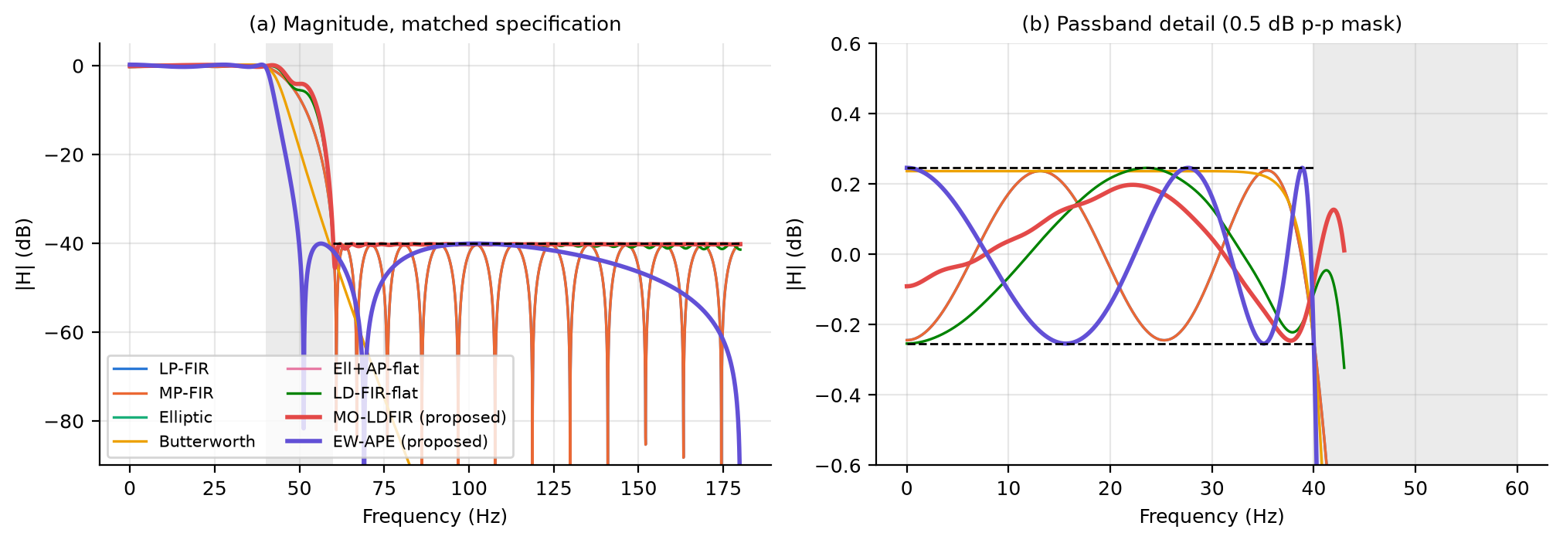
Fig. 1. Magnitude responses of the matched-spec set: (a) full band with the 40-dB stopband mask; (b) passband ripple against the ±δp mask. The grey band is the 40–60 Hz transition band.
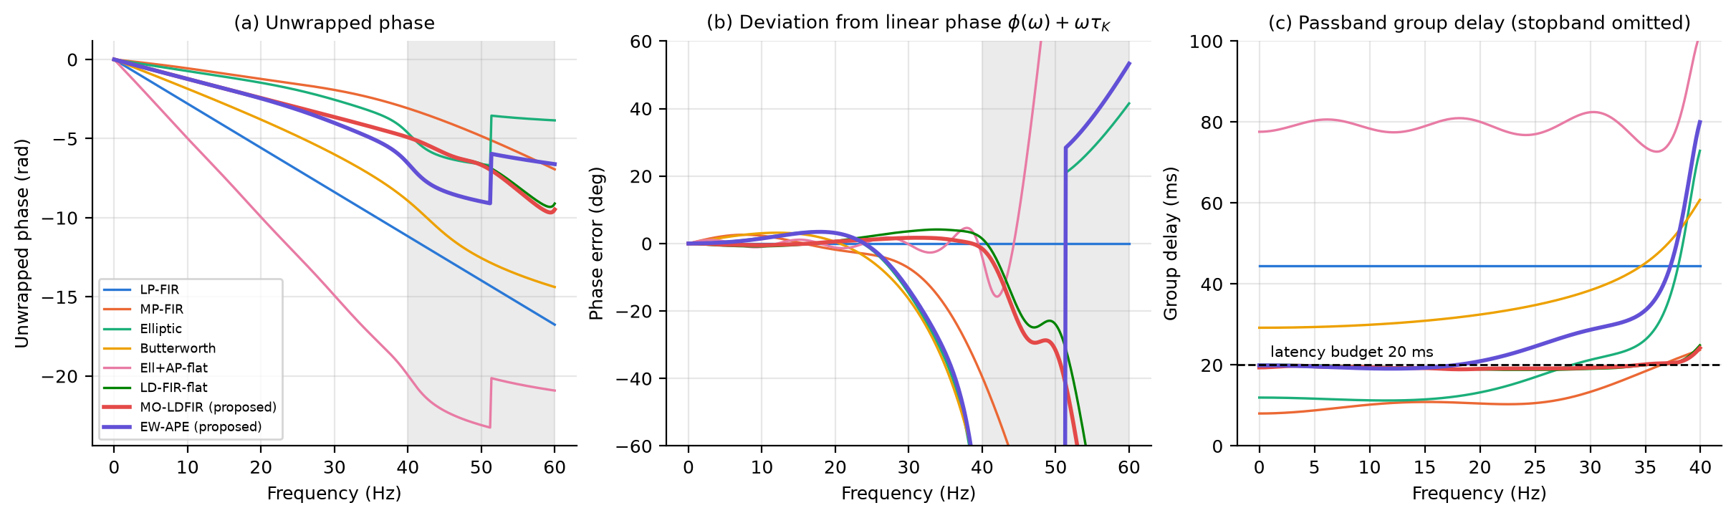
Fig. 2. (a) Unwrapped phase. (b) Deviation from linear phase φ(ω)+ωτ̄_{K}, i.e. the phase error that distorts morphology. (c) Passband group delay with the 20-ms budget. Stopband group delay is deliberately not shown (it is not signal delay).
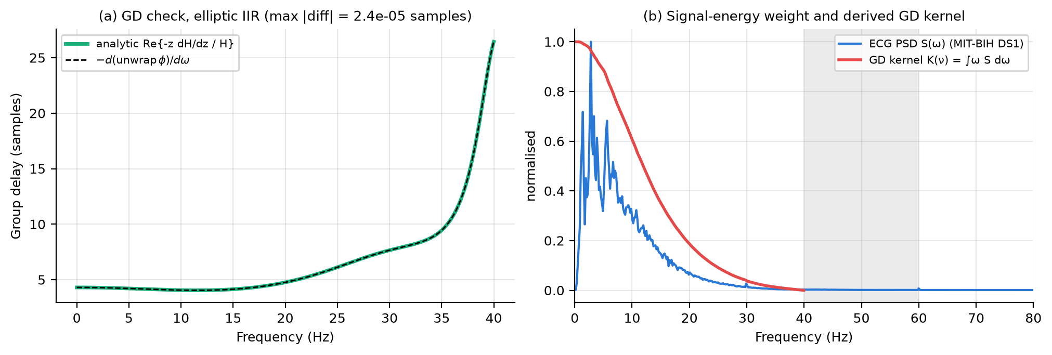
Fig. 3. (a) Analytic group delay agrees with the numerical derivative of the unwrapped phase. (b) The DS1 ECG PSD and the derived group-delay kernel K(ν): low-frequency group-delay error is weighted most.
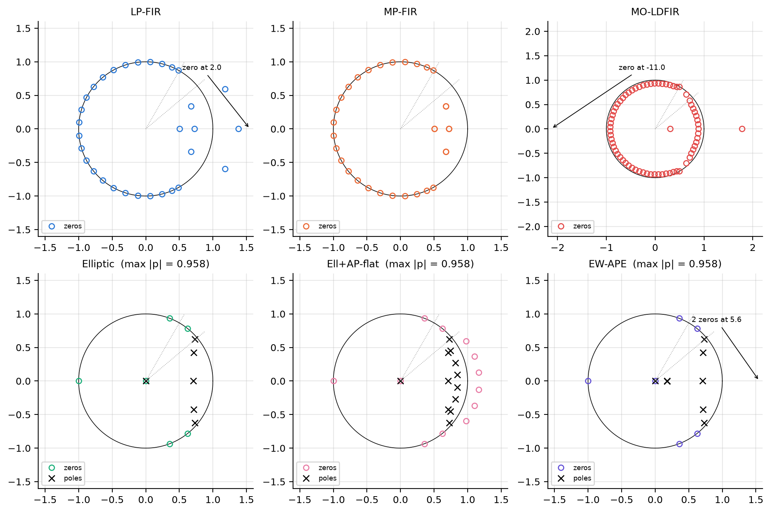
Fig. 4. Pole-zero maps; dotted rays mark ωp and ωs. MO-LDFIR is a non-minimum-phase FIR: 2 of its 70 zeros lie outside the unit circle (at z ≈ +1.78 and z ≈ −11.0, the latter indicated by an arrow), which is what allows a delay shorter than (N−1)/2. The all-pass poles of EW-APE under the budget are weak (small radius), because a strong section would exceed the latency budget.
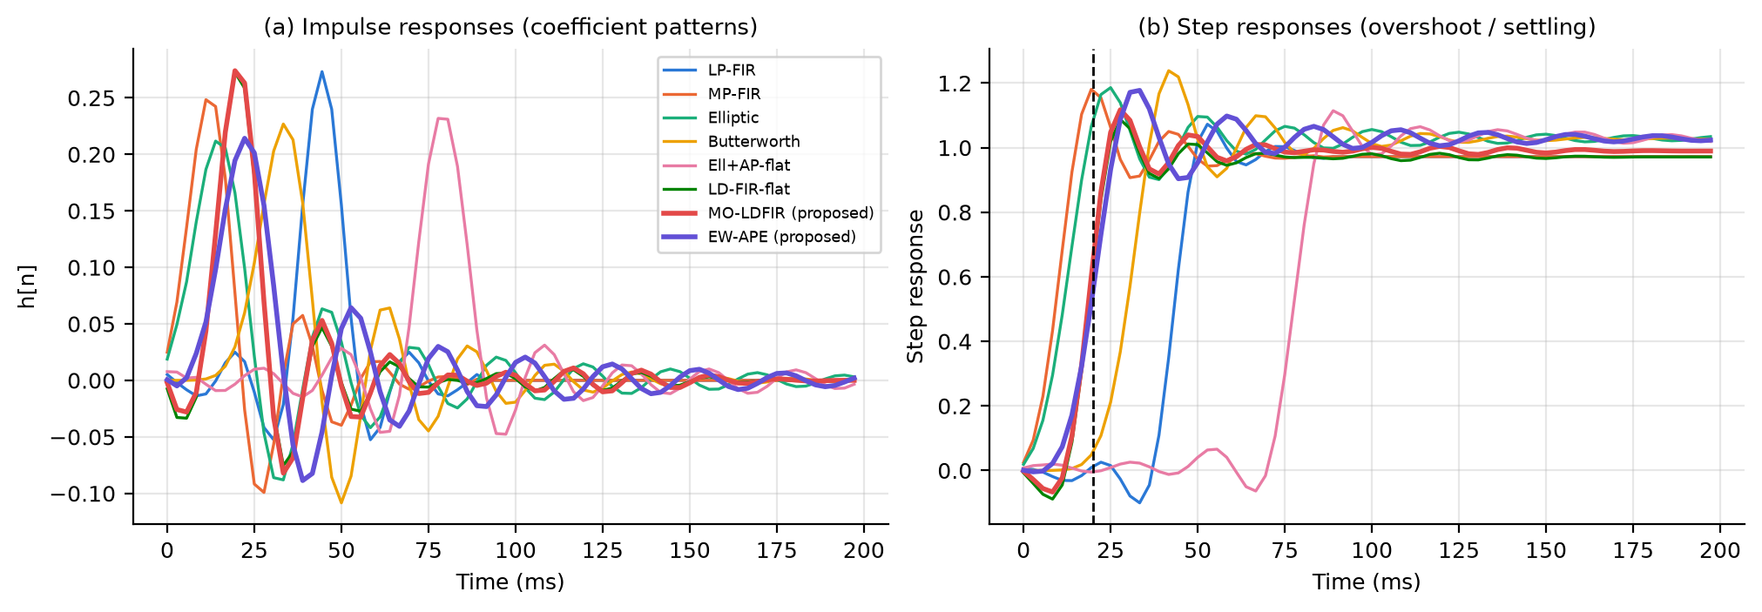
Fig. 5. Impulse responses (coefficient patterns) and step responses. The dashed line marks the 20-ms budget.
Table 2. Transient behavior (step and impulse). Late IR energy is the fraction of impulse-response energy arriving >30 ms after the energy centroid (ringing indicator).
Filter | 50% delay (ms) | Overshoot (%) | Pre-shoot (%) | Rise 10–90 (ms) | Settling 2% (ms) | Late IR energy (%)
LP-FIR | 44.4 | 10.3 | 10.3 | 11.1 | 77.8 | 0.26
MP-FIR | 11.1 | 21.4 | 0.0 | 8.3 | 58.3 | 2.01
Elliptic | 13.9 | 15.3 | 0.0 | 13.9 | 116.7 | 5.00
Butterworth | 30.6 | 20.5 | 0.0 | 13.9 | 105.6 | 3.75
Ell+AP-flat | 77.8 | 8.3 | 6.2 | 11.1 | 141.7 | 1.75
LD-FIR-flat | 19.4 | 12.0 | 9.1 | 8.3 | 61.1 | 1.05
MO-LDFIR | 19.4 | 12.9 | 6.7 | 11.1 | 69.4 | 1.62
EW-APE | 19.4 | 14.5 | 0.4 | 11.1 | 122.2 | 5.97

6.2 Pareto trade-offs: attenuation, group delay, latency and cost
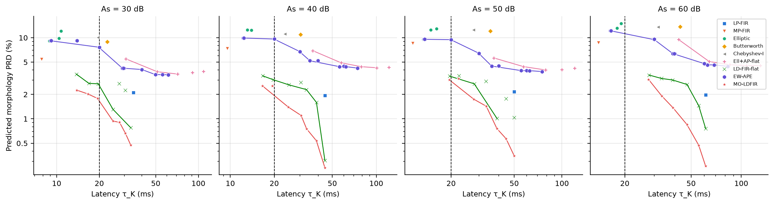
Fig. 6. Pareto map of latency τ̄_{K} versus predicted morphology PRD for stopband attenuation 30–60 dB (transition 40→60 Hz). Lines connect the non-dominated designs of each swept family; the dashed line is the 20-ms budget.
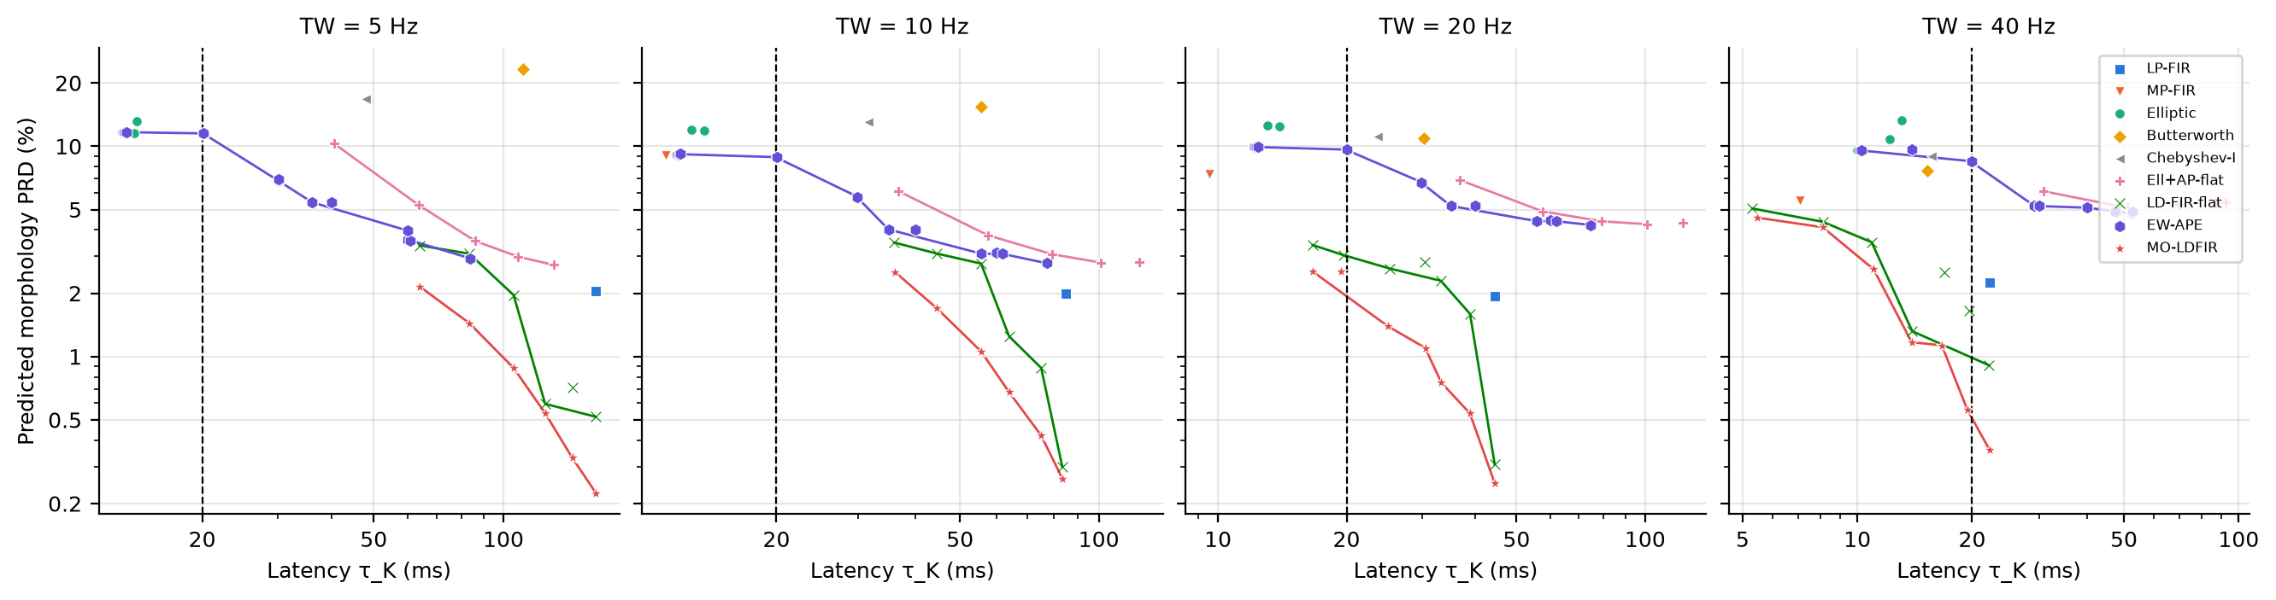
Fig. 7. The same Pareto map for transition widths of 5, 10, 20 and 40 Hz (As = 40 dB).
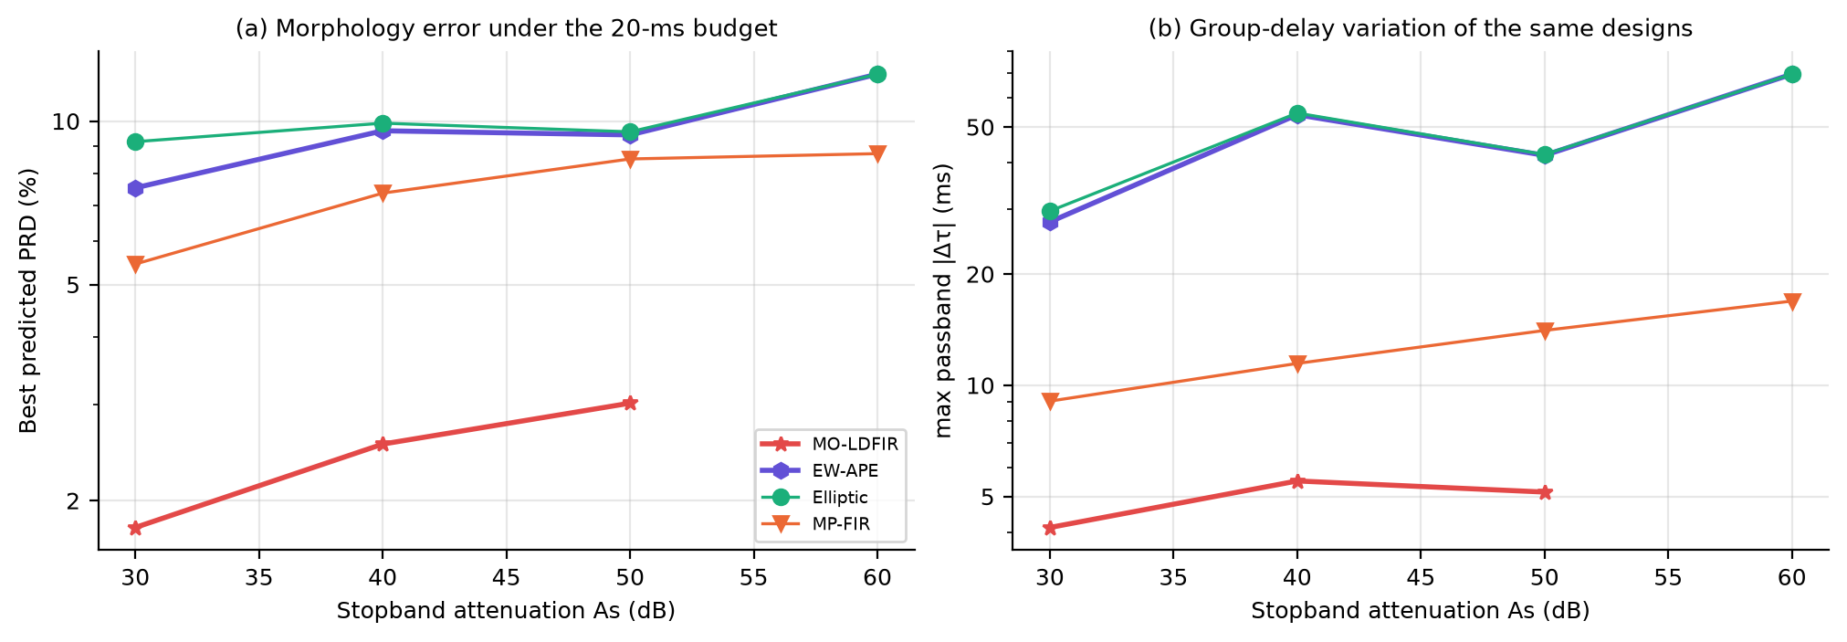
Fig. 8. Three-way trade-off under the 20-ms budget: best predicted PRD (a) and passband group-delay variation (b) of each architecture as the attenuation requirement grows.
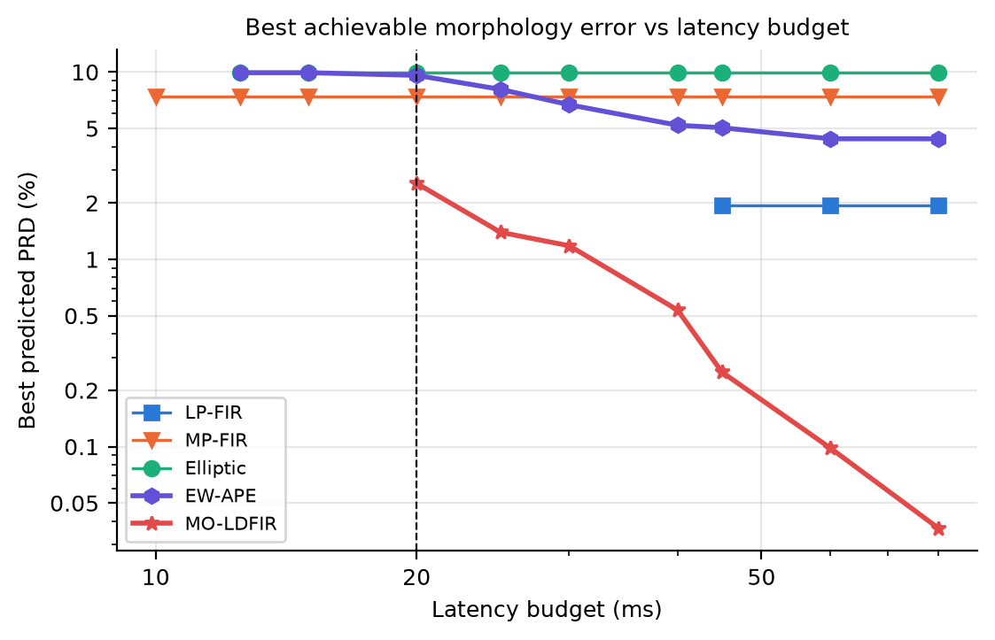
Fig. 9. Best achievable predicted morphology PRD as a function of the latency budget (As = 40 dB, 40→60 Hz).
Table 3. Best predicted PRD (%) achievable within the 20-ms budget, with multiplies/sample in parentheses. '–' means no design of that family meets both the mask and the budget.
Variant | LP-FIR | MP-FIR | Elliptic | Ell+AP-flat | EW-APE | LD-FIR-flat | MO-LDFIR
As=30 dB | – | 5.45 (26) | 9.16 (8) | – | 7.53 (12) | 2.70 (63) | 1.78 (63)
As=40 dB, TW=20 Hz (base) | – | 7.37 (33) | 9.91 (9) | – | 9.60 (13) | 3.04 (71) | 2.54 (84)
As=50 dB | – | 8.52 (37) | 9.55 (9) | – | 9.43 (13) | 3.36 (96) | 3.02 (96)
As=60 dB | – | 8.71 (45) | 12.20 (11) | – | 12.20 (15) | – | –
TW=5 Hz | – | – | 11.59 (12) | – | 11.67 (15) | – | –
TW=10 Hz | – | 9.03 (62) | 9.17 (9) | – | 8.83 (13) | – | –
TW=40 Hz | – | 5.52 (17) | 9.54 (8) | – | 8.40 (12) | 1.32 (50) | 0.56 (49)

Table 4. Minimum latency (ms) at which each family reaches a predicted PRD ≤ 3%, with multiplies/sample in parentheses. '–' means the family never reaches 3%.
Variant | LP-FIR | MP-FIR | Elliptic | Ell+AP-flat | EW-APE | LD-FIR-flat | MO-LDFIR
As=30 dB | 35 (13) | – | – | – | – | 17 (62) | 14 (66)
As=40 dB | 44 (17) | – | – | – | – | 25 (68) | 17 (84)
As=50 dB | 50 (19) | – | – | – | – | 28 (76) | 28 (76)
As=60 dB | 61 (23) | – | – | – | – | 47 (76) | 33 (79)
TW=5 Hz | 164 (60) | – | – | 108 (27) | 84 (23) | 106 (159) | 64 (249)
TW=10 Hz | 85 (31) | – | – | 101 (25) | 77 (21) | 56 (96) | 36 (117)
TW=40 Hz | 22 (9) | – | – | – | – | 14 (50) | 11 (54)

The Pareto maps (Figs. 6–9, Tables 3–4) answer the central question for the whole design space, not just one point. Three regimes emerge. (i) Budgets below the IIR/minimum-phase limit. At the base specification, nothing meets the mask below 9.5 ms (MP-FIR). Between that and about 17 ms only MP-FIR, the elliptic IIR and a weakly equalized IIR are feasible, all with PRD ≈ 7–10%. In this regime latency is bought with distortion, and no architecture can avoid it. (ii) Moderate budgets. Once the budget admits a low-delay FIR, MO-LDFIR dominates every other family. Within 20 ms it reaches 1.78%, 2.54% and 3.02% for 30/40/50 dB, against 7.5/9.6/9.4% for the best equalized IIR. The budget sweep (Fig. 9) shows that MO-LDFIR at the LP-FIR's own latency (44 ms) is more accurate than the minimum-length LP-FIR (0.25% vs 1.94%). The extra taps buy morphology accuracy rather than delay. (iii) Demanding specifications. At 60 dB, or with 10- and 5-Hz transition widths, the minimum latency of a mask-compliant low-delay FIR rises to 28, 36 and 64 ms, so no FIR meets 20 ms. Here only the IIR families are feasible, and attenuation can be traded for latency only by accepting their phase distortion (Fig. 8).
Cost. The FIR advantage is paid for in arithmetic. To reach PRD ≤ 3% at TW = 5 Hz, MO-LDFIR needs 249 multiplies/sample at 64 ms. EW-APE needs 23 at 84 ms, and the classical flat equalizer 27 at 108 ms. Of the 35 classical-equalizer designs in the sweep, 34 are dominated by an EW-APE design (equal or lower PRD at lower latency), because the EW-APE objective spends delay only where signal energy makes it worthwhile. The exception is the K = 5 flat equalizer at TW = 5 Hz (2.7% at 131 ms), which lies beyond the K ≤ 3 range swept for EW-APE. Equalized IIRs are therefore the cost-efficient choice when the transition band is narrow and a latency of about 77–84 ms (EW-APE at TW = 5–10 Hz) is tolerable. One baseline failure is reported for transparency: at TW = 5 Hz the minimum-phase factor of the 119-tap LP-FIR fails the mask, because root-finding a degree-118 polynomial is numerically ill-conditioned. A cepstral or optimization-based spectral factorization would be needed there.

6.3 Synthetic ground truth and validation of the error model
Table 5. Synthetic ECG Monte-Carlo (200 trials; exact ground truth): median [IQR] of the distortion of the clean component.
Filter | PRD_{opt} (%) | PRD_{nom} (%) | R timing err. (ms) | R amp. err. (%) | ST err. (µV)
LP-FIR | 2.36 [2.31, 2.48] | 2.36 [2.31, 2.48] | 0.010 [0.005, 0.013] | 0.23 [0.17, 0.25] | 0.44 [0.21, 0.92]
MP-FIR | 4.12 [3.83, 5.70] | 4.28 [4.10, 5.76] | 0.233 [0.101, 0.796] | 0.47 [0.20, 1.48] | 0.60 [0.29, 1.07]
Elliptic | 3.65 [2.81, 7.55] | 4.59 [4.07, 7.67] | 0.358 [0.199, 0.647] | 1.35 [0.53, 3.95] | 1.29 [0.59, 2.28]
Butterworth | 5.05 [4.10, 8.55] | 5.64 [5.34, 8.57] | 0.359 [0.186, 0.925] | 2.03 [1.36, 2.39] | 0.64 [0.30, 1.52]
Ell+AP-flat | 2.92 [2.82, 3.71] | 2.92 [2.82, 3.71] | 0.016 [0.009, 0.062] | 0.59 [0.27, 1.86] | 2.17 [1.05, 3.20]
LD-FIR-flat | 2.74 [2.62, 3.07] | 2.78 [2.67, 3.08] | 0.023 [0.017, 0.057] | 0.30 [0.15, 0.36] | 0.58 [0.28, 1.15]
MO-LDFIR | 1.38 [1.21, 2.01] | 1.38 [1.24, 2.01] | 0.021 [0.004, 0.164] | 0.72 [0.57, 0.83] | 0.60 [0.46, 0.86]
EW-APE | 3.51 [2.78, 7.27] | 4.40 [3.91, 7.40] | 0.343 [0.186, 0.615] | 1.27 [0.49, 3.78] | 1.18 [0.51, 2.08]

On synthetic data with exact ground truth, MO-LDFIR has the lowest distortion (PRD_{opt} 1.38% against 2.36% for the LP-FIR and 3.65% for the elliptic IIR). The noise reduction of the matched-spec filters is similar (17.0–18.3 dB median), confirming that the magnitude specifications are matched. The IIRs reject slightly more because their transition bands are steeper than required. The QRS-sharpness sweep (Fig. 10a) reveals the failure regime of the proposed design. For very narrow QRS complexes (width scale 0.5, σ_{R} = 5 ms) the energy moves toward the band edge, where the low-delay FIR's phase error is largest. There MO-LDFIR reaches 7.8% against 2.9% for the LP-FIR, although it still outperforms the IIR and MP-FIR (23.2% and 16.5%). The PSD weight is only optimal for the spectrum it was designed for.
The error model of Sec. 3 predicts the measured synthetic PRD from the filter's frequency response and the signal PSD alone. The log-log correlation across the eight designs is r = 0.969 (Fig. 10b). For MO-LDFIR the prediction is 1.41% against 1.36% measured. On real ECG the ranking is also preserved, but the absolute values differ because the stationary-PSD assumption is coarse for a quasi-periodic signal.
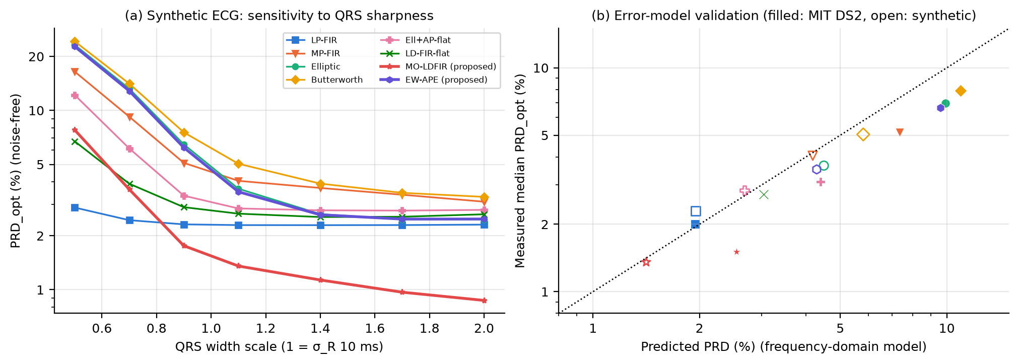
Fig. 10. (a) Noise-free distortion versus QRS sharpness (20 seeds per point). (b) Predicted versus measured PRD (filled: MIT-BIH DS2 medians with the DS1 PSD; open: synthetic ECG with its own PSD).

6.4 Held-out real ECG: MIT-BIH DS2 (inter-patient)
Table 6. MIT-BIH DS2 (22 held-out patients, 30 min each): median [IQR] over records.
Filter | Latency (ms) | PRD_{opt} (%) | PRD_{nom} (%) | R timing err. (ms) | R amp. err. (%) | ST err. (µV) | PRD_{nom} stress (%)
LP-FIR | 44.4 | 2.01 [1.93, 2.09] | 2.01 [1.93, 2.09] | 0.061 [0.039, 0.079] | 0.38 [0.18, 0.61] | 3.65 [3.16, 4.72] | 4.61 [3.84, 6.14]
MP-FIR | 9.5 | 5.14 [4.54, 7.26] | 5.17 [4.63, 7.66] | 0.637 [0.432, 0.978] | 2.65 [1.78, 4.76] | 4.84 [2.81, 8.46] | 7.42 [6.27, 8.48]
Elliptic | 12.1 | 6.94 [5.28, 11.69] | 6.96 [5.31, 11.87] | 0.613 [0.490, 1.454] | 4.78 [2.70, 7.36] | 4.79 [3.54, 6.73] | 8.17 [6.99, 12.31]
Butterworth | 30.3 | 7.93 [6.21, 12.12] | 7.93 [6.35, 12.64] | 0.774 [0.487, 1.597] | 3.40 [2.30, 5.85] | 5.11 [2.83, 7.65] | 9.06 [7.81, 13.04]
Ell+AP-flat | 79.1 | 3.10 [2.93, 3.92] | 3.10 [2.93, 3.92] | 0.286 [0.228, 0.391] | 1.58 [0.75, 2.28] | 10.18 [5.42, 12.17] | 5.21 [4.64, 6.33]
LD-FIR-flat | 19.7 | 2.73 [2.57, 3.00] | 2.73 [2.62, 3.08] | 0.200 [0.111, 0.268] | 0.74 [0.59, 1.20] | 3.95 [1.67, 5.11] | 5.18 [4.46, 6.53]
MO-LDFIR | 19.5 | 1.51 [1.37, 2.08] | 1.53 [1.39, 2.09] | 0.181 [0.094, 0.318] | 0.61 [0.45, 0.89] | 0.84 [0.61, 1.21] | 4.76 [3.93, 6.23]
EW-APE | 20.0 | 6.63 [5.11, 11.22] | 6.66 [5.13, 11.38] | 0.591 [0.457, 1.382] | 4.42 [2.71, 7.07] | 4.54 [3.39, 6.70] | 7.97 [6.79, 11.88]

Table 7. Paired comparisons: median difference (MO-LDFIR − comparator) with bootstrap 95% CI and Holm-corrected Wilcoxon p. Negative = MO-LDFIR better.
MO-LDFIR vs. | DS2 PRD_{opt} (pp) | DS2 ST err. (µV) | DS2 stress PRD_{nom} (pp) | PTB-XL PRD_{opt} (pp)
LP-FIR | -0.42 [-0.62, -0.06], p = 0.105 | -2.95 [-3.79, -2.24], p < 0.001 | +0.10 [+0.01, +0.21], p = 0.092 | +0.63 [+0.56, +0.78], p < 0.001
MP-FIR | -3.70 [-4.76, -3.26], p < 0.001 | -4.02 [-6.38, -2.46], p < 0.001 | -2.38 [-3.20, -2.06], p < 0.001 | -5.15 [-5.42, -4.90], p < 0.001
Elliptic | -5.49 [-8.85, -4.40], p < 0.001 | -4.00 [-5.25, -3.32], p < 0.001 | -3.63 [-6.56, -2.62], p < 0.001 | -8.54 [-9.12, -7.90], p < 0.001
Butterworth | -6.49 [-9.49, -5.17], p < 0.001 | -3.84 [-5.95, -2.42], p < 0.001 | -4.43 [-6.73, -3.67], p < 0.001 | -9.37 [-9.92, -8.69], p < 0.001
Ell+AP-flat | -1.68 [-1.86, -1.62], p < 0.001 | -9.52 [-10.98, -5.46], p < 0.001 | -0.50 [-0.77, -0.17], p = 0.002 | -1.86 [-1.96, -1.78], p < 0.001
LD-FIR-flat | -1.14 [-1.26, -0.92], p < 0.001 | -3.23 [-4.30, -1.86], p < 0.001 | -0.41 [-0.50, -0.30], p < 0.001 | -0.51 [-0.57, -0.45], p < 0.001
EW-APE | -5.19 [-8.43, -4.05], p < 0.001 | -3.75 [-4.84, -3.32], p < 0.001 | -3.41 [-5.59, -2.46], p < 0.001 | -7.97 [-8.68, -7.43], p < 0.001

On held-out patients, MO-LDFIR is significantly better than every other filter that meets the latency budget for both shape (PRD_{opt}) and ST level. Against the Elliptic IIR the median paired PRD reduction is 5.49 percentage points, and against the budget-constrained EW-APE it is 5.19 pp (both p_{Holm} < 0.001). Against the LP-FIR, which takes 44 ms, the PRD difference is -0.42 pp (p_{Holm} = 0.105). The most striking result is the ST level: 0.84 µV against 3.65 µV for the LP-FIR. The mechanism follows from Eq. (1). The PSD weight concentrates accuracy where the ECG energy is, near DC, so MO-LDFIR's low-frequency gain is very close to 1. The equiripple LP-FIR spends its full δp = 2.9% ripple budget there, which scales slow ST-segment levels. The LP-FIR keeps the smallest R-peak timing error, as expected from its exactly constant delay. Under the stress protocol, residual in-band noise dominates and MO-LDFIR and LP-FIR become statistically indistinguishable in PRD, while MO-LDFIR retains the ST advantage.
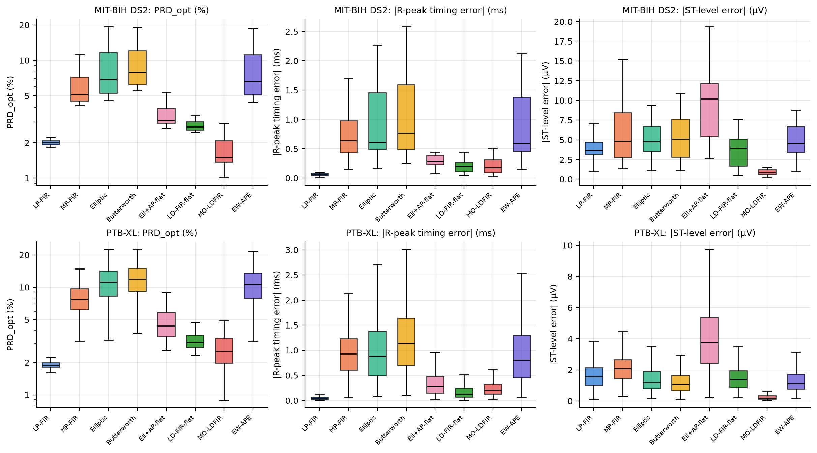
Fig. 11. Record-wise distributions on MIT-BIH DS2 (top) and PTB-XL (bottom): shape error, R-peak timing error relative to the nominal latency, and ST-level error.
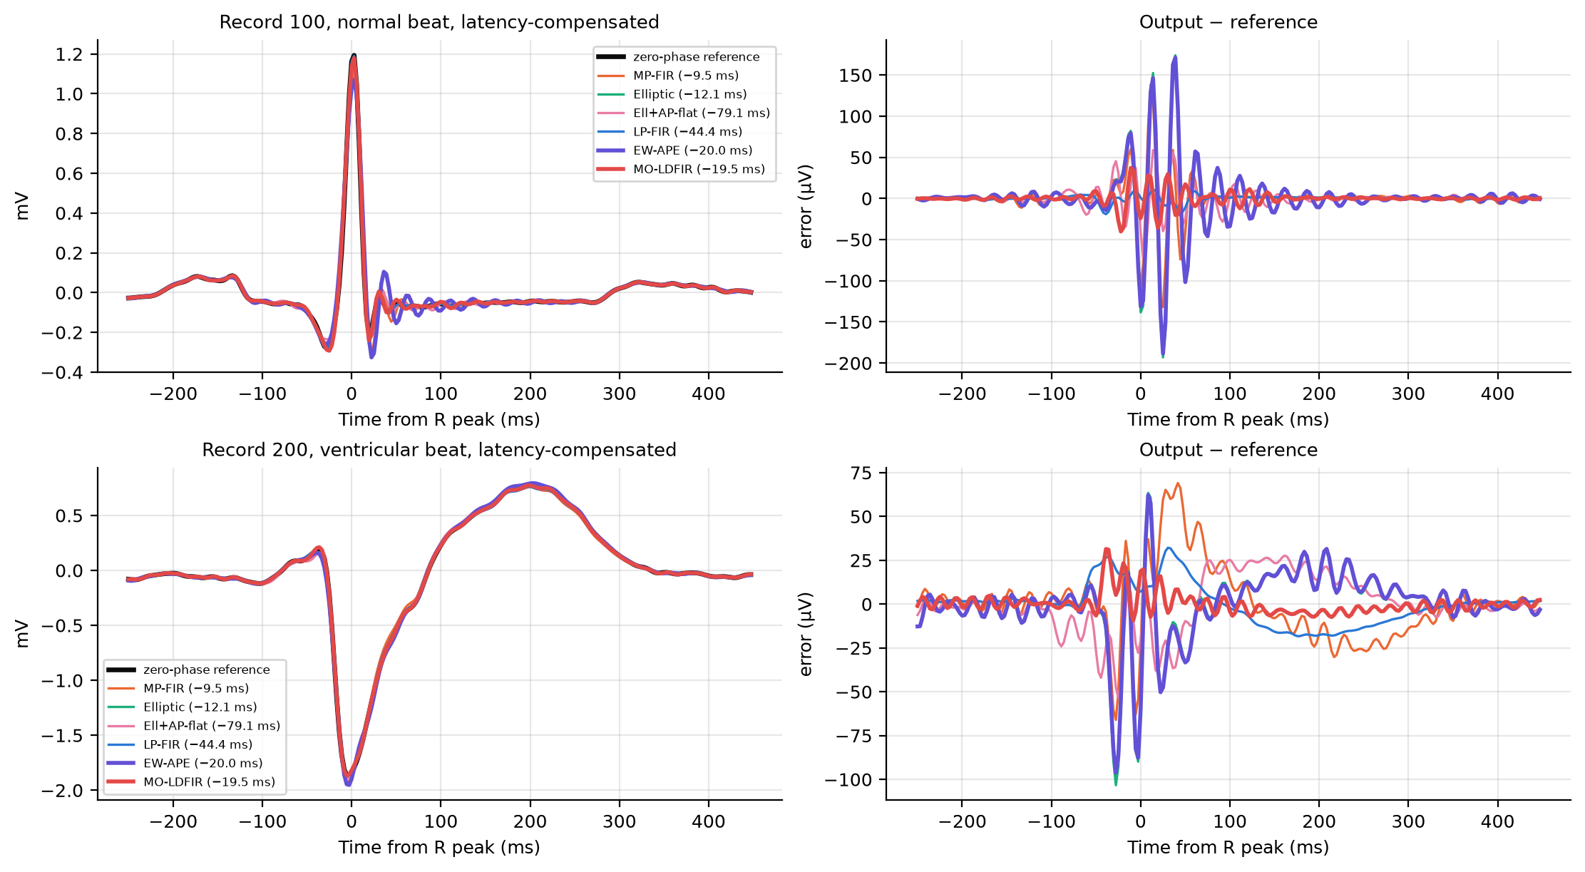
Fig. 12. Latency-compensated outputs and errors for a normal beat (record 100) and a ventricular ectopic beat (record 200). The IIR and MP-FIR errors are concentrated on the QRS complex and the following ringing; the equalized IIR shows pre-ringing.

6.5 Independent validation: PTB-XL (500 Hz, no re-tuning)
Table 8. PTB-XL fold 10 (300 records, lead II). Filters were redesigned at 500 Hz from the same physical specification and locked rules. LD-FIR-flat's kernel-weighted latency (20.2 ms) slightly exceeds the budget at 500 Hz: its uniform weighting does not control the group delay where the latency kernel K(ν) is largest.
Filter | Latency (ms) | mult | PRD_{opt} (%) | R timing err. (ms) | R amp. err. (%) | ST err. (µV)
LP-FIR | 45.0 | 23 | 1.89 [1.82, 2.00] | 0.036 [0.020, 0.066] | 0.19 [0.11, 0.33] | 1.56 [1.01, 2.15]
MP-FIR | 10.0 | 46 | 7.77 [6.21, 9.69] | 0.927 [0.607, 1.235] | 3.28 [1.67, 5.32] | 2.07 [1.44, 2.67]
Elliptic | 12.3 | 9 | 11.18 [8.29, 14.23] | 0.884 [0.491, 1.378] | 5.92 [2.90, 9.69] | 1.18 [0.80, 1.90]
Butterworth | 33.3 | 23 | 11.98 [9.18, 15.03] | 1.138 [0.705, 1.640] | 4.62 [2.64, 8.11] | 1.08 [0.67, 1.65]
Ell+AP-flat | 78.6 | 21 | 4.37 [3.48, 5.87] | 0.283 [0.152, 0.477] | 1.98 [1.05, 3.19] | 3.76 [2.43, 5.36]
LD-FIR-flat | 20.2 | 85 | 3.08 [2.76, 3.61] | 0.129 [0.067, 0.250] | 0.66 [0.38, 1.12] | 1.38 [0.87, 1.94]
MO-LDFIR | 20.0 | 85 | 2.54 [1.97, 3.39] | 0.209 [0.130, 0.331] | 0.81 [0.48, 1.37] | 0.20 [0.13, 0.35]
EW-APE | 20.0 | 13 | 10.69 [7.90, 13.64] | 0.811 [0.450, 1.302] | 5.62 [2.75, 9.17] | 1.12 [0.78, 1.73]

The ranking transfers to a different dataset, sampling rate and patient population without any re-tuning. MO-LDFIR (N = 85, 20.0 ms) is again the best latency-compliant design (2.54% against 11.18% for the elliptic IIR and 7.77% for the MP-FIR), and it has the lowest ST error. Here the 45-ms LP-FIR is better in shape by 0.63 pp (p_{Holm} < 0.001; better on 79% of records). This is a genuine latency-morphology trade-off. A plausible but untested explanation is a spectral mismatch between the MIT-BIH-derived weight and the PTB-XL lead-II population; the QRS-sharpness sweep (Fig. 10a) shows that MO-LDFIR's advantage shrinks when signal energy moves toward the band edge.

6.6 PPG case study
Table 9. Synthetic PPG (200 trials) under the PPG specification (fs = 125 Hz, 0–8 Hz, ≥40 dB above 12 Hz, budget 80 ms).
Filter | Latency (ms) | mult | PRD_{opt} (%) | Systolic-peak timing err. (ms) | Peak amp. err. (%)
LP-FIR | 224 | 29 | 3.75 [3.25, 4.53] | 0.07 [0.04, 0.10] | 0.64 [0.52, 0.77]
MP-FIR | 52 | 57 | 6.11 [5.26, 7.50] | 1.28 [0.66, 3.22] | 0.30 [0.07, 0.84]
Elliptic | 62 | 9 | 6.49 [5.21, 11.68] | 1.72 [0.58, 4.93] | 0.77 [0.45, 2.52]
Butterworth | 169 | 23 | 6.53 [5.44, 11.87] | 1.78 [0.88, 4.98] | 2.43 [1.65, 2.63]
Ell+AP-flat | 391 | 21 | 4.89 [4.04, 5.70] | 0.24 [0.19, 0.29] | 0.66 [0.40, 0.89]
LD-FIR-flat | 79 | 137 | 4.82 [4.21, 5.54] | 0.28 [0.14, 1.02] | 2.45 [2.15, 2.59]
MO-LDFIR | 80 | 137 | 1.62 [1.29, 1.98] | 0.19 [0.07, 0.84] | 0.45 [0.38, 0.52]
EW-APE | 80 | 13 | 6.49 [5.21, 11.67] | 1.72 [0.58, 4.92] | 0.77 [0.45, 2.51]

For the narrower relative transition band of the PPG specification, the LP-FIR needs 224 ms, nearly three times the budget. MO-LDFIR meets the budget with 1.62% shape error against 6.49% for the elliptic IIR. The cost grows to 137 multiplies per sample, against 9 for the IIR: a narrow transition band makes every FIR expensive (Sec. 7).
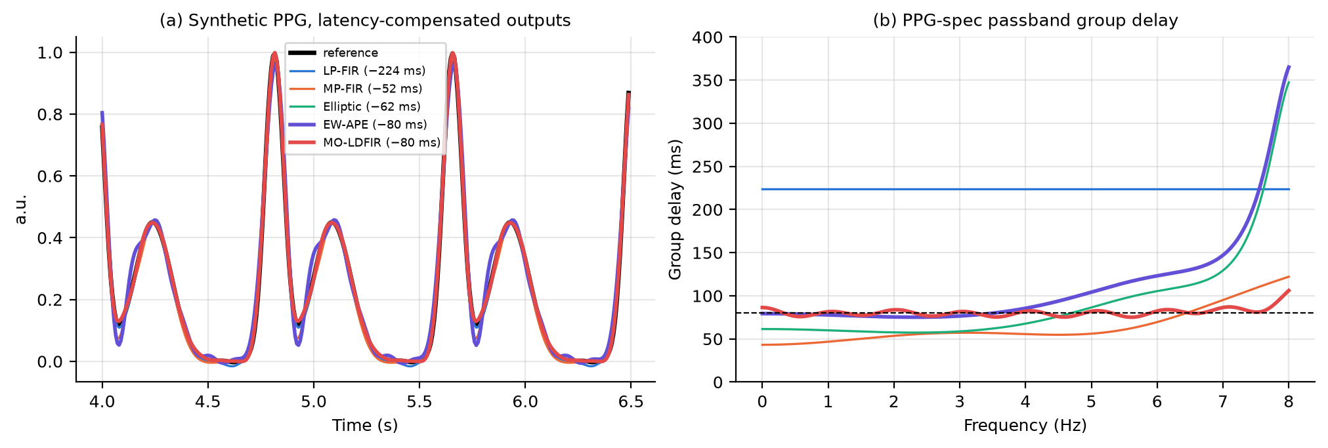
Fig. 13. PPG specification: (a) latency-compensated outputs; (b) passband group delay.

6.7 Ablation and sensitivity
Table 10. Ablation (DS2, first 10 min per record). The upper block varies MO-LDFIR components; the lower block compares all-pass criteria for K = 2 without a latency bound.
Variant | Meets spec | Latency (ms) | E_{τg} | PRD_{pred} (%) | DS2 PRD_{opt} (%) median [IQR]
MO-LDFIR (proposed) | yes | 19.5 | 2.56e-04 | 2.55 | 1.44 [1.35, 2.16]
without PSD weight (uniform weighting) | yes | 19.7 | 6.97e-04 | 3.04 | 2.71 [2.56, 3.03]
mismatched PSD (synthetic-ECG PSD) | yes | 19.5 | 5.56e-04 | 2.56 | 1.65 [1.54, 2.27]
without length slack (N = N_{min}) | yes | 19.6 | 4.66e-04 | 3.00 | 1.87 [1.81, 2.65]
PSD floor 10⁻⁴ | yes | 19.4 | 2.00e-04 | 2.64 | 1.37 [1.16, 2.20]
PSD floor 10⁻² | yes | 19.6 | 5.42e-04 | 2.62 | 2.04 [1.86, 2.53]
EW-APE exact criterion (proposed) K=2 | yes | 55.9 | 2.30e-03 | 4.40 | 3.08 [2.59, 4.32]
AP: GD-kernel surrogate K(v) K=2 | yes | 51.9 | 1.11e-03 | 4.68 | 3.20 [2.62, 4.49]
AP: PSD-weighted GD variance K=2 | yes | 54.2 | 1.43e-03 | 4.46 | 3.09 [2.57, 4.29]
AP: flat GD variance (classical) K=2 | yes | 57.5 | 9.99e-03 | 4.91 | 3.70 [3.39, 4.69]
AP: minimax GD (classical) K=2 | yes | 64.9 | 3.31e-01 | 15.86 | 14.22 [13.11, 16.28]

MO-LDFIR components. Removing the PSD weight, which leaves the classical uniformly weighted low-delay FIR with identical constraints and length, raises the DS2 median PRD from 1.44% to 2.71%. The signal-energy weighting is therefore the main source of the gain. Designing with the PSD of the synthetic ECG model instead of real DS1 ECG costs little (1.65%), so an approximate spectral model suffices. Removing the length slack (N = N_{min}) gives 1.87%: at the minimum feasible length the constraints leave almost no freedom for the objective. The PSD floor matters moderately (1.37% at 10⁻⁴, 2.04% at 10⁻²). A high floor flattens the weight toward the uniform design. The floor of 10⁻³ was fixed a priori and not tuned on test data.
All-pass criteria (K = 2, no latency bound). The exact morphology criterion of EW-APE gives the lowest error (3.08%). The PSD-weighted group-delay variance (3.09%) and the derived kernel surrogate (3.20%) come next, and the classical flat criterion is worst (3.70%), while also adding the most latency. The kernel surrogate is the cheapest to evaluate, because the group delay of an all-pass section is analytic, but it is a bound and therefore conservative. Our smoothed-minimax (p = 16) implementation of the classical minimax criterion converged to a poor local optimum (14.2%). We report it as an implementation limitation of that baseline, not as evidence against minimax equalization in general.

6.8 Finite word-length behavior
Table 11. Stopband attenuation (dB) after coefficient quantization (FIR: shared exponent; IIR: Q2.(B−2) per section). The float64 design is the high-precision reference.
Filter | 10 bit | 12 bit | 16 bit | 24 bit | float64
LP-FIR | 37.74 | 39.95 | 40.28 | 40.30 | 40.30
MP-FIR | 39.42 | 40.07 | 40.28 | 40.30 | 40.30
Elliptic | 40.06 | 40.06 | 40.05 | 40.05 | 40.05
Butterworth | 42.74 | 42.72 | 42.72 | 42.72 | 42.72
Ell+AP-flat | 40.05 | 40.06 | 40.05 | 40.05 | 40.05
LD-FIR-flat | 36.91 | 39.39 | 40.11 | 40.18 | 40.18
MO-LDFIR | 37.69 | 39.37 | 40.14 | 40.18 | 40.18
EW-APE | 40.06 | 40.06 | 40.05 | 40.05 | 40.05

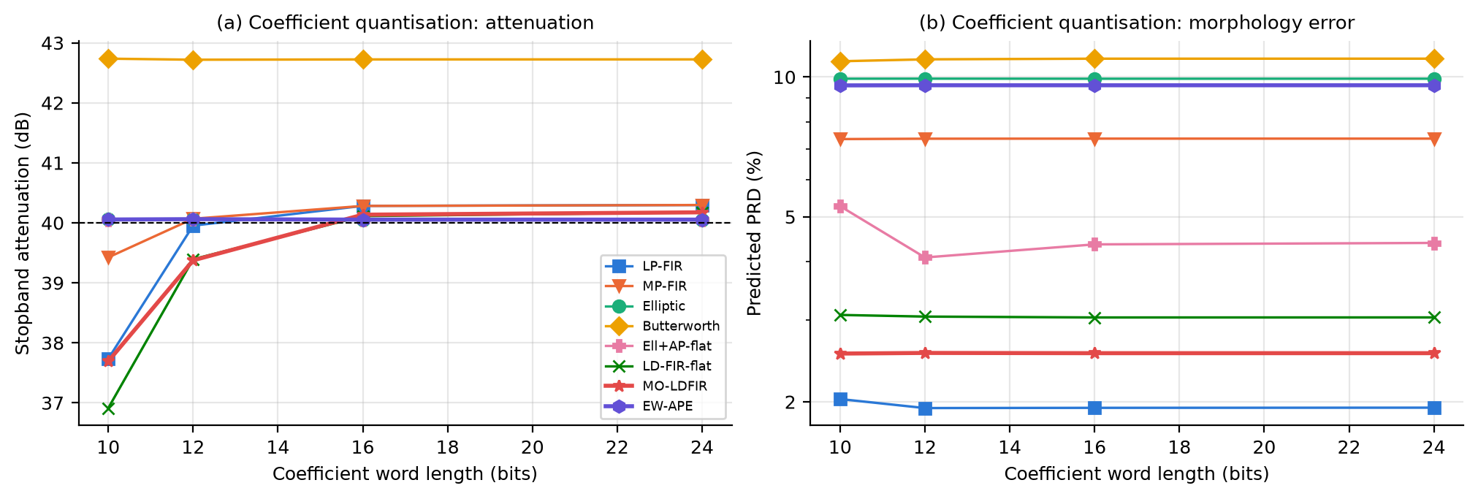
Fig. 14. Coefficient quantization: attenuation (a) and predicted morphology error (b) versus word length.
The IIR designs are realized as second-order sections with pole radius ≤ 0.958. They keep their stopband attenuation even with 10-bit coefficients (40.1 dB). However, the minimum-order elliptic filter sits exactly on the passband-ripple limit with zero margin, so any rounding violates the mask. At 16 bits, Elliptic, Ell+AP-flat and EW-APE exceed the ripple tolerance by 0.6–1.3% of δp, which is a very small but formal violation. At 16 bits all the FIRs pass (LP-FIR, MP-FIR, LD-FIR-flat and MO-LDFIR). At 12 bits LP-FIR, LD-FIR-flat and MO-LDFIR lose stopband attenuation, while the MP-FIR still meets the mask (40.1 dB). MO-LDFIR drops to 39.4 dB, because the SOCP optimum lies on the attenuation constraint with only ~0.2 dB margin and 71 taps accumulate rounding error. The LP-FIR drops to 39.95 dB. The predicted PRD at 16 bits is unchanged to within 0.031 pp for every design. The lesson is architecture-independent: designs placed exactly on a constraint by an optimizer or by minimum-order formulas need explicit margin before quantization. Margin can come from a tightened ripple or stopband target, or from quantization-aware constraints; neither was evaluated here.

7. Discussion and design recommendations
The central question, which architecture best preserves morphology for a fixed attenuation and latency budget, has no single answer. The evidence does, however, support the following rules, summarized in Table 12.
Table 12. Design recommendations derived from the results.
Situation | Recommended architecture | Evidence
Latency budget ≥ (N_{LP}−1)/2, i.e. the LP-FIR fits; robustness to unknown signal spectra matters | Linear-phase FIR (Parks–McClellan) | Exactly zero phase distortion and timing jitter; best on PTB-XL; insensitive to spectral mismatch (QRS sweep)
Latency budget between the IIR/MP limit and (N_{LP}−1)/2, transition ≥ ~20 Hz at 360 Hz, As ≤ 50 dB | MO-LDFIR (proposed) | Lowest PRD among compliant filters on DS2, PTB-XL and PPG and lowest ST error on DS2 and PTB-XL (p_{Holm} < 0.001); Pareto-dominant (Tables 3–4)
Same budget, but the full-length LP-FIR also fits and morphology fidelity is paramount | MO-LDFIR at D = budget with longer N | Lower predicted PRD than the minimum-length LP-FIR at equal latency (Fig. 9; model prediction, not measured on test data)
Narrow transition / high attenuation, latency tolerance ≈ 77–84 ms, tight arithmetic budget | Elliptic IIR + EW-APE (proposed) | Reaches PRD ≤ 3% at TW = 5–10 Hz with 21–23 multiplies, vs 117–249 for MO-LDFIR (36–64 ms) and 31–60 for the LP-FIR (85–164 ms); dominates 34 of 35 classical-equalizer designs
Budget below the low-delay-FIR limit (≈ 17 ms at the base spec) | Minimum-phase FIR or elliptic IIR (accept distortion) | Only feasible families; MP-FIR has lower PRD, the elliptic IIR far lower cost
Short coefficient word lengths (≤ 16 bits) | Design every architecture with explicit ripple/stopband margin; IIR in SOS form keeps its attenuation best | Quantization study (Table 11): zero-margin designs violate the mask
Offline analysis (no latency limit) | Zero-phase (forward-backward) filtering | Not a real-time solution; used here only as reference

Two DSP mechanisms explain these rules. First, morphology error is governed by the accumulated phase error weighted by signal energy (Eqs. 3–5), not by the peak group-delay deviation. The elliptic IIR's large band-edge Δτ_{max} matters less than its passband phase curvature, while the classical equalizer, which flattens group delay uniformly, wastes delay correcting a region with little signal energy. Second, an all-pass section can only add group delay. Under a strict budget it cannot pull the low-frequency group delay of an IIR up to a flat level without also raising the latency, so EW-APE collapses to a very weak equalizer (Table 1, Fig. 4). A low-delay FIR has no such restriction: its zeros outside the unit circle shape the phase freely, which is why it is the only architecture that improves morphology at fixed latency.

7.1 Limitations and threats to validity
- The error model assumes a wide-sense-stationary input. ECG is quasi-periodic, so the model predicts rankings well but absolute PRD only approximately (Fig. 10b).
- The morphology reference is a zero-phase ideal filter. A different, equally defensible reference, for example one with a different transition shape, would change absolute PRD values, mainly through the transition-band term common to all designs.
- MO-LDFIR is optimal for the PSD it was designed with. Mismatched spectra (very sharp QRS, paced beats, pediatric ECG) degrade it (Fig. 10a, PSD-mismatch ablation). In those cases a linear-phase FIR is the safe choice if its latency is acceptable.
- Only the low-pass stage was studied. High-pass baseline removal, where phase distortion of the ST segment is clinically more critical [14], has far narrower relative transition bands and would require proportionally longer low-delay FIRs. The same framework applies but was not evaluated.
- Latency was defined as the energy-kernel-weighted passband group delay. Other definitions, such as the 50%-step delay in Table 2, give a consistent ordering of the designs but differ in absolute value.
- Operation counts are direct-form algorithmic costs. No hardware or power claims are made, and no clinical claims are made: the 20-ms budget is illustrative.
- PTB-XL R-peaks were detected automatically on the reference signal. Detection errors affect all filters equally.

8. Conclusion
We compared linear-phase FIR, minimum-phase FIR, classical IIR and phase-equalized IIR filters under exactly matched magnitude specifications and an explicit latency budget. The derived morphology-error model defines the J = αE_{mag} + βE_{τg} + γD objective with α = β = 1 and a signal-energy group-delay kernel K(ν). It predicts the ranking of all designs from their frequency responses and the signal PSD. The proposed constrained low-delay FIR (MO-LDFIR) is a convex SOCP that guarantees the magnitude mask. Within a 20-ms budget it reduced the median shape error on held-out MIT-BIH patients from 6.9% (elliptic IIR) to 1.5%, and the ST-level error to below 1 µV. The ranking transferred without re-tuning to PTB-XL at 500 Hz and to a PPG specification. All-pass equalization is effective only when latency can grow. The proposed energy-weighted equalizer uses that latency more efficiently than the classical flat-delay criterion, and it is the cost-efficient option for narrow transition bands. The linear-phase FIR remains the most robust choice whenever its delay is acceptable. The proposed FIR's main weaknesses are its arithmetic cost, its sensitivity to coefficient word length, and its dependence on the assumed signal spectrum. Future work includes quantization-aware SOCP constraints, adaptive or patient-specific spectral weights, mixed FIR–IIR correctors, and the high-pass (baseline-removal) stage.

References
[1] T. W. Parks and J. H. McClellan, “Chebyshev approximation for nonrecursive digital filters with linear phase,” IEEE Trans. Circuit Theory, vol. 19, no. 2, pp. 189–194, 1972.
[2] A. V. Oppenheim and R. W. Schafer, Discrete-Time Signal Processing, 3rd ed. Pearson, 2010.
[3] C. Wu, D. Gao and K. L. Teo, “A direct optimization method for low group delay FIR filter design,” Signal Processing, vol. 93, no. 7, pp. 1764–1772, 2013. doi:10.1016/j.sigpro.2013.01.015.
[4] B. C. Garai, P. Das and A. K. Mishra, “Group delay reduction in FIR digital filters,” Signal Processing, vol. 91, no. 8, pp. 1812–1825, 2011. doi:10.1016/j.sigpro.2011.02.005.
[5] M. F. Quélhas and A. Petraglia, “Optimum design of group delay equalizers,” Digital Signal Processing, vol. 21, no. 1, pp. 1–12, 2011. doi:10.1016/j.dsp.2010.06.001.
[6] Y. Lyu, Z. Liu, K. Pan and Y. Shen, “Phase equalization using a hybrid cascade of causal and noncausal IIR allpass filters,” Digital Signal Processing, vol. 167, 105455, 2025. doi:10.1016/j.dsp.2025.105455.
[7] P. de Chazal, M. O'Dwyer and R. B. Reilly, “Automatic classification of heartbeats using ECG morphology and heartbeat interval features,” IEEE Trans. Biomed. Eng., vol. 51, no. 7, pp. 1196–1206, 2004.
[8] G. B. Moody and R. G. Mark, “The impact of the MIT-BIH Arrhythmia Database,” IEEE Eng. Med. Biol. Mag., vol. 20, no. 3, pp. 45–50, 2001. Data: physionet.org/content/mitdb/1.0.0 (ODC-By 1.0).
[9] A. L. Goldberger et al., “PhysioBank, PhysioToolkit, and PhysioNet,” Circulation, vol. 101, no. 23, pp. e215–e220, 2000.
[10] P. Wagner et al., “PTB-XL, a large publicly available electrocardiography dataset,” Scientific Data, vol. 7, 154, 2020. Data: physionet.org/content/ptb-xl/1.0.1 (CC BY 4.0).
[11] P. E. McSharry, G. D. Clifford, L. Tarassenko and L. A. Smith, “A dynamical model for generating synthetic electrocardiogram signals,” IEEE Trans. Biomed. Eng., vol. 50, no. 3, pp. 289–294, 2003.
[12] S. Boyd and L. Vandenberghe, Convex Optimization. Cambridge University Press, 2004.
[13] S. Diamond and S. Boyd, “CVXPY: A Python-embedded modeling language for convex optimization,” J. Mach. Learn. Res., vol. 17, no. 83, pp. 1–5, 2016.
[14] P. Kligfield et al., “Recommendations for the standardization and interpretation of the electrocardiogram: Part I,” Circulation, vol. 115, pp. 1306–1324, 2007.
[15] S. Holm, “A simple sequentially rejective multiple test procedure,” Scand. J. Statist., vol. 6, no. 2, pp. 65–70, 1979.

Appendix A. Development-set selection and reproducibility
Table 13. Hyperparameter selection on MIT-BIH DS1 only (first 600 s per record). Rule fixed in advance: smallest FIR slack within 2% of the best median PRD; EW-APE K with the lowest median PRD among latency-compliant candidates. Selected: slack = 32, K = 1.
Candidate | DS1 median PRD_{nom} (%) | DS1 median PRD_{opt} (%) | Latency (ms)
MO-LDFIR N = 39 (slack 0) | 2.185 | 2.116 | 19.56
MO-LDFIR N = 47 (slack 8) | 1.959 | 1.879 | 19.47
MO-LDFIR N = 55 (slack 16) | 1.906 | 1.859 | 19.47
MO-LDFIR N = 71 (slack 32) | 1.762 | 1.705 | 19.45
EW-APE K = 1 (D ≤ budget) | 7.628 | 7.609 | 20.00
EW-APE K = 2 (D ≤ budget) | 7.646 | 7.627 | 20.00
EW-APE K = 3 (D ≤ budget) | 7.663 | 7.645 | 20.00

Software. python 3.13.1, numpy 2.1.2, scipy 1.18.0, matplotlib 3.11.0, platform Windows-11-10.0.26200-SP0, cvxpy 1.9.3, wfdb 4.3.1, pandas 2.2.3. CVXPY solver: CLARABEL. Code repository: https://github.com/shahidibrahimvn015/low-delay-morphology-filtering. Reproduction: clone the repository, then pip install -r requirements.txt and python run_all.py. The datasets are downloaded by scripts/00_download_data.py from PhysioNet's AWS open-data mirror and are not redistributed. All parameters and seeds are in config/params.json, and every number in this report is taken from the output files in results/.

Author contributions
V N Shahid Ibrahim derived the morphology-error model and the group-delay kernel, formulated MO-LDFIR as a second-order-cone program, and carried out its ablations, the latency-budget sweep, the computational-cost analysis and the error-model validation. Nida Paravath defined the signal model, matched specification and metrics, designed the baseline filters, produced the phase, group-delay, pole-zero and transient analyses, and carried out the finite word-length study. Madhav Tripathi built the data and evaluation pipeline, including the DS1 hyperparameter selection, implemented the synthetic ECG Monte-Carlo experiments, ran the MIT-BIH DS2 and PTB-XL validation with the statistical analysis, and prepared the reproducibility package. Deepak Meena developed EW-APE and the classical equalizer baseline, ran the Pareto sweeps and the PPG case study, and wrote the design recommendations and limitations. All authors contributed to the literature review and to writing and revising the report.

