Table of Contents
1. Introduction 3
4. Classification 3
4.1 Substantive issue 3
4.2 Research Questions 3
4.3 Dataset and Variables 3
4.4 Methodology 4
4.5 Analysis 4
5. Reference 7
6. Dataset Links 7

Introduction
Machine learning is a branch of artificial intelligence (AI) that concentrates on algorithms capable of “learning” the patterns from training data and thereafter, making precise predictions about new data. This skill in pattern recognition allows machine learning models to make choices or forecasts without defined, rigid commands (IBM, 2026). It encompasses supervised learning, utilizing labelled datasets to develop algorithms for precise data classification, and unsupervised learning, where it covers analysing datasets to discover hidden patterns or clusters. In this project, real world datasets will be analysed using both supervised and unsupervised learning to identify patterns and derive valuable insights.

4. Classification

4.1 Substantive issue
Breast cancer continues to be a significant worldwide health issue. In 2022, approximately 2.3 million women were diagnosed with breast cancer, resulting in 670,000 deaths globally. (WHO,2025) Correctly distinguishing breast tumours as either malignant or benign is crucial for patients and healthcare providers, as timely and precise diagnosis can enhance treatment choices and survival rates. Machine learning models can aid this process by detecting patterns in diagnostic information and enhancing prediction accuracy. Thus, using classification methods on breast cancer data could greatly enhance clinical decision-making and public health results.

4.2 Research Questions
RQ1: Which machine learning model yields the highest accuracy in categorizing breast tumours as either malignant or benign?
RQ2: What diagnostic characteristics most significantly affect the prediction of a tumour being malignant or benign?

4.3 Dataset and Variables
The breast Cancer Wisconsin (Diagnostic dataset) contains 569 entries and 30 numerical predictor variables, with no missing data found in the dataset. Every observation relates to characteristics derived from digitized images of fine needle aspirate (FNA) samples of breast masses. These attributes define the properties of the cell nuclei found in the image, including radius, texture, perimeter, area and smoothness.
The dataset includes two target categories that indicate if a tumour is malignant (212 instances) or benign (357 instances). The goal of the classification models is to precisely differentiate between these two categories using the diagnostic attributes. The dataset serves as a common benchmark in machine learning research for assessing classification algorithms.
Below is a summary of chosen variables from the dataset.
Variable Name | Variable Description
Radius mean | Mean distance from the centre to points on the perimeter
Texture mean | Standard deviation of Gray-scale values
Perimeter mean | Mean size of the tumour perimeter
Area mean | Mean area of the tumour
Smoothness mean | Local variation in radius lengths
Compactness mean | Measure of tumour compactness calculated as (perimeter² / area – 1.0)
Concavity mean | Severity of concave portions of the tumour contour
Symmetry mean | Measure of symmetry of the tumour
Fractal dimension mean | Fractal dimension of the tumour boundary
Diagnosis | Tumour Classification (M = malignant, B = benign) (Target Variable)

4.4 Methodology
An initial exploratory data analysis (EDA) will be performed on the breast cancer dataset to investigate the distribution of diagnostic variables and their associations with the tumour classification outcome. This stage aids in recognizing possible patterns, relationships among variables, and general features of the dataset before proceeding with model development.
After the exploratory analysis, multiple classification algorithms will be used to determine if a tumour is malignant or benign. The training of these models will utilize the diagnostic features obtained from fine-needle aspirate images of breast tumours. The models seek to identify patterns in these features that effectively differentiate between malignant and benign tumour instances. The classification model’s performance will subsequently be assessed utilizing various evaluation metrics, such as accuracy, precision, recall, F1- score, and ROC-AUC. These metrics offer an extensive evaluation of model performance by assessing both general predictive accuracy and the model’s capacity to accurately pinpoint malignant tumour cases. Comparing with currently literature can offer valuable context for assessing the efficacy of machine learning models in medical diagnosis. Earlier studies have shown that diagnostic characteristics obtained from images of breast cells can be effectively utilized to distinguish tumours as malignant or benign through machine learning methods (Street, Wolberg and Mangasarian, 1993). Moreover, machine learning models like support vector machines, when integrated with feature selection, have demonstrated robust classification efficacy in breast cancer diagnostic datasets (Akay, 2009). These research efforts emphasize the capabilities of machine learning techniques in aiding breast cancer diagnosis and offer a valuable reference for assessing the models created in this research.

4.5 Analysis
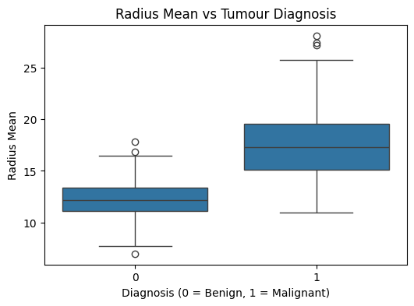
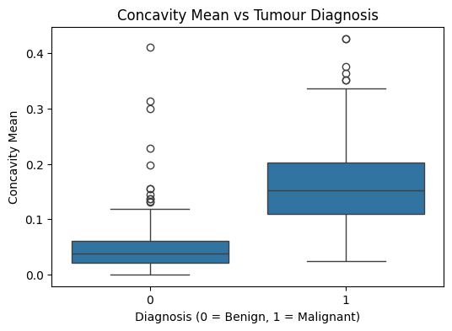
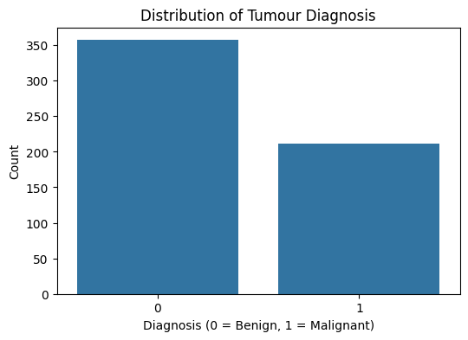
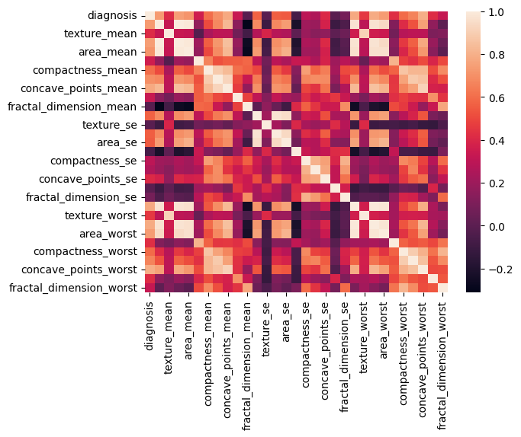
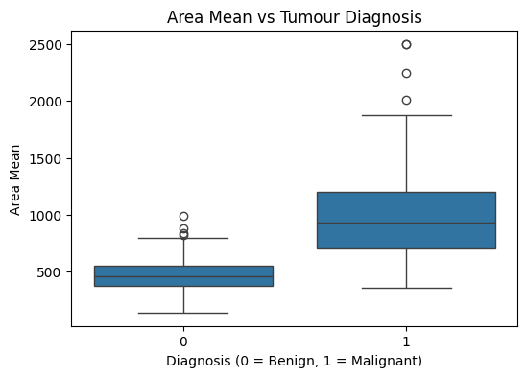
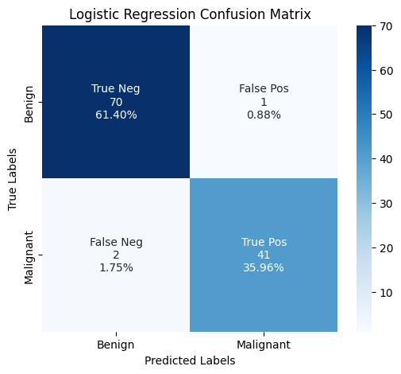
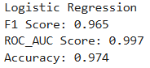
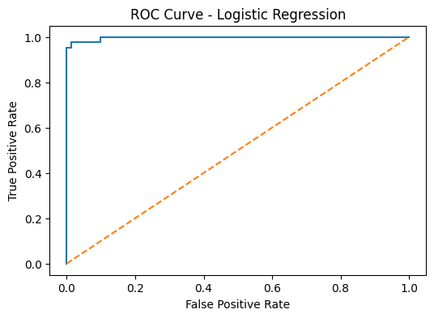
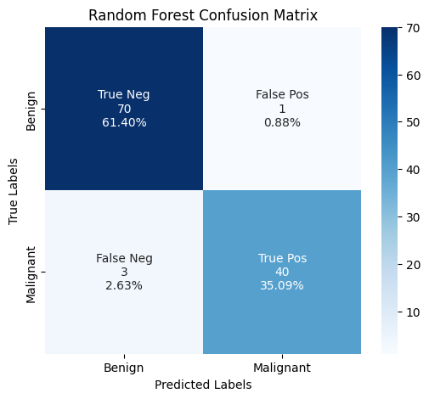
Preliminary analysis was carried out with a correlation heatmap to determine the connections among the variables in the breast cancer dataset. The heatmap reveals significant positive correlations between various variables associated with tumour size. Specifically, radius mean and perimeter mean exhibit a correlation of 0.99 and area mean is also strongly correlated with perimeter mean (0.99). Robust connections are also noted among the worst-case metrics, as radius worst and perimeter worst display correlations exceeding 0.97. The strong correlations suggest that variables related to tumour size are closely linked and could offer significant predictive capability for diagnosing breast cancer, as illustrated in figure 14. The target variable’s distribution was analysed to assess the dataset’s class balance. The findings indicate that the dataset contains 357 benign cases (62.7%) and 212 malignant cases (37.3%). While benign tumours are more common, the dataset keeps a balanced distribution, enabling machine learning models to efficiently discern patterns between the two classes, as illustrated in figure 15. Additional investigation was carried out to explore how tumour features vary between benign and malignant instances. The boxplots indicate that malignant tumours typically exhibit larger sizes in comparison to benign tumours. For instance, malignant tumours exhibit a higher median radius mean of about 17-18, while benign tumours have a median near 12-13. A comparable trend is seen with area mean, as malignant tumours attain values greater than 1000, whereas benign tumours predominantly stay under 500. Furthermore, the concavity mean values are significantly elevated in malignant tumours, suggesting more irregular tumour edges as illustrated from figure 16 to 18. After the exploratory analysis, the dataset was readied for machine learning modelling. The dataset was divided into training and testing sets with an 80:20 distribution, yielding 455 samples for training and 114 samples for testing. Feature scaling was conducted with the StandardScaler to normalize the variables prior to model training. Subsequently, three supervised learning algorithms were employed: Logistic Regression, Random Forest and K-nearest Neighbours (KNN). Model performance was assessed using Accuracy, F1 Score, and ROC-AUC metrics, along with confusion matrices and ROC curves. The Logistic Regression model obtained the best overall performance compared to the three models. The model achieved an accuracy of 97.37% and F1 score of 0.965, and a ROC-AUC score of 0.997. The confusion matrix indicates that 70 benign cases (61.40%) and 41 malignant cases (35.96%) were accurately categorized. The testing dataset revealed just 1 false positive (0.88%) and 2 false negatives (1.75%). The Roc Curve additionally illustrates robust classification performance, with the curve situated near the upper left corner, signifying a high true positive rate as depicted in figure 19 and 20.
Figure 17: Area vs Diagnosis boxplot
Figure 16: Radius vs Diagnosis boxplot
Figure 15: Distribution of Tumour
Figure 14: Correlation heatmap
Figure 18: Concavity vs Diagnosis boxplot
Figure 19: Logistic Regression Confusion Matrix
Figure 20: Logistic Regression ROC Curve

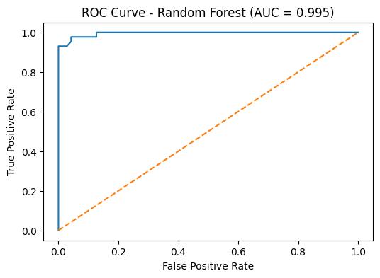

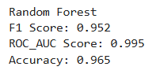
Figure 22: Random Forest ROC Curve
Figure 21 Random Forest Confusion Matrix
The Random Forest model demonstrated excellent predictive capability, achieving an accuracy of 96.49%, an F1 score of 0.952, and a ROC-AUC score of 0.995. The confusion matrix shows that 69 benign instances (60.53%) and 41 malignant instances (35.96%) were accurately identified. The analysis of feature importance indicates that area worst (0.156) and concave points worst (0.145) are the key variables in forecasting breast cancer diagnosis. Additional significant predictors are concave points mean (0.107) and radius worst (0.078), indicating that tumour size and irregular tumour edges are crucial signs of malignancy, as illustrated in figure 21.
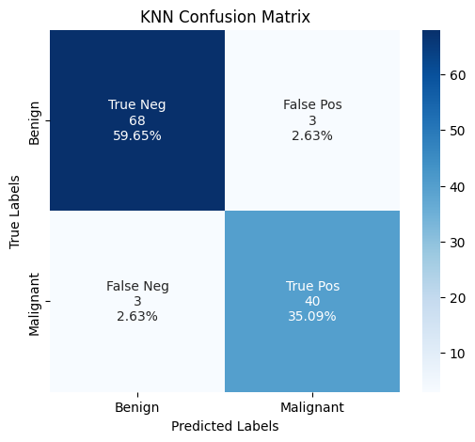
Figure 23: KNN Confusion Matrix

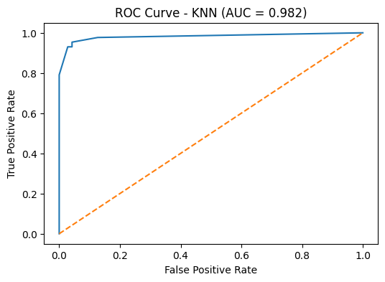

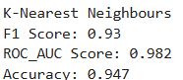
Figure 24: KNN ROC Curve
The K-Nearest Neighbour (KNN) algorithm attained an accuracy of 94.74%, along with an F1 score of 0.930 and a ROC-AUC score of 0.982. The confusion matrix indicates that 68 benign cases (59.65%) and 40 malignant cases (35.09%) were accurately categorized. Nonetheless, the model generated a few more misclassifications than the other models, recording 3 false positives (2.63%) found in the test set. Nevertheless, the ROC curve still demonstrates robust classification performance with an AUC value of 0.982.
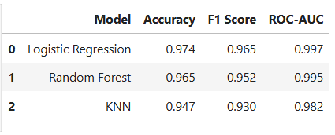
In conclusion, a comparison among the three machine learning models indicates that logistic Regression delivered the best overall performance, with the highest accuracy (97.37%), F1 score (0.965), and ROC-AUC score (0.997). Random Forest yielded similar results with an accuracy of 96.49% whereas KNN recorded the least performance with an accuracy of 94.74%. In this dataset, Logistic Regression demonstrated the most reliable predictive performance for breast cancer classification as shown in the model comparison table.

5. Reference
Chen, H., Yang, B., Pei, J. and Liu, J. (2008) Data mining for the Internet of Things: literature review and challenges. Available at: https://www.sciencedirect.com/science/article/abs/pii/S0957417408000912 (Accessed: 10 March 2026).
IBM (2026) What is machine learning? Available at: https://www.ibm.com/think/topics/machine-learning (Accessed: 9 March 2026).
Scikit-learn Developers (2024) Supervised learning. Available at: https://scikit-learn.org/stable/supervised_learning.html (Accessed: 10 March 2026).
Setiono, R. (1993) Extracting rules from neural networks. Available at: https://ui.adsabs.harvard.edu/abs/1993SPIE.1905..861S/abstract (Accessed: 10 March 2026).
World Health Organization (2024) Breast cancer. Available at: https://www.who.int/news-room/fact-sheets/detail/breast-cancer (Accessed: 11 March 2026).

6. Dataset Links
Classification
https://archive.ics.uci.edu/dataset/17/breast+cancer+wisconsin+diagnostic

