GEOG 786 Geographic Information Systems

Spring 2021

Assignment 2 Point in Polygon

50 points

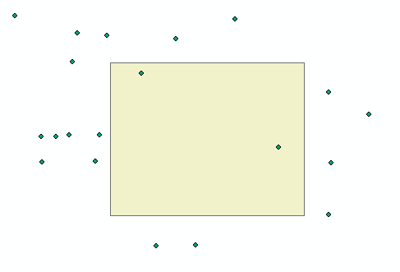

In this assignment, you will be given some points and a polygon (rectangle). You need to write a Python program to derive the points that fall within the polygon. In the given Python script “assignment2.py”, you are given list named “points”, which contains the ID, X coordinate and Y coordinate of the points. Moreover, a list variable named “polygon” contains all the vertexes of the polygon. You need to find out the points that fall within the polygon.

Here are the requirements for this assignment:

1. Implement a function named “pointInPolygon”, which takes a point and a polygon (a rectangle) as the input and checks whether the point falls within the polygon. The function will return **True** if the point is within the polygon and return **False** otherwise. (40 points)
2. In the **main** function, use loop to find out the points within the given polygon, store them in a list, and print out their IDs as well as the number of points in the console. (10 points)

You need to submit a python script named “assignment2.py” (compress it) in D2L. (Please review list and for loops in Python before you do this assignment if necessary).