

GEOG-741 Assignment-2

Landsat 8 Surface Reflactance

Shahid Nawaz Khan | Quantitative Remote Sensing

# Executive Summary

The main aim of this assignment was to analyze the landsat-8 level 2 data which is corrected for atmospheric effects. As the corrected data is stored in a standardized version the data was first converted using the linear relation between actual values versus stored values. The surface reflectance for same pixels was calculated and compared between TOA reflectance. The surface reflectance after corrections was considerably different from ToA reflectance which can have several reasons. In all the wavelengths the blue band was the most affected band by the atmospheric effects while NIR was the least affected bands by these effects.

# Step 1: Pixels Selections

Same pixels used in assignment-1 were selected so that to create an ease for comparison between ToA reflectance and surface reflectance. The two pixels each belonged to water class and vegetation class. These pixels were selected based on visual analysis and vegetation indices so that to lessen the chance of error in selecting pixels for each class.

# Step 2: Conversion from reflective band pixels values to Surface Reflectance

In this step the values from each pixel of image were transformed to surface reflectance using the provided equation and data in the meta data file. The data was used in equation to create the surface reflectance values for both classes in every band. The values generated were then compared with each other in the next step.

# Task 1: Plot TOA and Surface Reflectance together

Figure below plots the TOA and surface reflectance for both pixels using bands 2-7.

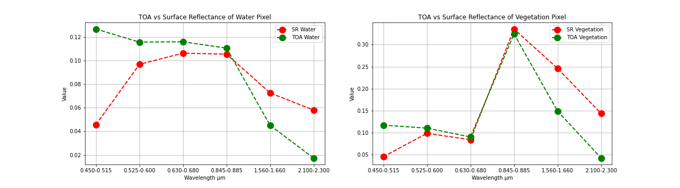

Figure 1 TOA vs Surface reflectance for water and vegetation

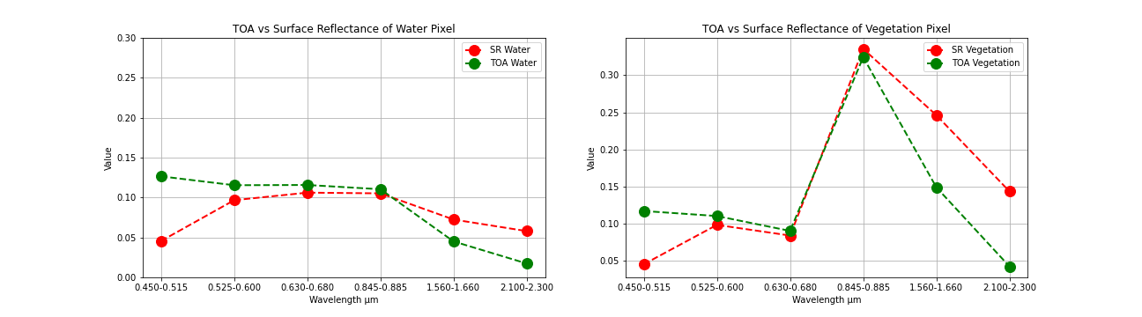

Figure 2 TOA vs Surface Reflectance with same vertical scale

Analyzing the differences between surface and TOA reflectance for two different materials were different using figure 1 so the vertical scales were made uniform (can be seen in figure 2) so that it can ascertained whether material properties have any impact on differences or not.

# Task 2: Explain the difference between TOA and Surface reflectance for both pixels

Figure 2 clearly depicts the differences between TOA reflectance and surface reflectance for both the water and vegetation pixels. It can be inferred from the figure that atmospheric effects are wavelength dependent. In this case the effects were seen larger in case of blue band and started decreasing and were minimum in NIR band however they were found increasing beyond NIR the reason of which I could not ascertain. Figure 3 depicts the differences in both study pixels however I was not able to infer how can the surface reflectance be more than TOA reflectance in this case. Please see figure 3.

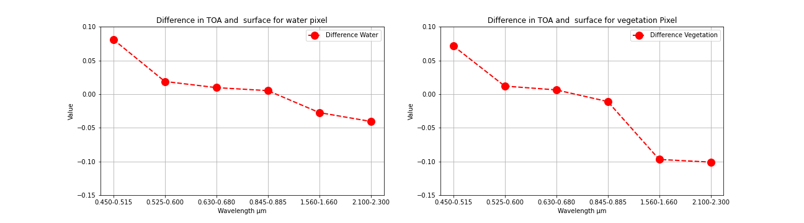

Figure 3 Differences in TOA and SR

Question: How USGS derive Level 2 product?

Converting TOA reflectance to surface reflectance requires several parameters to be quantified such as amount of difference elements in the atmosphere and their properties. There are different other sensor which are specifically designed for quantify those parameters. USGS uses those data along with ground measurements and data from its own sensor to quantify the atmospheric effects on images and later correct the images based on those quantified parameters.

Code and Processing Information:

Python code and outputs of this assignment has been uloaded to github and can be seen along with outputs using the link given below. [Click here to access code](https://github.com/shahidnawazkhan/geog741new/blob/master/assignment2.ipynb)

References

1. Vermote, E., Justice, C., Claverie, M., & Franch, B. (2016). Preliminary analysis of the performance of the Landsat 8/OLI land surface reflectance product. *Remote Sensing of Environment*, *185*, 46-56.
2. USGS EROS archive - LANDSAT archives - Landsat 8-9 Oli/tirs Collection 2 Level-2 Science products. (n.d.). Retrieved March 01, 2021, from <https://www.usgs.gov/centers/eros/science/usgs-eros-archive-landsat-archives-landsat-8-9-olitirs-collection-2-level-2?qt-science_center_objects=0#qt-science_center_objects>. <https://doi.org/10.5066/P9OGBGM6>