GEOG 786 Geographic Information Systems

Spring 2021
  - Assignment 2 Point in Polygon
50 points
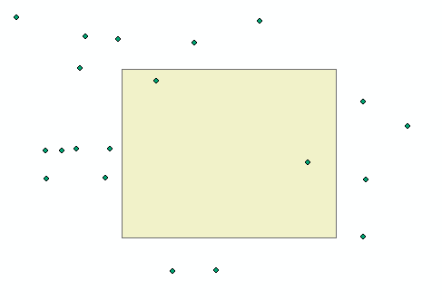
In this assignment, you will be given some points and a polygon (rectangle). You need to write a Python program to derive the points that fall within the polygon. In the given Python script “assignment2.py”, you are given list named “points”, which contains the ID, X coordinate and Y coordinate of the points. Moreover, a list variable named “polygon” contains all the vertexes of the polygon. You need to find out the points that fall within the polygon.
Here are the requirements for this assignment:
- Implement a function named “pointInPolygon”, which takes a point and a polygon (a rectangle) as the input and checks whether the point falls within the polygon. The function will return True if the point is within the polygon and return False otherwise. (40 points)
- In the main function, use loop to find out the points within the given polygon, store them in a list, and print out their IDs as well as the number of points in the console. (10 points)
You need to submit a python script named “assignment2.py” (compress it) in D2L. (Please review list and for loops in Python before you do this assignment if necessary).

