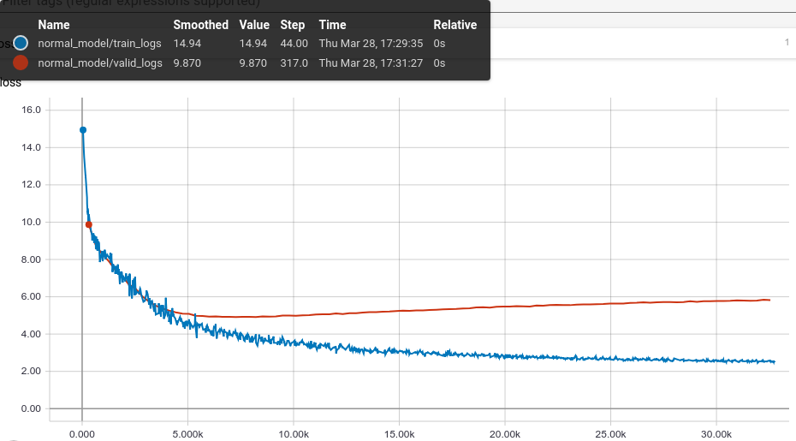

le lays Teguia apieSSIUS Supreu

O

**Name Smoothed Value Step Time**

Relative normal_model/train_logs 14.94 14.94 44.00 Thu Mar 28, 17:29:35 Os normal_model/valid_logs 9.870 9.870 317,0 Thu Mar 28, 17:31:27 Os

**1035**

0.000

5.000k

10.00k

15.00k

20.00k

25.00k

30.00k