SANESH PADMAN N C
B.E Mechanical

“Saketham”  Chedichery  Peruvalathuparamba P.O,  Irikkur  Kannur  Kerala - 670 593 | 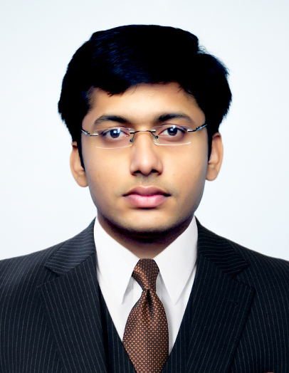

Email : sansnc@yahoo.co.in
Mob No : 08080323193

OBJECTIVE
To be honest and effective, give best of my strength to the organization and direct my learning towards organization objective and contribute my skills towards organization growth. To obtain a suitable position in your esteemed organization, where I can utilize my education, experience ability and skills for increasing and developing the profits of the organization.
- Young and motivated individual.
- Ability to learn and adapt new methods.
- Well disciplined and social worker.
- Hard working and result oriented.

EDUCATION PROFILE
Course | School / College | University/ Board | Year of Passing
MBA  Operation Management | MICE | SMUDE | -
B.E  Mechanical Engineering | Anjuman Engineering College | V.T.U | 2009
Plus Two | G.H.S.S. Irikkur | Kerala | 2004
S.S.L.C | K.P.C.H.S  Kannur | Kerala | 2002

EXPERIENCE

- Working as an Assistant Engineer with Sun N Sand Hotel Mumbai from 21st may 2012 onwards.

- Worked as an Engineering executive in The Leela Palace Hotel, Udaipur from 3rd January 2011 till 18th may 2012

- Worked as a Mechanical Project Engineer in D.S Gupta Construction Pvt.Ltd from December 2009 till 2011 January.

SKILLS

- Responsible for developing, implementing and supervising maintenance programs in guest rooms, building structure, mechanical, electrical machinery, HVAC, Fire Fighting Systems, and all other related equipments like Laundry and kitchen equipments ,CCTV etc.

- Preparation of HLP report and HLP Budgeting .

- Energy conservation planning and cost control planning for the department.

- Monitoring the department expenses against budgets.

- Preparation of necessary documents for Financial Reviews and Annual Budgets.

- Responsible and custodian for handling all licenses and legal documents.

- Preparation of AMC’s and Work Orders as and when required.

- Maintenance & rectification of complaints plant room equipments, guest rooms, and kitchen & laundry equipments.

- Incharge of the Engineering Store independently handles the maintenance & back bone of the company.

- Maintenance and monitoring of quality of water, water filter soft water & swimming pool water.

- Develop, implement, and maintain preventive maintenance and energy conservation programs for guest rooms, public areas, back-of-house, building systems, etc. according to Corporate and hotel standards

- Excellent at managing pressure and busy situations, without compromising on the work quality.

IT EXPOSURE

  - Software packages known: C Programming, Auto CAD,CATIA

  - Basics: M S Word, Excel, Power Point, Internet.

  - Operating system: Windows 7,

PERSONAL PROFILE

Name : Sanesh Padman N C
Father’s Name : K.V.Padmanabhan

Date of Birth : 01-06-1987

Sex : Male

Nationality : Indian
Permanent address : Saketham (H)
Chedichery, Peruvalathuparamba (P.O)
Irikkur, Kannur (Dt)
Kerala - 670 593
Hobbies :,playing chess, listening to music,

LANGUAGES KNOWN
English, Hindi, Malayalam, , Tamil ,kannada
SUMMARY
I am a young aggressive B.E graduate who is keen to work in a culture that requires talent, encourages innovation and prompt growth, where I can prove my technical and creative thinking as a team member. I am seeking a challenging position in an organisation, where I can use my expertise to the fullest and grow in my career as well as contribute to the success of the organization.
I assure you that if given an opportunity in your firm I shall increase the breadth of the firm by getting more exposure to the market.

DECLARATION
I here by declare that the information furnished above is true to the best of my knowledge.

Place : Kannur (SANESH PADMAN N C)
Date :

