
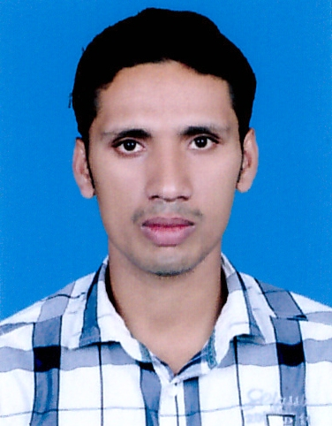

ABDUL RAFEEK
E-mail: abdulrafeekthooppil@gmail.com
Contact no: +919947631891
Palakkad
Kerala, India

Objective:

To seek a challenging position in the field of System Administration and Networking, to work under experienced and qualified professionals where in my theoretical knowledge and practical experience would be employed to their full potential and experience can be utilized in all aspects of Industrial development as well as meeting corporate objectives

TECHNICAL PROFICIENCY:

- MCITP - Microsoft certified IT professional (Certified)
- MCSA - Microsoft certified System Administrator (Certified)
- Microsoft Exchange Server 2003, 2007, 2010, 2013
- CCNA , CWNA, RHCE
Packages & Languages Known:

- Microsoft Office 2003, 2007, 2010, 2013
- Accounting packages TALLY, PEACH TREE

Professional experience

Company : GULF NETWORKS & IT SOLUTIONS
MUSCAT, OMAN.
Designation : System Administrator
Period : 1st June 2013 to 22nd September 2014

About Company: Gulf Networks & IT Solutions deals with the projects for IT Setup and maintenance. The main role of the company is to analyze the network infrastructure required and supply & fulfill all the IT needs
Responsibilities:

- Installation and configuring Windows Server 2003, 2008, 2012
- Installing Active Directory
- Configuring Addition Domain Controller, Member Server & Clients
- Installing and Configuring Servers DHCP, DNS, IIS (FTP & Web Server)
- Activating the services like Remote Access Service, Terminal Services, Windows Deployment Services
- Installing Exchange Server 2010, 2007, 2003
- Proficient in system maintenance, performance tuning, disaster recovery, data recovery and backup.
- Hardware up gradation, maintenance, and configuration of Desktops, Laptops and Network Printers including Dell/HP.
- Security & Firewall Administration
- Installing, Configuring & Managing PABX.
- Providing remote support for servers and clients.
- Implementing POS systems and providing support.
- Implementing Biometric & Security Solutions and providing support.
- Implementing Security & Surveillance Solutions and providing support.

Company : ROYAL DENTAL COLLEGE.
KERALA, INDIA.
Designation : NETWORK & SYSTEM ADMINISTRATOR
Period : March 2010 to May 2013
About Company : Royal Dental College is the institute of dental studies for MDS, BDS. It is the under the Government of India.

Responsibilities:

- To manage a web server and administer of a local area network containing a large number of hosts centralizing with active directory.
- Provide system administration and troubleshoot hardware and software issues.
- Configured and maintained Exchange server and Active Directory.
- Management of all basic network administration duties including user account administration e-mail accounts and allocating internet access.
- Managed daily backup systems.
- Implemented and maintained both Windows Linux servers and clients and made easy the sharing resources between both operating systems.
- Installation and Maintaining Biometrics.

Company : Ultra Oasis Techno Solutions. Pvt Ltd.
KERALA, INDIA.
Designation : DESKTOP SUPPORT
Period : July 2009 to February 2010
About Company : Ultra Oasis Techno Solutions deals with all types of IT Infrastructure including Hardware & software Sales, marketing and maintenance.

Responsibilities:

- Troubleshooting and repairing of various hardware (PC build).
- Installation and subsequent maintenance of software.
- Provide assistance in testing new equipment and systems.
- Configuration & installation server 2008 Active directory , DC,ADC,DHCP,DNS,IIS WEB
- Management of all basic network administration duties including user account administration e-mail accounts and allocating internet access.
- Clipping & cables with RJ45 Connector (Straight, Cross & Rollover )
- Responsible for printer patch panel switches installation and maintenance.
- Identifying new LAN, WAN requirements, both hardware and software.
- Implementing regular housekeeping procedures, including data backups.
- Checking systems in order to optimise performance and to initiate recovery action after system failures.
- Generating reports in Microsoft Excel and Word.
- Establishing and controlling system access and security.
- Coordinating protocols for operation within multi-user IT networks.

Education:

- BA English & History 2005- 2008
- Advanced Diploma in IT infrastructure and Network Engineering from Accel IT Academy Kerala, India. (A+,N+,CCNA, MCITP and REDHAT) with ISO Certification

PERSONAL PROFILE:

Date of Birth : 10 May 1986
Sex : Male
Marital Status : Single
Nationality : Indian
Experience : 5 Years
Language Known: English, Malayalam
Passport No : H5137243
Passport Issue Date: 07-07-2009
Passport Expiry Date: 06-07-2019
Permanent Address: Thooppil (house)
Mala (PO), Kakkattiri
Palakkad (District)
Kerala, India
679534 – Pin Code

