Kanchan Mitra 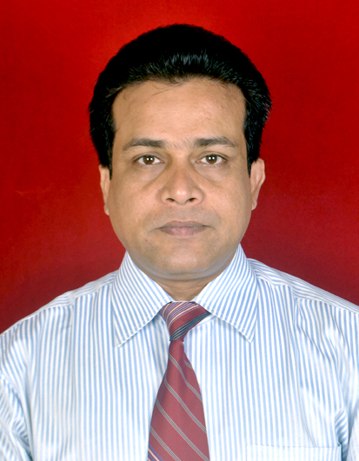

Mobile: 91 8095595643,
E-mail:mitkanchan@gmail.com,

Date of Birth: 16th December 1974

Address: A- 801,802, Riviera Tower, Lokhandwala Township, Kandivali East, Mumbai - 400101

Professional Synopsis

Have played key role in defining Human Resource strategies around Talent development, Resource acquisition, Legal compliances, HR Policies Administration, Employee engagement, Business HR and Payroll Administration in leading BPO, KPO, IT and ITES organizations, across varied domains including Insurance, Financial services, Banking, Technology and Procurement.

Thought leader and a trusted advisor in strategic, Organization and People development initiatives. Have quality exposure in understanding different dimensions of business issues by making sense out of complexity and uncertain market environments.

A career span of 19 years, in IT, ITES, BPO, KPO, Facilities Management and Hospitality industry. Presently based in Bangalore, as the India Head- HR Operations and Employee Engagement with Xchanging India, an U.K based Technology Company with employee strength of four thousand in India.

Organizational Experience

Tenure Company name Designation

March’12 – Till date Xchanging India, Bangalore India Head HR Operations

April’10 – March’12 Nouvasys Solutions India Global HR Manager
Pvt.Ltd. Mumbai

Sept’08 – March’10 Bank of America Continuum Manager Human Resource
India Pvt.Ltd. Mumbai

Nov’03 – Aug’08 IBM Business Process services Assistant Manager HR
Pvt.Ltd. Gurgaon, Kolkata (HR role since August 2004)

Oct’01 – Aug’03 Radhakrishna Hospitality Regional Manager Operations Services Limited, Delhi (Facilities Management)

Jul’2000 - Sep’01 The Habitat World at the Assistant Manager F&B Service India Habitat Center, Delhi

Apr’98 – Jun’2000 The Hotel Cannaught Place Assistant Manager F&B Service

May’95 – Feb’98 Choice Hotels International Assistant Manager Operations
(May’95-May’96 as Management Trainee)

Summary of Roles performed

- Lead a team of HR professionals towards the development and execution of the Human Resources strategies and initiatives to support and partner the business goals and objectives..
- Set up, implement and drive the HR Processes, Policies and Systems of start up business and leading IT/ITES organizations , by creating various Employee touch points, to ensure effective and sustainable business performance.
- Own and lead implementation of performance and career development framework and strategic talent development initiatives, across multiple businesses, locations and entities.
- Lead the Payroll and HR Business Partner team in administering yearly appraisals, including conducting Market compensation surveys and recommend yearly appraisal budget.
- Own HR MIS and HRIS tools. Led the development of internal HR application and implementation of ‘Workday’ in India.
- Own the entire gamut of HR Operations activities, including employee induction, joining process, employee record management, compliance around BGV, Medical and other mandatory checks, vendor management etc.
- Managed Business ramp ups through Bulk, lateral hiring and internal Resource Management.
- Lead the PCMM initiative for Xchanging India entities.
- Implementation of Labor Laws & its due compliances as per legal framework. (License Renewals, Returns & Attending court hearings) through an appointed Advocate, and liaise with the Government Authorities and make necessary compliance provisions.
- End to end Payroll administration.
- Own internal audits of all HR Policies, Programs, and Practices end to end Personal file Management and statutory audit.

Projects

- Lead the Workday Implementation in India.
- One HR System: Led the One HR System project to develop an HR tool to automate the entire Hire to Retire process.
- Global HR shared services: Led the GHRSS initiative to transition the HR operations activities across the global Xchanging entities to India.
- Competency framework: Lead the implementation of the internal competency assessment and development framework for the Technology division in Xchanging.
- On time hiring: Led the project to increase the effectiveness of hiring process and reduce revenue leakage and hiring cost in Xchanging.
- Compensation: Instituted the Total compensation framework for Xchanging by working with external agencies like AON Hewitt, Towers Watson on the market benchmarking of different Job families and roles and internal parity study.

Scholastics

- Completed International MBA with United Business Institute, in March 2013.
- Completed Three years Diploma in Hotel Management Catering Technology and Applied Nutrition (I.H.M.C.T.A.N.) from Institute of Hotel Management, Bhubaneswar in June 1995
- Passed Std. XII with Central Board of Secondary Education (CBSE) from Indian School of learning, Dhanbad in the year 1990.
- Passed School Final with Indian certificate of Secondary Education (I.C.S.E) from De-Nobili School C.F.R.I. in the year 1988.

