From:
KARUN PILLAI
No. 14, 11th Cross,
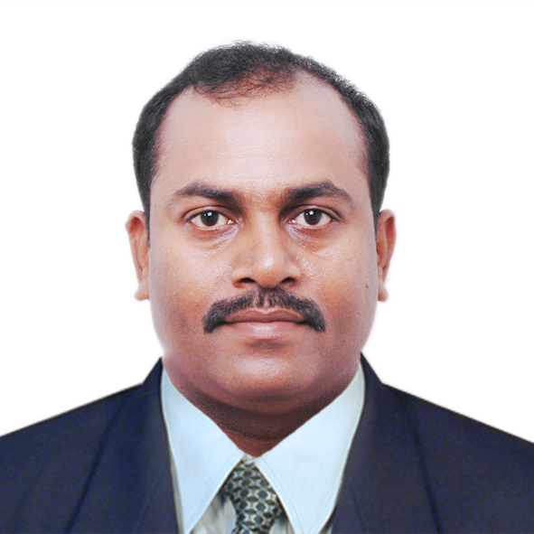
Raghavendra Layout,
Kammagondanahalli Post,
Jalahalli West Bangalore - 560 015
India.
Mobile: - 9986265187
E-mail: karun.pillai@gmail.com
Portfolio: http://karunpillai.webs.com/
Linkedin: http://www.linkedin.com/pub/karun-pillai/10/11b/124

Dear Sir/Madam:

With relevant background and multiple recognition during my assignment with
AOL America Online, Inc., where achievements of being the most consistent performer for 2 consecutive times got me the Best Newbie Q4, Star Performing Team Certifications, Top Performance - in 2007, 2009 and Spot award for 2010 for covering grand finale TV show 2010: 'American Idol' and 'Dancing with the stars'. I know. I can be a contributing member in your organization in a responsible position demanding design and development expertise.

Briefly, some of my key strengths include:

- Creative, visual, photo, design, online, print, news, editorial.
- Good at understanding the requirements and providing viable solutions and consistent support during the development.
- Competent with Adobe PhotoShop, Adobe PageMaker, Adobe Illustrator, Adobe In-design Adobe Acrobat & Corel Draw.
- Apt with process of design and development in the print and publication industry will consistently strive on the aspects pertaining to efficiency improvements.
- Excellent at project scheduling and execution for effectively completing the assignments within the stipulated time frames.
- Efficient in completing work on strict editorial deadlines.
- Create reports and deliver metrics with respect to specific channels, using “Omniture Discover ”
- Work within deadlines to ensure that articles are published on time.
- Responsible for contributing to increased page views through social media and SEO.
- Performed lead on entertainment channel in the publicity and editorial photography.
- Demonstrated ability to learn and use new technology
Apart from coordinating work between the local and international teams, I also tracks metrics, publish galleries, develop photo research, pitch story ideas and create online content for AOL's various websites including entertainment sites like Moviefone, Spinner, AOL TV, AOL Music.

Additional details of my background and contributions are documented in the enclosed résumé.

Sincerely,

KARUN PILLAI

RESUME
KARUN PILLAI
No. 14, 11th Cross,
Raghavendra Layout,
Kammagondanahalli Post,
Jalahalli West Bangalore - 560 015
India.
Mobile: - 9986265187
E-mail: karun.pillai@gmail.com
Date of Birth : 14th October 1975
Martial Status : Married
Language Known : English, Hindi, Kannada, Tamil & Assames
Qualification : B.Com
Professional : Diploma in Multimedia & Animation
from EDIT INSTITUTE
Passport Details:

Passport no. : H0003220

Place of issue : Bangalore, India

Date of issue : 25/07/2008

Date of expiry : 24/07/2018

Visa Type : B1 visa for USA (Oct 14th, 2012 to Aug 29th 2022)
Summary of Computer Knowledge:
Hardware Platform : IBM, Apple Macintosh and Splash Server
Area of expertise:
Operation Systems : Mac and Windows NT/2000/98/XP
Graphics : Adobe Photoshop and Coral Draw
Illustration : Adobe PageMaker and Adobe Illustrator/In-design
Animation : 3DS4, 2D Animation and Macromedia Director

Work Experience:

NEILMED DEVICES PVT LTD. (16th Jan 2012 to till date)

Sr. Graphic Designer

My current role at NeilMed is to coordinate with the team based out of USA. My role includes working on graphic designing, designing logos, branding design, magazines, brochures, flyers and other art designs.
Onsite training program:
October 15, 2012 to November 03, 2012, (USA, San Francisco)
I had been to USA, San Francisco to attend training session conducted for entire graphics team.

NeilMed Brand of Products Education
– Details, benefits, differences with 22 Product line
– Availability in 12 countries with different languages
– Individual Product graphical branding elements
– Registrations and trademarks

Graphic Production
– Hands-on graphic design and print production of:
Retail product boxes, cans, labels, marketing flyers,
Point of purchase displays, trade show banners,
Product brochures in different languages, marketing cards,
Promotional coupons (instant or manufacturer’s) for marketing
Publications with tracking procedure for response assessment

Document Control & File Release
– Product SKUs, UPC’s and subcategorized revisions
– Internal NeilMed marketing numbering system for archival, legal audit and documentation purposes
– Quality Form 423.2 Word template update protocol
– Submission to Quality Control for document release

AOL AMERICA ONLINE, INC. (9th June 2006 to 31 June 2011)
Photo Editor

Responsibilities:
• I work here in coordination with International Photo-Editors based in New York and Dulles. I am responsible for the entertainment channels e.g. Moviefone, Music and TV.

• Edited, researched and programmed best available photography for editorial content of AOL.com
And its entertainment sites (Moviefone, AOL TV, & AOL Music).

• Editing photography for use in daily promotional spots, photo features, photo galleries, and individual articles. Working on the images e.g. color correction, cropping, optimizing & resizing the images for publishing these on the AOL websites.

• Coordinating the acquisition of images from vendors outside of AOL, including wire services, stock agencies, freelance photographers, royalty free corporations, partners and various other sources.

• Articulating editing choices and be mature in their communications within the company. Meeting regularly with programmers, designers and other photography editors throughout AOL and coming up with content and photography to engage a worldwide audience.

• Research and collect images from various B2B resource / ADAM and maintain high quality images on AOL Moviefone product page.

• Special expertise in growing lasting photography and editing, digital asset management, creative development, production/workflow coordination, as well as an in-depth comprehension of copyright, clearances, licenses and contracts.

Weekly movie release analysis:
• Responsibilities to prove that moviefone product page channel should be ahead between Yahoo Movies, MSN Movies and IMDB.

Special events coverage:
Golden globes 2007 - Contribution in helping to produce over 40 million page views to AOL’s Golden Globe Awards Package with NY team.

Emmy awards 2008 - Responsible for archiving the images to the database with file naming conventions and Metadata.

Covered grand finale TV show 2010: - American Idol and Dancing with the stars
I have taken over the responsibility to cover the TV show in a span of time I have visited the TV publicity sites/Agency and downloaded each individual image according to their guidelines in the style guide (Color correction, cropping and appropriate captions) edited and published via V3 Tool., well ahead of our competitors. This has resulted in huge traffic to our site. This work is appreciated by (David Eun, President, AOL Media and Studios). Also I have received a Spot Award for the same.

American Idol
http://television.aol.com/american-idol/photos

Dancing with the stars
http://television.aol.com/show/dancing-with-the-stars/419134/main/

Oscar award 2011 - Contribution in helping to produce AOL’s Oscar awards package with NY team.
Below are the galleries details-:

Never Won an Oscar: Oscars' Biggest Losers
http://blog.moviefone.com/oscars-academy-awards/oscars-biggest-losers/?_r=true

Actors Who've Never Been Nominated for Oscars
http://blog.moviefone.com/oscars-academy-awards/actors-never-been-nominated/

Worst Best Picture Oscar Winners: 10 Movies That Shouldn't Have Won
http://blog.moviefone.com/oscars-academy-awards/worst-best-picture-winners/

Top 25 Oscar Best Picture Winners: 'The Godfather,' 'Annie Hall' and More
http://blog.moviefone.com/oscars-academy-awards/top-best-picture-winners/

Advice for James Franco and Anne Hathaway from the Best & Worst Oscar Hosts in History http://blog.moviefone.com/oscars-academy-awards/oscar-host-best-worst-moments/

Some of the latest memorable gallery:

Best Romance Movies:
http://blog.moviefone.com/2011/01/28/bald-action-movie-actors/

Bald Action Stars:
http://blog.moviefone.com/2011/01/28/bald-action-movie-actors/

50 Best Movies of 2010:
http://blog.moviefone.com/2010/09/01/best-movies-of-2010/

Christmas Movies You've Never Seen: 13 Underrated Classics
http://blog.moviefone.com/2010/12/15/christmas-movies-youve-never-seen/

Best Thanksgiving Movies
http://blog.moviefone.com/2010/11/25/thanksgiving-movies/

50 Best Movies of 2010
http://blog.moviefone.com/2010/09/01/best-movies-of-2010/

Best Movies of 2006
http://blog.moviefone.com/2006/12/29/best-movies-of-2006/

Best/Worst Movies of 2007
http://blog.moviefone.com/2007/12/20/best-movies-of-2007/

Best Movies of 2008
http://blog.moviefone.com/2008/12/19/best-movies-of-2008/

Best Movies of 2005
http://blog.moviefone.com/2010/11/05/best-movies-of-2005

Macmillan India Limited. (Pindar Department) (June 2005 to June 2006)
VISUAL COMMUNICATOR

GRADE 3 GRAPHIC DESIGNER
With over 1 years of experience in the one of the world’s largest publication companies. Macmillan India Ltd., Member of a prestigious Spec Team – Designing Advertisement for YB involved in Good Design Advertisements and Prototype Development.
- Design and execute the ad listings to be placed in the business directories
As per customer’s requirement.
- Work extensively with the entire team to freeze on the page designs and layouts.
- Conversant with designing, documentation and processing procedures.
- Ability to verify and validate type documents provided by the customers.
- Focus on customer satisfaction and relationship management.
Extensive involvement in training new employees on subjects pertaining to software and production process while mentoring the existing team of 15 team members in the absence of the Team Leader.

XEROX MODICORP LTD., on Contract (Feb. 1999 to June 2005)
Graphic Designer

Responsibilities:

- In charge of Design & Development in the color section.
- Designing of broachers, logo, cinema slide, hoardings, image editing & layout.
- Responsible for project works of NIFT Student, Mount Carmel College & Ambedkar College of dental. Work includes Color correction, Special effects, Image manipulation, images restoration & Converting B&W images into color images.
- Set Design Guidelines and review at various stages of projects to ensure quality standards are met in the programs.
- Designing and maintaining the standardized graphics.
- Converting hard copy to soft copy using Kodak high speed scanner and page capturing for editable format like MS word Excel & Acrobat.

FUTURE INTERESTS
Web Multimedia, Video Conferencing, Touch Screen Technology, Voice recognition software and Quick Time Virtual Reality.

HOBBIES
Hobbies include Reading Books, Computer and Science magazines, Attending I.T. Exhibitions and Seminars, Watching Discovery and National Geographic channels, Browsing the Net, Watching Cricket, Listening to Music and regularly getting updated with the latest technology.
In view of the above particulars, I would very much appreciate the opportunity to talk to you and get your opinion, whether my background and inclination would be suitable for your job requirement.

Place: - Bangalore

KARUN PILLAI

Signature

