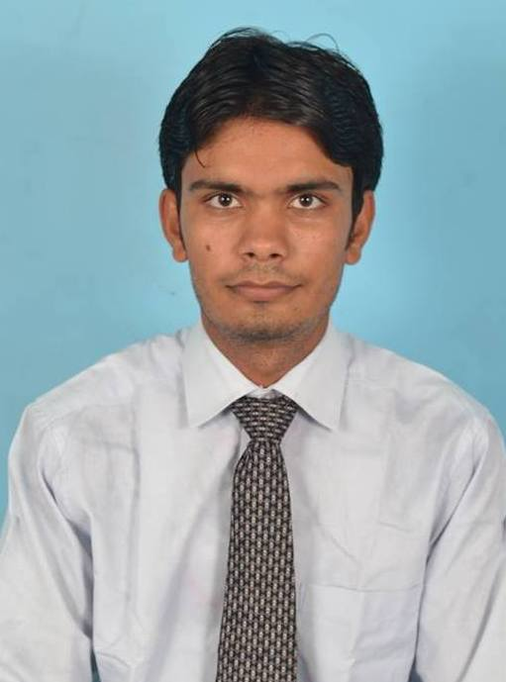 | Manvendra Kumar  Mobile No.: +919916671057, +919026020110  Email: manvendrasinghs04@gmail.com M.Tech(IT) 2014 Batch  Indian Institute of Information Technology Allahabad

Objective

To develop my career as a Software Developer where I will be a valuable team member, contributing quality ideas and work for an organization where there is an ample scope for individual as well as organization growth in Software Design and Development.

Computer Skills

Operating Systems : Linux, Windows
Programming Languages : C, C++,Java,SQL
Databases : SQL Server 2008
Technical Skills : Data Structure, Algorithm, Concepts of Operating system, DBMS.

Educational Qualification

Degree/Course | Board/University | Passing Year | Cgpa/Aggregate (%)
MTech(IT) | Indian Institute of Information Technology Allahabad | 2014 | 7.75 Cgpa
B.Tech(CSE) | Uttar Pradesh Technical University Lucknow | 2012 | 75.40
12th | Up board allahabad | 2007 | 60.00
10th | Up board allahabad | 2005 | 61.33

Workshop:
- Participate in Data mining workshop in IIITA.
- Participated and organized Intelligent Interactive technology and Multimedia conference.
- Participated in Android and Matlab workshop in IIITA.

Projects Done

- Title : Agro-Management System
Duration : May, 2011-July, 2011
Platform : MS. Windows XP, Windows 7
Language : C, Java, C# with .Net
Technology : ASP
Scripting Languages : HTML
Database : SQL Server
Description : Now these days, area of IT service is increasing. So to do help of farmers we designed this project. This project is completed to help of farmers because at the time crop production farmer need of seeds. This Project is helpful to found the different variety of seasonal seeds, and also helpful to show the price and available quantity for the.

- Title : Railway Reservation System
Duration : January, 2012- June 2012
Language : C, JAVA, C# with .NET
Database : SQL Server
Description : This project introduces Railway Reservation System. Main aim of this Project is to provide a secure and easy way to book train tickets. It has to manage the information of train arrivals, departure, online reservation, and ticketing and it has to manage information about the vacant seat available on each train, and it also maintains the information about its passengers and their own employees. This project is developed in Visual Basic 2008 and SQL SERVER 2008 Database.

- Title : Segmentation evaluation in Image Processing
Duration : July, 2013-June, 2014
Language : C
Tools & Technology : C, Java, Opencv, Matlab
Description : Now these day image segmentation is widely used in the image processing, computer vision and video processing. Segmentation of the images is widely used in the every field such as medical, object detection; face recognition etc. segmentation evaluation is used to check which of the segmentation methods is better for segmentation. In this thesis, my works on the segmentation evaluation using unsupervised methods.

I hereby declare that all the above information given by me is true to the best of my knowledge and belief.

Place: Bangalore
Date: 24 /08/2014 Manvendra Kumar

