Ramanand S. Varadkar
1/38, Bharat bldg;
Mangalwadi,
Girgaon, Mumbai 400 004
Contact no. 8097071476
email: ramanandvaradkar@gmail.com

An enthusiastic technology oriented Professional experience of 14 years with experience of Business Analyst of 3+ years experience, in areas of business requirement analysis, Documenting functional specifications, Project management in Banking, Insurance & Process Improvement domain.

PROFESSIONAL SYNOPSIS
- An technology experience of qualitative and enriching experience in Business analyst, Process management, Operations Management & Relationship Management.
- Currently designated as Senior Executive in Fino Paytech Ltd. (Process Improvement Domain, Banking Domain & Insurance Domain)
- Depth in process of Banking projects from inception, requirement specs, testing, planning, and closure with cross-cultural teams.
- Adept in gathering the requirements & delivering the project requirements as per the scope of the project.
- An energetic, self-motivated team leader with hands on experience in Datacenter operations projects.
- Worked as an DATACENTER administrator at RBS.

Project Management
- Taking requirements from Users, data gathering, Drafting BFS (Business Functional Specification) & getting sign offs.
- Sending the Requirement to Development team, getting timelines from them.
- Timeline received from Team is Published to Business Users.
- Cordinate with User for UAT sign off.
- Coordinate for Production Movement with IT.
- Post Production Movement, if some new enhancement arises on the same, New requirement is raised by the User & same process cycle is carried out.
- Co-ordinate & follow up with various Teams to seek sign off /Approval on the various project artifacts.
- Functional Testing.

Applications:
- Microsoft Word, Excel, Outlook. Libre office.
- Serena Application, where tracking is done from PRF raising Stage to Production Movement completion stage.
- Finacle (AIX) & RTGS (Participant Interface) application
- AS400 server (JDEdward Application)

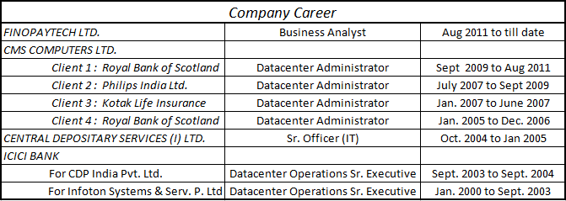

Fino Paytech Ltd. (Since 24th August 2011 - till date)
Profile: Senior Executive (Sr. Business Analyst)
Responsibilities:
- Detail out the requirement from the user/ associated external customer in the stipulated BFS format along with planned UAT cases.
- All sections of the document are detailed
- All process level impact analysis need to be captured. Buy-ins from each such impacted process owners need to be obtained before BRS finalization.
- BFS and UAT cases are documented.
- Interface and coordinate with each technology component Dev and QC owner and his/ her nominated person for:
a. Closing the gaps and clarifications.
b. Re-Scheduling of development with multiple development teams, QC and UAT support (by QC).
c. Tracking the status of Dev, QC.
d. Re-Scheduling of rollout support.
- Update and Publish weekly PRF timelines to the Users

Responsibilities at rest of the Companies:
- End of Day process on Finacle Application System.
- Monitoring of regular system services & disk space using Finacle Operator Console.
- Taking regular backups on different Servers on respective medias.
- Monitoring QPH (Quaestor Payment Hub) & QLM (Quaestor Liquidity Manager) queues & channels of transactions remotely.& Link monitoring established with Finacle.
- Monitoring RBS ATM’s links all over India which includes ATM’s, VSAT, Master & UTI links.

- Backups on AS400 server (JDEdward Application)
- Worked with User Profiles Authorizations
- System Monitoring (System Status, Disk Status, Job Status, Connection Status
- Releasing the jobq which go in HLD or MSGW mode.

- Running batches on AS400 server (Life Asia application)
- Taking backups on NT & AS400 server
- Unlocking and Resetting Passwords of users in Active Directory
- Releasing the jobq which go in HLD or MSGW mode.

- Daily backup through Omni back & NT Bkps.
- Transferring logs of daily process to DR server at DR site.
- Monitoring network connectivity of clients and Disaster Recovery Site.
- Taking backups, restoring at Disaster Recovery Site.

- Daily backup through NT & VERITAS NETBACKUP
- Induction of servers into Data center.
- Coordination with other Project Incharges
- Monitoring disk space on various servers & maintaining server room temperature.

- Downloading of Visa Credit & Debit Card files from VAP (Visa Access Point) from Singapore.
- Taking backup of Credit Card Production & Development Server
- Monitoring Visa Connectivity & solving Online problem related to vision plus

EDUCATIONAL QUALIFICATION
- B.Com Graduate from Mumbai University

KEY COMPETENCIES
- Analysis and problem solving
- Commitment and priority setting
- Integrity, trust and fairness

HOBBIES
- Photography
- Listening Music

LANGUAGES KNOWN
- English, Hindi, Marathi & Guajarati

DATE OF BIRTH 11TH MAY, 1972

Ramanand S. Varadkar

