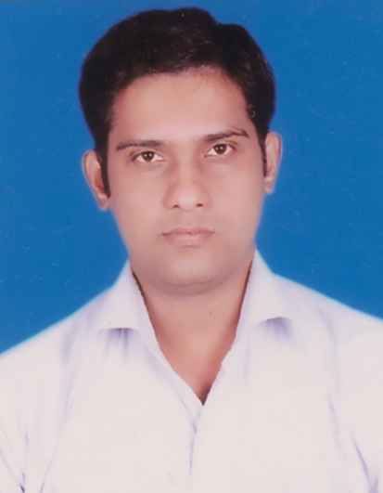
RAHUL RANJAN
F-51,KATWARIA SARIA ,HAUZ KHASH
NEW DELHI-110016.

E-mail: rkj32003@yahoo.co.in,
rkj32003@gmail.com Mobile: +918375988579

Career objective:-
To achieve challenging positions in design and development of industry with the state of art technology where my analytical problem solving skills and application can be utilized to benefit the organization as well as to increase and enhance my knowledge.

PROFESSIONAL EXPERIENCE: -
1.SRIRAM TRANSPORT FINANCE CO LTD.

SHRIRAM TRANSPORT FINANCE COMPANY LTD. is an Non banking finance company (NBFC).Where i am working as a Branch management at Nagpur Branch. Our company provided commercial vehicle loan to customer & helping in assets safety (provided company insurance). I am working for this company From 14th Nov 2011. to 18th may 2012. My working responsibility is :-

1. Manage the branch operation work.
2. Maintain outsourcing working schedule.
3. Working on Excel sheet and generate MIS sheet .
4. Manage to customer problem(Tech &Non Tech) & solves .
5. Distribute work among field officer according to employee status.
6. Complete the branch pending work and maintain the branch position.
7. Portfolio Management Asset Domain.
8. Report to senior or Head office.
9. Selling of Financial loan to our desire customer.
10. Inspection of customer, commercial vehicle for loan purpose.

2.R M CONTROL PVT LTD, 13/3 MATHURA ROAD FARIDABAD, Faridabad.

R M CONTROL is a designing and manufactured company. its use engineering technology and supply different product to client. Working area of our company is Electrical/Electronics/instrumentation sector.
From 12th August 2009 to 11th Nov 2011.Working as Sr. Engineer .
My working knowledge is service and sales management.
Working area of my job are:-
- Production Related to Switchgear Assembly,Wiring, Testing &
Final Inspection of the Electrical Panels.
2. Assistance to Senior Executives during the training compliance
for technical & quality standards .
3. Timely submission of the completion reports of the executed projects.
4. Assistance in Preparation of General Arrangement Drawings for
purpose of pre-submission documents for final approval.
5. Assistance in Preparation of Electrical Single Line Diagrams &
Control Schematic for the approved GA Drawings & Interlocking Logics.
6. Final inspection of RYB connection with electrical equipment.
3.NUTRONICS INDIA PRIVATE LTD, A-72, Ph-2, Industrial area, Mangolpuri, DELHIFrom 1st August 2008 to 29th July 2009.Working as Engineer –service /sales. Working area of my job is:- Nutronics India is dedicated to provide Electronic Process Control Instruments for Industrial use like Digital temperature Controller, Digital Timers, Event Counters, Humidity Indicator, pH Indicator, Sensors etc. It has been our continuous endeavour to provide Innovative, simple to use and cost effective products. My working area is.
- Production Related to Electronics Wiring , Testing & Final
Inspection of the Electronics Panels.
2. Single layer pcb mounting and component testing.
3. Testing of electronics sensor, controller, timer ,counter.
4. Final inspection of temperature sensor (j, k type, pt100 ,btc),
Timer, counter, controller.
5. Programming installation in IC.
- .Circuit drawing and designing.

Academic Profile:-

- PGD in INTELLECTUAL PROPERTY RIGHT from IGNOU University(2010-2011).
- B. Tech (ELECTRONICS & INSTRUMENTATION ENGINEER) from Dr. M.G.R University, Chennai with 82.4 %year(2004- 2008).
3. Intermediate from J.I.E.C, Ranchi with 54% year 2003.
4. Matriculation from J.S.E.B, Ranchi with 64% year 2001.

SOFTWARE SKILLS:-

Language : BASIC computer,MATLAB,MICROPROCESSOR,EXCEL SHEET,MIS MANAGEMENT.

INTERESTS:-
Cooking, playing game.
PERSONAL DETAILS:-

Name : Rahul Ranjan
Father’s Name : Sri Bibeka Nand Jha
Nationality : Indian
Date of Birth : 2nd JAN 1986
Marital Status : Single (male)
Language known : English and Hindi

DECLARATION:-

I hereby declare that all the information provided above are true to the best of my knowledge and I hold myself responsible for any irregularities if found.

Rahul Ranjan

