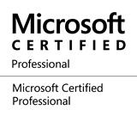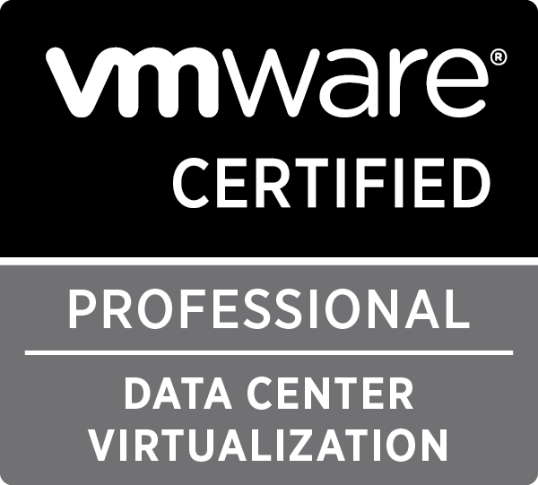

ROOPESH R

Anand Nagar,Marthahalli,
Bangalore,Karnataka-560037
Cell :+919739510878 I E-mail : roopesh_gwr@yahoo.com
LinkedIn : http://www.linkedin.com/pub/roopesh-r/28/37a/274

Seeking positions in Vmware/Windows Administration role with an Organization of repute.

Technical Expertise in Windows and VMware Platform

An Overview
- VMware & Microsoft Certified Professional with 6 years of rich experience in effective management of IT Infrastructure team for new facilities, Data Center Upgradation of Hardware & Software, Microsoft Technologies, VMware Virtualisation, Storage Design, IT Asset Management and IT securities.

- Demonstrated excellence in leading enterprise-wide virtualisation effort with accountability of overseeing vendor / hardware qualification, architecture / design, installation, configuration, migration & documentation.

- Proficiency in installation & troubleshooting of Rack Servers, etc. viz. Dell, HP, IBM and Assembled.

- Adept at maintaining complete IT infrastructure including Server Hardware, Vmware Environment, Data Storage, Backups, E-Mail, and all Microsoft Technologies.

- Strong Customer Centric Approach with excellent analytical, coordination, presentation and leadership skills; skilled in grasping the big picture and conceptualising solutions.

Career Record
Since Aug’07 working in an IT based industries.
Growth Path
Aug’07 - Jan’09 Desktop Hardware Engineer - HCL Infosystem Ltd
Nov’09 - Aug’10 IT Support Executive - First American India
Oct’10 – Apr’11 System Engineer - Adecco Systems (Client – IBS Software Services)
Jun’11 – Oct 14 System Administrator (Infrastructure Team) – Revenuemed India Pvt Ltd

Skills and Expertise

Virtualisation Environment Management
- Esxi 5.5 installation and configuration via vCenter server
- Copy the configuration of one host to another host via Host profile feature
- V-Motion of servers using hot and cold V-Motion, HA, DRS Cluster
- Patching on ESX -Host through update manager.
- Managing Server through V Center Server
- Monitoring of servers about CPU Usages, Memory usages via vCenter server.
- Converting Physical server to virtual server through P2V
- Creating and deploying virtual machine through templates, create templates.
- Move server in different cluster in V-center server
- Datastore up gradation VMFS3 to VMFS5.
- Creation, Management and Configuration of Virtual Machines, Clone and Templates.
- Snapshot manager.
- Provided complete L3 support for VMware virtual infrastructures.
- Led complete Physical-to-Virtual (P2V), Virtual-to-Virtual (V2V) and Virtual-to-Physical (V2P) migration of Windows 2008 and 2012 servers.
- Resolved all issues related with performance of SAN backed VMware ESX Infrastructure to determine proper allocation of resources to a multi-department user population with widely varying needs.
- Our team is responsible for VMware and Windows support for Implementation, configuration & maintenance of Revenuemed IT. It includes multiple data centers with more than 100 Servers (VMware ESX servers 5.5and Windows 2008/2012 servers).
Windows Server Administration
- Responsible for the IT support of 1,500+ Revenuemed users; supporting multiple levels of IT infrastructure and associated devices.
- Maintain daily operations for Windows server infrastructure and components (HP ProLiant DL180, DL360, DL380, Dell PowerEdge R710, R410, and IBM X3620 M3).
- Specialized in installation and configuration of Windows 2008, Windows 2012 Servers like RODC, DHCP, DNS, File Server etc.
- Developed variety of batch scripts to automate server administration throughout the enterprise.
- Setting up shared folders and mapping drives and dealing with permissions.
- Using group policy objects to install software and adjusting group policy that affecting in domain level.
- WSUS Server Monitoring and Testing and approving Windows security updates and service packs for deployment.
- System Administration with ADS, IIS, FTP and Proxy.
- Creating DC backup solutions for Windows 2008 R2 server using System state and Baremetal backup.
- Experienced in Desktop administration and support on Multi platforms like Windows Vista, Win7, Win 8.1 & Linux (Ubuntu).
- Configuration and support for WDS & MDT servers.
- Responsible for Windows XP and Vista to Windows 7 Enterprise Migration for users at the Revenuemed.
- Monitoring Servers using New Relic and Network devices using PRTG monitoring tool and makes reports according to results.
- Participated in the AD migration project of Windows 2008 to 2012 server upgradation.

Centralized Management Tools

- Microsoft TMG Server – Configuring, managing the tool as proxy server and for VPN server.
- Nessus Server – Configuring ,managing the tool for checking the Vulnerabilities in all the devices in the whole Organization as a part of maintaining the security
- Acronis Backup – Installing and managing the tool for the backups of file servers etc.
- Sapphire IMS(Configuration change management tool)- Installing ,Configuring and managing the Tool.
- Lansweeper – Installing ,Configuring and managing the tool for inventory, taking assets and for small kind of software deployments
- Microsoft Forefront client Security (Antivirus) – Configuring and managing the antivirus server

Certifications

- VMware Certifications:
- VMware certified Professional (VCP5-DCV).
- VCP on VMware vSphere 5.5.
- VMware Install and Configure Vsphere5.5. Attended 5 Day Training from Koenig Training Center.
- Microsoft Certifications:
- MCP certified (070-410) – Windows server 2012.
- CCNA Certified (IP Ver4).

Education

- Diploma in Electronics Engineering from Board of Technical Education.
- BCA from Sikkim Manipal University.

Personal Details

Nationality : Indian

Date of Birth : 23th October 1987

Marital Status: Single

Gender : Male

Languages : English, Hindi, Malayalam

