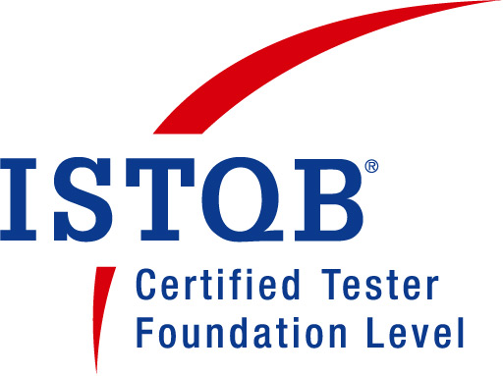
Rahul Pathak
E-mail: rahul.pathak274@gmail.com
Contact No. : 91-9953180876(M)

Objective:
To secure a position of responsibility in an organization that-
- Allows me to utilize & refine my analytical and problem solving skills while working on organization's assignment & shape my career to grow with the organization.

Job Experience:
- ISTQB certified with 5 Years of experience in the field of IT with focus on QA in all phases of life cycle, Client Interaction, Requirement collection from client, Release Owner, CMMI-3 processes.
- Current Employer: Working as Senior QA Engineer in Shree InfoSoft till date from Mar-2016.
- Previous Employer: Working as QA Engineer/Release Owner in Skilrock Technologies June-2012 to Mar-2016.
- Previous Employer: Worked as QA Engineer in Bluent eSolutions from Nov-2011 to June-2012.
- On-Site Experience of 5 months in Benin for Project Release..

Professional Summary:
- Requirement collection from client & give Training.
- Release Owner
- Review requirements and make timelines with the team.
- Work as SEPG member.
- Experience in a CMMI Level 3 process environment.
- Auditing projects based on different Process Areas.
- Participated in SCAMPI A appraisal method.
- Sound understanding of Agile methodology.
- Doing quarterly audit of different projects documentation.
- User Acceptance Testing
- Onsite visit for operation/support
- Manual Testing
- Manage Live Database scripts
- Soap UI testing for API integration
- Toad testing for DB schema comparision.
- Test case development
- Coordination with developers to fix defects
- Build and deploy the solution into Production environment

Skills:
- Domain Knowledge of Aviation, Online Gaming & E-Commerce Industry.
- Knowledge of Navitaire Tools like SkySpeed, SkyPort, SkySchedule, Go Now, GDS Booking, Travel Advisory etc.
- Knowledge of MySql queries and database.
- Worked on tools like HP Quality Center, Soap UI, SQL-Yog, LLT, FileZilla, BugZilla, Mantis, Winscp , Putty, Toad.
- Worked on MS-Office knowledge to boost the management process

Live Project(s):

- Aviation Management
Customer: Spirit Airlines
Description: Spirit Airlines is a web based Travel project. It will provide online facility to customers’ of USA to book their ticket online for domestic and international tickets. It’s a ULTRA low cost airlines provides least price seats to the customers of USA
Team Size: 18

Contribution:
- Manual Testing of modules
- Test case preparation
- Presenting Daily Status Report to Client
- Testing Airport Kiosk
- Attend Daily Scrum,UAT
- Giving Support while Staging & Deployment
- Requirement Clarification meetings with Client for Different Projects

- Lottery Gaming
Customer: Different clients from Ghana, Lagos, Benin, Zimbabwe.
Description: RMS is a comprehensive system for Retailer Point of sale supporting all functionalities of a POS including game Distribution management, Online Draw Game Retailing and Ticket Validation.
Team Size: 20

Contribution:
- Manual Testing of internal and external bugs
- Test case preparation
- Maintaining Documentation according to CMMI standard.
- Collect requirements from client
- Fix the deadlines with team
- Training to client for the new features
- On Site support in operations
- Releasing builds on QA, UAT & Prod Environment.

- MOBILE BETTING
Customer: Winlot Lagos , National Lottery Authority Ghana.
Description: Mobile lottery is a similar project like RMS but it provides an interface on your mobile so that you can have your own wallet system on your mobile and you can play the lottery games from your wallet amount.
Team Size: 10

Contribution:
- Collect requirements from client
- Fix the deadlines with team
- Training to client for the new features
- On Site support in operations

- E-COMMERECE AND CONTENT MANAGEMENT SYSTEM
Customer: Greatskin
Description: Greatskin is an Internet retail e- commerce sales program on web specializing in customized cosmetic and therapeutic skincare. Our in-depth skincare questionare draws the complete picture of client’s skin. This helps professionals to respond to them accordingly and recommend few products for them.
Team Size: 4

Contribution:
- Manual Testing of modules.
- Test case preparation.
- Database testing.
- Bug reporting.
- Verifying Forms via CMS like CakePhp, Joomla etc.

Qualifications:

- B.TECH in I.T.(2007-11) from R.D.Engineering College(GBTU) with 64% aggregate.

- Intermediate (2005-06) from M.C.L. Public School (C.B.S.E.) with 65% aggregate.

- High School (2003-04) from M.C.L. Public School (C.B.S.E.) with 73% aggregate.

Achievements:

- Rising Star Certificate from Bluent e-Solutions.
- Employee of the month - Dec – 2013 from SkilRock Technologies

