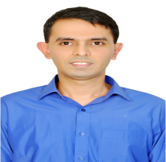

**ASHISH GROVER**

Mobile No.: 09833639678

E-Mail:[ashishgrover79@gmail.com](mailto:ashishgrover79@gmail.com)

Aiming for challenging assignments in Sales & Marketing / Key Account Management / Business Development with an organization of repute

**________________________________________________________PROFILE SUMMARY________________________________________________________**

* A competent professional with nearly 13 years of experience entailing nearly 3 years in Sales & Marketing, Key Account Management, Business Development& Customer Service and 7 years in BPO industry of handling technical & non-technical process operations
* Completed Diploma in Sales from NIS (National Institute of Sales, a subsidiary of NIIT) , Andheri, Mumbai in 2001
* Analyzing & reviewing the market response / requirements and communicating the same to the sales teams for accomplishment of the business goals by effectuating pre-planned sales strategies for accomplishment of performance milestones.
* Ensuring good client relation with company by keeping teams updated on regular feedback and developing plans to meet the market demands.
* Sound understanding of identifying training needs across levels through the analysis of the existing level of competencies
* Resourceful at maintaining relationships with clients to achieve quality product and service norms by resolving their service related critical issues
* A proactive planner with a flair for adopting emerging trends and addressing industry requirements to achieve organizational objectives & profitability norms
* Proficient in providing value added customer service by resolving customer issues & ensuring their satisfaction.

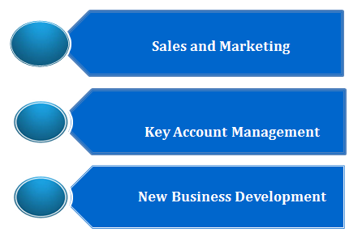





**Knowledge Domain Brands Associated With**

**_______________________________________________________CORE COMPETENCIES_______________________________________________________**

* Managing service operations for rendering and achieving quality services; providing first line customer support by answering queries & resolving their issues, ensuring minimum TAT
* Handling customer service operations inclusive of implementing short / long term plans; coordinating with team with focus on excelling business targets & service delivery metrics
* Monitoring the overall functioning of process, identifying improvement areas and implementing adequate measures to maximize customer satisfaction level
* Preparing MIS reports & other statements with a view to apprise management of process operations and assisting in critical decision-making process
* Building and maintaining healthy business relations with clients, ensuring high customer satisfaction matrices by achieving delivery & service quality norms
* Enhancing customer satisfaction matrices and ensuring speedy resolution of queries & grievances
* Assessing customer feedback, evaluating areas of improvements & providing critical feedback

**_________________________________________________ORGANISATIONAL EXPERIENCE_________________________________________________**

**Aug’11– Mar 14 with Eclinicalworks, Mumbai as Strategic Account Manager**

**Role:**

* Served as a primary point of contact for practices in USA
* Coordinating between support teams and practices for handling query / issues related to EMR
* Served as an active member of cultural team called “Tarang”

**Highlights:**

* Recognized as:
* Rising Star” for Performance in 1styear of joining in 2012
* All Star for performance in 2ndyear – 2013
* 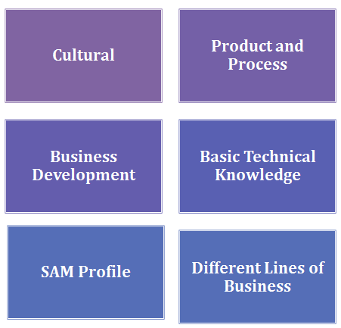Holds the distinction of being selected for training in USA at company headquarters(Westborough, MA)

# **Training Received:**

* Cultural
* Product and Process
* Business Development
* Basic Technical Knowledge
* SAM Profile
* Different Lines of Business

**Oct’06-Apr’11 with 3 Global Services, Mumbai(Hutchison Whampoa Ltd.) as Lead Advisor and Mentor**

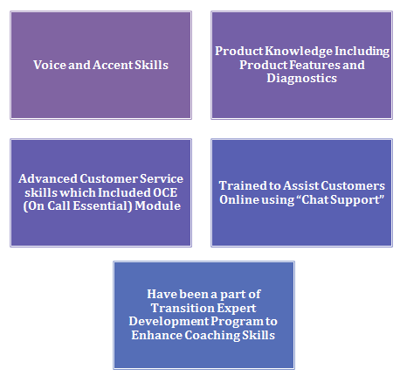

**Role:**

* Served as a:
  + Lead Advisor for voice based process (Iphone Technical Support)
  + Transition Expert (mentor) including support to players for assisting UK based customers with queries / issues on 3G handsets
* Steering efforts by organizing coaching sessions as a part of knowledge development

# **Training Received:**

* Voice and Accent Skills
* Product Knowledge Including Product Features and Diagnostics
* Advanced Customer Service Skills included On Call Essential Module
* Trained to Assist Customers Online using “Chat Support”
* Have been a part of Transition Expert Development Program to Enhance Coaching Skills

**Mar’04-Sep’06 with Wipro BPO, Mumbai (formerly Wipro-Spectramind) as Technical Support Associate**

**Role:**

* Assisted AOL’s customers with queries & issues entailing entire spectrum of transaction i.e. frompurchase of software toinstallation and un-installation
* Worked for Delta Airlines Process involving Ticket Reservation's for Domestic Customers across US

# **Training Received:**

* Voice and Accent Skills
* Product and Software Knowledge Including Product Upgrades
* Advanced Customer Service Skills

**_______________________________________________PREVIOUS WORK EXPERIENCE __________________________________________________**

# **May 03 – Feb 04**with Dr Wood Marketing, Mumbaias Sales Associate

*Looked after sales for both retail and corporate clients*

**Mar 02- Nov 02**with Andromeda (Citibank & Orange DSA), Mumbaias Tele-Marketing & Sales Associate

*Handled Personal Loansbesides Customer Service for Orange Pre-Paid Users*

**Jun 01-Sep 01**with Eureka Forbes Ltd., Mumbaias Direct Sales Executive - Security Systems Division

**Aug 00 –Feb 01** with Westside, A Trent Ltd., Mumbai as Sales Associate - Men’s Department (Promotions)

**Apr 00 –July 00** with ORG Marg Research Ltd., Mumbaias Front Line Market Research Representative

**____________________________________________________________EDUCATION______________________________________________________________**

* S.Y.B.A. (Economics, Physchology and Political Science from University Of Mumbai: 2000
* Diploma in Sales from NIS (National Institute of Sales, A Subsidiary of NIIT) , Andheri, Mumbai: 2001

**_______________________________________________________IT SKILLS_______________________________________________________**

* Computer Basics and E-Mail & Internet Applications

**_______________________________________________________PERSONAL DETAILS__________________________________________________________**

Date of Birth: 8th October 1979

Address: A-201, Max Blue Apartments,Lions Club of Marol,Landmark: Opposite Leela Galleria,

Andheri-Kurla Road, Andheri (E), Mumbai – 59

Languages Known: English, Hindi and Punjabi