C:\Users\macav\OneDrive\Hoffman-Charlie\PossibleWorkingQuestionnaires

Question Generator Selector 2020-05-15

New github password: cH467:9K:iKZWjb as of 2022-11-08

Use f12 to access developer tools and
- Go to elements

Notes on Folder : 20201013
- Saving to Cloud

Terms form:
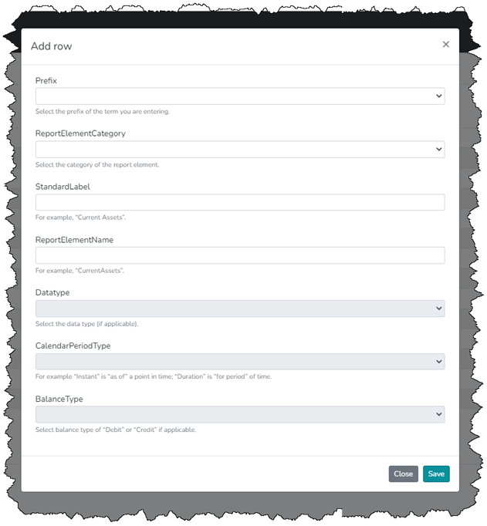

Notes on Folder : 20220729
- Saving to cloud
- HTML of New Question with content:
As user sees, follows by html:
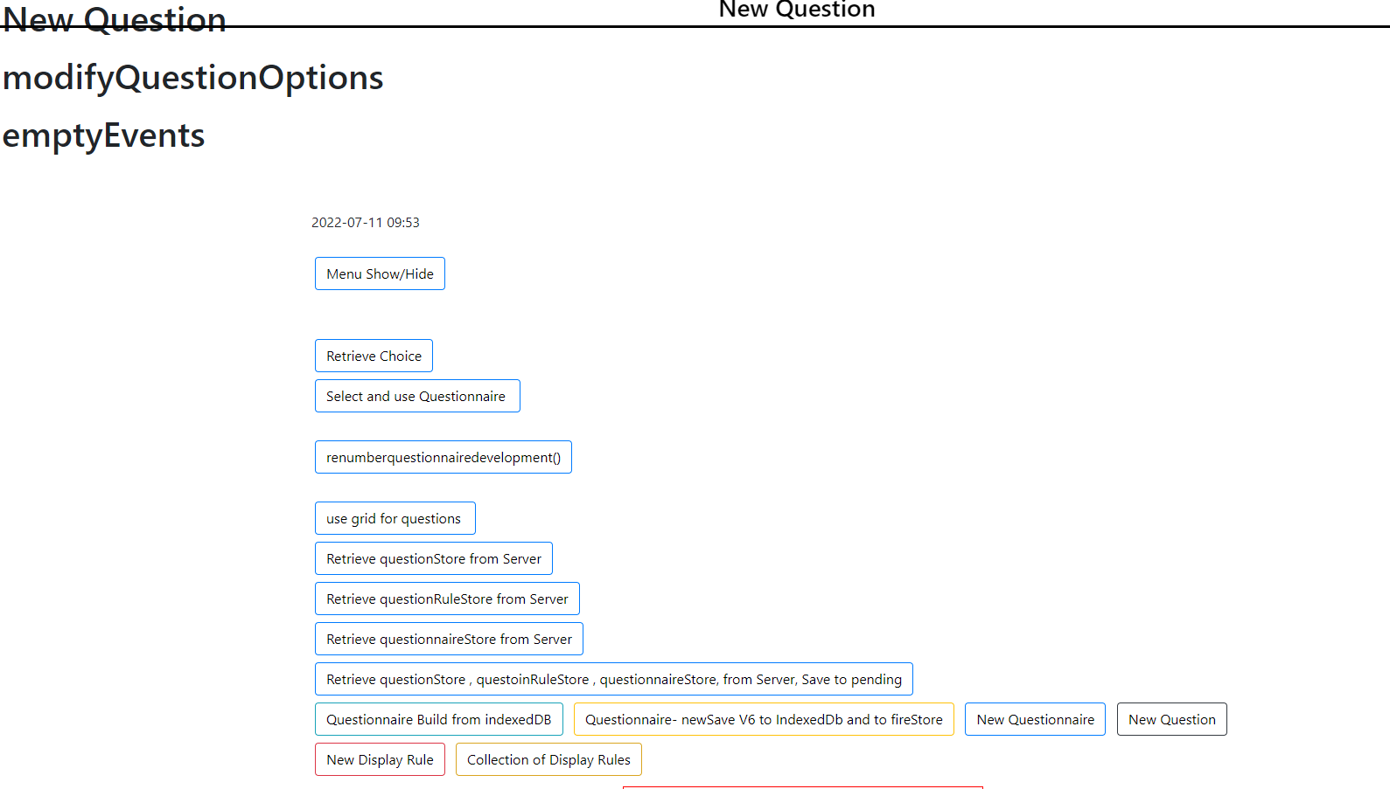
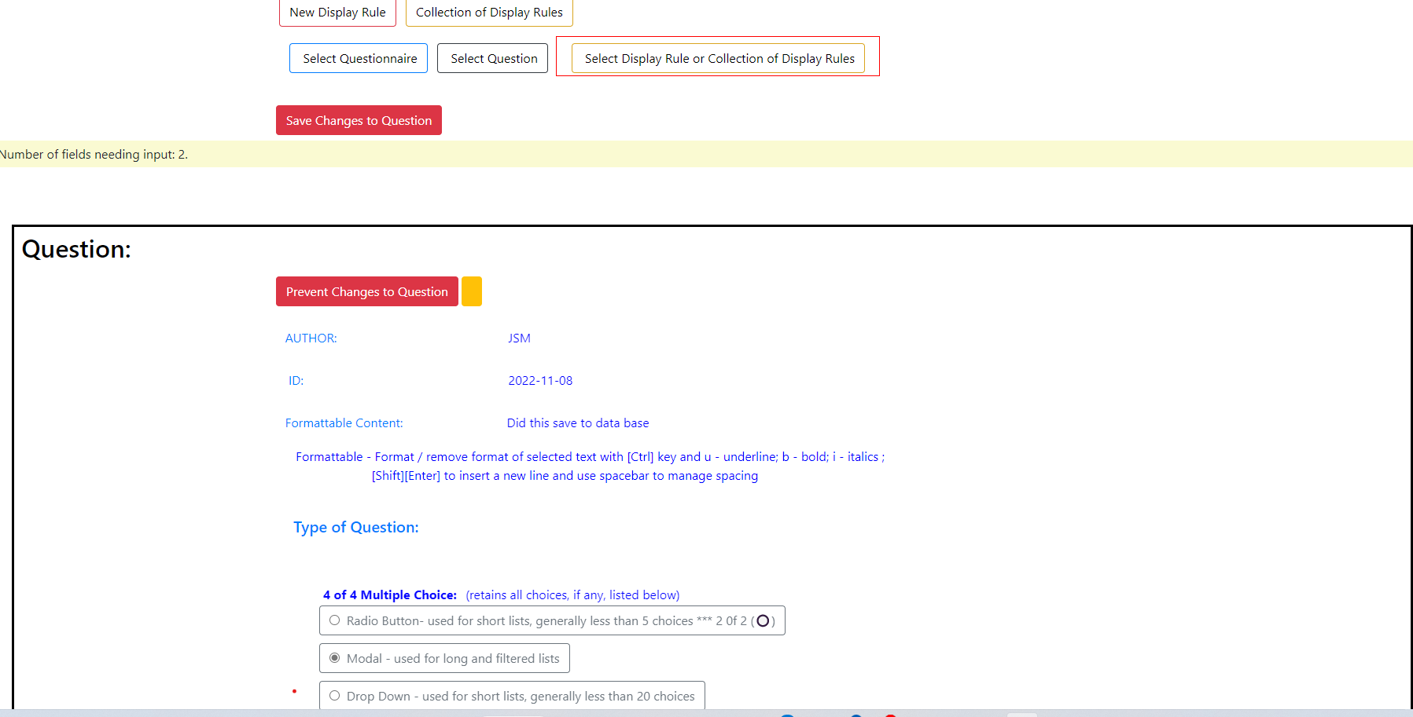
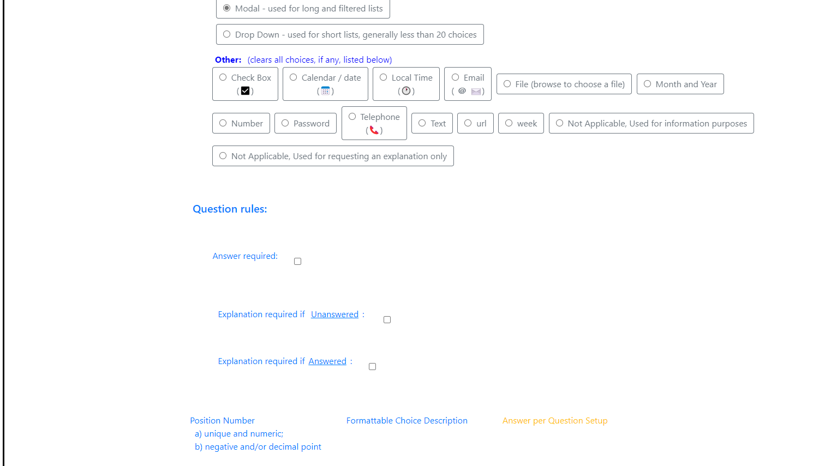
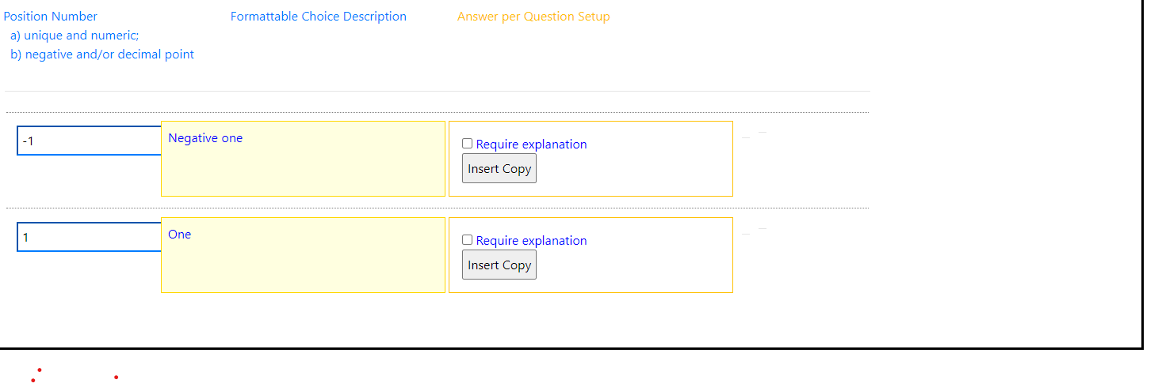
<html><head>
<!--
<meta charset="utf-8">
<meta name="viewport" content="width=device-width, initial-scale=1.0">

-->
<title>Question Generator Selector 2020-05-15</title>
<meta charset="utf-8">
<meta name="viewport" content="width=device-width, initial-scale=1">
<link rel="stylesheet" href="https://maxcdn.bootstrapcdn.com/bootstrap/4.4.1/css/bootstrap.min.css">
<link rel="stylesheet" href="questionGeneratorSelector.css">
<script src="https://ajax.googleapis.com/ajax/libs/jquery/3.4.1/jquery.min.js"></script>
<script src="https://cdnjs.cloudflare.com/ajax/libs/popper.js/1.16.0/umd/popper.min.js"></script>
<script src="https://maxcdn.bootstrapcdn.com/bootstrap/4.4.1/js/bootstrap.min.js"></script>
<script src="https://www.gstatic.com/firebasejs/7.22.1/firebase-app.js"></script>
<script src="https://www.gstatic.com/firebasejs/7.22.1/firebase-firestore.js"></script>

<!--BOOTSTRAP CSS-->
<!--
<link rel="stylesheet" href="https://maxcdn.bootstrapcdn.com/bootstrap/4.0.0/css/bootstrap.min.css" integrity="sha384-Gn5384xqQ1aoWXA+058RXPxPg6fy4IWvTNh0E263XmFcJlSAwiGgFAW/dAiS6JXm" crossorigin="anonymous">
-->
<!--
<link rel="stylesheet" type="text/css" href="20200422rebuild.css">
-->

<style>

</style>

<!-- setup indexedDB files if they do not exist *** KEEP *** -->
<script src="setupIndexedDB.js"></script>
<!-- <script src="20200422rebuild.js"></script> *** temp 2020-05-07 just to test save -->
<script>
</script>
<style>
</style>

</head>
<body data-spy="scroll" data-target=".navbar" data-offset="50">
<h3 id="formtitle" class="formtitlequestion">New Question</h3>
<!-- *** NOTE TO READER *** ??? Below used as temporary session based storage. CONSIDER changing code in browsers for makemodal to send a variable or change code or use of session storage. THIS IS not sensitive data, it just CONTROLS workflow. HOWEVER, does session storage keep data separate by tab and window for same user, they could be using multiple screens and if data used by all, even temporarily, then it is not the answer, current version works, so save the issue for post MVP *** -->
<h1 id="testForChange" class="hidealways firstRequiredExplanation" data-currentuser="JSM" data-screen="newQuestion"></h1> <!--class="hidealways" "testForChange"-->
<h1 id="process0" class="">New Question</h1> <!--// class="hidealways" "process0"-->
<h1 id="process1" class="">modifyQuestionOptions</h1> <!--//class="hidealways" "process1"-->
<h1 id="process2" class="">emptyEvents</h1> <!--//class="hidealways" "process1"-->
<h1 id="testForChange2" class="hidealways"></h1> <!--//class="hidealways" "process1"-->
<h1 id="process2Count" class="hidealways">0</h1> <!--//class="hidealways" "process1"-->

<div id="menuChoices" class="container">
<br><br> 2022-07-11 09:53
<br><br>
<input type="Button" class="btn btn-outline-primary btext" value="Menu Show/Hide">
<br>
<br>
<br>
<input type="Button" class="btn btn-outline-primary btext" onclick="doModalChoice(0)" value="Retrieve Choice">
<br>
<input type="Button" class="btn btn-outline-primary btext" onclick="buildSelectQuestionnaire()" value="Select and use Questionnaire ">
<br>
<br>
<input type="Button" class="btn btn-outline-primary btext" onclick="renumberquestionnairedevelopment()" value="renumberquestionnairedevelopment()">
<br>
<br>
<input type="Button" class="btn btn-outline-primary btext" onclick="updateGridRowsFromDatabase()" value="use grid for questions ">
<br>
<input type="Button" class="btn btn-outline-primary btext" onclick="getFromFireStore('questionStore')" value="Retrieve questionStore from Server">
<br>
<input type="Button" class="btn btn-outline-primary btext" onclick="getFromFireStore('questionRuleStore')" value="Retrieve questionRuleStore from Server">
<br>
<input type="Button" class="btn btn-outline-primary btext" onclick="getFromFireStore('questionnaireStore')" value="Retrieve questionnaireStore from Server">
<br><input type="Button" class="btn btn-outline-primary btext" onclick="getAllFromFireStore()" value="Retrieve questionStore , questoinRuleStore , questionnaireStore, from Server, Save to pending"><br>

<!-- The actual snackbar -->
<div id="snackbar">Some text some message..</div>

<input type="Button" class="btn btn-outline-info btext" onclick="buildQuestionnaireFromAllDetails()" value="Questionnaire Build from indexedDB">

<input type="Button" class="btn btn-outline-warning btext" onclick="getAllListCombinationsV6()" value="Questionnaire- newSave V6 to IndexedDb and to fireStore">

<!--
<input type="Button" class="btn btn-outline-primary btext" onclick= "emptyQuestionnaire()" value="New Questionnaire">
-->
<input type="Button" class="btn btn-outline-primary btext" value="New Questionnaire" data-screen="newQuestionnaire">

<!-- <input type="Button" class="btn btn-outline-dark btext" onclick= "saveNewQuestionButtonClicked(`New Question`)" value="New Question" >-->
<input type="Button" class="btn btn-outline-dark btext" value="New Question" data-screen="newQuestion">

<!--<input type="Button" class="btn btn-outline-danger btext" onclick= "emptyRule()" value=" New True Rule"> -->
<input type="Button" class="btn btn-outline-danger btext" value="New Display Rule" data-screen="newDisplayRule">
<!--
<input type="Button" class="btn btn-outline-warning buttongrouprule btext" onclick= "emptyGroupRule()" value="Collection of Display Rules">
-->
<input type="Button" class="btn btn-outline-warning buttongrouprule btext" value="Collection of Display Rules" data-screen="collectionOfDisplayRules">
<div class="btnmargin">
<input type="Button" class="btn btn-outline-primary btext" onclick="selectQuestionnaire()" value=" Select Questionnaire">
<input type="Button" class="btn btn-outline-dark btext" onclick="selectQuestion()" value=" Select Question">

<!--<input type="Button" class="btn btn-outline-danger btext" onclick= "selectRule()" value=" Select Rule"> -->
<span class="formtitlerule2">
<input type="Button" class="btn btn-outline-warning buttongrouprule btext" onclick="selectGroupRule()" value=" Select Display Rule or Collection of Display Rules">
</span>
</div><br>
<input type="Button" class="btn btn-danger saver" onclick="saveAnswers()" value="Save Changes to Question" id="saveButton" style="display: inline;">
<input id="outofOrderBtn" class="btn btn-primary hidealways" type="Button" onclick="sortByValueAsNumber0()" value=" Sort by Position Number" style="display: none;">
</div>
<div id="missing" style="display: block; background-color: lightgoldenrodyellow;">Number of fields needing input: 2.</div>
<!-- The Modal -->
<div id="myModal" class="modal">
<!-- overflow-y:scroll -->
<div class="modal-dialog modal-lg modal-dialog-scrollable "> <!-- large lg small sm *** *** -->
<!-- Modal content -->
<div class="modal-content" id="modal-content">
<div class="modal-header">
<h1 class="formtitlequestion" id="modaltitle">Select Question</h1>
<button type="button" class="close" data-dismiss="modal">×</button>
<!-- <span class="close">&times;</span>
<h2>Modal Header</h2> -->
</div>
<!-- Modal body -->
<div class="modal-body">
<span id="modal-body-1">
<h5> Author Search:
<input type="text" id="modalJoeInput" onkeyup="modalJoeFilter()" placeholder="Search for author.." title="Type in a name"> *
</h5>
<h5>ID Search:
<input type="text" id="modalJoeIDInput" onkeyup="modalJoeFilter()" placeholder="Search for ID .." title="Type in a name"> *
</h5>
<h5>Question Search:
<input type="text" id="modalJoeWordInput" onkeyup="modalJoeFilter()" placeholder="Search for wording .." title="Type in a name"> *
</h5>
* Not filtered until input begins, prior input there for information purposes only.
</span>
<span id="modal-body-2" class="hideAlways">
Choose Answer to Question:
</span>

<div id="modal-list">
</div>
</div>
<span class="close">×</span>
<div class="modal-footer">
<button type="button" class="btn btn-danger" data-dismiss="modal">Close</button>
</div>
</div>
</div>
</div>

<!--______________________________________________________________________________________________ ______ -->
<div id="notCleared">
<div class="container-fluid saver m-1" style="display: inline;"><!-- class: moveLeft--></div>
</div>
<div></div>

<!--____________________________________________________________________________________________________ -->

<div id="allWrappers">
<div class="questionnairetitle">
<div id="questionnaireWrapper" class="hidealways"></div>
<div id="groupruleWrapper" class="hidealways"></div>
<div id="ruleWrapper" class="hidealways"></div> <!-- end of rulewrpper-->
<div id="questionWrapper" class="questionwrapper">
<h2 id="questiontitle" class="questiontitle">Question: </h2>
<div class="container" id="questionHeader20200707">
<input class="btn btn-danger saver" type="Button" onclick="lockAll()" value="Prevent Changes to Question" id="preventAllChanges" style="display: inline;">
<input class="btn btn-warning" type="Button" onclick="unlockAll()" value="" id="allowAllChanges">
<input type="checkbox" value="false" id="makeCopy" class="hidealways">
</div>
<div class="container" id="questionAuthorContent">

<div class="row">
<div class="bg-white text-primary col-3 mt-1">
<input type="checkbox" class="checkboxNoChange hidealways" disabled="">&nbsp;AUTHOR:
</div>
<div id="questionAuthor" class="center questionQuestionContent required col-2 m-1" contenteditable="false">JSM</div>
</div>
<div class="row">
<div class="bg-white text-primary col-3 mt-1">
<input type="checkbox" class="checkboxNoChange hidealways" disabled="">&nbsp; ID:
</div>
<div id="questionID" class="center col-2 m-1 questionQuestionContent required focusFormattingID" contenteditable="true" onblur="trimCapNoFormattingID()">2022-11-08</div>
</div>
<div class="row">
<div class="bg-white text-primary col-3 mt-1">
<input type="checkbox" class="checkboxNoChange hidealways" disabled="">&nbsp;Formattable Content:
</div>
<div id="questionContent" class="center col-8 mt-1 questionQuestionContent required" contenteditable="true" onblur="trimCapNoFormatting()">Did this save to data base</div>
</div>
<div class="row">
&nbsp; &nbsp; &nbsp; &nbsp; Formattable - Format / remove format of selected text with [Ctrl] key and u - underline; b - bold; i - italics ; <br>&nbsp; &nbsp; &nbsp; &nbsp; &nbsp; &nbsp; &nbsp; &nbsp; &nbsp; &nbsp; &nbsp; &nbsp; &nbsp; &nbsp; &nbsp; [Shift][Enter] to insert a new line and use spacebar to manage spacing
</div>
<div id="typeOfQuestion20200707" class="container">
<br><h5 class="bg-white text-primary">Type of Question:</h5>
<div id="questionTypeDiv" class="">
<div class="btn-group btn-group-toggle" data-toggle="buttons">
<div class="col-12">
<p id="allChoiceTypes" class=""></p><div><b> 4 of 4 Multiple Choice:</b> (retains all choices, if any, listed below)<br>
<label class="btn btn-outline-secondary" for="questionTypeDiv_radio">
<input type="radio" id="questionTypeDiv_radio" name="questionTypeDiv" class="questionTypeDivList" value="questionTypeDiv_radio" onclick="trueTypeQuestion()">&nbsp; Radio Button- used for short lists, generally less than 5 choices *** 2 0f 2 (🔘)
</label>
<br>
<label class="btn btn-outline-secondary" for="questionTypeDiv_modal">
<input type="radio" id="questionTypeDiv_modal" name="questionTypeDiv" class="questionTypeDivList" value="questionTypeDiv_modal" onclick="trueTypeQuestion()">&nbsp; Modal - used for long and filtered lists
</label>
<br>
<label class="btn btn-outline-secondary" for="questionTypeDiv_dropdown">
<input type="radio" id="questionTypeDiv_dropdown" name="questionTypeDiv" class="questionTypeDivList" value="questionTypeDiv_dropdown" onclick="trueTypeQuestion()">&nbsp; Drop Down - used for short lists, generally less than 20 choices
</label>
</div>
<b>Other:</b> (clears all choices, if any, listed below) <br>
<label class="btn btn-outline-secondary" for="questionTypeDiv_checkbox">
<input type="radio" id="questionTypeDiv_checkbox" name="questionTypeDiv" class="questionTypeDivList" value="questionTypeDiv_checkbox" onclick="trueTypeQuestion()">&nbsp; Check Box<br>(☑)
</label>
<label class="btn btn-outline-secondary" for="questionTypeDiv_date">
<input type="radio" id="questionTypeDiv_date" name="questionTypeDiv" class="questionTypeDivList" value="questionTypeDiv_date" onclick="trueTypeQuestion()">&nbsp; Calendar / date<br>(📅)
</label>
<label class="btn btn-outline-secondary" for="questionTypeDiv_datetime-local">
<input type="radio" id="questionTypeDiv_datetime-local" name="questionTypeDiv" class="questionTypeDivList" value="questionTypeDiv_datetime-local" onclick="trueTypeQuestion()">&nbsp; Local Time<br>(🕐)
</label>
<label class="btn btn-outline-secondary" for="questionTypeDiv_email">
<input type="radio" id="questionTypeDiv_email" name="questionTypeDiv" class="questionTypeDivList" value="questionTypeDiv_email" onclick="trueTypeQuestion()">&nbsp; Email<br>(<b>@</b>✉)
</label>
<label class="btn btn-outline-secondary" for="questionTypeDiv_file">
<input type="radio" id="questionTypeDiv_file" name="questionTypeDiv" class="questionTypeDivList" value="questionTypeDiv_file" onclick="trueTypeQuestion()">&nbsp; File (browse to choose a file)
</label>
<label class="btn btn-outline-secondary" for="questionTypeDiv_month">
<input type="radio" id="questionTypeDiv_month" name="questionTypeDiv" class="questionTypeDivList" value="questionTypeDiv_month" onclick="trueTypeQuestion()">&nbsp; Month and Year
</label>
<label class="btn btn-outline-secondary" for="questionTypeDiv_number">
<input type="radio" id="questionTypeDiv_number" name="questionTypeDiv" class="questionTypeDivList" value="questionTypeDiv_number" onclick="trueTypeQuestion()">&nbsp; Number
</label>
<label class="btn btn-outline-secondary" for="questionTypeDiv_password">
<input type="radio" id="questionTypeDiv_password" name="questionTypeDiv" class="questionTypeDivList" value="questionTypeDiv_password" onclick="trueTypeQuestion()">&nbsp; Password
</label>
<label class="btn btn-outline-secondary" for="questionTypeDiv_tel">
<input type="radio" id="questionTypeDiv_tel" name="questionTypeDiv" class="questionTypeDivList" value="questionTypeDiv_tel" onclick="trueTypeQuestion()">&nbsp; Telephone<br>(📞)
</label>
<label class="btn btn-outline-secondary" for="questionTypeDiv_text">
<input type="radio" id="questionTypeDiv_text" name="questionTypeDiv" class="questionTypeDivList" value="questionTypeDiv_text" onclick="trueTypeQuestion()">&nbsp; Text
</label>
<label class="btn btn-outline-secondary" for="questionTypeDiv_url">
<input type="radio" id="questionTypeDiv_url" name="questionTypeDiv" class="questionTypeDivList" value="questionTypeDiv_url" onclick="trueTypeQuestion()">&nbsp; url
</label>
<label class="btn btn-outline-secondary" for="questionTypeDiv_week">
<input type="radio" id="questionTypeDiv_week" name="questionTypeDiv" class="questionTypeDivList" value="questionTypeDiv_week" onclick="trueTypeQuestion()">&nbsp; week
</label>
<label class="btn btn-outline-secondary" for="questionTypeDiv_na">
<input type="radio" id="questionTypeDiv_na" name="questionTypeDiv" class="questionTypeDivList" value="questionTypeDiv_na" onclick="trueTypeQuestion()">&nbsp; Not Applicable, Used for information purposes
</label>
<label class="btn btn-outline-secondary" for="questionTypeDiv_naExplained">
<input type="radio" id="questionTypeDiv_naExplained" name="questionTypeDiv" class="questionTypeDivList" value="questionTypeDiv_naExplained" onclick="trueTypeQuestion()">&nbsp; Not Applicable, Used for requesting an explanation only
</label>
<p></p>
</div>
</div>
</div>
<div class="row">
<h5 class="bg-white text-primary">Question rules:</h5>
</div>
<div class="row">
<div class="bg-white text-primary col-6 mt-1">
&nbsp;&nbsp;&nbsp;&nbsp;&nbsp; Answer required:&nbsp;
<div class="btn-group" data-toggle="buttons">
<label class="btn btn-default"><br>
<input type="checkbox" autocomplete="off" id="questionUnansweredComplete">
<span class="glyphicon glyphicon-ok"></span>
</label>
</div>
</div>
</div>
<!--<div class="row">-->
<div class="bg-white text-primary col-6 mt-1 questionQuestionID">
&nbsp;&nbsp;&nbsp;&nbsp;&nbsp; Explanation required if <u>Unanswered</u>:&nbsp;&nbsp;
<div class="btn-group" data-toggle="buttons">
<label class="btn btn-default"><br>
<input type="checkbox" autocomplete="off" id="questionUnansweredRequiresExplanation">
<span class="glyphicon glyphicon-ok"></span>
</label>
</div><br>
&nbsp;&nbsp;&nbsp;&nbsp;&nbsp; Explanation required if<u>Answered</u>:&nbsp;
<div class="btn-group" data-toggle="buttons">
<label class="btn btn-default"><br>
<input type="checkbox" autocomplete="off" id="questionAnsweredRequiresExplanation">
<span class="glyphicon glyphicon-ok"></span>
</label>
</div>
</div>
<!--</div>
<div class="row">
???
</div>-->
</div>
<div class="container saver" style="display: inline;">
<div id="questionAnswerChoicesHeader" class="row"> <div class="text-primary col-3">
Position Number<br>&nbsp; a) unique and numeric; <br>&nbsp; b) negative and/or decimal point
</div>
<div class="questionAnswerTitle col-3 text-primary">Formattable Choice Description </div>
<div class="questionAnswerTitle col-3 text-warning">Answer per Question Setup</div>

<div class="questionAnswerTitle col-3 text-danger trueRuleDiv hidealways" style="text-align:center"> Check to Display<br>
<div class="btn-group rulecheckbox p-1" data-toggle="buttons" style="text-align:right">
<label class="btn btn-outline-danger" style="text-align:right">
<input type="checkbox" autocomplete="off" checked="true" disabled="true"> Display
<span class="glyphicon glyphicon-ok"></span>
</label>
</div>

</div></div>
<ul id="questionAnswerChoices" class=""><hr><div class="row rowChoice">
<div class="col-2 numerical-input m-1 p-1">
<!-- <input type="number" class = "questionAnswerSort missing border-primary"> -->
<input type="number" class="questionAnswerSort border-primary" style="">
</div>
<div class="questionAnswerDescription missing col-4 p-2" contenteditable="true">Negative one</div>
<div class="questionExplanationRequireYesNo col-4 p-3 border border-warning">
<input type="checkbox" class="checkboxExplain"> Require explanation
<input type="checkbox" class="checkboxNoChange hidealways" disabled=""><br>
<input type="button" value="Insert Copy" class="copyBtn">&nbsp;&nbsp;&nbsp;&nbsp;&nbsp;&nbsp;<input type="button" value="Delete" class="deleteBtn deleteBtn2 hidealways" style="">
</div>
<!-- <div class="questionAnswerNotesDescription col-2" contenteditable="true"></div> -->
<div class="btn-group trueRuleDiv rulecheckbox p-1 hidealways" data-toggle="buttons">
<label class="btn btn-outline-danger">
<input type="checkbox" class="trueRule" autocomplete="off"> Display
<span class="glyphicon glyphicon-ok"></span>
</label>
</div>
<div>
<hr>
</div>
<hr>
</div><div class="row rowChoice">
<div class="col-2 numerical-input m-1 p-1">
<!-- <input type="number" class = "questionAnswerSort missing border-primary"> -->
<input type="number" class="questionAnswerSort border-primary">
</div>
<div class="questionAnswerDescription missing col-4 p-2" contenteditable="true">One</div>
<div class="questionExplanationRequireYesNo col-4 p-3 border border-warning">
<input type="checkbox" class="checkboxExplain"> Require explanation
<input type="checkbox" class="checkboxNoChange hidealways" disabled=""><br>
<input type="button" value="Insert Copy" class="copyBtn">&nbsp;&nbsp;&nbsp;&nbsp;&nbsp;&nbsp;<input type="button" value="Delete" class="deleteBtn deleteBtn2 hidealways" style="">
</div>
<!-- <div class="questionAnswerNotesDescription col-2" contenteditable="true"></div> -->
<div class="btn-group trueRuleDiv rulecheckbox p-1 hidealways" data-toggle="buttons">
<label class="btn btn-outline-danger">
<input type="checkbox" class="trueRule" autocomplete="off"> Display
<span class="glyphicon glyphicon-ok"></span>
</label>
</div>
<div>
<hr>
</div>
<hr>
</div></ul>
</div>
</div>
</div>
<!-- <div id="questionAnswersList"> </div> -->
</div>
</div>

<h5>
<div id="firstGrid1" class="grid1 hidealways"></div>
</h5>

<div class="footer">
<p class="p" p="">Footer</p>
</div>

<script src="questionGeneratorSelector.js"></script>

</body></html>
IN colour: ???
<html><head>
<!--
<meta charset="utf-8">
<meta name="viewport" content="width=device-width, initial-scale=1.0">

-->
<title>Question Generator Selector 2020-05-15</title>
<meta charset="utf-8">
<meta name="viewport" content="width=device-width, initial-scale=1">
<link rel="stylesheet" href="https://maxcdn.bootstrapcdn.com/bootstrap/4.4.1/css/bootstrap.min.css">
<link rel="stylesheet" href="questionGeneratorSelector.css">
<script src="https://ajax.googleapis.com/ajax/libs/jquery/3.4.1/jquery.min.js"></script>
<script src="https://cdnjs.cloudflare.com/ajax/libs/popper.js/1.16.0/umd/popper.min.js"></script>
<script src="https://maxcdn.bootstrapcdn.com/bootstrap/4.4.1/js/bootstrap.min.js"></script>
<script src="https://www.gstatic.com/firebasejs/7.22.1/firebase-app.js"></script>
<script src="https://www.gstatic.com/firebasejs/7.22.1/firebase-firestore.js"></script>

<!--BOOTSTRAP CSS-->
<!--
<link rel="stylesheet" href="https://maxcdn.bootstrapcdn.com/bootstrap/4.0.0/css/bootstrap.min.css" integrity="sha384-Gn5384xqQ1aoWXA+058RXPxPg6fy4IWvTNh0E263XmFcJlSAwiGgFAW/dAiS6JXm" crossorigin="anonymous">
-->
<!--
<link rel="stylesheet" type="text/css" href="20200422rebuild.css">
-->

<style>

</style>

<!-- setup indexedDB files if they do not exist *** KEEP *** -->
<script src="setupIndexedDB.js"></script>
<!-- <script src="20200422rebuild.js"></script> *** temp 2020-05-07 just to test save -->
<script>
</script>
<style>
</style>

</head>
<body data-spy="scroll" data-target=".navbar" data-offset="50">
<h3 id="formtitle" class="formtitlequestion">New Question</h3>
<!-- *** NOTE TO READER *** ??? Below used as temporary session based storage. CONSIDER changing code in browsers for makemodal to send a variable or change code or use of session storage. THIS IS not sensitive data, it just CONTROLS workflow. HOWEVER, does session storage keep data separate by tab and window for same user, they could be using multiple screens and if data used by all, even temporarily, then it is not the answer, current version works, so save the issue for post MVP *** -->
<h1 id="testForChange" class="hidealways firstRequiredExplanation" data-currentuser="JSM" data-screen="newQuestion"></h1> <!--class="hidealways" "testForChange"-->
<h1 id="process0" class="">New Question</h1> <!--// class="hidealways" "process0"-->
<h1 id="process1" class="">modifyQuestionOptions</h1> <!--//class="hidealways" "process1"-->
<h1 id="process2" class="">emptyEvents</h1> <!--//class="hidealways" "process1"-->
<h1 id="testForChange2" class="hidealways"></h1> <!--//class="hidealways" "process1"-->
<h1 id="process2Count" class="hidealways">0</h1> <!--//class="hidealways" "process1"-->

<div id="menuChoices" class="container">
<br><br> 2022-07-11 09:53
<br><br>
<input type="Button" class="btn btn-outline-primary btext" value="Menu Show/Hide">
<br>
<br>
<br>
<input type="Button" class="btn btn-outline-primary btext" onclick="doModalChoice(0)" value="Retrieve Choice">
<br>
<input type="Button" class="btn btn-outline-primary btext" onclick="buildSelectQuestionnaire()" value="Select and use Questionnaire ">
<br>
<br>
<input type="Button" class="btn btn-outline-primary btext" onclick="renumberquestionnairedevelopment()" value="renumberquestionnairedevelopment()">
<br>
<br>
<input type="Button" class="btn btn-outline-primary btext" onclick="updateGridRowsFromDatabase()" value="use grid for questions ">
<br>
<input type="Button" class="btn btn-outline-primary btext" onclick="getFromFireStore('questionStore')" value="Retrieve questionStore from Server">
<br>
<input type="Button" class="btn btn-outline-primary btext" onclick="getFromFireStore('questionRuleStore')" value="Retrieve questionRuleStore from Server">
<br>
<input type="Button" class="btn btn-outline-primary btext" onclick="getFromFireStore('questionnaireStore')" value="Retrieve questionnaireStore from Server">
<br><input type="Button" class="btn btn-outline-primary btext" onclick="getAllFromFireStore()" value="Retrieve questionStore , questoinRuleStore , questionnaireStore, from Server, Save to pending"><br>

<!-- The actual snackbar -->
<div id="snackbar">Some text some message..</div>

<input type="Button" class="btn btn-outline-info btext" onclick="buildQuestionnaireFromAllDetails()" value="Questionnaire Build from indexedDB">

<input type="Button" class="btn btn-outline-warning btext" onclick="getAllListCombinationsV6()" value="Questionnaire- newSave V6 to IndexedDb and to fireStore">

<!--
<input type="Button" class="btn btn-outline-primary btext" onclick= "emptyQuestionnaire()" value="New Questionnaire">
-->
<input type="Button" class="btn btn-outline-primary btext" value="New Questionnaire" data-screen="newQuestionnaire">

<!-- <input type="Button" class="btn btn-outline-dark btext" onclick= "saveNewQuestionButtonClicked(`New Question`)" value="New Question" >-->
<input type="Button" class="btn btn-outline-dark btext" value="New Question" data-screen="newQuestion">

<!--<input type="Button" class="btn btn-outline-danger btext" onclick= "emptyRule()" value=" New True Rule"> -->
<input type="Button" class="btn btn-outline-danger btext" value="New Display Rule" data-screen="newDisplayRule">
<!--
<input type="Button" class="btn btn-outline-warning buttongrouprule btext" onclick= "emptyGroupRule()" value="Collection of Display Rules">
-->
<input type="Button" class="btn btn-outline-warning buttongrouprule btext" value="Collection of Display Rules" data-screen="collectionOfDisplayRules">
<div class="btnmargin">
<input type="Button" class="btn btn-outline-primary btext" onclick="selectQuestionnaire()" value=" Select Questionnaire">
<input type="Button" class="btn btn-outline-dark btext" onclick="selectQuestion()" value=" Select Question">

<!--<input type="Button" class="btn btn-outline-danger btext" onclick= "selectRule()" value=" Select Rule"> -->
<span class="formtitlerule2">
<input type="Button" class="btn btn-outline-warning buttongrouprule btext" onclick="selectGroupRule()" value=" Select Display Rule or Collection of Display Rules">
</span>
</div><br>
<input type="Button" class="btn btn-danger saver" onclick="saveAnswers()" value="Save Changes to Question" id="saveButton" style="display: inline;">
<input id="outofOrderBtn" class="btn btn-primary hidealways" type="Button" onclick="sortByValueAsNumber0()" value=" Sort by Position Number" style="display: none;">
</div>
<div id="missing" style="display: block; background-color: lightgoldenrodyellow;">Number of fields needing input: 2.</div>
<!-- The Modal -->
<div id="myModal" class="modal">
<!-- overflow-y:scroll -->
<div class="modal-dialog modal-lg modal-dialog-scrollable "> <!-- large lg small sm *** *** -->
<!-- Modal content -->
<div class="modal-content" id="modal-content">
<div class="modal-header">
<h1 class="formtitlequestion" id="modaltitle">Select Question</h1>
<button type="button" class="close" data-dismiss="modal">×</button>
<!-- <span class="close">&times;</span>
<h2>Modal Header</h2> -->
</div>
<!-- Modal body -->
<div class="modal-body">
<span id="modal-body-1">
<h5> Author Search:
<input type="text" id="modalJoeInput" onkeyup="modalJoeFilter()" placeholder="Search for author.." title="Type in a name"> *
</h5>
<h5>ID Search:
<input type="text" id="modalJoeIDInput" onkeyup="modalJoeFilter()" placeholder="Search for ID .." title="Type in a name"> *
</h5>
<h5>Question Search:
<input type="text" id="modalJoeWordInput" onkeyup="modalJoeFilter()" placeholder="Search for wording .." title="Type in a name"> *
</h5>
* Not filtered until input begins, prior input there for information purposes only.
</span>
<span id="modal-body-2" class="hideAlways">
Choose Answer to Question:
</span>

<div id="modal-list">
</div>
</div>
<span class="close">×</span>
<div class="modal-footer">
<button type="button" class="btn btn-danger" data-dismiss="modal">Close</button>
</div>
</div>
</div>
</div>

<!--______________________________________________________________________________________________ ______ -->
<div id="notCleared">
<div class="container-fluid saver m-1" style="display: inline;"><!-- class: moveLeft--></div>
</div>
<div></div>

<!--____________________________________________________________________________________________________ -->

<div id="allWrappers">
<div class="questionnairetitle">
<div id="questionnaireWrapper" class="hidealways"></div>
<div id="groupruleWrapper" class="hidealways"></div>
<div id="ruleWrapper" class="hidealways"></div> <!-- end of rulewrpper-->
<div id="questionWrapper" class="questionwrapper">
<h2 id="questiontitle" class="questiontitle">Question: </h2>
<div class="container" id="questionHeader20200707">
<input class="btn btn-danger saver" type="Button" onclick="lockAll()" value="Prevent Changes to Question" id="preventAllChanges" style="display: inline;">
<input class="btn btn-warning" type="Button" onclick="unlockAll()" value="" id="allowAllChanges">
<input type="checkbox" value="false" id="makeCopy" class="hidealways">
</div>
<div class="container" id="questionAuthorContent">

<div class="row">
<div class="bg-white text-primary col-3 mt-1">
<input type="checkbox" class="checkboxNoChange hidealways" disabled="">&nbsp;AUTHOR:
</div>
<div id="questionAuthor" class="center questionQuestionContent required col-2 m-1" contenteditable="false">JSM</div>
</div>
<div class="row">
<div class="bg-white text-primary col-3 mt-1">
<input type="checkbox" class="checkboxNoChange hidealways" disabled="">&nbsp; ID:
</div>
<div id="questionID" class="center col-2 m-1 questionQuestionContent required focusFormattingID" contenteditable="true" onblur="trimCapNoFormattingID()">2022-11-08</div>
</div>
<div class="row">
<div class="bg-white text-primary col-3 mt-1">
<input type="checkbox" class="checkboxNoChange hidealways" disabled="">&nbsp;Formattable Content:
</div>
<div id="questionContent" class="center col-8 mt-1 questionQuestionContent required" contenteditable="true" onblur="trimCapNoFormatting()">Did this save to data base</div>
</div>
<div class="row">
&nbsp; &nbsp; &nbsp; &nbsp; Formattable - Format / remove format of selected text with [Ctrl] key and u - underline; b - bold; i - italics ; <br>&nbsp; &nbsp; &nbsp; &nbsp; &nbsp; &nbsp; &nbsp; &nbsp; &nbsp; &nbsp; &nbsp; &nbsp; &nbsp; &nbsp; &nbsp; [Shift][Enter] to insert a new line and use spacebar to manage spacing
</div>
<div id="typeOfQuestion20200707" class="container">
<br><h5 class="bg-white text-primary">Type of Question:</h5>
<div id="questionTypeDiv" class="">
<div class="btn-group btn-group-toggle" data-toggle="buttons">
<div class="col-12">
<p id="allChoiceTypes" class=""></p><div><b> 4 of 4 Multiple Choice:</b> (retains all choices, if any, listed below)<br>
<label class="btn btn-outline-secondary" for="questionTypeDiv_radio">
<input type="radio" id="questionTypeDiv_radio" name="questionTypeDiv" class="questionTypeDivList" value="questionTypeDiv_radio" onclick="trueTypeQuestion()">&nbsp; Radio Button- used for short lists, generally less than 5 choices *** 2 0f 2 (🔘)
</label>
<br>
<label class="btn btn-outline-secondary" for="questionTypeDiv_modal">
<input type="radio" id="questionTypeDiv_modal" name="questionTypeDiv" class="questionTypeDivList" value="questionTypeDiv_modal" onclick="trueTypeQuestion()">&nbsp; Modal - used for long and filtered lists
</label>
<br>
<label class="btn btn-outline-secondary" for="questionTypeDiv_dropdown">
<input type="radio" id="questionTypeDiv_dropdown" name="questionTypeDiv" class="questionTypeDivList" value="questionTypeDiv_dropdown" onclick="trueTypeQuestion()">&nbsp; Drop Down - used for short lists, generally less than 20 choices
</label>
</div>
<b>Other:</b> (clears all choices, if any, listed below) <br>
<label class="btn btn-outline-secondary" for="questionTypeDiv_checkbox">
<input type="radio" id="questionTypeDiv_checkbox" name="questionTypeDiv" class="questionTypeDivList" value="questionTypeDiv_checkbox" onclick="trueTypeQuestion()">&nbsp; Check Box<br>(☑)
</label>
<label class="btn btn-outline-secondary" for="questionTypeDiv_date">
<input type="radio" id="questionTypeDiv_date" name="questionTypeDiv" class="questionTypeDivList" value="questionTypeDiv_date" onclick="trueTypeQuestion()">&nbsp; Calendar / date<br>(📅)
</label>
<label class="btn btn-outline-secondary" for="questionTypeDiv_datetime-local">
<input type="radio" id="questionTypeDiv_datetime-local" name="questionTypeDiv" class="questionTypeDivList" value="questionTypeDiv_datetime-local" onclick="trueTypeQuestion()">&nbsp; Local Time<br>(🕐)
</label>
<label class="btn btn-outline-secondary" for="questionTypeDiv_email">
<input type="radio" id="questionTypeDiv_email" name="questionTypeDiv" class="questionTypeDivList" value="questionTypeDiv_email" onclick="trueTypeQuestion()">&nbsp; Email<br>(<b>@</b>✉)
</label>
<label class="btn btn-outline-secondary" for="questionTypeDiv_file">
<input type="radio" id="questionTypeDiv_file" name="questionTypeDiv" class="questionTypeDivList" value="questionTypeDiv_file" onclick="trueTypeQuestion()">&nbsp; File (browse to choose a file)
</label>
<label class="btn btn-outline-secondary" for="questionTypeDiv_month">
<input type="radio" id="questionTypeDiv_month" name="questionTypeDiv" class="questionTypeDivList" value="questionTypeDiv_month" onclick="trueTypeQuestion()">&nbsp; Month and Year
</label>
<label class="btn btn-outline-secondary" for="questionTypeDiv_number">
<input type="radio" id="questionTypeDiv_number" name="questionTypeDiv" class="questionTypeDivList" value="questionTypeDiv_number" onclick="trueTypeQuestion()">&nbsp; Number
</label>
<label class="btn btn-outline-secondary" for="questionTypeDiv_password">
<input type="radio" id="questionTypeDiv_password" name="questionTypeDiv" class="questionTypeDivList" value="questionTypeDiv_password" onclick="trueTypeQuestion()">&nbsp; Password
</label>
<label class="btn btn-outline-secondary" for="questionTypeDiv_tel">
<input type="radio" id="questionTypeDiv_tel" name="questionTypeDiv" class="questionTypeDivList" value="questionTypeDiv_tel" onclick="trueTypeQuestion()">&nbsp; Telephone<br>(📞)
</label>
<label class="btn btn-outline-secondary" for="questionTypeDiv_text">
<input type="radio" id="questionTypeDiv_text" name="questionTypeDiv" class="questionTypeDivList" value="questionTypeDiv_text" onclick="trueTypeQuestion()">&nbsp; Text
</label>
<label class="btn btn-outline-secondary" for="questionTypeDiv_url">
<input type="radio" id="questionTypeDiv_url" name="questionTypeDiv" class="questionTypeDivList" value="questionTypeDiv_url" onclick="trueTypeQuestion()">&nbsp; url
</label>
<label class="btn btn-outline-secondary" for="questionTypeDiv_week">
<input type="radio" id="questionTypeDiv_week" name="questionTypeDiv" class="questionTypeDivList" value="questionTypeDiv_week" onclick="trueTypeQuestion()">&nbsp; week
</label>
<label class="btn btn-outline-secondary" for="questionTypeDiv_na">
<input type="radio" id="questionTypeDiv_na" name="questionTypeDiv" class="questionTypeDivList" value="questionTypeDiv_na" onclick="trueTypeQuestion()">&nbsp; Not Applicable, Used for information purposes
</label>
<label class="btn btn-outline-secondary" for="questionTypeDiv_naExplained">
<input type="radio" id="questionTypeDiv_naExplained" name="questionTypeDiv" class="questionTypeDivList" value="questionTypeDiv_naExplained" onclick="trueTypeQuestion()">&nbsp; Not Applicable, Used for requesting an explanation only
</label>
<p></p>
</div>
</div>
</div>
<div class="row">
<h5 class="bg-white text-primary">Question rules:</h5>
</div>
<div class="row">
<div class="bg-white text-primary col-6 mt-1">
&nbsp;&nbsp;&nbsp;&nbsp;&nbsp; Answer required:&nbsp;
<div class="btn-group" data-toggle="buttons">
<label class="btn btn-default"><br>
<input type="checkbox" autocomplete="off" id="questionUnansweredComplete">
<span class="glyphicon glyphicon-ok"></span>
</label>
</div>
</div>
</div>
<!--<div class="row">-->
<div class="bg-white text-primary col-6 mt-1 questionQuestionID">
&nbsp;&nbsp;&nbsp;&nbsp;&nbsp; Explanation required if <u>Unanswered</u>:&nbsp;&nbsp;
<div class="btn-group" data-toggle="buttons">
<label class="btn btn-default"><br>
<input type="checkbox" autocomplete="off" id="questionUnansweredRequiresExplanation">
<span class="glyphicon glyphicon-ok"></span>
</label>
</div><br>
&nbsp;&nbsp;&nbsp;&nbsp;&nbsp; Explanation required if<u>Answered</u>:&nbsp;
<div class="btn-group" data-toggle="buttons">
<label class="btn btn-default"><br>
<input type="checkbox" autocomplete="off" id="questionAnsweredRequiresExplanation">
<span class="glyphicon glyphicon-ok"></span>
</label>
</div>
</div>
<!--</div>
<div class="row">
???
</div>-->
</div>
<div class="container saver" style="display: inline;">
<div id="questionAnswerChoicesHeader" class="row"> <div class="text-primary col-3">
Position Number<br>&nbsp; a) unique and numeric; <br>&nbsp; b) negative and/or decimal point
</div>
<div class="questionAnswerTitle col-3 text-primary">Formattable Choice Description </div>
<div class="questionAnswerTitle col-3 text-warning">Answer per Question Setup</div>

<div class="questionAnswerTitle col-3 text-danger trueRuleDiv hidealways" style="text-align:center"> Check to Display<br>
<div class="btn-group rulecheckbox p-1" data-toggle="buttons" style="text-align:right">
<label class="btn btn-outline-danger" style="text-align:right">
<input type="checkbox" autocomplete="off" checked="true" disabled="true"> Display
<span class="glyphicon glyphicon-ok"></span>
</label>
</div>

</div></div>
<ul id="questionAnswerChoices" class=""><hr><div class="row rowChoice">
<div class="col-2 numerical-input m-1 p-1">
<!-- <input type="number" class = "questionAnswerSort missing border-primary"> -->
<input type="number" class="questionAnswerSort border-primary" style="">
</div>
<div class="questionAnswerDescription missing col-4 p-2" contenteditable="true">Negative one</div>
<div class="questionExplanationRequireYesNo col-4 p-3 border border-warning">
<input type="checkbox" class="checkboxExplain"> Require explanation
<input type="checkbox" class="checkboxNoChange hidealways" disabled=""><br>
<input type="button" value="Insert Copy" class="copyBtn">&nbsp;&nbsp;&nbsp;&nbsp;&nbsp;&nbsp;<input type="button" value="Delete" class="deleteBtn deleteBtn2 hidealways" style="">
</div>
<!-- <div class="questionAnswerNotesDescription col-2" contenteditable="true"></div> -->
<div class="btn-group trueRuleDiv rulecheckbox p-1 hidealways" data-toggle="buttons">
<label class="btn btn-outline-danger">
<input type="checkbox" class="trueRule" autocomplete="off"> Display
<span class="glyphicon glyphicon-ok"></span>
</label>
</div>
<div>
<hr>
</div>
<hr>
</div><div class="row rowChoice">
<div class="col-2 numerical-input m-1 p-1">
<!-- <input type="number" class = "questionAnswerSort missing border-primary"> -->
<input type="number" class="questionAnswerSort border-primary">
</div>
<div class="questionAnswerDescription missing col-4 p-2" contenteditable="true">One</div>
<div class="questionExplanationRequireYesNo col-4 p-3 border border-warning">
<input type="checkbox" class="checkboxExplain"> Require explanation
<input type="checkbox" class="checkboxNoChange hidealways" disabled=""><br>
<input type="button" value="Insert Copy" class="copyBtn">&nbsp;&nbsp;&nbsp;&nbsp;&nbsp;&nbsp;<input type="button" value="Delete" class="deleteBtn deleteBtn2 hidealways" style="">
</div>
<!-- <div class="questionAnswerNotesDescription col-2" contenteditable="true"></div> -->
<div class="btn-group trueRuleDiv rulecheckbox p-1 hidealways" data-toggle="buttons">
<label class="btn btn-outline-danger">
<input type="checkbox" class="trueRule" autocomplete="off"> Display
<span class="glyphicon glyphicon-ok"></span>
</label>
</div>
<div>
<hr>
</div>
<hr>
</div></ul>
</div>
</div>
</div>
<!-- <div id="questionAnswersList"> </div> -->
</div>
</div>

<h5>
<div id="firstGrid1" class="grid1 hidealways"></div>
</h5>

<div class="footer">
<p class="p" p="">Footer</p>
</div>

<script src="questionGeneratorSelector.js"></script>

</body></html>

  - Comments

