Initially, the downloaded file looked like this and it is in pdf format. We need some preprocessing before generating the routine. Please follow the steps below carefully.

1) First, convert the pdf file to an excel file. You can use <https://smallpdf.com/pdf-to-excel> or any converter to convert the pdf to excel.

2) After the conversion, open the excel file and remove the first red color indicated row and the last red color indicated row. See the below demo for a better understanding.

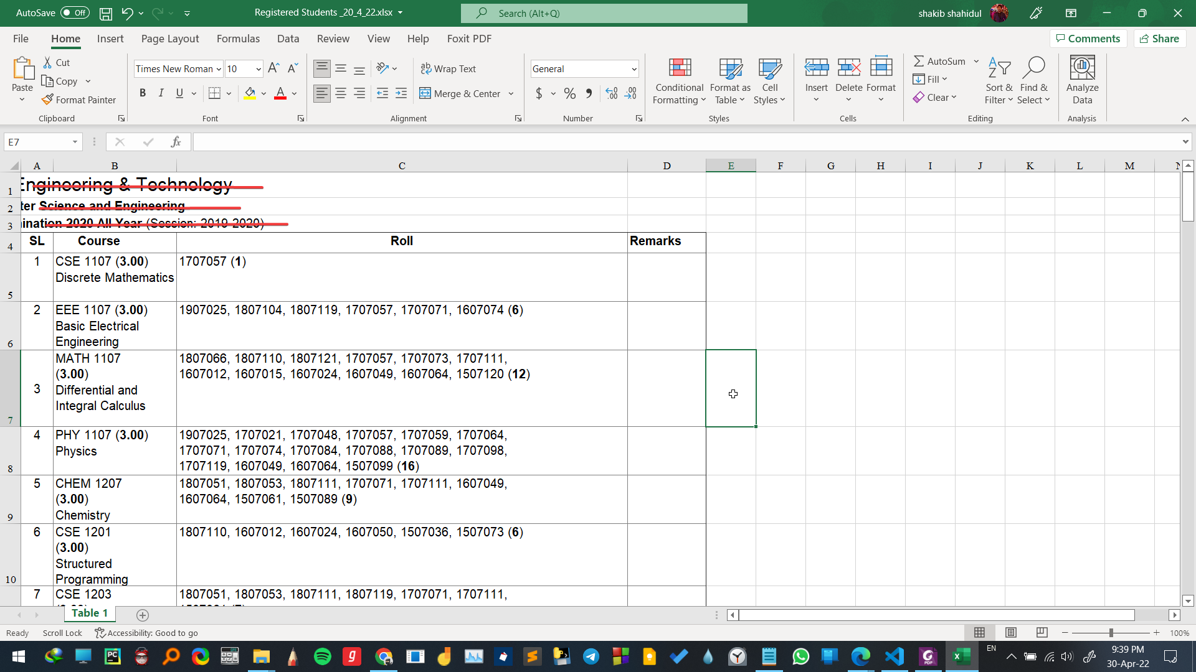

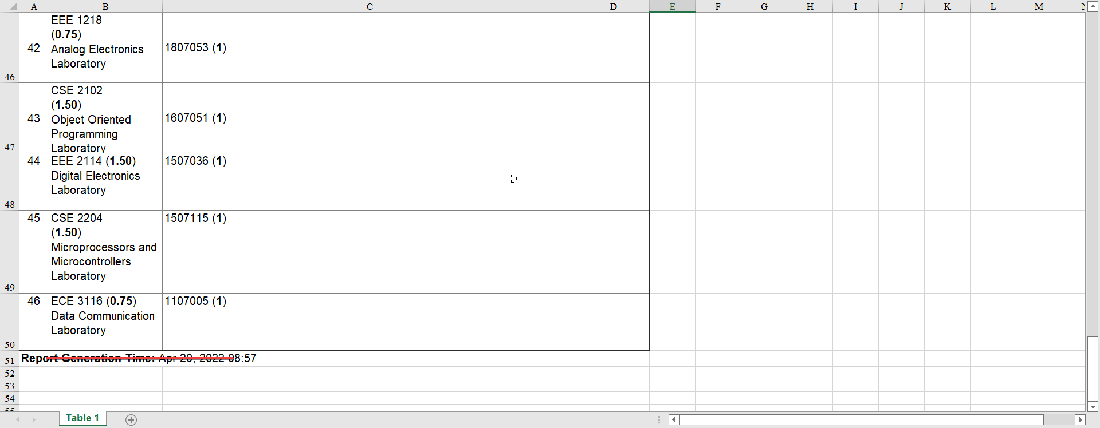

After deleting the row, the final excel file looks like this. See the demo below.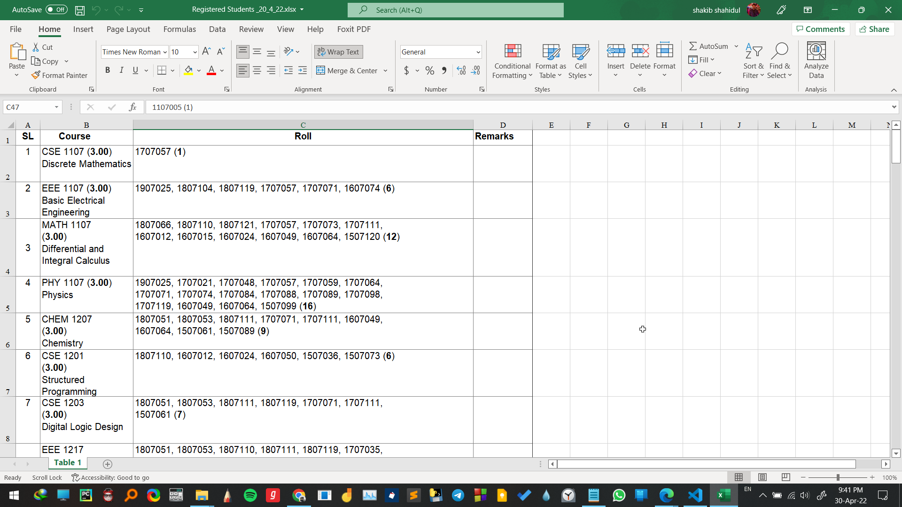

3) Then, Save the file as a “CSV” file format. Now, the file is ready for processing.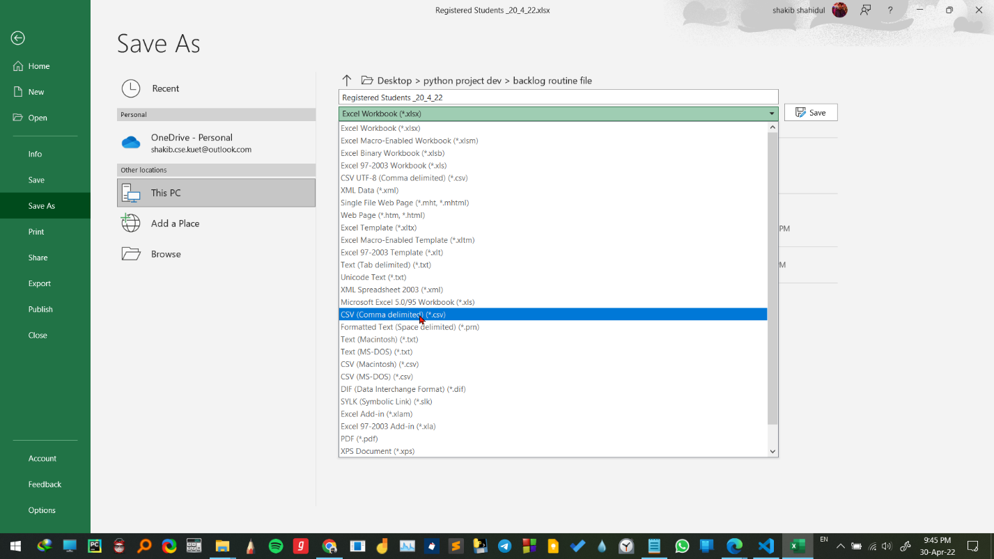

4) Finally, upload the file and click the submit button. It will generate the three files (course_info.csv, backlog_routine.txt, and student_info.csv). backlog_routine.txt is the backlog routine file and (course_info.csv, student_info.csv) are for cross-checking the routine (if they have any mistakes in the generated backlog routine)

You can click the Download backlog routine button for the download the routine.

🡺 If you face any problem or find any bugs. Please contact us.(Email: [shahidulshakib034@gmail.com](mailto:shahidulshakib034@gmail.com) Mobile No:01779866124)