**Assignment Module-15**

**Name: Md. Shahidul Islam**

**Course Name:** **PHP & Laravel Batch-1**

**User ID: 01834348932**

**Task 1: Request Validation**

Implement request validation for a registration form that contains the following fields: name, email, and password. Validate the following rules:

name: required, string, minimum length 2.

email: required, valid email format.

password: required, string, minimum length 8.

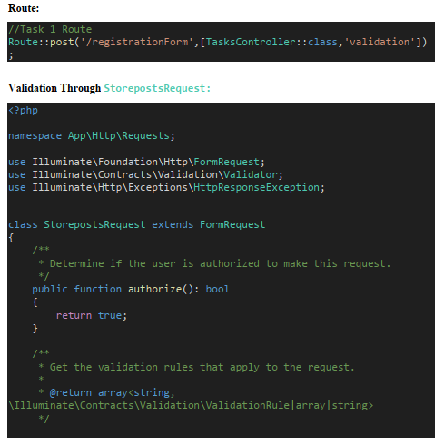

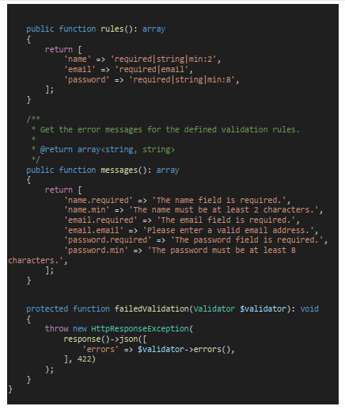

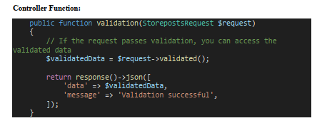

**Task 2: Request Redirect**

Create a route /home that redirects to /dashboard using a 302 redirect.

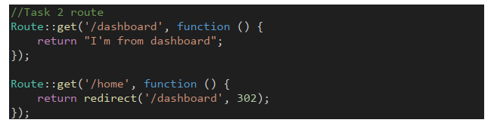

**Task 3: Global Middleware**

Create a global middleware that logs the request method and URL for every incoming request. Log the information to the Laravel log file.



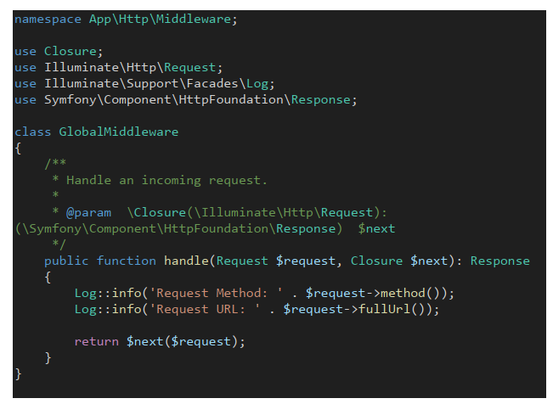

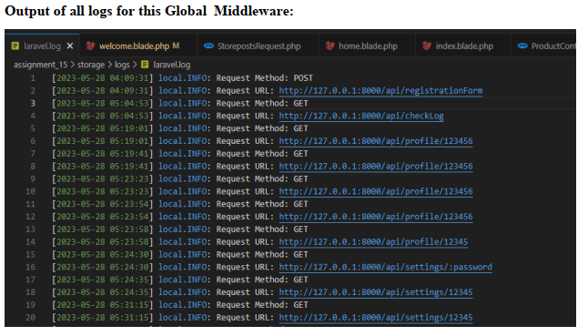

**Task 4: Route Middleware**

Create a route group for authenticated users only. This group should include routes for /profile and /settings. Apply a middleware called AuthMiddleware to the route group to ensure only authenticated users can access these routes.

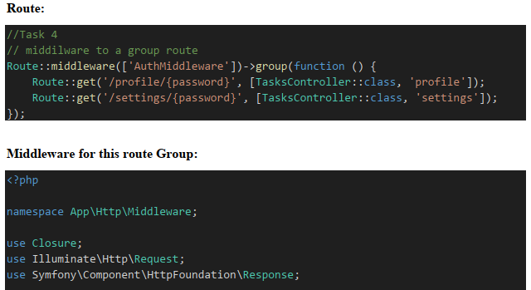

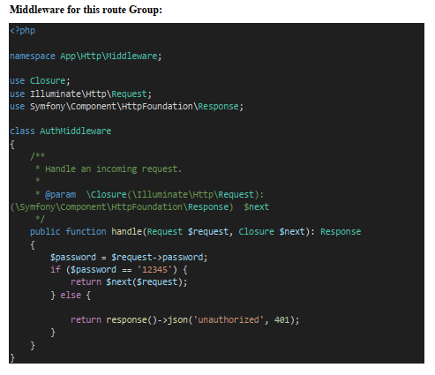

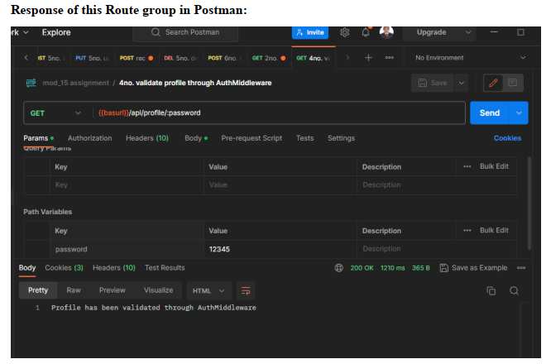

**Task 5: Controller**

Create a controller called ProductController that handles CRUD operations for a resource called Product. Implement the following methods:

index(): Display a list of all products.

create(): Display the form to create a new product.

store(): Store a newly created product.

edit($id): Display the form to edit an existing product.

update($id): Update the specified product.

destroy($id): Delete the specified product.

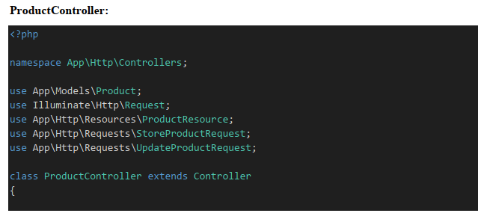

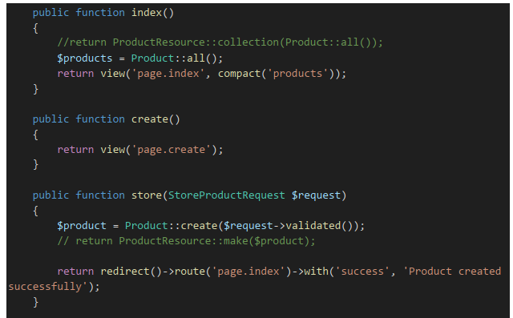

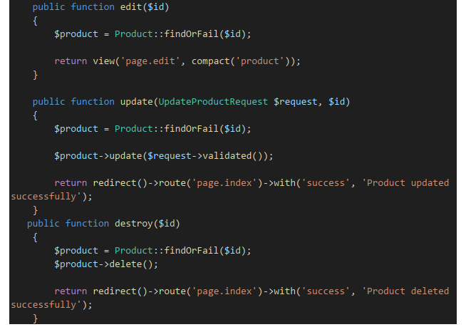



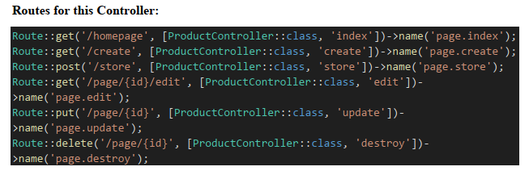

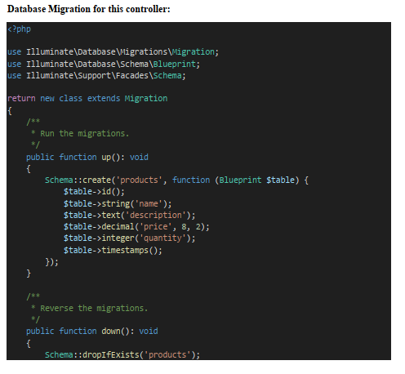

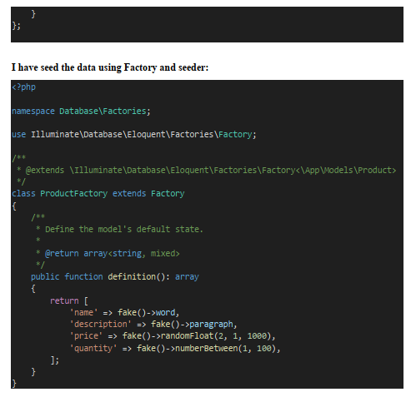

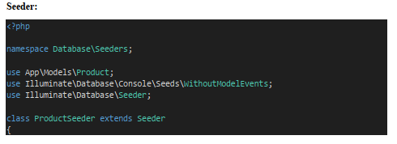

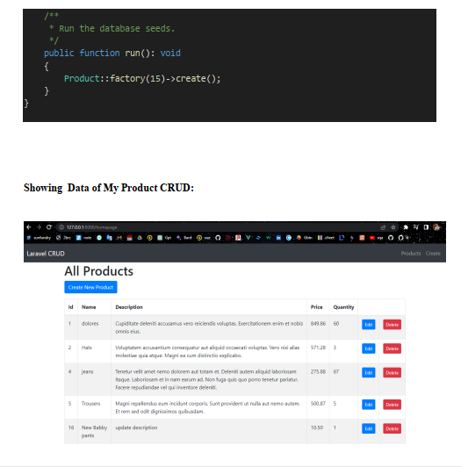



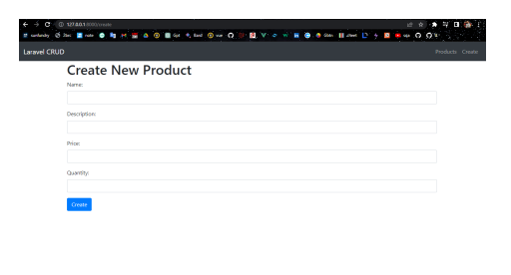

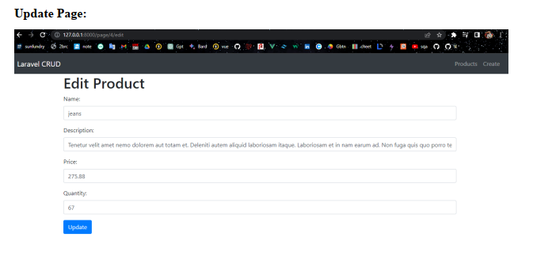

**Task 6: Single Action Controller**

Create a single action controller called ContactController that handles a contact form submission. Implement the __invoke() method to process the form submission and send an email to a predefined address with the submitted data.

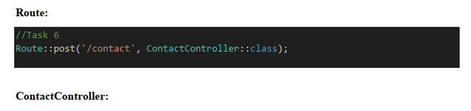

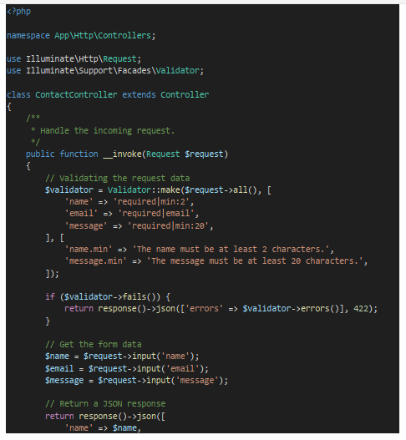

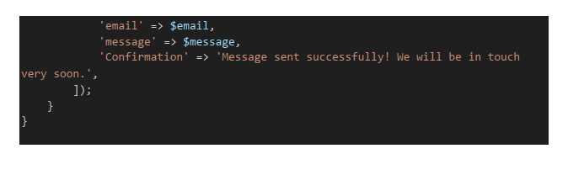

**Task 7: Resource Controller**

Create a resource controller called PostController that handles CRUD operations for a resource called Post. Ensure that the controller provides the necessary methods for the resourceful routing conventions in Laravel.

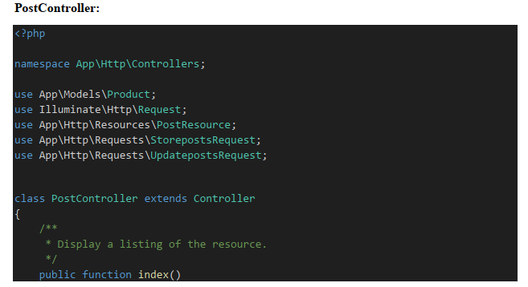

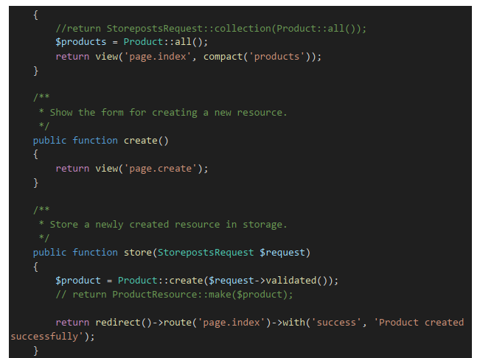

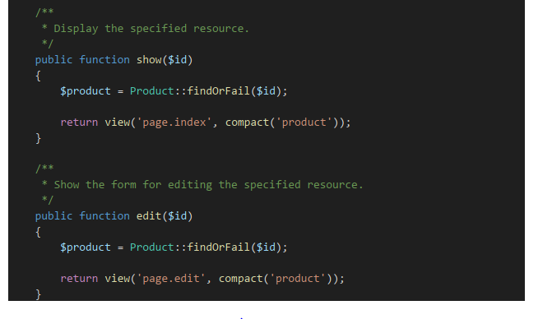

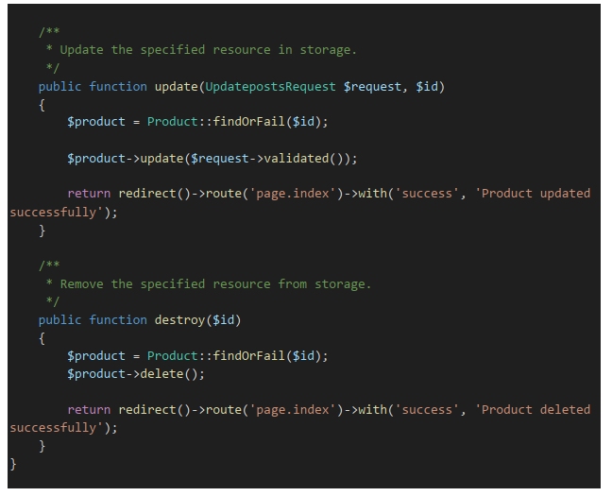

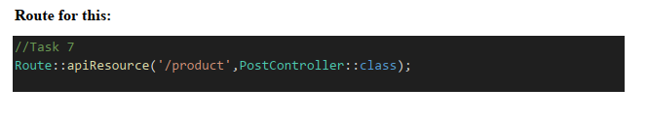

**Task 8: Blade Template Engine**

Create a Blade view called welcome.blade.php that includes a navigation bar and a section displaying the text "Welcome to Laravel!".

