PART A
1.Write a shell program to find the factorial of an number.
#!/bin/bash
echo "enter the n value:"
read n
fact=1
for((i=1;i<=$n;i++))
do
fact=$((fact*i))
done
echo "$n factorial is $fact"

outputs:
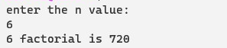
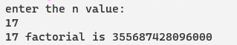

2.Write a shell program to find and display n Fibonacci numbers.
#!/bin/bash
echo "enter the number:"
read N
a=0
b=1
echo -e "fibonnaci series are:-"
for((i=0;i<N;i++))
do
echo "$a"
fn=$((a+b))
a=$b
b=$fn

done
outputs:

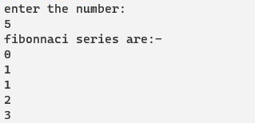

3. Write a shell program to accept n and find sum of the series 1!+2!+3!+…..+n!.
#!/bin/bash
echo "enter the number"
read n
sum=0
fact=1
for((i=1;i<=$n;i++))
do
fact=$((fact*i))
sum=$((sum+fact))
echo "$i factorial is $fact"
done
echo "sum of series up to $n factorial =$sum"

outputs:
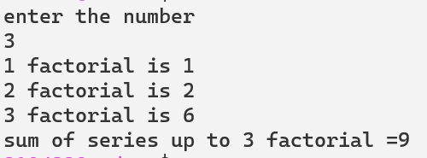
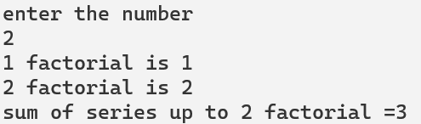

4.write a shell script to read a string, reverse it and check whether its palindrome or not.
#!/bin/bash
echo "enter the string "
read str
len=${#str}
for ((i=$len-1;i>=0;i--))
do
rev="$rev${str:$i:1}"
done
if [[ $str = $rev ]]
then
echo "palindrome"
else
echo "not palindrome"
fi
outputs:

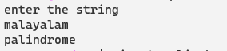

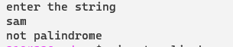

5. Write a shell program to find weather the entered number is prime or not.
#!/bin/bash
echo "enter the number"
read n
f=0
if [ $n -eq 1 ]
then
f=1
fi
for ((i=2;i<=$n/2;i++))
do
if [ $((n%i)) -eq 0 ]
then
f=1
fi
done
if [ $f -eq 1 ]
then
echo "$n is not prime no"
else
echo "$n is an prime"
fi
outputs:
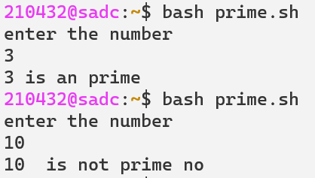
6. Write a shell program to display natural numbers between two integers and find their sum.
#!/bin/bash
echo "enter the lower limit"
read l
echo "enter the upper limit"
read u
echo "natural numbers b/w $l and $u are :"
sum=0
for((i=$l;i<=$u;i++))
do
echo "$i"
sum=$((sum+i))
done
echo "sum of natural numbers b/w $l and $u=$sum"
outputs:
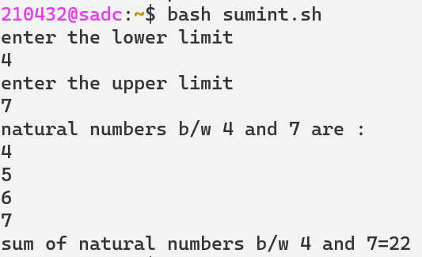
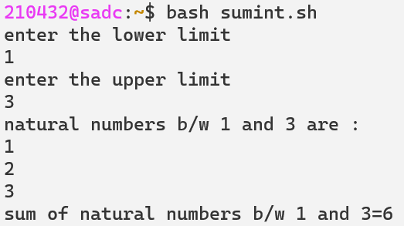

7. Write a shell program to find the largest among the set of integers.
#!/bin/bash
echo "enter the size"
read n
echo "entr the values"
for ((i=0;i<$n;i++))
do
read num
a[ i ]=$num
done
max=${a[0]}
for ((i=0;i<$n;i++))
do
if [ ${a[i]} -gt $max ]
then
max=${a[i]}
fi
done
echo "the largest no is $max"
outputs:
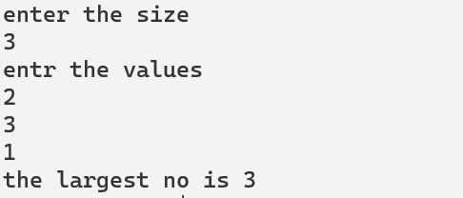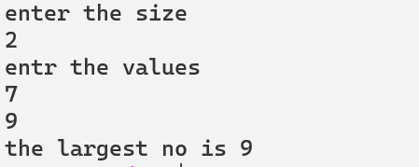

8.write a shell script to generate mark sheet of a student. take 3 subject, calculate and display total marks, percentage and class obtained by the student.

echo "student marksheet"
echo "****************"
echo "enter os mark"
read os
echo "enter c++ mark"
read cc
echo "enter java mark"
read java
echo "*****************"
total=$(($os+$cc+$java))
echo "Total marks = $total"
percent=$(($total/3))
echo "percent = $percent %"
if [ $percent -ge 60 ]
then
echo "class : First calss Distnction "
elif [ $percent -ge 50 ]
then
echo "class : First calss "
elif [ $percent -ge 40 ]
then
echo "class : Second calss "
else
echo "fail"
fi
outputs:
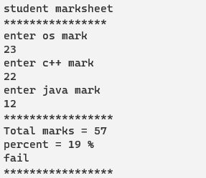
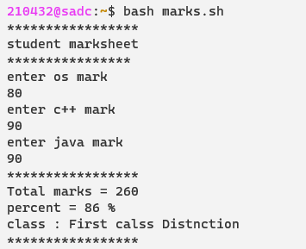

PART B
9. Write a shell program to accept an integer find the reverse and sum.also check for palindrome.
#!/bin/bash
echo "enter the number"
read number
rev=0
sum=0
orginal=$number
while [ $number -ne 0 ]
do
rem=$(( $number % 10))
rev=$(( $rev*10+$rem ))
number=$(( $number/10 ))
sum=$(( $sum+$rem ))
done
echo "$sum"
echo "$rev"
if [ $orginal -eq $rev ]
then
echo "palindrome"
else
echo "not an palindrome"
fi
outputs
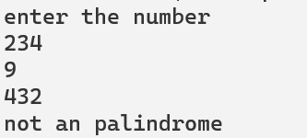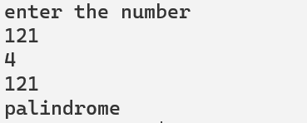

10.Write a shell program to perform arithmetic operations using case statements
#!/bin/bash
echo "enter two numbers"
read a b
i=1
while [ $i -gt 0 ]
do
echo -e " menu\n"
echo -e " 1.Addition\n 2.substraction\n 3.Multiplication\n 4.division\n 5.modulus\n 6.exit\n"
echo -e " enter your choice"
read ch
case $ch in
1)sum=0
sum=$((a+b))
echo "sum=$sum"
;;
2)diff=0
diff=$((a-b))
echo "diff=$diff"
;;
3)mul=0
mul=$((a*b))
echo "mul=$mul"
;;
4)div=0
div=$((a/b))
echo "div=$div"
;;
5)mod=0
mod=$((a%b))
echo "mod=$mod"
;;
6)break
;;
esac
done

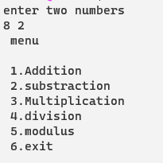
output:

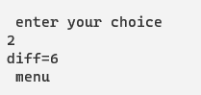
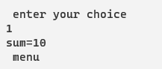

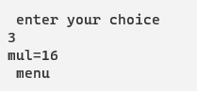
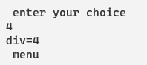

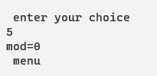

11.Write a shell program to accept n integer and count number of +ve,-ve and zeros.
Also find the sum of positive numbers and negative numbers.
#!/bin/bash
echo "enter the size"
read n
echo "enter the elements"
for ((i=0;i<n;i++))
do
read ele
num[i]=$ele
done
echo "elements ${num[*]}"
ps_count=0
ps_sum=0
ng_count=0
ng_sum=0
z_count=0
for ((i=0;i<n;i++))
do
if [ ${num[i]} -gt 0 ]
then
ps_count=$((ps_count+1))
ps_sum=$((ps_sum+${num[i]}))
elif [ ${num[i]} -lt 0 ]
then
ng_count=$((ng_count+1))
ng_sum=$((ng_sum+${num[i]}))
else
z_count=$((z_count+1))
fi
done
echo "count of positive number is = $ps_count"
echo "count of negative number is = $ng_count"
echo "count of zero is = $z_count"
echo "sum of positive numbers are= $ps_sum"
echo "sum of negative numbers are = $ng_sum"
outputs:

12.Write a shell program to accept many characters and count individual vowels, digits, space, special characters and consonants.

13.Write a shell program to accept a word and check whether it begins with lowercase vowel or uppercase vowel and with a digit or whether it is a 3 letter word.

14.write a shell program to accept student name and marks in 3 subjects through command line arguments and find the total marks and grade.
clear
echo "-------------------------"
echo "Today we gonna calculate 3 subject marks"
echo "-------------------------"
echo "Register NO : "$USER
echo -e "Date : \c"
date
echo "-------------------------"
echo ""
echo -e "Kannada mark : \c"
read sub1
echo -e "English mark : \c"
read sub2
echo -e "Hindi mark : \c"
read sub3
echo -e "Math mark : \c"
read sub4
echo -e "Social mark : \c"
read sub5
echo -e "Science mark : \c"
read sub6
grade=""
remarks=""
total=$((sub1+sub2+sub3+sub4+sub5+sub6))
per=$((total*100))
per=$((per/600))
if [[ $per -le 30 ]]
then
grade="FAIL"
remarks="Better Search for job then !>>>"
elif [[ $per -gt 90 ]]
then
grade="A+"
remarks="Better focus on your social life litte"
elif [[ $per -gt 80 && $per -le 90 ]]
then
grade="A"
remarks="A for apple,get ready for the afterlife"
elif [[ $per -gt 70 && $per -le 80 ]]
then
grade="B+"
remarks="Same like nathoor road, useless"
elif [[ $per -gt 60 && $per -le 70 ]]
then
grade="B"
remarks="waste fellow, Go study man!! group study itseems"
elif [[ $per -gt 50 && $per -le 60 ]]
then
grade="C+"
remarks="'HAHAH' last night study didnt workout"
elif [[ $per -gt 30 && $per -le 50 ]]
then
grade="C"
remarks="C yea??, See your face !HAHAH"
fi
echo "-------------------------"
echo " MARKSHEET"
echo "-------------------------"
echo "Grade : $grade"
echo "total : $total / 600"
echo "percentage : $per"
echo "-------------------------"
echo "$remarks"
echo ""
outputs:
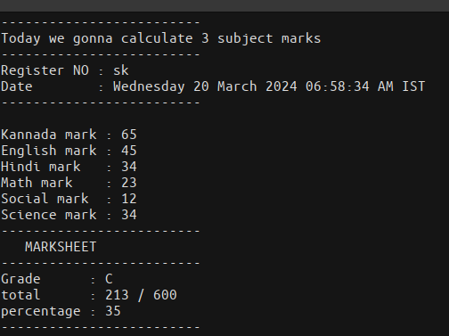
8.vowels.
clear
echo ""
echo -e "Enter A character : \c"
read ch

if [[ $ch == [A-Z] ]]
then
ty='UPPER_CASE'
elif [[ $ch == [a-z] ]]
then
ty='LOWER_CASE'
elif [[ $ch == [0-9] ]]
then
ty="DIGIT"
fi

if [[ $ch == [1234567890] ]]
then
v='NUMERIC'
elif [[ $ch == [AEIOUaeiou] ]]
then
v='VOWEL'
else
v='CONSTANT'
fi

echo ""
echo "------------------------------"
echo "TYPE : $ty ($v)"
echo "------------------------------"
echo ""
outputs:
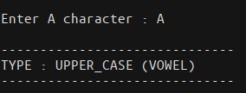
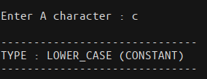

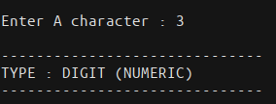

Part - C
13.Write a menu driven program to do the following
1 ) Display the stored content of file.
2 ) Dispaly the current date and time .
3 ) Display the files in the current directory.
4 ) Exit.

clear
echo ""
echo "MENU"
echo " 1. Display the stored content"
echo " 2. Dispaly the current date and time"
echo " 3. Dispaly the file in current directory"
echo " 4. Exit"
while [ true ]
do
echo ""
echo -e "Enter your choice : \c"
read ch
case $ch in
1)
echo -e "Enter the filename : \c"
read fname
if [ -f $fname ]
then
echo "----CONETENT START----"
echo ""
cat $fname
echo ""
echo "----CONETENT ENDS-----"
else
echo ""
echo "FILE DOES NOT EXISTS"
fi
;;
2) echo -e "((Current date and time)) : \c"
date
;;
3) echo "Listing files in Current Directory"
ls
;;
*)exit
;;
esac
done
outputs:

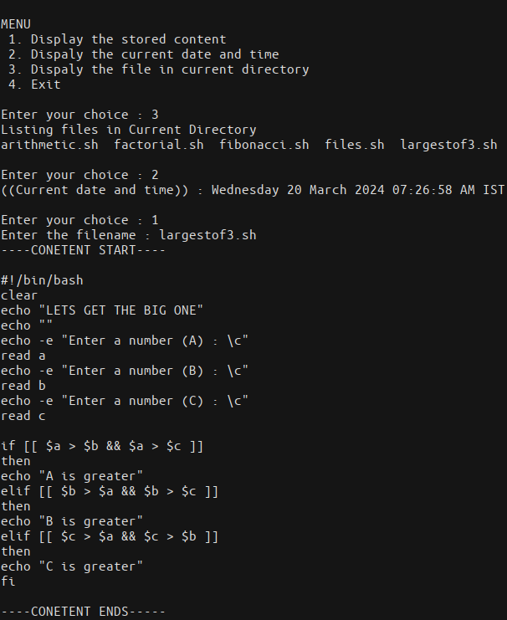

14.Write a menu driven program to do the following
1 ) Renaming a file.
2 ) Dispalying the current working directory .
3 ) List the users logged in.
4)Append the contents of a file to another file.

Clear
echo "Menu"
echo "1.Renaming a file"
echo "2.Display a current working directory"
echo "3.list the user login"
echo "4.append the content of a file in to another file"
echo "5.exit"
while [ true ]
do
echo ""
echo -e "Enter your choice : \c"
read ch
case $ch in
1)
echo "enter file name"
read fname
echo "enter dest name"
read dname
if [ -f $fname ]
then
cat $fname
else
echo "file doesnot exsist"
fi
echo "renameing a file name"
mv $fname $dname
cat $dname
;;
2)echo "display the current working directory"
pwd
;;
3)echo "list the users logged in"
who -u
;;
4) echo "enter fname"
read fname
echo "enter dname"
read dname
echo "append the content of a file o another file"
cat $fname $dname
;;
*)break
;;
esac
done

outputs:
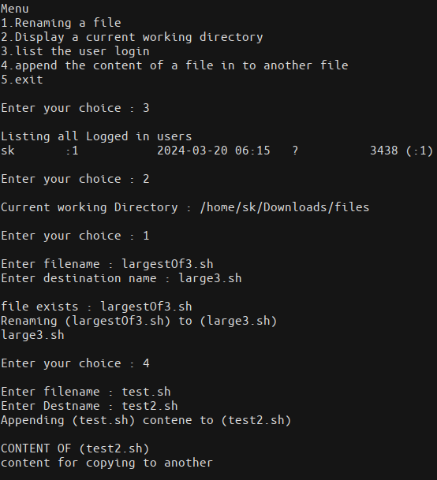
15.Write a menu driven program to do the following
1 ) Display the total no.of words,lines and charecter in a file.
2 ) List the directory having all the permissions.
3 ) Copy the content of one file to another file.
4)Delete specific file.

16.Write a shell script that receives any no.of files or directories as commandline argument.
1)If the input is afile display the no.of lines in the file.
2) If the input is a directory display the files in the directories.

