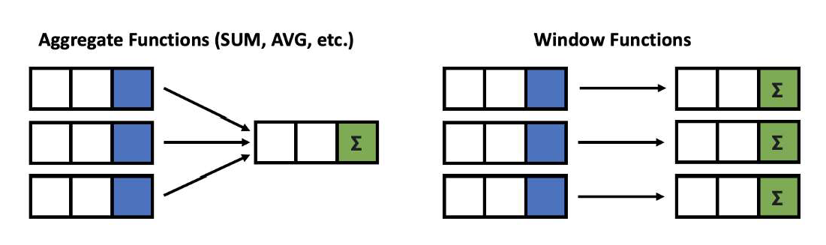

**Window functions** applies aggregate, ranking and analytic functions over a particular window (set of rows).

And **OVER** clause is used with window functions to define that window.

Give output one row per aggregation The rows maintain their separate identities

80



|  |  |  |
| --- | --- | --- |
| **fun**( ) |  | **OVER** |









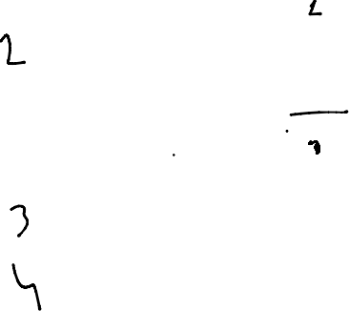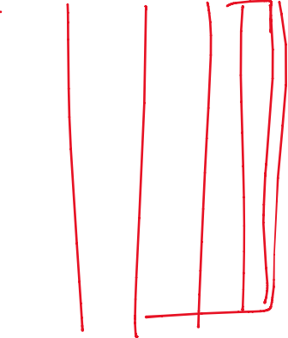

**Select a function** Aggregate functions Ranking functions Analytic functions

SELECT column_name(s),

**(** [ <PARTITION BY Clause> ] [ <ORDER BY Clause> ]

[ <ROW or RANGE Clause> ] **)**

FROM table_name

**Define a Window** PARTITION BY ORDER BY ROWS





81







**Window function** applies aggregate, ranking and analytic functions over a particular window; for example, sum, avg, or row_number

**Expression** is the name of the column that we want the window function operated on. This may not be necessary depending on what window function is used

**OVER** is just to signify that this is a window function

**PARTITION BY** divides the rows into partitions so we can specify which rows to use to compute the window function

**ORDER BY** is used so that we can order the rows within each partition. This is optional and does not have to be specified

**ROWS** can be used if we want to further limit the rows within our partition. This is optional and usually not used

82



There is no official division of the SQL window functions into categories but high level we can divide into three types

**Value/Analytic**

LEAD LAG

FIRST_VALUE

LAST_VALUE

**Ranking**

ROW_NUMBER RANK DENSE_RANK PERCENT_RANK

**Aggregate**

SUM AVG COUNT MIN MAX

**Window Functions**

83

**SELECT** new_id, new_cat,

**AGGREGATE FUNCTION**

**Example**

**SUM**(new_id) **OVER**( PARTITION BY new_cat ORDER BY new_id ) AS "Total", **AVG**(new_id) **OVER**( PARTITION BY new_cat ORDER BY new_id ) AS "Average", **COUNT**(new_id) **OVER**( PARTITION BY new_cat ORDER BY new_id ) AS "Count", **MIN**(new_id) **OVER**( PARTITION BY new_cat ORDER BY new_id ) AS "Min", **MAX**(new_id) **OVER**( PARTITION BY new_cat ORDER BY new_id ) AS "Max" **FROM** test_data

|  |  |  |  |  |  |  |
| --- | --- | --- | --- | --- | --- | --- |
| **new_id** | **new_cat** | **Total** | **Average** | **Count** | **Min** | **Max** |
| 100 | Agni | 300 | 150 | 2 | 100 | 200 |
| 200 | Agni | 300 | 150 | 2 | 100 | 200 |
| 500 | Dharti | 1200 | 600 | 2 | 500 | 700 |
| 700 | Dharti | 1200 | 600 | 2 | 500 | 700 |
| 200 | Vayu | 1000 | 333.33333 | 3 | 200 | 500 |
| 300 | Vayu | 1000 | 333.33333 | 3 | 200 | 500 |
| 500 | Vayu | 1000 | 333.33333 | 3 | 200 | 500 |

84

**SELECT** new_id, new_cat,

**SUM**(new_id) **OVER**( ORDER BY new_id ROWS BETWEEN UNBOUNDED PRECEDING AND UNBOUNDED FOLLOWING) AS "Total", **AVG**(new_id) **OVER**( ORDER BY new_id ROWS BETWEEN UNBOUNDED PRECEDING AND UNBOUNDED FOLLOWING) AS "Average", **COUNT**(new_id) **OVER**( ORDER BY new_id ROWS BETWEEN UNBOUNDED PRECEDING AND UNBOUNDED FOLLOWING) AS "Count", **MIN**(new_id) **OVER**( ORDER BY new_id ROWS BETWEEN UNBOUNDED PRECEDING AND UNBOUNDED FOLLOWING) AS "Min", **MAX**(new_id) **OVER**( ORDER BY new_id ROWS BETWEEN UNBOUNDED PRECEDING AND UNBOUNDED FOLLOWING) AS "Max"

**FROM** test_data

|  |  |  |  |  |  |  |
| --- | --- | --- | --- | --- | --- | --- |
| **new_id** | **new_cat** | **Total** | **Average** | **Count** | **Min** | **Max** |
| 100 | Agni | 2500 | 357.14286 | 7 | 100 | 700 |
| 200 | Agni | 2500 | 357.14286 | 7 | 100 | 700 |
| 200 | Vayu | 2500 | 357.14286 | 7 | 100 | 700 |
| 300 | Vayu | 2500 | 357.14286 | 7 | 100 | 700 |
| 500 | Vayu | 2500 | 357.14286 | 7 | 100 | 700 |
| 500 | Dharti | 2500 | 357.14286 | 7 | 100 | 700 |
| 700 | Dharti | 2500 | 357.14286 | 7 | 100 | 700 |

**AGGREGATE FUNCTION**

**Example**

85



**NOTE**: Above we have used **ROWS**

which will give a SINGLE output based on all INPUT Vaused)

SELECT new_id,

**RANKING FUNCTION**

**Example**

ROW_NUMBER() OVER(ORDER BY new_id) AS "ROW_NUMBER", RANK() OVER(ORDER BY new_id) AS "RANK",

DENSE_RANK() OVER(ORDER BY new_id) AS "DENSE_RANK", PERCENT_RANK() OVER(ORDER BY new_id) AS "PERCENT_RANK"

FROM test_data

|  |  |  |  |  |
| --- | --- | --- | --- | --- |
| **new_id** | **ROW_NUMBER** | **RANK** | **DENSE_RANK** | **PERCENT_RANK** |
| 100 | 1 | 1 | 1 | 0 |
| 200 | 2 | 2 | 2 | 0.166 |
| 200 | 3 | 2 | 2 | 0.166 |
| 300 | 4 | 4 | 3 | 0.5 |
| 500 | 5 | 5 | 4 | 0.666 |
| 500 | 6 | 5 | 4 | 0.666 |
| 700 | 7 | 7 | 5 | 1 |

86

**SELECT** new_id,

**ANALYTIC FUNCTION**

**Example**

**FIRST_VALUE**(new_id) **OVER**( ORDER BY new_id) AS "FIRST_VALUE", **LAST_VALUE**(new_id) **OVER**( ORDER BY new_id) AS "LAST_VALUE", **LEAD**(new_id) **OVER**( ORDER BY new_id) AS "LEAD",

**LAG**(new_id) **OVER**( ORDER BY new_id) AS "LAG"

**FROM** test_data

|  |  |  |  |  |
| --- | --- | --- | --- | --- |
| **new_id** | **FIRST_VALUE** | **LAST_VALUE** | **LEAD** | **LAG** |
| 100 | 100 | 100 | 200 | null |
| 200 | 100 | 200 | 200 | 100 |
| 200 | 100 | 200 | 300 | 200 |
| 300 | 100 | 300 | 500 | 200 |
| 500 | 100 | 500 | 500 | 300 |
| 500 | 100 | 500 | 700 | 500 |
| 700 | 100 | 700 | null | 500 |

87



**NOTE**: If you just want the single last value from whole column, use **ROWS** BETWEEN



**Offset the LEAD and LAG values by 2 in the output columns ?**

|  |  |  |  |  |  |
| --- | --- | --- | --- | --- | --- |
| **INPUT** |  |  | **OUTPUT** |  |  |
|  |  |  |  |  |  |
| **new_id** |  | **new_id** | **LEAD** | **LAG** |  |
| 100 |  | 100 | 200 | NULL |  |
| 200 |  | 200 | 300 | NULL |  |
| 200 |  | 200 | 500 | 100 |  |
| 300 |  | 300 | 500 | 200 |  |
| 500 |  | 500 | 700 | 200 |  |
| 500 |  | 500 | NULL | 300 |  |
| 700 |  | 700 | NULL | 500 |  |
|  |  |  |  |  | 88 |

**SELECT** new_id,

**ANALYTIC FUNCTION**

**Assignment**

**LEAD**(new_id**, 2**) **OVER**( ORDER BY new_id) AS "LEAD_by2", **LAG**(new_id**, 2**) **OVER**( ORDER BY new_id) AS "LAG_by2" **FROM** test_data

|  |  |  |
| --- | --- | --- |
| **new_id** | **LEAD_by2** | **LAG_by2** |
| 100 | 200 | null |
| 200 | 300 | null |
| 200 | 500 | 100 |
| 300 | 500 | 200 |
| 500 | 700 | 200 |
| 500 | null | 300 |
| 700 | null | 500 |