**SUPERSTORE SALES**

**KPI - total sales ,total profit, sales and profit in % total product count**

**pie chart segment wise slaes**

**sales and profit trend line order date**

**colmn chart category sales**

**top 5 product based on profit**

**table : customerid, total sales ,salesin %**

**slicer: region, ship mode, category**

**map sales state**

**Project: 1** Project - In United States, there are many stores in which a survey was conducted based on students i.e. how much they are spending on different kind of purchases like Video games, Indoor games, Toys, Books, Gadgets etc. In the data set (Student Survey), Store setting is the column that explains the Type of location in which the store is present. By using data set (Student Survey), try to extract the meaningful Insights.

**Industry Type** – Retail Store

**Data set** - Student survey <https://docs.google.com/spreadsheets/d/19PAZIJ7T2pvf50t94_R5tZCiog_aaP24/edit?usp=sharing&ouid=113177982973203432452&rtpof=true&sd=true>

**Problem Statement-** Create a Power BI Report: 1. Tabular Visualization - Format the total amount of purchase (TAP) based on ‘Store location’ and ‘Store setting’: -

* If 0<TAP<35000, then records should be in red color •
* If 35000<=TAP<60000, then records should be in yellow color
* If TAP>=60000, then records should be in Blue color

**2 Matrix Visualization –** Create Matrix Visualization to show the amount spent on Outdoor sports across different ages and ‘Store setting’. Do the color formatting for the amount spent in total outdoor sports.

**3. Funnel chart –** Create a Funnel chart to show Total amount of purchase by ‘Store setting’. Show the data labels as Percentage of First.

**4. Pie chart –** Show the total amount of purchase by different ‘Store location’ for Suburban ‘Store setting’ only. Hint: Use Filter context

**5. a) Scatter plot -** Video games purchase and Outdoor sports spent across the different ages. **b) any plot** - Indoor sports and Video games spent across the different age groups.

**6.** Restrict data access for the given users in User mapping table. **For ex**. Mani deals with Rural area only so she should be able to view the data which belongs to Rural only, not urban and suburban data.

**7.** Publish the report on Power BI cloud service and Design the Master Dashboard consisting of Funnel chart and scatter plots. Then create a schedule refresh for six times in every 4 hours for the Dashboard in a day.

**8. Use Q&A feature** of Power BI –

**a)** To show average age of students

**b)** Donut chart for total amount of purchases by ‘Store location

CALCULATE TABLE,RANKx,SELECTEDVALUE,SUMMERIZE,TOPN

IF and Switch in DAX

totsales

avg sales

profit

count

**chart**

line monthly trends

column chart cateogry wise

map state wise sales

pie region wise profit

table sub categores wies sales , profit ,profit %

**fillter**

segemt

city

ship mode

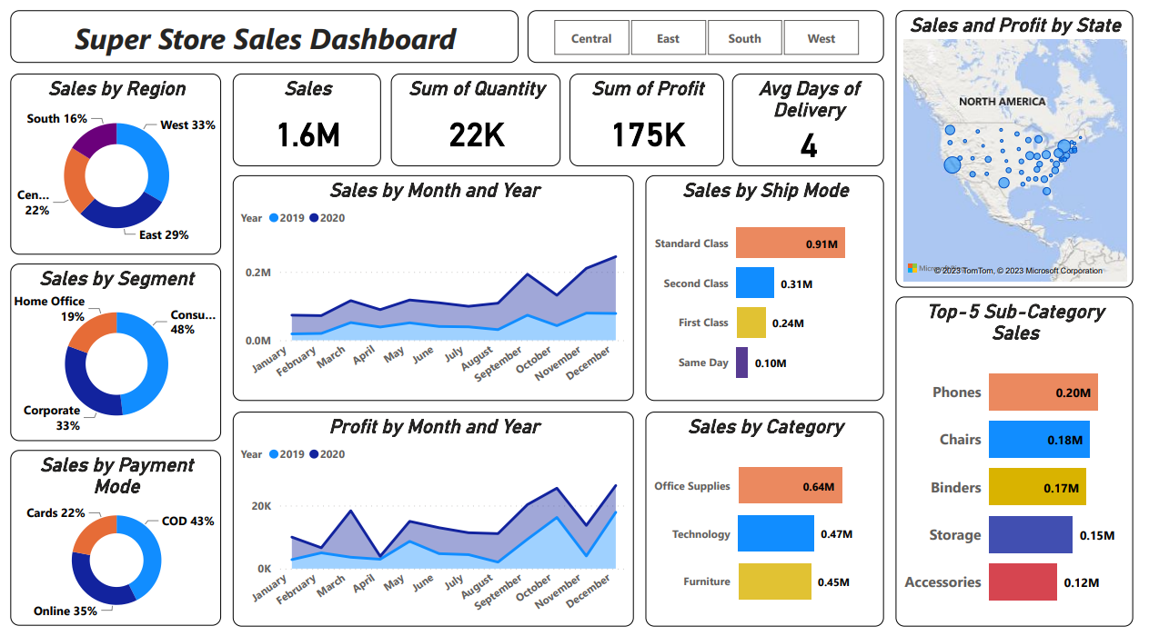

<https://mavenanalytics.io/project/9002>



https://www.pexels.com/search/gradient%20background/

<https://metricalist.com/powerbi-solutions/global-superstore-dashboard/>

