<https://github.com/jvns/pandas-cookbook>

<https://www.webpages.uidaho.edu/~stevel/504/pandas%20dataframe%20notes.pdf>

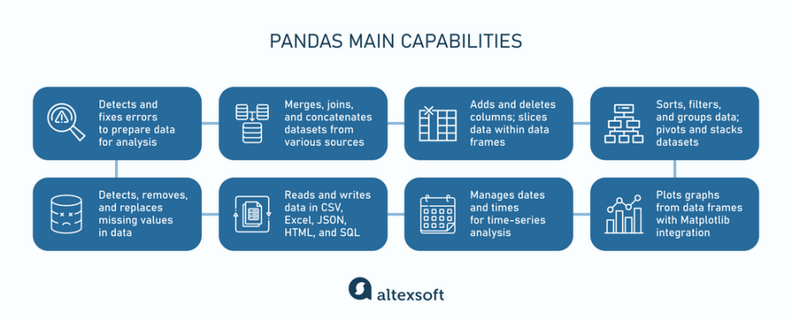

<https://www.devopsschool.com/blog/what-is-pandas-and-use-cases-of-pandas/>

<https://www.altexsoft.com/blog/time-series-analysis-and-forecasting-novel-business-perspectives/>