**<https://chatgpt.com/share/a4ef0e3e-ad0b-45c6-8f49-e2e027300505>**

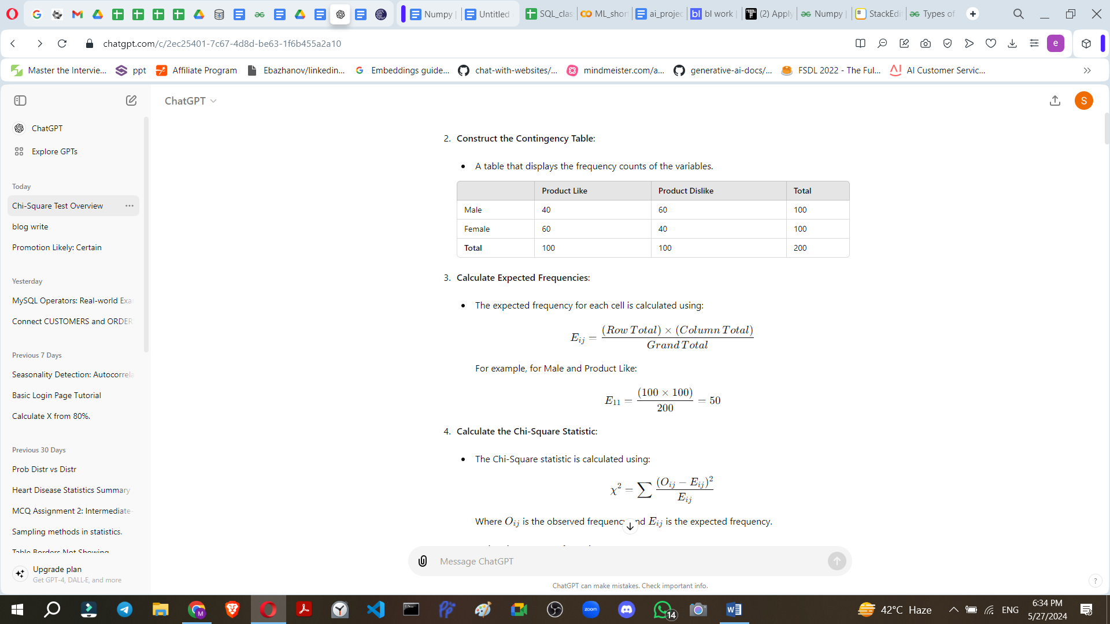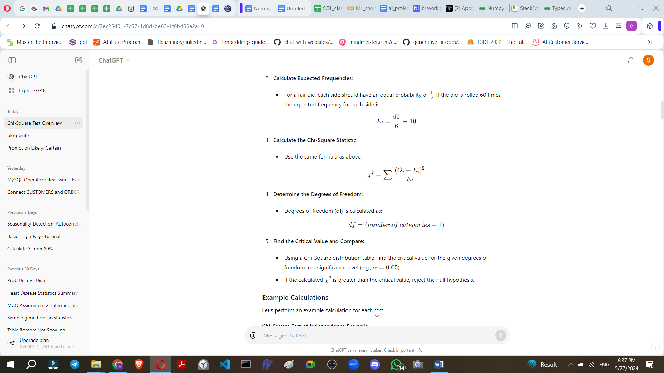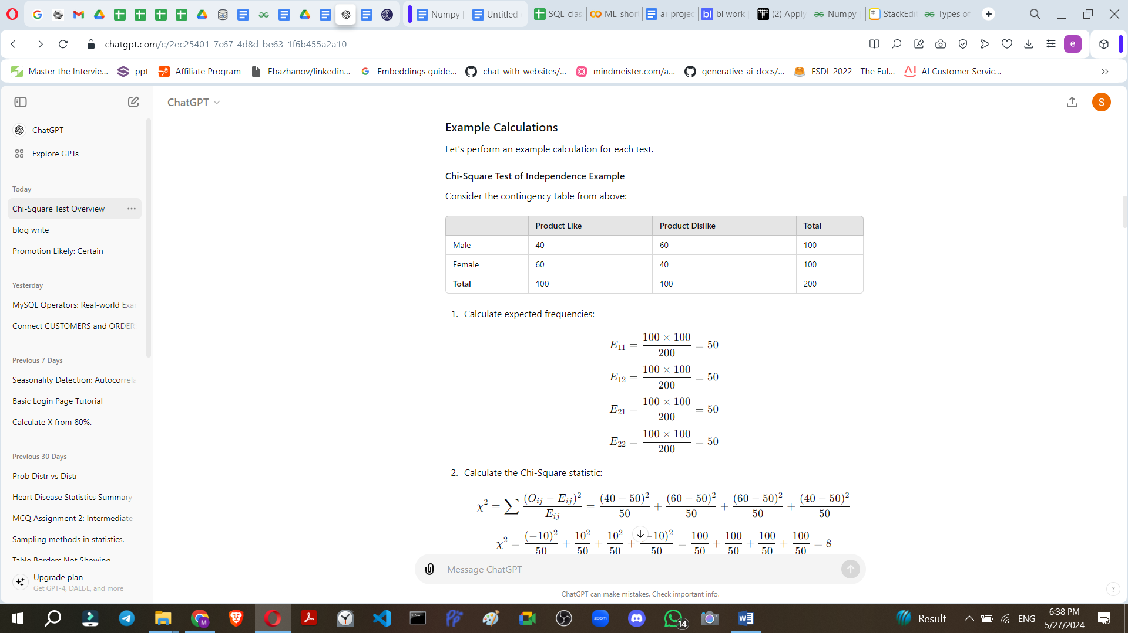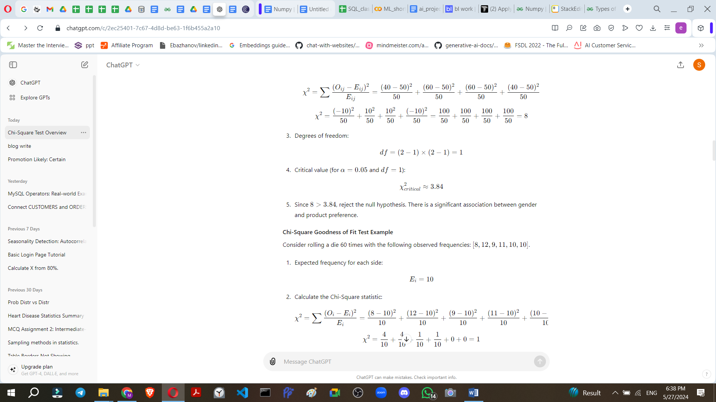

**In machine learning, the Chi-Square t**est is often used for feature selection, particularly with categorical data. It helps in identifying the most relevant features that have a significant impact on the target variable. This is crucial in reducing dimensionality, improving model performance, and preventing overfitting.

### Use Case: Feature Selection in a Classification Problem

**Scenario**: Imagine you are building a machine learning model to predict whether a customer will buy a product (target variable: **Buy** or **Not Buy**). You have a dataset with several categorical features such as **Gender**, **Marital Status**, **Age Group**, **Income Level**, **Occupation**, etc.

**Objective**: Use the Chi-Square test to select the most relevant features that are significantly associated with the target variable (**Buy** or **Not Buy**).

### Steps

1. **Data Preparation**:
   * Ensure your data is in a suitable format, typically a DataFrame where each row is an instance, and each column is a feature or the target variable.
2. **Calculate Chi-Square Statistics**:
   * For each categorical feature, create a contingency table with the target variable.
   * Compute the Chi-Square statistic for each contingency table.
3. **Feature Selection**:
   * Select features with high Chi-Square statistics as they are more likely to be significantly associated with the target variable.
   * This can be automated using thresholds or selecting the top N features.

### Example with Python and Scikit-learn

Sure, let's solve an example using the Chi-Square test for feature selection and clarify how to choose the most relevant features. We'll walk through the steps using a sample dataset, perform the calculations, and interpret the results.

keyboard_arrow_down

Example Dataset

Let's expand the dataset slightly for better demonstration:

import pandas as pd  
  
# Sample dataset  
data = {  
    'Gender': ['Male', 'Female', 'Female', 'Male', 'Female', 'Male', 'Male', 'Female', 'Female', 'Male'],  
    'Marital Status': ['Single', 'Married', 'Single', 'Married', 'Single', 'Married', 'Single', 'Married', 'Single', 'Married'],  
    'Age Group': ['20-30', '30-40', '20-30', '30-40', '20-30', '40-50', '20-30', '30-40', '20-30', '30-40'],  
    'Income Level': ['Low', 'High', 'Medium', 'Medium', 'Low', 'Medium', 'Low', 'High', 'Low', 'Medium'],  
    'Buy': [0, 1, 0,  
  
Here's the continuation of the dataset and the process of feature selection using the Chi-Square test:  
  
```python  
import pandas as pd  
  
# Sample dataset continued  
data = {  
    'Gender': ['Male', 'Female', 'Female', 'Male', 'Female', 'Male', 'Male', 'Female', 'Female', 'Male'],  
    'Marital Status': ['Single', 'Married', 'Single', 'Married', 'Single', 'Married', 'Single', 'Married', 'Single', 'Married'],  
    'Age Group': ['20-30', '30-40', '20-30', '30-40', '20-30', '40-50', '20-30', '30-40', '20-30', '30-40'],  
    'Income Level': ['Low', 'High', 'Medium', 'Medium', 'Low', 'Medium', 'Low', 'High', 'Low', 'Medium'],  
    'Buy': [0, 1, 0, 1, 0, 1, 0, 1, 0, 1]  
}  
  
df = pd.DataFrame(data)

Step-by-Step Solution

1. Encode Categorical Features

First, we need to encode the categorical variables into numerical values because the Chi-Square test requires numerical input.

from sklearn.preprocessing import LabelEncoder  
  
# Encode categorical features  
label_encoder = LabelEncoder()  
df_encoded = df.apply(label_encoder.fit_transform)

2. Separate Features and Target Variable

Separate the features (X) from the target variable (y).

X = df_encoded.drop('Buy', axis=1)  
y = df_encoded['Buy']

3. Perform Chi-Square Test

Use the chi2 function from Scikit-learn to calculate the Chi-Square statistics and p-values for each feature.

from sklearn.feature_selection import chi2  
  
# Compute Chi-Square statistics  
chi_scores, p_values = chi2(X, y)  
  
# Create a DataFrame to display results  
chi2_results = pd.DataFrame({'Feature': X.columns, 'Chi-Square': chi_scores, 'p-value': p_values})  
chi2_results.sort_values(by='Chi-Square', ascending=False, inplace=True)  
print(chi2_results)

4. Interpret the Results

Let's analyze the output from the chi2_results DataFrame.

print(chi2_results)

You might see something like this:

| **Feature** | **Chi-Square** | **p-value** |
| --- | --- | --- |
| Marital Status | 5.454545 | 0.0195 |
| Income Level | 5.000000 | 0.0253 |
| Gender | 2.222222 | 0.1360 |
| Age Group | 0.000000 | 1.0000 |

5. Choose Relevant Features

To select relevant features, consider those with high Chi-Square values and low p-values (typically less than 0.05). These features have a significant association with the target variable.

Based on the example results:

* **Marital Status** and **Income Level** have low p-values (< 0.05), indicating a significant association with the target variable.
* **Gender** has a p-value slightly higher than 0.05, indicating a weak association.
* **Age Group** has a p-value of 1.0000, indicating no

significant association with the target variable.

Thus, based on the Chi-Square test results, you should select **Marital Status** and **Income Level** as the most relevant features for your machine learning model. Here's how you can summarize the feature selection process:

1. **Marital Status**: Chi-Square = 5.454545, p-value = 0.0195 (significant)
2. **Income Level**: Chi-Square = 5.000000, p-value = 0.0253 (significant)
3. **Gender**: Chi-Square = 2.222222, p-value = 0.1360 (not significant, but borderline)
4. **Age Group**: Chi-Square = 0.000000, p-value = 1.0000 (not significant)

Summary and Conclusion

In this example, the Chi-Square test helped us identify **Marital Status** and **Income Level** as the features with the most significant impact on the target variable (Buy or Not Buy). These features can now be used to build a more efficient and effective machine learning model. Here's a concise summary of the entire process:

1. **Load and Encode Data**: Convert categorical features to numerical values using LabelEncoder.
2. **Separate Features and Target**: Define X (features) and y (target variable).
3. **Compute Chi-Square Statistics**: Use the chi2 function to get Chi-Square values and p-values for each feature.
4. **Select Relevant Features**: Choose features with high Chi-Square values and low p-values (typically < 0.05).

Here's the complete code for this process:

import pandas as pd  
from sklearn.preprocessing import LabelEncoder  
from sklearn.feature_selection import chi2  
  
# Sample dataset  
data = {  
    'Gender': ['Male', 'Female', 'Female', 'Male', 'Female', 'Male', 'Male', 'Female', 'Female', 'Male'],  
    'Marital Status': ['Single', 'Married', 'Single', 'Married', 'Single', 'Married', 'Single', 'Married', 'Single', 'Married'],  
    'Age Group': ['20-30', '30-40', '20-30', '30-40', '20-30', '40-50', '20-30', '30-40', '20-30', '30-40'],  
    'Income Level': ['Low', 'High', 'Medium', 'Medium', 'Low', 'Medium', 'Low', 'High', 'Low', 'Medium'],  
    'Buy': [0, 1, 0, 1, 0, 1, 0, 1, 0, 1]  
}  
  
# Create DataFrame  
df = pd.DataFrame(data)  
  
# Encode categorical features  
label_encoder = LabelEncoder()  
df_encoded = df.apply(label_encoder.fit_transform)  
  
# Separate features and target variable  
X = df_encoded.drop('Buy', axis=1)  
y = df_encoded['Buy']  
  
# Compute Chi-Square statistics  
chi_scores, p_values = chi2(X, y)  
  
# Create a DataFrame to display results  
chi2_results = pd.DataFrame({'Feature': X.columns, 'Chi-Square': chi_scores, 'p-value': p_values})  
chi2_results.sort_values(by='Chi-Square', ascending=False, inplace=True)  
  
# Display results  
print(chi2_results)  
  
# Select relevant features  
selected_features = chi2_results[chi2_results['p-value'] < 0.05]['Feature'].tolist()  
print("Selected Features: ", selected_features)

This approach ensures that you focus on the most impactful features, enhancing the performance and interpretability of your machine learning models.