<https://theanalyticsgeek.com/central-limit-theorem/>

<https://onlinestatbook.com/2/index.html>

<https://www.youtube.com/watch?v=2QcVJHVrcH0>

**The Normal Distribution**

One of the most commonly observed continuous random variables has a bell-shaped probability distribution (or bell curve).

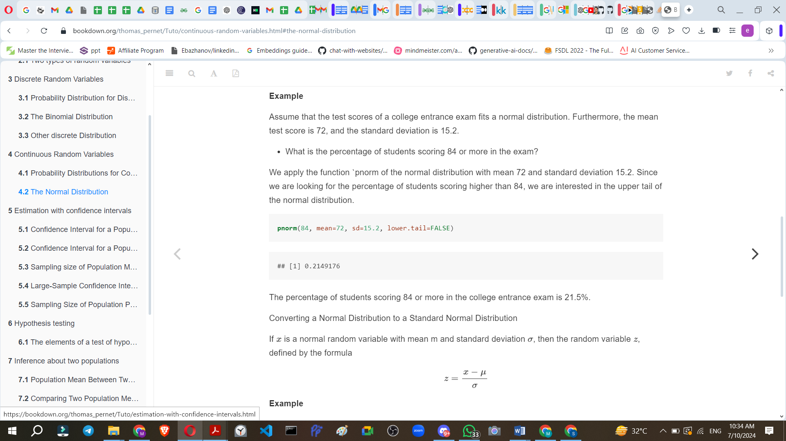

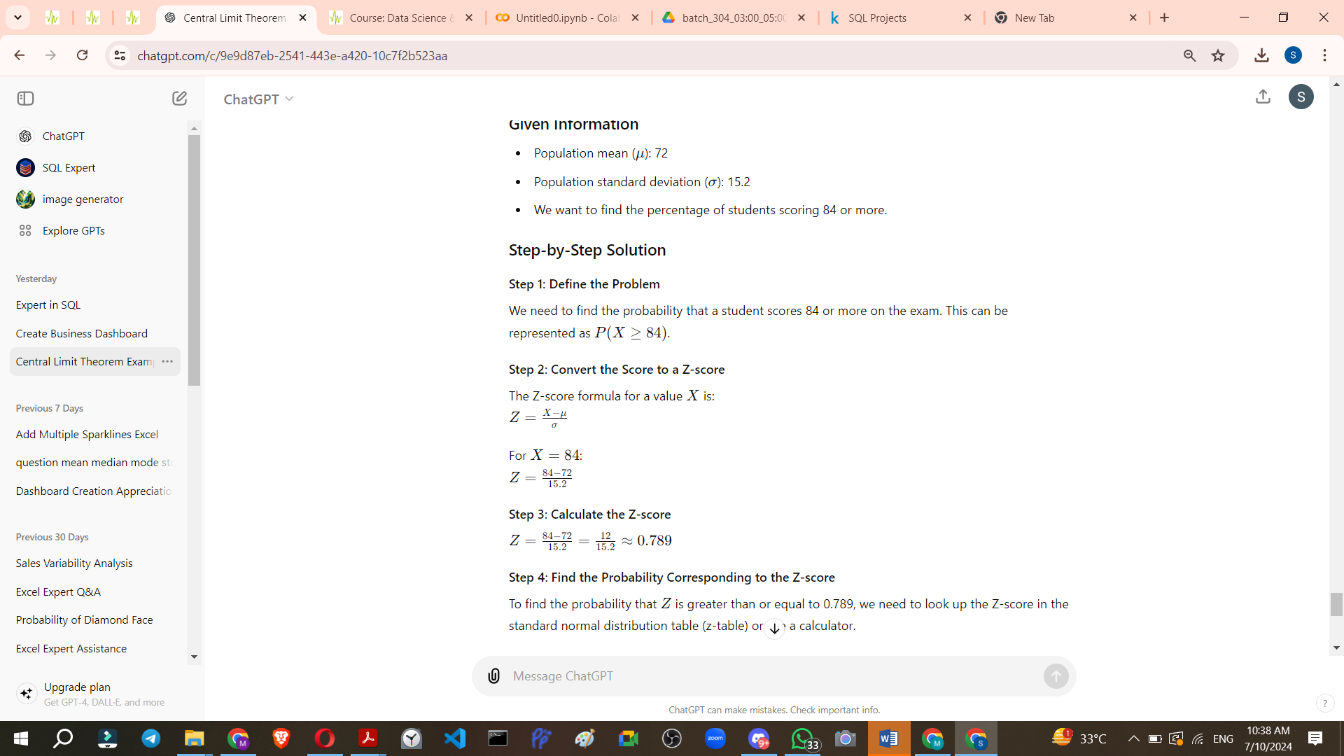

CLT

<https://chatgpt.com/share/a6d0ccbf-6cb8-43f7-b63e-cb6eef2cb675>

**Question**

**Marketing:** What is the probability that the average spending of a sample of 200 customers will be within $5 of the population mean spending?

v

