Subquery in MySQL

Definition:
A subquery, also known as an inner query or nested query, is a query nested within another SQL query. It allows you to use the result of one query as a part of another query.

Or
A Subquery or Inner query or a Nested query allows us to create complex query on the output of another query.
Sub query syntax involves two SELECT statements
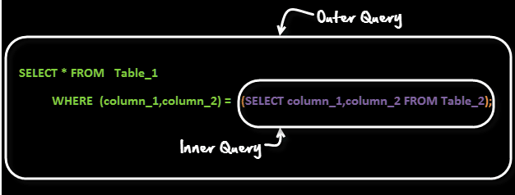

Types of Subqueries:
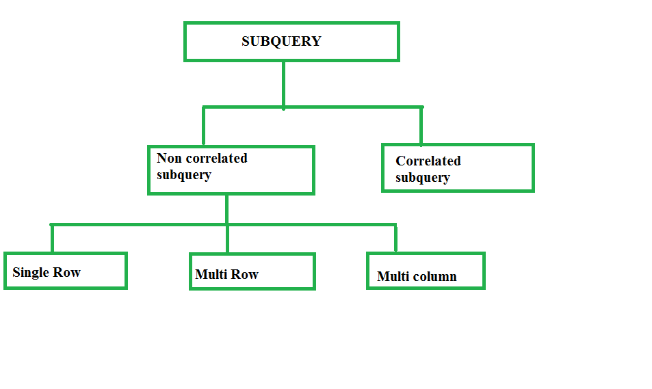

SYNTAX

Scalar Subquery:
A scalar subquery returns a single value (scalar) and can be used wherever an expression is allowed.
SELECT column1, (SELECT MAX(column2) FROM table2) AS max_value0
FROM table1;

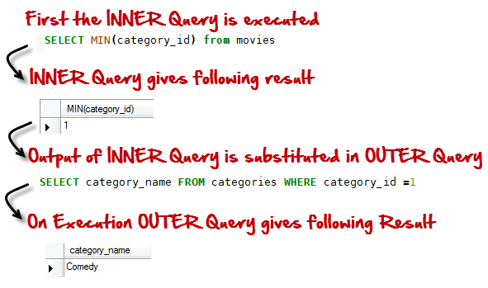

Single-Row Subquery:
A single-row subquery returns one row of data to the outer query. It's used with comparison operators that expect single values.
SELECT column1
FROM table1
WHERE column2 = (SELECT column2 FROM table2 WHERE condition);

Multi-Row Subquery:
A multi-row subquery returns multiple rows of data to the outer query. It's used with operators that expect multiple values.
SELECT column1
FROM table1
WHERE column2 IN (SELECT column2 FROM table2 WHERE condition);

Correlated Subquery:
A correlated subquery depends on the outer query and is evaluated once for each row processed by the outer query.
SELECT column1
FROM table1 t1
WHERE column2 = (SELECT MAX(column2) FROM table2 WHERE t1.column3 = table2.column3);

Usage of Subqueries:

In SELECT Statement:
Subqueries can be used in the SELECT statement to retrieve additional information.
SELECT column1, (SELECT MAX(column2) FROM table2) AS max_value
FROM table1;

In WHERE Clause:
Subqueries can be used in the WHERE clause to filter rows based on certain conditions.
SELECT column1
FROM table1
WHERE column2 = (SELECT column2 FROM table2 WHERE condition);

In FROM Clause:
Subqueries can be used in the FROM clause to treat the result of the subquery as a temporary table.
SELECT *
FROM (SELECT column1 FROM table1 WHERE condition) AS subquery_table;

In INSERT, UPDATE, DELETE Statements:
Subqueries can be used in INSERT, UPDATE, and DELETE statements to perform operations based on the result of another query.
DELETE FROM table1
WHERE column1 IN (SELECT column1 FROM table2 WHERE condition);

Subquery Best Practices:
- Use subqueries when necessary, but avoid nesting too deeply as it can impact readability and performance.
- Test subqueries separately to ensure they return the expected results before incorporating them into larger queries.
- Optimize subqueries by ensuring proper indexing on columns used in subqueries' conditions.
Subqueries are powerful tools in SQL that allow you to perform complex data manipulations and retrieve specific information from your database. Understanding how to use them effectively can greatly enhance your SQL querying capabilities. Adjust the table names, column names, and conditions according to your database schema.

Practical

-- Create Database
CREATE DATABASE IF NOT EXISTS mydatabase;
USE mydatabase;

-- Create `employees` Table
CREATE TABLE employees (
employee_id INT PRIMARY KEY,
first_name VARCHAR(50),
last_name VARCHAR(50),
department_id INT,
salary DECIMAL(10, 2)
);

-- Create `departments` Table
CREATE TABLE departments (
department_id INT PRIMARY KEY,
department_name VARCHAR(50)
);

-- Create `projects` Table
CREATE TABLE projects (
project_id INT PRIMARY KEY,
project_name VARCHAR(50),
manager_id INT
);

-- Insert Data into `employees` Table
INSERT INTO employees (employee_id, first_name, last_name, department_id, salary) VALUES
(1, 'John', 'Doe', 101, 60000.00),
(2, 'Jane', 'Smith', 102, 75000.00),
(3, 'Alice', 'Johnson', 101, 50000.00),
(4, 'Bob', 'Lee', 103, 55000.00),
(5, 'Charlie', 'Brown', 102, 70000.00);

-- Insert Data into `departments` Table
INSERT INTO departments (department_id, department_name) VALUES
(101, 'HR'),
(102, 'IT'),
(103, 'Finance');

-- Insert Data into `projects` Table
INSERT INTO projects (project_id, project_name, manager_id) VALUES
(1001, 'Alpha', 2),
(1002, 'Beta', 3),
(1003, 'Gamma', 5);

Let's assume we have the following tables:
Table: employees
employee_id | first_name | last_name | department_id | salary
1 | John | Doe | 101 | 60000
2 | Jane | Smith | 102 | 75000
3 | Alice | Johnson | 101 | 50000
4 | Bob | Lee | 103 | 55000
5 | Charlie | Brown | 102 | 70000
Table: departments
department_id | department_name
101 | HR
102 | IT
103 | Finance

Table: projects
project_id | project_name | manager_id
1001 | Alpha | 2
1002 | Beta | 3
1003 | Gamma | 5

Types of Subqueries



Scalar Subquery
A scalar subquery returns a single value. It can be used where an expression is expected.
Example: Get the highest salary among all employees and display it along with each employee's details.
SELECT
employee_id,
first_name,
last_name,
salary,
(SELECT MAX(salary) FROM employees) AS highest_salary
FROM employees;

Single-Row Subquery
A single-row subquery returns one row of data to the outer query.
Example: Find the employee whose salary is the highest.
SELECT first_name, last_name, salary
FROM employees
WHERE salary = (SELECT MAX(salary) FROM employees);

Multi-Row Subquery
A multi-row subquery returns multiple rows of data. It is used with operators that expect multiple values like IN.
Example: Find employees who work in the IT department.
SELECT first_name, last_name
FROM employees
WHERE department_id IN (SELECT department_id FROM departments WHERE department_name = 'IT');

Correlated Subquery
A correlated subquery is evaluated once for each row processed by the outer query.
Example: Find employees whose salary is greater than the average salary of their respective departments.
SELECT employee_id, first_name, last_name, salary
FROM employees e
WHERE salary > (SELECT AVG(salary)
FROM employees
WHERE department_id = e.department_id);5

Usage of Subqueries

In SELECT Statement
Example: Get the highest salary in each department along with employee details.
SELECT employee_id, first_name, last_name, department_id, salary,
(SELECT MAX(salary) FROM employees e2 WHERE e2.department_id = e1.department_id) AS highest_salary_in_dept
FROM employees e1;

In WHERE Clause
Example: Find employees who are managers of any project.
SELECT first_name, last_name
FROM employees
WHERE employee_id IN (SELECT manager_id FROM projects);

In FROM Clause
Example: Get the average salary of employees grouped by department.
SELECT dept_avg.department_id, dept_avg.avg_salary
FROM (SELECT department_id, AVG(salary) AS avg_salary
FROM employees
GROUP BY department_id) AS dept_avg;

In INSERT, UPDATE, DELETE Statements
Example: Delete employees who do not manage any projects.
DELETE FROM employees
WHERE employee_id NOT IN (SELECT manager_id FROM projects);

Subquery Best Practices
- Use subqueries when necessary: Subqueries are useful but can become complex. Avoid excessive nesting.
- Test subqueries separately: Ensure subqueries return the expected results before incorporating them.
- Optimize subqueries: Use proper indexing on columns used in subqueries' conditions to improve performance.

Summary
Subqueries are powerful tools in SQL for performing complex data manipulations and retrieving specific information. They can be used in various parts of SQL queries, including SELECT, WHERE, FROM, and even in INSERT, UPDATE, and DELETE statements. Understanding how to use subqueries effectively can greatly enhance your SQL querying capabilities.

Reference https://www.mysqltutorial.org/mysql-basics/mysql-subquery/

https://www.guru99.com/sub-queries.html
https://mariadb.com/kb/en/subquery-optimizations-map/
https://www.scaler.com/topics/sql/correlated-subquery/

