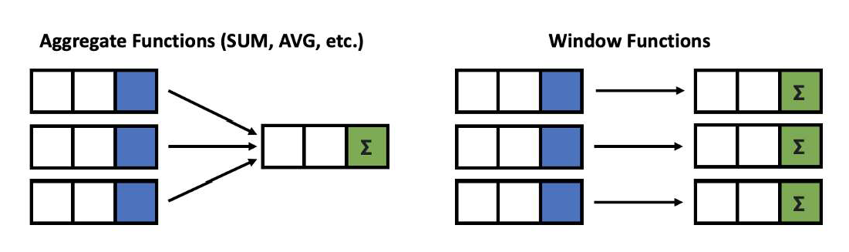

Window functions applies aggregate, ranking and analytic functions over a particular window (set of rows).
And OVER clause is used with window functions to define that window.

Give output one row per aggregation The rows maintain their separate identities

80

fun( ) |  | OVER

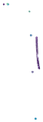

Select a function Aggregate functions Ranking functions Analytic functions
SELECT column_name(s),
( [ <PARTITION BY Clause> ] [ <ORDER BY Clause> ]
[ <ROW or RANGE Clause> ] )
FROM table_name
Define a Window PARTITION BY ORDER BY ROWS

81




Window function applies aggregate, ranking and analytic functions over a particular window; for example, sum, avg, or row_number
Expression is the name of the column that we want the window function operated on. This may not be necessary depending on what window function is used
OVER is just to signify that this is a window function
PARTITION BY divides the rows into partitions so we can specify which rows to use to compute the window function
ORDER BY is used so that we can order the rows within each partition. This is optional and does not have to be specified
ROWS can be used if we want to further limit the rows within our partition. This is optional and usually not used

82

There is no official division of the SQL window functions into categories but high level we can divide into three types
Value/Analytic
LEAD LAG
FIRST_VALUE
LAST_VALUE
Ranking
ROW_NUMBER RANK DENSE_RANK PERCENT_RANK
Aggregate
SUM AVG COUNT MIN MAX
Window Functions

83

SELECT new_id, new_cat,
AGGREGATE FUNCTION
Example
SUM(new_id) OVER( PARTITION BY new_cat ORDER BY new_id ) AS "Total", AVG(new_id) OVER( PARTITION BY new_cat ORDER BY new_id ) AS "Average", COUNT(new_id) OVER( PARTITION BY new_cat ORDER BY new_id ) AS "Count", MIN(new_id) OVER( PARTITION BY new_cat ORDER BY new_id ) AS "Min", MAX(new_id) OVER( PARTITION BY new_cat ORDER BY new_id ) AS "Max" FROM test_data

new_id | new_cat | Total | Average | Count | Min | Max
100 | Agni | 300 | 150 | 2 | 100 | 200
200 | Agni | 300 | 150 | 2 | 100 | 200
500 | Dharti | 1200 | 600 | 2 | 500 | 700
700 | Dharti | 1200 | 600 | 2 | 500 | 700
200 | Vayu | 1000 | 333.33333 | 3 | 200 | 500
300 | Vayu | 1000 | 333.33333 | 3 | 200 | 500
500 | Vayu | 1000 | 333.33333 | 3 | 200 | 500

84

SELECT new_id, new_cat,
SUM(new_id) OVER( ORDER BY new_id ROWS BETWEEN UNBOUNDED PRECEDING AND UNBOUNDED FOLLOWING) AS "Total", AVG(new_id) OVER( ORDER BY new_id ROWS BETWEEN UNBOUNDED PRECEDING AND UNBOUNDED FOLLOWING) AS "Average", COUNT(new_id) OVER( ORDER BY new_id ROWS BETWEEN UNBOUNDED PRECEDING AND UNBOUNDED FOLLOWING) AS "Count", MIN(new_id) OVER( ORDER BY new_id ROWS BETWEEN UNBOUNDED PRECEDING AND UNBOUNDED FOLLOWING) AS "Min", MAX(new_id) OVER( ORDER BY new_id ROWS BETWEEN UNBOUNDED PRECEDING AND UNBOUNDED FOLLOWING) AS "Max"
FROM test_data
new_id | new_cat | Total | Average | Count | Min | Max
100 | Agni | 2500 | 357.14286 | 7 | 100 | 700
200 | Agni | 2500 | 357.14286 | 7 | 100 | 700
200 | Vayu | 2500 | 357.14286 | 7 | 100 | 700
300 | Vayu | 2500 | 357.14286 | 7 | 100 | 700
500 | Vayu | 2500 | 357.14286 | 7 | 100 | 700
500 | Dharti | 2500 | 357.14286 | 7 | 100 | 700
700 | Dharti | 2500 | 357.14286 | 7 | 100 | 700

AGGREGATE FUNCTION
Example

85
NOTE: Above we have used ROWS
which will give a SINGLE output based on all INPUT Vaused)

SELECT new_id,
RANKING FUNCTION
Example
ROW_NUMBER() OVER(ORDER BY new_id) AS "ROW_NUMBER", RANK() OVER(ORDER BY new_id) AS "RANK",
DENSE_RANK() OVER(ORDER BY new_id) AS "DENSE_RANK", PERCENT_RANK() OVER(ORDER BY new_id) AS "PERCENT_RANK"
FROM test_data

new_id | ROW_NUMBER | RANK | DENSE_RANK | PERCENT_RANK
100 | 1 | 1 | 1 | 0
200 | 2 | 2 | 2 | 0.166
200 | 3 | 2 | 2 | 0.166
300 | 4 | 4 | 3 | 0.5
500 | 5 | 5 | 4 | 0.666
500 | 6 | 5 | 4 | 0.666
700 | 7 | 7 | 5 | 1
86

SELECT new_id,
ANALYTIC FUNCTION
Example
FIRST_VALUE(new_id) OVER( ORDER BY new_id) AS "FIRST_VALUE", LAST_VALUE(new_id) OVER( ORDER BY new_id) AS "LAST_VALUE", LEAD(new_id) OVER( ORDER BY new_id) AS "LEAD",
LAG(new_id) OVER( ORDER BY new_id) AS "LAG"
FROM test_data

new_id | FIRST_VALUE | LAST_VALUE | LEAD | LAG
100 | 100 | 100 | 200 | null
200 | 100 | 200 | 200 | 100
200 | 100 | 200 | 300 | 200
300 | 100 | 300 | 500 | 200
500 | 100 | 500 | 500 | 300
500 | 100 | 500 | 700 | 500
700 | 100 | 700 | null | 500

87
NOTE: If you just want the single last value from whole column, use ROWS BETWEEN

Offset the LEAD and LAG values by 2 in the output columns ?

INPUT |  |  | OUTPUT
new_id |  | new_id | LEAD | LAG
100 |  | 100 | 200 | NULL
200 |  | 200 | 300 | NULL
200 |  | 200 | 500 | 100
300 |  | 300 | 500 | 200
500 |  | 500 | 700 | 200
500 |  | 500 | NULL | 300
700 |  | 700 | NULL | 500
 |  |  |  |  | 88

SELECT new_id,
ANALYTIC FUNCTION
Assignment
LEAD(new_id, 2) OVER( ORDER BY new_id) AS "LEAD_by2", LAG(new_id, 2) OVER( ORDER BY new_id) AS "LAG_by2" FROM test_data

new_id | LEAD_by2 | LAG_by2
100 | 200 | null
200 | 300 | null
200 | 500 | 100
300 | 500 | 200
500 | 700 | 200
500 | null | 300
700 | null | 500

