https://www.six-sigma-material.com/Hypothesis-Testing.html
https://www.analyticsvidhya.com/blog/2022/01/learn-all-about-hypothesis-testing/
https://www.ncl.ac.uk/webtemplate/ask-assets/external/maths-resources/statistics/hypothesis-testing/one-tailed-and-two-tailed-tests.html
https://www.scribbr.com/statistics/p-value/ https://www.investopedia.com/terms/t/type_1_error.asp
https://www.investopedia.com/terms/t/type-ii-error.asp

Statistical/Hypothesis Tests are used to make the generalization/summarize about the population from the sample. These tests are used to check whether there is a enough evidence in sample data to conclude/deduce that any particular/specific/certain condition is also true for entire population.
Certain condition/pattern of sample≈ Certain condition/pattern for population
These test completely relies on the probability distribution, to support Hypothesis.We perform these tests to know the below :
1) Comparison : Is there any difference between two data-sets/groups/data.
2) Relationship : Is there any connection between two groups/columns/data/variables.
There are various ways to achieve/perform a Statistical/Hypothesis tests on data depending upon the type of variables in the data and type of test.
There are two types of tests in Statistical/Hypothesis Tests.
1) Parametric tests
2) Non Parametric Tests
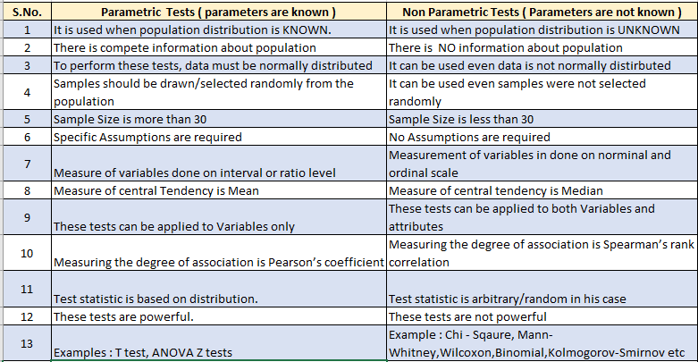
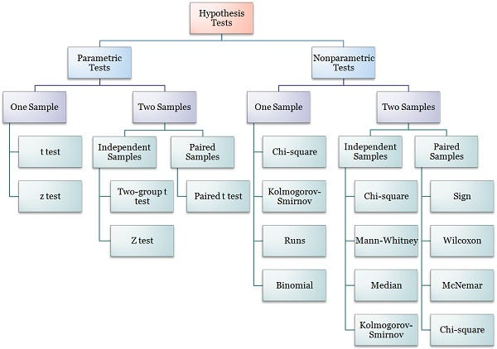
- Z-Test ( the sample is assumed to be normally distributed )
(population mean and population standard deviation are known)
Used to validate hypothesis that the sample drawn belongs to the same population.
Null : Mean of sample = Mean of population
Alternate : Mean of sample ≠Mean of population
- T-Test ( the sample is assumed to be normally distributed )
(population mean and population standard deviation are known)
Used to compare the mean of only two given samples. ( for three , we used ANOVA).
3 Types of T-Test : One sample , Independent and Paired.
Large T-Test Score = group are different
Small T-Test Score = Group are same
Null : Mean of one sample = Mean of other sample
Alternate : Mean of other sample ≠Mean of other sample
- ANOVA Test ( Analysis of Variance ) : (random sample, Homogeneity, Normality) (2 Types of Anova: One Way Anova and Multi-Way Anova )
Used to compare multiple (three or more) samples with a single test/multiple tests and used to compare datasets as well.
Null : All samples are equal
Alternate : All samples are not equal
- Chi-Square Test (χ2) ( Comparison and Categorical )
Used to compare 2 or more categorical variables.
Types :
i. Goodness of fit test, which determines if a sample matches the population.
ii. A chi-square fit test for two independent variables is used to compare two variables in a contingency table to check if the data fits.
a. A small chi-square value means that data fits
b. A high chi-square value means that data doesn’t fit.
Null: Variable A and Variable B are independent
Alternate: Variable A and Variable B are not independent.
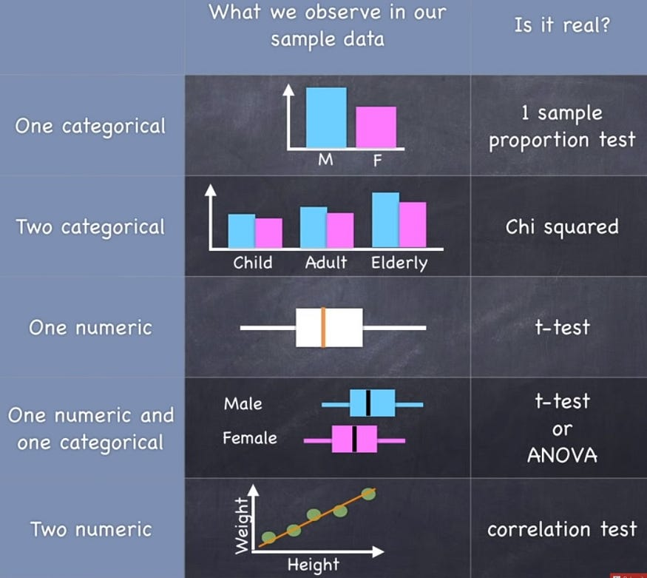
These topics are very complicated and i have tried my best to cut it down to very brief , not to bombard with formulas and heavy jargon

