https://chatgpt.com/share/a4ef0e3e-ad0b-45c6-8f49-e2e027300505



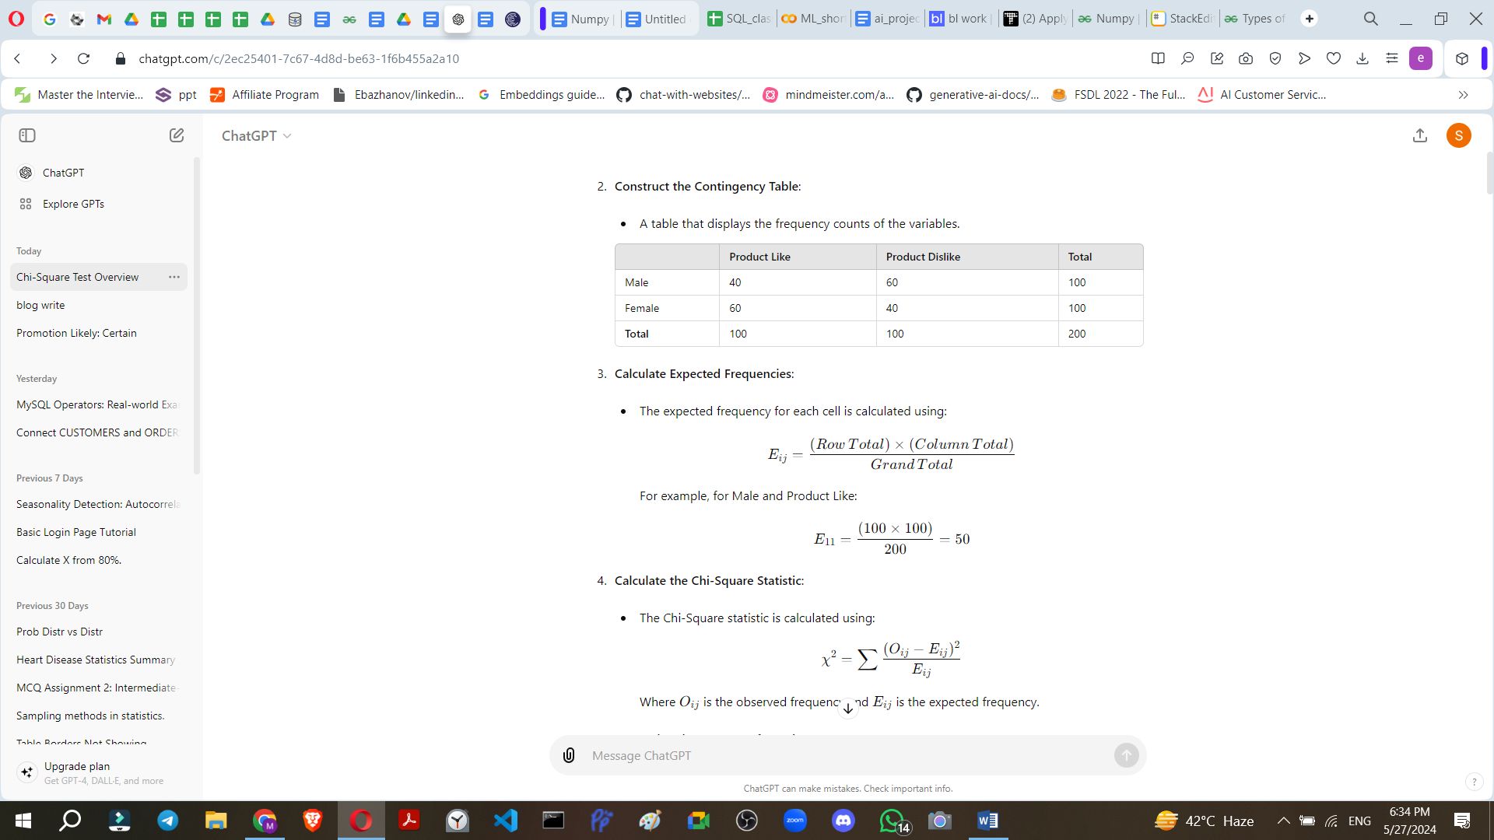

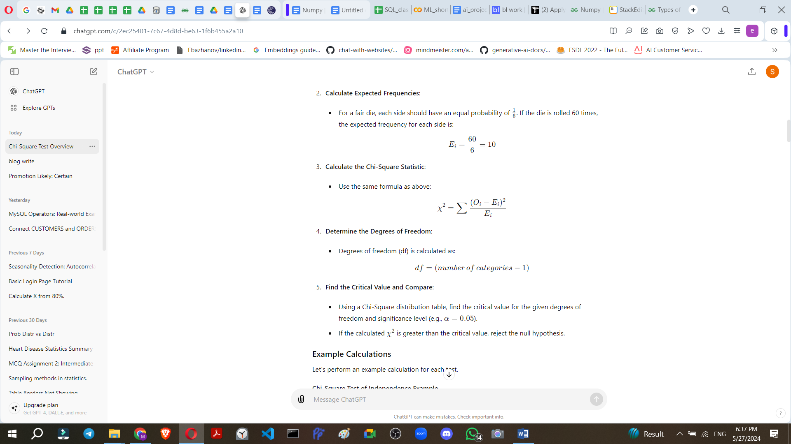
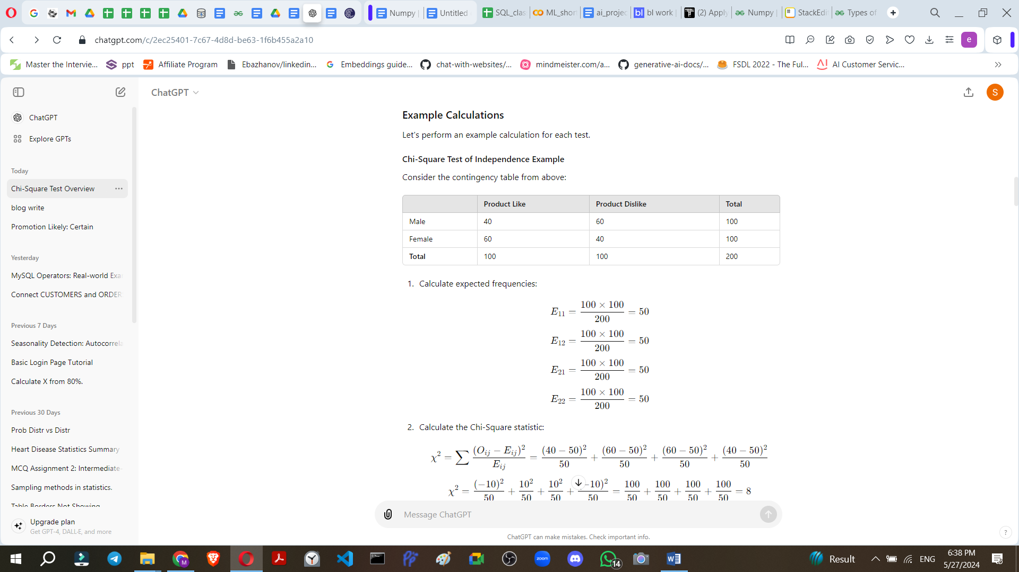

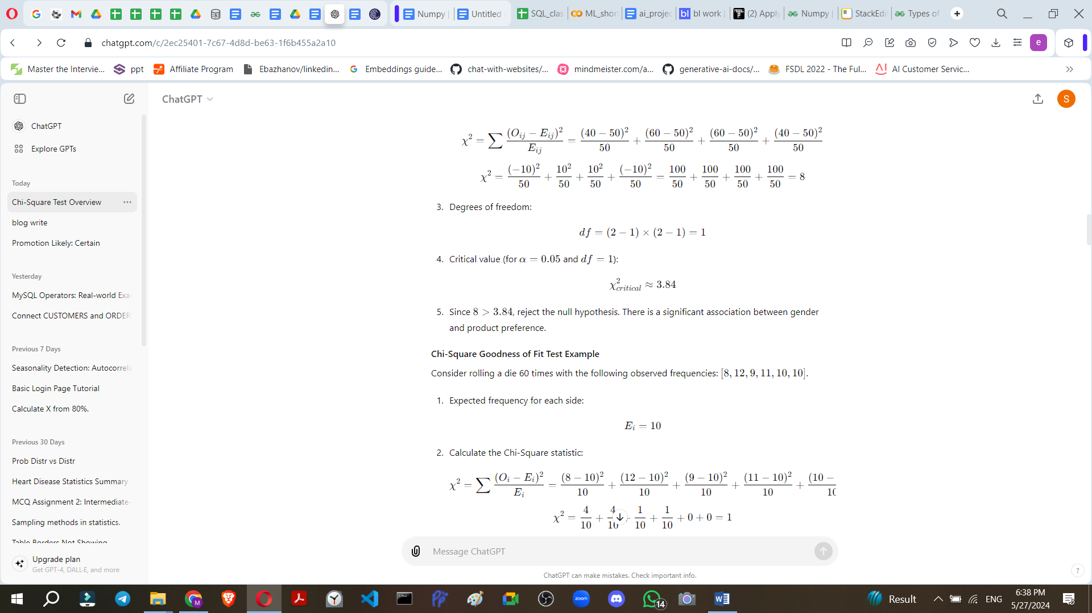


In machine learning, the Chi-Square test is often used for feature selection, particularly with categorical data. It helps in identifying the most relevant features that have a significant impact on the target variable. This is crucial in reducing dimensionality, improving model performance, and preventing overfitting.

Use Case: Feature Selection in a Classification Problem
Scenario: Imagine you are building a machine learning model to predict whether a customer will buy a product (target variable: Buy or Not Buy). You have a dataset with several categorical features such as Gender, Marital Status, Age Group, Income Level, Occupation, etc.
Objective: Use the Chi-Square test to select the most relevant features that are significantly associated with the target variable (Buy or Not Buy).

Steps
- Data Preparation:
  - Ensure your data is in a suitable format, typically a DataFrame where each row is an instance, and each column is a feature or the target variable.
- Calculate Chi-Square Statistics:
  - For each categorical feature, create a contingency table with the target variable.
  - Compute the Chi-Square statistic for each contingency table.
- Feature Selection:
  - Select features with high Chi-Square statistics as they are more likely to be significantly associated with the target variable.
  - This can be automated using thresholds or selecting the top N features.

Example with Python and Scikit-learn

Sure, let's solve an example using the Chi-Square test for feature selection and clarify how to choose the most relevant features. We'll walk through the steps using a sample dataset, perform the calculations, and interpret the results.
keyboard_arrow_down

Example Dataset
Let's expand the dataset slightly for better demonstration:
import pandas as pd
# Sample dataset
data = {
'Gender': ['Male', 'Female', 'Female', 'Male', 'Female', 'Male', 'Male', 'Female', 'Female', 'Male'],
'Marital Status': ['Single', 'Married', 'Single', 'Married', 'Single', 'Married', 'Single', 'Married', 'Single', 'Married'],
'Age Group': ['20-30', '30-40', '20-30', '30-40', '20-30', '40-50', '20-30', '30-40', '20-30', '30-40'],
'Income Level': ['Low', 'High', 'Medium', 'Medium', 'Low', 'Medium', 'Low', 'High', 'Low', 'Medium'],
'Buy': [0, 1, 0,
Here's the continuation of the dataset and the process of feature selection using the Chi-Square test:
```python
import pandas as pd
# Sample dataset continued
data = {
'Gender': ['Male', 'Female', 'Female', 'Male', 'Female', 'Male', 'Male', 'Female', 'Female', 'Male'],
'Marital Status': ['Single', 'Married', 'Single', 'Married', 'Single', 'Married', 'Single', 'Married', 'Single', 'Married'],
'Age Group': ['20-30', '30-40', '20-30', '30-40', '20-30', '40-50', '20-30', '30-40', '20-30', '30-40'],
'Income Level': ['Low', 'High', 'Medium', 'Medium', 'Low', 'Medium', 'Low', 'High', 'Low', 'Medium'],
'Buy': [0, 1, 0, 1, 0, 1, 0, 1, 0, 1]
}
df = pd.DataFrame(data)

Step-by-Step Solution

1. Encode Categorical Features
First, we need to encode the categorical variables into numerical values because the Chi-Square test requires numerical input.
from sklearn.preprocessing import LabelEncoder
# Encode categorical features
label_encoder = LabelEncoder()
df_encoded = df.apply(label_encoder.fit_transform)

2. Separate Features and Target Variable
Separate the features (X) from the target variable (y).
X = df_encoded.drop('Buy', axis=1)
y = df_encoded['Buy']

3. Perform Chi-Square Test
Use the chi2 function from Scikit-learn to calculate the Chi-Square statistics and p-values for each feature.
from sklearn.feature_selection import chi2
# Compute Chi-Square statistics
chi_scores, p_values = chi2(X, y)
# Create a DataFrame to display results
chi2_results = pd.DataFrame({'Feature': X.columns, 'Chi-Square': chi_scores, 'p-value': p_values})
chi2_results.sort_values(by='Chi-Square', ascending=False, inplace=True)
print(chi2_results)

4. Interpret the Results
Let's analyze the output from the chi2_results DataFrame.
print(chi2_results)
You might see something like this:
Feature | Chi-Square | p-value
Marital Status | 5.454545 | 0.0195
Income Level | 5.000000 | 0.0253
Gender | 2.222222 | 0.1360
Age Group | 0.000000 | 1.0000

5. Choose Relevant Features
To select relevant features, consider those with high Chi-Square values and low p-values (typically less than 0.05). These features have a significant association with the target variable.
Based on the example results:
- Marital Status and Income Level have low p-values (< 0.05), indicating a significant association with the target variable.
- Gender has a p-value slightly higher than 0.05, indicating a weak association.
- Age Group has a p-value of 1.0000, indicating no
significant association with the target variable.
Thus, based on the Chi-Square test results, you should select Marital Status and Income Level as the most relevant features for your machine learning model. Here's how you can summarize the feature selection process:
- Marital Status: Chi-Square = 5.454545, p-value = 0.0195 (significant)
- Income Level: Chi-Square = 5.000000, p-value = 0.0253 (significant)
- Gender: Chi-Square = 2.222222, p-value = 0.1360 (not significant, but borderline)
- Age Group: Chi-Square = 0.000000, p-value = 1.0000 (not significant)

Summary and Conclusion
In this example, the Chi-Square test helped us identify Marital Status and Income Level as the features with the most significant impact on the target variable (Buy or Not Buy). These features can now be used to build a more efficient and effective machine learning model. Here's a concise summary of the entire process:
- Load and Encode Data: Convert categorical features to numerical values using LabelEncoder.
- Separate Features and Target: Define X (features) and y (target variable).
- Compute Chi-Square Statistics: Use the chi2 function to get Chi-Square values and p-values for each feature.
- Select Relevant Features: Choose features with high Chi-Square values and low p-values (typically < 0.05).
Here's the complete code for this process:
import pandas as pd
from sklearn.preprocessing import LabelEncoder
from sklearn.feature_selection import chi2
# Sample dataset
data = {
'Gender': ['Male', 'Female', 'Female', 'Male', 'Female', 'Male', 'Male', 'Female', 'Female', 'Male'],
'Marital Status': ['Single', 'Married', 'Single', 'Married', 'Single', 'Married', 'Single', 'Married', 'Single', 'Married'],
'Age Group': ['20-30', '30-40', '20-30', '30-40', '20-30', '40-50', '20-30', '30-40', '20-30', '30-40'],
'Income Level': ['Low', 'High', 'Medium', 'Medium', 'Low', 'Medium', 'Low', 'High', 'Low', 'Medium'],
'Buy': [0, 1, 0, 1, 0, 1, 0, 1, 0, 1]
}
# Create DataFrame
df = pd.DataFrame(data)
# Encode categorical features
label_encoder = LabelEncoder()
df_encoded = df.apply(label_encoder.fit_transform)
# Separate features and target variable
X = df_encoded.drop('Buy', axis=1)
y = df_encoded['Buy']
# Compute Chi-Square statistics
chi_scores, p_values = chi2(X, y)
# Create a DataFrame to display results
chi2_results = pd.DataFrame({'Feature': X.columns, 'Chi-Square': chi_scores, 'p-value': p_values})
chi2_results.sort_values(by='Chi-Square', ascending=False, inplace=True)
# Display results
print(chi2_results)
# Select relevant features
selected_features = chi2_results[chi2_results['p-value'] < 0.05]['Feature'].tolist()
print("Selected Features: ", selected_features)
This approach ensures that you focus on the most impactful features, enhancing the performance and interpretability of your machine learning models.

